Chlorophyll-a patterns during Magellanic penguin breeding at Punta Tombo

Anna Sulc

Department of Oceanography

sulca@uw.edu

06/02/2019

Abstract

Organisms in the ocean depend ultimately on phytoplankton, as it is the base of the marine food web. The use of satellite imaging, as indicators of photosynthesis such as chlorophyll-A is often used as an index of primary production in the ocean. Located on the southeast coast of Argentina, Punta Tombo is among the largest breeding colonies for Magellanic penguins. Starvation accounts tor 40% of chick deaths (Rebstock & Boersma, Climate Change Increases Reproductive Failure in Magellanic Penguins, 2014)

Using spatial analysis tools, for 10 breeding seasons, I used chlorophyll-a patterns to determine the relationship between chlorophyll-a abundance and Magellanic penguin chicks’ starvation. I did not find a strong relationship between chick starvation and chlorophyll-a abundance, but the overall distribution of chlorophyll-a appeared to influence chick starvation. Low chick starvation was observed when the study area had large phytoplankton blooms in a consistent location, surrounded by less productive regions. In years where moderate concentrations of chlorophyll-a were dispersed across the study area, more chicks starved.

I-Introduction

Located in the Southwestern Atlantic, the Patagonian shelf is an extremely productive, rich and diverse marine environment (Marrari, Piola , & Valla, 2017). These favorable conditions are the result of the shallow bathymetry of the Patagonian shelf, the Malvinas current and large tides. The relatively shallow (maximum depth of 200m) and flat (slope of approximately 1:1000m) (Romero, Piola, Charo, & Eiras Garcia, 2006) shelf extends from the Rio de la Plata estuary down to the southern tip of a continent. In its entirety, it covers 1.2 million square kilometers widening from 150km width at its north most point to about 850km at 50S (NASA Earth Observatory, 2002). The strong Malvinas current brings cold, fresh, nutrient rich water from the south. The current along with the shallow Patagonian shelf work together to create a highly productive and nutrient rich environment. (Matano & Palma, 2008). High nutrient concentrations are important for sustaining large amounts of primary productivity, the large tides on the shelf enhance vertical mixing close to shore and create tidal fronts between areas with enhanced vertical mixing and stratified water columns (Romero, Piola, Charo, & Eiras Garcia, 2006).
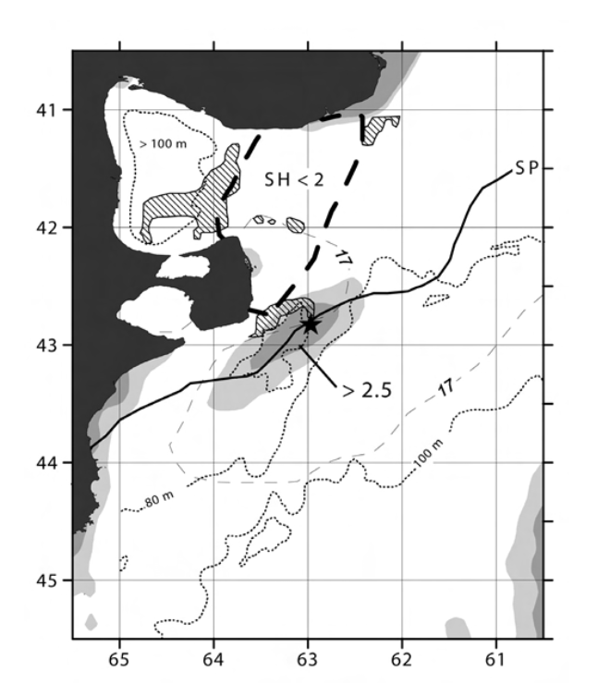
Tidal fronts occur in areas close to shore with shallow bathymetry and large tidal oscillations. Without large tides, most temperate coastal waters develop thermoclines during warm months. However, tidal energy can create enough turbulent mixing to overcome the thermal stratification (Derisio, Alemany, Acha, & Mianzan, 2014). As depth increases, the mixing of the column will become weaker until a front between a well-mixed and a stratified layer is created. With such a sharp change in conditions, tidal fronts can be identified by an abrupt change in salinity and sea surface temperature (Cho, 2010). Fronts isolate a layer of high nutrient water close to the surface, creating the ideal environment for concentrated phytoplankton growth (Figure 1). At the base of the marine food web, phytoplankton supports the growth zooplankton. Zooplankton is in turn prey for small fish and squid (Marrari, Piola , & Valla, 2017). These relationships suggest small fish and squid populations will be influenced by phytoplankton abundance. An example of a highly productive and consistently occurring frontal system is the Peninsula Valdes tidal front (Derisio, Alemany, Acha, & Mianzan, 2014). Its favorable conditions have resulted in important phytoplankton and zooplankton growth, making it vital to Argentine fisheries as a spawning ground for commercial fish (Sánchez & Ciechomski, 1995). Systems like the Peninsula Valdes frontal system are one of the many factors that contribute to high productivity of the Patagonian shelf. Many species of marine birds and mammals come to the Argentine coast to breed due to this high productivity. One such animal is the Magellanic penguin.
Figure 1: Mean January SeaWiFS derived surface chl-a (mg m 3) distribution in the region of Valdés Peninsula (gray shading: light gray >2 mg m -3, dark gray >2.5 mg m -3). Peninsula Valdes is located approximately 200 km northeast of the Punta Tombo colony. Map also shows depth contours. Shallow bathymetry is beneficial to successful foraging. Taken from Derision, Alemany, Acha & Miazan, 2014.

Magellanic penguins breed along the coasts of Argentina and Chile. (Boersma & García-Borboroglu, Penguins: Natural History and Conservation, 2013). They are considered as a near threatened species of penguin by the IUCN (International Union for Conservation of Nature). As a migratory species of penguin, they spend half of each year at sea at low latitude wintering grounds close to Brazil and Peru (Boersma & García-Borboroglu, Penguins: Natural History and Conservation, 2013). Magellanic penguins prey mainly on small pelagic species that occur in aggregations (Scolaro, et al., 1999). Along the coast of Argentina, they predominantly consume sprats, anchovy, hake, silversides, squid and crustaceans (Scolaro, et al., 1999). Due to the variation in the composition of their diets between colonies, it seems Magellanic penguin foraging is a reflection of the availability of different types of pelagic prey rather than diet choices specific to the species. While not much is known about their behavior at sea during the austral winter, they spend the other 6 months of the year on land at breeding colonies. In late September, adults swim hundreds of kilometers back to colonies, often to where they hatched (Boersma, Penguins as Marine Sentinels, 2008). Males arrive first and attempt to secure a nest in preparation for the arrival of the females (Stokes & Boersma, Where Breeding Magellanic Penguins Spheniscus Magellanicus Forage: Satellite Telemetry Results and Their Implications for Penguin Conservation, 1999).
Magellanic penguins are seasonally monogamous, remaining faithful to one mate for an entire breeding season (Boersma & García-Borboroglu, Penguins: Natural History and Conservation, 2013). If a pair has been successful in rearing chicks in past seasons, they may continue to breed together for many consecutive seasons. (Boersma & García-Borboroglu, Penguins: Natural History and Conservation, 2013, p. 239). Parents share incubation and chick-rearing responsibilities, taking turns going to sea to forage for themselves and for their young. A female will lay two eggs in early October and both parents will take turns incubating them for about 40 days until they hatch in mid-November (Boersma & García-Borboroglu, Penguins: Natural History and Conservation, 2013, p. 241) At egg laying, males have fasted for as long as five weeks and leave to sea to forage. Foraging trips during egg incubation are between 3 and 4 weeks long and become shorter as hatching approaches, sometimes as short as one to two days. As the chicks age, foraging trips again increase in length (Figure 2) (Stokes & Boersma, Where Breeding Magellanic Penguins Spheniscus Magellanicus Forage: Satellite Telemetry Results and Their Implications for Penguin Conservation, 1999). During these trips, adults will travel between 100 and 600 km and dive up to 100 m to search for small fish, squid and crustaceans (Boersma & Rebstock, Foraging distance affects reproductive success in Magellanic penguins, 2009). Timely return of the parents is essential for the chick’s survival, especially in the first 10 days of their lives when chicks must be fed every one to two days to avoid starvation (Boersma & García-Borboroglu, Penguins: Natural History and Conservation, 2013). While predation accounts for most chick death, exposure to rain and the cold is another important cause for chick deaths in years with high precipitation (Rebstock & Boersma, Climate Change Increases Reproductive Failure in Magellanic Penguins, 2014). While predation typically accounts for 10% of chick death, in many years, exposure accounts for a considerable amount of chick mortality. On average starvation was responsible for an average of 39% of chick deaths (Rebstock & Boersma, Climate Change Increases Reproductive Failure in Magellanic Penguins, 2014). Most of these deaths occur in the first 30 days of hatching (Boersma, Rebstock, & García-Borboroglu, Marine protection is needed for Magellanic penguins in Argentina based on long-term data, 2015). Since starvation is such an important factor in determining reproductive success of Magellanic penguins, understanding the causes behind a lack of food during the breeding season is important.
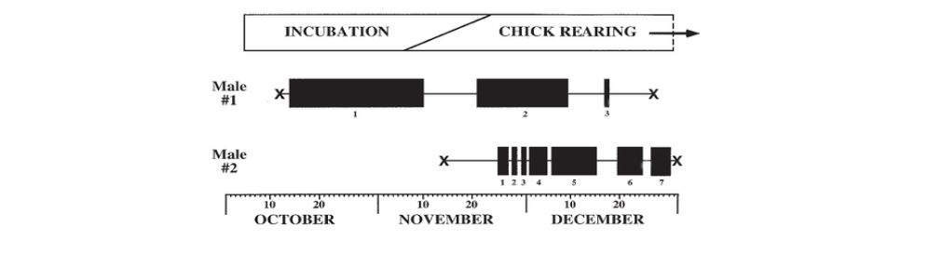
Figure 2: Timing of foraging trips of two satellite-tagged male Magellanic Penguins breeding at Punta Tombo, Argentina, during the incubation and early chick-rearing stages of the 1995/1996 breeding season. Solid blocks indicate foraging trips (trip number shown beneath); thin lines indicate presence at the nest. ‘X’ denotes dates of attachment and removal of devices. Male One’s three foraging trips averaged 15.0 days in duration; Male Two’s seven trips averaged 3.9 days. Colony breeding phenology is shown at top. During incubation (Male #1) trips are long on the scale of 3-4 weeks. When chicks hatch, parents take turns going on short foraging trips on the scale of 1-2 days (Male #2, trips 1, 2,3 and 4) and trips become progressively longer as chicks age (Trips 5,6,7). Taken from Stokes & Boersma, 1999.

Led by Professor P. Dee Boersma, the Center for Ecosystem Sentinels at the University of Washington has studied the Punta Tombo colony since 1982 and has determined reproductive success for 35 years. The colony has declined by 40% (Rebstock & Boersma, Oceanographic conditions in wintering grounds affect arrival date and body condition in breeding female Magellanic penguins, 2018) (Boersma, unpublished data). Magellanic penguins are sentinels of our oceans (Boersma, Penguins as Marine Sentinels, 2008). To use these penguins as sentinels it is important to understand both the biology of these marine birds and the local oceanography. Their survival is critically dependent on ocean conditions around them, and because they nest on land and we can get reliable colony-wide survival and breeding success measurements, we can use the health of the penguins as a vector of nearby ocean conditions.
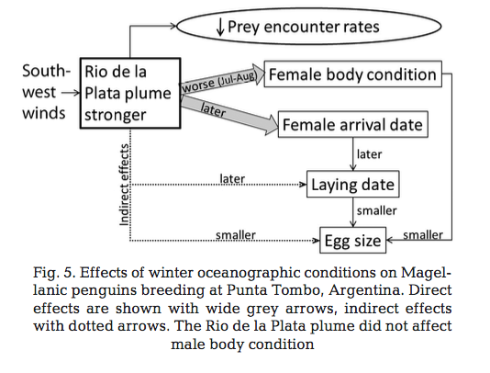
There are many studies in this region investigating either marine bird behavior or ocean conditions. Few studies have examined the relationship between ocean conditions and the foraging behavior of marine organisms. Long-term data shows that river discharge from the Rio de la Plata influences the body condition of returning breeding female penguins (Rebstock & Boersma, 2018). The Rio de la Plata is located over 1,200 km north of Punta Tombo and coincides with the location of Magellanic penguin wintering grounds (Stokes, Boersma, de Casenave, & García-Borboroglu, 2014) (Stokes & Boersma, Where Breeding Magellanic Penguins Spheniscus Magellanicus Forage: Satellite Telemetry Results and Their Implications for Penguin Conservation, 1999). High in nutrients, river water provides favorable conditions for phytoplankton growth and attracts penguin prey. However, Rebstock & Boersma 2018 found that when the river plume was strong, penguins return late, were in poorer body condition and laid smaller eggs (Rebstock & Boersma, Oceanographic conditions in wintering grounds affect arrival date and body condition in breeding female Magellanic penguins, 2018) (Figure 3). While abundant in nutrients, a strong river plume could create turbid water making foraging difficult for visual predators like Magellanic penguins.
Figure 3: Effects of winter oceanographic conditions on Magellanic penguins breeding at Punta Tombo, Argentina. The mouth of the Rio de la Plata river supplies nutrients to coastal waters making them productive and abundant in penguin prey. As the fresh water from the river diffuses it creates a plume of water high in chlorophyll-a. However, river water also carries sediment. In years where winds promote the spread of river water, the plume extends further out to sea and increases the area where prey can be found in addition to increasing turbidity. As visual hunters, Magellanic penguins struggles in these conditions. Taken from Rebstock & Boersma, 2018

I investigated if and how chlorophyll-a might influence the starvation of Magellanic penguin chicks at Punta Tombo by comparing primary productivity near Punta Tombo and Magellanic penguin chick starvation. Using Professor P. Dee Boersma’s 35-year data set, I determined the percentage of chicks dead due to starvation for every breeding season from 2002 to 2018. From these years I selected 10 “extreme” years where starvation in chicks was either very high or very low. I also analyzed satellite derived ocean color (chlorophyll-a concentration) measured by MODIS near Punta Tombo. Using ArcMap, I observed patterns in the distribution of high chlorophyll-a concentrations and their variation with time across a study area off the coast of the breeding colony. By comparing these two sets of data, this study hopes to determine the relationship between primary productivity and starvation of Magellanic penguin chicks.
I predicted that when average chlorophyll-a was high over the entire study area, chick starvation would be low. I believed that when chlorophyll-a concentration, a proxy for primary productivity, is located in several large patches fewer chicks starve. I expected parents to be less successful in rearing chicks in years where concentrations of chlorophyll-a across the study area were low and chlorophyll-a is dispersed in many small patches. My results partially supported this hypothesis. Chlorophyll-a abundance did not appear a strong influence on chick starvation. However, the distribution patterns and the variation of the location of high chlorophyll-a concentrations over the course of the season appeared to have an influence on chick survival.
II-Methods

Chick Starvation data
We used data on collected from nest checks at Punta Tombo each year (Rebstock and Boersma 2014). Data are collected over the course of the 5 months, from mid-September to mid-February, when the birds are breeding. Observations of behavior and bird health are made as frequently as 2 times a day and as infrequently as every 10 days depending the part of the colony. Methods were adapted from Rebstock & Boersma 2018. Using SQL Server, we extracted chick data for each season (Figure 4).
Figure 4: SQL Server code used to collect data on Magellanic penguin chick starvation at Punta Tombo. Code counts all followed chicks (ChickNum) for each year from 2002 to 2017 with a health status (death by starvation is one of many health statuses). Numbers of starvation deaths were manually recorded for each year. Table names are specific to Ecosystem Sentinels data base.

To determine starvation in the colony, I counted the amount of deaths of chicks linked to starvation in nests that were regularly monitored during a season. Chick considered as starved (marked as D-STA in the database) are chicks that were necropsied to determine the cause of death. Indications of starvation in chicks are no body fat, dehydration, very low body weight and no stomach contents (Boersma, unpublished data). I calculated a ratio from these values and used them to determine years when fewer chicks starved and food was more abundant and years when many chicks starved so food was less available. Breeding seasons were selected for chlorophyll-a observations using this ratio. Consistent satellite derived chlorophyll-a data was available starting in 2002. The percent of chicks starved was calculated for each breeding season from years 2002 to 2017 (Figure 5.). Of all years between 2002 and 2017, I chose 10 extreme years or years that had either very high or very low starvation. I selected five “Good” years (years with less than 12% of deaths due to starvation) and five “Bad” years (years with over 18% starvation) for comparisons in ocean conditions.
Year | Starved Chicks | Total followed chicks | Percent dead by starvation
2002 | 100 | 342 | 30
2003 | 102 | 585 | 17
2004 | 64 | 587 | 11
2005 | 168 | 708 | 24
2006 | 102 | 690 | 15
2007 | 95 | 805 | 12
2008 | 45 | 815 | 6
2009 | 151 | 822 | 18
2010 | 116 | 922 | 13
2011
2012 | 274 | 614 | 45
2013 | 141 | 455 | 31
2014 | 38 | 305 | 12
2015 | 52 | 485 | 11
2016 | 28 | 545 | 5
2017 | 94 | 539 | 17
Chlorophyll-a Data
Figure 5: Table of reproductive success of a season using chick health. Starved chicks are chicks with a death linked to a lack of food (SQL code: D-STA) and Fledged Chicks are chicks that survived past January 10 and weighed over 1800g (SQL code: D-FLEDG). Total followed chicks are the number of chicks observed regularly that season. Percent dead was calculated as the ratio of Starved Chicks to Total followed chicks. Light red rows represent high starvation years compared with chlorophyll-a distribution in the study area. Green rows represent low starvation years.

Collection
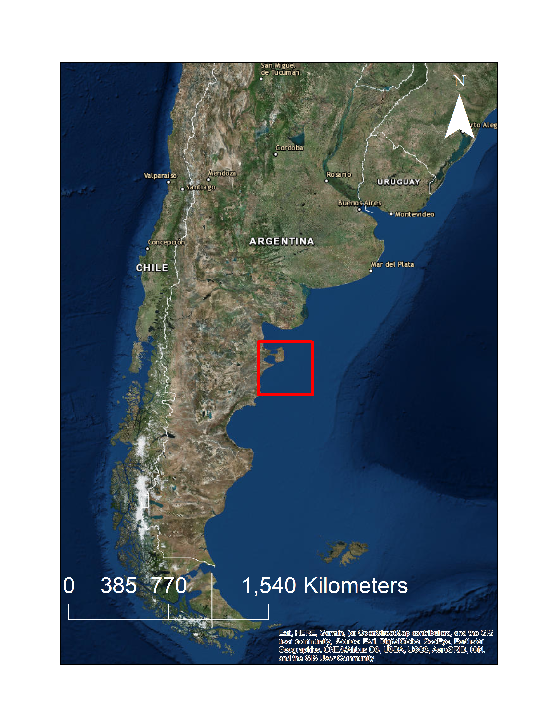
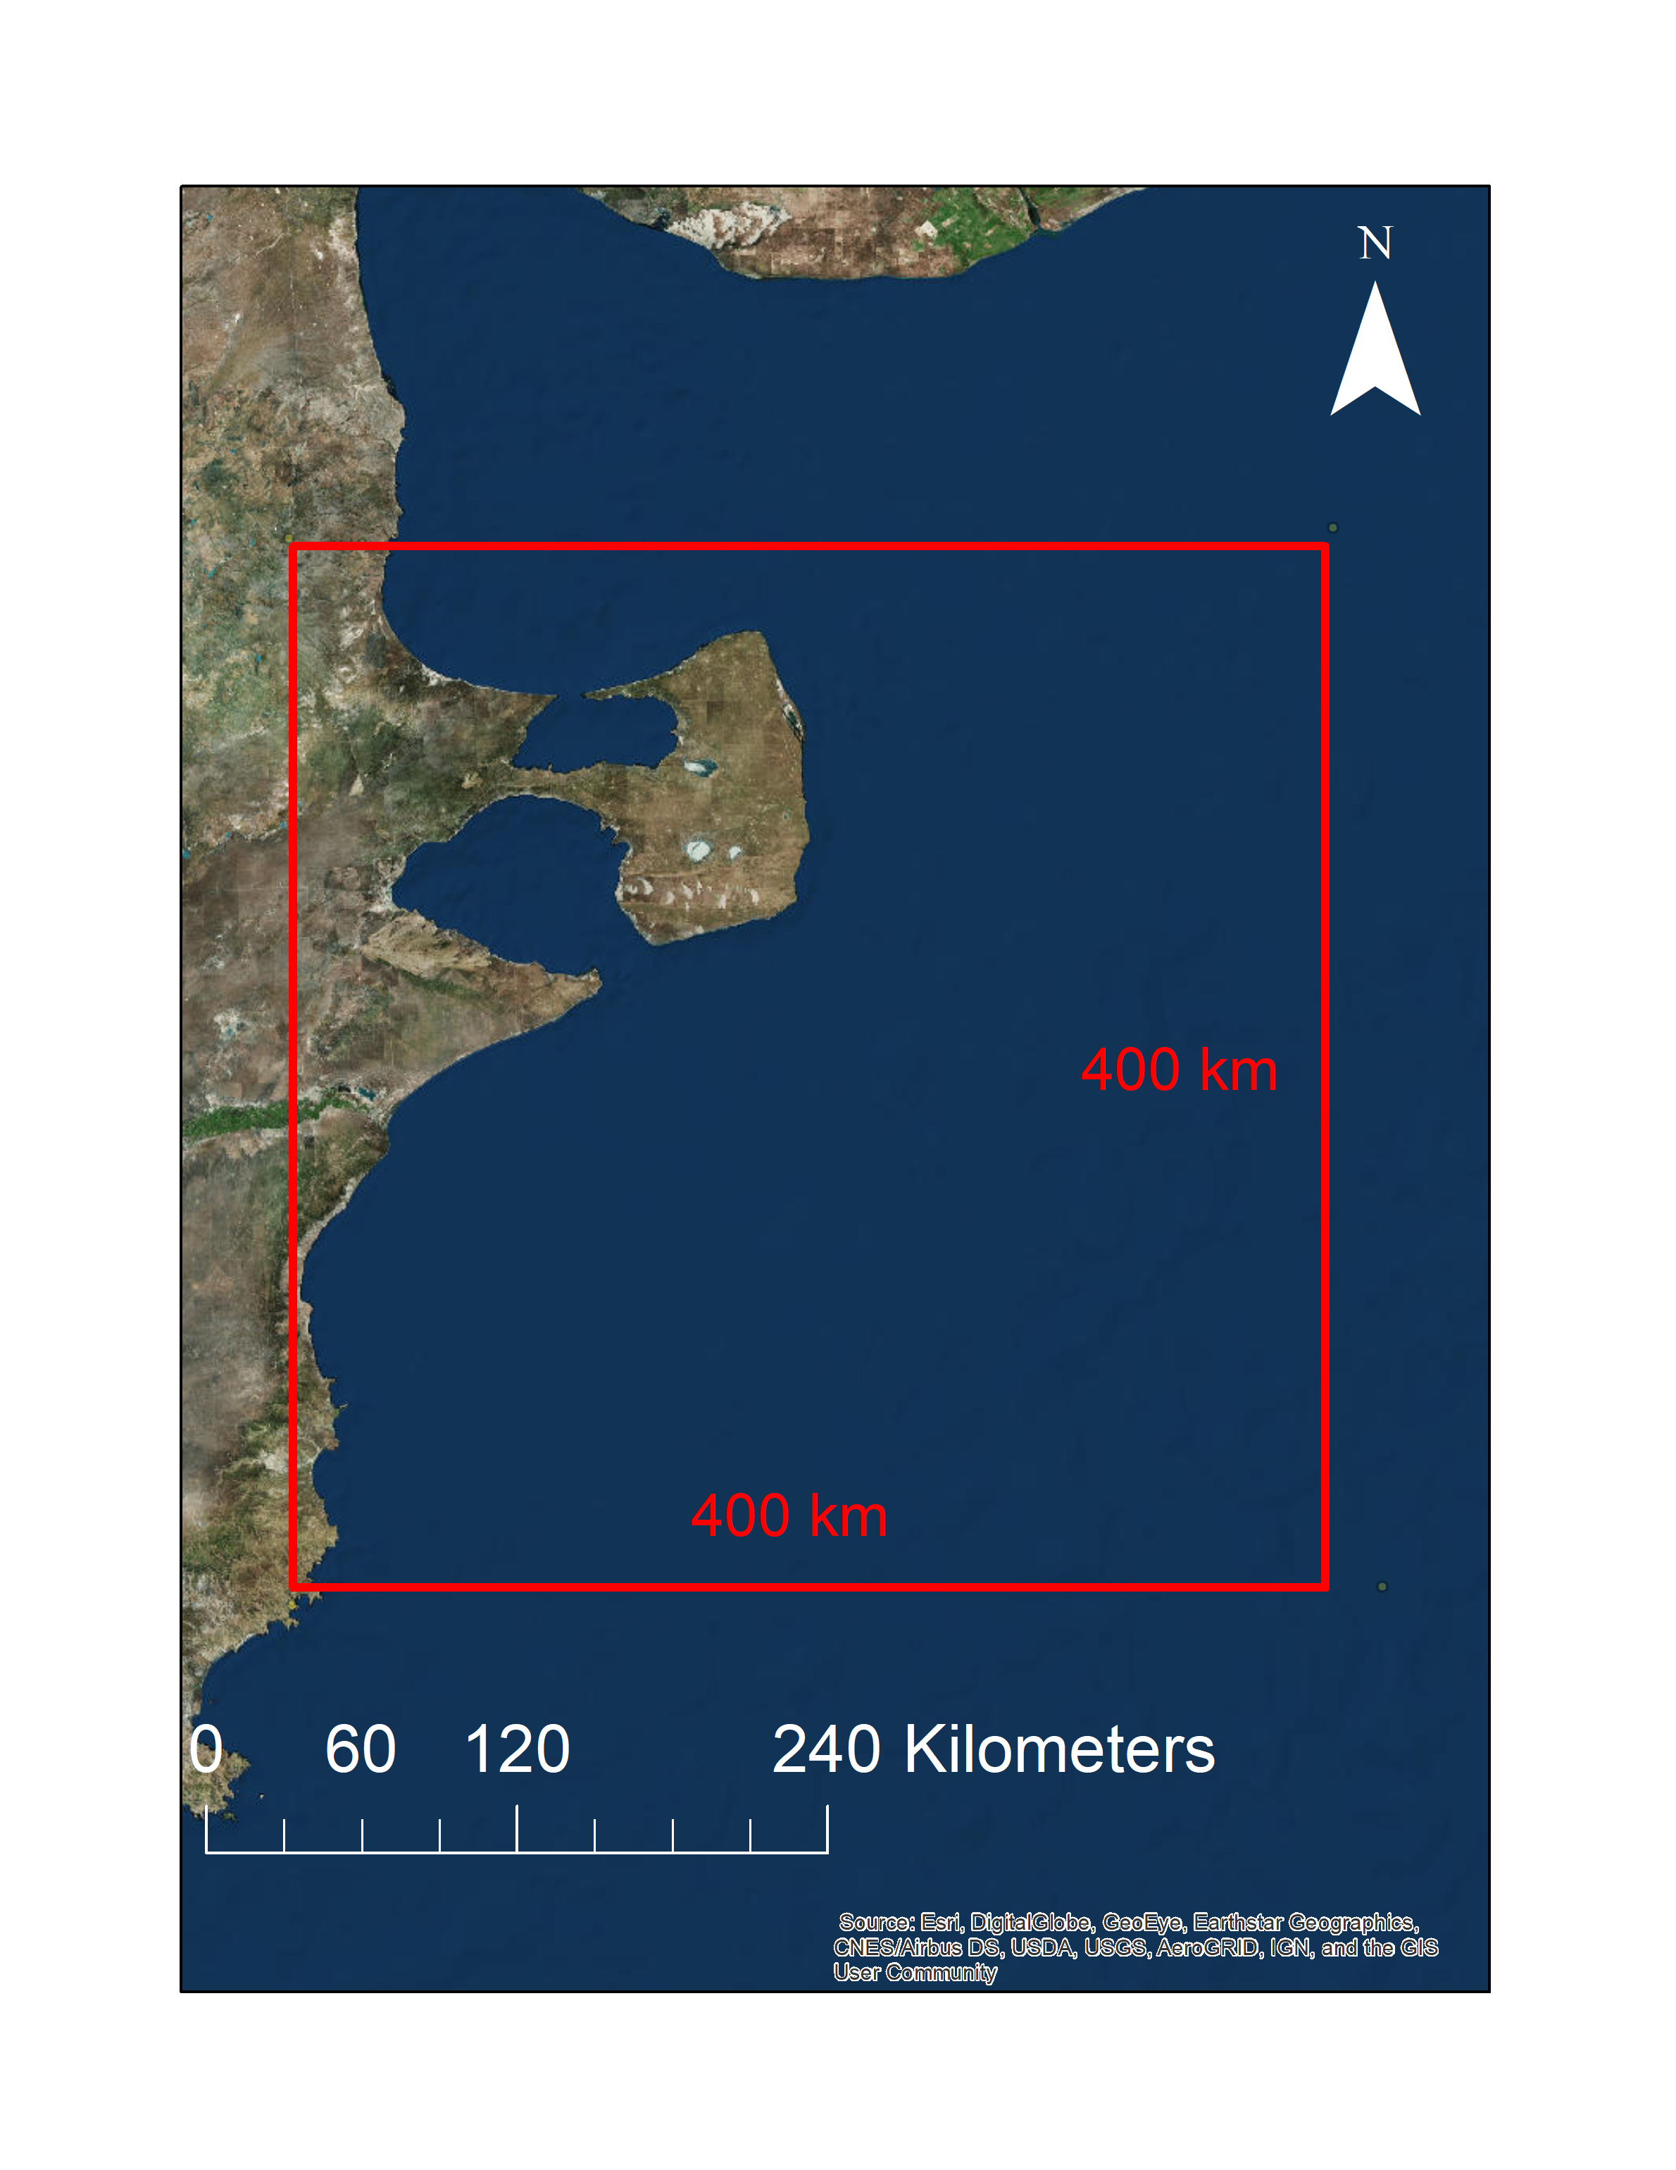
Using NASA Earth Sciences Data and Information Services Center Distributed Active Archive Center (DAAC) along with data visualization tools like GIOVANNI and programs like ArcGIS, I observed satellite derived ocean color (chlorophyll-a concentration) values measured by MODIS off the coast of Punta Tombo. The study area for collecting data was a 400 by 400 km square (Figure 6). The dimensions of this box were based on Magellanic penguin foraging behavior. Boersma & Rebstock 2009 found looked at foraging distances in foraging adults. They found that as mean foraging distance increased, colony reproductive success decreased (Boersma & Rebstock, Foraging distance affects reproductive success in Magellanic penguins, 2009). Adults with chicks rarely forage further than 350km off the coast of the colony and tend to swim North or Northeast (Boersma and Restock 2009). Those that made trips of a length of 350 km or greater rarely had chicks that survived. I assumed that a foraging adult would be uninterested or unable to benefit from prey located outside of a 350 km range. I gave the study area a 400km limit to accommodate ocean conditions that could still influence adults foraging at the maximum distance observed from Punta Tombo.

Figure 6: Study area location and boundaries. Coordinates of the corners used for the study area are: Northwest corner: (-41.838752, -65.393037), Northeast Corner: (-41.810108, -61.765426), Southeast corner: (-44.490853, -61.592929), Southwest corner: (-44.537051, -65.379764)

I observed the location and concentrations of chlorophyll-a for the selected 10 breeding seasons between 2002 and 2017. For this comparison I chose five “Good” years (years with less than 12% of deaths due to starvation) and five “Bad” years (years with over 18% starvation) for comparisons in ocean conditions. Other seasons in this window did not show enough variation to be valuable for a comparison. For each year, I collected ocean color derived chlorophyll-a data for weeks between November 17th to January 25th, in 8-day intervals using NASA Earth Sciences program GIOVANNI. The data set used for observing chlorophyll-a was from MODIS-Aqua with a temporal resolution of 8 days and spatial resolution of 4 km. The snapshots used the same units (mg m⁻³) and the same maximum and minimum values for measured chlorophyll (maximum concentration of 350 mg m⁻³ and minimum of 8mg m⁻³. Images were transferred into ArcMap as GEOTIFF files.
Data analysis
Data were analyzed using tools in ArcMap with a WGS 1984 coordinate system. Each breeding seasons had eight satellite images that were taken over 8 days. For each 8-day snapshot of satellite derived ocean color, chlorophyll-a concentration was divided into 3 classes using Jenks Natural Breaks. Pixels attributed a class 1 were those with the lowest concentration of chlorophyll-a for that snapshot and class 3 pixels with the highest. Jenks reclassification divides data in to groups with the greatest similarities between sets all while maximizing their difference. This algorithm divides data in to groups based on distinct shifts in data. Group cut offs remain relative to each data set. This method is appropriate for an all-season comparison as I focused on the location of maximums and minimums in each year, from week to week, for that year only rather than comparing fixed levels of chlorophyll-a abundance between years.
Reclassed, the snapshots were stacked or overlapped and then analyzed using 3 tools: variety, majority and region group. All tools used a scale of 1-3. Variety compares how many different classes (1-3) are observed for each pixel over the course of a season. A high number of high variability pixels indicates that chlorophyll-a concentrations fluctuated considerably over the course of the 8 weeks. Majority calculates the most common class observed for every pixel over the 8 images observed for a season. A season with a high percentage of majority 1 pixels indicates most pixels maintained the same chlorophyll-a concentration for all 8 satellite images. Finally, Region Group was used to analyze the interconnectivity of the different classes of pixels in the study area. This tool was applied to a map that pooled data from all 8 weeks between November and January. Pixels in the study area were re-assigned values depending on what class value had been assigned to that pixel the most frequently over the course of the season. I counted the number of groups or interconnected patches of pixels and calculated the average number of pixels per patch. A season with a small number of patches with a high average number of pixels per patch was hypothesized to be preferable for foraging Magellanic penguins as the effort expended to find prey would be smaller once a large patch was found. Large numbers of small patches were hypothesized to be detrimental.
Assumptions
In this study, starvation of Magellanic penguin chicks was compared to ocean chlorophyll-a patterns. To examine a relationship between chlorophyll and chick starvation, I made several broad assumptions I looked for patterns between starvation and productivity.
The area for which satellite data were selected for this study was defined based on the average travel distance of a Magellanic penguin parent. The average distance and direction tend to remain similar from year to year, although trips can range between and 600 km (Boersma & Rebstock, Foraging distance affects reproductive success in Magellanic penguins, 2009). While foraging adults can swim far out to sea, Boersma & Rebstock 2009 showed that as travel distance increases the probability of raising a chick declines. In addition, this study showed that the probability of fledging two chicks was high for penguins that made the shortest trips (under 70km). Maximum foraging distances observed in this study that spanned across 10 breeding seasons were between 275, 307 and 372 km. All of these trips lasted over 18 days. An average trip lasts 2.9 days suggesting these trips were unlikely to provide food in time for a chick to survive. I used these results to define my study area. I assumed that a foraging adult would be uninterested or unable to benefit from prey located outside of a 400 km by 400km square. In addition to distance, the direction of the foraging tracks of adults changed with every season. Such observations suggest that the location of a stable food source is essential to a successful breeding season.
Next, I assumed that high chlorophyll-a concentrations always resulted in an abundance of prey. I chose to simplify the coastal ecosystem and directly link chick starvation to primary production. However, the environment off the coast of Argentina is far more complex than this model. Phytoplankton blooms are generally beneficial for the marine food web. However, different blooms influence marine life differently. The response times of other organisms may vary, or the lags in influence on the ecosystem may make a relationship harder to see. In addition, certain types of algae are toxic. Large blooms of toxic algae have resulted in deaths in both adults and chicks at the Punta Tombo colony in the past suggesting that excessively high concentrations of chlorophyll-a could be harmful rather than beneficial (Shumway, Allen, & Boersma, 2003).
III-Results
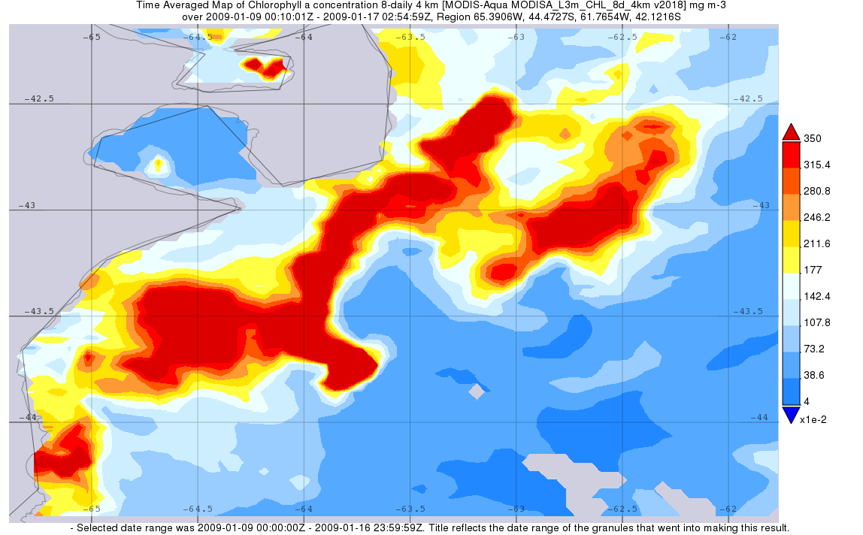
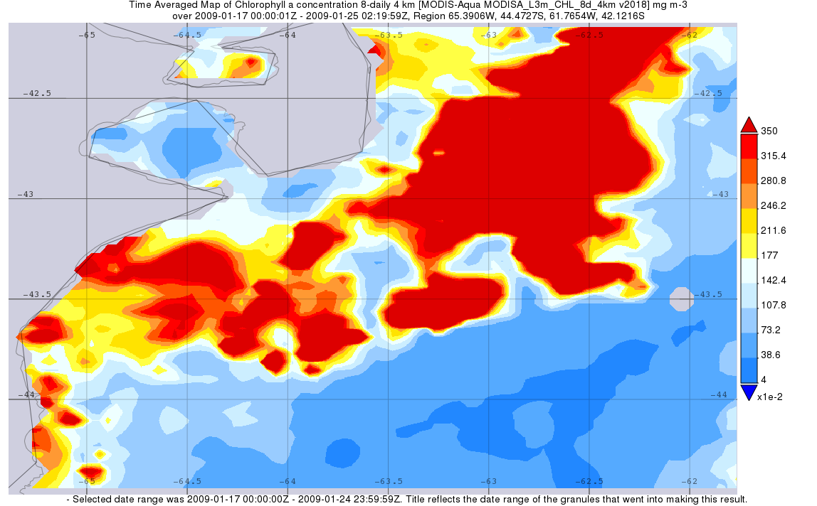
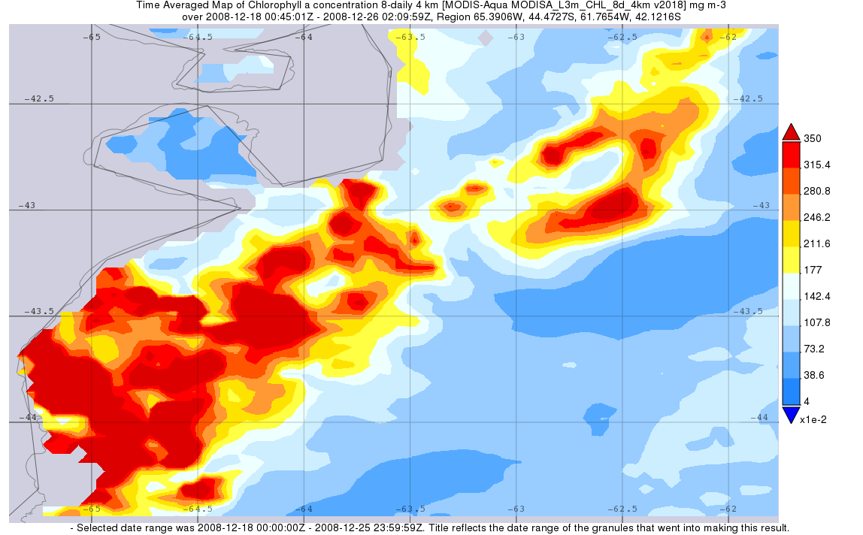
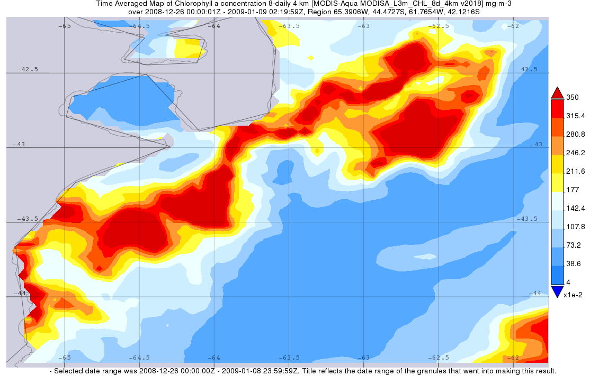
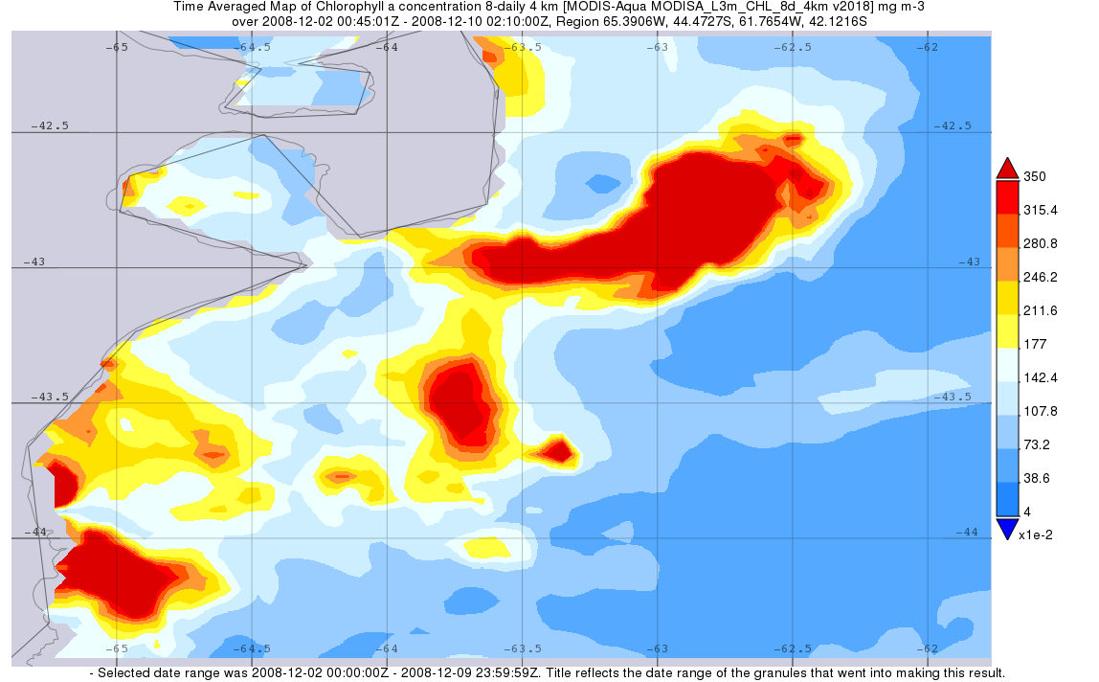
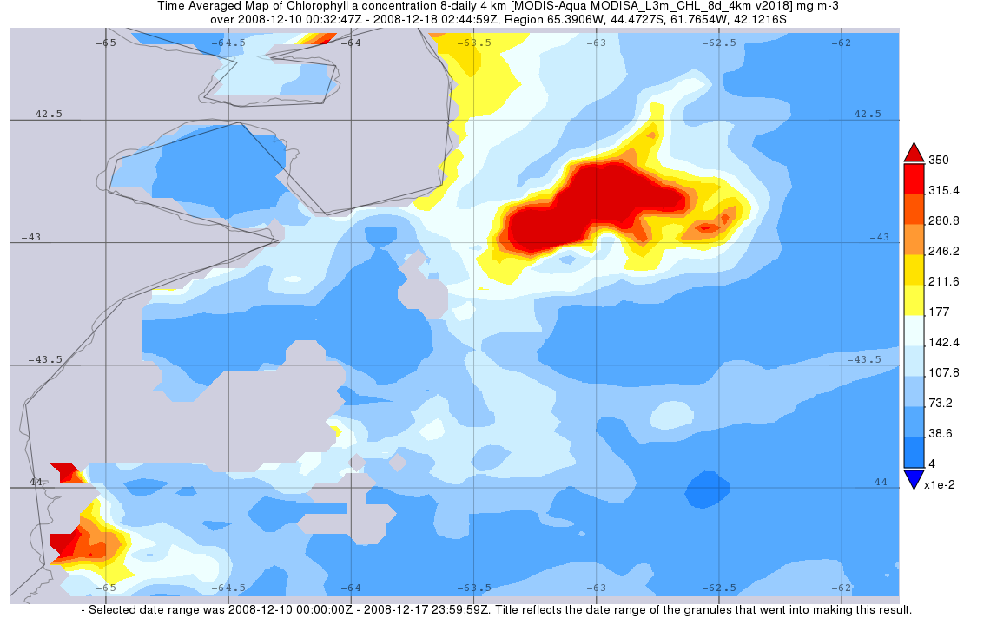
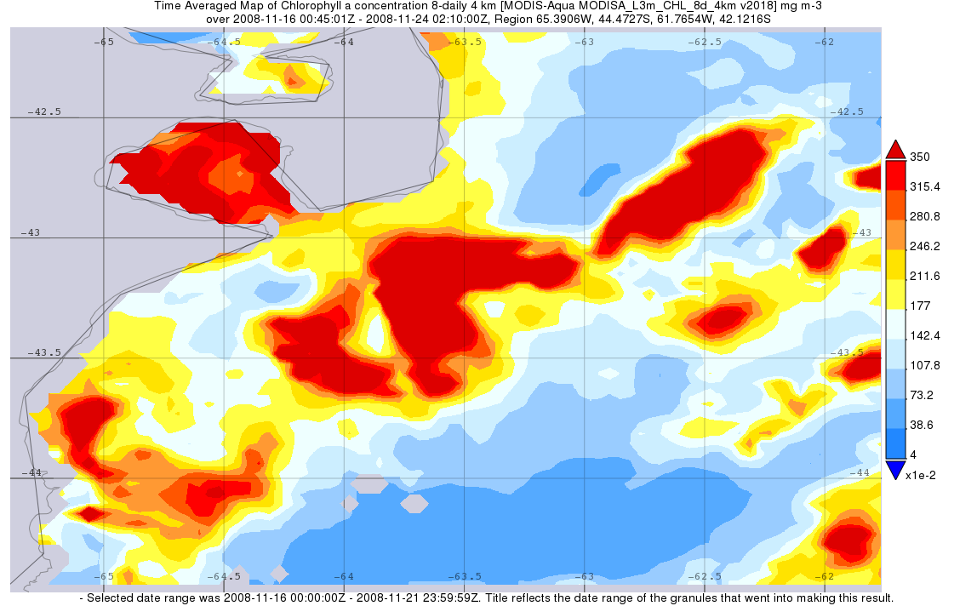
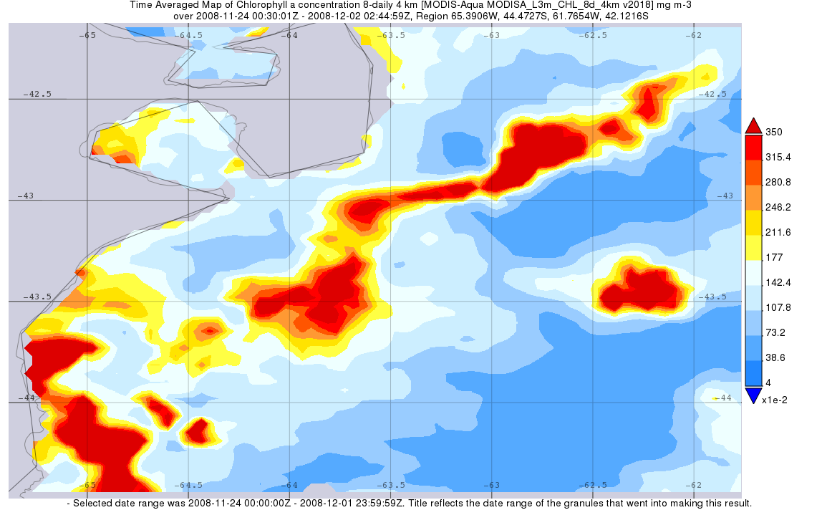
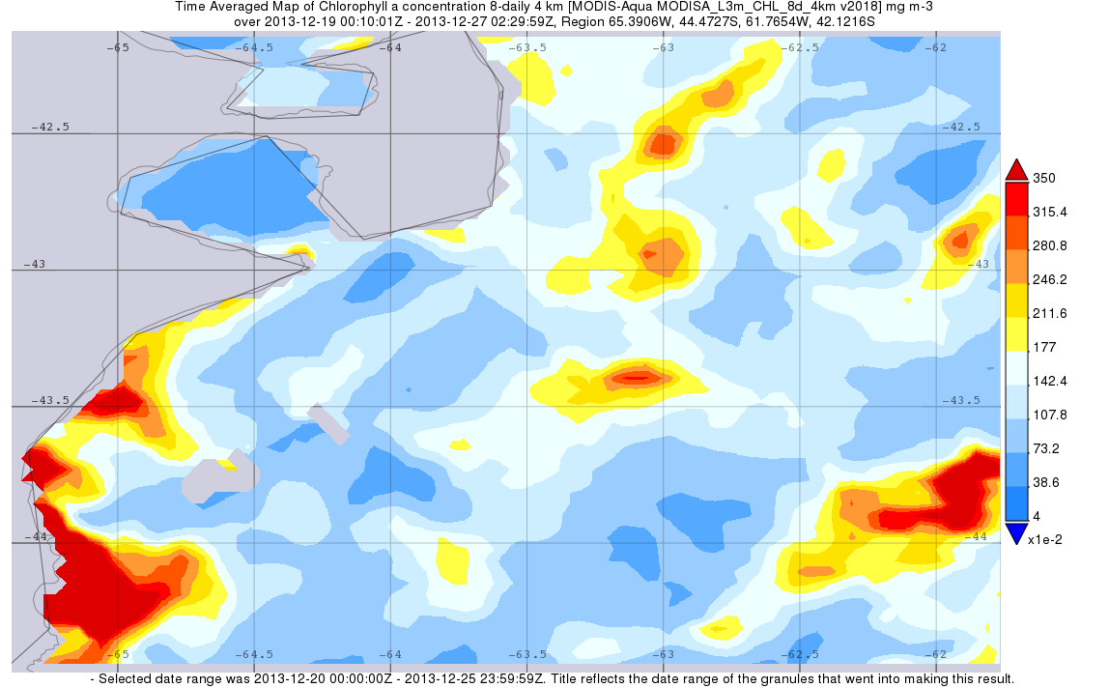
Chlorophyll-a distribution
A.
A.

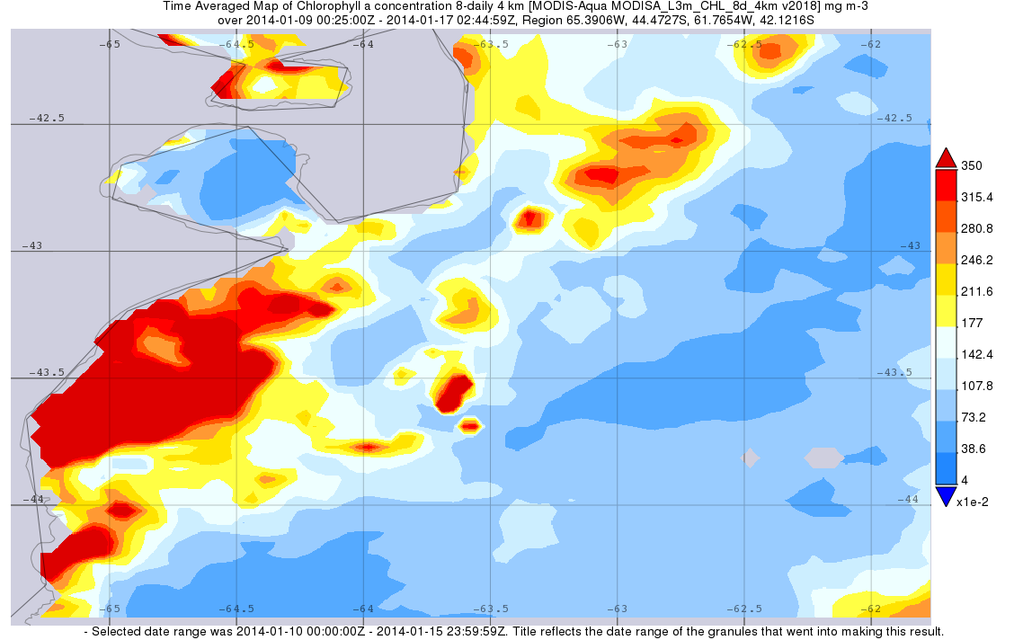
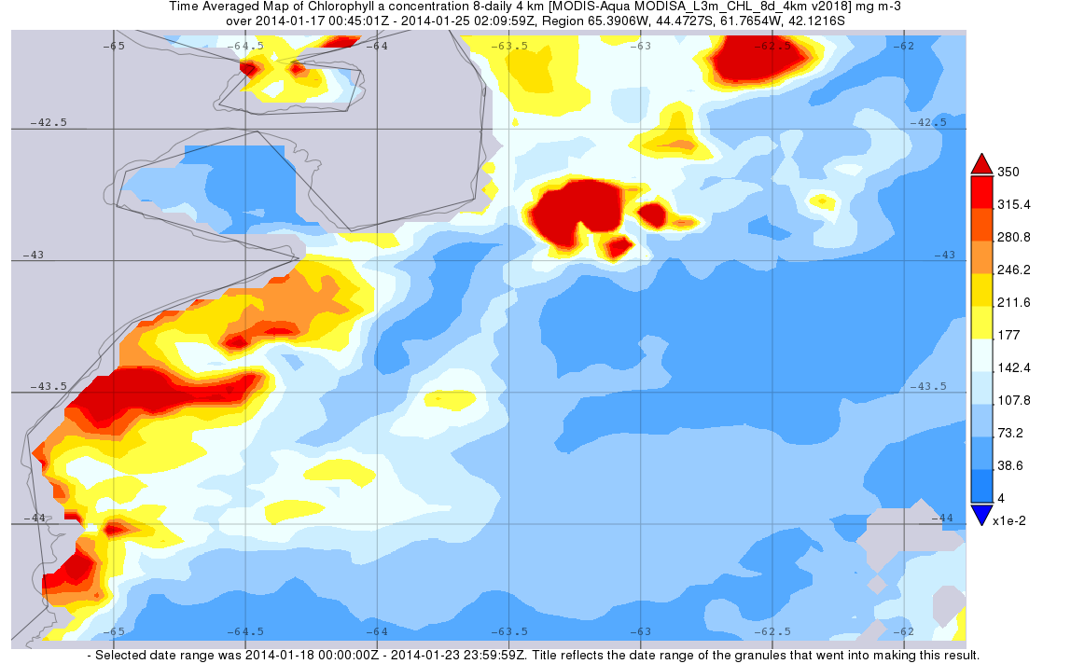
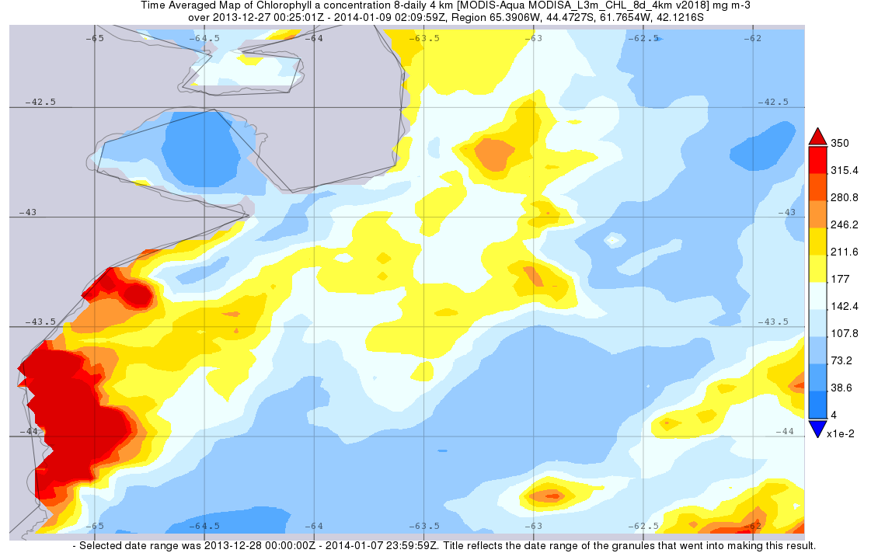
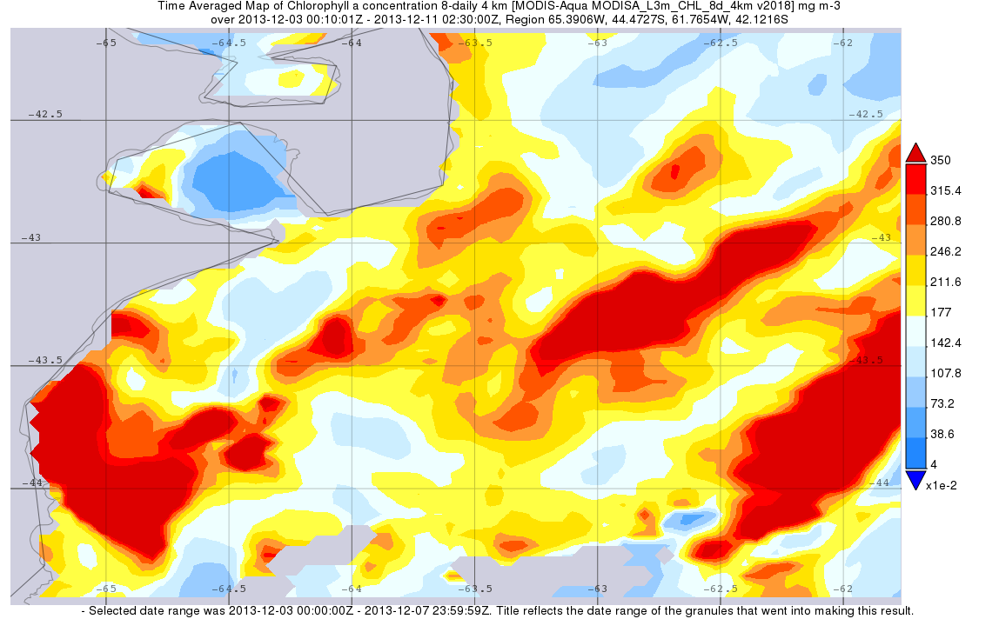
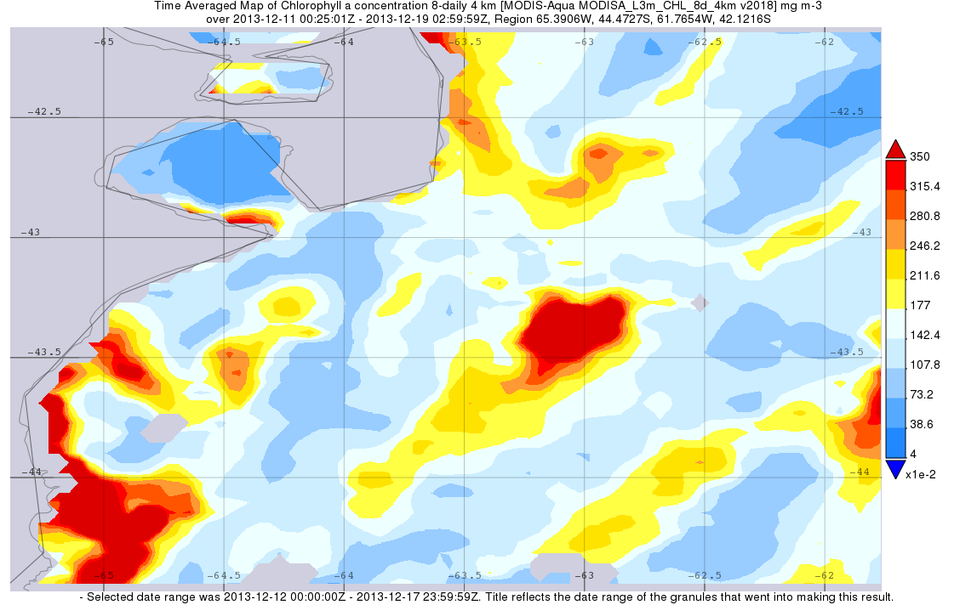
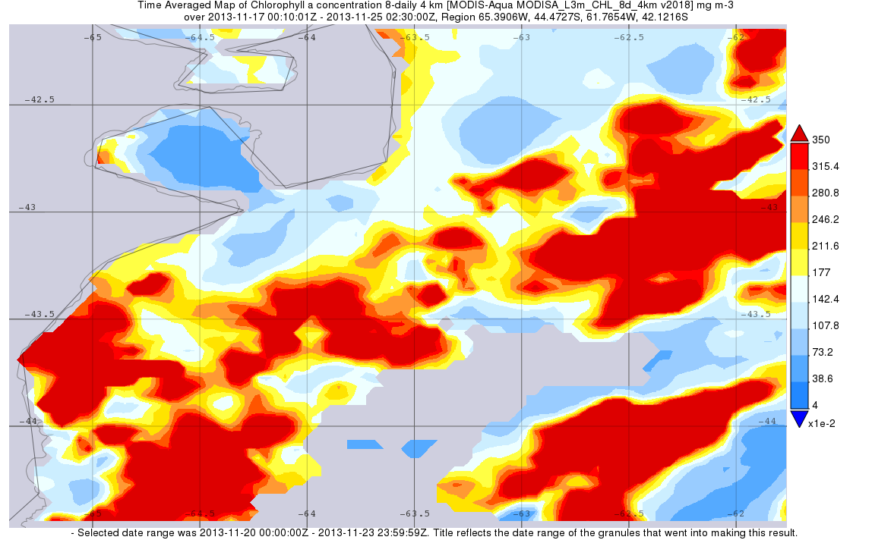
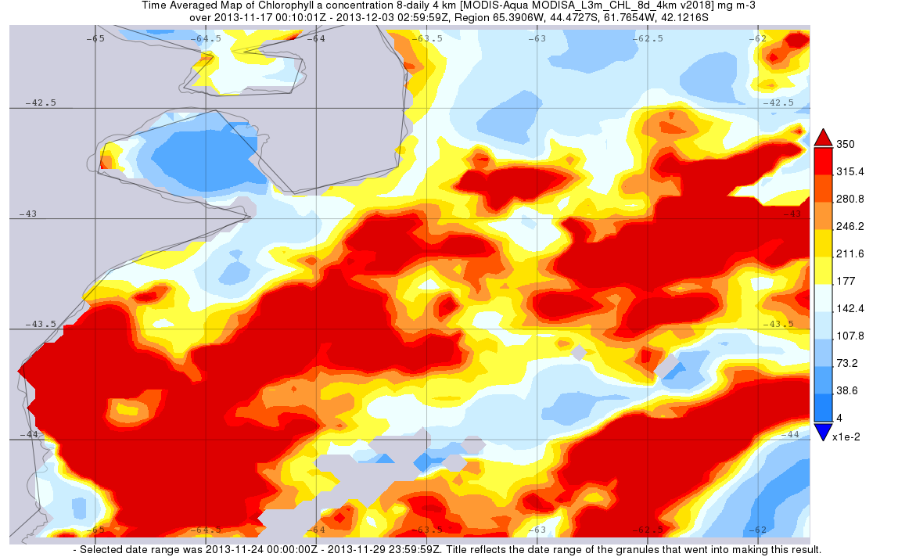
Figure 7: Chlorophyll-a concentrations (in mgm⁻³) off the coast of Punta Tombo, Argentina (location represented by the star) measured using data from NASA satellite MODIS. Data was visualized using GIOVANNI. Each satellite image represents an 8-day average. Images were taken starting on November 26 and ending on January 24. The blue star in the bottom left corner indicates the location of the breeding colony.
Figure A. shows data from 2008, a “good” year, where 6% of chicks died of starvation. The blue circle highlights a large patch of high chlorophyll-a concentration. The rest of the map shows low chlorophyll-a levels. This pattern is consistent for the full 8-week period
Figure B. shows data from 2013, a “bad” year, where 31% of chicks died of starvation. The blue circle highlights the expected location of high chlorophyll-a; however, it is inconsistently observed. In addition, chlorophyll-a levels remain moderate across the study area.
B.

Between low and high starvation years, I observed different patterns in distribution of chlorophyll-a. Low starvation years showed concentrated, high values of chlorophyll-a consistently located northeast of the colony. Patches of high chlorophyll-a were surrounded by large areas of low values of chlorophyll-a (Figure 7.A.). High starvation years showed higher amounts of moderate concentrations of chlorophyll-a and patches of high primary productivity that changed location from week to week (Figure 7.B).

Variability
A.
B.
Figure 8: Percentage composition of the study area by the 3 different classes of chlorophyll-a as determined by Jenks Natural Breaks classification for breeding seasons 2008, 2012, 2013 and 2016. Column values correspond to 8-day satellite averages with 1 corresponding to November 16-24 and 8 corresponding to January 17-25. The red line marks the average abundance of Class 1chlorophyll-a concentrations. Average abundance of Class 1 chlorophyll-a is 70%
Figure 8.A: 2008 and 2016 are low starvation years with chicks dead due to starvation making up of 6% and 5% of the total followed chicks respectively.
Figure 8.B: 2012 and 2013 are high starvation years with chicks dead due to starvation making up 45% and 31% of the total followed chicks respectively.
Breeding seasons were divided in to “good” years and “bad” years. “Good” years were breeding seasons where chick deaths due to starvation made up only 12% or less of the total chicks while “bad” years were years where atleast 18% of chicks died of starvation. Low starvation years showed a higher number of large, concentrated patches of high chlorophyll-a abundance surrounded by low chlorophyll-a concentrations. When analyzing composition of the study area by the 3 classes of chlorophyll-a, “good” years. showed less variation in percentage composition of the study area. Class 1 composition remained close to 70% throughout the season and most variation was observed in Class 3. Years with high starvation, in contrast, showed more variation in Class 1 composition in addition to variation in Class 3. In 2013, 5 of 8 weeks had a Class 3 composition of under 4% (Figure 8.B) while low starvation years like 2008 had only 1 week below 4% with most weeks ranging between 5% and 8% (Figure 8.A.). “Bad” years (chicks starvation was over 18%) also had a greater percentage of Class 2 or moderate concentrations of chlorophyll-a.

A.
1
2
3
4
5
6
7
8
B.

Figure 9:
Figure 9.A. Satellite derived chlorophyll-a concentrations in the study area for the breeding season of 2013. The blue star indicates the location of Punta Tombo. The blue circle highlights the expected location of high chlorophyll-a; however, it is inconsistently observed. Each map is given a number that corresponds to an 8-day satellite averages with 1 corresponding to November 16-24 and 8 corresponding to January 17-25. Each map has a corresponding number and column in Figure 8.B.
Figure 9.B. Percentage composition of the study area by the 3 different classes of chlorophyll-a as determined by Jenks Natural Breaks classification for the breeding season of 2013. Column values correspond to 8-day satellite averages with 1 corresponding to November 16-24 and 8 corresponding to January 17-25. Class 1 chlorophyll-a concentrations (the class with the lowest chlorophyll-a abundance) on average made up 70% of the study area. The red line emphasizes this average.

In a “bad” year (high starvation), chlorophyll-a is dispersed across the study area in small patches of moderate to high chlorophyll-a concentrations. While chlorophyll-a abundance was high, no consistent patch of high chlorophyll-a concentration was observed north east of the colony (blue circle, Figure 9.A.). The location of high concentration patches showed great variability from week to week and few patches maintained the same location for the entire season (Figure 9.A.). Composition of the study area by different classes of chlorophyll-a concentration confirmed the variability in composition observed in the satellite data. Composition of the study area by class 1 chlorophyll-a concentration fluctuated over and under the average of 70% unlike low starvation years where it remained consistent at the average (Figure 8)

IV-Discussion
In this study, high concentrations of chlorophyll-a were used as a proxy for the location of food for Magellanic penguins. It was predicted that high chlorophyll-a values all throughout the study area would lead to low starvation. Between 10 “extreme” years between 2002 and 2018, 5 “good” years (low starvation) and 5 “bad” years (high starvation) were observed. Starvation at the Magellanic penguin colony at Punta Tombo was a percentage of starvation related deaths out of the total chicks followed that year.
The link between ocean chlorophyll-a abundance and starvation is at best a poor one. In low starvation years, over all chlorophyll-a abundance was high. However, in several years where a large percentage of chicks starved, chlorophyll-a abundance was the same as low starvation years if not higher (Figure 7). There are many reasons why a relationship between chlorophyll-a abundance may not exist. To begin with, productivity was assumed to be equivalent to high prey availability. Magellanic penguins feed primarily on small fish (anchovy, hake, etc.), squid and crustaceans (Scolaro, et al., 1999); they are not directly dependent on chlorophyll-a. Many factors influence the dynamics of the populations of their prey (predation by other species, fishing, etc) making it possible that high chlorophyll-a does not always result in abundance prey. Another possible cause for a lack of relationship is the method used to determine chlorophyll-a concentration. NASA satellite MODIS uses water color to calculate chlorophyll-a concentrations. Any plant material in the water column could be responsible for the values. Boersma & Rebstock 2018 conclude that high turbidity conditions at the Rio de la Plata river plume result in poor body condition in female penguins returning to the colony to breed. While prey is more abundant in these conditions, as visual predators, Magellanic penguins struggle to locate food. If turbidity has a negative influence on foraging and can be interpreted as high chlorophyll-a it is essential to analyze water turbidity in parallel with chlorophyll-a abundance. This comparison could help determine whether high chlorophyll-a concentrations coincided with turbid conditions and were detrimental to foraging success as Boersma and Rebstock concluded in their study.
Finally, the time scale of this study may not be fine enough to observe the influence of food availability on chick survival. Chicks may take days to week to starve so the relationship will be no more direct than productivity is to fish abundance. Newly hatched chicks must be fed every one to two days. With such time dependent needs, a stable source of food close to the colony is likely to reduce starvation (Boersma et al 2015). In future studies, comparing the total number of chick deaths due to starvation at the same intervals (every 8-days) as the satellite images could indicate which changes in distribution and concentration have the greatest impact on reproductive success. I used only “good” or “bad” years. Using an entire season may be helping to obscure any relationship between chlorophyll-a concentrations and chick starvation. It is possible that if food is scarce for two weeks when chicks are young, many chicks die but for the rest of the season the surviving chicks fledge in unusually good health (Anna Sulc, personal observations).
While no strong relationship could be established between chlorophyll abundance and starvation, distribution of chlorophyll-a played an important role in determining chick survival. Satellite data were classified in to 3 classes using Jenks Natural Breaks rather than comparing net concentrations of chlorophyll-a between years. This method created a set of 3 classes. Each pixel is assigned a value of 1,2, or 3 in each satellite image. While these new values are the same for all satellite images, the chlorophyll-a concentration value attributed to each class for each 8-day period is relative to each image making it possible to compare the distribution of chlorophyll-a off the coast of Punta Tombo between all images while disregarding the net concentrations in each scenario. Between low and high starvation years, I observed different patterns in distribution of chlorophyll-a.
Low starvation years showed concentrated, high values of chlorophyll-a consistently located northeast of the colony. Patches of high chlorophyll-a were surrounded by large areas of low values of chlorophyll-a (Figure 7.A.). High starvation years showed higher amounts of moderate concentrations of chlorophyll-a and patches of high primary productivity that changed location from week to week (Figure 7.B). Dispersed, moderate concentrations of chlorophyll-a suggest that although prey was present, it was spread across a large area. This trend suggests that foraging parents depend on small, isolated but high concentration sources of prey. With the time dependent needs of their chicks, a foraging must be both time and energy efficient in order to ensure chick survival. As visual predators, Magellanic penguins meander out from the colony, swimming slowly to find food and swiftly return to the colony once they find sufficient prey (Boersma & Rebstock, Foraging distance affects reproductive success in Magellanic penguins, 2009). If penguins must search for prey distributed across a large area, they will expend more energy and spend more time at sea satisfying their own needs than just those of their chicks. If parents are in poor condition or struggle to find food, they may not return to the colony for extended periods of time reducing the chance of the survival of their chicks (Boersma & Rebstock, Foraging distance affects reproductive success in Magellanic penguins, 2009). If their body condition continues to deteriorate parents may even abandon their chicks and stay at sea (Frere, Gandini, & Boersma, 1998). Higher chick survival in years where chlorophyll-a is concentrated suggests not only that penguins prefer patches of concentrated prey but that they rely on a consistent location of their food source.
The impacts of time and distance travelled out to sea on chick survival suggest that location is important for chick survival, however, consistency of the location of a food source over the course of a season proved to be just as important. When analyzing composition of the study area by the 3 classes of chlorophyll-a determined by Jenks Natural Breaks, “good” years. showed less variation in percentage composition of the study area. Class 1 composition remained close to 70% throughout the season and most variation was observed in Class 3 (highest concentrations of chlorophyll-a). Years with high starvation showed more variation in Class 1 composition in addition to variation in Class 3. “Bad” years (chicks starvation was over 18%) also had a greater percentage of Class 2 or moderate concentrations of chlorophyll-a. These results suggest that foraging adults do poorly in an environment where prey availability and location change rapidly. Variability in Class 1 or low chlorophyll-a concentrations suggest that chlorophyll-a distribution changed from being concentrated in larger patches to being dispersed in small groups from week to week. If adults rely on memory to search for prey in a location they have found food in the past, it is possible such conditions could be detrimental. Foraging penguins would expend more energy in finding food not just because they are meandering in hopes of finding dispersed food but they may be mislead by searching in areas where prey was abundant previously resulting in longer, more exhausting trips. In the future, it would be interesting to compare satellite tracked foraging paths between years with high variability in chlorophyll-a distribution and areas where high chlorophyll-a concentrations maintained a consistent location. This comparisons could establish if Magellanic penguins seem to rely on memory to locate prey.

V-Conclusion
This study established a relationship between chlorophyll-a abundance and distribution on Magellanic Penguin chicks off the coast of Argentina. Using MODIS satellite data, chlorophyll-a concentrations were determined for waters just off the coast of the Punta Tombo breeding colony. Chlorophyll-a abundance, distribution and variability were compared between unusually high and low starvation years between 2002 and 2017. Results partially support the initial hypothesis. I predicted a strong relationship between chlorophyll-a abundance but found that rather than being solely dependent on the quantity of chlorophyll-a, consistent, concentrated patches of high chlorophyll-a are preferred to moderate amounts of chlorophyll-a dispersed evenly across the study area. While chlorophyll-a is not directly linked to abundant prey, when productivity is higher and remains in concentrated the same location over the course of a breeding season penguin chicks are less likely to starve.
Some relationship was observed between starvation in Magellanic penguins’ chicks and the abundance of chlorophyll-a but the relationship is poor. However, there was a pattern of years with low chick starvation having larger patches of chlorophyll-a, surrounded by unproductive waters (Figure 7). In addition, a consistent location of these patches over the course of a breeding season seemed to be beneficial to chick survival (Figure 8). In high starvation years, location of prey moved frequently and was more dispersed (Figure 9). The 10 extreme years between 2002 and 2017, where starvation was either unusually high (over 18%) or very low (less than 12%) selected for this study suggest that rather than being solely dependent on chlorophyll-a abundance, it is the stability of the food source that has the greatest impact on Magellanic penguin survival. Other factors including where the productivity is, the ability of parents to find food, and lags between primary production and secondary production all seem to be important in chick survival.
In order to provide a strong conclusion, more research in to other factors that control food availability such as sea surface temperature and turbidity is required. In future studies, it would be beneficial to observe not only net chlorophyll concentration and distribution in a large area, standard for all breeding seasons but the overlap of satellite tracked foraging penguin trips with high chlorophyll areas as well. Analyzing swim tracks between seasons in addition to observing chlorophyll-a distribution could help further understand whether breeding success is related to location rather than overall concentrations of chlorophyll. In addition, a larger array of years is needed. Finally, with the age of chicks being an important factor in limiting foraging trip length and duration, analyzing chlorophyll-a and chick starvation on the scale of 8-day rather is needed to understand what patterns in ocean productivity can be associated with successful breeding seasons. Moreover, since a chick’s food storage capacity depends on size and age a finer analysis on the when and the size of the chicks that starved would likely provide more insight into these patterns.
Further investigation in to the relationship between large scale ocean patterns and the behavior of marine animals is vital for the understanding and the conservation of our oceans. Over the past 35 years, the Punta Tombo colony has declined by 40% (Rebstock & Boersma, Oceanographic conditions in wintering grounds affect arrival date and body condition in breeding female Magellanic penguins, 2018) (Boersma, unpublished data). Magellanic penguins are sentinels of our oceans (Boersma, Penguins as Marine Sentinels, 2008). Their survival is critically dependent on ocean conditions around them, and because they nest on land and we can get reliable colony-wide survival and breeding success measurements, we can use the health of the penguins as an indicator of the condition of our oceans. This study shows that penguins at Punta Tombo are influenced by, if not dependent, on large scale ocean patterns off the coast of Argentina. Boersma, Rebstock and Garcia-Borboroglu 2015 showed that a Marine Protected Area (MPA) was important for the preservation of the penguin breeding colony using satellite tracks of adults foraging for chicks. This study argued that competition from local fisheries was deteriorating to reproductive success of the colony (Boersma, Rebstock, & García-Borboroglu , Marine protection is needed for Magellanic penguins in Argentina based on long-term data, 2015). The results of Boersma, Rebstock and Garcia-Borboroglu 2015 and others helped put an MPA in place. Future studies like this one on the relationship between penguins and oceanographic conditions that extend outside of the current MPA could be a reason to expand this area to ensure Punta Tombo remains a prominent Magellanic penguin breeding colony.
Acknowledgements
I would like to thank my advisors P. Dee Boersma, Arthur Nowell and Eric d’Asarro for their guidance, support and patience over the course of this past year. I would also like to thank Ginger Rebstock for her suggestions and feedback on my methods and data analysis. Finally, I would like to thank Miles Langdon for his rapid but thorough explanation of program ArcMap that was essential allowing me to visualize and understand my data.

Works Cited
Boersma, P. D. (2008). Penguins as Marine Sentinels. Bioscience Magazine, 597-607.

Boersma, P. D., & García-Borboroglu, P. (2013). Penguins: Natural History and Conservation. Seattle: University of Washington Press.

Boersma, P. D., & Rebstock, G. A. (2009). Foraging distance affects reproductive success in Magellanic penguins. Marine Ecology Progress Series, 263-275.

Boersma, P. D., Rebstock, G. A., & García-Borboroglu , P. (2015). Marine protection is needed for Magellanic penguins in Argentina based on long-term data. Biological Conservation, 197-204.

Boersma, P. D., Rebstock, G. A., & García-Borboroglu, P. (2015). Marine protection is needed for Magellanic penguins in Argentina based on long-term data. Biological Conservation, 197-204.

Cho, Y.-K. (2010). Tidal front and its relation to the biological process in coastal water. Ocean Science Journal, online.

Derisio, C., Alemany, D., Acha, E. M., & Mianzan, H. (2014). Influence of a tidal front on zooplankton abundance, assemblages and life histories in Península Valdés, Argentina. Journal of Marine Systems.

Frere, E., Gandini, P., & Boersma, P. D. (1998). The Breeding Ecology of Magellanic Penguins at Cabo Virgenes, Argentina: What Factors Determine Reproductive Success? Colonial Waterbirds, 205-210.

Marrari, M., Piola , A., & Valla, D. (2017). Variability and 20-Year Trends in Satellite-Derived Surface Chlorophyll Concentrations in Large Marine Ecosystems around South and Western Central America . Frontiers in Marine Science , online.

Matano, R. P., & Palma, E. D. (2008). On the Upwelling of Downwelling Currents. Journal of Physical Oceanography, 2482-2500.

NASA Earth Observatory. (2002). Currents Collide and Coastal Waters Bloom off Patagonia. Retrieved from Earth Observatory: https://earthobservatory.nasa.gov/images/42270/currents-collide-and-coastal-waters-bloom-off-patagonia

Rebstock, G. A., & Boersma, P. D. (2014). Climate Change Increases Reproductive Failure in Magellanic Penguins. PLoS ONE, e85602.

Rebstock, G. A., & Boersma, P. D. (2018). Oceanographic conditions in wintering grounds affect arrival date and body condition in breeding female Magellanic penguins. Marine Ecology Progress Series.

Romero, S., Piola, A., Charo, M., & Eiras Garcia, C. (2006). Chlorophyll-a variability off Patagonia based on SeaWiFS data. Journal of Geophysical Research.

Sánchez, R., & Ciechomski, J. (1995). Spawning and nursery grounds of pelagic fish species in the sea-shelf off Argentina and adjacent areas. Scientia Marina , 455-478.

Scolaro, J. A., Wilson, R. P., Laurenti, S., Kierspel, M., Gallelli, H., & Upton, J. A. (1999). Feeding Preferences of the Magellanic Penguin over Its Breeding Range in Argentina. Waterbirds: The International Journal of Waterbird Biology, 104-110.

Shumway, S. E., Allen, S. M., & Boersma, P. D. (2003). Marine birds and harmful algal blooms: sporadic victims or under-reported events? Harmful Algae, 1-17.

Stokes, D. L., & Boersma, P. D. (1999). Where Breeding Magellanic Penguins Spheniscus Magellanicus Forage: Satellite Telemetry Results and Their Implications for Penguin Conservation. Marine Ornithology, 59-65.

Stokes, D. L., Boersma, P. D., de Casenave, J. L., & García-Borboroglu, P. (2014). Conservation of migratory Magellanic penguins requires marine zoning. Biological Conservation, 151-161.

