Emerging Science and Technology Options in Monitoring Invasive Tunicate Colonization

Claire Galloway
Miles Logsdon, Science Advisor
Ocean Technology Center, University of Washington
cogallow@uw.edu
November 12, 2017

Abstract:
Marine invasive species are a growing problem exacerbated by the evolution and emergence of marine technology and modes of transportation. Current tracking and observation methods of tunicate colonization relies on the observations of trained human divers, which can be extremely costly, time-consuming, create inconsistent outcomes between individual divers, and require advanced permitting when preformed in busy ports and marine settings. Most other surveying equipment is expensive and requires a technological and mechanical skill set. Monitoring these species via embedded systems such as Remotely Operated Vehicles can help to better understand the qualities that make them so invasive, as well as potentially how to eradicate them without damaging native species or their ecosystems. This project focuses on a market competition of technology components used in monitoring the establishment and growth of invasive tunicate colonies in the Puget Sound, through the compared performance, suitability, and cost-effectiveness of each component. A three-part approach was created to evaluate all components affectively. From this process, it was concluded that a mid-cost Open ROV trident coupled with open source GIS and photo-editing software is a viable technique for monitoring the establishment and colonization of tunicates.

I: Introduction
With the rapid advance of marine observational technology and the increase in regional dependency of global shipping of goods, the impact of invasive marine species has become a prominent issue. Populations all over the world have increased their dependency on shipping for trade and to boost their economies. In 2008 and 2009, based off of the peak of the Baltic Dry Index, a barometer of the price of moving raw materials by sea, ship owners from dominant countries such as the US and Japan began rapidly producing ships for maritime transport. The increase of ships for importing and exporting goods brought with it an increase in the introduction of invasive species. Invasive species can have the ability to live in the ballast water of ships, which is often disposed of while in transit. Once expelled from the ship, the species are left to take over the ecosystems they remain in. A species is considered to be invasive if they are introduced to non-native environmental habitats and sub-sequentially have a net negative impact on an environment, economy, and/or a population’s health. Once introduced, the invasive species don’t experience predation and can be specialized within a niche of the ecosystem. They can affect the water quality or productivity of the aquatic environment, which in turn can cause damage to local species, ecosystems, and both local and global economies. With the expansion of the shipping industry, vectors for invasion have amplified and innovation into monitoring systems has increased. The mechanisms currently in place for the monitoring and eradication of these species have been mainly limited to human divers and Remotely Operated Vehicle (ROV) expeditions, used to observe and remove the species in question.
Members of the non-native tunicate genera have become a key invasive species issue for marine managers of the West Coast of the United States. These invasive species have been allowed entry critical marine habitats by way of marinas and boat launch facilities where they out-compete native species for space and resources (Curran, Chan et al. 2013). Mainly do to the lack of predation on these genera, they can have detrimental affects on native species of the coast. The absence of predation allows the invasive tunicate to establish and reproduce quickly and asexually, swiftly dominating ecosystems otherwise important for native organisms (www.pnwscuba.com/invasives/).
- The current monitoring mechanisms and systems in place for the observation and removal of tunicates, human divers and ROVs, remain difficult in the retrieval and reliability of the data collected. Involving individual divers is expensive and requires permits and licenses in order to take place. In addition, allowing individual divers to perform assessments under strict time constraints produces errors and/or mixed results. Indirect viewing through embedded cameras on ROV systems are also unreliable due difficulties with maneuverability in strong currents and can lead to uncertainty in terms of number of individuals.
The Puget Sound in Washington State is a significant marine resource providing ecological and economic services to its populous. The ports, harbors, marinas, and recreational facilities of these inland waters are all opportunities for the introduction of the invasive tunicate. With an increased awareness of the impacts that invasive Tunicates can have on both the ecology and economy of the Puget Sound and the growing concern for the issue, comes a renewed effort into solutions for low-cost monitoring programs. Innovations in monitoring technology have so far been focused upon improving and extending aspects of ROVs and in-situ systems while maintaining a relatively low and cost effective price point. Development of higher quality cameras, more powerful thrusters, and deeper depth ratings have set apart the truly sophisticated systems from the introductory level systems currently out on the market. This project focuses on a market competition of technology components used in monitoring the establishment and growth of invasive tunicate colonies in the Puget Sound, through the compared performance, suitability, and cost-effectiveness of each component.
II: Background
Tunicates are small, colored, cylindrical organisms with a firm yet flexible body covering, called a tunic. Most tunicates spend their lives in shallow waters attached to hard surfaces, such as docks, rocks, or the undersides of boats via the posterior end of their cylindrical bodies. At the opposite end they have two siphons used for drawing in and expelling water, where they filter feed on plankton and take in oxygen. They live in water temperatures of 11–27°C and salinities of 22–36, making the West coast an ideal ecosystem for them (Curran, Chan et al. 2013).
Invasive tunicates, specifically Styela Clava, originated on the Pacific coasts of Asia and were brought over mainly through the ballast water of ships (Pederson, Judith et al. 2005). Once present, they are capable of rapid reproductive and territorial expansion, displacing most native marine organisms and potentially even consuming the spawn or larvae of other marine species. The establishment of invasive tunicates in non-native areas can lead to the alteration of species interactions, nutrient cycles, and the energy flow (Pederson, Judith et al. 2005). These alterations can lead to decreases in biological diversity. Eradication of an invasive species is very difficult to achieve once established (Burbank, Nichols et al. 2007). Current methods of eradication are too dangerous for native species, meaning extraction is restricted mainly to dives, in which volunteers go out and physically removed the tunicates from the environment (Pleus et al. 2008). A large portion of the reported colonies sighted is received is from call-in reportings different locations (www.pnwscuba.com/invasives/).
Managing and eradicating infestations of invasive tunicates after they are established is extremely costly and with very limited success. Currently, most efforts are being focused on monitoring programs in places across the span of the West coast to locate and observe non-native tunicate species. A renewed effort to control the contents of ballast water has been implemented in California, as well as an extended monitoring system that determines whether new introductions of tunicate species have occurred since the original baseline. In Washington and Oregon, considerable resources have been invested in surveying, monitoring and managing tunicate populations since their discovery. Continued development and implementation of the states tunicate management systems has mainly consisted of marina dive surveys for presence confirmation as well as removal (Meachum, Pleus 2007). Dive groups throughout the Sound specifically are engaged in noting occurrences and removal of some of these species where possible (http://www.dnr.wa.gov/Publications/aqr_nisqually_reserve_finalplan_2011.pdf). The state of Washington has also put together an aquatic invasive species unit, working with the Tunicate Response Advisory Committee, who has been tasked with the implementation of an Invasive Tunicate Species Management Program (wdfw.wa.gov/ais/Tunicates.html). Given the prevalence of invasive tunicate management, endeavors will likely continue to be directed towards vector management (trans-oceanic and coastal movement) and monitoring.
Current tracking and observation methods of tunicate colonization relies on the observations of trained human divers, which can be extremely costly, time-consuming, create inconsistent outcomes between individual divers, and require advanced permitting when preformed in busy ports and marine settings. Most other surveying equipment is expensive and requires a technological and mechanical skill set. The emerging technologies supporting the development of underwater remote observations have opened up new opportunities in the business market for instruments designed specifically for marine monitoring. These new observational platforms are being marketed to managers, researchers, and citizen science communities at a variety of price points and in a variety of configurations. Upcoming innovations for monitoring will include sampling using PVC settling plates and analysis using genetic tools to ensure consistent taxonomic assignment, identify obscure and unknown taxa, and build a strong molecular voucher database for rapid, high-throughput, and highly responsive Non-Indigenous Species (NIS) detection (Pederson, Judith et al. 2005).
III. Methods
Underwater observation tools used in invasive species identification and monitoring depend upon similar key components of the ROVs (cameras and thruster) as well as image analysis and Geographic Information Systems software in the observation and characterization of the number, diversity, and colonization behavior of target species. In evaluating cost effective strategies for monitoring invasive tunicate colonization trends in Puget Sound, three distinct approaches of investigation were combined resulting in a set of recommendations for resource managers.
- Approach One - Specifications of Component and Analysis tools
The first approach was focused on identifying the key components and analytical tools currently on the market and/or in use for the monitoring of invasive tunicates. The components compared for this thesis include two cameras, three ROVs, two thrusters, three Geographic Information System programs, and two photo-editing systems. Each item was chosen for its range in price point and capability. The ROVs compared were the Deep Trekker: DTG2 Worker (found at https://www.deeptrekker.com/product/dtg2-worker/), the OpenROV: Trident (found at https://www.openrov.com/products/trident/), and the Mate: Triggerfish (found at https://seamate.org/products/seamate-triggerfish-rov-kit-rev-3). The cameras compared were the GoPro Hero 5 (found at https://shop.gopro.com/cameras/hero5-black/CHDHX-502-master.html),, a generic car backup-camera, and the internal cameras of the Deep Trekker: DTG2 Worker and the OpenROV: Trident. The thrusters compared were the Mate: bilge pump thrusters, the Blue Robotics: T100 thrusters (found at https://www.bluerobotics.com/store/thrusters/t100-thruster/), and the thrusters embedded in the DTG2 Worker and the Trident. The special analysis software compared were ArcGIS (found at https://www.arcgis.com/features/index.html),, Global Mapper (found at http://www.bluemarblegeo.com/products/global-mapper.php),, and QGIS (found at https://qgis.org/en/site/),. The photo-editing software compared were Photoshop (found at https://www.adobe.com/products/photoshop.html?sdid=KKQIN&mv=search&s_kwcid=AL!3085!3!226997989086!e!!g!!photoshop&ef_id=WWGKhAAAA4Y95eL8:20180528021315:s) and Picasa (found at https://picasa.en.uptodown.com/windows),. A cross-comparison of all of the components and software was made in order to understand the full capabilities of and identify the necessary aspects of each component and analytical program for monitoring invasive tunicate colonies. Measurements such as thrust and photo quality were documented, as well as less measurable aspects like maneuverability. Each component also had an identified price point used to evaluate the cost of each system and determine the possibility of a cost effective monitoring system for the business market.
- Approach Two - Performance of Component and Analysis tools
Approach two consisted of physical performance tests, which were conducted to determine the desired qualities for a potential monitoring system, as well as to evaluate the functionality of some of the components and software compared in the previous approach. The inclusion of the specific components was determined by physical availability of the component as well as the necessity to analyze its qualities further based off of approach one’s results.
Performance tests were conducted in the salt-water test tank in the Oceanographic Sciences Building at the University of Washington in order to maintain control over outside factors. In this approach the only components tested were the Triggerfish, the GoPro, the T100 and bilge pump thrusters, Photoshop, and ArcGIS. The triggerfish was tested by being driven around the tank in order to assess maneuverability of the ROV. The GoPro was tested by attaching it to the Triggerfish and capturing video footage of a camera test chart over a change in distance in order to evaluate the quality and color accuracy of the camera. The thrusters were tested by being attached to a spring weight and driven downward in the water in turn to measure thrust in the form of pounds (lbs).
Because all photo-editing programs and GIS software from the first comparison had all necessary qualities for a monitoring system, ArcGIS and Photoshop were the only two systems used for analysis in this approach. Images were taken from the GoPro video footage and transferred to Photoshop, where color distortion was measured. To test the capabilities of the ArcGIS software, a categorical raster data set was produced to simulate a classified image of a tunicate habitat Two additional raster data sets were generated using the Majority Filter, which replaces cells in a raster based on the majority of their contiguous neighbors to simulate change states of tunicate expansion for each time step. Next, the minus function and raster calculator were used to find the transition states of tunicate expansion. Finally, the raster calculator was used once more to track the change states over all raster representations in order to view the category of each individual pixel in each raster and its variation. From this, specific variations in the data can be found over all representations. Two matrices (total and %) were created using excel to look at all of the different combinations of changes each pixel underwent in throughout the rasters.
- Approach Three - Integrated system test
Approach three involves physically testing an integrated system in a location where tunicates were known to be present. Due to the outcomes of the tests in approaches one and two, the systems tested during approach three only included the integrated system Trident ROV, as well as a GoPro mounted for image quality assessment. For consistency, Photoshop and ArcGIS were used for the analysis portion of this approach. The GoPro, which was attached to the ROV, was included in order to test and compare the camera quality of the GoPro vs. the Trident’s embedded camera system. The location of this test was Shilshole Bay on the afternoon of Tuesday, May 8, 2018. The ROV was placed in the water from off the side of the University of Washington Welander and was driven around in order to locate a community of tunicates. Both forms of the video footage were analyzed using Photoshop and ArcGIS for image analysis comparison.
The image analysis was used to evaluate spatial change for raster representations of a simulated tunicate colony. These raster representations consisted of video images from both the GoPro and the Trident camera over a time series in order to detect transitions between the raster representations, representing the spatial variation over time. In order to perform the analysis, the images were imported to ArcGIS and georeferenced. Once georeferenced, the minus function was used on the images to subtract the values of the final input raster from the values of the first input raster (as well as from the others) on a pixel-by-pixel basis. This, along with the raster calculator, was used to display variation between two images at a time. This displays the overall change between the rasters, but does not distinguish how they transitioned through all time steps specifically. Once the variations between all distinct images were evaluated, the ‘table’ view was used to find the differences between the colonization at specific times. Finally, the ‘Raster Calculator’ function was used to track the changes over all rasters in order to view the contents of each individual pixel in each raster and its variation. From this, we can find specific changes in the data over all rasters. For evaluative ease, the ‘symbology’ tool is used under the layer properties to create a visual that displays the differences between the rasters in a more comprehensive way.
IV. Results and Discussion
- Approach One - Specifications of Component and Analysis tools
For approach one, a table was constructed (Table 1) to explain the cross comparisons between the different software and components.
The MATE: Triggerfish, at the lowest price, had the least amount of information on its system. The kit consists of the pieces needed to build the ROV, but does not come with the option of adding amenities such as a light, a camera, or any sort of recording memory system. For this reason, a rear-view car camera was added with the capability of streaming live footage back to a monitor for location visualization. The camera added has no recording or storage capabilities. No information was found on the cameras quality, resolution, or storage options. The battery used to power the ROV is external so access to a power source is vital for the ROVs function. For all of these reasons, even at it’s low price point, the MATE: Triggerfish cannot compete with the other two ROVs compared in this approach.
The OpenROV: Trident, at the medium price point, contains many more amenities including lights, a low-light, high-resolution camera, a rechargeable internal battery, and a video storage system. It has a depth of 100 m, making it a viable option for many invasive species, not just Tunicates. While more expensive than the MATE ROV, the increase in quality makes the Trident a much more cost effective monitoring system for monitoring invasive Tunicate colonies.
Likewise, the Deep Trekker: DTG2 Worker, at the highest price point, contains all of the amenities of both of the other ROVs compared. It has a depth rating of 125m, out-competing the rating of the Trident, making it an even more viable monitoring system for other invasive species. For our purposes here, however, the price difference in the two ROVs makes the Trident a theoretically more cost effective system for the monitoring of invasive tunicate colonies.
The GoPro, a potential installation for a monitoring system, is a good quality, mid-price range camera that has an underwater depth rating of 60 m and the capability of recording and storing video for later analysis. Size and length of footage is dependant on the SanDisk (SD) memory card, as well as the internal battery. It has no way of live-streaming footage from underwater, due to the fact that it uses Wi-Fi for streaming purposes and Wi-Fi does not function underwater. For these reasons, the GoPro is a good alternative when in need of a high-quality camera for diving, but it’s lack of ability to stream live video makes it a less desirable component for its implementation to monitoring systems.
The thrusters compared in this stage were the bilge thrusters, which also appear on the Triggerfish, and the T100 thrusters by BlueRobotics. The T100 thrusters are capable of 2.5 lbs of working strength, making it stronger than the bilge pump thrusters, capable of only .49 lbs. Due to the oceanic currents, the T100 thrusters would be more reliable in a monitoring system than the bilge pump thrusters. The T100 thrusters cost more than the bilge thrusters and therefore may not be the most cost effective thruster for a monitoring system.
For the software comparisons, the main criteria to qualify for the GIS program was to contain the map algebra function, and the capability of vector overlaying and importing raster formatting, which all three programs did. This leads to the conclusion that out of all three potential systems being compared, the cheapest system, QGIS, would be the most cost effective system for data analysis.
Likewise, both photo-editing programs fulfilled all necessities for the spatial analysis (color-correction and color-detection), making Picasa, the free alternative, the most cost effective software to use for image analysis.

- Approach Two - Performance of Component and Analysis tools
Approach two physically tested the components accessible from approach one, taking its results into account.
The triggerfish had very low maneuverability in the test tank. The thrusters embedded in the Triggerfish, the same bilge pump thrusters compared separately, were very low power and would have low, if any, functionality in an ocean current. This confirmed the previous finding that the Triggerfish, while significantly cheaper than either of the other ROVs compared in approach one, is not a cost effective monitoring system for Tunicate colonization.
The rear-view camera attached to the triggerfish was not included in the test due to the lack of video storage. Instead, the GoPro was attached and tested for image quality and color accuracy. Since the GoPro was the only imaging system tested in this approach, all images used in analysis came from it. Since the camera had no capability of streaming underwater, it proved difficult to know whether the camera was picking up the correct footage while the test was under way. This made it a less likely candidate for the camera of a tunicate monitoring system.
The thrusters test confirmed that the T100 thrusters were more powerful than the bilge pump thrusters of the Triggerfish (Figure 1). This was evident in the maneuverability test for the Triggerfish, which proved as hard as anticipated to control. Consequentially, while the T100 thrusters are more expensive, seeing the bilge pump thrusters in action makes it clear that out of the two options, T100 thrusters are the more cost effective of the two when creating a monitoring system for the ocean.
The images taken from the GoPro footage were taken post-test and imported to Photoshop where they showed that blue was the highest additive color, but that with distance, all three colors dissipated from the original colors displayed during the test (Figure 2). Similarly, all four subtractive colors dissipated with time with cyan being the highest subtractive color for the majority of the time (Figure 3). This speaks to the color perception of the camera when underwater and its variation with distance and depth. When looking into cameras, it is important to remember that light and color attenuates differently in water and therefore should be taken into account when looking for an underwater camera for a monitoring system. However, with no other cameras to compare it to, it is difficult to draw a conclusion of the quality of this camera in comparison to another.
Lastly, the data was georeferenced (Figure 4) and ArcGIS was used to interpret simulated categorical raster data, and evaluate its use in monitoring for invasive species. The raster data sets displayed the variations in the simulated data (Figure 5) and two matrices (total and %) were created to look at all of the different combinations of changes each pixel underwent in throughout the rasters (Figure 6).

- Approach Three - Integrated system test
For the third approach the Trident was physically tested at Shilshole as an integrated system viable for monitoring invasive tunicate colonies. The GoPro was also tested as a way of comparing the two cameras image quality.
The Tridents maneuverability was far superior to the Triggerfish’s from approach two, and the thrusters had additional power, making it much more quick and agile than the Triggerfish. The live video stream from the Tridents embedded camera was mostly clear with a few low-resolution frames. Since the GoPro has no way for streaming underwater, the images were looked at post-test. Since no tunicates were located, a mussel colony was found that was a suitable simulation for tunicate colonization.
The images from both cameras were uploaded to Photoshop and compared for image quality (Figures 7 and 8). While the GoPro’s footage had great resolution throughout the video footage, the Trident’s ability to both stream and record simultaneously in such high quality makes it a much more reliable and functional component for a monitoring system. Likewise, the tridents color recognition and low-light optimization makes it the clear choice out of the two components.
Photoshop was then used to display the ability of locating, selecting, and counting mussels over the images taken from the Trident’s footage (Figure 9).
V. Conclusions
Homemade ROVs do not perform the requirements necessary for invasive monitoring systems. With low thrust capability, no camera-streaming or video storage, the integrated system is not a viable candidate for monitoring invasive species.
The GoPro, while a good camera, is unable to stream real time data, and cannot provide location or reception of usable video footage. Therefore, the GoPro is not a practical camera for a stand-alone monitoring system.
The functionality of post-monitoring analysis is present on all photo editing and GIS software. Therefore, costly software is not necessary for the analysis used in this monitoring process.
Of the ROVs tested, the most cost effectiveness integrative system is the OpenROV: Trident, whose components are all embedded for the ease of use. Because the deep trekker was not tested it is impracticable to determine if its price point is appropriate and outcompetes the trident. The mid-cost Open ROV trident coupled with open source GIS and photo-editing software is a viable technique for monitoring the establishment and colonization of tunicates.
Table 1.
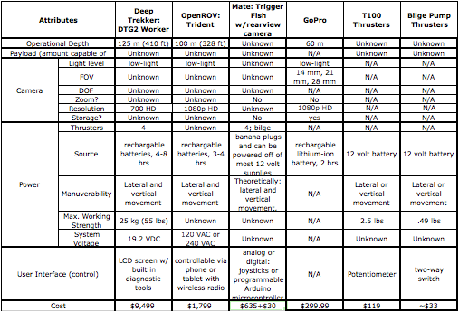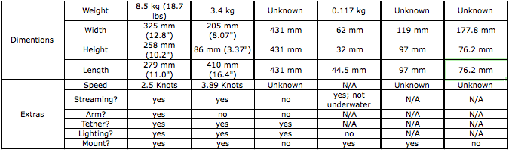
Comparison between main components used in ROV monitoring systems
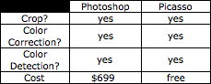
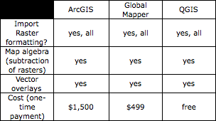
Comparisons between image-editing and GIS software
Figure 1.
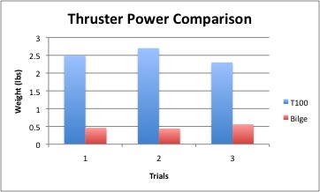
Two thrusters were tested to see which functioned at a higher capacity

Figure 2.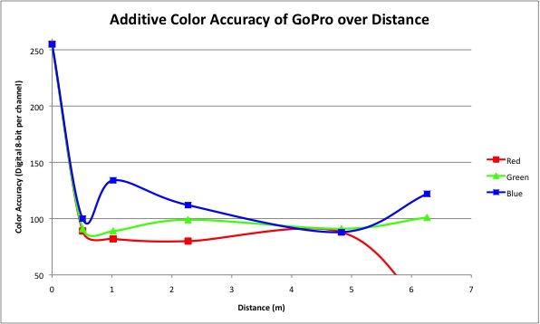
Screen captures were taken with the GoPro camera at 5 different distances and comparisons between the real additive color and the cameras perception of the additive colors were made; please note that 0 is the real color, not the distance
Figure 3.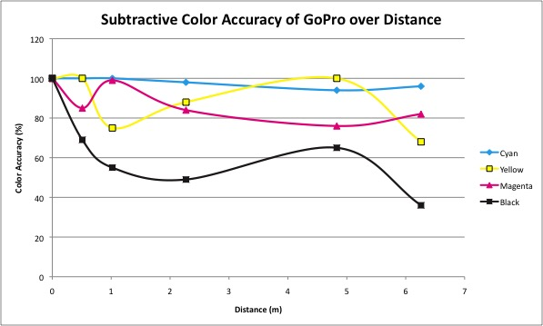
Screen captures were taken with the GoPro camera at 5 different distances and comparisons between the real subtractive color and the cameras perception of the subtractive colors were made; please note that 0 is the real color, not the distance

Figure 4.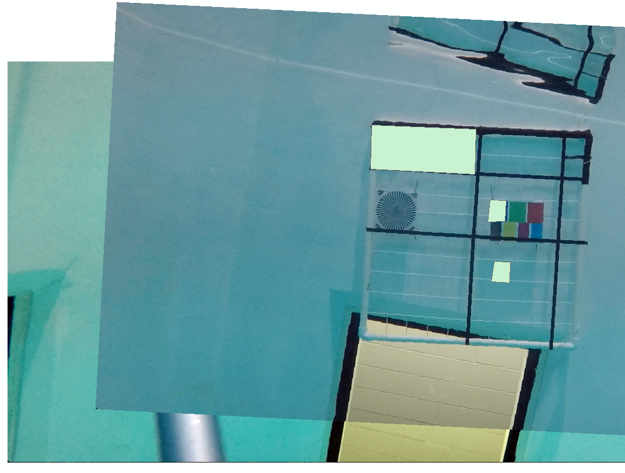
Georeferencing of two separate images was done for spacial analysis of simulated tunicate coonization
Figure 5.
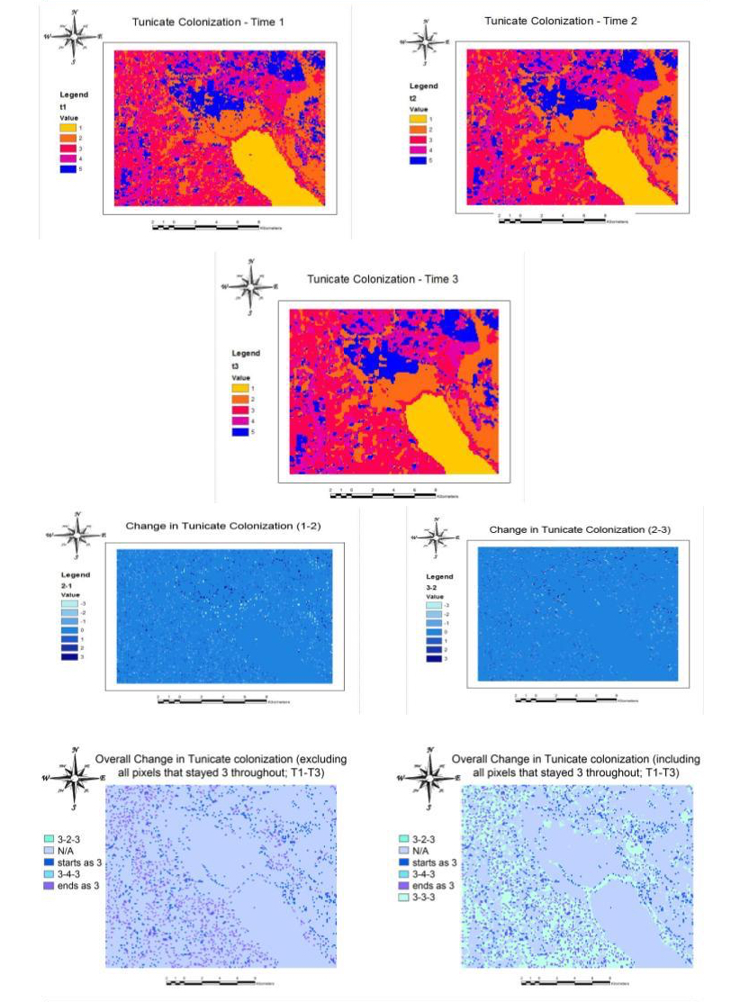
Top three panels: Three identical frames that were taken at different times in order to see spatial variation over time
Middle two panels: The overall transition between the first and second two rasters that does not distinguish how they changed specifically
Bottom two panels: The changes over all three rasters, shows the contents of each individual pixel in each raster and its variation
Figure 6.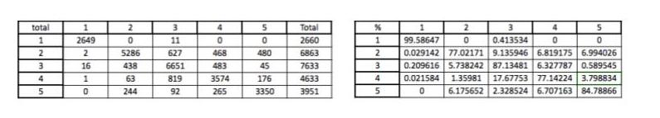
Two matrices (total and %) that look at all of the diffferent combinations of changes each pixel underwent thoughout the rasters

Figure 7.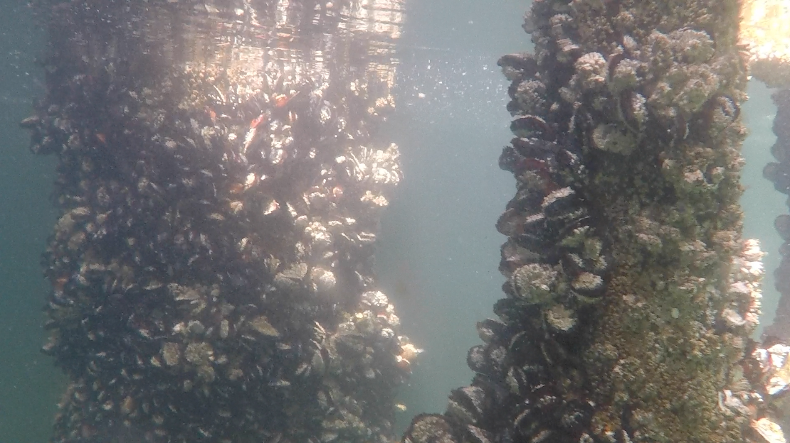
Image captured from GoPro footage for image quality analysis

Figure 8.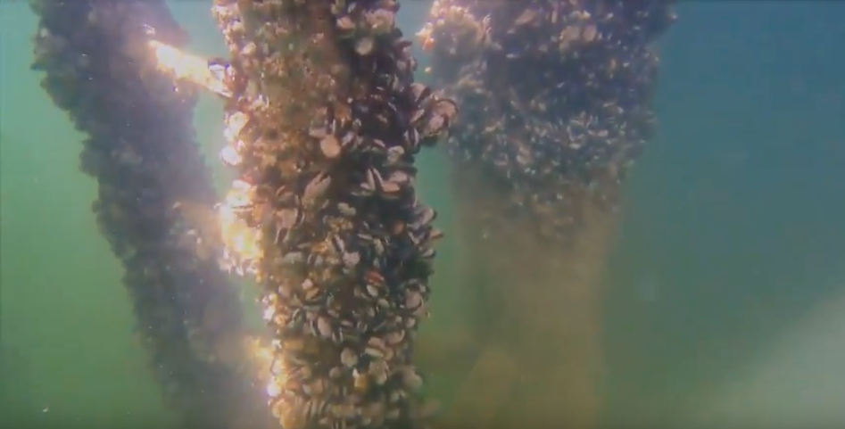
Image captured from Trident footage for image quality analysis
Figure 9.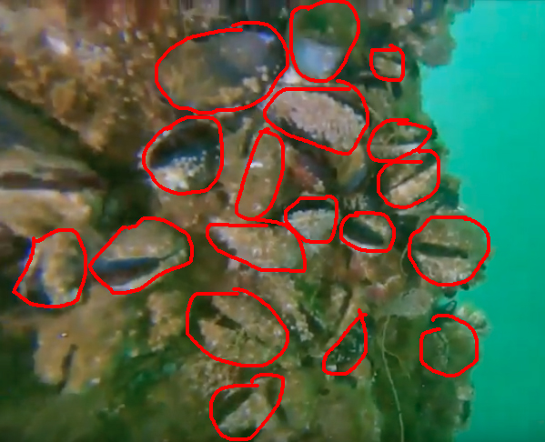
Detection, selection, and location of mussels from Trident footage

References:
1. Curran, Lorne, and Samuel Chan. “Invasive Tunicates In The Pacific Northwest.”
2013, seagrant.oregonstate.edu/sites/seagrant.oregonstate.edu/files/sgpubs/onlinepubs/h-13-001-accessible.pdf.
2. “Invasive Tunicates in Washington State.” Invasive Tunicates in Washington State,
Puget Sound and Hood Canal - Home, Pacific NW Critter Watchers, www.pnwscuba.com/invasives/.
3. Pederson, Judith, Robert Bullock, James Carlton, Jennifer Dijkstra, Nicole Dobroski,
Peter Dyrynda, Ryan Fisher et al. Marine invaders in the northeast: Rapid assessment survey of non-native and native marine species of floating dock communities, August 2003. Massachusetts Institute of Technology. Sea Grant College Program, 2005.
5. Burbank, Luke, and Janna Nichols. “'Sea Squirts' Slime Puget Sound.” NPR, 26 Feb.
2007.
6. Meachum, Pam, and Allen Pleus. Washington State Aquatic Nuisance Species
Committee Report to the 2008 Legislature. State of Washington, Department of Fish and Wildlife, 2007.
7. "Reserve Management Plan - WA - DNR." Nisqually Reach Aquatic Reserve
Management Plan. Accessed May 28, 2018. http://www.dnr.wa.gov/Publications/aqr_nisqually_reserve_finalplan_2011.pdf.
8. “Invasive Tunicate Species Management Program.” Invasive Tunicate Species
Management Program - Aquatic Invasive Species | Washington Department of Fish & Wildlife, Washington Department of Fish and Wildlife, wdfw.wa.gov/ais/Tunicates.html.

