Book List for Self-Confidence

Note: These books are diverse in culture from different religious and non-religious concepts, these books are suggestions to allow students to see a different way to look at life and develop into themselves. Please do not take these suggestion as anything but as a way to educate students on stress management, choices, and self-confidence. Thank you!

It’s Up To You by Dizgar Kongtrul
The Fifth Agreement by Don Miguel Ruiz
The Celestine Prophecy by James Redfield
Reinventing the Body, Resurrecting the Soul: How to Create a New You by Deepak Chopra
The Power of Your Subconscious Mind by Joseph Murphy
The Mastery of Love by Don Miguel Ruiz
The Secret by Rhonda Byrne

Group Presentations

Week 3, 6, and 9 groups will present about the topic discussed for that section.
Groups will be from groups set previous week during seminar.

Must have:
Introduction to topic
Every group must present what they learned
How group is going to apply topic to life
Ideas for Presentations:
Be creative in ways to present information such as
Role Play(s)
Art Installation
Power Point of important information not discussed in topic

Mindfulness Exercise
For Instructor:
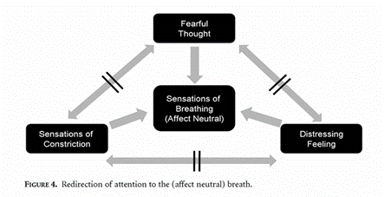
Carmody, 2009
This picture shows what the breathing exercise achieves.
Last PP on the slides should have a calming picture.
Follow instructions with students below.

Student exercise: (Do exercise for 15 minutes)
Step 1: Students find a place in chair or in classroom either sit up straight with shoulders back or laying down.
Step 2: For a minute, have student look at nature setting. Ask them to try to memorize this picture.
Step 3: Ask Students how this picture makes them feel. Continue with this picture if response is a positive or neutral response. Explain to students when they have a stressful thought, feeling, or sensation to think of this picture or how the picture makes them feel, think, have as a sensation.
Step 4: Tell student not to ignore stressful thought, feeling, and/or sensation but accept the thought, feeling, sensation and realize that is does not make them who they are but is a temporary situation, feeling, thought, sensation.
Step5: While they are going through this process have them breathe in their nose slowly then pause for one second and release breathe slowly. While doing this they are accepting the situation, feeling, thought, and/or sensation and breathing through the stress or negative feelings, thoughts, and/or sensations.

Instructor Note: For first session, take last 3 minutes to ask how the students feel. Goal is for students to feel relaxed and/or not stressed.

Prosocial Behavior of Student
A Teachers Evaluation
This is evaluating the student progress over last 9 weeks while engaged in SCS program:

- Student has been more active in participating in group activities YES NO
- Student has worked positively during group activities YES NO
- Student has improved in participating in group discussions YES NO
- Student has improved in managing classroom expectations YES NO
- Student has improved in interacting positively with others YES NO
- Student has improved demonstrating positive self-image YES NO
- Student has improved in actively participating in academic success YES NO
- Student has displayed outburst in class YES NO
- Student has isolated self even during group activities and discussions YES NO
- Student has not turned in homework YES NO
Addition Comments: __________________________________________________________________________________________________________________________________________________________________________________________________________________________________________________________________________________________________________________________________________________________________________________________________________________________________________________________________________________________________________________________________________________________________________________________________________________________________________________________________________________________________________________________________________________________________________________________________________________________________________________________________________________________________________________________________________________________________________________________________________________________________________________________________________________________________________________________________________________________________________________________________________________
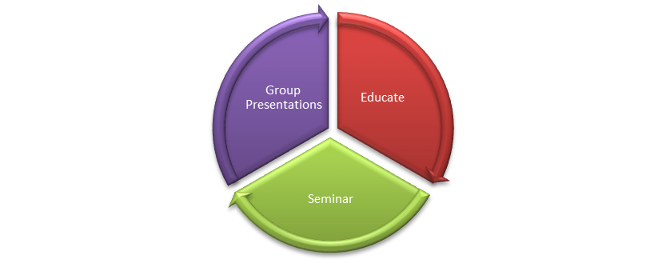

SCS program PLEDGE OF CONFIDENTIALITY

This is to certify that I, ______________________________, a student of Stress Management, Choices, and Self-Confidence program, understand that any information (written, verbal or other form) obtained during the performance of my duties must remain confidential. This includes all information about members, clients, families, employees and other associate organizations, as well as any other information otherwise marked or known to be confidential.
I understand that any unauthorized release or carelessness in the handling of this confidential information is considered a breach of the duty to maintain confidentiality.
I further understand that any breach of the duty to maintain confidentiality could be grounds for immediate dismissal and/or possible liability in any legal action arising from such breach.
_______________________________________________
Signature of Student/Facilitator
_______________________________________________
Date
_______________________________________________
Staff Signature

Self Esteem Survey

Name______________________________________________ Date ___________________________

Directions: Please circle the number for each question that best describes your agreement with each statement.

Strongly Agree Disagree Strongly
Agree Somewhat Somewhat Disagree

- I feel that I’m a person of worth, at least on 3 2 1 0
an equal pair with others.

- I feel that I have a number of good qualities. 3 2 1 0

- All in all, I am inclined to feel that I’m a failure. 3 2 1 0

- I am able to do things as well as most other people. 3 2 1 0

- I feel I do not have much to be proud of. 3 2 1 0

- I take a positive attitude toward myself. 3 2 1 0

- On the whole, I am satisfied with myself. 3 2 1 0

- I wish I could have more respect for myself. 3 2 1 0

- I certainly feel useless at times. 3 2 1 0

- At times I think that I am no good at all. 3 2 1 0

Administrative use only:

Score _________________

Scorer Name ______________________________________

Program Name ____________________________________

Youth entrance into program date __________________________________

Source: Centers for Disease Control and Prevention, National Center for Injury Prevention and Control. (2005). Violence-Related Attitudes, Behaviors, and Influences Among Youths: A Compendium of Assessment Tools, 2nd ed. Atlanta, GA: Dahlberg LL, Toal SB, Swahn M, Behrens CB. Electronic version available: http://www.cdc.gov/ncipc/pub-res/measure.htm.

Self Esteem Inventory Scoring Instrument

Name ______________________________________________ Date ___________________________

Directions: Please circle the number for each question that best describes your agreement with each statement.

Strongly | Agree Disagree Strongly
Agree | Somewhat Somewhat Disagree
1. I feel that I’m a person of worth, at least on an 3 equal par with others. | 2 | 1 |  | 0
Score 3 | 2 | 1 |  | 0
2. I feel that I have a number of good qualities. 3 | 2 | 1 |  | 0
Score 3 | 2 | 1 |  | 0
3. All in all, I am inclined to feel that I’m a failure. 3 | 2 | 1 |  | 0
Reverse Coded Score 0 | 1 | 2 |  | 3
4. I am able to do things as well as most other people. 3 | 2 | 1 |  | 0
Score 3 | 2 | 1 |  | 0
5. I feel I do not have much to be proud of. 3 | 2 | 1 |  | 0
Reverse Coded Score 0 | 1 | 2 |  | 3
6. I take a positive attitude toward myself. 3 | 2 | 1 |  | 0
Score 3 | 2 | 1 |  | 0
7. On the whole, I am satisfied with myself. 3 | 2 | 1 |  | 0
Score 3 | 2 | 1 |  | 0
8. I wish I could have more respect for myself. 3 | 2 | 1 |  | 0
Reverse Coded Score 0 | 1 | 2 |  | 3
9. I certainly feel useless at times. 3 | 2 | 1 |  | 0
Reverse Coded Score 0 | 1 | 2 |  | 3
10. At times I think that I am no good at all. 3 | 2 | 1 |  | 0
Reverse Coded Score 0 | 1 | 2 |  | 3

Scoring:

Points values are as indicated above, with the exception of items 3,5,8,9, and 10 which are reverse coded (score indicated in gray). To score the test, the points values of each response should be summed. A higher score indicates greater self-esteem.

Source: Centers for Disease Control and Prevention, National Center for Injury Prevention and Control. (2005). Violence-Related Attitudes, Behaviors, and Influences Among Youths: A Compendium of Assessment Tools, 2nd ed. Atlanta, GA: Dahlberg LL, Toal SB, Swahn M, Behrens CB. Electronic version available: http://www.cdc.gov/ncipc/pub-res/measure.htm.

Session 2- Seminar Talking Points

Students count off into groups, four groups preferred:
(Groups should change each seminar creating diversity)
Talking Points:
(Instructor should walk around and listen to the groups)

What have you learned from the content?
What are some ways you have dealt with stress?
Are there any ways you are working on creating a better way to deal with stress?
How are you creating better ways to deal with stress?
Why do you feel stress management is a topic for the class?
How are some ways you have seen others deal with stress in a negative way?

Reminder: These groups will be the same for group presentations next week

Session 4 Role Plays

Activity Objective:
To practice making positive choices by role-playing different moral dilemmas and explaining the steps used to reach a decision.
Lesson Outcome:
The children will understand the role of free will in making positive choices.
Materials
•Descriptions of moral dilemmas
•Groups should have copy of Power Point slides
•Divide the children into small groups, or allow them to choose a partner for this activity.
•Explain that they will be given a description of a situation in which they must make a positive choice.
•In each case they are to:
1. Agree on what they would say or do in that situation,
2. Decide how to role-play the situation for the larger group,
•Distribute the following descriptions of moral dilemmas, one to each group.
- You go with a friend to the mall and stop in a music store. As you are looking through the CDs, your friend finds a new release by his or her favorite rock group. Before you can even say anything, your friend quickly hides the CD in a jacket pocket. What do you say or do?

- Lately you've begun to notice that Josh, a quiet kid in your math class, gets picked on by other kids. Two of your best friends pick on Josh fairly often. You like hanging around with them, but you feel uncomfortable by some of the things they do to Josh. What do you do or say?

- You’re hanging out with your friends and you all decide to go to the mall. On the way to the mall some of the kids start to smoke cigarettes. One of the kids looks over and offers you one. What do you do or say?

- For the last few weeks, a girl that is supposed to be a good friend of yours has been saying very mean things about you to others. What do you do or say?

•Give all the groups time to plan their role-play of the situations and what steps they used to make their decisions.
•Allow each group one or two minutes to role-play their dilemmas and to share with the whole group how they arrived at their decisions of what to do or say.
•Ask the rest of the group to decide whether each decision was a positive choice.
Approximate Time:
15 minutes
Hints:
Be sure that each small group is given the proper respect and attention when they do their role-play and explain their decision.

Session 5 Seminar Talking Points

Students count off into groups, four groups preferred:
(Groups should change each seminar creating diversity)
Talking Points:
(Instructor should walk around and listen to the groups)
What have you learned from the content?
What are some ways to make positive choices?
Are there any ways you are working on creating a better way to make positive choices?
Why do you feel choices is a topic for the class?
How are some ways you have seen others deal with negative choices?

Reminder: These groups will be the same for group presentations next week.

Session 8 Seminar Talking Points

Students count off into groups, four groups preferred:
(Groups should change each seminar creating diversity)
Talking Points:
(Instructor should walk around and listen to the groups)
What have you learned from the content?
What are some ways to boost self-esteem?
Are there any ways you are working on to think positively about self?
Why do you feel self-confidence is a topic for the class?
How are some ways you have seen others deal with negative self-confidence or seen them become arrogant?

