Predation of crabs on different species of jellyfish
By: Katerina Boukouzis

University of Washington Friday Harbor Labs
FHL 470: Research in Marine Biology
Professor Terrie Klinger
May 24, 2022

Abstract
For decades, reports have shown that jellyfish have clogged seawater cooling systems and killed large populations of salmon. After numerous attempts to decrease the jellyfish populations, researchers have not yet been successful as jellyfish have the ability to avoid predation and withstand environmental changes. I looked at the possibility for Cancer productus crabs to prey on Mitrocoma cellularia, Aequorea victoria, and Eutonina indicans jellyfish. Two treatment groups of crabs were used to examine species preferences and time of the day that the crabs prefer feeding. The data shows that Cancer productus crabs prefer to consume Mitrocoma cellularia and Eutonina indicans jellyfish over Aequorea victoria and that they prefer to eat at night instead of during the day. More research is needed to determine why crabs preferred smaller, more flexible jellyfish over larger, tougher jellyfish, and understand if we can use these findings to reduce jellyfish blooms.

Introduction
Jellyfish are known for their ability to cause many problems when they occur in large numbers. For example, 40 million people in Thailand were left in a blackout back in 1999 after “...fifty truckloads of jellyfish had been sucked into the seawater cooling system of the coal-fired Sual power station…” [Gershwin, 2013]. In addition, jellyfish have caused problems for salmon farmers in New Zealand, Australia, Norway, Chile, Ireland, and Scotland [Gershwin, 2013]. The salmon were either suffocated by the mucus from the jellyfish, were overloaded with toxins from their nematocysts (stinging cells) or had competed with salmon for food such as plankton [Ruzicka, 2016]. This occurrence creates a positive feedback loop as the nutrients from the dead salmon increase the fitness of the jellyfish, providing them with access to more nutrients [Gershwin, 2013]. The extensive list of troubles that jellyfish blooms have created are expected to continue as our oceans warm. As a result of climate change, jellyfish blooms are expected to become more prevalent, as “...slight increases in temperature tend to increase the reproductive and growth rates of jellyfish…” [Gershwin, 2013] . Therefore, it is important to understand what we can do to minimize the negative effects of jellyfish blooms.
There is no single variable that is known to cause jellyfish blooms, but instead many different factors. Jellyfish can reproduce asexually and have fairly short generation times, thereby allowing populations to grow rapidly. In addition, jellyfish can withstand environmental changes, as they are able to survive in large temperature ranges [Pitt, 2014]. There have been many methods implemented to attempt to reduce these large populations of jellyfish, including electric shocks, chemical repellents, acoustic shocks, and more [Gershwin, 2013].. Due to jellyfish's simple anatomy, they are unresponsive when shocked or sprayed with chemicals, and continue to cause problems despite human efforts. However, there is minimal literature concerning predators that may be able to prey on jellyfish and prevent jellyfish blooms from being so destructive. To explore this possibility, local San Juan Island red rock crabs and different species of jellyfish were used to investigate the relationship between crab feeding patterns and different jellyfish species.

Methods
Cancer productus crabs were collected from Cattle Point on San Juan Island, and Mitrocoma cellularia, Aequorea victoria, and Eutonina indicans jellyfish were collected from the UW Friday Harbor Labs dock. Two treatment groups were used to test differences in Red Rock Crab feeding during the day time versus at night. Sixteen total crabs were divided into two sea tables. Crabs in the daytime feeding group were fed at 10am, and crabs in the nighttime feeding group were fed at 10pm. Three different species of jellyfish, Mitrocoma cellularia, Aequorea victoria, and Eutonina indicans were placed in each of the sea tables every 24 hours and were left in the table for 12 hours. I began my experiment by placing 20 Mitrocoma cellularia into the sea table with my night-fed crabs for 12 hours overnight. The next morning, I counted all the remaining jellyfish, removed them from the tank, and placed 20 Mitrocoma cellularia into the sea table with my day-fed crabs. The same routine was used for each of the three species. Each species of jellyfish cycled between the two treatment groups for two days. Due to limited availability of jellyfish, I fed each crab treatment group 20 Mitrocoma cellularia, six Aequorea victoria and eight Eutonina indicans every morning and night. Species were added separately into each of the sea tables.
When the jellyfish were placed in the sea tables, I turned down the flow rate and added air stones to provide the crabs with extra oxygen, as crabs respire quickly. Jellyfish that were not placed in the sea tables right away were put into buckets with air stones to keep the jellyfish with a constant supply of oxygen. I changed the water in the jellyfish buckets multiple times a day to provide the jellyfish with an adequate supply of nutrients for feeding and to keep the environment at a chilled temperature of approximately 10 degrees Celsius. Soft mesh secured by rubber bands were placed around the drainpipes to prevent the jellyfish from getting sucked down or clogging the drain. Rubber bands were placed at the bottom of the drainpipes to block off any leaks that could suck jellyfish in. When the experiment concluded, the Mitrocoma cellularia, Aequorea victoria, and Eutonina indicans jellyfish were returned to the UW FHL dock, and the sixteen Cancer productus crabs were placed back in the tide pool they were found at Cattle Point.

Results
 | Percent jellyfish eaten by species
 | Mitrocoma cellularia | Aequorea victoria | Eutonina indicans
Night Trial 1 | 40 | 0 | 50
Day Trial 1 | 15 | 0 | 0
Night Trial 2 | 40 | 0 | 12.5
Day Trial 2 | 10 | 0 | 37.5

Figure 1: Raw data showing the percent jellyfish eaten by species during the multiple day and night trials.
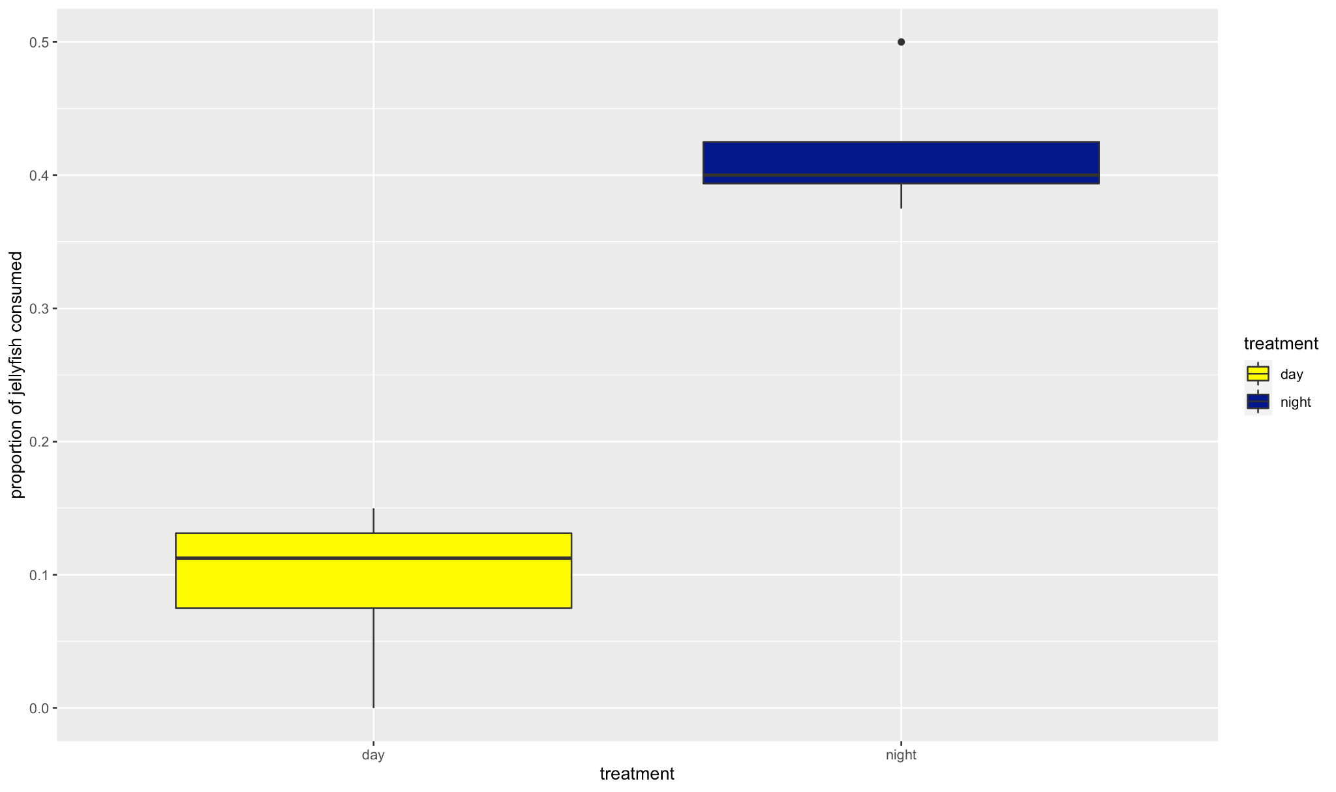
Figure 2: Difference between crab feeding on jellyfish during the day versus the night (Wilcoxon rank sum test with continuity correction, P = 0.03).

When provided with jellyfish during the day versus at night, Cancer productus crabs tend to prefer to eat at night (Figure 1; P = 0.03). Aequorea victoria jellyfish were not included in the data, as the graph only looks at when the consumed jellyfish were eaten, and there were no Aequorea victoria jellyfish eaten during any of the trials.

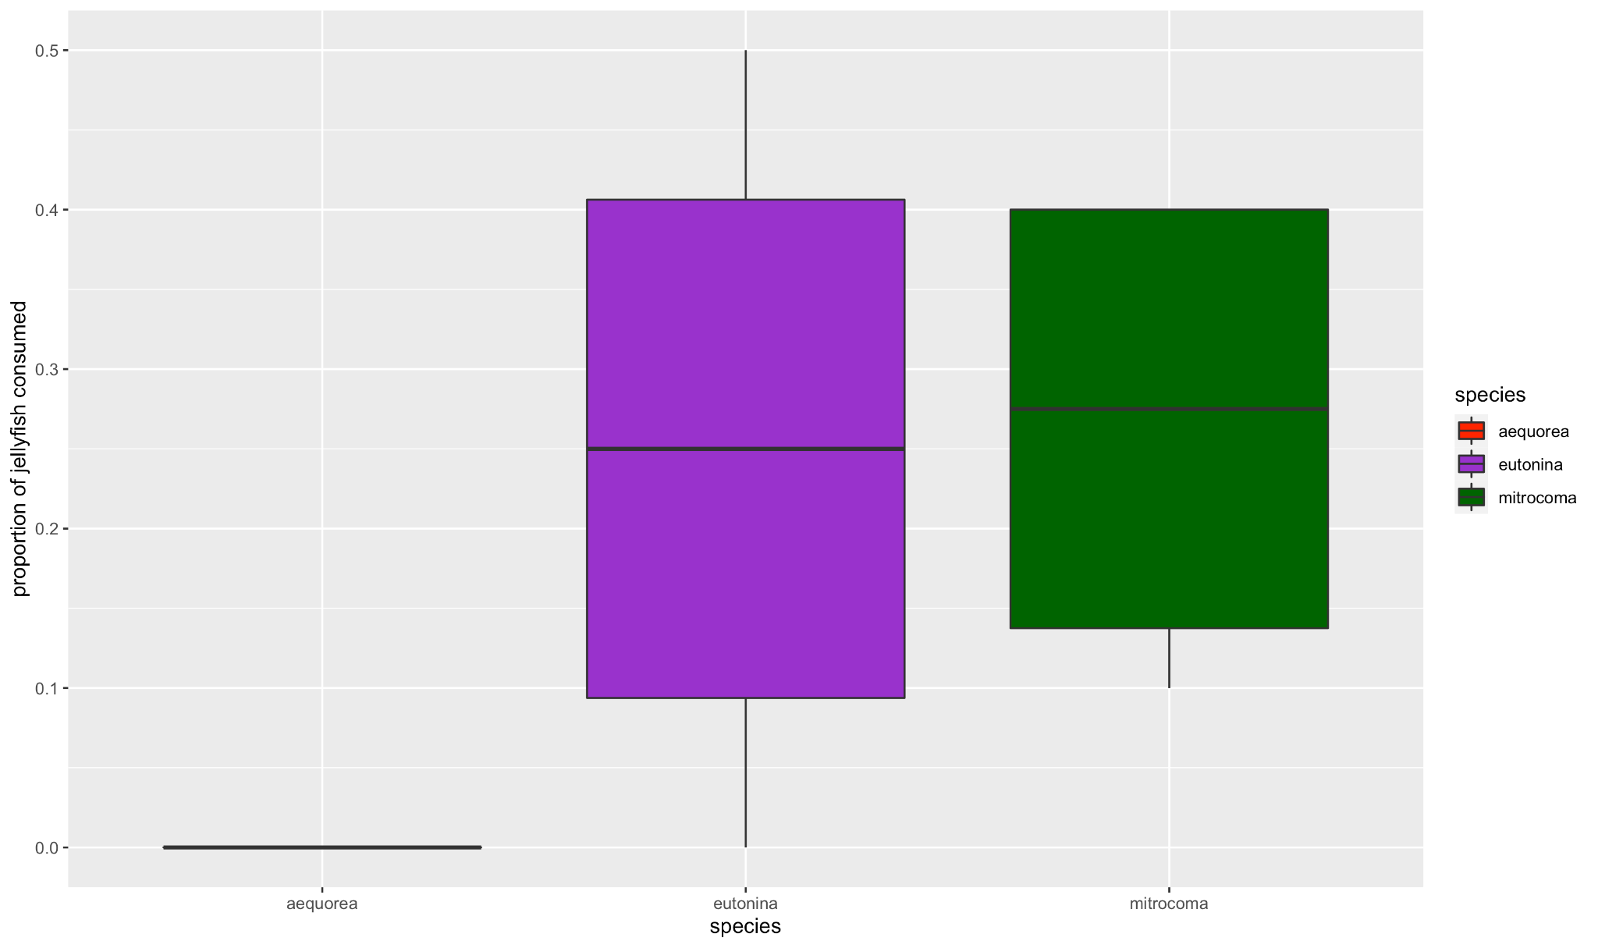
Figure 3: Differences in crab feeding preferences between the jellyfish species Mitrocoma cellularia, Aequorea victoria, and Eutonina indicans (Kruskal-Wallis rank sum test, P = 0.04).
When the Cancer productus crabs were provided with three different species of jellyfish, they preferred to eat the Eutonina indicans and Mitrocoma cellularia over the Aequorea victoria (P = 0.04). Figure 2 displays the total proportion of all jellyfish consumed by the crabs in each species, grouping together the numerous trials performed per species. The crabs do not appear to have a significant preference between eating Eutonina indicans and Mitrocoma cellularia jellyfish.
Discussion
The results indicate that Cancer productus crabs are more active feeders at night and prefer to prey on smaller, more flexible species of jellyfish. Depending on the gender and size of Cancer productus crabs, studies indicate that they feed at different times of the day, therefore I was surprised that my data shows a significant different between nighttime and daytime feeding behavior [Robles, 2007]. In addition, I also found it surprising that the crabs did not consume the large Aequorea victoria, as I expected they would favor that species because they are more dense.
Although I specifically chose the larger jellyfish of each species for this experiment, as it would be easier to spot them after the 12 hour feeding periods, the average size of the individuals in each species were different. Eutonina indicans and Mitrocoma cellularia were much smaller in size compared to Aequorea victoria, which may contribute to why I reported less Aequorea victoria eaten. In addition, I observed that the crabs slurp the jellyfish when feeding, rather than grasp them with their chelates. This may explain why there were more Eutonina indicans and Mitrocoma cellularia consumed by the crabs than the Aequorea victoria, as they are much smaller in size and possibly easier for the crabs to eat.
Although these findings indicate feeding preferences of red rock crabs, there continue to be questions on how these crabs will have access to these different species of jellyfish. Because Cancer productus crabs are an intertidal species and Eutonina indicans, Aequorea victoria, and Mitrocoma cellularia are all pelagic jellyfish species, they occupy different habitats and therefore may not interact in the wild. However, if data continues to show that crabs prey on specific jellyfish species, is there a possibility of releasing crabs into ecosystems that are notorious for having jellyfish blooms? Although Cancer productus crabs are native to the west coast of the US, this question raises eyebrows as ecological control can greatly affect the species and habitats that the crabs would be introduced to [Ens 2021]. It is unclear whether the benefits of releasing Cancer productus crabs in foreign habitats would outweigh the consequences that could alter the habitats of the organisms in the ecosystem, However, jellyfish blooms continue to thrive and destruct man-made entities, therefore we need to continue to explore what kinds of marine animals eat jellyfish and how effectively.

Bibliography:

Gershwin, Lisa-ann. Stung! On Jellyfish Blooms and the Future of Our Ocean. The University of Chicago Press, 2013.

Pitt, Kylie A., and Cathy H. Lucas. Jellyfish Blooms. Springer Netherlands, 2014.

Ruzicka, James J, et al. “Evidence That Summer Jellyfish Blooms Impact Pacific Northwest Salmon Production.” Ecosphere: An ESA Open Access Journal, 28 Apr. 2016, https://esajournals.onlinelibrary.wiley.com/doi/full/10.1002/ecs2.1324.

Hamilton, Garry. “The Secret Lives of Jellyfish: Long Regarded as Minor Players in Ocean Ecology, Jellyfish Are Actually Important Parts of the Marine Food Web.” Shibboleth Authentication Request, 24 Mar. 2016, https://go-gale-com.offcampus.lib.washington.edu/ps/i.do?p=AONE&u=wash_main&id=GALE%7CA447638077&v=2.1&it=r.
Jachowski, R. Observations on the moon jelly,Aurelia aurita, and the spider crab,Libinia dubia . Chesapeake Science 4, 195 (1963). https://doi-org.offcampus.lib.washington.edu/10.2307/1351361
Robles, C, et al. “Diel Variation of Intertidal Foraging by Cancer Productus L. in British Columbia.” Taylor & Francis, 17 Feb. 2007, https://www.tandfonline.com/doi/abs/10.1080/00222938900770951.

Ens, Nicholas J, et al. “A Comparison of the Predatory Impacts of an Invasive and Native Crab Species Using a Functional Response Approach.” Shibboleth Authentication Request, 3 Apr. 2021, https://link-springer-com.offcampus.lib.washington.edu/article/10.1007/s10530-021-02508-5.

