Examining the Relationship Between Rostanga pulchra and Clathria pennata Under Climate Extremes.
Alex Coenen
FHL 470, Spring 2022
Abstract
Intertidal species relationships are some of the most robust and well-studied examples of species adaptability and resilience. Due to climate change, increasing marine temperatures are altering relationships between marine symbiotic species. An important marine symbiotic species found in intertidal ecosystems is that between the nudibranch R. pulchra and the sponge C. pennata. R. pulchra spends most of its life on the sponge both feeding on and laying its eggs directly on the sponge. This symbiotic relationship could possibly be affected by climate change since R. pulchra larvae are temperature sensitive and adults use scent to find the sponge. To examine this, R. pulchra specimens were exposed to foraging time trials to observe how long it would take individuals to reach the symbiotic sponge, C. pennata under different temperatures. R. pulchra individuals were placed in enclosed containers with both C. pennata and Haliclona permollis, another common intertidal sponge species. There was a tank at an ambient temperature of around 10°C, a 13°C treatment, and 16°C treatment. The experiment revealed that temperature does not affect the ability of R. pulchra to find the symbiont sponge, C. pennata over the other sponge, H. permollis. R. pulchra reached each sponge species at a similar proportions in each of the temperature treatments. In addition, it took on average the same time for R. pulchra to reach C. pennata in each treatment. This indicates that even though marine temperatures are rapidly increasing and affecting many symbiotic relationships, it is possible that the relationship between R. pulchra and C. pennata is not as highly affected.

Introduction
Increasing temperatures can have many different effects on population dynamics and species interactions. Changes in species interactions have potential to alter community structure and composition which are possibly even more significant than the direct effects of a changing climate. Specifically, mutualism allows individuals to prosper in otherwise marginal habitats by avoiding competition and exploiting new niches (Six, 2009). For example, the symbiotic relationships between corals and dinoflagellates are a well-known pair that dominate their environments, where they support each other (Hoegh-Guldberg, 2011).
Mutualistic relationships between marine species are especially essential since most marine species are ectotherms and therefore are particularly sensitive to increases in temperature (Six, 2009). Due to increasing temperatures caused by climate change, these relationships could be particularly affected. Species in intertidal ecosystems will be increasingly affected by climate change. As oceans warm, we should anticipate many changes in mutualistic relationships. Coral bleaching is a well-known environmental problem affecting the previously mentioned coral-dinoflagellate symbiotic relationship due to increasing ocean temperatures (Hoegh-Guldberg, 2011). This issue is well-studied, but other marine symbiotic relationships that might face difficulties under climate change are not.
Sponges and nudibranchs are commonly found throughout the intertidal. Rostanga pulchra is a vibrant orange nudibranch species with a symbiotic relationship with a similarly colored sponge, Clathria pennata (previously referred to as Ophlitaspongia pennata). R. pulchra is often found on C. pennata and relies heavily on the sponge as it lays eggs on, and feeds off the sponge (MacFarland, 1905). It is possible that the nudibranch's bright orange coloring comes from feeding on the sponge (Anderson, 1971). In addition, R. pulchra lays its spiral-shaped orange egg masses on C. pennata annually in spring to early summer (Sept, 2019). An encounter with C. pennata can induce larvae, which are planktonic for 30-45 days, to settle back on the sponge (Anderson, 1971). Egg development is affected by temperature such that in warmer waters, it is typically much shorter than normal (Hurst, 1967). Yet, although some R. pulchra individuals seem to stay relatively close to one area of C. pennata, others are capable of traversing for distant sponges. R. pulchra individuals can distinguish between C. pennata and other sponges if given a choice between the two as adults can locate and navigate to distant C. pennata by smell (Kozloff, 1993). One marking study revealed a strong association between R. pulchra and sponge species, C. pennata. This study indicated that R. pulchra typically remains on or near an individual sponge for several days, but they can and do leave the sponge to move from one location to another (Anderson, 1971).
These two species have a strong bond and it is unknown how much of an effect an increase in ocean temperatures will have on their interactions. Here I investigate if the symbiotic relationship between Rostanga pulchra and Clathria pennata will be affected by extreme marine temperatures due to climate change in the future. The research examines the ability of R. pulchra to find C. pennata when faced with increasing temperatures and a second common intertidal sponge, Haliclona permollis. This species was chosen as another variable in the experiment to observe whether R. pulchra would become confused due to increasing temperature and end up on a different sponge. With this experiment, I hope to reveal any underlying factors that may affect this symbiotic relationship between R. pulchra and C. pennata in the future.

Methods
Research and data collection were performed in three outdoor saltwater tables at Friday Harbor Labs on San Juan Island, WA. A total of nine R. pulchra individuals were used for this experiment. Three were placed into each treatment. C. pennata and R. pulchra specimens were collected from Argyle Creek, San Juan, WA, and H. permollis was collected from Cattle Point, San Juan, WA prior to the experiment. In total, six sponge specimen were used for the experiment consisting of three of H. permollis and three of C. pennata.
Treatment tanks were heated using aquarium heating rods, and water flow was held constant in each tank. The control sea table was left at an ambient temperature while a separate sea table was set to a temperature of 13°C, and a third temperature treatment was set to 16°C. Thermometers were placed in each saltwater table to monitor temperature. Sponge and nudibranch specimens were put into smaller containers inside the larger tanks. Rocks that had encrusted C. pennata were placed into each of the three treatments. H. permollis specimens were scraped off their respective substrate in the field and were also placed into the containers. Thin mesh was clipped onto the tops of the smaller containers so the nudibranchs would not escape during or after the experimental trials. Nudibranchs were held in a secluded container in the control tank until it was time to start the experiment.
Time trials were conducted during mid-May. The sponges were placed at one end of the container throughout the duration of the experiment. At the beginning of each trial, the three R. pulchra were placed at the other end of the container. A stopwatch was used to record the time that had passed. If R. pulchra reached C. pennata and remained on the sponge for over one minute, the time that individual had taken to reach C. pennata was recorded. For instances when R. pulchra ended up on H. permollis and remained there for over a minute, it was counted as a separate category of data called “mismatch”. If R. pulchra never fully settled on either C. pennata nor H. permollis after 50 minutes, it was categorized as “incomplete”. After each nudibranch reached either sponge and remained on it for one minute, it was removed and placed back into the secluded holding container.
Data analysis was performed in Excel and R Studio. A box and whisker plot was constructed to represent the average time and variance for each nudibranch to reach C. pennata. In addition, an equality of proportions analysis was conducted to represent the proportion of R. pulchra that reached C. pennata versus those that reached H. permollis.

Results
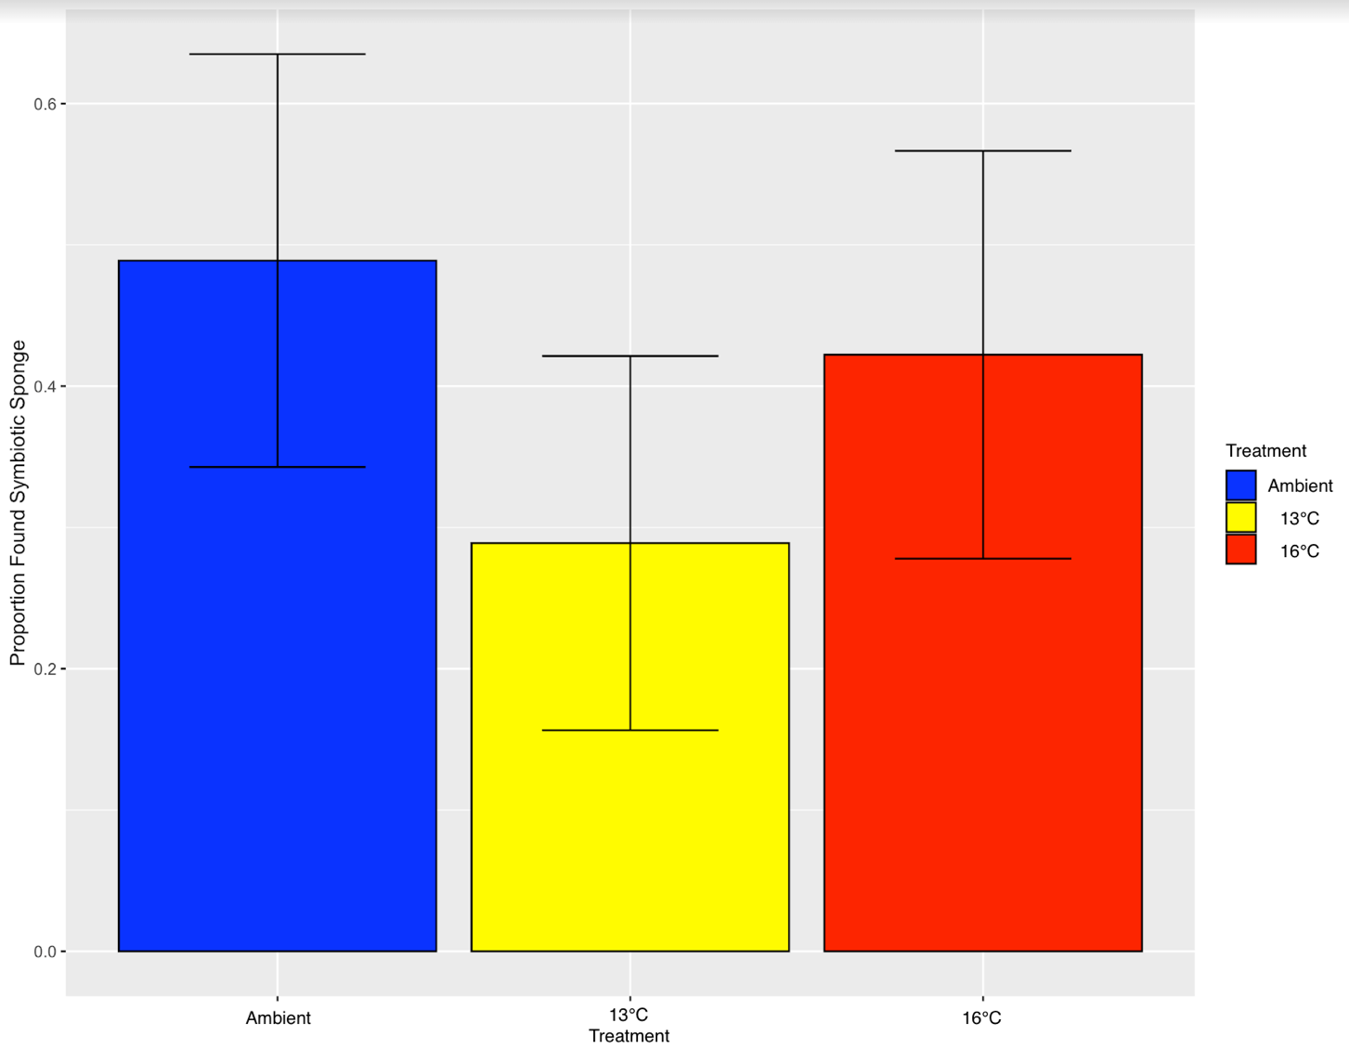
Analysis of the data shows that there was no effect of temperature among the three treatments. On average, R. pulchra individuals proportionally reached the symbiotic sponge, C. pennata, the same number of times that it reached the non-symbiotic sponge, H. permollis. As indicated from the proportion success rate of each treatment (Figure 1), out of the three treatments, the one set to 13°C on average has the lowest number of R. pulchra individuals end up on either sponge. With error bars, it is evident that each treatment was not statistically significant from one another. There was no distinct preference in sponges with an increase in temperature. Temperature did not affect the nudibranchs ability to distinguish between C. pennata and H. permollis.
Figure 1. An equality of proportions analysis revealing that out of the three temperature treatments, R. pulchra individuals in each treatment had similar proportions reaching the symbiotic sponge, C. pennata, and the non-symbiotic sponge, H. permollis.
In addition, a 3-sample pairwise test for the equality of proportions revealed that each of the three temperature treatments were not significantly different from each other (Table 1). This analysis indicates that each of the treatments generated statistically the same number of data points. R. pulchra will ended up reaching C. pennata statistically the same number of times that it will end up on H. permollis under increasing temperature treatments (p-value=0.1431).

3-Sample Test for Equality of Proportions Without Continuity Correction
X-squared=3.8889 | df=2 | p-value=0.1431
Table 1. A 3-sample test for equality of proportions without continuity correction. Data analysis for the equality of proportions test showed that the three temperature treatments had no statistical difference in the amount of times R. pulchra reached C. pennata versus the number of times R. pulchra individuals reached H. permollis (p-value=0.1431)

A box and whisker plot was constructed to represent the average time it took for R. pulchra to reach just its symbiotic sponge C. pennata under each temperature treatment (Figure 2). Times from the time trials were analyzed for each treatment separately revealing the averages for each to be statistically similar. The plot (Figure 2) shows that the treatments were not statistically different from one another as indicated from the overlapping boxes and error bars. Even though all treatments display a large amount of variance in the data, the box and whisker plot revealed that ambient temperature produced the highest variability in the resulting data.
Figure 2. The three temperature treatments during the experiment yielded relatively similar average times for R. pulchra to reach C. pennata as revealed from this box and whisker plot.
Discussion
Individuals of R. pulchra reached C. pennata and H. permollis relatively the same number of times under each temperature treatment. This indicates that temperature has little to no effect on the ability of R. pulchra to distinguish between its symbiotic sponge versus other sponges. In ecological terms, this finding indicates that under increasing temperatures, R. pulchra is likely to reach C. pennata the same number of times that it will reach H. permollis in an ambient environment (p-value=0.1431). Under climate extremes, it is likely that R. pulchra will not face direct consequences when separated from C. pennata. This symbiotic relationship does not appear to be highly sensitive to increasing temperatures.
All three temperatures resulted in statistically the same average foraging time indicating that no effect of temperature on searching time was found (Figure 2). In each of the trials, the nudibranchs had similar searching patterns. This suggests that with increasing ocean temperatures due to climate change, R. pulchra should have relatively the same probability of finding C. pennata if it were to leave the sponge compared to normal temperatures. It is also possible that R. pulchra would forage for other similar sponge species if an individual were to leave the encrusted sponge (Rudman, 1989). This is surprising though, as previous studies have shown that R. pulchra has an close association with C. pennata, and only this species (Cook, 1962).
Multiple factors could have occurred during the experiment to yield these results. It is possible that the nudibranchs took their time getting back because they had eaten and were not as hungry in the preliminary trials. In addition, in the hottest treatment, the heat could have degraded sponge quicker. In that tank, algal growth was also very noticeable by the last day of trials. The results though, are not entirely surprising. While I had thought that the nudibranchs would have slowed down their foraging time in the highest temperature tank, it is possible that temperature has no effect on nudibranchs, as revealed in my data analysis. These results show that R. pulchra will likely not be affected to increasing marine temperatures. Yet we should not discount the possibility that its symbiotic sponge, C. pennata may be increasingly affected by ocean acidification. Sponges contain CaCO₃ structures called ossicles that may degrade with higher concentrations of CO₂ in marine ecosystems from anthropogenic emissions (University of British Columbia, 2020). Predicting the future implications that climate change can have on individual species is difficult. To fully understand the complexities that climate change could bring, we should observe all interaction species to make predictions about just one (Lee, 2012). R. pulchra may still be indirectly negatively affected by climate change because of its association with C. pennata. It is fundamental that more research is applied to symbiotic species interactions because of how integral they are to each other and the function of essential marine ecosystems.

References
Anderson, E. S. (1971). The Association of the Nudibranch Rostanga pulchra (MacFarland, 1905) with the Sponges Ophlitaspongia pennata, Esperiopsis Originalis, and Plocamia Karykina. University of California, Santa Cruz.
Cook, E. F. (1962). Berkeley, CA, California Malacozoological Society. The veliger. Retrieved May 24, 2022, from https://www.biodiversitylibrary.org/part/97479
Hoegh-Guldberg, O. (2011). Coral reef ecosystems and anthropogenic climate change. Reg Environ Change 11, 215–227 https://doi.org/10.1007/s10113-010-0189-2
Hurst, A. 1967. The egg masses and veligers of thirty northeast Pacific opisthobranchs. Veliger 9: 255-288.
Lee, Hannah & Hughes, Lesley. (2012). Climate Change Impacts on Species Interactions: Assessing the Threat of Cascading Extinctions. In Saving a Million Species (1st ed. 2012., pp. 337–359). Island Press. https://doi.org/10.5822/978-1-61091-182-5_18
Kozloff, Eugene. (1993). Seashore Life of the Northern Pacific Coast. University of Washington Press, Seattle, WA. 370 pp.
MacFarland, F. M. (1905). A preliminary account of the Dorididae of Monterey Bay, California. Proceedings of the Biological Society of Washington. 18: 35-54.
Rudman, W.B. & Avern, G.J. (1989) The genus Rostanga Bergh, 1879 (Nudibranchia: Dorididae) in the Indo-West Pacific. Zoological Journal of the Linnean Society 96: 281-338.
Sept, J. Duane. (2019). The Beachcomber's Guide to Seashore Life in the Pacific Northwest. Harbour Publishing, Madeira Park, BC, Canada. Paperback, 235 pp. ISBN 1-55017-204-2.
Six, D. (2009). Climate change and mutualism. Nat Rev Microbiol 7, 686. https://doi.org/10.1038/nrmicro2232
University of British Columbia. (2020). Climate change an imminent threat to glass sponge reefs: First long-term lab study of glass sponges reveals dire impacts of ocean warming and acidification. ScienceDaily.

