Dietary and Spatial Analysis of Salmon in San Juan Archipelago, Puget Sound, and Alaska

Sarah Miyabi Hendricks

University of Washington Friday Harbor Labs

Pelagic Ecosystem Function in the San Juan Archipelago 2023

Abstract

This study aims to compare three different species of salmon (king, silver, and pink) in three different regions (San Juan Archipelago, Puget Sound, and Alaska) to add to a six-year-long diet and spatial analysis data set. The data for 2018-2023 suggest temporal changes in the amount and presence of prey species of interest. Pacific Herring was the highest prey of all salmon species in SJA. There was a decrease in sand lance in 2023 for nearly all species of salmon from the three regions. PS pink salmon were found to only feed on crustaceans from 2021-2023. King salmon in AK were found to be nearly all herring in their diet with some bones and digested sand lance. Spatial analysis shows that the feeding behavior of salmon species in SJA and PS are statistically similar. The spatial analysis also suggests that stomach fullness differences between salmon species in SJA from 2018-2023 are statistically similar.

Introduction

Exploring the dietary patterns of organisms unveils crucial insights into their ecological context. This significance becomes particularly evident when studying predators, as they often serve as keystone species in their habitats. Keystone species, such as salmon, play a critical role in maintaining the balance of ecosystems by connecting higher to lower trophic levels (Davic, 2003). Without these keystone species, ecosystems become more vulnerable to the adverse effects of environmental change.
Conducting a predatory diet analysis contributes to a deeper understanding of the feeding behavior of species, the dynamics of competition among predators, and the availability of prey (Ahlbeck et al., 2012). This type of analysis sheds light on the intricate relationships within ecosystems and underscores the importance of predators in shaping ecological processes.
In addition to dietary analysis, investigating the spatial distribution of predatory species further enhances our ecological insights. This research illustrates key aspects such as habitat preference, migration routes, and population dynamics (Reid et al. 2004). For instance, examining three specific locations—San Juan Archipelago, Puget Sound, and Sitka, Alaska—provides a comprehensive view of how predators and prey species interact within distinct geographic contexts, offering valuable information for conservation and management efforts.
Salmon showcase remarkable adaptability in their dietary preferences, with a notable capacity for significant shifts in response to prey availability (Dixon et al. 2017). This adaptability is particularly advantageous for researchers examining the diet composition of fish species like salmon, given their tendency to consume prey whole, facilitating the identification of consumed contents (Amundsen & Sánchez‐Hernández, 2019). Among the prey species in their diet are Pacific Herring, Pacific sand lance, and various crustaceans, including krill, crab larvae, amphipods, shrimp, and mysids. Notably, king and silver salmon exhibit the highest diet variability, with a substantial portion comprising forage fish (Brodeur et al. 2007). This variability may be attributed to the size of king salmon, which, reaching up to 58 inches and 126 pounds, can consume large quantities without slowing down due to their firm esophagus. In contrast, smaller pink salmon, around 30 inches and 12 pounds, focus primarily on various species of crustaceans (Brodeur et al. 2007). Interestingly, the feeding behaviors of these salmon species are more influenced by spatial distribution than temporal factors, with those captured in northern environments displaying higher stomach fullness ratios compared to their southern counterparts (Brodeur et al. 2007)."
This study focuses on comparing and contrasting the diets of three salmon species—king salmon (Oncorhynchus tshawytscha), silver salmon (Oncorhynchus kisutch), and pink salmon (Oncorhynchus gorbuscha)—across three distinct regions: San Juan Archipelago, Puget Sound, Washington, and Sitka, Alaska. By examining the dietary patterns and spatial analysis of these salmon populations, the research aims to provide insights into their reliance on different prey species, the abundance of their prey, and the dynamics of competition within various trophic levels.
The differences in caught salmon location (AL, SJI, PS) will be crucial as they all possess different qualities from one another. For example, compared to Puget Sound and the San Juan Islands, Alaska is much colder and more rural. Puget Sound, in contrast, is very urbanized but possesses a large amount of freshwater input – the ideal habitat for salmon (Losee et al. 2019). Finally, the San Juan Islands have a unique bathymetry and tidal current ideal for many marine organisms (Sisson & Baker, 2017).
This study will include work from the current year as well as past years, such as Eva Hasegawa (2018), Julia Glassy (2019), Connor Brainard (2020), Andrew Fletcher (2021), and Tyler Cordova (2022). Studying stomach contents amongst varying regions will provide insight into the diet of local (PS) and non-local (AK) salmon populations. It will provide an abundance of prey species and signs of competition amongst other salmon species. Spatial analysis of salmon can provide species feeding behaviors compared to location and keep a conservatory eye on specific populations if they are in danger. Spatial analysis can also offer locations of prey species and the health of the prey species. This study aims to contribute to existing data on salmon stomach analysis and hopefully gain more knowledge.

Methods
Study Area
Samples were collected from three different regions to capture the essence that abiotic and biotic factors play on salmon diets. These locations were the San Juan Archipelago, Puget Sound, and Alaska (Figure 1). The coordinates for these locations start at 47.7237° N - 122.4713° W and end at 57.0532° N - 135.3346° W.
Sample Collection
All processed samples were kindly provided by Juan Valero, Andy Derksema, and Karen Johnson. Juan provided the samples from Puget Sound, Andy from The San Juan Archipelago, and Karen from Sitka, Alaska.
Salmon in the San Juan Archipelago were caught from July 13, 2023 to September 3, 2023. Puget Sound salmon were caught from June 22, 2023 to September 23, 2023. Alaska salmon samples were caught from January 15, 2023 to February 4, 2023.
There were 23 salmon stomachs for The San Juan Archipelago, 44 for Alaska, and 57 for Puget Sound. Most samples were tagged with latitude and longitude or a catch location name. The other identifiers were the sex of the fish, capture date, fish length, tidal state, and depth at which the fish were caught.

Dissection
The processed salmon samples included compiled organs, namely the stomach, esophagus, liver, intestinal tract, and pyloric caeca (Fig. 2). During the dissection, the stomach was separated from other organs and weighed in its entirety. All samples were weighed using a Mettler Toledo scale recorded to the nearest hundredth of a gram. Following the initial full-weight measurement, the stomach was opened, emptied, and then reweighed to determine its empty weight. The stomach contents were identified by prey species, such as Clupea pallasii, Ammodytes personatus, and various crustaceans including crab larvae. Each prey species was individually numbered and weighed as identifiable groups.
Empty stomachs were denoted as either 'Y' for yes or 'N' for no. Their weights were recorded in grams when bones and unidentifiable digested remains were present. Due to the physical impact of being caught, some salmon regurgitated their prey, and these instances were also noted in the total weight of a full stomach. Additionally, data from previous PEF students—Julia Glassy, Connor Brainard, Eva Hasegawa, Andrew Fletcher, and Tyler Cordova—were incorporated into this subset for comparative analysis spanning the years 2018-2022, providing additional context to the current data collected in 2023.

The Presence-Absence Method (PA)
The presence-absence technique relies on identifying specific prey types rather than quantifying each prey type's numerical or spatial abundance. This approach serves as a means of simply documenting the presence or absence of various prey types within a given sample or sample group. While it effectively records the presence of prey species, it may overestimate the significance of small or infrequently encountered prey types. Therefore, the presence-absence method does not offer reliable estimates of prey type quantities but can be utilized to investigate the frequency of a prey type's occurrence within a sample group (Amundsen & Sánchez‐Hernández, 2019).
The Numerical Method (NM)
The quantitative approach entails enumerating all distinct prey species in a salmon's stomach. This is followed by expressing this count as the frequency of each specific prey type. This method depends on intact and identifiable stomach contents and does not accommodate digested material, unidentifiable remains, or heavily fragmented remnants. Additionally, it may yield inaccurate outcomes when a substantial quantity of small prey species is within the stomach (Amundsen & Sánchez‐Hernández, 2019).
The Gravimetric Method (MM)
Among the stomach analysis techniques employed in this study, the gravimetric approach delivers the most precise insight into the proportions between various prey types within a stomach. Each prey category is individually weighed and represented as a percentage of the total stomach content mass in this methodology. Although it could overstate the significance of slowly digested remains, this method also accommodates digested and unidentifiable remnants (Amundsen & Sánchez‐Hernández, 2019).
Frequency of Occurrence
The term "frequency of occurrence" pertains to the number of stomachs containing a particular prey type, expressed as a percentage of the overall stomach samples. The formula provided by (Amundsen & Sánchez‐Hernández, 2019)was employed to compute the frequency of occurrence.
f_{i} = N_{i} / N
Here, 'N' represents the total count of salmon possessing identifiable stomach contents, while 'i' denotes the specific prey type being considered.
Relative Prey Abundance
Relative prey abundance pertains to the ratio of all predators' cumulative identifiable stomach contents to the entire stomach contents associated with a particular prey type. Stomach contents can be quantified in mass, volume, or quantity. In this investigation, we have computed relative prey abundance based on mass. The formula defining relative prey abundance can be found in (Amundsen & Sánchez‐Hernández, 2019).
p_{i} = ΣS_{i} / ΣS_{T}
Here, 'Si' represents the mass of the specific prey type under consideration, 'ST' denotes the combined mass of all identifiable prey types, and 'i' signifies the individual prey type.
Stomach Fullness ratio
Stomach fullness ratios contrast the masses of satiated and empty stomachs, offering insights into a fish's food consumption. The equation for the stomach fullness ratio is as follows.
R = s/s₀
R is the fullness ratio, s is the mass of the full stomach, and s₀ is the mass of the empty stomach (Hasegawa, E. 2018)
Statistical Analysis
The Shapiro-Wilk test is a statistical test used to assess whether a sample comes from a normally distributed population. It is often used in statistics to check the normality assumption before applying specific parametric statistical tests that assume normality (Royston, 1983).
The Kruskal-Wallis test is commonly used when the assumptions of parametric tests (like ANOVA) are violated, such as when the data is not normally distributed or when the variances are not homogeneous across groups. It is important to note that a significant result in the Kruskal-Wallis test indicates only the presence of a difference between groups. Still, it does not identify which specific groups are different. Additional post hoc tests may be necessary to determine the specific group differences (McKight & Najab, 2010).
The Dunn's test is particularly useful when there is a significant result from the Kruskal-Wallis test and want to explore which specific groups differ from each other. It is a non-parametric alternative to post hoc tests used after ANOVA (analysis of variance) when the assumptions of normality and homogeneity of variances are unmet (Dinno, 2015).
Spatial Analysis
Using the Kruskal-Wallis test, differences amongst groups were noted, and if significance was indicated, the Dunn test was followed. The Dunn test will then identify specific pairwise differences between groups, e.g., Alaska and San Juan Archipelago. A map was then made in National Geographic to note locations of salmon caught in the San Juan Archipelago. Locations with sand lance were noted with a yellow mark for clearance. All longitudes and latitudes were noted in degree format.
Exclusivity
This approach assesses whether the stomachs of salmon contain a variety of prey or just a single type. It allows for inferences about whether individual salmon prefer a particular prey type or if salmon tend to focus on a single prey type during each feeding event, potentially influenced by their prey's schooling or aggregative behavior. The formula for this method is as follows:
E= NT/Np
Here, 'Np' represents the total count of stomachs exclusively containing a specific prey group, while 'Nt' denotes the overall count of stomachs with any prey.

Results
San Juan Archipelago (SJA)
Twenty-three samples were processed for SJA in 2023: one king salmon, seventeen pink salmon, and five silver salmon. For the one king salmon that was caught, the stomach was found empty. For the seventeen pink salmon, their diets consisted of 1% sand lance, 35% herring, 7% crustacean, and 57% bones and digested material (Fig 5). Finally, for the five silver salmon, 56% of herring and 44% of bones were digested (Fig 7).
Previous years in SJA 2018-2022 show king salmon fed 19% on sand lance, 43% on herring, 20% on crustacean, and 18% on bones and digested (Fig. 3). The pink salmon diet consisted of 1% sand lance, 45% herring, 25% crustacean, and 29% bones and digested (Fig. 4). Finally, the silver salmon diet consisted of 1% sand lance, 40% herring, 25% smelt, 2% crustacean, and 32% of bones and digested (Fig. 6).
Puget Sound (PS) 2023
There were 57 samples from PS: four king salmon, fourteen pink salmon, and thirty-nine silver salmon. For the four king salmon found, their diets consisted of 88% herring and 12% of bones and digested (Fig. 9). The fourteen pink salmon diets consisted of 100% crustacean (Fig. 11). Finally, all thirty-nine silver salmon were found to have 1% of herring and 99% to be bones and digested (Fig. 13).
Previous years in PS 2018-2022 show king salmon fed on 4% of sand lance and 96% on herring (Fig. 8). Pink salmon, similar to 2023, also fed 100% on crustaceans (Fig. 10). Finally, silver salmon in PS preyed on 1% of salmon, 4% of herring, and 95% on bones and digested (Fig. 12).
Sitka, Alaska (AK) 2023
There were 44 samples from AK, and all were king salmon, which will be noted during statistical analysis due to the possible skewing of data. The diet of these salmon consisted of 89% of herring, 10% bones and digested, and 1% sand lance (Fig. 14).
AK was a new sample location and will not have any previous years of work to be based on.
Stomach fullness
Three box plots were generated to illustrate stomach fullness ratios. The first plot (Fig. 16) compared stomach fullness across past years, excluding AK, to avoid potential data skewing. The second plot (Fig. 17) differentiated stomach fullness in 2023 by region: SJA, PS, and AK. The third and final plot (Fig. 18) depicted stomach fullness of salmon species in SJA, aggregated across all years (2018-2023).
Examining stomach fullness for king, pink, and silver salmon from 2018 to 2023 revealed that king salmon generally had the fullest stomachs, with a few outliers (Fig. 16). Notably, silver and pink salmon lacked samples for 2019. In 2020, king salmon led in stomach fullness, followed by silver salmon with outliers. 2021 displayed silver salmon with the highest stomach fullness, king salmon, and pink salmon with outliers. Although 2022 lacked data for pink salmon, king salmon exhibited the highest stomach fullness, and silver salmon ranked second with several outliers. In 2023, silver salmon had the fullest stomachs, followed by pink, and lastly, king salmon (Fig. 17).
Examining stomach fullness in 2023 based on regions (SJA, PS, and AK) revealed AK to have the highest stomach fullness, whereas SJA and PS exhibited similar lower stomach fullness. It is crucial to note that all AK samples were king salmon with full stomachs, potentially causing data skewing (Fig. 17).
The final plot (Fig. 18) showcased stomach fullness of SJA salmon species aggregated across 2018-2023. Pink salmon displayed the highest stomach fullness, followed by king and silver salmon. All salmon species had several outliers, and the medians were similar for pink and king salmon.

Spatial Analysis
Kruskal-Wallis and Dunn tests were performed for both (Fig. 17) and (Fig. 18) for spatial analysis and creating a map for SJA salmon for 2023 with the location of sand lance being represented with a yellow mark and without a red mark. Once the Shapiro-Wilk test (Fig. 15) was run, it was shown that the trend did not follow normality. Then, the Kruskal-Wallis test was run (Fig. 17, Table 1), showing a p-value = 7.359 x 10⁻⁶, which means it was significant. The Dunn test (Fig. 17, Table 2) showed AK-PS to have a p-value of 4.428603 x 10⁻⁵, AK-SJA a p-value of 2.016473 x 10⁻⁴, and PS-SJA to have a p-value of 5.953924 x 10⁻¹. This explains the box plot analytically where AK and PS differ; this is the same for AK and SJA. However, PS and SJA were similar to one another in comparison to the others. The same was done for (Fig. 18, Table 3); the Kruskal-Wallis test showed a p-value of 0.06339, which is insignificant. The Dunn test (Fig. 18, Table 4) was also run, showing a p-value of 0.65908663 for king and pink salmon. King salmon and silver salmon showed a p-value of 0.05716455. Finally, pink salmon and silver salmon showed a p-value of 0.21587553. All of which were not significant and were similar to each other.

Discussion
There are many benefits to studying the diets of organisms, especially predators. Predators are often keystone species of that ecosystem; their roles in maintaining ecological balance highlight the interconnectedness of species within ecosystems. When a keystone species disappears, it is often easier for that environment to be susceptible to implications or declines of other critters. Predatory diet analysis can also provide insight into the feeding behavior of the species, competition amongst the predatory species, and prey availability (Ahlbeck et al. 2012). In addition to dietary analysis, spatial analysis can provide patterns and trends in geographic data and their significance to one another.
This study attempts to cover the dietary and spatial analysis of three well-known predatory species of salmon: the king salmon (Oncorhynchus tshawytscha), silver salmon (Oncorhynchus kisutch), and pink salmon (Oncorhynchus gorbuscha). This study, in combination with past literature from PEF, will hopefully offer a deeper insight into the feeding behaviors of salmon from three different locations: SJA, PS, and AK.
In 2023, the feeding patterns of king salmon in SJA remained broadly consistent, with herring comprising the highest proportion, while crustaceans, sand lance, bones, and digested contents exhibited comparable percentages. In contrast, pink salmon in SJA displayed a subtle shift from the patterns observed in previous years (2019-2022), characterized by increased bones and digested material and reduced consumption of herring and crustaceans. Similarly, silver salmon in SJA demonstrated changes from the preceding years (2019-2022), marked by a decreased reliance on sand lance and an exclusive diet of herring, bones, and digested matter. This alteration may be influenced by the fact that once caught, salmon take approximately 48 hours to digest their prey fully (Aas et al. 2017). Considering this, most silver salmon in SJA for this year might have been caught post-digestion, posing challenges in accurately categorizing prey into distinct groups.
In 2023, samples from Puget Sound (PS) closely resemble dietary patterns observed in previous years, except for the absence of sand lance, which has been replaced by bones and digested material. Notably, both the 2023 samples and those from past years share a noteworthy consistency in their diets, consisting entirely of crustaceans. This uniformity could be attributed to the smaller size of salmon in the PS region or the prevalence of crustaceans as a reliable prey source. In contrast to pink salmon in the San Juan Archipelago (SJA), which has a diverse array of prey options such as sand lance, herring, and smelt, pink salmon in PS appear to be constrained to feeding exclusively on crustaceans, potentially due to heightened inter-species competition. Examining silver salmon in PS against past years reveals minimal variation, with decreased sand lance. Unlike silver salmon in SJA, PS silver salmon predominantly consume bones and digested material, potentially influenced by the timing of their capture.
Unlike the varied prey selection observed in the San Juan Archipelago (SJA), Puget Sound (PS) displayed distinct dietary patterns. In PS, all three salmon species exhibited a more limited range of prey choices than their SJA counterparts. Specifically, SJA salmon showcased a diverse diet involving herring, crustaceans, and sand lance (Fig. 3), whereas PS salmon predominantly chose a singular prey type, such as herring (Fig. 8).
Salmon, known for their role as generalist consumers, exhibit the remarkable ability to adapt their diets significantly based on prey availability (Dixon et al. 2017). In the case of samples from Alaska (AK), newly introduced to the dataset, only 2023 data was available, as the samples primarily consisted of king salmon caught by commercial fishermen targeting this specific species. Notably, the dietary analysis revealed that king salmon in AK primarily consumed herring, supplemented with bones and digested material. This dietary pattern could be attributed to the considerable size of king salmon, similar to pink salmon, suggesting that size may influence their feeding behavior. King salmon, the largest among salmon species, can consume prey much larger than their stomachs.
Another significant observation is the prevalence of sand lance in the salmon diet in the San Juan Archipelago (SJA), which surpasses that in any other region. This distinction may be attributed to the larger population of sand lance in the SJA area compared to Puget Sound (PS) and AK, making it a consistent and abundant source of prey for salmon in the region.
In 2023, a comprehensive analysis of stomach fullness levels revealed distinct patterns among salmon species. Kings consistently exhibit the fullest stomachs, followed by silver and pink salmon, which display the lowest stomach fullness. This aligns with the expectation that kings, the largest, excel at scavenging, while silvers come in second, and pinks exhibit the least stomach fullness. Further examination of regional differences in stomach fullness highlights Alaska (AK) as having the fullest stomachs, whereas San Juan Archipelago (SJA) and Puget Sound (PS) show similar, lower stomach fullness. However, it is crucial to note that AK samples are exclusively kings, potentially skewing the data.
Exploring stomach fullness across species in SJA over the years reveals an intriguing finding. Despite pink salmon having a smaller sample size than king and silver salmon, they consistently exhibit fuller stomachs. This contrasts with the larger sample size of king salmon, indicating that even though fewer pink salmon are caught, they tend to have higher stomach fullness.
Spatial analysis underscores significant differences between AK and PS and AK and SJA in stomach fullness, suggesting diverse feeding habits for salmon species in these regions in 2023. Meanwhile, the similarity in stomach fullness between PS and SJA indicates comparable feeding behaviors. However, the analysis across 2018-2023 shows no significant differences in stomach fullness among king-pink, king-silver, and pink-silver pairings in SJA, indicating statistical similarity in stomach fullness across the years for these salmon species.
In general, the dietary patterns of salmon species exhibited variation among regions, reflecting specific, consistent trends observed in previous years. While examining stomach contents can provide valuable insights into the dietary composition of salmon, it is essential to acknowledge that this method has limitations. One significant issue with stomach content analysis arises from the varying digestion rates of prey species, as noted above. Consequently, some species may be disproportionately represented in recorded fish diets. Moreover, identifying partially digested stomach contents poses challenges, and employing more precise but less accessible techniques like DNA analysis may be necessary to depict stomach contents accurately. The fragmentation of remains further complicates assessments of the actual abundance of each prey species (Amundsen & Sánchez‐Hernández, 2019). It may be beneficial for alternative methods like isotope analysis for studying the long-term diets of these fish (Dixon et al., 2017). The reliability of this study was also affected by incomplete or inaccurate data from prior research. Some studies recorded the presence of prey types without the weights of each prey species in salmon caught or did not write the specific species of salmon, which can lead to mistakes in individual assessing of diet based on species. Additionally, challenges arose with spatial analysis as some sample sizes were too large (AK) compared to other regions (SJA/PS), leading to skewing of data.
Further research into the diet of salmon in SJA, PS, or AK should consist of a higher sample size and similar amounts of salmon species, as low sample size or low variation in salmon species can skew results significantly. AK's high sample size impacted this study but had low variation (king salmon only). SJA had a very small sample size compared to PS and AK, which also caused some skewing and was not representative of salmon species in this region. As stomach content analysis continues in upcoming years, a more robust data set will be created, and new trends will be observed. It will be essential to keep the data as clean as possible and to include all the information to input, as that will also end in insignificant data. Longitude and latitude should be kept in the correct format of degrees, allowing the following studies to be done easier if needed to be used in GIS. If time allows, it may also be beneficial to identify crustaceans by species rather than one prey category type. AK was the first sample region in 2023, and it will be interesting to see if that is continued, how the diets may differ between species in subarctic regions, and how their diets differ from more temporal regions.

Acknowledgments

The Pelagic Ecosystem Functions apprenticeship has been one of the most unique experiences I have ever had, and I would like to thank several people. First, I would like to thank the three fishermen who supplied us with the samples: Andy Derksema, Juan Valero, and Karen Johnson. Without their donations of samples, none of this would have been possible. I never truly understood the importance of salmon until now, and since this project, I have grown to have a huge interest in salmon and even a love for it. I believe that working with fishermen is crucial as they have knowledge that I, as a scientist, do not have, and they do as they see them every day and see them change throughout the years. So, again, I thank Andy, who supplied the SJA salmon stomachs, Juan, who supplied the PS samples, and Karen, who supplied us with AK samples. Thank you, and please continue to do the work that you do. When possible, please help any further Pelagic Ecosystem functions apprenticeship students in the future. I would also like to thank my Pelagic Ecosystem Functions apprenticeship instructors. Dr. Jan Newtown, Dr. Rebecca Guenther, and Dr. Israel Marquez (Alex) thank you for providing me with the help I needed to start and finish this project. I would especially like to thank Dr. Matthew Baker for being my primary instructor, always available for help when needed, and always willing to go the extra mile with students under his care. Dr. Mike Sigler helped me day and night with the statistics aspect of this project and was always readily available. I would also like to thank my classmate, Marilyn Duncan, for helping me analyze the salmon stomach diets. And finally, all of the past PEF students who worked on diet analysis of salmon stomachs, Eva Hasegawa (2018), Julia Glassy (2019), Connor Brainard (2020), Andrew Fletcher (2021), and Tyler Cordova (2022) for creating a great data set to follow and making it easy for future students to follow in their footsteps. Friday Harbor Labs has been a wonderful place to work and make new friendships, and I will forever be grateful for all the people I have come into contact with here; thank you, PEF, for allowing that to happen.

References

Aas, T. S., Sixten, H. J., Hillestad, M., Sveier, H., Ytrestøyl, T., Hatlen, B., & Åsgård, T. (2017). Measurement of gastrointestinal passage rate in Atlantic salmon ( Salmo salar ) fed dry or soaked feed. Aquaculture Reports, 8, 49–57. https://doi.org/10.1016/j.aqrep.2017.10.001
Ahlbeck, I., Hansson, S., & Hjerne, O. (2012). Evaluating fish diet analysis methods by individual-based modeling. Canadian Journal of Fisheries and Aquatic Sciences, 69(7), 1184–1201. https://doi.org/10.1139/f2012-051
Amundsen, P., & Sánchez‐Hernández, J. (2019). Feeding studies take guts – critical review and recommendations of methods for stomach contents analysis in fish. Journal of Fish Biology, 95(6), 1364–1373. https://doi.org/10.1111/jfb.14151
Brodeur, R. A., Daly, E. A., Sturdevant, M. V., Miller, T. W., Moss, J. H., Thiess, M. E., Trudel, M., Weitkamp, L. A., Armstrong, J., & Norton, E. C. (2007). Regional comparisons of juvenile salmon feeding in coastal marine waters off the west coast of North America. American Fisheries Society Symposium, American Fisheries Society. 183-203.
Brainard, C. (2020). ?. Pelagic Ecosystem Function in the San Juan Archipelago Research Apprenticeship. Friday Harbor Laboratories, University of Washington.
Cordova, T. (2022). A Dietary And Spatial Analysis of Salish Sea Salmon Stomachs. Pelagic Ecosystem Function in the San Juan Archipelago Research Apprenticeship. Friday Harbor Laboratories, University of Washington.
Davic, R. D. (2003). Linking Keystone Species and Functional Groups. Conservation Ecology, 7(1). JSTOR. http://www.jstor.org/stable/26271938
Dinno, A. (2015). Nonparametric Pairwise Multiple Comparisons in Independent Groups using Dunn’s Test. The Stata Journal: Promoting Communications on Statistics and Stata, 15(1), 292–300. https://doi.org/10.1177/1536867X1501500117
Dixon, H. J., Dempson, J. B., Sheehan, T. F., Renkawitz, M. D., & Power, M. (2017). Assessing the diet of North American Atlantic salmon ( Salmo et al.) off the West Greenland coast using gut content and stable isotope analyses. Fisheries Oceanography, 26(5), 555–568. https://doi.org/10.1111/fog.12216
Fletcher, A. (2021). Dietary and Spatial Analysis of Salmon in the San Juan Archipelago and the Salish Sea. Friday Harbor, Washington: University of Washington.
Glassy, J. (2019). Relationship Between Predatory Fish and Forage Fish in the San Juan
Archipelago and the Chukchi Sea. Pelagic Ecosystem Function in the San Juan Archipelago Research Apprenticeship. Friday Harbor Laboratories, University of Washington.
Hasegawa, E. (2018). Salmon Preying on Pacific Sand Lance, Ammodytes personatus, in the San Juan Archipelago and Sand Lance Feeding Behavior. Pelagic Ecosystem Function in the San Juan Archipelago Research Apprenticeship. Friday Harbor Laboratories, University of Washington.
Losee, J. P., Kendall, N. W., & Dufault, A. (2019). Changing salmon: An analysis of body mass, abundance, survival, and productivity trends across 45 years in Puget Sound. Fish and Fisheries, 20(5), 934–951. https://doi.org/10.1111/faf.12385

McKight, P. E., & Najab, J. (2010). Kruskal‐Wallis Test. In I. B. Weiner & W. E. Craighead (Eds.), The Corsini Encyclopedia of Psychology (1st ed., pp. 1–1). Wiley. https://doi.org/10.1002/9780470479216.corpsy0491
Reid, K., Sims, M., White, R., & Gillon, K. (2004). Spatial distribution of predator/prey interactions in the Scotia Sea: Implications for measuring predator/fisheries overlap. Deep Sea Research Part II: Topical Studies in Oceanography, 51(12–13), 1383–1396. https://doi.org/10.1016/S0967-0645(04)00086-4
Royston, J. P. (1983). Some Techniques for Assessing Multivariate Normality Based on the Shapiro-Wilk W. Applied Statistics, 32(2), 121. https://doi.org/10.2307/2347291
Sisson, N. B., & Baker, M. R. (2017). Feeding Ecology of Pacific Sand Lance in the San Juan Archipelago. Marine and Coastal Fisheries, 9(1), 612–625. https://doi.org/10.1080/19425120.2017.1370043

Figures and Table
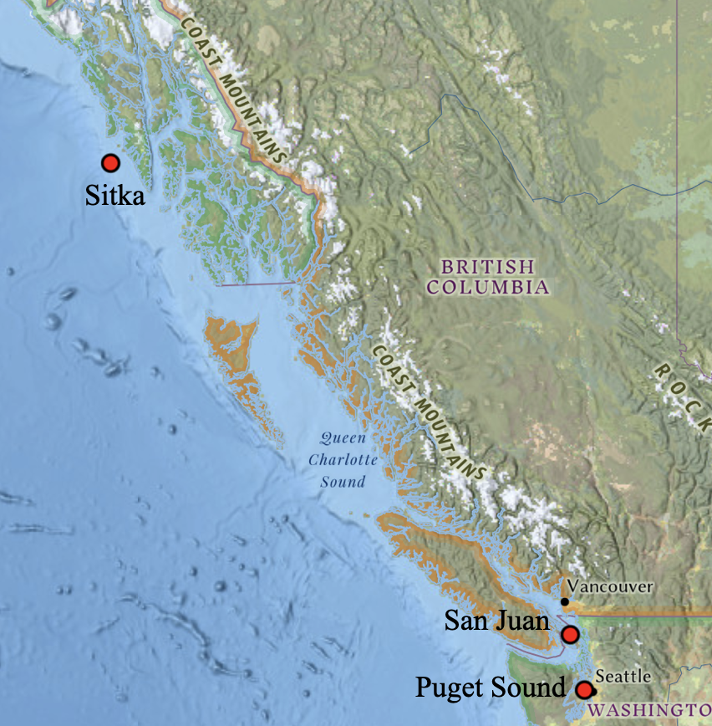
Figure 1. Area of study

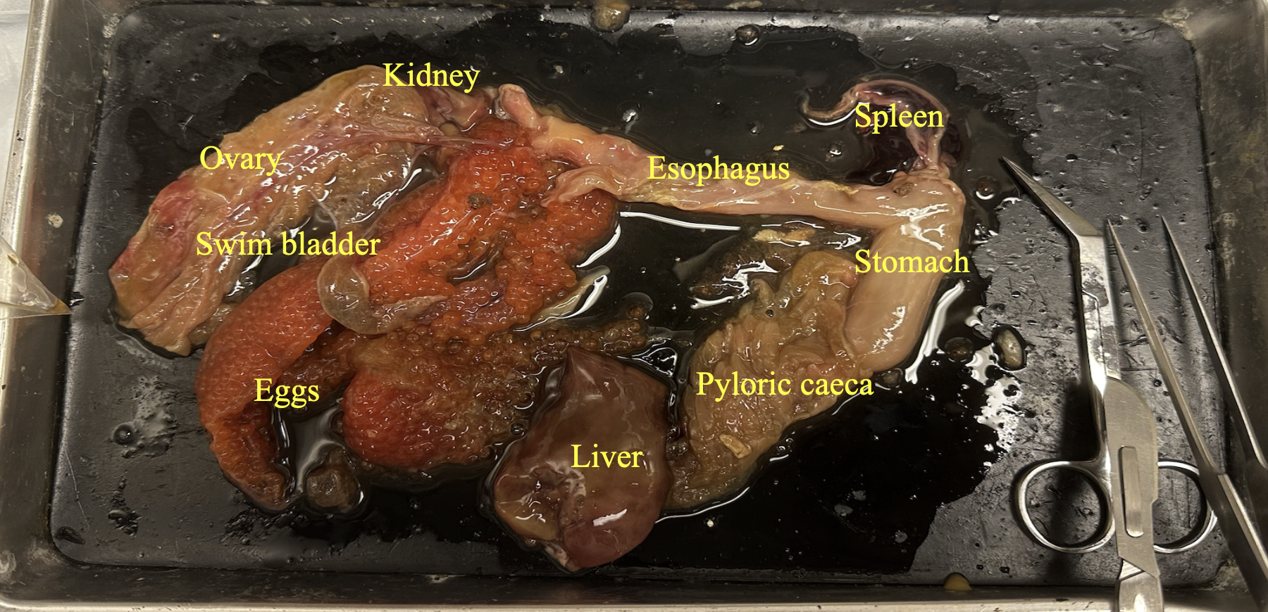
Figure 2. Labeled stomach and digestive tract

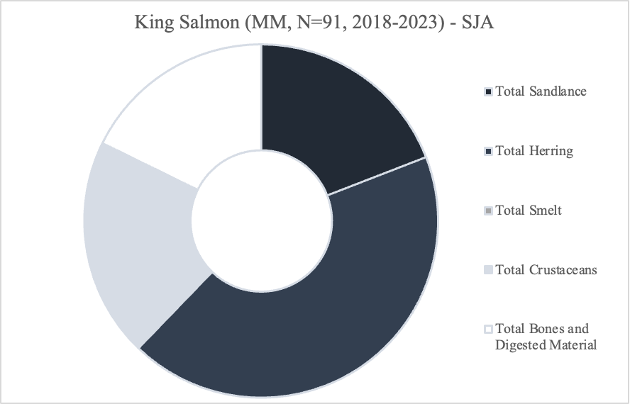
Figure 3. Diet content of king salmon in SJA

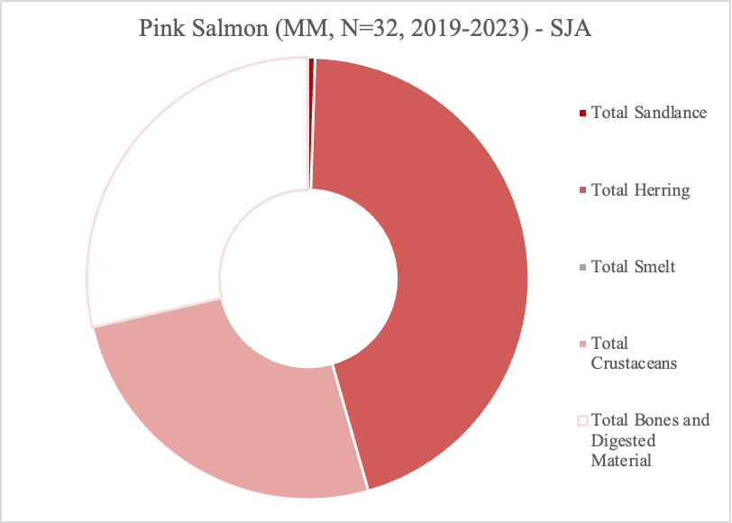
Figure 4. Diet content of pink salmon in SJA (2019-2023)

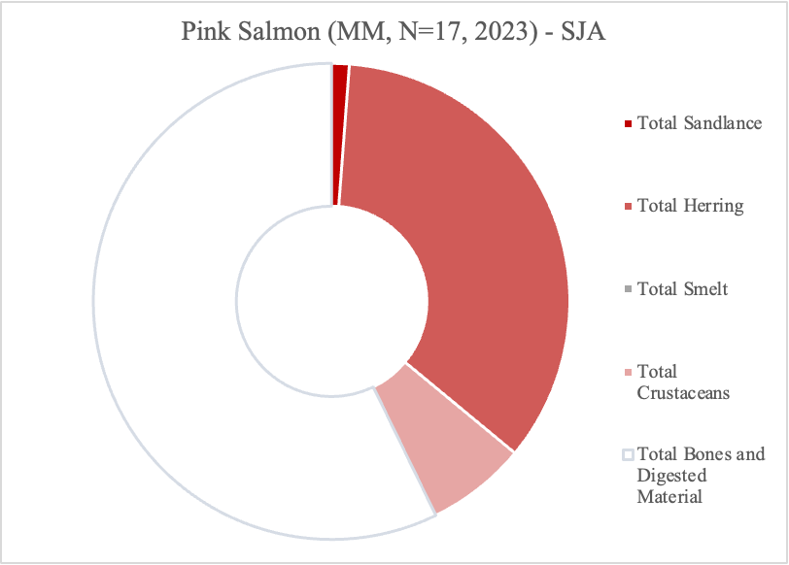
Figure 5. Diet content of pink salmon in SJA (2023)
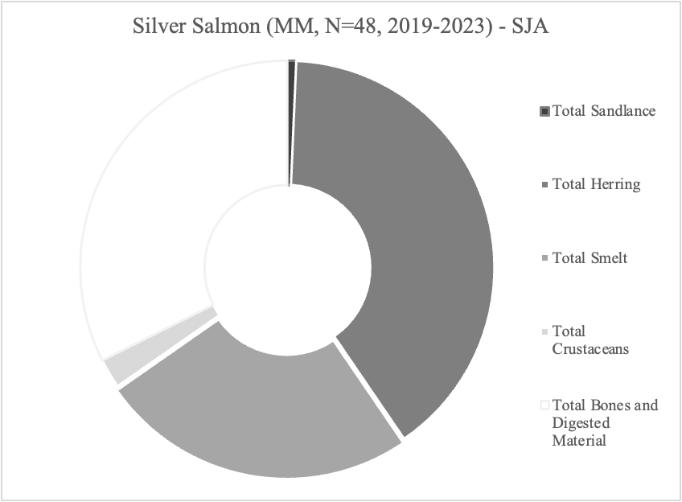
Figure 6. Diet content of silver salmon in SJA (2019-2023)

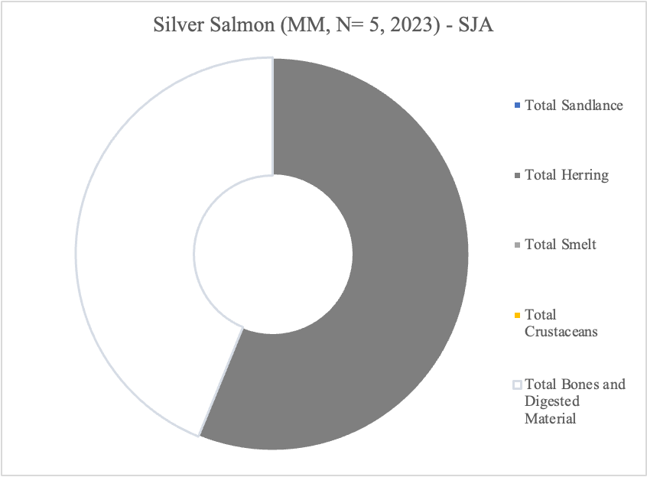
Figure 7. Diet content of silver salmon in SJA (2023)

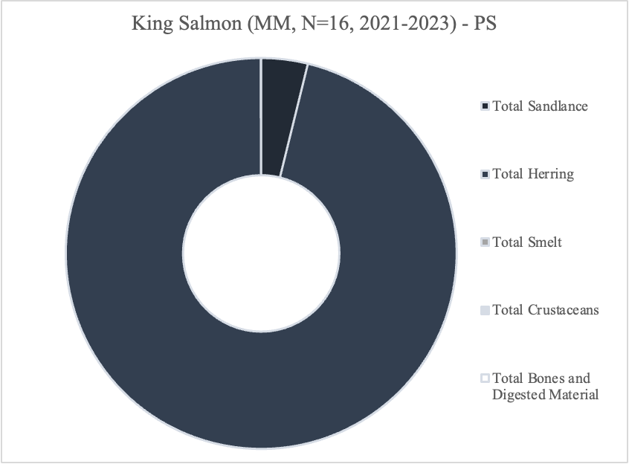
Figure 8. Diet content of king salmon in PS (2021-2023)

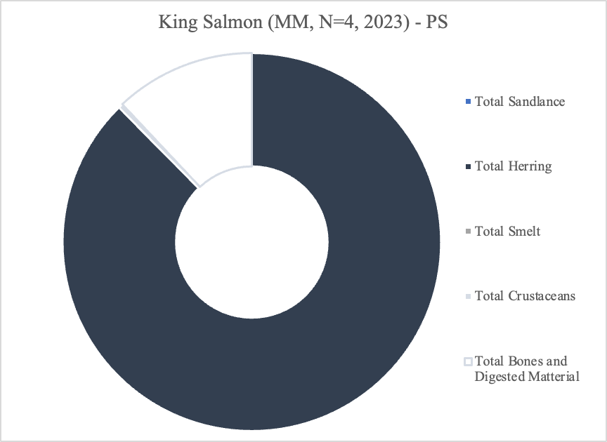
Figure 9. Diet content of king salmon in PS (2023)

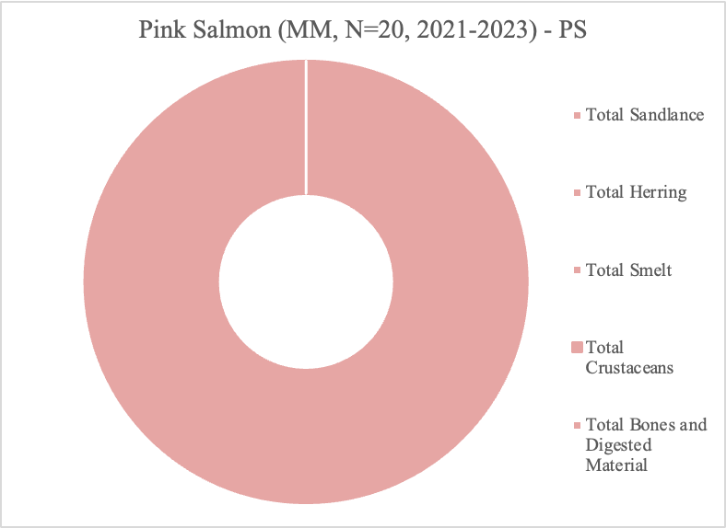
Figure 10. Diet content of pink salmon in PS (2021-2023)

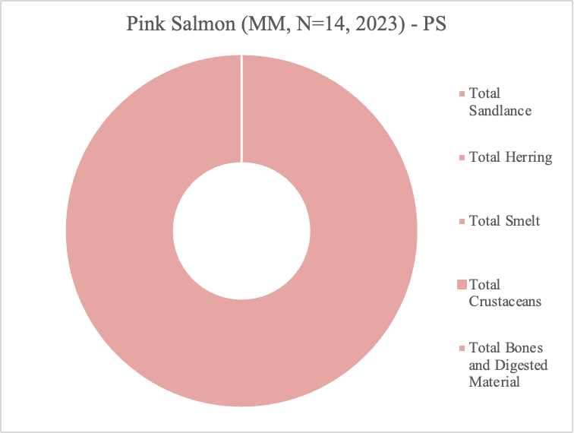
Figure 11. Diet content of pink salmon in PS (2023)
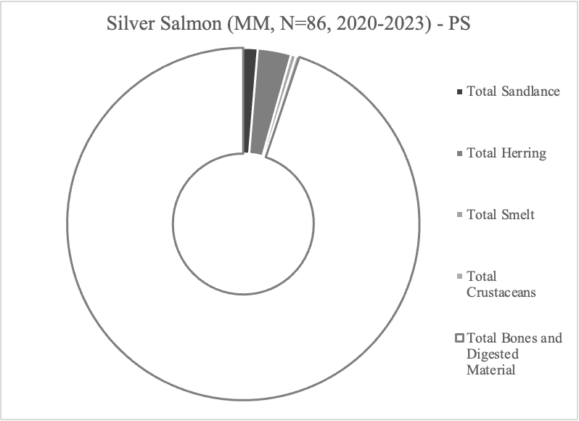
Figure 12. Diet content of silver salmon in PS (2020-2023)

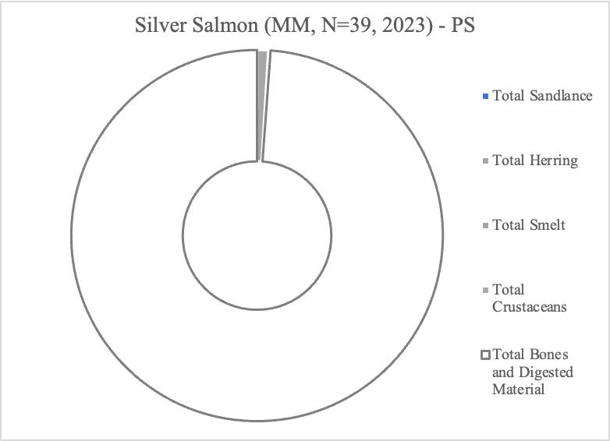
Figure 13. Diet content of silver salmon in PS (2023)

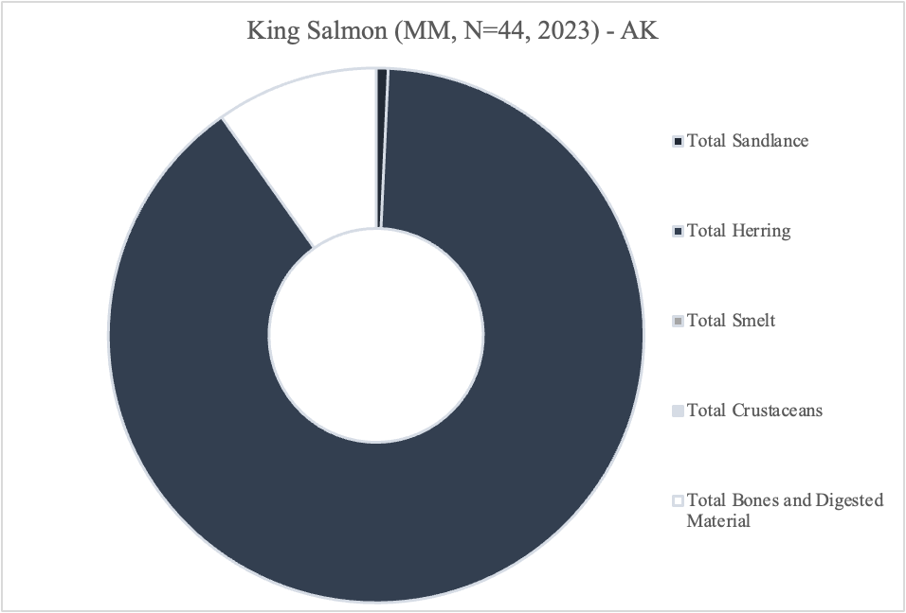
Figure 14. Diet content of king salmon in AK (2023)

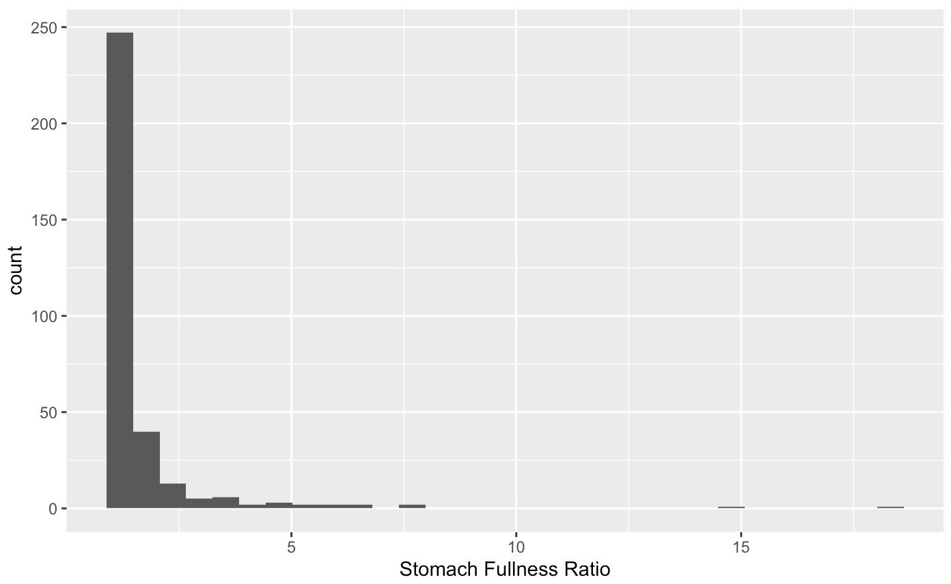
Figure 15. Shapiro-Wilk test for normality

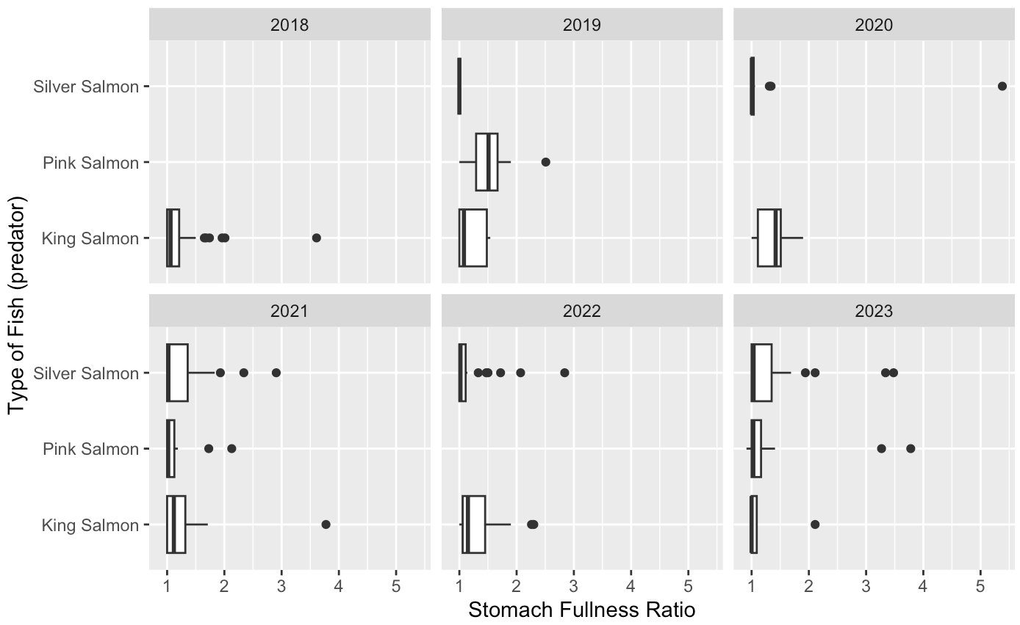
Figure 16. Stomach fullness 2023 in comparison to past years (2018-2023)

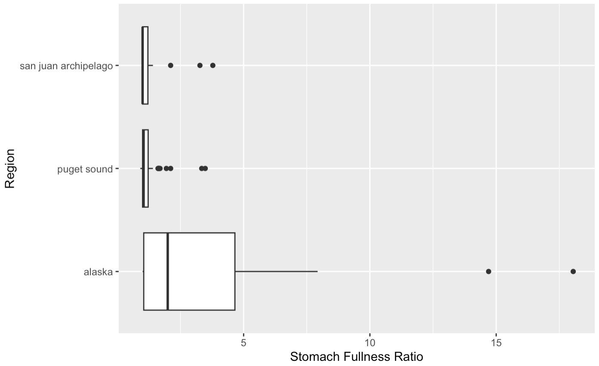
Figure 17. Stomach fullness (2023) regional difference (excluding AK)

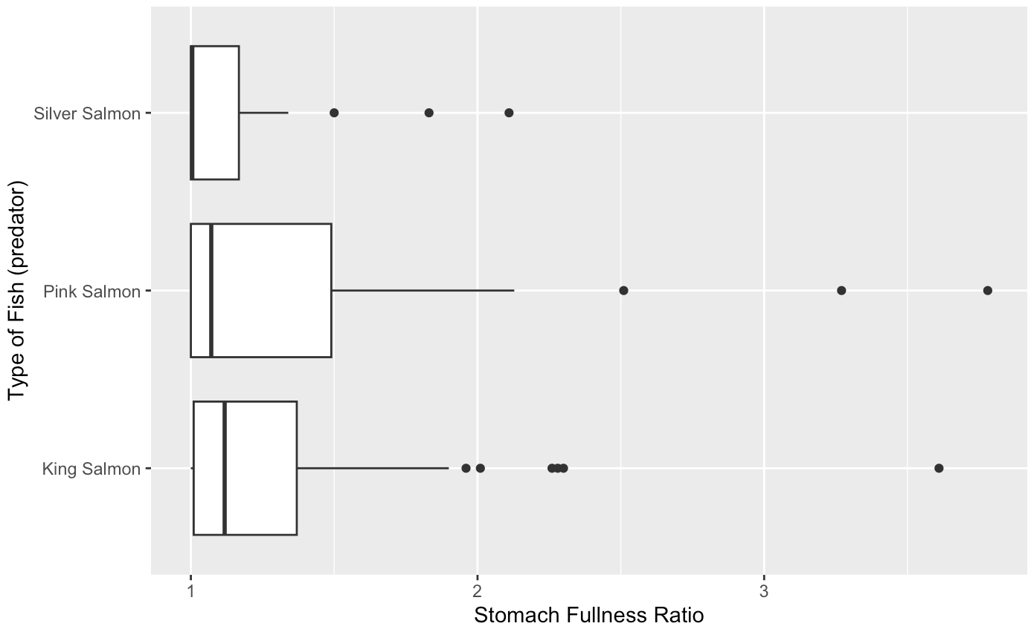
Figure 18. Stomach fullness differences between species in SJA (2018-2023)

Table 1. Kruskal-Wallis rank sum test for stomach fullness ratio by region 2023 (Fig. 17)
Data: | Stomach Fullness Ratio by Region
Kruskal-Wallis chi-squared = 23.639 | df = 2 | P-value = 7.359 x 10⁻⁶

Table 2. Dunn test for stomach fullness ratio by region 2023 (Fig. 17)
Comparison | z | P.unadj | P.adj
AK-PS | 4.3322210 | 1.476201 x 10⁻⁵ | 4.428603 x 10⁻⁵
AK-SJA | 3.888601 | 1.008237 x 10⁻⁴ | 2.016473 x 10⁻⁴
PS-SJA | 0.531038 | 5.953924 x 10⁻¹ | 5.953924 x 10⁻¹

Table 3. Kruskal-Wallis rank sum test for stomach fullness ratio by species of salmon for all years (SJA 2018-2023) (Fig 18)
Data: | Stomach fullness ratio by type of fish (predator)
Kruskal-Wallis chi-squared = 5.517 | df = 2 | P-value = 0.06339

Table 4. Dunn test for stomach fullness ratio by species of salmon for all years (SJA 2018-2023) (Fig 18)
Comparison | Z | P.unadj | P.adj
K-P | 0.4411746 | 0.65908663 | 0.65908663
K-S | 2.3444561 | 0.01905485 | 0.05716455
P-S | 1.6075318 | 0.10793777 | 0.21587553

