Perceptions: a Sociospatial Significance Indicator of Green Space Heather Minnella
University of Washington GIS Certificate Program 2008-2009

Introduction:
To many Americans images of Bald Eagles, Yosemite, Yellow Stone, and the Grand Canyon remind us immediately of our national heritage and excite a strong pride. In England, however, a strong tie to the landscape is lacking. According to Anjana Khatwa (personal communication) of the Jurassic Coast Organization in Dorset County, England, the images that symbolize Britain are of the Queen, cuisine, Stonehenge and other relic buildings, and the flag. However, the English flag of St. George’s Cross inspires a feeling similar to what Americans would feel when the Confederate Flag is flown. This is due to the mass Indian migration to England that occurred after World War II. Many English were not in favor of the new population and would fly the flag of St. George’s Cross in protest to their presence. Along with this came the idea of ‘what it takes to be British’ and being an immigrant was not included in the prerequisites. As a result the community became isolated and along with this lost a national identity. A geographic divide then formed based off privilege and class and this lead to a strong disconnect between the underprivileged and nature (Anjana Khatwa personal communication). The wealthy, predominately white, are able to move out of the cities and into the countryside, which puts them closer to sites of heritage such as the Jurassic Coast, a World Heritage Site, while lower socio-economic classes remain concentrated in large cities, limited by transportation and awareness to get to these areas of high nature value. This lead me to the questions of how race, national identity, wealth, and mobility change perception, appreciation and dedication to conserve and preserve the environment. Using GIS as a means to empower overlooked populations through a participatory GIS approach social capital can be measured. A community’s richness in identity, civic engagement, networks and trust can be measured in what Morrow (2001) calls social capital. It is within this same article that Morrow discusses how “children and young people, who are so often seen as ‘the problem’ in urban and suburban environments… [are] overlooked by the participation process ‘precisely the group whose perceived lack of citizenship causes such concern to many.” Given that there is a subculture of sort within the youth community and with increasing concern for the environment and a changing climate it was decided that for this project I would work with students from the Tacoma School of the Arts (SOTA), a high school located in downtown Tacoma. The intention to see how youth in an urban environment see the worth of areas where they feel connected to nature and how certain factors such as fear, proximity to industry, transportation and quality of land change that perspective.
Specifically I wanted to fined if within the built environment, which areas facilitate the development of a connection between people and nature and how those areas are defined. This is to say if people are immersed in an urban environment with a limited amount of ‘traditional’ green space does their sensitivity to what green space is increase. Another aspect is the concerns about safety and the cleanliness of areas given Tacoma’s negative reputation as being crime laden largely industrial. I wanted to see if there were intersections of areas where there was concern for safety but in areas where there was still a perceived environmental value.
It was decided that a participatory BUGIS (Bottom up GIS) approach to representing environmental perceptions would be used. BUGIS puts an emphasis on projecting perceptions of community members rather than just objective facts and focuses on the incorporation of local knowledge (Talen 2000). A participatory approach to GIS involves input from the community for which the information is gathered, usually by operating the program or having input as to what information is gathered. My approach was to develop a survey that would include both questions and sketch mapping. It was thought that whatever questions asked should be used as a way to classify the participants. Using Schultz and Zelenzy (1999) as a model they identified three distinct values for what they called environmental attitudes those being; egoistic (egocentric), social-altruistic (anthropocentric), and biocentric (ecocentric). Ecocentric attitudes put the individual first while anthropocentric put the race of humans at the center of the issue and ecocentric attitudes put the value of the ecosystem first. It is by defining these and asking questions that describe these viewpoints that people can be classified with ArcGIS. This enables us to see how people think and given other questions and through the sketch maps we can see how they act. Belram (2004) stated that environmental attitude is affected by place location. Therefore, students were asked the questions if they considered their place of origin to be urban, suburban, or rural. Many of the students that attend SOTA are not within Tacoma city limits and therefore a variety of perspectives are available. Bogner and Wiseman (1997) found no difference in perception based on origin, however, participation in green spaces was greater in rural students while a sense of attachment was higher in urban students. On the maps students were asked to indicate approximately where they lived and if they lived outside the city limit they were asked to draw an arrow in the direction to which they to do live.
The basemap for the survey was developed by first finding the addresses of the buildings that SOTA resides in. There are ten buildings across the downtown landscape that the students travel to. These addresses were then geocoded In arc using 40% accuracy and therefore had to be groundtrouthed. After the buildings had been located three orthophotos were imported into the map so that the buildings could be digitized. The digitized layers were saved to a feature class called SOTA_Footprints after which the orthophotos were removed from the map. . A key part to this exercise was that the area to choose from was restricted so that the participants would have overlapping polygons (Balram Dragicevic 2004). The area all the participants have in common is the area around the SOTA campus therefore the first extent chosen was downtown Tacoma. The second extent was the entirety of Tacoma. This was chosen so as to incorporate a finer scale of “home areas” and a more macro scale “city areas”(Balram Dragicevic 2004)..
The map questions were developed based on what Alessa et al. (2008) defined as two forms of mapping; generic feature mapping and specific place mapping. Generic feature mapping allows participants to rank, evaluate or quantify geographic features. That is they would evaluate a specific region and apply values on an arbitrary scale. Specific place mapping allows for participants to indicate an associated value as a description that explains how an area is perceived. For example someone may describe an area as having value because of the feeling of spirituality that is evoked from it.
Four maps were included in the survey, one with the extent of Tacoma and three with the extent of downtown. Map 1 was the Tacoma extent and the specific place map. Along with indicating origin participants were asked to outline areas that they identified as green spaces and then indicate, using a list of descriptive words, attributes associated with these areas. The words given were; place to be avoided, gathering place, art display, opportunity for activities, history and culture, polluted, beautiful landscape, valuable nature site, space and freedom, smelly, peace and tranquility, noisy and other. In addition they also indicated places in Tacoma that discouraged them from spending time in the city, as well as places in Tacoma where they enjoy spending time. The intentions of these questions were to get at a level of attachment. I was trying to see if where value was in the landscape and if it correlated to green spaces. In map 2 participants were asked to outline the areas of Tacoma they would change and spend the most time. In map 3 they were asked to draw the route taken to and from classes and the areas they felt connected to nature. They were then asked to rank them by importance by placing a value from 1-3 beside or inside the areas, 1 being most valuable and 3 being least valuable. The intention of this map was to use the routes to determine a range of perspective of green space. Map 4 was used to indicate areas of safety. Participants were asked to outline areas where they felt safe and unsafe.
With the partnership of the school I was able to administer the survey to three science classes on May 6th 2009 for a total participation of 43 students. Due to a limitation of time for the purpose of this project only Maps 3 and 4 were used. The basic steps to the analysis of the project are to digitize the maps, convert the polylines to polygons, convert the polygons to rasters, reclassify, and use either raster calculator or overlay in the spatial analyst tool bar.
In order to digitize the sketch maps, first pictures were taken. There were 168 total for all four maps. They were then brought into Adobe Photoshop in which as a batch the images were leveled so as to produce the most readable image. The newly leveled maps were brought into arc individually. When creating the basemap the extent at which it was printed was not written down and therefore while digitizing manipulation was needed. This was done by first fixing an approximate extent and then using the “Fit to Display” command in the georeferencing tool bar. The manipulation tools were used to get the map positioned and aligned, there was room for error given that the accuracy of the fit of the maps was not vital. A feature class was created for each question answered on the map. In this case since only two maps were digitized and only two questions were asked on each map, four feature classes were created and set as polylines. The editor tool was then used to trace over the areas. In the attribute table of the new polylines a field was created called ‘Student_Map_ID’ in which the map number was entered. This was done so that later the classifications and map indicators could be visualized. It was at this point that the realization that polylines were not what was needed happened. In order to rasterize the data it needed to be in polygon form. Therefore a tool called geowizard was downloaded from http://www.ian-ko.com/ and the conversion was successful. After all the polygons had been digitized the maps showed clear trends in where people felt connected to nature and unsafe. I then used a GPS unit to collect waypoints that indicated a built or ungroomed open space and natural and groomed points.
Many approaches were taken to complete the steps of converting from polygon to raster and to reclassified raster. In the first attempt a single attribute was highlighted within the polygon table and then within the conversion tool box to raster feature to raster was chosen. A cell size of6 six was chosen. This was successful but in both the connected to nature and unsafe feature classes 10 polygons did not convert over correctly, for an unknown reason. They looked as though the raster had been formed but the extent was divided into two colors one of which was not classified. After attempting to use the raster calculator and Spatial Analyst overlay tools and having errors it was concluded that the rasters needed to be reclassified so that the ‘no data’ field read 0 instead of ‘no data’. Again some of the rasters did not process right. Those that did were processed using the raster calculator. After evaluating the map for connected to nature it I realized that the value range of 1-3, 1 being most valued and 3 least was a bad arrangement and should have been represented in the reverse. This is because when you add them together more value is given to the least valued. This along with the rasters that did not work it was decided to redo the process using a slightly different method. Instead of highlighting each polygon within the one layer the polygons were split using a Hawth’s Vector Editing Tool. This created shapefiles for all the polygons and therefore a batch could be run for the conversion to raster as well as the reclassify. A word of advice, while running a batch in the environments do not set a mask, this increases the processing time exponentially! This process produced all the polygon to raster and reclassified data and was therefore run through the calculator. For the ranked connected to nature polygons the results came up with a value range of 0-20 meaning that the polygons intersected 0 up to 20 times. This gives an indication of areas of repeated value and therefore shows a consensus of perception for where areas are seen as more valued then others. In figure 5 it is indicated by red and orange where this overlap happens most. There is a high concentration along the water which the waypoints also indicate has more groomed, natural points. This map also shows what Alessa et al. (2008) call social-ecological hotspots. These are areas where human interest and value is given to biophysical locations. Identifying these regions within an urban landscape can provide insight into what citizens want and need to remain connected to their environment.
For future studies I would like to carry over into the maps the attribute data from the survey questions to explore more how certain people with different perspectives are acting in the environment. To do this I would like to revamp the survey. It seemed that the Tacoma extent map confused many of the students without any features on it. The question about seasonality did not fit the question that it was asking about and the how to define a forest had more responses in other then an other answer. I would also like to look at demographics as well including gender and possibly race. Extend the survey to different schools with different backgrounds. I would also like to include more then just students to see if there is a difference between generations and how they see green spaces.

Figure 1. Georeferenced connected to Figure 2. Digitized connected to nature
nature sketch map in Arc polygons
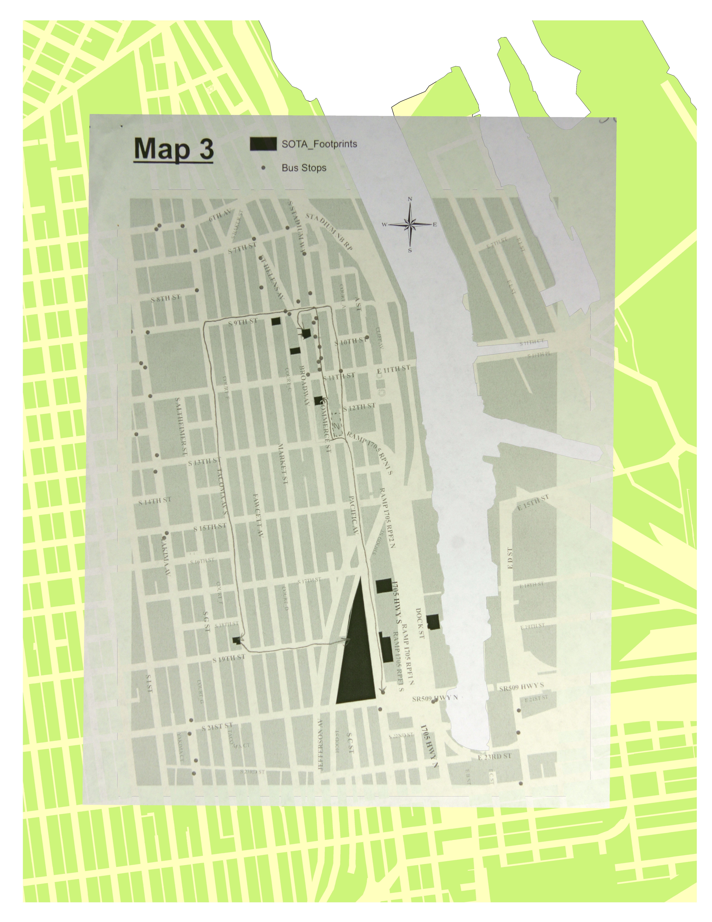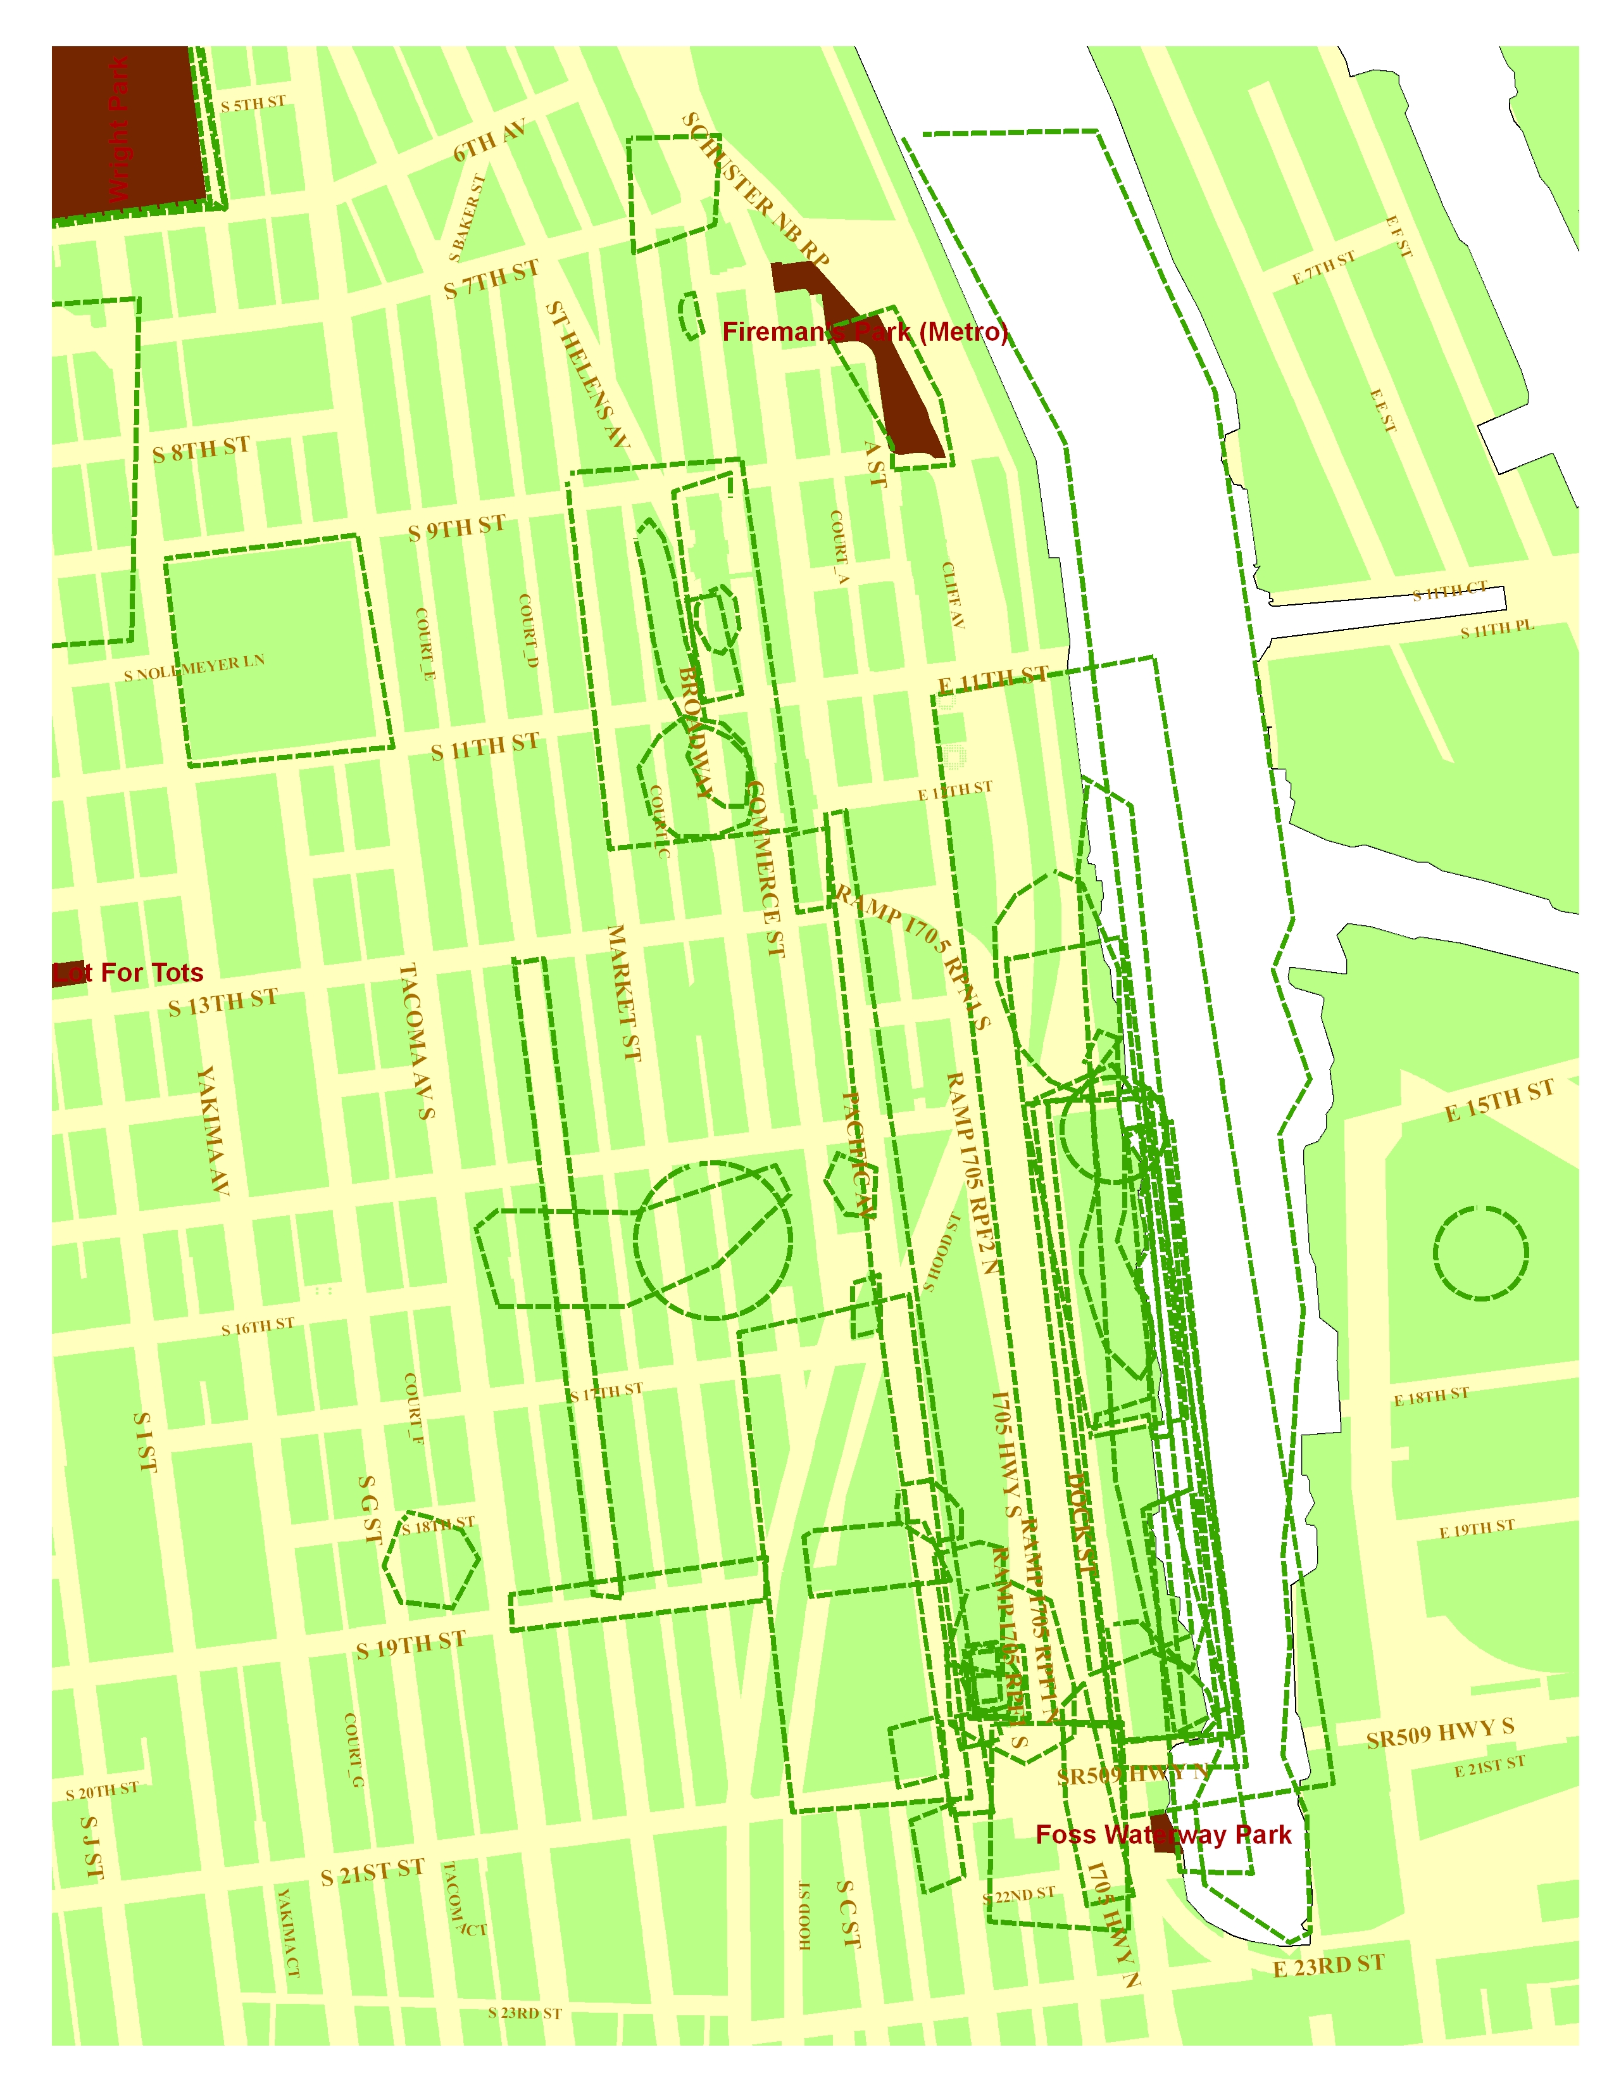
Figure 3. Georeferenced Unsafe sketch Figure 4. Digitized unsafe map
map in Arc polygons
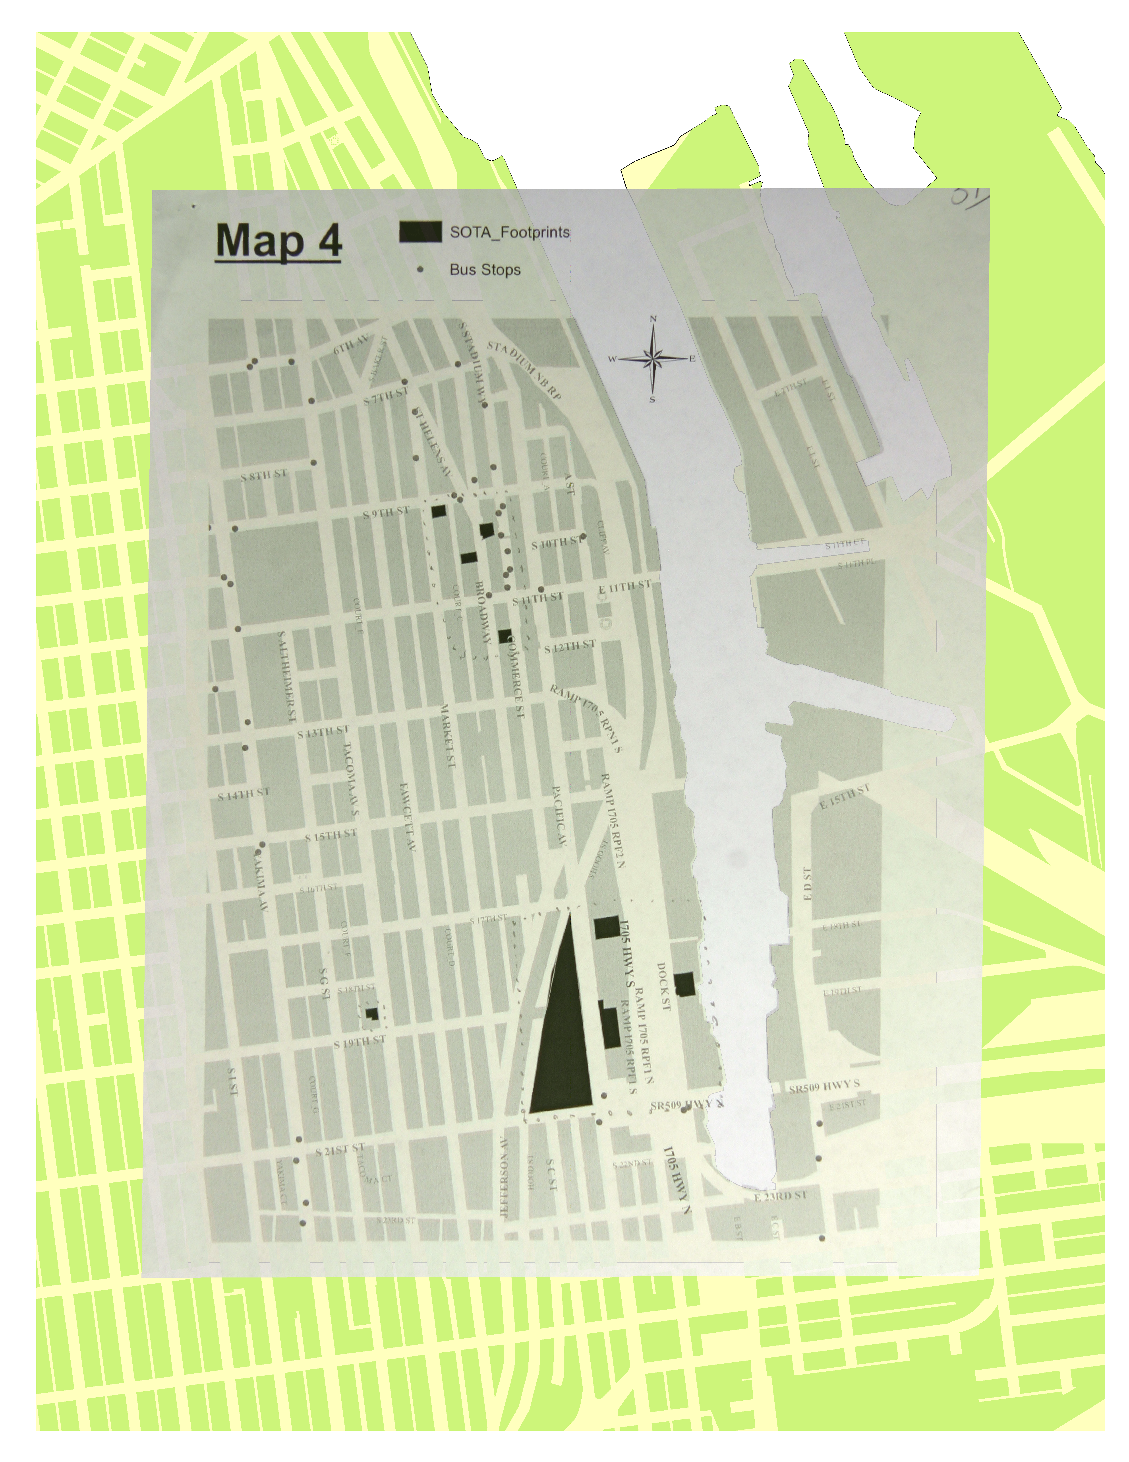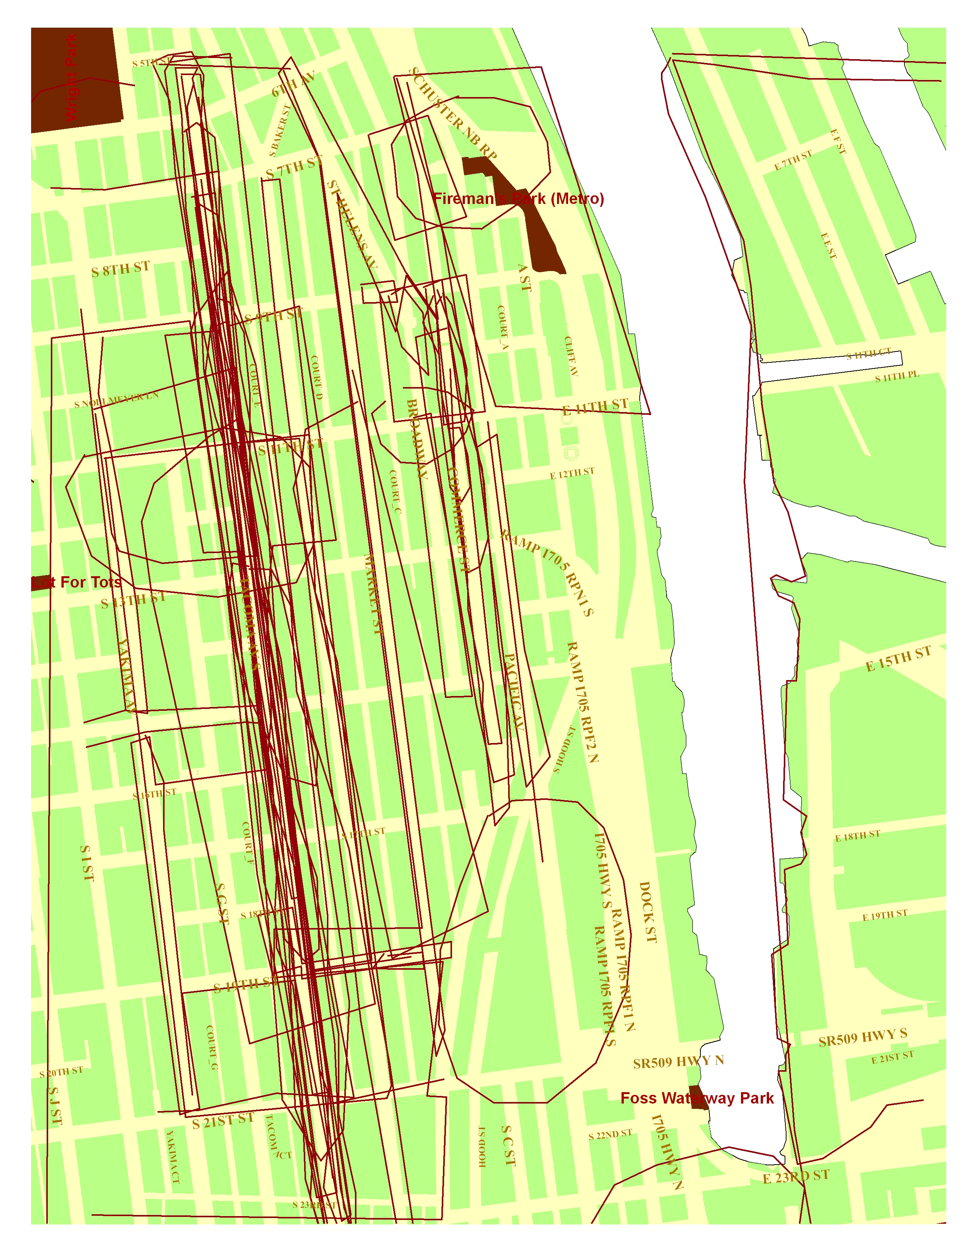
Figure 5. Areas feel connected to nature Figure 6. Areas where feel unsafe
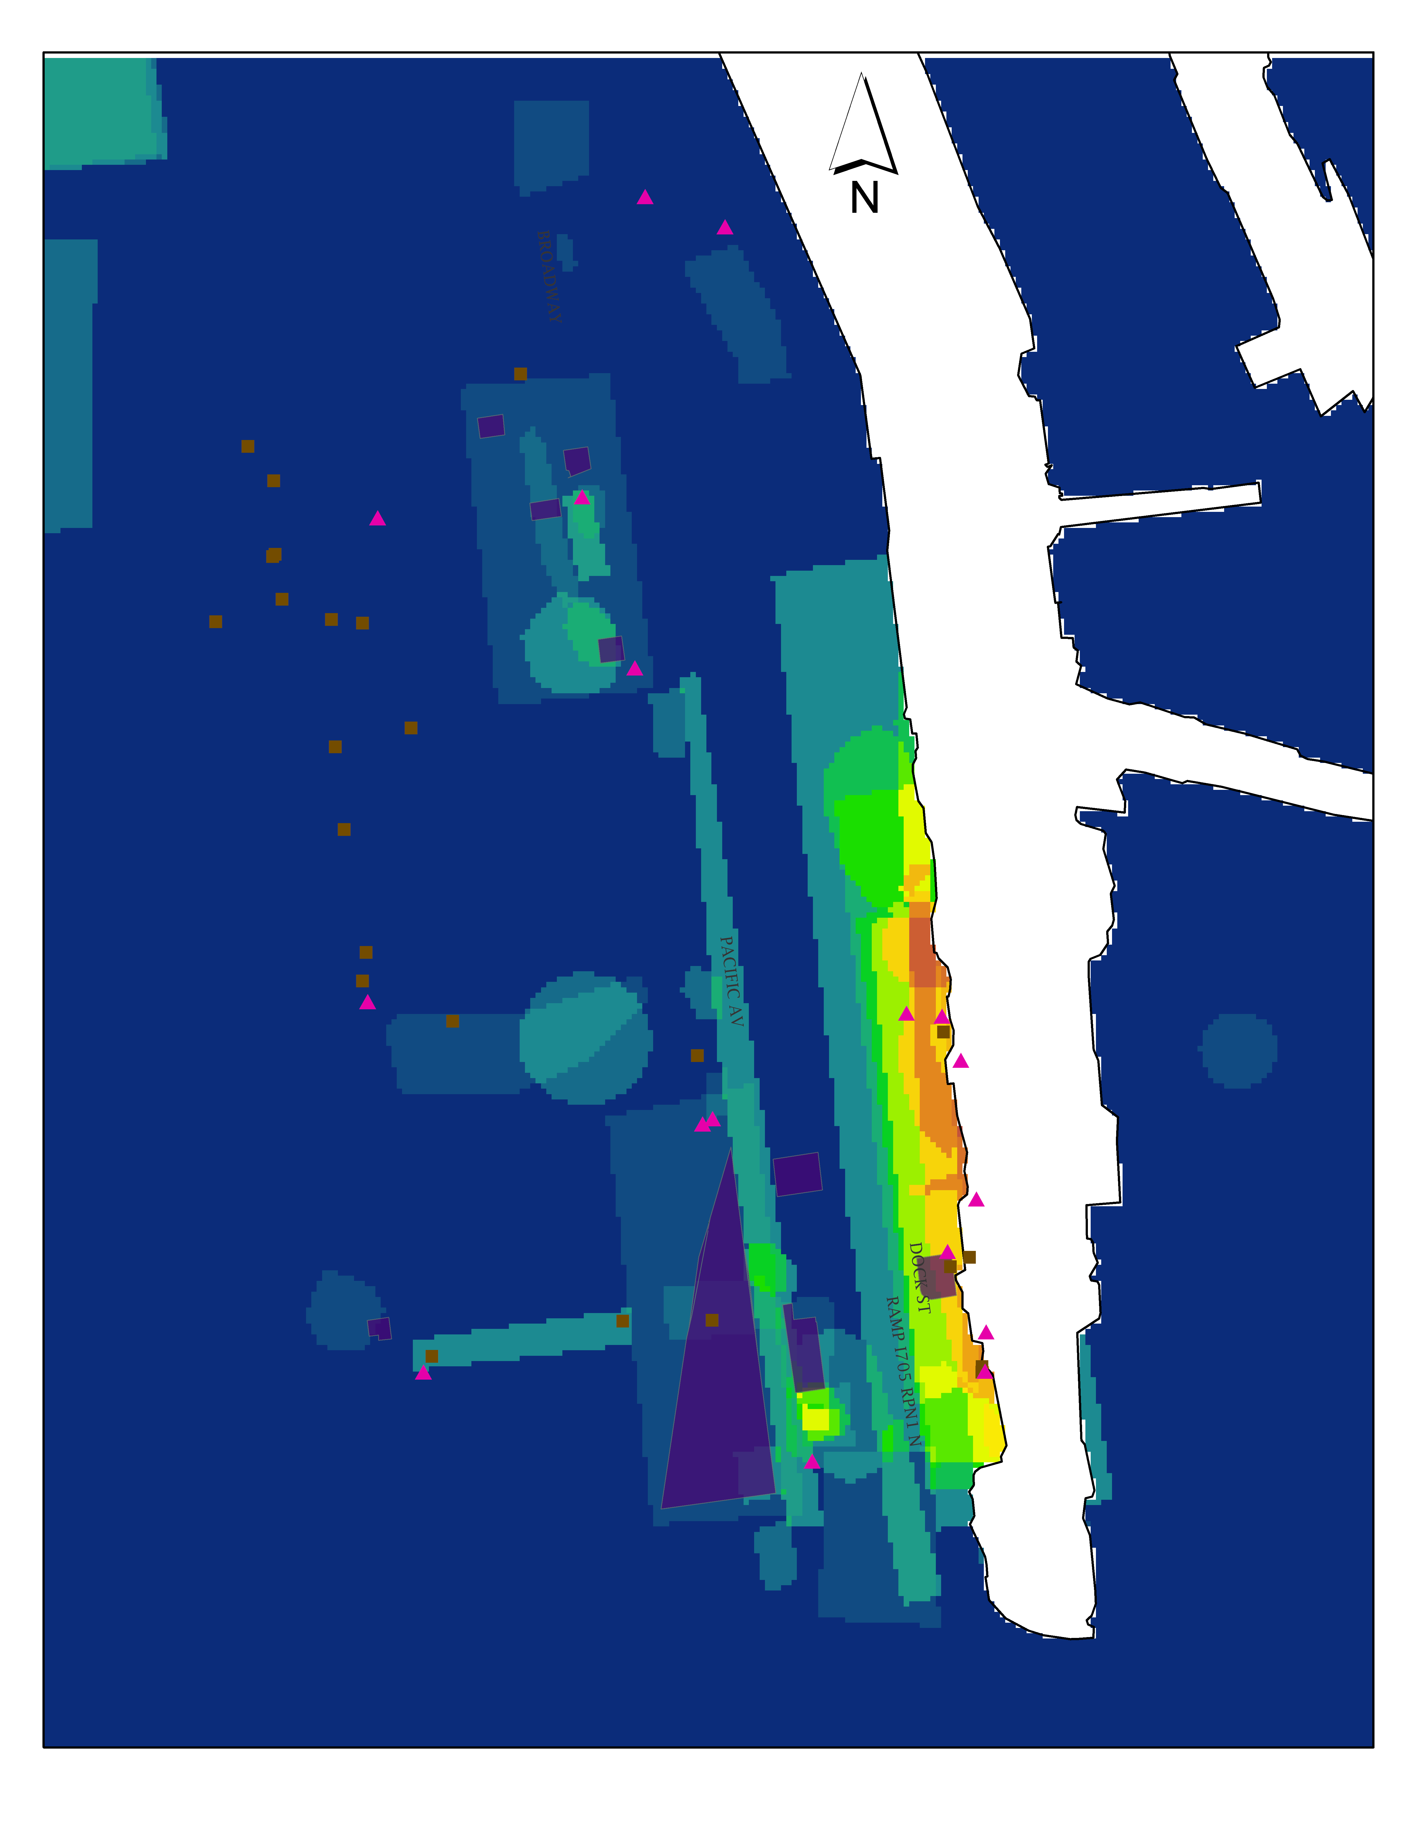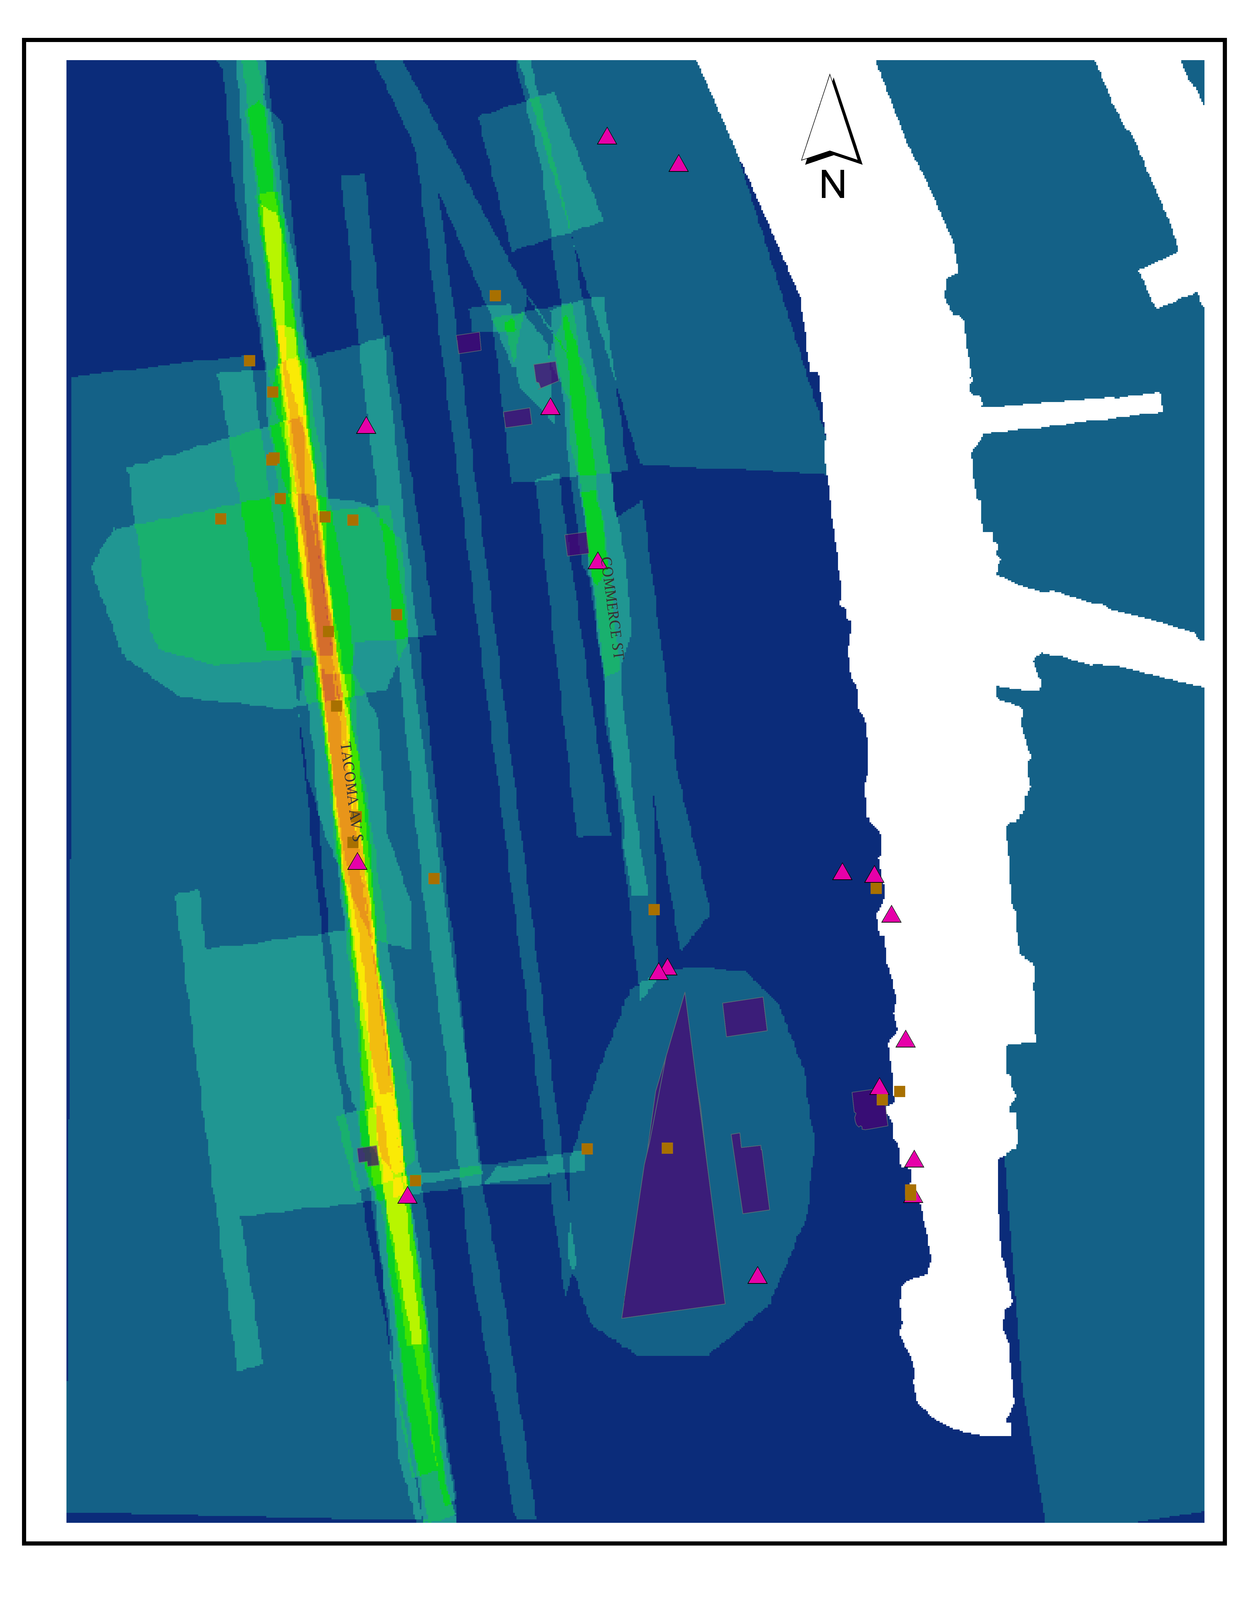

Table 1.
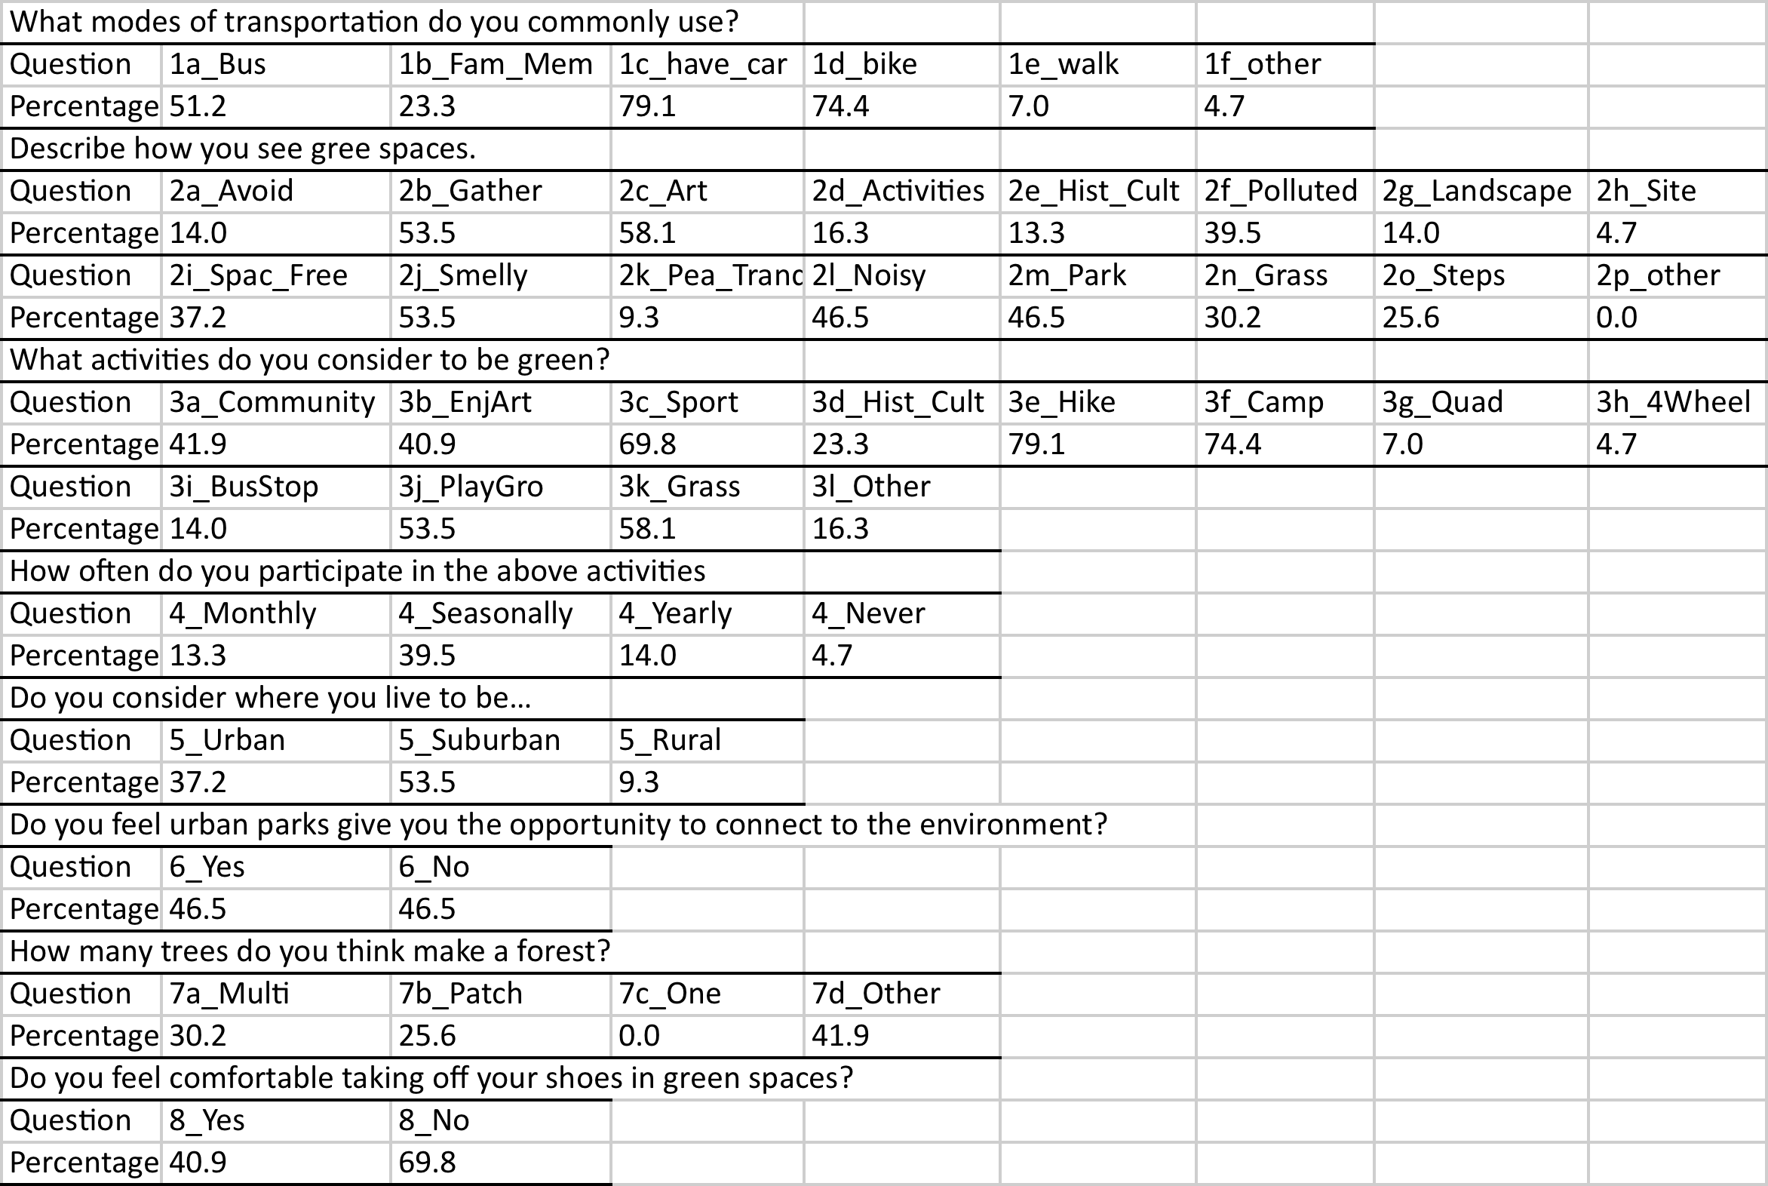
Citations
Alessa, L., A. Kliskey, &G. Brown (2008).Social-ecological hotspots mapping: A spatial
approach for identifying coupled social-ecological space. Landscape and Urban
Planning. 85, 27-29.
Balram, S. & S. Dragicevic (2004).Attitudes toward urban green spaces:
integrating questionnaire survey and collaborative GIS techniques to improve
attitude measurements. Landscape and Urban Planning. 71, 147-162.
Bogner, F.X.& M. Wiseman (1997). Environmental Perception of Rural and Urban
Pupils. Journal of Environmental Psychology. 17, 111-122.
Morrow, V. (2001).Using qualitative methods to elicit young people's perspectives on
their environments: some ideas for community health initiatives. Health Education
Research. 16, 255-268.

Schulz, P.W. & L. Zelenzny (1999).Values as Predictors of Environmental Attitudes:
Evidence for Consistency Across 14 Countries. Journal of Environmental Psychology.
19, 255-265.
Talen, E. (2000).Bottom-up GIS: A new tool for individual and group expression in
participatory planning. Journal of the American Planning Association. 66,
279-294.

