Appendix 3. Stratigraphic columns
The following stratigraphic columns were illustrated from sections measured and described during this study. They include the stratigraphic position that samples of this study were taken, including plant macrofossils, tuffs for radiometric dating, and rock samples for isolation of palynomorphs and phytoliths. They are presented in order of age, from oldest to youngest.

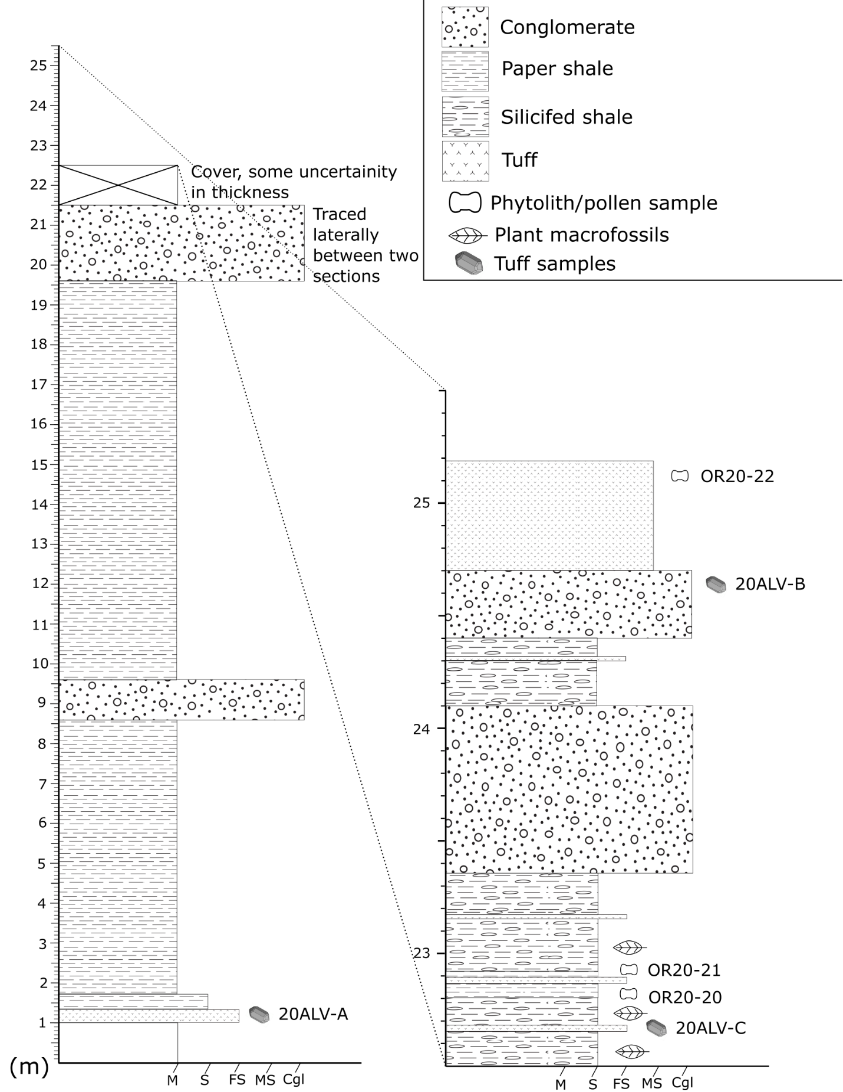
Figure A3.1. Stratigraphic column for the Alvord South Fork sub locality.
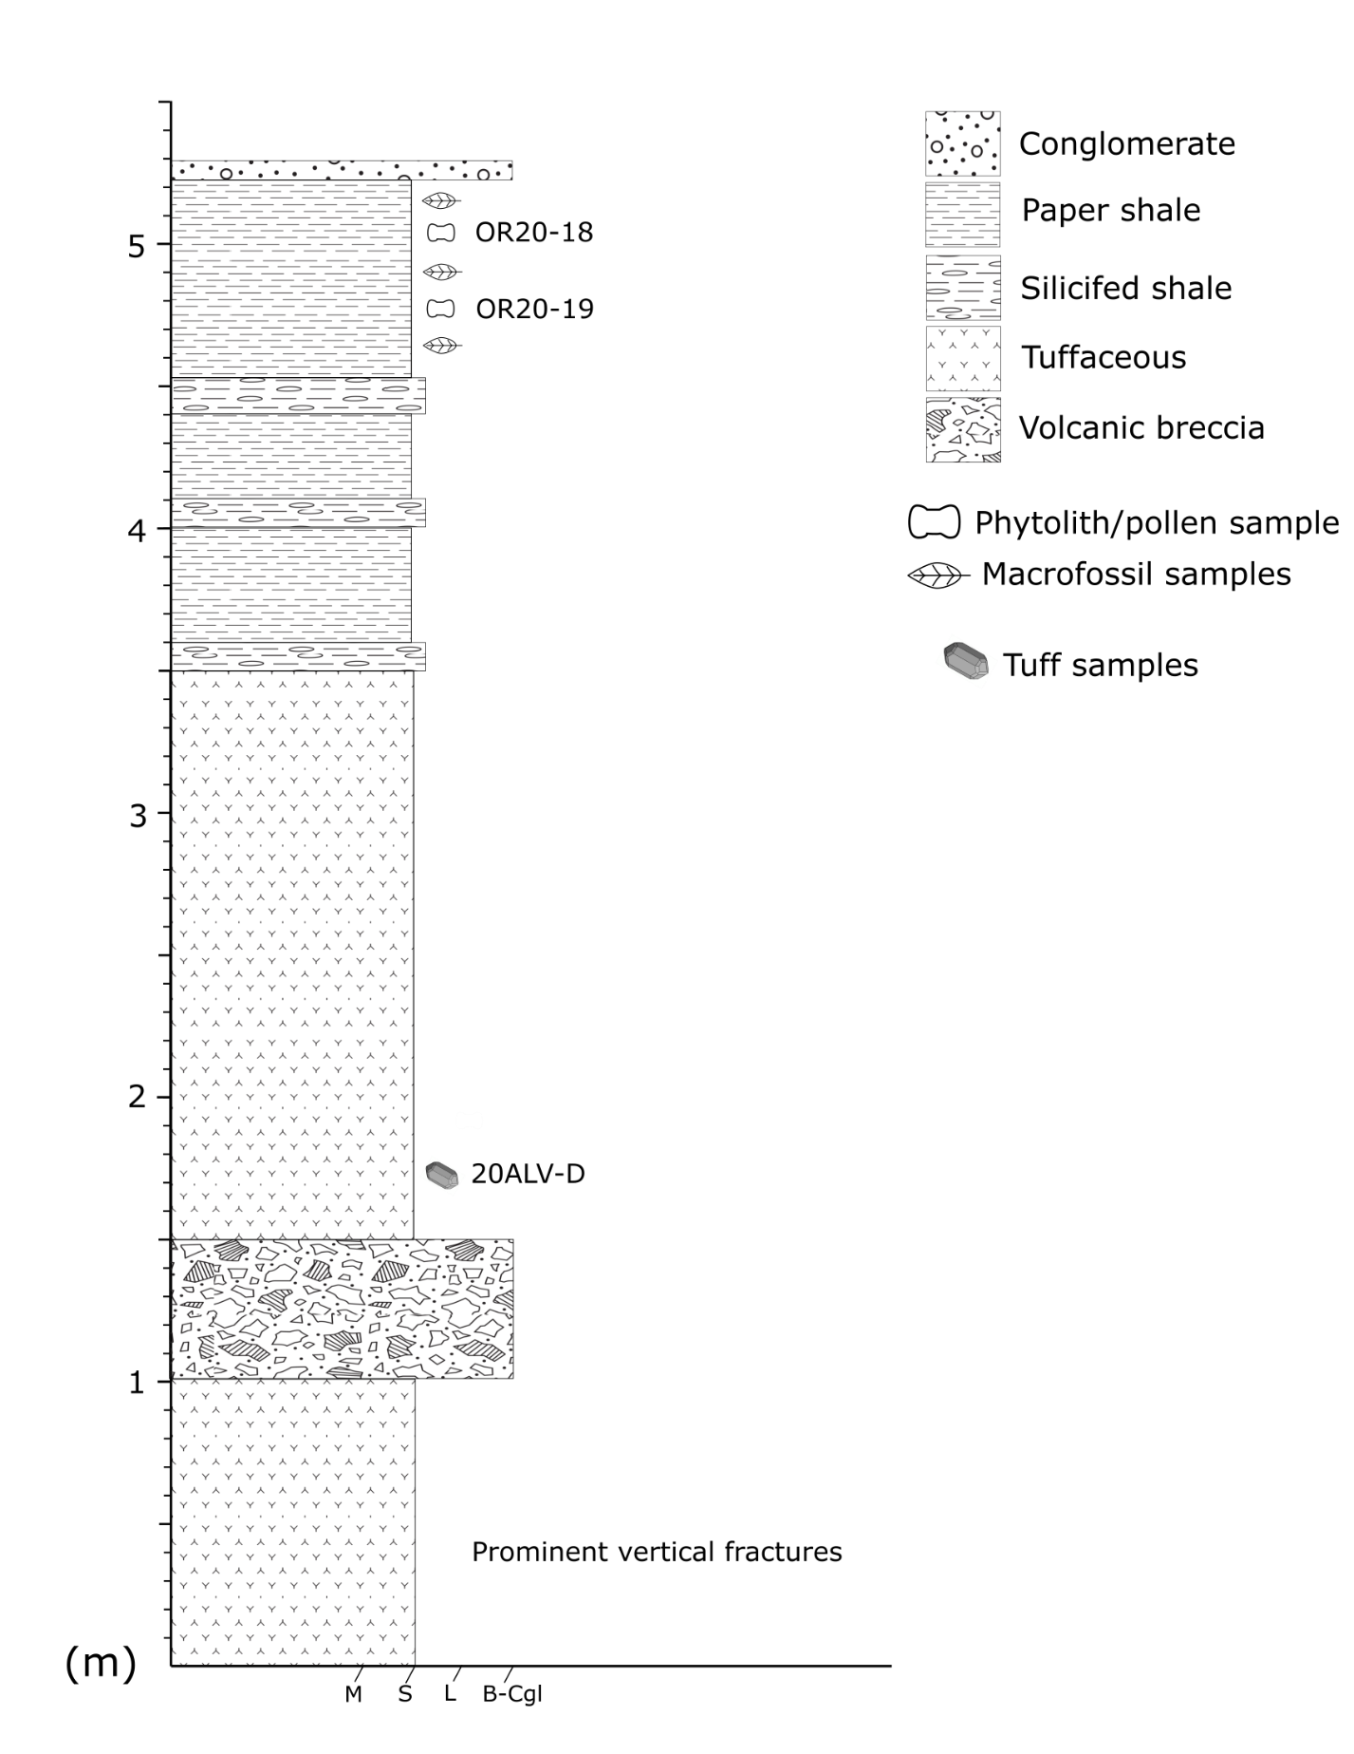
Figure A3.2. Stratigraphic column for the Alvord Scarp sub locality.

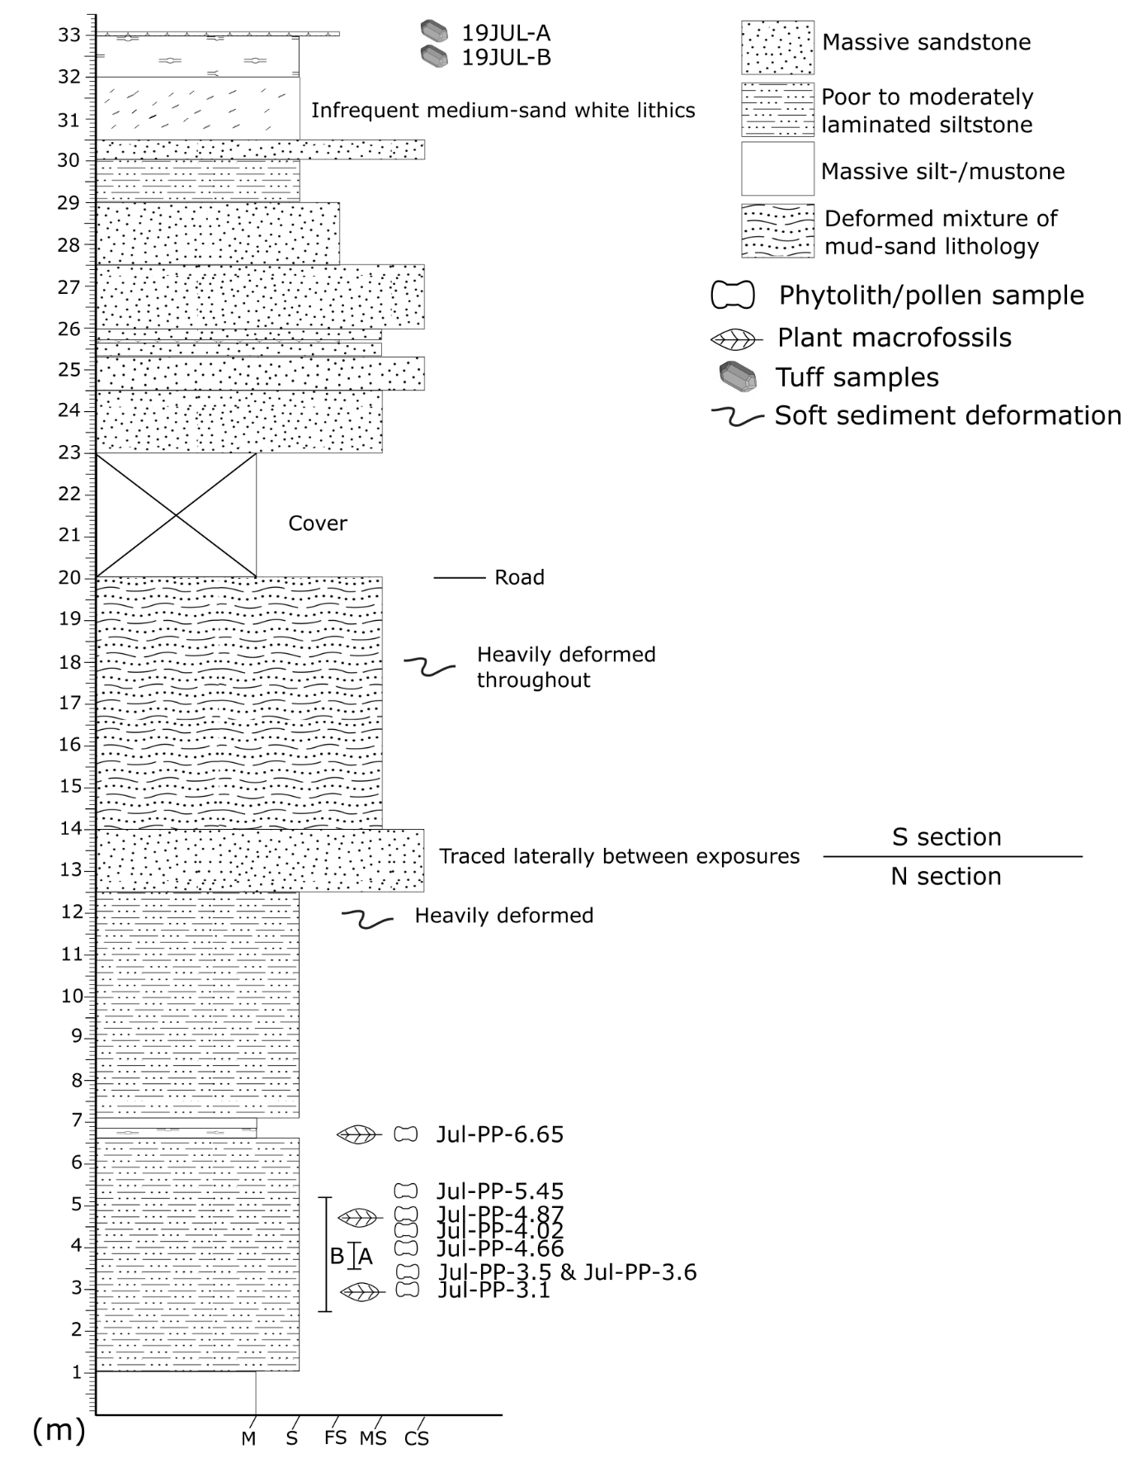
Figure A3.3. Stratigraphic column for Juliaetta. Section begins on the north side of the exposure, ~4.5 m above the ditch next to the road.
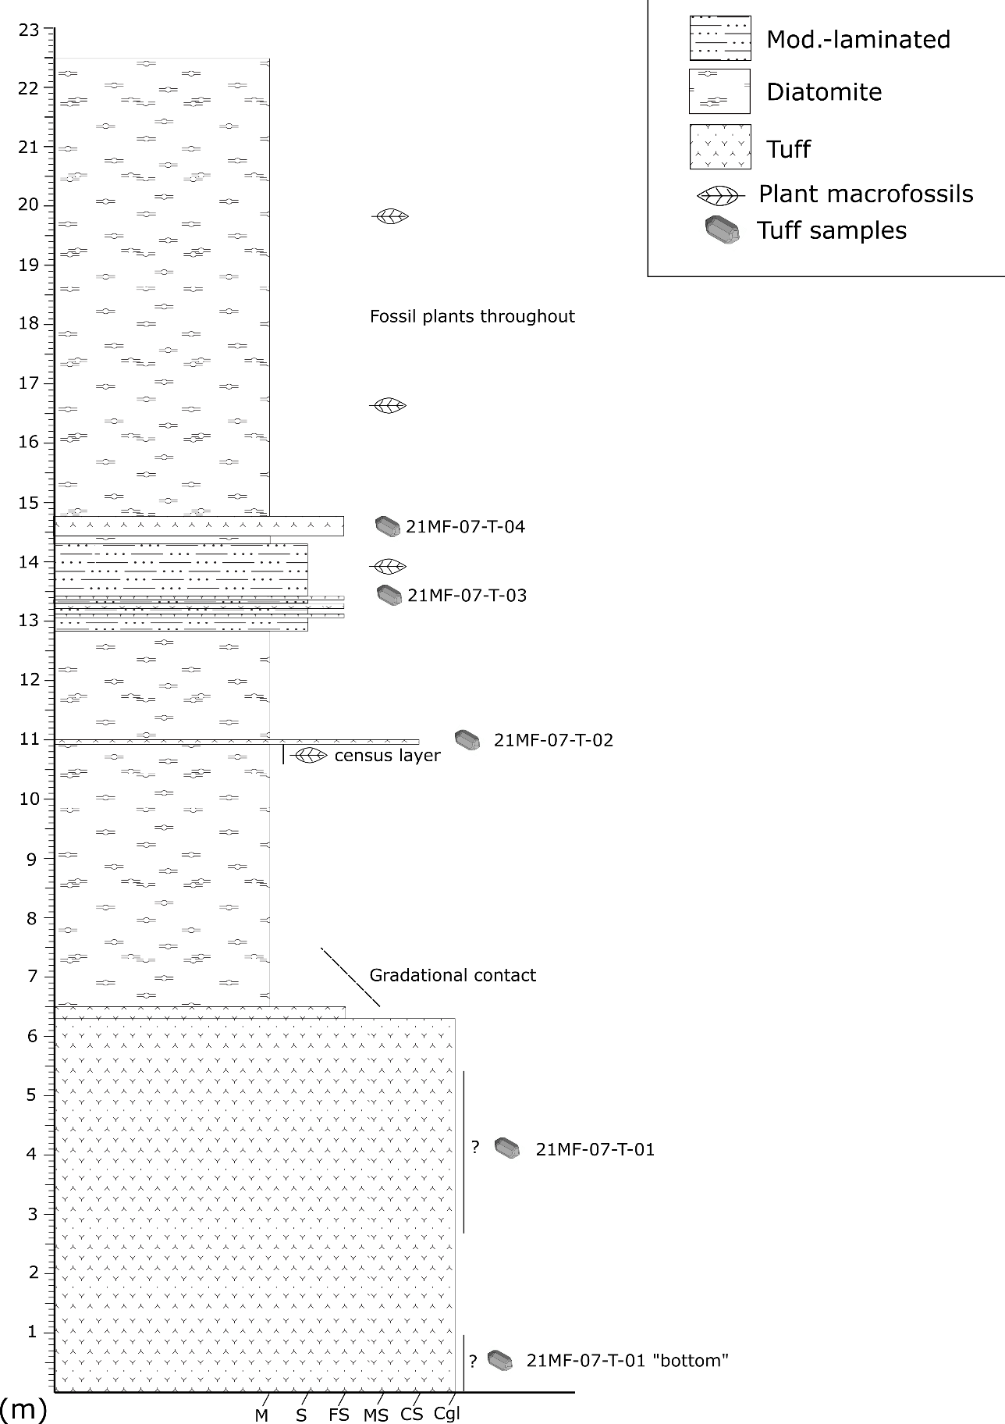
Figure A3.4. Stratigraphic column for the Mascall White Hills sub locality. Section starts at the thick volcanic unit at the base of the hill
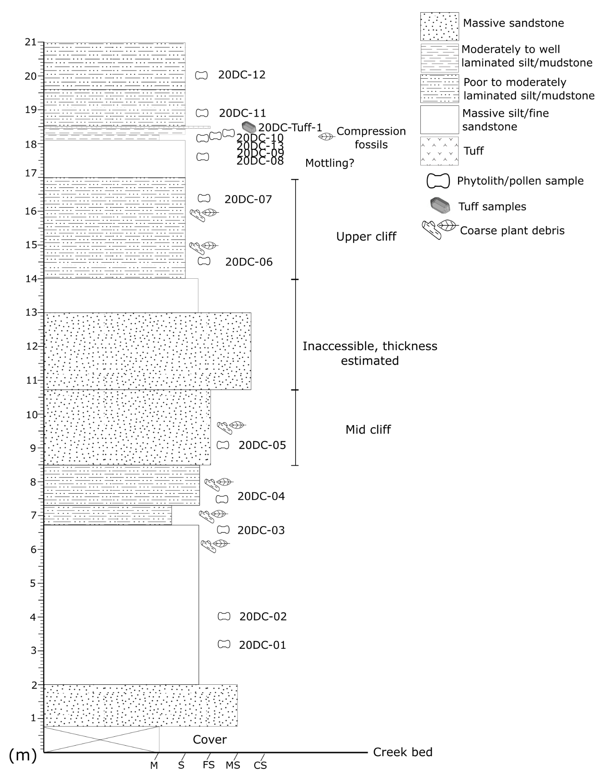
Figure A3.5. Stratigraphic column for the Spokane Deep Creek sub locality. The section starts at the base of the hill at the creek bed level.
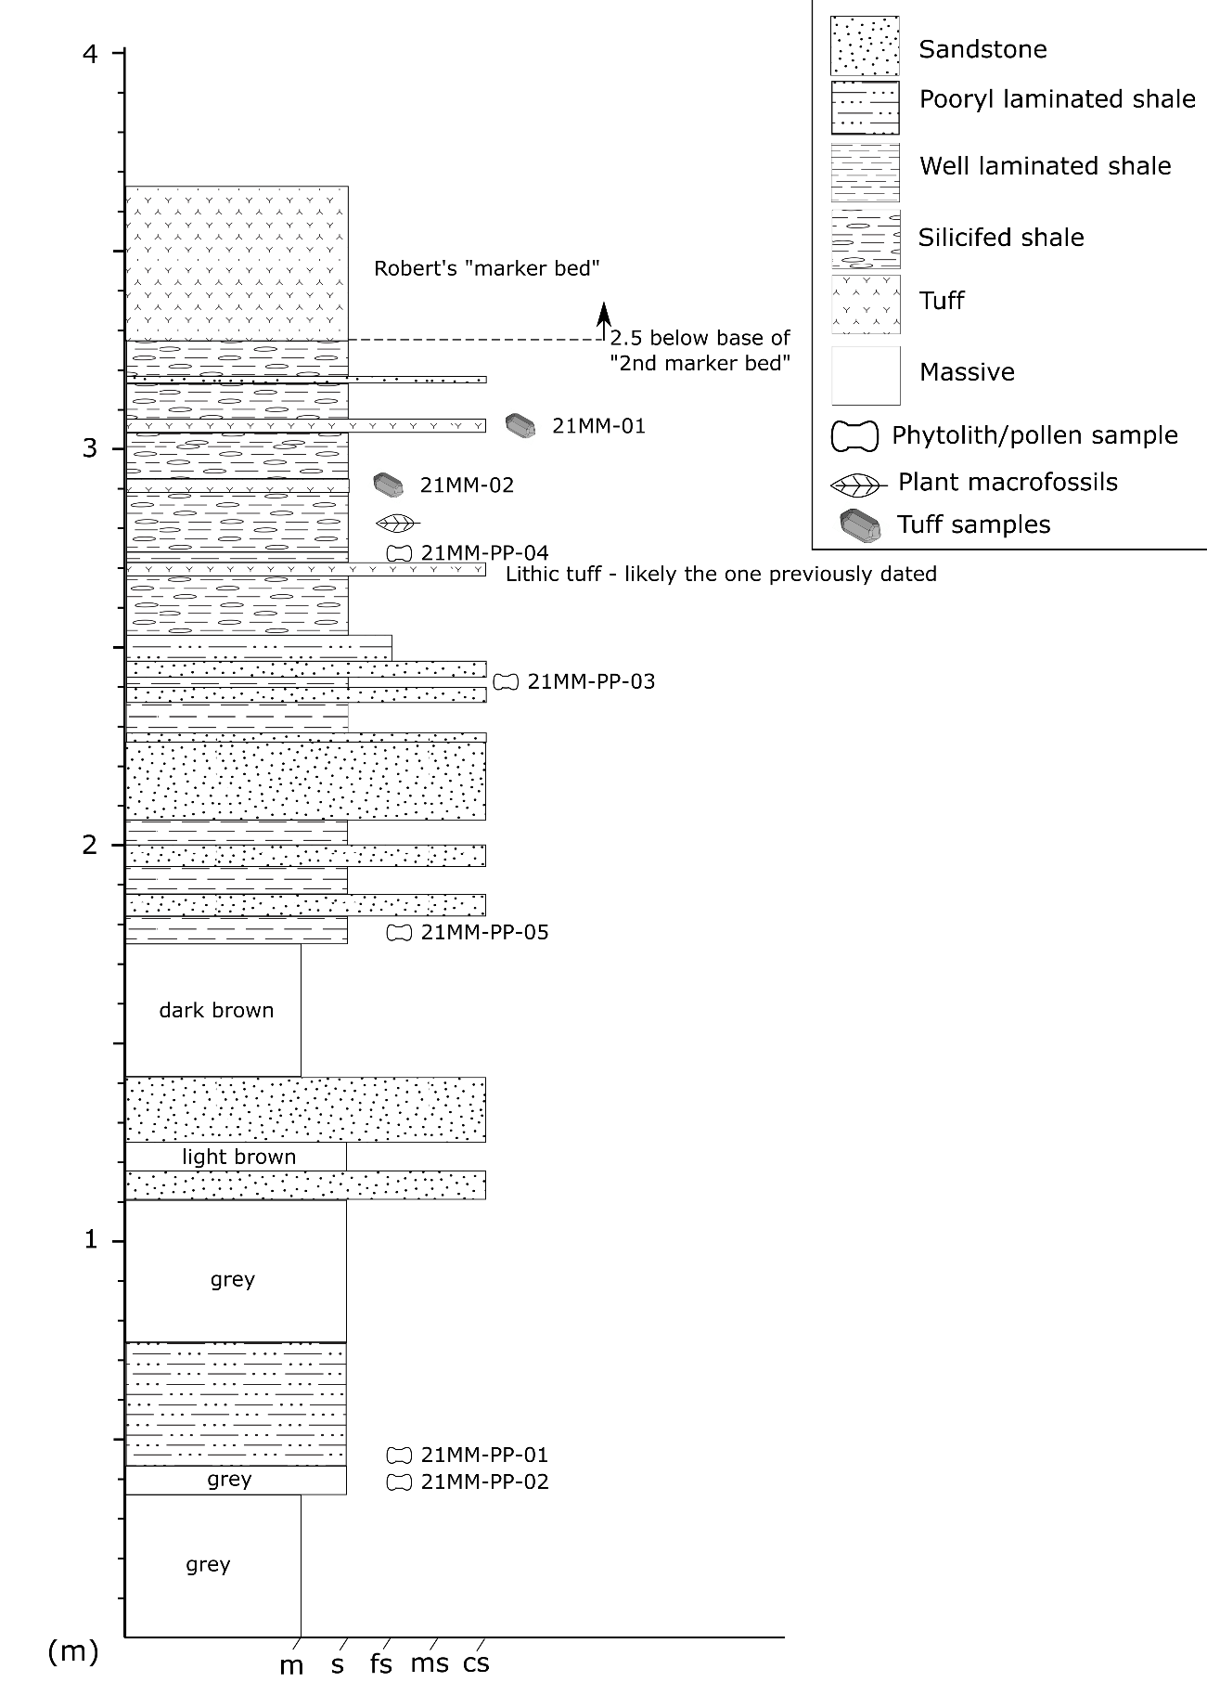
Figure A3.6. Stratigraphic column of the Moose Mountain site. The section starts near the base of the exposure and close to the road level.
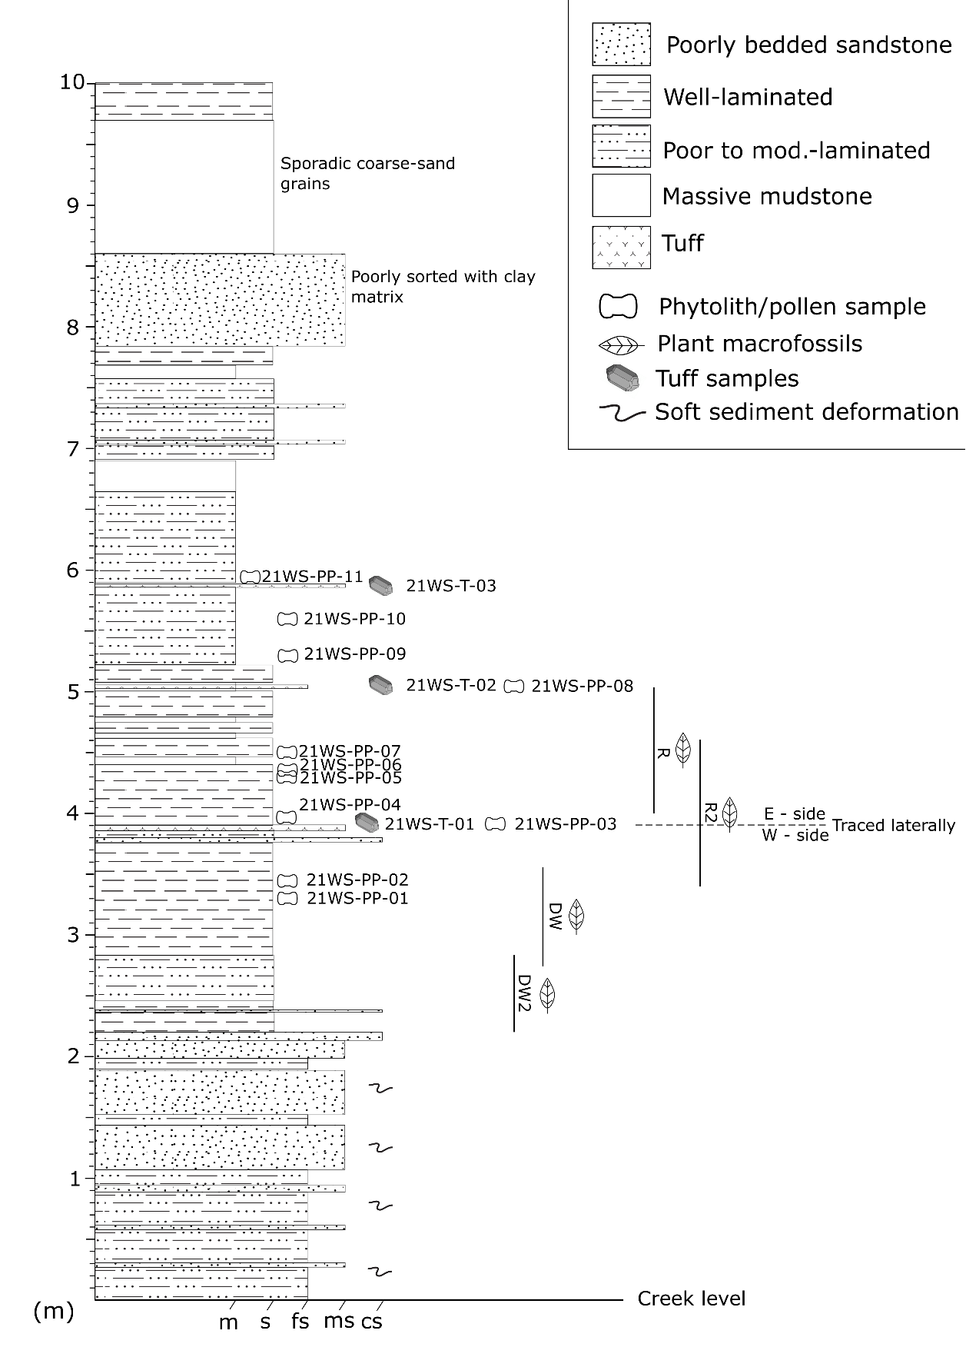
Figure A3.7. Stratigraphic column of the Succor Creek Watersnake sub locality, representing only the lower lacustrine interval (WS Zone 1). The census collection spanned the upper R horizons to the lower DW2 horizons. The section started from the (at the time) creek level.
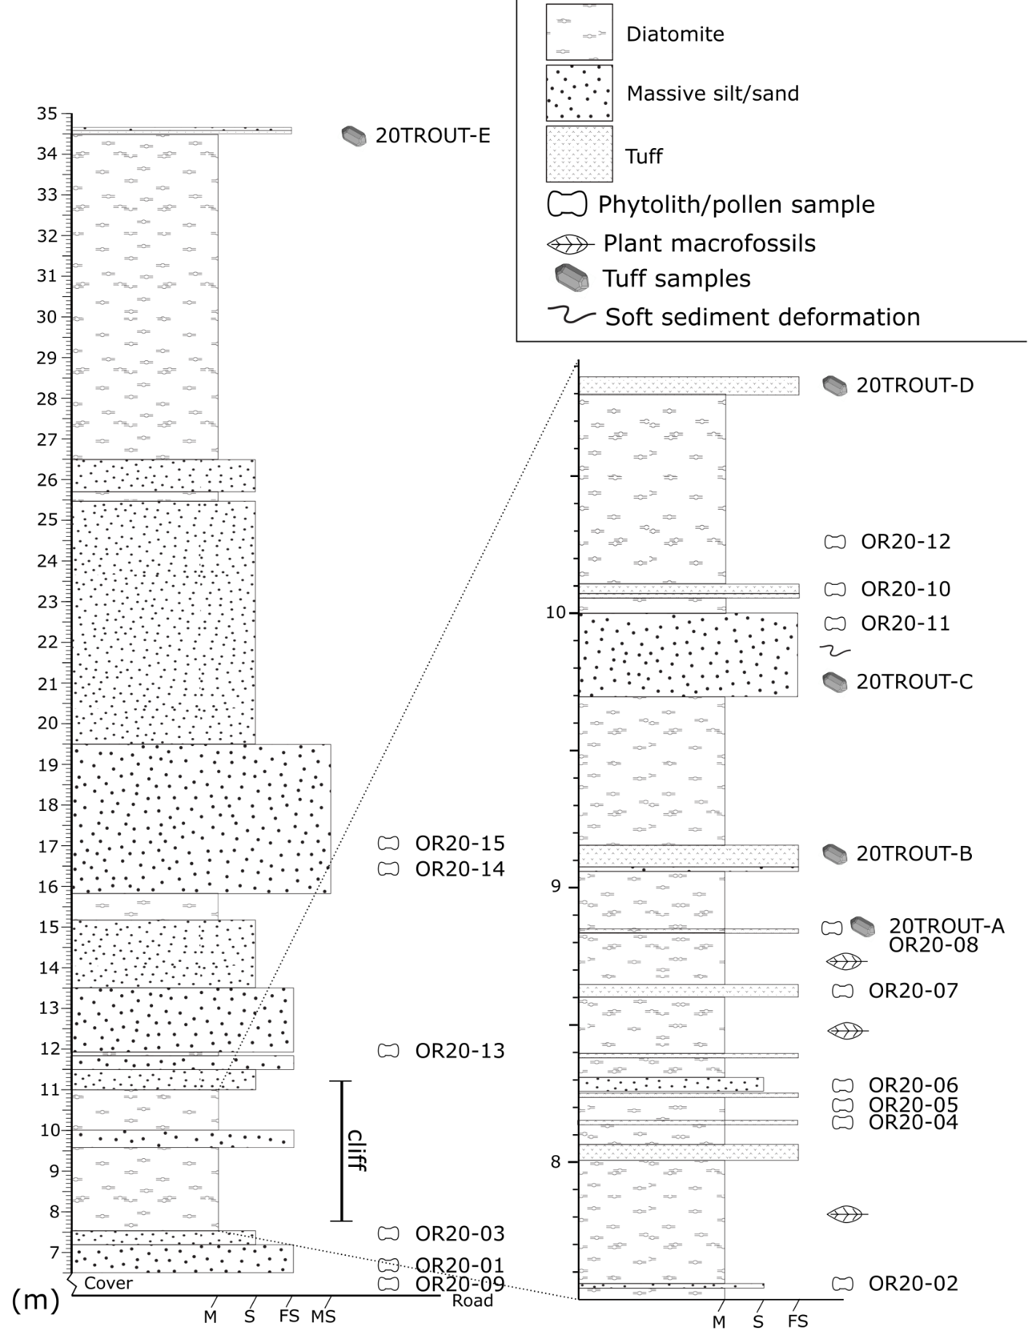
Figure A3.8. Stratigraphic column of the Trout Creek “West Quarry” sub locality. The section starts at the road level at the base of the exposure.
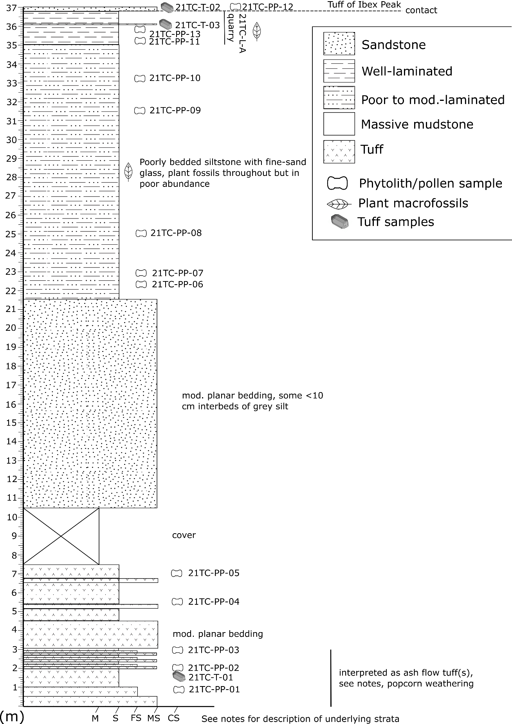
Figure A3.9. Stratigraphic column of the Trapper Creek Western Exposure sub locality. Section begins near the base of the exposure.

