Idotea wosnesenskii distribution and spatial preference in the intertidal areas of the south and east side of San Juan Island

Hanna Zulmuthi
FHL 470: Research in Marine Biology
May 27, 2022
Friday Harbor Labs, University of Washington
- Abstract
Idotea wosnesenskii is one of the common isopod species observed on the rocky shores of San Juan Island. This highly mobile isopod is known to have a wide geographical distribution from intertidal to subtidal areas. It feeds on macroalgae along the shoreline as an herbivore and tends to live on algae like Fucus spp. and under rocks for shelter. While its range of occupation along the intertidal zone is vast, its specific spatial preference remains unclear. We did quadrat sampling of I. wosnesenskii at different intertidal heights, recorded the types of the substrate it occupies, and measured the width of the rock we found I. wosnesenskii under. We hypothesized that I. wosnesenskii would be abundant at high tide areas with large boulders, under a rock with bigger width, and absent of shore crabs. Our findings show that I. wosnesenskii prefers seaweed compared to rocky habitats and tends to be in aggregate under bigger rock width. However, the results of this study do not suggest that intertidal heights and the presence of shore crabs affect I. wosnesenskii distribution.

- Introduction
The intertidal zone may include many different habitats, one of which is rocky shores. Rocky shores are one of the most common littoral habitats (Thompson et al., 2002), depositing large boulders, cobbles, gravel, and sand horizontally and vertically, interspersed with algae and marine invertebrates (Crisp, 1965). The rocky intertidal zone provides vast areas for feeding, resting, spawning, and nursery for mobile marine animals (Thompson et al., 2002). Isopods (Idotea spp.) are one of the mobile species that occupy the intertidal zone and play a central role as grazers in removing epiphytes (Leidenberger et al., 2012); its distribution is known to range from intertidal to subtidal habitats (Salemaa, 1979).
One of the most common Idotea species found on the rocky shores of San Juan Island is Idotea wosnesenskii. They occur primarily amongst algae (Naylor, 1955) and are mainly herbivores that feed on algae. However, they are also said to be potentially omnivorous and feed on decaying animal materials (Kroer, 1986). I. wosnesenskii is found under rocks and boulders, in rock crevices, empty shells, and worm tubes (Orav-Kotta & Kotta, 2004). In addition, this isopod species exhibits high tolerance toward salinity and temperature changes (Brusca, 1961). It can also camouflage with the substrate it stays on and acts as an adaptation in reducing predation (Hultgren & Mittelstaedt, 2015). I. wosnesenskii is a highly adaptive marine isopod, allowing them to occupy a wide range of the intertidal zone.
Despite that, I. wosnesenskii specific spatial preference is still not known. To determine whether I. wosnesenskii have a preferred type and size of substrates, we examined the relationship between the abundance of Idotea wosnesenskii and 1) different types of substrates and 2) the width of the rock we found I. wosnesenskii under. We also looked at the effect of different intertidal heights and the presence of shore crabs on the distribution of I. wosnesenskii. To do this, we used quadrat sampling of I. wosnesenskii at three different intertidal heights. We hypothesized that I. wosnesenskii abundance would be higher at high tide, in areas with many large boulders, under bigger rock width, and absent of shore crabs.

- Methods
  - Study area
Four sites with prevalent rocky shores located on the south and east sides of San Juan Island were sampled: Eagle Cove, Third Lagoon, Cattle Point (south), and Beaverton Cove (east).
  - Sampling-data collection
We spent one day sampling each site during low tide. Starting from the point closest to the lowest tide, three fixed positions (5 m apart) were chosen to represent the low, medium, and high intertidal zone (Fig. 1). We sampled 10 random quadrats (dimension of 50 cm²) along a 15 m transect parallel to the tide (Fig. 1). We searched for I. wosnesenskii underneath pebbles (0.4 cm – 6.4 cm), cobbles (6.4 cm – 25.6 cm), boulders (>25.6 cm), on bedrock, and seaweed contained in the quadrat. The rock sizes are categorized based on the Wentworth scale (Wentworth, 1922). We measured the width using a meter stick for every rock we found I. wosnesenskii under.
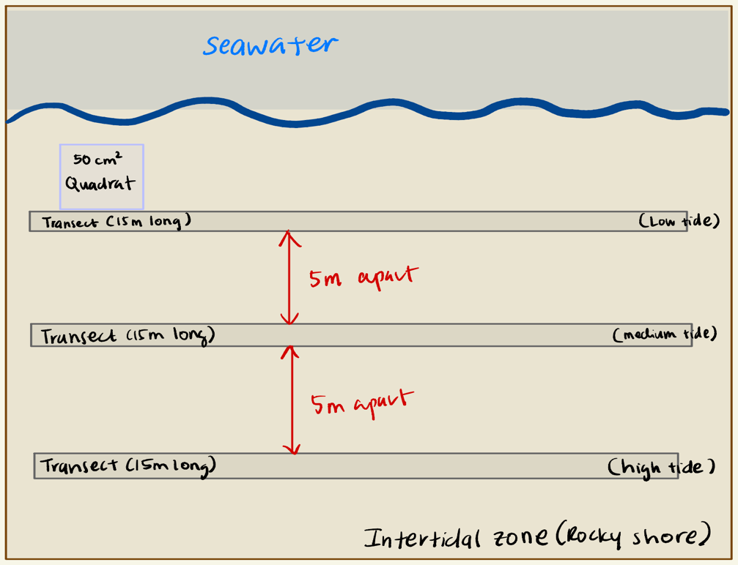
Fig 1. Sketch of the sampling design

  - Data analysis
The distribution of I. wosnesenskii based on the substrate was analyzed using an ANOVA test to determine whether there are statistically significant differences between substrates. The abundance of I. wosnesenskii based on rock width was analyzed using Poisson distribution as the sample count were non-negative integers. Further analysis was done to assess if there were significant differences in the abundance of I. wosnesenskii at different intertidal heights and the presence of shore crabs using the ANOVA test.

- Results
We found no significant association between the abundance of Idotea wosnesenskii and intertidal heights (p>0.05, ANOVA test, Fig. 2A). The data shows a large variation of I. wosnesenskii abundance at low, medium, and high tides.
We examined the relationship between I. wosnesenskii and different substrates and found a significant association (p<0.05, Fig. 2B). I. wosnesenskii is the most abundant in seaweed than the rocky habitat, with the highest total count of 53. However, focusing on the rocky habitat, I. wosnesenskii occurs the most in cobbles, followed by boulders and bedrock. Pebbles have the lowest I. wosnesenskii count of 2.
The data also show that I. wosnesenskii abundance has no significant association with the presence of shore crabs (p>0.05, ANOVA test, Fig. 2C). However, the abundance of I. wosnesenskii is more varied in the absence of shore crabs than when shore crabs are present. The presence of shore crabs may affect the abundance of I. wosnesenskii, but there is not enough data to further test the relationship since the number of shore crabs present was not collected.
We found that the abundance of I. wosnesenskii had a significant association with rock width (p<0.05, Poisson regression, Fig. 2D). Although there is variation in the data, a clear pattern could be seen where I. wosnesenskii tend to be in aggregate under larger rock width and solitary under smaller rock width.
Fig 2. Isopod (I. wosnesenskii) count according to (A) intertidal heights, (B) substrate, (C) presence of shore crabs, and (D) rock width.

- Discussion
Our results demonstrate that Idotea wosnesenskii is widely distributed in the intertidal zone with no spatial preference based on different intertidal heights. We propose that this is likely because I. wosnesenskii is highly adaptable with its ability to background match to reduce predation (Hultgren & Mittelstaedt, 2015) and thus can settle on any area in the intertidal zone as long as the habitat can provide either food, shelter or both (Orav-Kotta & Kotta, 2004). Our method of categorizing the low, medium, and high tide could also affect our results as the transects were laid 5 m apart. The distance might not be significant enough to show differences in I. wosnesenskii abundance between different intertidal heights.
The abundance of Idotea wosnesenskii is the highest on seaweed, specifically Fucus distichus. This habitat choice might be because F. distichus can provide support to I. wosnesenskii with food and shelter (Svensson et al., 2004). Isopod species in the genus Idotea are primarily herbivores (Starko et al., 2016), and I. wosnesenskii might prefer to graze on the Fucus species (Svensson et al., 2004). In addition, I. wosnesenskii ability to attach to Fucus distichus using its hooked claws allows it to lessen the risk of dislodgement from the wave-swept shores (Starko et al., 2016) and thus provide a good location as a shelter. However, focusing on the rocky habitat, I. wosnesenskii prefers settling under rocks bigger than 6.4 cm in size: cobbles, boulders, and bedrock. This could be because bigger rocks are heavier and provide more stability and space as a shelter and lessen the risk of getting dislodged by the waves hitting the intertidal zone. This is further supported by our data that shows a significant association between the abundance of I. wosnesenskii and rock width (Fig. 2D). We suggest that I. wosnesenskii tend to aggregate under larger rock width because of bigger space to occupy as a shelter.
Our findings also reveal that the distribution of I. wosnesenskii is not significantly affected by the presence of shore crabs. However, the data shows a greater variation in the distribution of I. wosnesenskii when there is an absence of shore crabs than when the crabs are present. We suggest that I. wosnesenskii and the shore crabs compete for space. Competition is likely between two species settling in the same habitat and similar niches that push for small-scale spatial niche separation, although it might not be obvious (Al-Wazzan et al., 2019). Despite that, our data does not account for the number of shore crabs, and thus we can only imply that the presence of crabs may affect I. wosnesenskii abundance, albeit not significant.
This study concludes that Idotea wosnesenskii chooses habitats that can provide either food, shelter, or both in the intertidal zone. The structure of the substrate selected by I. wosnesenskii exhibits the characteristics that can either provide food, protection from predators, waves from the ocean, or desiccation. Seaweed offers the best fit for these characteristics. Along with I. wosnesenskii color polymorphism ability (Hultgren & Mittelstaedt, 2015), this isopod species exhibits a wide range of adaptations living in the intertidal zone.

Literature cited

Al-Wazzan, Z., Giménez, L., Behbehani, M., &amp; Le Vay, L. (2019). Trophic niche separation in sympatric rocky shore crabs. Journal of the Marine Biological Association of the United Kingdom, 99(5), 1171–1180. https://doi.org/10.1017/s0025315419000134
Brusca, Gary John. (1961). A physiological comparison of isopods in the transition from a marine to a terrestrial habitat : with notes on their morphology and behavior. University of the Pacific, Thesis. https://scholarlycommons.pacific.edu/uop_etds/1485
Crisp, D. J. (1965). British rocky shores: the ecology of Rocky Shores . J. R. Lewis. English Universities Press, London, 1964. XII + 323 pp. illus. 42s. Science, 147(3658), 601–601. https://doi.org/10.1126/science.147.3658.601-a
Hultgren, K. M., &amp; Mittelstaedt, H. (2015). Color change in a marine isopod is adaptive in reducing predation. Current Zoology, 61(4), 739–748. https://doi.org/10.1093/czoolo/61.4.739
Kroer, N. (1986). Distribution and habitat segregation of four species ofidotea(isopoda) in a Danish fjord. Ophelia, 25(3), 199–207. https://doi.org/10.1080/00785326.1986.10429750
Leidenberger, S., Harding, K., &amp; Jonsson, P. R. (2012). Ecology and distribution of the isopod genus Idotea in the Baltic Sea: Key species in a changing environment. Journal of Crustacean Biology, 32(3), 359–389. https://doi.org/10.1163/193724012x626485
Naylor, E. (1955). The ecological distribution of British species of Idotea (Isopoda). The Journal of Animal Ecology, 24(2), 255. https://doi.org/10.2307/1713
Orav-Kotta, H., &amp; Kotta, J. (2004). Food and habitat choice of the isopod Idotea Baltica in the northeastern Baltic Sea. Biology of the Baltic Sea, 79–85. https://doi.org/10.1007/978-94-017-0920-0_7
Salemaa, H. (1979). Ecology of idotea spp. (Isopoda) in the northern baltic. Ophelia, 18(1), 133–150. https://doi.org/10.1080/00785326.1979.10425495
Starko, S., Smyth, C., &amp; Kucera, H. (2016). Attachment strength of the herbivorous rockweed isopod, Idotea wosnesenskii (Isopoda, Crustaceae, Arthropoda), depends on properties of its seaweed host. Journal of Experimental Marine Biology and Ecology, 477, 1–6. https://doi.org/10.1016/j.jembe.2016.01.006
Svensson, P. A., Malm, T., &amp; Engkvist, R. (2004). Distribution and host plant preference ofidotea Baltica(Pallas) (Crustacea: Isopoda) on shallow rocky shores in the central Baltic Sea. Sarsia, 89(1), 1–7. https://doi.org/10.1080/00364820310003217
Thompson, R. C., Crowe, T. P., &amp; Hawkins, S. J. (2002). Rocky intertidal communities: Past environmental changes, present status and predictions for the next 25 Years. Environmental Conservation, 29(2), 168–191. https://doi.org/10.1017/s0376892902000115
Wentworth, C. K. (1922). A scale of grade and class terms for clastic sediments. The Journal of Geology, 30(5), 377–392. https://doi.org/10.1086/622910

