Appendix A. Summary of Literature on Group-based Social Skills Training for Young Children with Disabilities

Appendix B: Social Skills Checklist

Name of Child: __________________________ Date Completed: _____________________________

Birth date:_______________ Teacher or Family Member Completing Form: ___________________

- Based on your observations, in a variety of situations, rate the child's following skill level. Put a check mark in the box that best represents the child's current level (scoring below).
- Write additional information in the comments section.
- After completing the checklist, place a check in the far right column, next to skills which are a priority to target for instruction.

SCORING
2 = Consistently/always meets criterion
The child consistently displays this skill in many occasions, settings and with a variety of people.
1 = Inconsistently/sometimes meets criterion
The child displays this skill on a few occasions, settings and with a few people.
0 = Does not/never meet criterion
The child has never or rarely displays this skill. In their daily routine, is uncommon to see the
child demonstrate this skill.

Section 1: Social Play and Emotional Development
Does the Child... | Scoring | Comments | Priority
1.1 Beginning Play Behaviors
- Maintain proximity to peers within 1 foot  During play, is proximal to peers (does not need to be engaged in play). | 0 1 2
- Observe peers in play vicinity within 3 feet.  During play, will watch peers engaged in play. | 0 1 2
- Parallel play near peers using the same or similar materials  Parallel play such as building with blocks next to peer who is also playing with blocks. | 0 1 2
- Imitate peer (physical or verbal)  Imitate play actions of peer. For example, in dramatic play, peer pretends to eat and child imitates and pretends to eat as well. Imitate verbal action of peer. For example in | 0 1 2
- Take turns during simple games  Rolls ball back and forth with peer. Plays simple board game. | 0 1 2

1.2 Intermediate Play Behaviors | Scoring | Comments | *
- Play associatively with other children  Shares toys and talks about the play activity even if the play agenda of the other child may be different. | 0 1 2
- Respond to interactions from peers  Put out hand to accept toy from a peer. Answer questions from peers. | 0 1 2
- Return and initiate greetings with peers  Waves hand to greet or says “hello”. | 0 1 2
- Know acceptable ways of joining in an activity with others  Observes peers at playing with blocks and asks to join in “can I play?” or offers a block to put on the structure they are building. | 0 1 2
- Invite others to play.  Ask a peer to play or offers toy to peer. | 0 1 2
- Take turns during structured games/activities  For social games will wait for turn and take turn during musical chairs. For a board game, will wait turn and take turn when appropriate. | 0 1 2
- Ask peers for toys, food, and materials  Asking (with pictures or speech) in a variety of ways such as “Can I have ___?” | 0 1 2

1.3 Advanced Play Behavior | Scoring | Comments | *
- Play cooperatively with peers  Take on pretend role during dramatic play, lead the play by offering play suggestions to peers, and follow game with rules. | 0 1 2
- Make comments about what he/she is playing to peers  When drawing will remark, “I am drawing a train” or when building playing with plastic animals will comment, “the shark is swimming I the ocean.” | 0 1 2
- Organize play by suggesting play plan  Might suggest, “Let’s make a train track and then drive the trains.” | 0 1 2
- Follow another peers play ideas  If peer suggests making a train track and drive trains, the child will join the play to make a track. | 0 1 2
- Take turns during unstructured activities  When playing with art materials that are limited, the child will wait for a turn for the scissors.  When playing grocery store in dramatic play, the child will wait for turn to be the cashier. | 0 1 2
- Give up toys, food and materials to peers  If peer asks for a turn, the child will share their toy with the peer. | 0 1 2
- Offer toys, food, and materials to peers  When playing in the sand, will offer peer shovel to play with. | 0 1 2

Section 2: Emotional Regulation
2.1 Understanding Emotions | Scoring | Comments | *
- Identify likes and dislikes  When asked if they like ice cream the child will say yes or no. The child will be able to talk about things they like and dislike. | 0 1 2
- Label and identify emotions in self  If their toy breaks, and the child is sad, they can label that emotion accurately when asked, “how do you feel?" | 0 1 2
- Label and identify emotions in others  If a peer is angry, the child will be able to say, “he is mad.” | 0 1 2
- Justify an emotion once identified/labeled  If a girl is crying the child can say she is crying because she fell down and is hurt. | 0 1 2
- Demonstrate affection toward peers  Gives hugs or hand shakes to peers. | 0 1 2
- Demonstrate empathy toward peers  If a peer falls down, the child may help them get up or ask if they are okay. | 0 1 2
- Demonstrate aggressive behavior toward others  Physical aggression towards peers (hitting, kicking, throwing objects, etc.). | 0 1 2
- Demonstrate aggressive behavior toward self  Physical aggression toward self (hitting, pinching, hitting head, etc.) | 0 1 2
- Demonstrate intense fears  The child will not go near dogs and becomes upset when a dog is near. | 0 1 2
- Uses tone of voice to convey a message  When the child is sad he/she uses a quiet voice or when saying “stop” uses a firm voice. | 0 1 2
2.2 Self Regulation | Scoring | Comments | *
- Allow others to comfort him/her if upset or agitated  Allows caregiver or familiar adult to give them a hug or peers to pat their back. | 0 1 2
- Self regulate when tense or upset  Calms self by counting to 10, taking a breath, taking a break, etc. | 0 1 2
- Self regulate when energy level is high or low  If energy level is high, the child may count to 10 or squeeze a squishy ball. If energy level is low, the child may walk around the room or jump on a trampoline. | 0 1 2

- Use acceptable ways to express anger or frustration  Says, “I’m mad” when angry or ask to take a break when frustrated. | 0 1 2
- Deal with being teased in acceptable ways  When teased, the child ignores, walks away, or tells an adult. | 0 1 2
- Deals with being left out of group  If peers are playing a ball game and the child is not asks to join in or is excluded from the game they may ask to join in, seek help from an adult or make another play choice. | 0 1 2
- Requests a "break" or to be “all done” when upset.  When building with interlocking blocks the child becomes frustrated and asks to take a break. | 0 1 2
- Accept not being first at a game or activity  During a group game the child does not have the first turn and does not protests and will participate in the game. | 0 1 2

- Say “no” in an acceptable way to things s/he doesn’t want to do  During a non preferred activity the child will say, “no”, “no thanks” or “I’m done.” | 0 1 2
j. Accept being told “no” without becoming upset/angry  When the child is told that they cannot have the object or activity, they accept without becoming upset. | 0 1 2
- Able to say "I don't know."  If asked a question that the child does not know, the child will state they don’t know instead of supplying an answer that is incorrect because they want to give a response. | 0 1 2
- Deals with winning appropriately  If a child wins the game, they do not brag to their peers. | 0 1 2
- Accept losing at a game without becoming upset/angry  If a child does not finish first in the game, they do not protest, may say, “that’s okay…maybe next time” or congratulate the winner. | 0 1 2
2.3 Flexibility | Scoring | Comments | *
- Accept making mistakes without becoming upset/angry  For example, if a child is drawing a picture and they make an unintended mark, the child does not rip up their paper. | 0 1 2
- Accept consequences of his/her behaviors without becoming upset/angry  The child does not complete a task and has to stay in from recess to finish the task. | 0 1 2
- Ignore others or situations when it is desirable to do so  During class, a peer is inappropriate, the child ignores and does not imitate. For example, if a child is “being silly” and not listening to the teacher, the child ignores and keeps attending to the teacher. | 0 1 2

- Accept unexpected changes  During the school day there is a fire drill and the child goes along with change. | 0 1 2
- Accept changes in routine  The child goes along with the routine if there is a different teacher, activity or a change in schedule. | 0 1 2
- Continue to try when something is difficult  The child is trying to put a toy together and the pieces don’t fit, but they persist to put the pieces together. | 0 1 2
2.4 Problem Solving | Scoring | Comments | *
- Claim and defend possessions  For example, if a peer takes the child’s trading cards, the child will try to hold on to them or say, “that’s mine.” | 0 1 2
- Identify/define problems  If two children want the same toy, the problem is two children want one toy. | 0 1 2
- Generate solutions

If an art project rips, the child may suggest getting tape to fix or it or making a new one.
- Carry out solutions by negotiating or compromising  Two children want the same toy and the child suggests they have take turns, do eeney meaney miney mo or sets a timer to show when a turn is over. | 0 1 2

Section 3: Group Skills
3.1 Seeking Assistance | Scoring | Comments | *
- Seek assistance from adults  If the child needs help to zip their coat, they will seek out an adult and request help. | 0 1 2
- Seek assistance from peers  If the child is trying to get a toy to work, they will ask a peer to help them. | 0 1 2
- Give assistance to peers  If a peer is trying to get a toy to work, the child will try to help them. | 0 1 2
3.2 Participate in Group | Scoring | Comments | *
- Respond/participate when one other child is present  During a small group, the child will participate. For example, if another peer is playing in the sensory table, the child will participate as well. | 0 1 2
- Respond/participate when more than one other child is present  During a large group, the child will participate. For example, during circle with multiple peers, the child will sing along. | 0 1 2
- Use appropriate attention seeking behaviors  When seeking attention, the child will call someone’s name or tap their shoulder. | 0 1 2

3.3 Follow Group | Scoring | Comments | *
- Remain with group  During class or community activities the child stays proximal to peers and with the group. | 0 1 2
- Follow the group routine  During class routines, the child follows and sequencing steps of the routine. | 0 1 2
- Follow directions  The child is able to follow and sequence directions with two or more steps. | 0 1 2
- Make transition to next activity when directed  For example, follows along with the activities and transitions between activities. | 0 1 2
- Accept interruptions/unexpected change.  For example, if the child is building with blocks and the teacher says it’s time to be done before the child can finish building; the child will stop and clean up. | 0 1 2

Section 4: Communication Skills
4.1 Conversational Skills | Scoring | Comments | *
- Initiate a conversation around specified topics  Child asks peers, “Guess what I did yesterday?” or “Did you see this movie?” | 0 1 2
- Initiate conversations when it is appropriate to do so  The child initiates at recess and not during a time for quiet independent work at school. | 0 1 2
- Ask “Wh” questions for information  Child will ask “Where are my shoes?” or ”Who is that girl?”. | 0 1 2
- Respond to “Wh” questions.  Answers a variety of WH questions both in context and about past or future events. | 0 1 2
- Respond appropriately to changes in topic  If peer changes the topic from skiing to swimming, the child will now talk about swimming. | 0 1 2
- Make a variety of comments, related to the topic, during conversations  If a friend says, “I have blue truck.” The child responds, “I have a green truck.” | 0 1 2
g. Ask questions to gain more information  When seeing a novel toy, the child may ask what it is or what does it do. | 0 1 2
h. Introduce him/herself to someone new  When meeting someone new, the child will say their name. | 0 1 2
i. Introduce people to each other  When two people the child knows meet, the child will introduce them to each other by giving their names. | 0 1 2
j. Demonstrate the difference between  telling information and asking for more  information  For example, when talking about a movie the child can tell information about the movie. Also, if someone else is talking about a movie, the child can ask questions about the movie. | 0 1 2
4.2 Nonverbal Conversational Skills | Scoring | Comments | *
- Maintain appropriate proximity to conversation partner  The child does not stand too close or touch other person. | 0 1 2
- Orient body to speaker.  During a conversation, the child turns their body to the other person. | 0 1 2
- Maintain appropriate eye contact  During a conversation, the child looks in the direction of the other person. | 0 1 2
- Use an appropriate voice volume  When inside a building, does not talk loudly. | 0 1 2
4.2 Nonverbal Conversational Continued | Scoring | Comments | *
- Pay attention to a person’s nonverbal language and understand what is being communicated  For example, if someone shakes their head that means no and nodding your head means yes. | 0 1 2
- Wait to interject  During a conversation, the child waits until there is a pause or the other person stops talking before they begin talking. | 0 1 2
- Appropriately interject  During a conversation, the child says “guess what” or “do you know what I did”. | 0 1 2
- End the conversation appropriately  When the conversation is over the child says, “I have to go now” or “see you later”. | 0 1 2
4.3 Questions | Scoring | Comments | *
- Answer Yes/No questions.  Will state Yes/No accurately to questions. | 0 1 2
- Answer simple social questions (e.g., name, age, hair color, address).  Can answer questions such as “What is your name or age or phone number?” or “Who are the people in your family?” | 0 1 2
- Answer subjective questions  Asks questions such as “what do you like to eat/drink?” or “what is your favorite color/video?” | 0 1 2
- Respond simple “Wh” questions  Can answer questions such as “What color is that ball?” or “Where are your shoes?”. | 0 1 2
- Ask questions to gain more information.  If a peer is sharing a toy, the child may ask “how does it work?” or “what is it?” | 0 1 2
- Answer questions about past events  Can answer questions such as “What did you have for lunch?” or “Where did you go for vacation?” | 0 1 2
- Stay on topic by making comments or asking questions related to the topic.  If talking about music, the child makes a comment or asks a question about music and not about action heroes. | 0 1 2
- Use “please” and “thank you” at appropriate times.  When requesting the child says “please”. When receiving an item the child says “thank you.” | 0 1 2
4.4 Compliments | Scoring | Comments | *
- Give compliments to peers.  Says, “I like____________.” | 0 1 2
- Appropriately receive compliments  Says, “thank you” to reciprocate compliment. | 0 1 2

After completing the checklist, place a check in the far right column, next to skills which are a priority to target for instruction.
For Instructor Use: Fill out priority skills for instruction based on check marked skills above.

Section 1: Social Play and Emotional Development
Skill Area | Priority Skill(s) for Instruction
1.1 Beginning Play Behaviors
1.2 Intermediate Play Behaviors
1.3 Advanced Play Behavior

Section 2: Emotional Regulation
Skill Area | Priority Skill(s) for Instruction
2.1 Understanding Emotions
2.2 Self Regulation
2.3 Flexibility

2.4 Problem Solving

Section 3: Group Skills
Skill Area | Priority Skill(s) for Instruction
3.1 Seeking Assistance
3.2 Participate in Group
3.3 Follow Group

Section 4: Communication Skills
Skill Area | Priority Skill(s) for Instruction
4.1 Conversational Skills
4.2 Nonverbal Conversational Skills
4.3 Questions
4.4 Compliments

Appendix C: Sample Newsletter and Homework
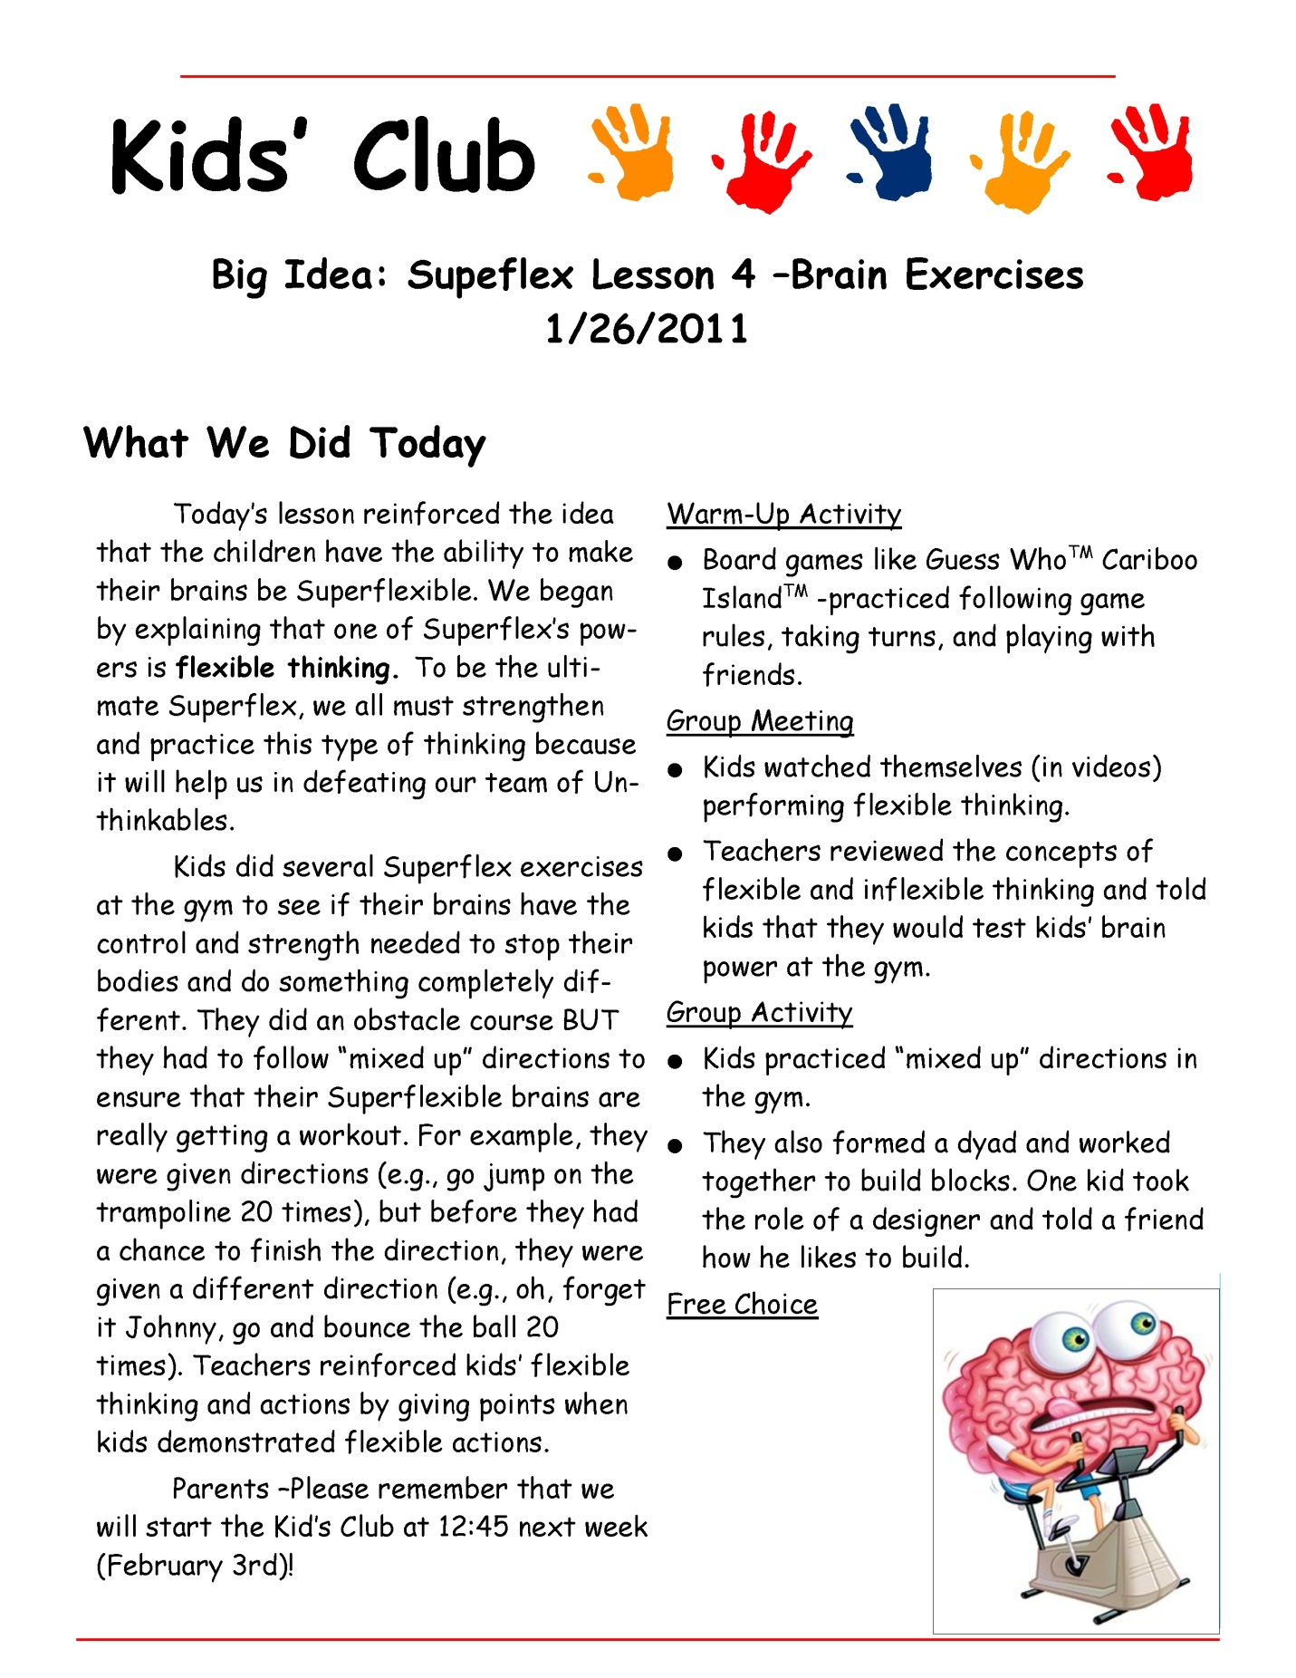

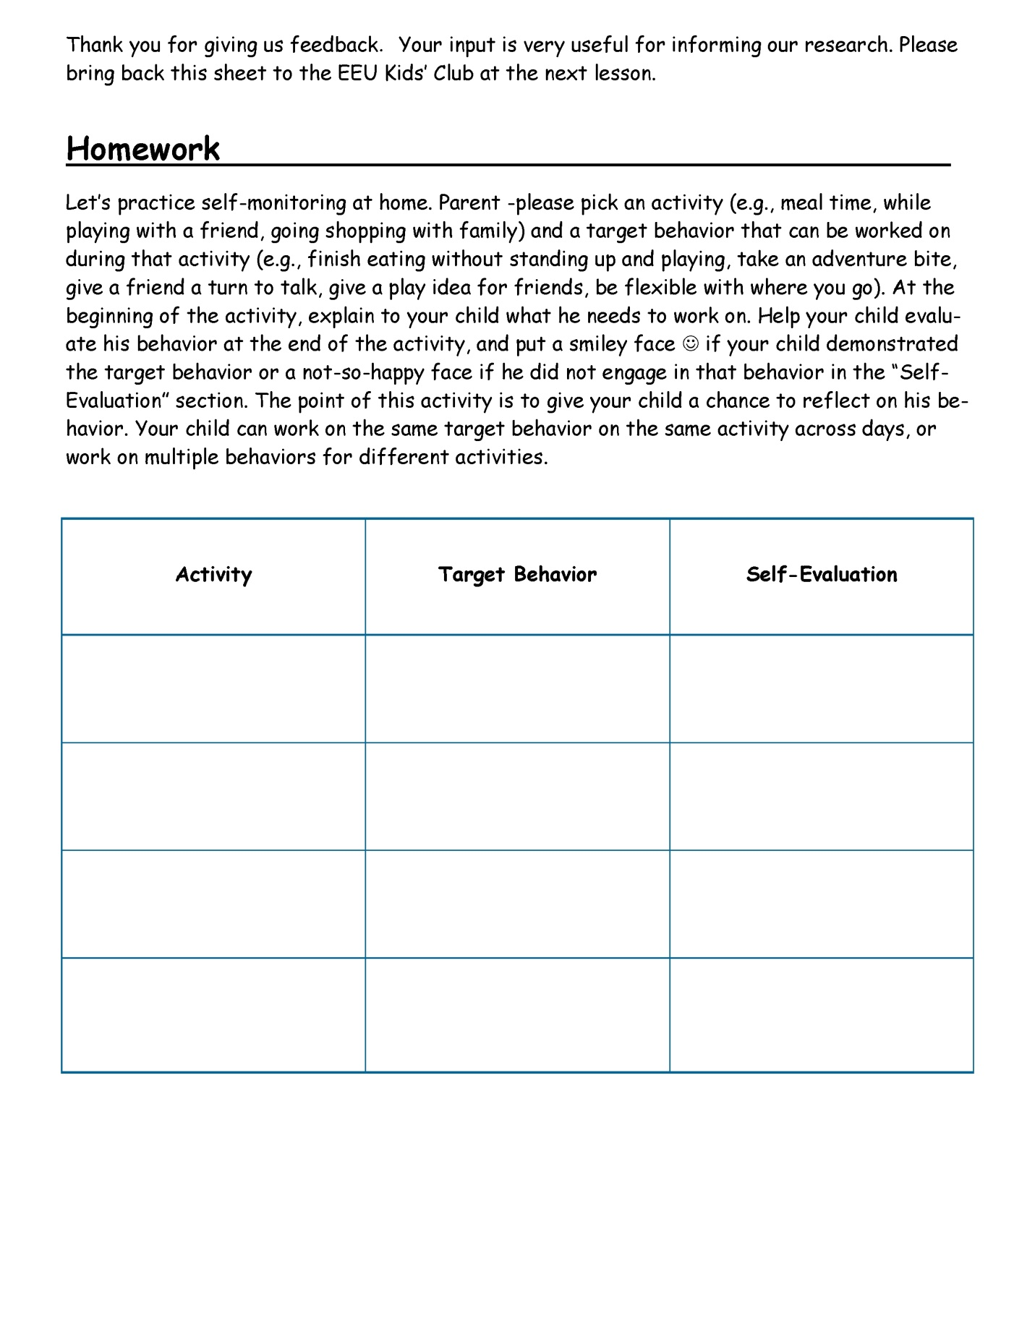
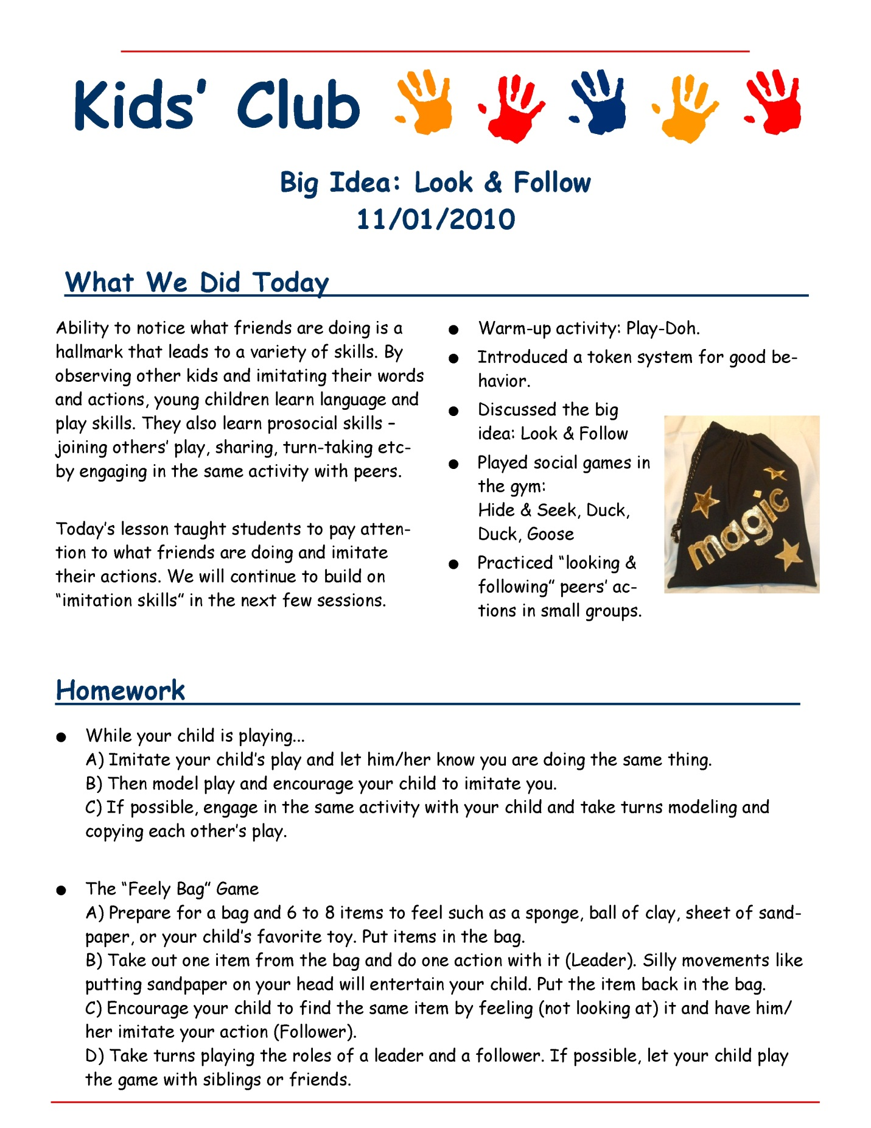

Appendix D. Sample Child-specific Behavior Objectives Matrix

ACTIVITY | Child 1 | Child 2 | Child 3 | Child 4
Opening Activity | Assertiveness/Voice  0 1 2 3 4  Initiate to Peers  0 1 2 3 4  Appropriate Space  0 1 2 3 4 | Orienting/eye contact  0 1 2 3 4  Invite Peers to Play  0 1 2 3 4  Persisting  0 1 2 3 4 | Orienting/eye contact  0 1 2 3 4  Imitates Peers  0 1 2 3 4  Staying on Topic  0 1 2 3 4 | Appropriate Space  0 1 2 3 4  Invites Peers to Play  0 1 2 3 4  Staying on Topic  0 1 2 3 4
Group Meeting | Assertiveness/Voice  0 1 2 3 4  Appropriate Space  0 1 2 3 4 | Orienting/eye contact  0 1 2 3 4  Persisting  0 1 2 3 4 | Orienting/eye contact  0 1 2 3 4  Staying on Topic  0 1 2 3 4 | Appropriate Space  0 1 2 3 4  Staying on Topic  0 1 2 3 4
Large Group Activity | Assertiveness/Voice  0 1 2 3 4  Initiate to Peers  0 1 2 3 4  Appropriate Space  0 1 2 3 4 | Orienting/eye contact  0 1 2 3 4  Invite Peers to Play  0 1 2 3 4  Persisting  0 1 2 3 4 | Orienting/eye contact  0 1 2 3 4  Imitates Peers  0 1 2 3 4  Staying on Topic  0 1 2 3 4 | Appropriate Space  0 1 2 3 4  Invites Peers to Play  0 1 2 3 4  Staying on Topic  0 1 2 3 4
Games | Assertiveness/Voice  0 1 2 3 4  Initiate to Peers  0 1 2 3 4  Appropriate Space  0 1 2 3 4 | Orienting/eye contact  0 1 2 3 4  Invite Peers to Play  0 1 2 3 4  Persisting  0 1 2 3 4 | Orienting/eye contact  0 1 2 3 4  Imitates Peers  0 1 2 3 4  Staying on Topic  0 1 2 3 4 | Appropriate Space  0 1 2 3 4  Invites Peers to Play  0 1 2 3 4  Staying on Topic  0 1 2 3 4
Rating Scale:
0 Refused or protested, aggressive or overt behaviors
1 No response or initiation most of the time, with prompting
2 Prompting needed most of the time for a response or initiation
3 Responded or initiated correctly without prompts more than 50% of the time
4 Minimal to no prompting necessary (at least 80% independence)

Appendix E. Social Skills Group Free Play Coding Sheet

Tape #: __________________ Coder: ________________ Coding date: ________________

0 min |  |  |  | 1min
Child____  Eng: + －  SI SR | Child____  Eng: + －  SI SR | Child____  Eng: + －  SI SR | Child____  Eng: + －  SI SR | Child____  Eng: + －  SI SR | Child____  Eng: + －  SI SR | Child____  Eng: + －  SI SR | Child____  Eng: + －  SI SR
2 min |  |  |  | 3min
Child____  Eng: + －  SI SR | Child____  Eng: + －  SI SR | Child____  Eng: + －  SI SR | Child____  Eng: + －  SI SR | Child____  Eng: + －  SI SR | Child____  Eng: + －  SI SR | Child____  Eng: + －  SI SR | Child____  Eng: + －  SI SR
4 min |  |  |  | 5 min
Child____  Eng: + －  SI SR | Child____  Eng: + －  SI SR | Child____  Eng: + －  SI SR | Child____  Eng: + －  SI SR | Child____  Eng: + －  SI SR | Child____  Eng: + －  SI SR | Child____  Eng: + －  SI SR | Child____  Eng: + －  SI SR
6 min |  |  |  | 7 min
Child____  Eng: + －  SI SR | Child____  Eng: + －  SI SR | Child____  Eng: + －  SI SR | Child____  Eng: + －  SI SR | Child____  Eng: + －  SI SR | Child____  Eng: + －  SI SR | Child____  Eng: + －  SI SR | Child____  Eng: + －  SI SR
8 min |  |  |  | 9 min
Child____  Eng: + －  SI SR | Child____  Eng: + －  SI SR | Child____  Eng: + －  SI SR | Child____  Eng: + －  SI SR | Child____  Eng: + －  SI SR | Child____  Eng: + －  SI SR | Child____  Eng: + －  SI SR | Child____  Eng: + －  SI SR
10 min |  |  |  | 11min
Child____  Eng: + －  SI SR | Child____  Eng: + －  SI SR | Child____  Eng: + －  SI SR | Child____  Eng: + －  SI SR | Child____  Eng: + －  SI SR | Child____  Eng: + －  SI SR | Child____  Eng: + －  SI SR | Child____  Eng: + －  SI SR
12 min |  |  |  | 13 min
Child____  Eng: + －  SI SR | Child____  Eng: + －  SI SR | Child____  Eng: + －  SI SR | Child____  Eng: + －  SI SR | Child____  Eng: + －  SI SR | Child____  Eng: + －  SI SR | Child____  Eng: + －  SI SR | Child____  Eng: + －  SI SR
14 min
Child____  Eng: + －  SI SR | Child____  Eng: + －  SI SR | Child____  Eng: + －  SI SR | Child____  Eng: + －  SI SR
Momentary Time-sampling (at the end of every 15 seconds)
+: Active Engagement (either social engagement or engagement in play)
－: Non-engagement (non-engagement, undifferentiated, casual attention, focused attention)

Partial-interval (any time during the 15 seconds)
SI: Social initiation to a peer (not adult)
SR: Social response to a peer’s social initiation

Appendix F. Classroom Free Play Coding Sheet

Child: ___________________ Coder: ________________ Coding date: ________________
0 min |  |  |  | 1min
Eng: + －  SI SR  Directive | Eng: + －  SI SR  Directive | Eng: + －  SI SR  Directive | Eng: + －  SI SR  Directive | Eng: + －  SI SR  Directive | Eng: + －  SI SR  Directive | Eng: + －  SI SR  Directive | Eng: + －  SI SR  Directive
2 min |  |  |  | 3min
Eng: + －  SI SR  Directive | Eng: + －  SI SR  Directive | Eng: + －  SI SR  Directive | Eng: + －  SI SR  Directive | Eng: + －  SI SR  Directive | Eng: + －  SI SR  Directive | Eng: + －  SI SR  Directive | Eng: + －  SI SR  Directive
4 min |  |  |  | 5 min
Eng: + －  SI SR  Directive | Eng: + －  SI SR  Directive | Eng: + －  SI SR  Directive | Eng: + －  SI SR  Directive | Eng: + －  SI SR  Directive | Eng: + －  SI SR  Directive | Eng: + －  SI SR  Directive | Eng: + －  SI SR  Directive
6 min |  |  |  | 7 min
Eng: + －  SI SR  Directive | Eng: + －  SI SR  Directive | Eng: + －  SI SR  Directive | Eng: + －  SI SR  Directive | Eng: + －  SI SR  Directive | Eng: + －  SI SR  Directive | Eng: + －  SI SR  Directive | Eng: + －  SI SR  Directive
8 min |  |  |  | 9 min
Eng: + －  SI SR  Directive | Eng: + －  SI SR  Directive | Eng: + －  SI SR  Directive | Eng: + －  SI SR  Directive | Eng: + －  SI SR  Directive | Eng: + －  SI SR  Directive | Eng: + －  SI SR  Directive | Eng: + －  SI SR  Directive
10 min |  |  |  | 11min
Eng: + －  SI SR  Directive | Eng: + －  SI SR  Directive | Eng: + －  SI SR  Directive | Eng: + －  SI SR  Directive | Eng: + －  SI SR  Directive | Eng: + －  SI SR  Directive | Eng: + －  SI SR  Directive | Eng: + －  SI SR  Directive
12 min |  |  |  | 13 min
Eng: + －  SI SR  Directive | Eng: + －  SI SR  Directive | Eng: + －  SI SR  Directive | Eng: + －  SI SR  Directive | Eng: + －  SI SR  Directive | Eng: + －  SI SR  Directive | Eng: + －  SI SR  Directive | Eng: + －  SI SR  Directive
14 min
Eng: + －  SI SR  Directive | Eng: + －  SI SR  Directive | Eng: + －  SI SR  Directive | Eng: + －  SI SR  Directive
Overall Rating of the Child’s Sociability with Peers
4: Playing / interacting with peers most of the time
3: Playing / interacting with peers half the time
2: Playing / interacting with peers 20-30% of the time
1: Hardly playing / interacting with peers
Momentary Time-sampling (at the end of every 15 seconds)
+: Active Engagement (either social engagement or engagement in play)
－: Non-engagement (non-engagement, undifferentiated, casual attention, focused attention)
Partial-interval (any time during the 15 seconds)
SI: Social initiation to a peer (not adult)
SR: Social response to a peer’s social initiation
Directive: a teacher’s prompt to engage the target child (not a peer) in SI or SR
Appendix G. Parent Feedback Form


The Haring Center, Kid’s Club
Below is a survey regarding our social skills groups. Your feedback is important to us for improving this intervention service. The survey will be returned to Julie Ashmun, the Coordinator of the Professional Development Unit at the Haring Center. Your answers will remain anonymous. Thank you for feedback.

Please rate the following items, check your response according to the following 1-5 scale:
 | SCALE: 1 - Strongly Disagree 2 - Disagree  3 - Neutral 4 - Agree  5 - Strongly Agree Not Applicable | 1 - strongly disagree | 2 - disagree | 3 - neutral | 4 - agree | 5 - strongly agree | Not Applicable
1 | The format of instruction and activities were appropriate for my child.
2 | The group was effective for improving my child’s social skills.
3 | I would like to sign up my child for the group again.
4 | My child's goals for the group were effectively addressed.
5 | (If you received homework)  Homework was helpful for improving my child’s social skills.
6 | (If you received homework)  Homework was easy to implement.
7 | (If you received homework)  What percentage of homework were you able to do with your child (0-100%)?
8 | Has your child been in a social skills group before? If so, how long?
9 | What was your main reason for enrolling your child in the social skills group?
10 | What do you think your child learned from the group?
11 | Please provide any suggestions to improve our practice.
12 | Did you look at the newsletter each week? Was it helpful? Would you prefer this to be a weekly email or in paper form?
13 | Did you access the one hour consultation? If so, was it helpful? If not, why not?

Appendix H. Implementation Checklist

Did the following activities occur at today’s social skills group session?

Date: _____________

□ Warm-Up Activity  □ Group Meeting  □ Social Games  □ Group Activity  □ Free Choice  □ Other: ______________ | _____________ minutes  _____________ minutes  _____________ minutes  _____________ minutes  _____________ minutes  _____________ minutes

[Please note that the format of the checklist may be modified slightly.]

Appendix I. List of Individual Objectives

Monday Group  Emma  - Respond to peer interactions  - Use an appropriate voice volume  - Ask peers for items or a turn  - Claim and defend possessions  - Follow a peer’s play idea  - Offer a play suggestion  Sara  - Wait for a turn  - Use an appropriate voice volume  - Follow a game with rules  - Express anger appropriately  - Initiate peer interactions  - Follow a peer’s play idea  - Offer a play suggestion  Isla  - Orient to a speaker  - Wait for a turn  - Join peers  - Increase flexibility  - Follow a peer’s play  - Offer a play suggestion  Oscar (the first 10 sessions)  - Initiate to peers  - Offer a play suggestion  - Follow a peer’s play idea  - Suggest a play idea  - Claim and defend possessions  - Join an activity with peers  - Comment/request with peers  Nancy (the second 10 sessions)  - Stay with group  - Respond to peer interactions  - Initiate to peers | Wednesday Group  Martin  (the first 10 sessions)  - Initiate and stay on topic  - Use appropriate non-verbal communication  - Suggest a play plan  - Engage in cooperative play  (the second 10 sessions)  - Wait for a turn to talk  - Engage in cooperative play  Kyle  (the first 10 sessions)  - Appropriate attention seeking  - Problem solving  - Self-regulation  (the second 10 sessions)  - Understand tone of voice  - Engage in cooperative play  - Self-regulation  - Problem solving  Mike  (the first 10 sessions)  - Understand emotions  - Improve nonverbal communication  - Join in and follow play with peers  - Problem solving  (the second 10 sessions)  - Initiate to peers  - Increase flexibility  - Join in and follow play with peers  - Respond to peers  Chris  (the first 10 sessions)  - Self-regulation  - Initiate and stay on topic | - Join peer’s play  - Invite others to play  - Stay close and orient to peers  (the second 10 sessions)  - Wait for a turn to talk  - Engage in cooperative play  - Self-regulation  Warren  (the first 10 sessions)  - Self-regulation  - Improve nonverbal communication  - Engage in cooperative play  - Initiate and stay on topic  - Problem solving  (the second 10 sessions)  - Maintain conversation  - Engage in cooperative play  Friday Group  Bella  - Respond to peers  - Be flexible  Eric  - Respond to peers  - Take turns  Hanah  - Get a peer’s attention  - Be flexible  Oren  - Respond to peers  - Take turns  Nancy (the second 10 sessions)  - Respond to peers  - Get a peer’s attention

Curriculum Vitae
Takanori Koyama

EDUCATION
University of Washington, Seattle, WA
Doctor of Philosophy in Special Education, 2011
Dissertation thesis on social skills groups for young children with social delays
Cumulative GPA: 3.92 on a 4.0 scale
University of Washington, Seattle, WA
Master of Education in Early Childhood Special Education, 2005
Washington Special Education Residency Certificate, 2005
Master’s thesis on embedded instructions in preschool classroom
Cumulative GPA: 3.88 on a 4.0 scale
Duke University, Durham, NC (exchange program, 2000-2001)
Major: Psychology
GPA: 3.80 on a 4.0 scale
International Christian University, Tokyo, Japan
Bachelor of Arts in Psychology, 2002
Cumulative GPA: 3.58 on a 4.0 scale

TEACHING EXPERIENCE
Board Certified Behavior Analyst (BCBA), 2010-present
Maxim Healthcare Services, Tacoma, WA
- Conducted functional assessment and wrote behavior plans for children with autism
- Supervised tutors to implement instructional programs and behavior plans at children’s homes
Assistant Teacher in Japanese Language, 2008-2011
University of Washington, Seattle, WA
- Taught six quiz sessions per week
Special Education Teacher in Developmental Kindergarten, 2007-2008
Silver Firs Elementary, Everett, WA
- Taught academic/pre-academic skills in reading, writing, and math
Preschool Special Education Teacher, 2005-2007
Cedar Wood Elementary, Bothell, WA
- Taught preschool students with a variety of disabilities
- Supervised the Extended Day program (behavioral program for children with autism)
Assistant Teacher in Infant and Toddler Class, 2004-2005
Experimental Education Unit, Seattle, WA
- Taught toddler classes (1-2 years old) in inclusive setting
- Planned, implemented, collected data on specialized instructions
- Collaborated with a head teacher to create an effective learning environment
- Supervised classroom aides and assisted parents
Assistant Teacher in Developmental Preschool, 2003-2004
Experimental Education Unit, Seattle, WA
- Assisted a head teacher in managing an inclusive preschool classroom (3-5 years old) with implementation of instructions, data collection, and classroom environment
Behavior Therapist, 2003-2004
Experimental Education Unit, Seattle, WA
- Conducted Applied Behavior Analysis (ABA) therapies for toddlers in individualized setting under the supervision of a program coordinator
- Taught basic skills such as eye contact, imitations with objects, and vocal imitations
Behavior Therapist, 2003-2006
- Conducted behavior therapies in children’s homes
- Consulted parents of children with disabilities on various issues
Summer Camp Counselor, 2001
Camp Royall, Moncure, NC
- Helped children and adults with autism participate in camp activities (e.g., swimming, nature walk) and follow daily routines (e.g., bathing, sleeping)

PUBLICATIONS
Koyama, T., & Wang, T. (2011). Use of Activity Schedule to Promote Independent Performance of Individuals with Autism and Other Intellectual Disabilities: A Review, Research in Developmental Disabilities. In Press.
Koyama, T., West, E., Kemper, T., & Wang, T. (in review). The Effects of Language, Word Functions and Symbol Sets on the Transparency of Picture Symbols, Augmentative and Alternative Communication.

PRESENTATIONS, WORKSHOPS
Koyama, T., & Sandall, S. (2011). Efficacy of social skills groups for young children with social delays, Poster presented at the Division for Early Childhood Annual Conference.
Koyama, T. (2011). Addresssing challenging behavior at home, workshop presented for the Open Doors for Multicultural Families, Seattle WA.
Koyama, T., Hilgenfeld, M., & Fung, J. (2009). Using activity schedules to increase engagement and independence of toddlers with autism, Poster presented at the Division for Early Childhood Annual Conference.
Wang, H., & Koyama, T. (2009). Successful components of video modeling for children with autism and practical implications, Poster presented at the Division for Early Childhood Annual Conference.

Koyama, T., & Wang, H. (2009). Promoting independent performance of individuals with disabilities: Successful components of activity schedule intervention, Poster presented at the Association for Behavior Analysis International Annual Conference.

Koyama, T. (2009). Promoting independent performance of individuals with disabilities: A review on activity schedules, Poster presented at the Council for Exceptional Children Annual Conference.

Chen, P., Koyama, T., & Casillas, N. (2008). The effects of sensory integration intervention on self-stimulating and self-injurious behavior: Literature review, Poster presented at the Association for Behavior Analysis International Annual Conference, Chicago, IL.
Koyama, T., Casillas, N., & Chen, P. (2008). Motivating young children in school: The effective use of reinforcement, Presented at the Infant and Early Childhood Conference, Bellevue, WA.
Koyama, T. (2007). Understanding, preventing, and addressing challenging behavior, presented at Fukuoka University of Education Summer Seminar, Fukuoka, Japan.
Koyama, T. (2006). Supporting language development in classroom, presented at Fukuoka University of Education Workshop, Fukuoka, Japan.

SCHOLARSHIPS, AWARDS & HONORS

Doi Dissertation Fund, 2011
University of Washington

The Gatzert Child Welfare Dissertation Fellowship, 2010

University of Washington

Nomination for the Excellence in Teaching Award, 2010
University of Washington

The Organization for Autism Research Graduate Student Research Grant, 2009

The Use of a Visual Cue and Reinforcer Time Delay to Teach Waiting Behavior for Young Children with Autism, In collaboration with Hui-Ting Wang.

The Distinguished Teaching Assistant Award (Japanese language), 2009
The Department of Asian Languages and Literature, the University of Washington

The Herbert J. Prehm Student Presentation Award, 2009
The Division on Developmental Disabilities, the Council for Exceptional Children
The Alice H. Hayden Scholarship, 2008
The College of Education, the University of Washington

SERVICES
Board Member, International Educators of the College of Education, 2009-present
The College of Education, the University of Washington
Steward, UAW Local 4121 (the Student Union at the University of Washington), 2010-present
University of Washington

