Technology in Support of Shoreline Surveys for Characterizing Spatial Complexity
Report on the Design and Build of the Water Bunny and Relevance to Migrating and Spawning Habitat of the Puget Sound Salmon

Submitted by:
Lisa Michelle Burk
School of Oceanography
Ocean Technology Center, University of Washington
m1sslisa@uw.edu
May 27th, 2018
Submitted to:
Miles Logsdon
Ocean Technology Center, University of Washington
1503 NE Boat St
Seattle, Washington 98105

Executive Summary:
There are numerous issues related to the management of shoreline development in Puget Sound. As shoreline property owners armor and protect their coastal property from erosion and slope failure, many natural processes are interrupted. This ongoing alteration of natural processes in the nearshore by anthropogenic uses is now thought to result in a less complex, more homogenous nearshore environment that has negative implications for species which use the nearshore for migration and spawning (Logsdon et al., 2011). The dynamic interactions of ecological functions for migrating salmon within units of the shoreline that have uniform physical controls on the transport of sediments (i.e. process units) are impacted by anthropogenic use.
Changes in the physical structure of these process units, which create variety in shoreline complexity, are thought to be related to the observed decline in suitable habitat for salmon migration and spawning. Characterizing beach complexity will not only help address causes of the decrease in complexity itself, but also tie in the lack of suitable habitat affecting local salmon species. Several species of salmon in the Pacific Northwest are either in decline, or already represented in the federal Endangered Species Act.
We developed a tethered remotely operated water surface vehicle as a technological addition, with a deployment protocol that is used to assess the nearshore environment of Puget Sound. This is accompanied by developmental designs and schematics of the sensor, along with the code necessary to duplicate the build process. Correlating the anthropogenic effects in the process unit to the decrease in beach complexity and therefore loss of suitable habitat for migrating and spawning Chinook, also known as King Salmon. Using the developed sensor within a process unit, we identified a correlation of habitat loss due to anthropogenic processes with sea grass changes, quantified the extent of armoring, landslides, and natural beaches visually as a percent. This deployment protocol may be used in the future to characterize a variety of beaches in reference to other species, in addition to the Chinook.
Introduction
Puget Sound’s shoreline is strongly influenced by its glacial history and characterized by a steep bluff-dominated coastline with narrow mixed sand and gravel beaches, a coastal sediment system largely fed by bluff erosion, and an irregular coastline divided into hundreds of individual littoral [drift] cells (Figure 1). A littoral cell is defined as a sector of shoreline focusing on sediment-transport from source to the area of deposition. “The irregular shape of the shoreline, combined with the fetch-limited wave environment, leads to the division of the coast into hundreds of discrete littoral cells, each with its own sources and sinks of sediment (Schwartz and others, 1989).” The varied beach communities of Puget Sound link to adjacent terrestrial and marine ecosystems in a variety of ways, some of which are disrupted by shoreline armoring which affects roughly one third of the shoreline, predominantly the Puget Sound’s urbanized eastern shore (Shipman et al., 2010). A decrease in shoreline complexity by inclusion of shoreline armoring, giving rise to a more uniform nearshore environment, is theorized to be tied to the decrease in suitable habitat for species that spawn and migrate in the Puget Sound (PSNERP). The loss of nearshore, typically a narrow platform confined between a steep terrestrial landscape and deeper water offshore (Shipman et al., 2010), may be impacting the decline in local salmon species, which have particular significance in the Puget Sound. Prior work has utilized a terrestrial point of view, focusing on land driven processes and interactions, and lacked the use of the drift cell as a significant process unit. The process unit signified a connection between anthropogenic changes and sediment transport by natural processes in the marine environment. When considering shoreline complexity, the non-uniformity of a shoreline, there are a number of impacted variables to be taken into account (coastal sediment supply and transport, the interaction of waves with beaches, and groundwater flows to the beach, as well as impacting ecological functions, such as spawning, detritus production and food web processes, and the maintenance of beach and nearshore habitats) (Shipman et al., 2010). “Ultimately, a better understanding of the impacts of armoring on sheltered and estuarine shorelines will provide the scientific basis for guiding principles and recommendations that lead to better decisions related to locating and regulating shoreline armoring” (Shipman et al., 2010).
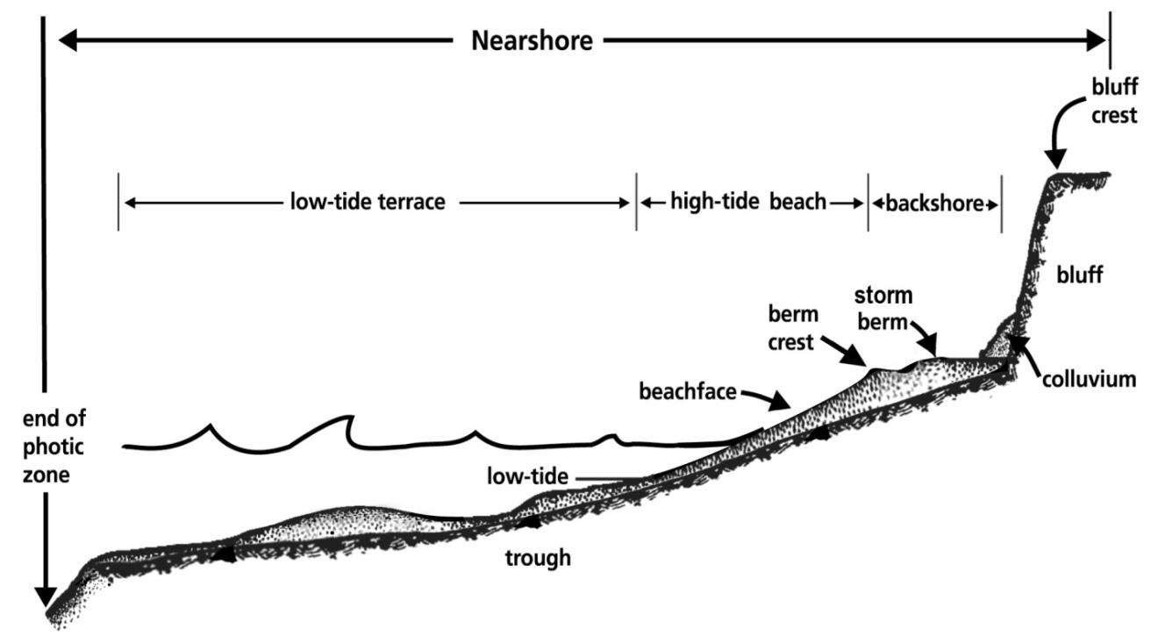
Figure 1
Figure 1
A vertical cross section of a beach perpendicular to the shoreline. Individual features on Puget Sound region beach profile are illustrated above (Johannessen, 2014).
Drift cell: A littoral [drift] cell is a coastal compartment that contains a complete cycle of sedimentation including sources, transport paths, and sinks. The cell boundaries delineate the geographical area within which the budget of sediment is balanced, providing the framework for the quantitative analysis of coastal erosion and accretion. See Johannessen and MacLennan (2007) for further description of drift cells.
Backshore: The upper zone of a beach beyond the reach of normal waves and tides, landward of the beachface. The backshore is subject to periodic flooding by storms and extreme tides, and is often the site of dunes and back-barrier wetlands (Clancy et al. 2009). Width is measured cross-shore from the waterward extent of the backshore to the waterward extent of upland vegetation or anthropogenic modifications. Backshore areas tend to be highly modified or nonexistent on developed properties.
Bank or Bluff: A steep slope rising from the shore, generally formed by erosion and mass wasting of poorly consolidated material such as glacial or fluvial sediments. The term bluff is typically used in the Pacific Northwest for a steep sea cliff composed of unconsolidated sediment that has no to moderate amounts of vegetation. The term bank is typically used in the Northwest for lower elevation sea cliff with a well vegetated bank face. Within this document bank and bluff may be used interchangeably.
Beachface: The section of the beach normally exposed to the action of waves. This is typically the sloping beach between the low tide terrace and the backshore.
Beach profile: A vertical cross section of a beach perpendicular to the shoreline. Individual features on Puget Sound region beach profile are illustrated below.
Berm crest: The waterward point of a beach berm where the sloping foreshore meets the more gently sloping backshore.
Bluff crest: The highest point of a sloping bluff or bank from which the slopes levels off as part of the uplands.
Colluvium: Loose heterogeneous and incoherent mass of soil and rock material deposited by surface water runoff, slow continuous creep or other erosive mechanism, usually collecting at the base of a slope.
High tide beach: The sloping portion of the beach profile located above and landward of the low-tide terrace and below mean higher high water.
Low tide terrace: A broad flat portion of the beach profile located near the mean lower low water level.
Nearshore: As defined by PSNERP, includes the area from the deepest part of the photic zone (approximately 10 meters below Mean Lower Low Water [MLLW]) landward to the top of coastal bluffs, or in estuaries upstream to the head of tidal influence (Clancy et al. 2009).
Low tide: The minimum height reached by each falling tide. The accepted popular synonym of low water in the sea.
Trough: A small linear depression formed just offshore on the bottom of a sea or lake on the landward side of an alongshore bar. It is generally parallel to shore and is always under water. Formed by extreme turbulence from wave and current action in the zone where breakers collapse.
Storm berm: The higher elevation depositional feature, typically in the backshore of a beach, formed by infrequent large waves, located higher and more landward than the active or ordinary berm.
We address the interruption of nearshore processes by anthropogenic changes as they result in a less complex, more homogenous, physical nearshore environment. The technological addition and deployment protocol was created to monitor and quantify changes in the nearshore complexity of Puget Sound (grain size, eel grass presence, water clarity, brown kelp presence, change in beach back bluff). Deploying the sensor for a case study and field trial in several drift cells (each canvasing a 5-minute moving time segment of the waterfront) along a stretch of public beach on Camano Island within the State Park has allowed for a better idea of the stresses that the sensor is capable of withstanding and simultaneously monitoring. As Chinook migrate in late winter to early spring, we chose April as the month to collect the performance data. Once further field testing has been conducted utilizing the developed sensor, data may be manually analyzed. The intent of the sensor and deployment protocol is to aid in future studies and deign development in addition to restoration projects, such as the Puget Sound Nearshore Ecosystem Restoration Project (PSNERP).
II. Methods
The technological addition, the sensor which we named the Water Bunny, and survey protocol are designed to address the need for a technological addition to aid in the characterization of the nearshore in Puget Sound. The sensor and deployment protocol allow the monitoring of variables that migrating and spawning Chinook are subject to, both in the nearshore environment and the beach to foreshore. The survey protocol refers to the entirety of the sensor deployment, both in the area of low tide along the beach and in the subtidal zone throughout the low-tide terrace. However, the Water Bunny itself is specifically designed as a maneuverable, light weight and moderately sized tool which is easily transported for the purpose of surveys within the subtidal zone of the Puget Sound Nearshore. The sensor utilizes a platform with downward facing 7-LED night vision waterproof camera with a classic 135° viewing angle, two Blue Robotics variable speed thrusters, and an Arduino GPS logger shield mounted upon a RedBoard, which is used to record the data (date, time, latitude, longitude, altitude, speed, course and stats) onto a 16GB memory card. Through the use of a 29’ tether from the sensor to the operator on the shoreline, the sensor is driven parallel to the track-line of the operator and the waterfront. A tethered design element was incorporated into the Water Bunny as a means to overcome the distance that separates the surveyor from the habitat where eel grass is most likely to be seen with a live feed video. The tether gave the sensor a longer lifespan and eliminated the need for a heavy battery mounted on the maneuverable platform, which expanded the potential options for thruster components. The same cable that tethers the camera and thrusters to the controller and the mounted 4.3” LCD color monitor, held by the operator, is paired with a cable that draws power from a 12 V battery within the 16-liter pack carried by the operator. The need for a clear visualization of the nearshore environment that Chinook salmon encounter required the sub-surface camera which is housed within an air tight PVC housing, along-side the GPS logger shield and memory card running on a RedBoard which was housed within a Pelican case mounted to the device’s platform. The GPS allows the recording of the time and place that each observation was made, when the observer is seeing the image in real time and manually recording these observations from the shoreline. The need for this development to move parallel to the operator and withstand the wave movement was addressed utilizing the two variable speed thrusters, with the speed being recorded on the memory card along with the time and location. The future utilization of the Water Bunny and experimental protocol by users may be useful for adding data to the online Puget Sound Nearshore Environment Restoration Project (PSNERP), the Washington Department of Ecology, and the Puget Sound Partnership (PSP), and lead to further innovation and development of rules and regulations regarding the armoring of shoreline properties as the population expands.
- Design Elements
In order to achieve a classification of beach complexity in the nearshore environment of Puget Sound that relates to the migration and spawning of Chinook salmon, the Water Bunny and its survey protocol are a developed technological addition for gathering and storing data in the nearshore environment. This sensor is the first development of its kind created to address the presumed correlation of a decline in the nearshore complexity as it relates to the decline in health and presence of the native Chinook salmon, which utilize this environment for the purposes of migrating and spawning. The design parameters for the real time visualization of the nearshore environment required the Water Bunny to have a water tight housing to keep the electronic components dry, capable of flotation, and movement along the nearshore parallel the water front. Prototype III of the Water Bunny meets additional design requirements for simplification, in addition to a thrust capable of controlling the sensor in the field. The sensor is controlled by a handheld device carried by the operator, as well as the power source.
- Project Progression
Design of the Water Bunny began in October 2017 as part of the University of Washington’s Ocean Technology senior thesis track. I identified the design parameters (buoyancy, speed, maneuverability, video imaging and location recording capability, lifespan) of a survey protocol and technological development for characterizing the nearshore environment in Puget Sound to have a low cost and be easily transported/portable. Prototype I of the Water Bunny was constructed by 22 February 2018 and prepared for its first functionality test in the salt water tank at UW OTC. Design flaws were present, and the Water Bunny did not provide satisfactory feedback data during testing of components in the salt water tank at the UW Ocean Sciences Building. Analysis of Prototype I determined that lining the threads up properly and carefully is needed to fully open and close the water tight PVC housing and that, in addition to insufficient thrust with the Puffer Fish components, the sensor was found to have a center of buoyancy higher than its center of mass, causing instability. Prototype II was developed to address the lessons learned from the functionality testing of Prototype I components.
Design, build, and testing of the Water Bunny Prototype II was conducted over the months of March and April 2018. During the winter months, I had determined the flaws of Prototype I, and already had a second design alternative prepared as a solution (See Appendix D), which was then altered throughout the last month prior to deployment in the field. The required adjustments were made to the modification, taking the initial Prototype II to completion. The finalization of the thruster replacement with BlueRobotics components, design simplification by removing excess PVC from platform, controller build and GPS/RedBoard soldering and coding led to a short functionality test upon the UW dock on 27 April 2018.
The functionality test on 27 April 2018 allowed me to determine further flotation was needed to level the platform, as to not submerge the platform upon initiating thrusters. The Water Bunny Prototype III was improved by use of more foam in the base of the platform where flotation needed to be increased and disbursed in areas which caused the sensor to tilt, and the use of electrical tape to enclose circuitry in case of splashing. A hot glue was applied to the tether/PVC interfaces with the intent of increasing the sensors resistance to water splashing on the platform surface when released in the region of possible wave breaking. The sensor did receive GPS data utilizing the code provided by Miles Logsdon, after alterations were applied to the code (removal of light measurements), to incorporate only the variables relevant to the survey protocol.
The case study along the waterfront in Camano State Park took place on 29 April 2018. The weather was consistently overcast, without precipitation or significant winds. The Water Bunny setup following protocol was successful, however the deployment did not yield the desired outcome. Upon deployment initiation, a single large wave splashed over the sensor platform while being released within the area of wave breaking at low tide (11:37AM), rendering the left thruster inoperable and flushing the Velcro-adhered Pelican case housing the GPS shield off into the intertidal zone. The pelican case was recovered, and the Water Bunny returned to shore for ~40 minutes of troubleshooting, which proved unable to be repairable due to light water intrusion within the PVC housing. Protocol was continued without the use of the Water Bunny, and an implemented decision to make the GPS track line following the waterfront with the surveyor, separating recorded data into drift cell units based upon 5-minute moving time beach walks, with manual recording of observations as entailed in the protocol. There was an additional track line of GPS data obtained by walking back along the length of the beach wrack. Data collection was recorded by hand in the users’ notebook, and later transferred to an Excel spreadsheet.
- The Water Bunny Prototype III Case Study
Prototype III was bench tested to identify functionality of GPS, camera, and thrusters separately. Once wiring was completed and water tight sealants applied, Prototype III was made ready for a field test. The field test of the Water Bunny was conducted on the waterfront of the Camano State Park in Washington. The waterfront along Camano Island was chosen based on its availability for public access, varying beach types (anthropogenic vs. natural), and known eelgrass patches that are utilized during the spawning and migration of the Chinook salmon. The final case study was conducted in late April 2018. The protocol was utilized, and Prototype III was intended to be deployed for 5-minute interval beach walks to visualize the shoreline as well as the nearshore environment ~29’ outwards, parallel to the operator during the study. However, the sensor was damaged in the splash zone upon release, and manual beach walks were performed. The case study collected 4 beach walks where drift cell observations were recorded for analysis, and there was a continual track line along the beach wrack.
III. Deliverables
The development of the Water Bunny has included the design, build, and functionality testing of three instruments, both bench testing and in the field. The design parameters of a low cost and easily transported sensor capable of aiding in beach quantification and characterization within the Puget Sound were met with Prototype III. The final prototype of the Water Bunny (Prototype III) utilized two variable speed thrusters, an Arduino GPS Logger Shield, and a downward facing camera mounted upon a maneuverable platform which was tethered to a controller and 12V battery operated by the surveyor. The final bench test was complete with the function of all components and was additionally tested in the waters just off of the UW dock. (Figure 2) Following the bench test, the Water Bunny was deployed for a case study along the waterfront at Camano Island State Park. Upon deployment, the Water Bunny was struck by a large wave and entangled within the eel grass, the GPS housing torn from the platform, rendering the left thruster non-functional and the GPS housing detached. The data collected for analysis was retrieved utilizing the GPS Logger Shield in hand along the waterfront for the duration of the study, along with a log of field notes.
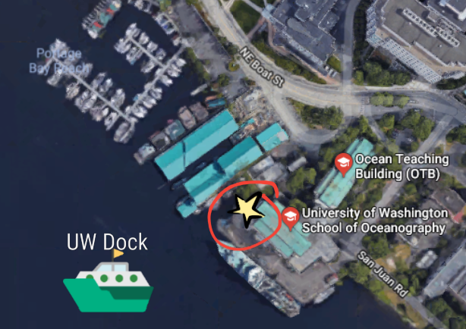
Figure 2
University of Washington Dock, located at 1503 NE Boat St, Seattle WA 98105. A functionality test of the Water Bunny III Prototype took place off of the North end of the dock on 04/27/2018.

- The Water Bunny Prototype III
The Water Bunny sensor is composed of three primary components: the water/air interface platform, the controller, and the battery pack. Each component was made to withstand appropriate conditions, splash proof housing and water-resistant cables and wiring. To aid in an easy deployment and transportation of the sensor, the platform was constructed using a 12 in. PVB Standard Valve Box Cover and 4 in. PVC tubing. The platform utilizes two variable speed Blue Robotics thrusters, and consists of an Arduino Uno, and an Arduino GPS Logger Shield equipped with a 16 GB SD card and a 9 V battery. The Arduino devices are housed in a small pelican case, and a downward facing 7 LED night vision waterproof camera is housed within the PVC tubing. A 12 V battery within a 20 L pack is worn by the operator during deployment, supplying the thrusters and camera power for the duration of the deployment. A tether attaches the interface component to the battery, but also to the controller which has a 4.3 in. color monitor to determine eel grass presence within the nearshore. The GPS records and stores the data (date, time, latitude, longitude, altitude, speed, course and stats) onto a 16GB memory card for a later analysis (Figure 3).
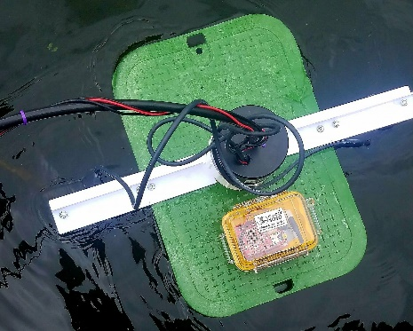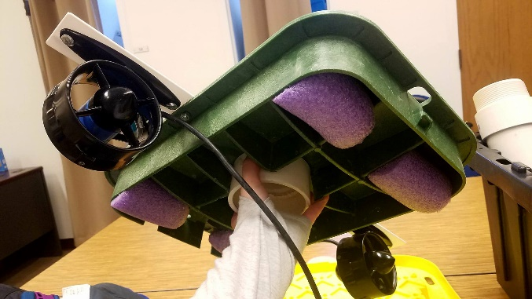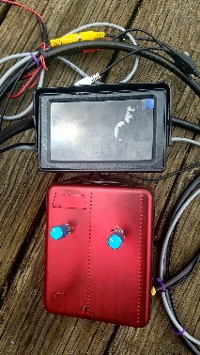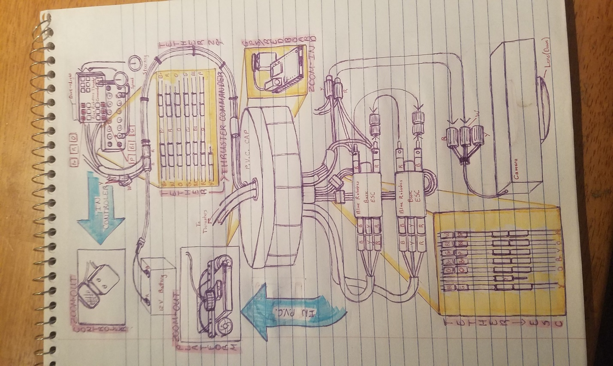
Figure 3
The Water Bunny Prototype III, top and bottom views of the platform, as well as the controller with monitor (Left to Right). The top image shows the platform with the start of a tether, and the pelican case which houses the GPS Logger Shield on a RedBoard, powered by a 9 V battery. The bottom view shows the platforms flotation by foam, and the two BlueRobotics thrusters. The handheld controller, which is attached to the platform by a 29’ tether, has both speed and direction controls, with a 4.3” color monitor.
The lower image gives the full schematic of the Water Bunny Prototype III. Detailing of each component within the PVC housing of the platform and controller, and providing the wiring diagrams needed to complete the build phase of the experiment.
Prototype III of the Water Bunny totaled approximately $389.00, with a total of just under $550.00 for the design and construction of all three prototypes with modifications. See Appendix B for a full parts list.
- Results of Testing
Confirmation of functional thrusters and the downward facing camera were seen in the final bench test off of the UW dock, the sensor was mobile and we were able to see the seafloor with some difficulty (overcast weather). Values recorded by the GPS Logger Shield were recorded in standardized units determined by the modified tinyGPS code utilized and provided in Appendix A. The bench test of the code for the device returned with continual data in 5 second intervals for the latitude, longitude, altitude (in feet), speed (in mph), course (in degrees), date, time, and number of satellites (Figure 4). The data is communicated to the GPS on pins 8 and 9 on the Uno RedBoard, and over SPI to log that data to the SD card with pin 10. The data is saved to the SD card as a .csv file for retrieval and analysis. There is a default baud rate of 9600 for the GPS module, with the monitor port defined as ‘Serial’. If the GPS data is valid, the return will read “GPS Logged”, and if we failed to log GPS, the return will read “Failed to log new GPS data.” During the bench testing in the Ocean Tech Center (OTC) at UW, we began receiving the readout “No GPS data. Stats: ”, which indicates that there are not yet enough satellites connected to the device for it to receive data. We continued to feed the GPS and proceeded to move the instrument outside and returned with an increasing number of satellites connecting to the GPS until we were provided with both the failed readout, followed by “GPS logged” and a stream of incoming data.
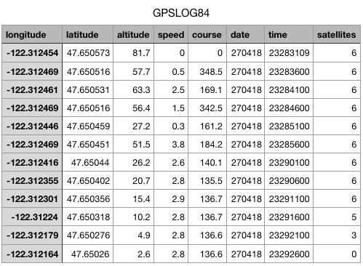
Figure 4
GPSLOG84 data in a csv. file resulting from the initial functionality testing of the GPS Logger Shield on 04/27/2018 at the University of Washington Ocean Tech Center. Readout resulted in successful latitude, longitude, altitude, speed, course, date, time, and satellites.

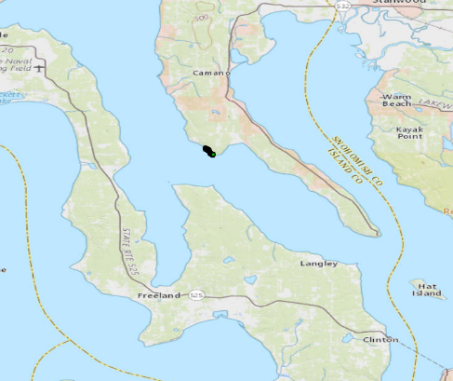
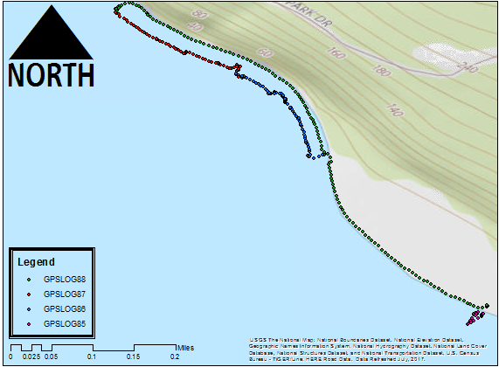
Figure 5
Maps indicating location of the field test and case study on the beach of Camano Island State Park, 2269 Lowell Point Rd, Camano Island, WA 98282. Opening up into the Puget Sound, and offering 6,700 feet of rocky shoreline known to harbor eel grass. GPSLOG85 is indicated by maroon, and was a failed 1st deployment of the Water Bunny Prototype III. GPSLOG86, in blue, represents Trek 2, and GPSLOG87 represents Trek 3. GPSLOG88, in green, is the trek back to the initial point of deployment along the beach wrack. Trek 1 did not successfully log, and is therefore not represented in the figure.

- Field Testing/ Case Study
The case study, conducted along the shoreline of Camano Island State Park at the end of April 2018, during low tide with mild/moderate overcast skies, resulted in four separate track lines utilizing the recorded GPS data from the Water Bunny (Figure 5). These coordinates were cross referenced with the data that was manually recoded in the log during the survey, using the time of the observation to determine the location of each data point. Presence/lack of eel grass was observed, as were anthropogenic uses (buildings, roads, and boat launches), grain size, changes in the bluff, shoreline wrack, water clarity, and the presence of other kelp species. Each of these observations was ranked on a scale of 0-5 (0 being none, and 5 being the maximum), regarding the percentage of the observed, for each data point recorded during the three back to back 5-minute moving time beach walks with the GPS instrument (Figure 6). An additional track line without manual recordings was conducted along the wrack line on the return, giving an outline of the beach width throughout the study.
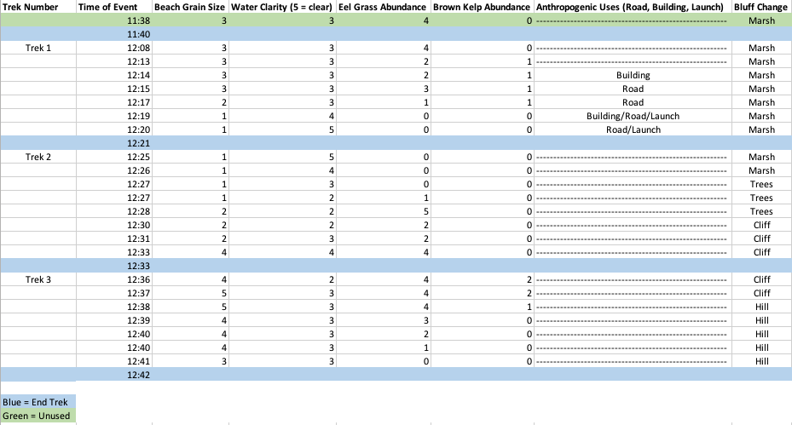
Figure 6
The data table gives all of the information gathered during the case study on Camano Island April 2018. Each trek was conducted by marking changes as they occur during a 5-minute, moving time, beach walk during low tide. Initial deployment of the Water Bunny Prototype III failed and was not represented as a trek. Trek 1 contained a variety of anthropogenic uses, and a steady marsh bluff. Trek 2 had no anthropogenic uses, but a changing bluff throughout. Trek 3 did not have anthropogenic uses, and only two types of bluff. The end of each trek is represented by a blue row, and unused data by a green row.

- Findings
The deployment of the Water Bunny began after completing the deployment protocol referenced in Appendix C. The sensor was removed from the water within minutes of deployment, as it was rendered unable to obtain real time video due to the loss of utility in the left thruster. There was a solitary swell which hit the front of the Water Bunny, tearing the pelican case housing the GPS from the platform and shoving the sensor backwards into the rocks and a patch of eel grass. The second attempt to initiate thrusters failed, and the sensor was returned to shore for unsuccessful troubleshooting, which revealed small amounts of water within the PVC housing along the electronics and wiring.
The decision was made to continue the case study by altering the deployment protocol, also referenced in Appendix C, continuing on foot along the waterfront holding the GPS and visually observing the presence/lack of eel grass and water clarity, as opposed to utilizing the Water Bunny. There were difficulties seeing further than ~4-6 feet outwards into the water without the aid of the Water Bunny, narrowing our knowledge of the nearshore environment, which would have had real time video to visualize the nearshore environment out to 29 feet.
Track Line 1 contains no anthropogenic uses, whereas Track Line 2 contains a boat launch, small buildings, and a road. Track Line 3 provided a cliff with a narrowed beach and a greatly increased grain size, ranging from large rocks to boulders. There was an observed decease in grain size in areas surrounding the boat launch and the buildings (small rocks and sand). The bluff went from being a forested marsh, to a forested hillside, and then to a dirt cliff with significantly less vegetation. There was no overhanging vegetation with regards to the waterfront, and significant amounts of eel grass presence were observed, in addition to another sparsely present kelp species. The eel grass was most abundant in quantity along Track Line 3, which contained no anthropogenic uses (Figure 7).
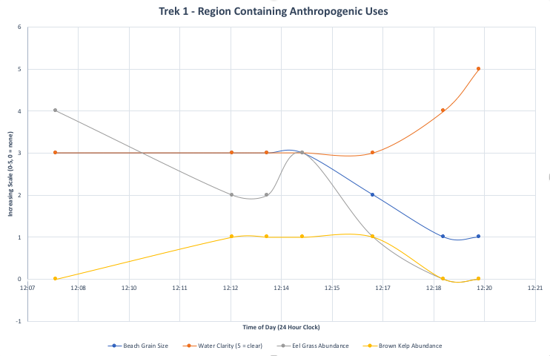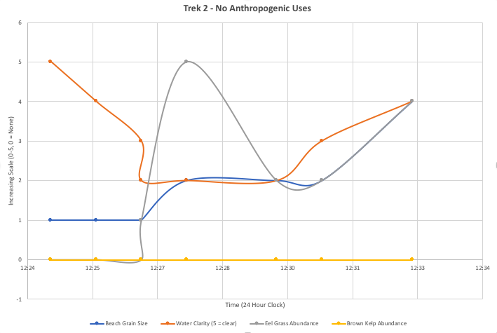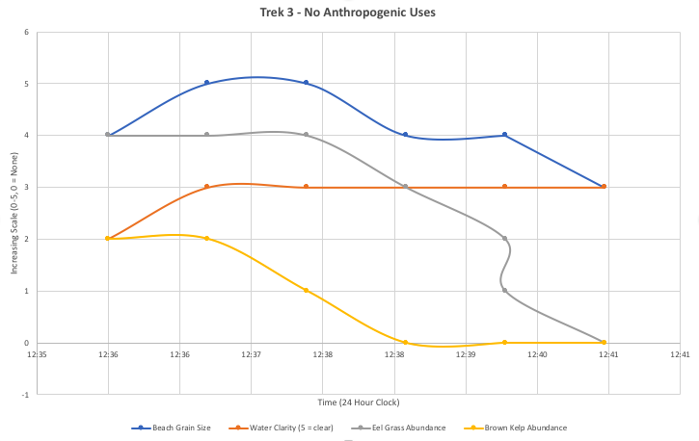
Figure 7
Treks 1-3 are represented graphically with a 24 hour clock along the x-axis, and change (in a range of 0-5, 0 = none) along the y-axis. Blue is referring to grain size, orange for a clarity of water, grey for the abundance of eel grass, and yellow showing brown kelp abundance.
Trek 1 shows that as eel grass decreases, the presence of brown kelp increases. Eel grass decreases as grain size decreases. Grain size decreases as a boat launch is approached and encountered at the end of the trek.

Trek 2 reveals an increase in eel grass presence as water clarity goes down, with grain size and eel grass presence increasing together. There is a maximum peak in eel grass during this trek between 12:27 and 12:28am. No kelp presence recorded. Grain size increased gradually as the trek moved farther from the boat launch present in Trek 1.

Trek 3, shows a decrease in both eel grass and kelp. The eel grass follows the decline in grain size, while water clarity remains somewhat constant.
IV. Conclusions
The Water Bunny development focused on the design and build of a prototype capable of aiding in the classification of the nearshore in Puget Sound. The project aimed to provide a low-cost, easily transportable and deployable sensor for citizens and fellow scientists to quantify characteristics within the nearshore environment, which are always under the water in the low-tide terrace. The prototype work in 2017/2018 did not achieve all of the outlined project requirements, however, the developed deployment protocol was of use. The relatively small and light weight sensor, the Water Bunny, was easily transported to the beach where the deployment protocol was successfully initiated. The sensor was determined to have adequate power supply, thrusters capable of maneuvering within the splash zone, and a functional GPS unit as well as real time video feed from the mobile camera to the monitor mounted upon the handheld controller (BlueRobotics Thruster Commander, speed and steering controls). While I was able to obtain the components for well under the desired cost, these components would result in a much higher price point if purchased by an individual outside of the OTC. The BlueRobotics thruster kit contributed to most of the cost but allowed the required thrust to have a mobile platform capable of resisting the tide in reasonable conditions. Further development is needed to ensure a watertight housing and a well secured GPS housing. The GPS was capable of meeting a portion of the project needs, providing data (lat., long., time, etc.) for the case study conducted along the beach at Camano Island State Park.
Case Study findings show that the developed deployment protocol, once altered following sensor malfunction, was capable of identifying the desired variables and ranking them on a predetermined scale (0-5). Analysis of the acquired data positively correlates the absence of eel grass with the presence of anthropogenic uses, and small grain sizes. Additionally, there was increased water quality (3-5) in areas with no eel grass presence (0). The gathered values are contrary to what is known about eel grass growth. Eel grass is known to grow in areas with better water quality as it requires light for photosynthesis, and the murky debris partially block the solar irradiance that the eel grass is exposed to. Further field studies would be required to support the correlated variables and their interpretation, to determine a positive correlation between the presence of eel grass and the lack of anthropogenic uses, as a one-time trial is insufficient.
However, valuable information was obtained with regards to the design and build of our prototype and the protocol used. The Pelican case housing the GPS needs to be firmly secured to the platform by means other than an adhesive Velcro, and additional efforts must be made to create a watertight housing capable of resisting wave action. Correction of these errors in the build and improvements on the protocol will lead to future sensor prototypes and a successful case study, increasing the range of the data collected during deployment in the field.
V. Recommendations
The Water Bunny prototypes and survey protocol developed in 2017/2018 are steps in the right direction for addressing the underlying causes (the hypothesized increase in anthropogenic uses) of a decrease in beach complexity as it relates to the decrease in suitable habitat for migrating and spawning Chinook salmon within the Puget Sound. Prototype III had many of the desired qualities to aid in quantifying beach complexity but needs further improvement in the way of water resistance and durability. Additional testing after improvements are made will provide visual data from the nearshore environment, as long as water quality is not significantly compromised by turbidity. As eel grass thrives in regions with higher water clarity, it is assumed that as distance from the zone of wave breaking increases, water clarity will be greatly improved. Testing needs to be continued as a means of verifying the validity of these improvements upon the Water Bunny, and to collect further case study data to support our findings.
The Water Bunny Prototype III has two areas in need of improvement:
- The GPS housing needs to be firmly secured to the platform.
- Watertight seals need to be created to withstand wave action.
- Additional use of electrical tape surrounding wire connections.
- Use of cable grip, sealing of the tether as it interacts with the PVC housing on the platform.
- Possible use of cage to deter eel grass from catching in thrusters.
- Field testing to determine range of visibility with the underwater camera when at the 29-foot extent of the tether.
- Further case studies to provide additional data.
- Deployment of the sensor and use of protocol along several other beaches within the Puget Sound.
- Data analysis to aid in an influx of information available to the public (PSNERP) and other organizations.

References
ABOUT. (2016). Retrieved from http://www.psp.wa.gov/vitalsigns/in-eelgrass-area.php

Best Places to Salmon Fish by Month | Washington Department of Fish & Wildlife. (2018). Retrieved from https://wdfw.wa.gov/fishing/salmon/whenwhere/month.html
Fresh K., M. Dethier, C. Simenstad, M. Logsdon, H. Shipman, C. Tanner, T. Leschine, T. Mumford, G. Gelfenbaum, R. Shuman, J. Newton. 2011. Implications of Observed Anthropogenic Changes to the Nearshore Ecosystems in Puget Sound. Prepared for the Puget Sound Nearshore Ecosystem Restoration Project. Technical Report 2011-03.
Johannessen, J., A. MacLennan, A. Blue, J. Waggoner, S. Williams, W. Gerstel, R. Barnard, R. Carman, and H. Shipman, 2014. Marine Shoreline Design Guidelines. Washington Department of Fish and Wildlife, Olympia, Washington.

Nearshore Habitat Eelgrass Monitoring | WA - DNR. (2018). Retrieved 2018, from https://www.dnr.wa.gov/programs-and-services/aquatics/aquatic-science/nearshore-habitat-eelgrass-monitoring

SALMON RECOVERY STATUS. (2016). Retrieved 2016, from http://www.psp.wa.gov/salmon-recovery-status.php

Shipman, H., 2010, The geomorphic setting of Puget Sound: implications for shoreline erosion and the impacts of erosion control structures, in Shipman, H., Dethier, M.N., Gelfenbaum, G., Fresh, K.L., and Dinicola, R.S., eds., 2010, Puget Sound Shorelines and the Impacts of Armoring— Proceedings of a State of the Science Workshop, May 2009: U.S. Geological Survey Scientific Investigations Report 2010-5254, p. 1-8, 19-34.

United States. (1983). The Endangered Species Act as amended by Public Law 97-304 (the Endangered Species Act amendments of 1982). Washington :U.S. G.P.O.

Appendix A – Code

/******************************************************************************
CSV_Logger_TinyGPSPlus.ino
Log GPS data to a CSV file on a uSD card
By Jim Lindblom @ SparkFun Electronics
February 9, 2016
https://github.com/sparkfun/GPS_Shield

This example uses SoftwareSerial to communicate with the GPS module on
pins 8 and 9, then communicates over SPI to log that data to a uSD card.

It uses the TinyGPS++ library to parse the NMEA strings sent by the GPS module,
and prints interesting GPS information - comma separated - to a newly created
file on the SD card.

Resources:
TinyGPS++ Library - https://github.com/mikalhart/TinyGPSPlus/releases
SD Library (Built-in)
SoftwareSerial Library (Built-in)

Development/hardware environment specifics:
Arduino IDE 1.6.7
GPS Logger Shield v2.0 - Make sure the UART switch is set to SW-UART
Arduino Uno, RedBoard, Pro, etc.
******************************************************************************/

#include <SPI.h>
#include <SD.h>
#include <TinyGPS++.h>

#define ARDUINO_USD_CS 10 // uSD card CS pin (pin 10 on SparkFun GPS Logger Shield)

/////////////////////////
// Log File Defintions //
/////////////////////////
// Keep in mind, the SD library has max file name lengths of 8.3 - 8 char prefix,
// and a 3 char suffix.
// Our log files are called "gpslogXX.csv, so "gpslog99.csv" is our max file.
#define LOG_FILE_PREFIX "gpslog" // Name of the log file.
#define MAX_LOG_FILES 100 // Number of log files that can be made
#define LOG_FILE_SUFFIX "csv" // Suffix of the log file
char logFileName[13]; // Char string to store the log file name
// Data to be logged:
#define LOG_COLUMN_COUNT 8
char * log_col_names[LOG_COLUMN_COUNT] = {
"longitude", "latitude", "altitude", "speed", "course", "date", "time", "satellites"
}; // log_col_names is printed at the top of the file.

//////////////////////
// Log Rate Control //
//////////////////////
#define LOG_RATE 5000 // Log every 5 seconds
unsigned long lastLog = 0; // Global var to keep of last time we logged

/////////////////////////
// TinyGPS Definitions //
/////////////////////////
TinyGPSPlus tinyGPS; // tinyGPSPlus object to be used throughout
#define GPS_BAUD 9600 // GPS module's default baud rate

/////////////////////////////////
// GPS Serial Port Definitions //
/////////////////////////////////
// If you're using an Arduino Uno, RedBoard, or any board that uses the
// 0/1 UART for programming/Serial monitor-ing, use SoftwareSerial:
#include <SoftwareSerial.h>
#define ARDUINO_GPS_RX 9 // GPS TX, Arduino RX pin
#define ARDUINO_GPS_TX 8 // GPS RX, Arduino TX pin
SoftwareSerial ssGPS(ARDUINO_GPS_TX, ARDUINO_GPS_RX); // Create a SoftwareSerial

// Set gpsPort to either ssGPS if using SoftwareSerial or Serial1 if using an
// Arduino with a dedicated hardware serial port
#define gpsPort ssGPS // Alternatively, use Serial1 on the Leonardo

// Define the serial monitor port. On the Uno, and Leonardo this is 'Serial'
// on other boards this may be 'SerialUSB'
#define SerialMonitor Serial

void setup()
{
SerialMonitor.begin(9600);
gpsPort.begin(GPS_BAUD);

SerialMonitor.println("Setting up SD card.");
// see if the card is present and can be initialized:
if (!SD.begin(ARDUINO_USD_CS))
{
SerialMonitor.println("Error initializing SD card.");
}
updateFileName(); // Each time we start, create a new file, increment the number
printHeader(); // Print a header at the top of the new file
}

void loop()
{
if ((lastLog + LOG_RATE) <= millis())
{ // If it's been LOG_RATE milliseconds since the last log:
if (tinyGPS.location.isUpdated()) // If the GPS data is vaild
{
if (logGPSData()) // Log the GPS data
{
SerialMonitor.println("GPS logged."); // Print a debug message
lastLog = millis(); // Update the lastLog variable
}
else // If we failed to log GPS
{ // Print an error, don't update lastLog
SerialMonitor.println("Failed to log new GPS data.");
}
}
else // If GPS data isn't valid
{
// Print a debug message. Maybe we don't have enough satellites yet.
SerialMonitor.print("No GPS data. Sats: ");
SerialMonitor.println(tinyGPS.satellites.value());
}
}

// If we're not logging, continue to "feed" the tinyGPS object:
while (gpsPort.available())
tinyGPS.encode(gpsPort.read());
}

byte logGPSData()
{
File logFile = SD.open(logFileName, FILE_WRITE); // Open the log file

if (logFile)
{ // Print longitude, latitude, altitude (in feet), speed (in mph), course
// in (degrees), date, time, and number of satellites.
logFile.print(tinyGPS.location.lng(), 6);
logFile.print(',');
logFile.print(tinyGPS.location.lat(), 6);
logFile.print(',');
logFile.print(tinyGPS.altitude.feet(), 1);
logFile.print(',');
logFile.print(tinyGPS.speed.mph(), 1);
logFile.print(',');
logFile.print(tinyGPS.course.deg(), 1);
logFile.print(',');
logFile.print(tinyGPS.date.value());
logFile.print(',');
logFile.print(tinyGPS.time.value());
logFile.print(',');
logFile.print(tinyGPS.satellites.value());
logFile.println();
logFile.close();

return 1; // Return success
}

return 0; // If we failed to open the file, return fail
}

// printHeader() - prints our eight column names to the top of our log file
void printHeader()
{
File logFile = SD.open(logFileName, FILE_WRITE); // Open the log file

if (logFile) // If the log file opened, print our column names to the file
{
int i = 0;
for (; i < LOG_COLUMN_COUNT; i++)
{
logFile.print(log_col_names[i]);
if (i < LOG_COLUMN_COUNT - 1) // If it's anything but the last column
logFile.print(','); // print a comma
else // If it's the last column
logFile.println(); // print a new line
}
logFile.close(); // close the file
}
}

// updateFileName() - Looks through the log files already present on a card,
// and creates a new file with an incremented file index.
void updateFileName()
{
int i = 0;
for (; i < MAX_LOG_FILES; i++)
{
memset(logFileName, 0, strlen(logFileName)); // Clear logFileName string
// Set logFileName to "gpslogXX.csv":
sprintf(logFileName, "%s%d.%s", LOG_FILE_PREFIX, i, LOG_FILE_SUFFIX);
if (!SD.exists(logFileName)) // If a file doesn't exist
{
break; // Break out of this loop. We found our index
}
else // Otherwise:
{
SerialMonitor.print(logFileName);
SerialMonitor.println(" exists"); // Print a debug statement
}
}
SerialMonitor.print("File name: ");
SerialMonitor.println(logFileName); // Debug print the file name

Appendix B – Parts

Item | Quantity | Price
T100 Thruster | 2 | 119
Counter Stove Gap Cover | 1 | 6.99
PVC Tube 4" | 1
PVC Tube 4" Male Adaptor | 1
PVC Tube 4" Cap | 1
Pelican Case | 1 | 14.95
9 V Battery | 1 | 1.95
9 V to Barrel Jack Adapter | 1 | 2.95
Sparkfun RedBoard | 1 | 19.95
Arduino GPS Logger Shield | 1 | 44.95
Arduino Stackable Header Pins | 1 | 1.5
Hot Glue | 1 | 3.3
Electrical Tape Roll | 1 | 6.19
Velcro | 1 | 9.69
SD Card 16 GB | 1 | 9.52
Heat Shrink Tubing Pack | 1 | 8.99
Pool Noodle | 1 | 2.87
Male-Female/Male Wires | 12 | 1.66
Banana Plugs | 4 | 7.49
Banana Jack Keystone Insert | 2 | 11.99
Screws | 6
Nuts | 6
3.3 V Battery | 1
Sm. Zip Ties Pack | 1 | 3.85
7 Wire Cable 39' | 1
4 Wire Cable 39' | 1
Backup Camera and Monitor Kit | 1 | 30.99
12 V Battery | 1 | 16.94
Backpack 20 L | 1 | 15
Controller Case | 1
Wire Plug | 1
Thruster Commander | 1 | 49
 |  | 389.72

Appendix C – Deployment/Survey Protocol
- Transport the bin containing the sensor until you are at the beach wrack line during low tide (Placing the bin near the water may result in damages as the tide comes in).
- At the wrack line, place the bin on the ground, open, and remove the Water Bunny to place it on the ground.
- Be sure that the tether is untangled, and that the PVC hosing is closed tightly (by hand), as to resist water intrusion upon the electronics.
- Place battery in the carrier’s 20L pack with any additional supplies and plug the power into the tether that connects to both the controller and the platform.
- Run a thruster test for function and ensure that monitor is on.
- Open Pelican case on the platform and plug the GPS Logger Shield/RedBoard into a 9V battery; when lights flash it is receiving power.
(Similarly, the thrusters will beep to indicate power supply prior to testing for thrust by using the dials on the controller. On the controller, note that the middle of each knob is the off, where turning the knob to the left powers the thrusters backwards, and turning the knob to the right powers the thrusters in the forward direction. This is used to steer the platform through the water.)
- Once checks have been completed, notepad and pen in hand, proceed to the waterfront with the sensor, and place the platform several feet out into the water before you let out the tether and operate the sensor using the controller from land.
- The operator of the sensor then begins a 5-minute moving time beach walk, pausing to write notes in the journal on specified variables: time, and value (0-5, 0= none) with regards to the water quality, presence of eel glass or brown kelp, and grain side. Change in the bluff and anthropogenic uses are to be noted as well. (Figure 5 gives an example of how to record variables in the notepad. Be sure that if you stop at all to write notes, that you utilize a stopwatch to ensure you have a full 5-minutes of moving time, which may differ from the time utilized to record the track line.)
- (When sensor is functioning fully.) When the 5-minutes is complete, remove pack to unplug 12V battery, reel in the sensor by the tether and carefully take it from the water. (This saves battery life for further data collection.)
- Unplug 9V battery from the GPS within the Pelican case, ending the data collection.
- Repeat above steps 3-10 as needed for multiple track lines. (Provides separate data files stored on the SD card.)
- Once several beach walks in 5-minute intervals have been completed, return to the initial site of deployment where the bin was placed, following the wrack line closely to get an idea of beach narrowing or widening of the beach.
- Place sensor back in the bin, unplugged, and return to method of transportation.

Appendix D – Schematics and Design Alternatives
Prototype I
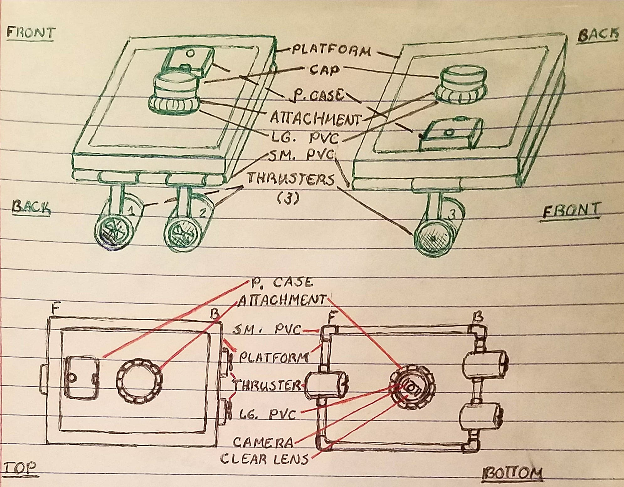
Prototype II
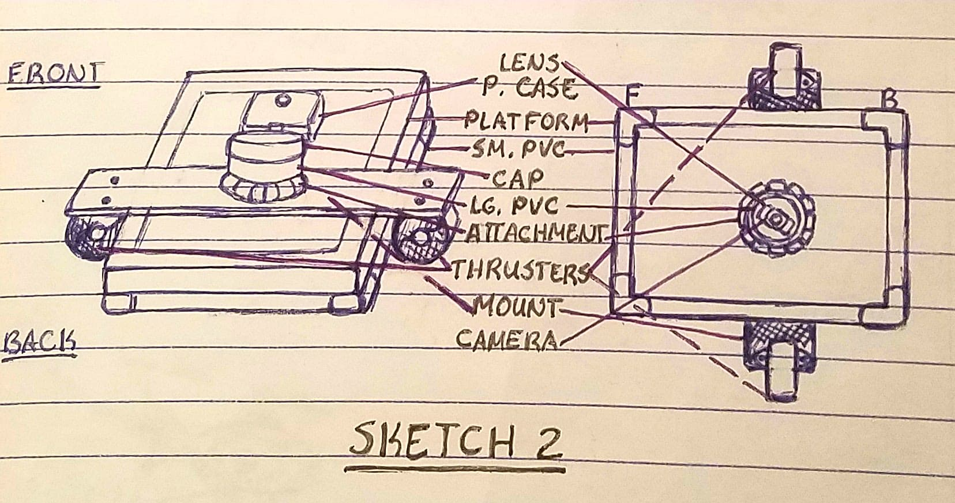
Camera and GPS/Accelerometer Utilized in Prototypes I and II, Bottom Thrusters Utilized in Only Prototype I
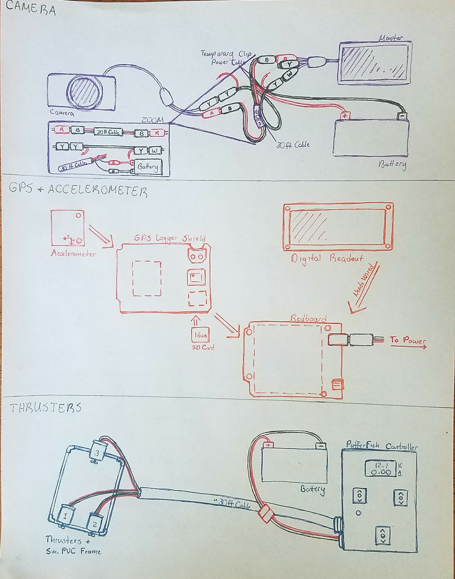

Prototype III
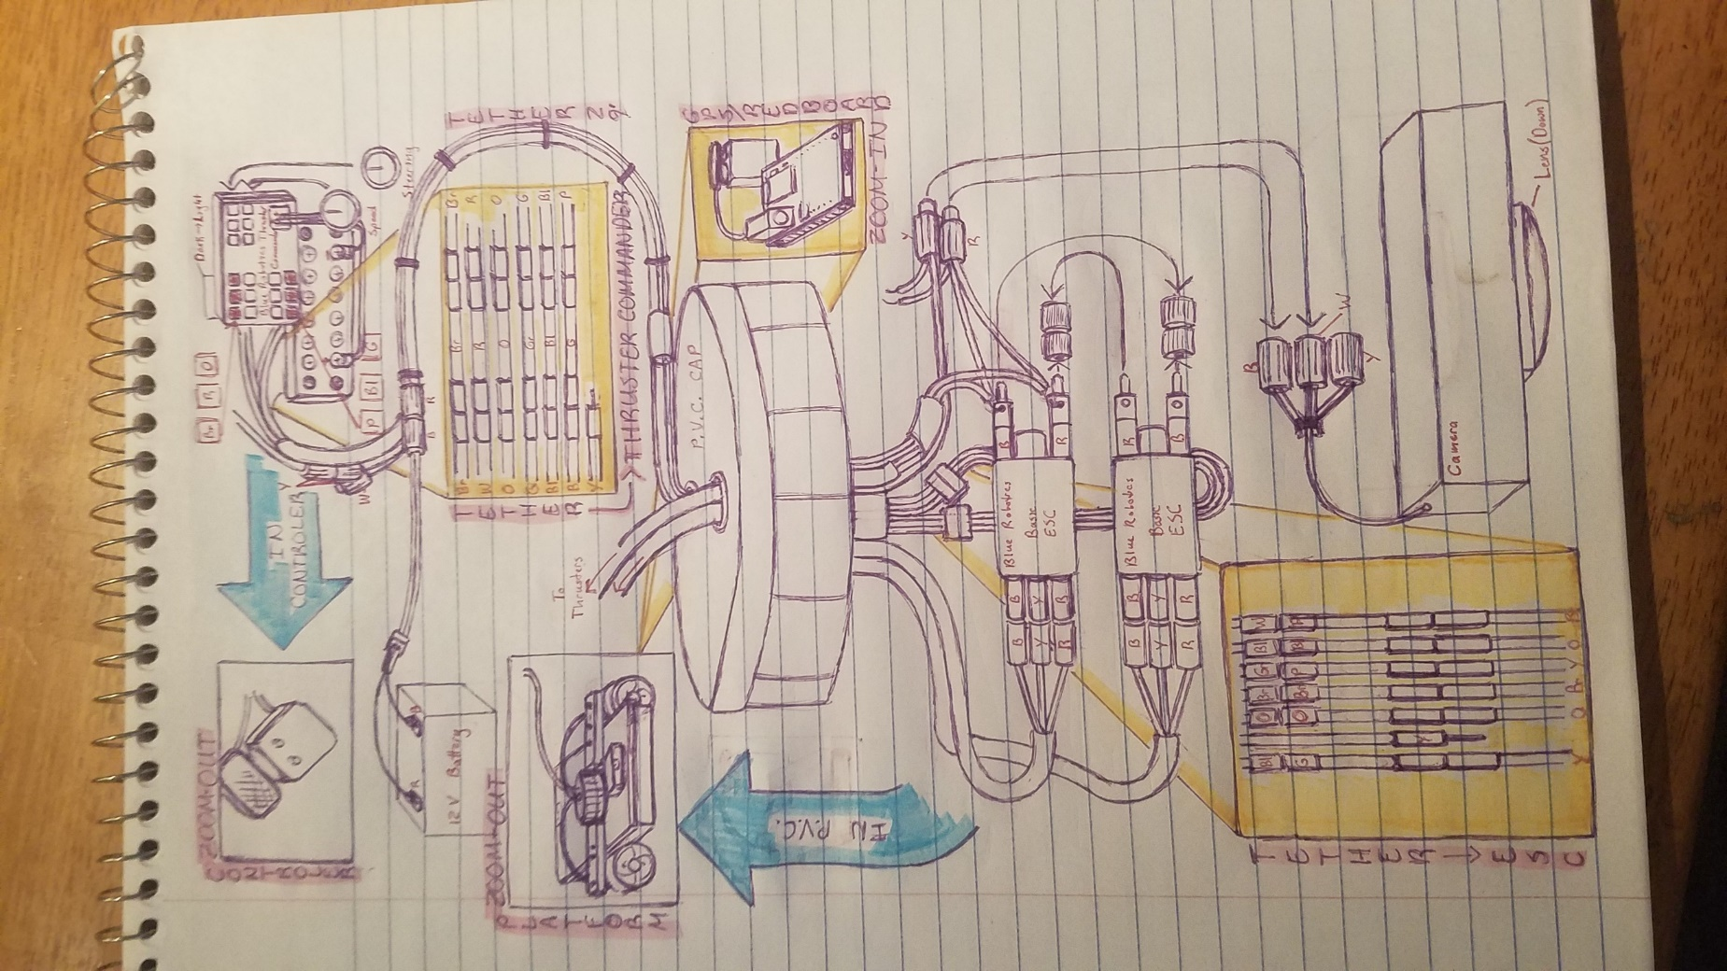
Appendix E – Prototype Build and Testing Photo Documentation

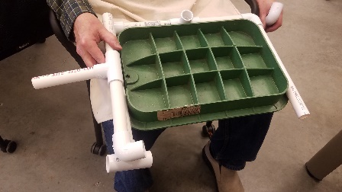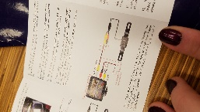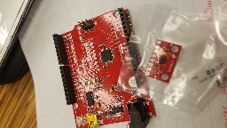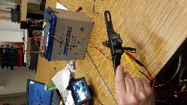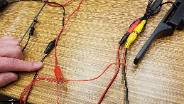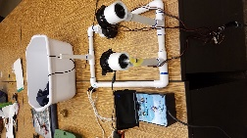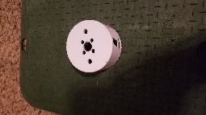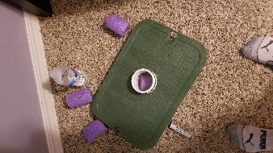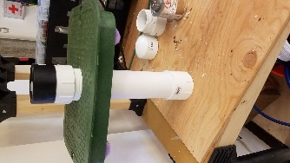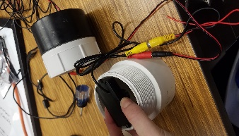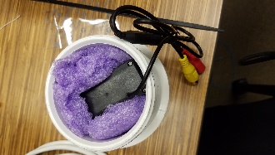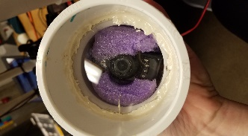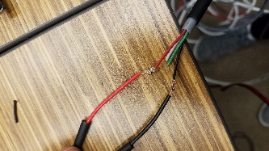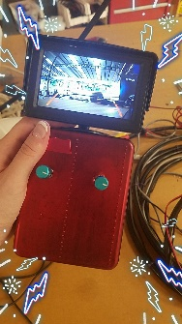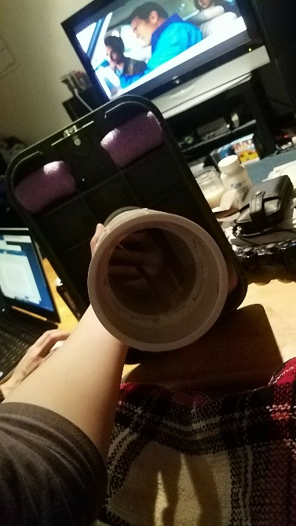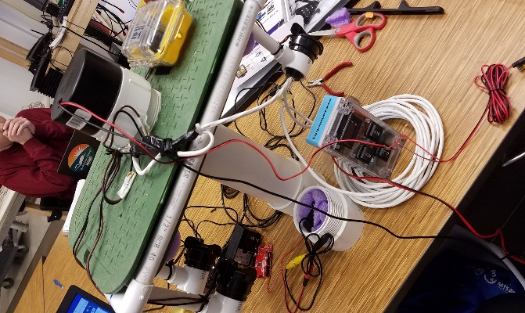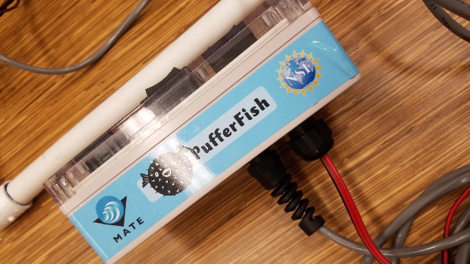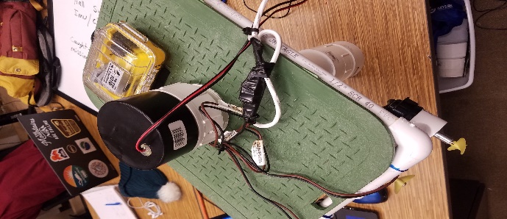
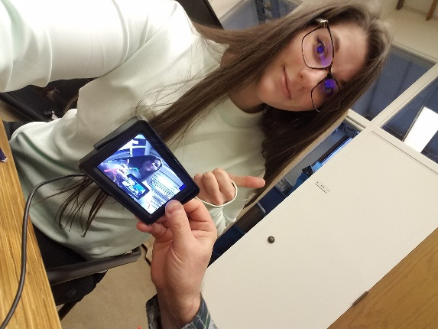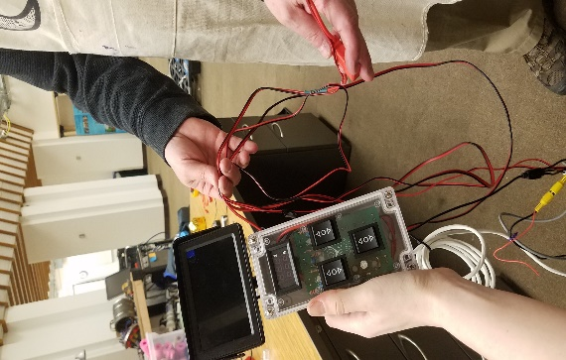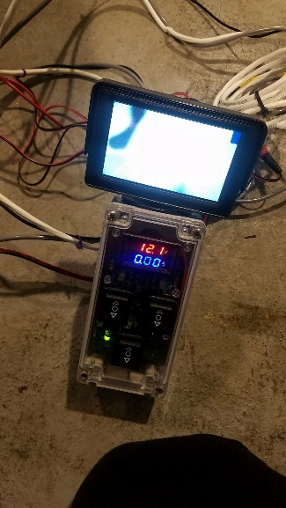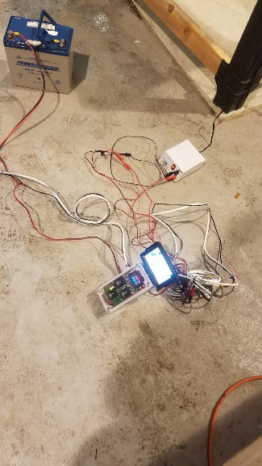
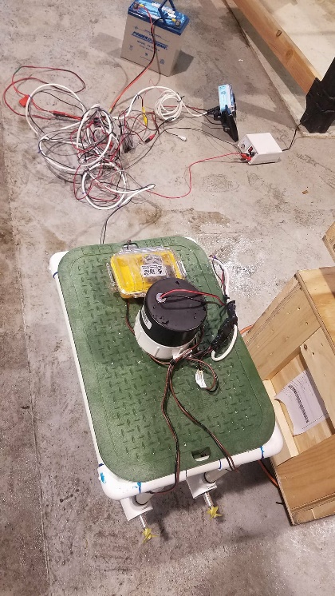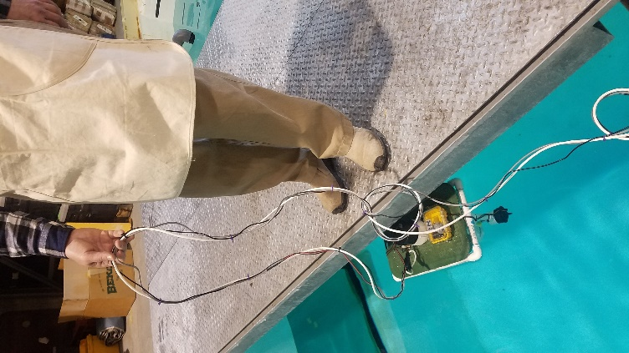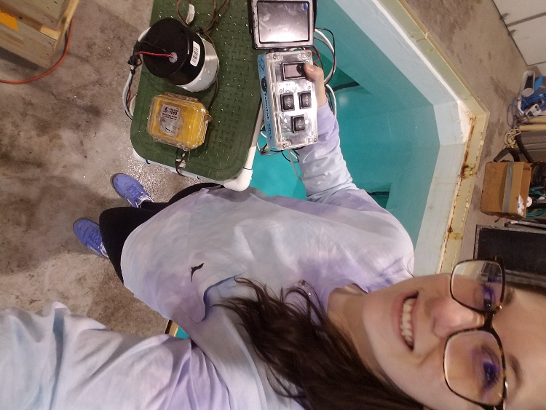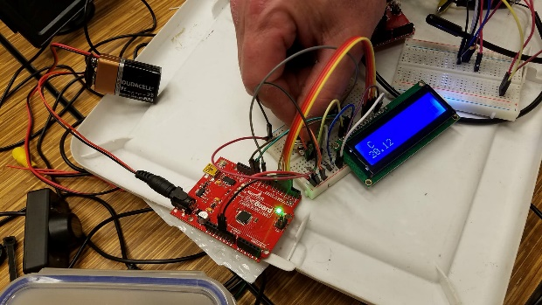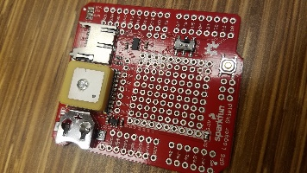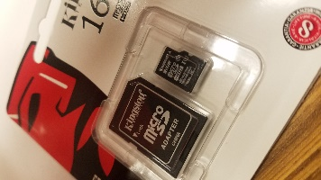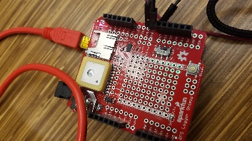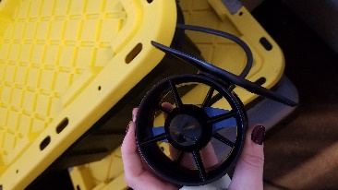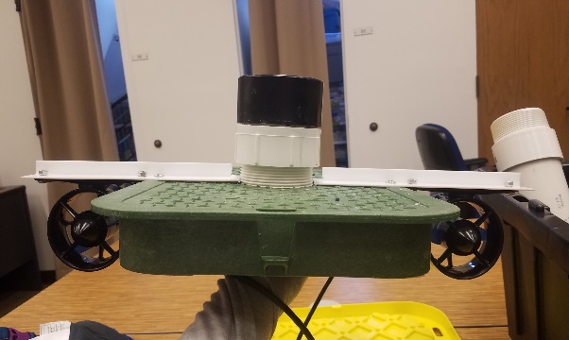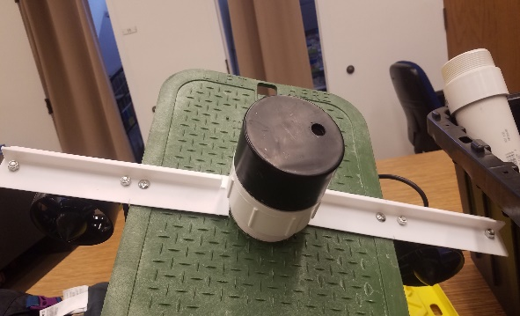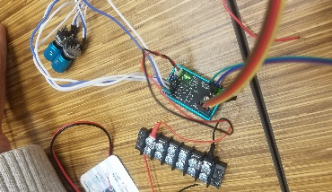
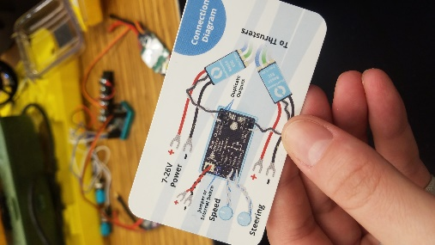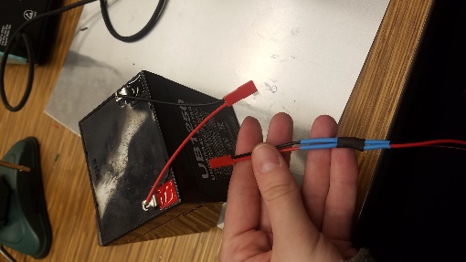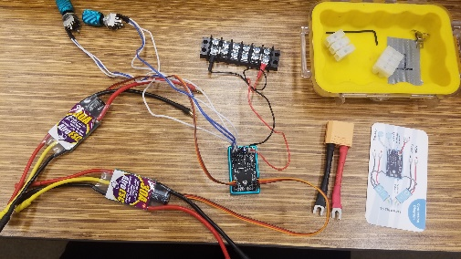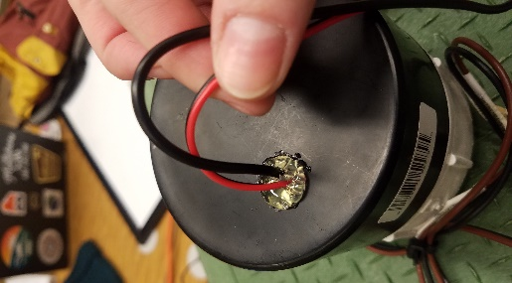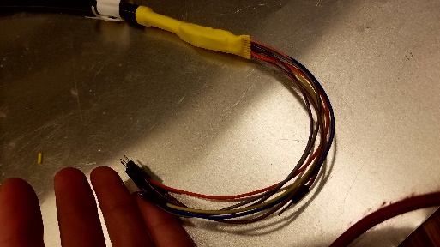

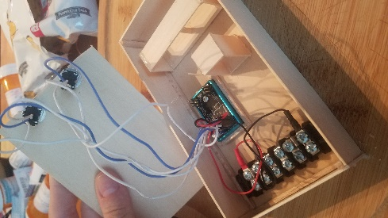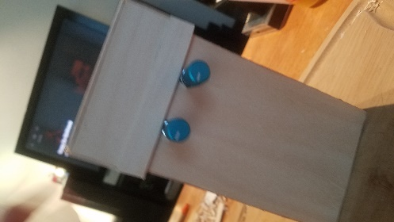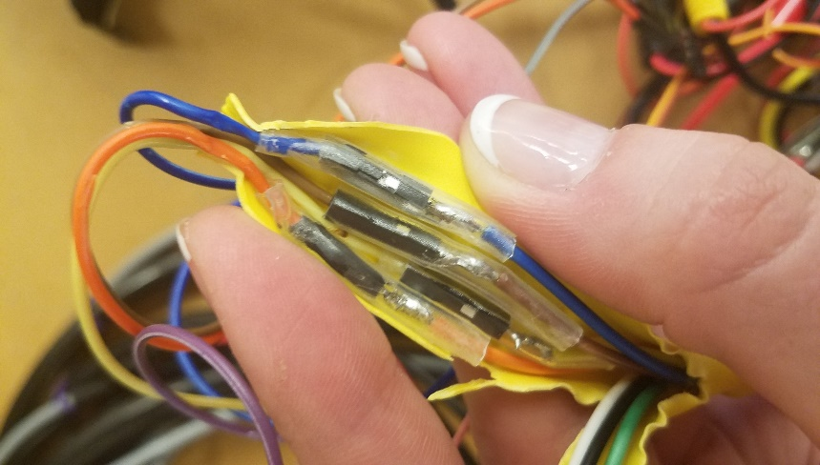
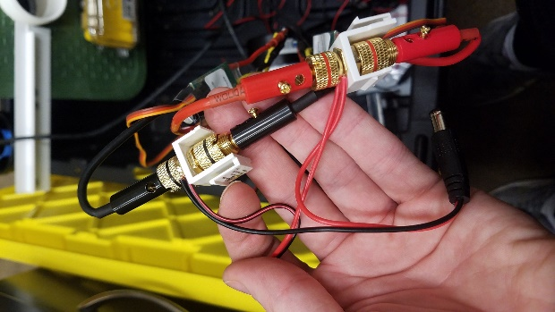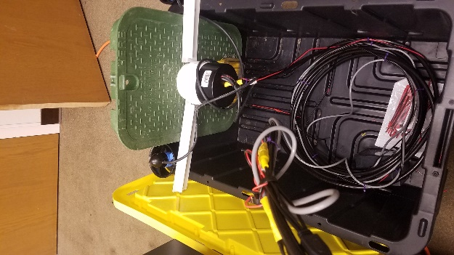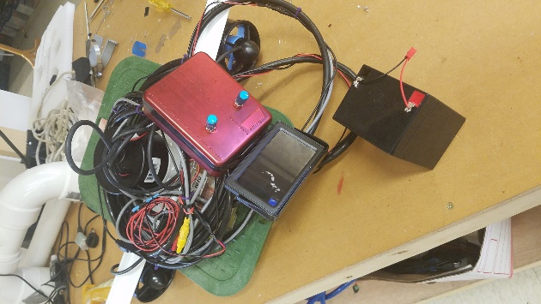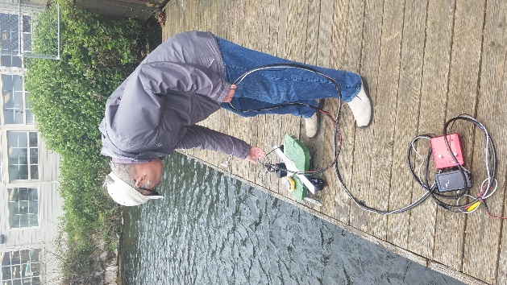
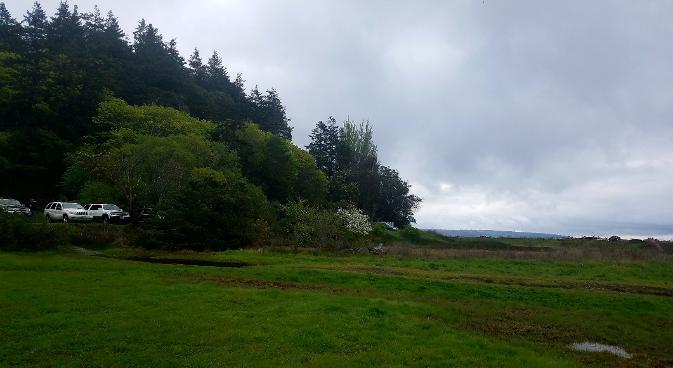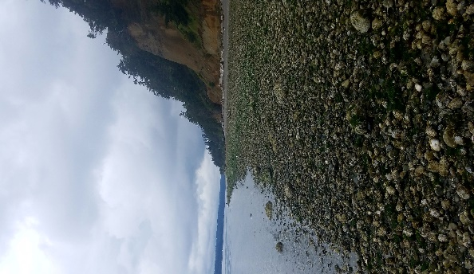
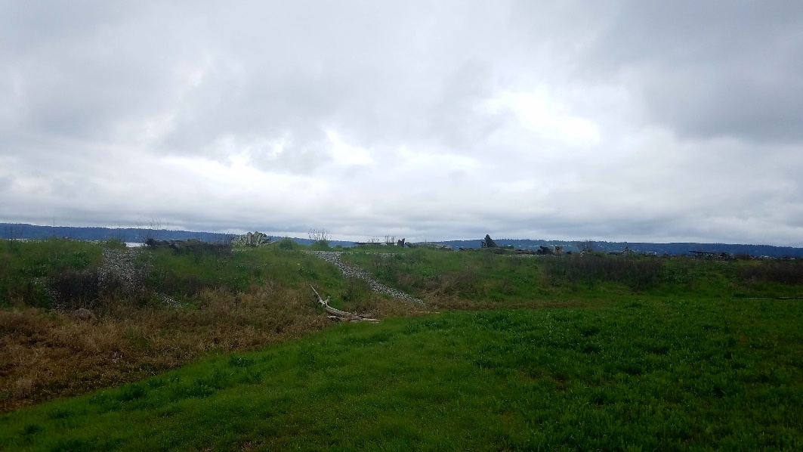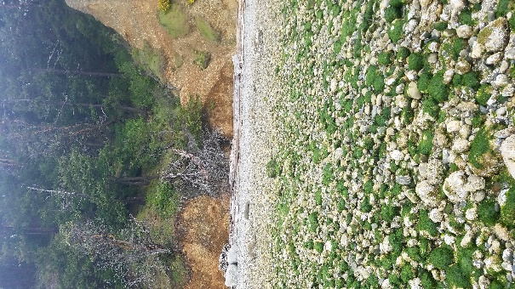
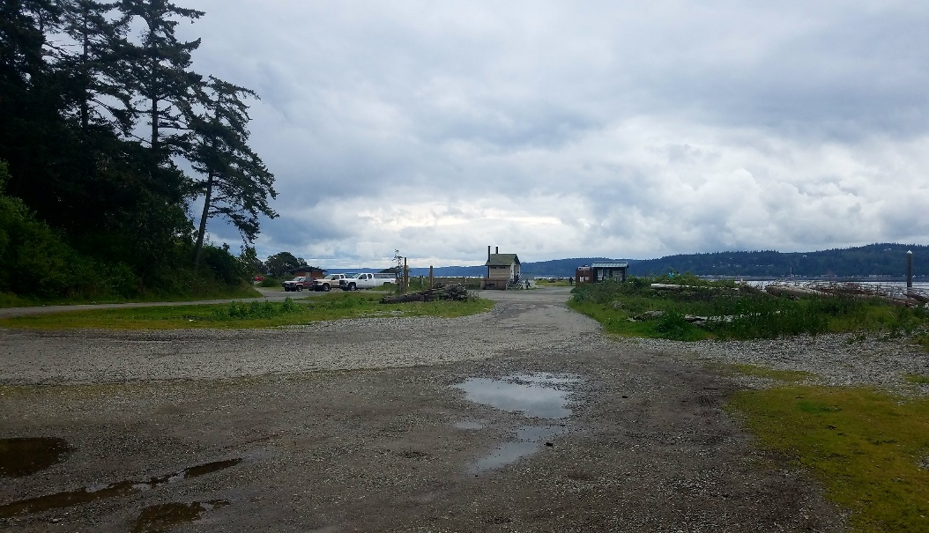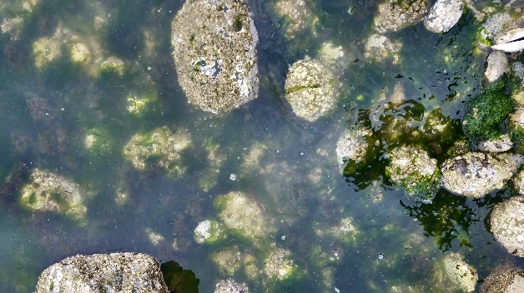
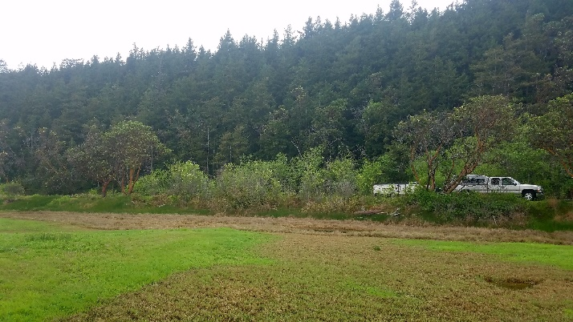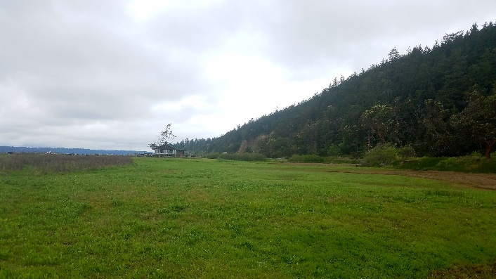
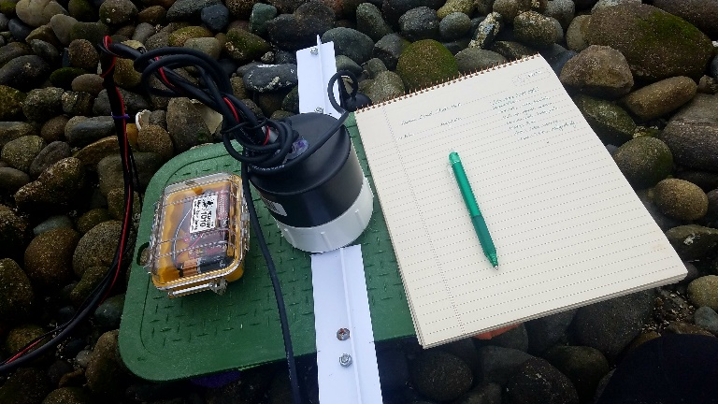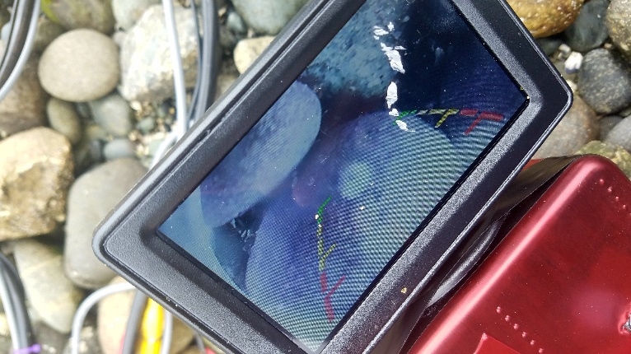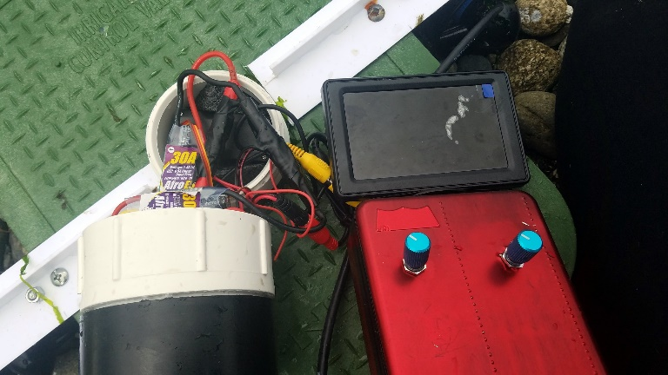
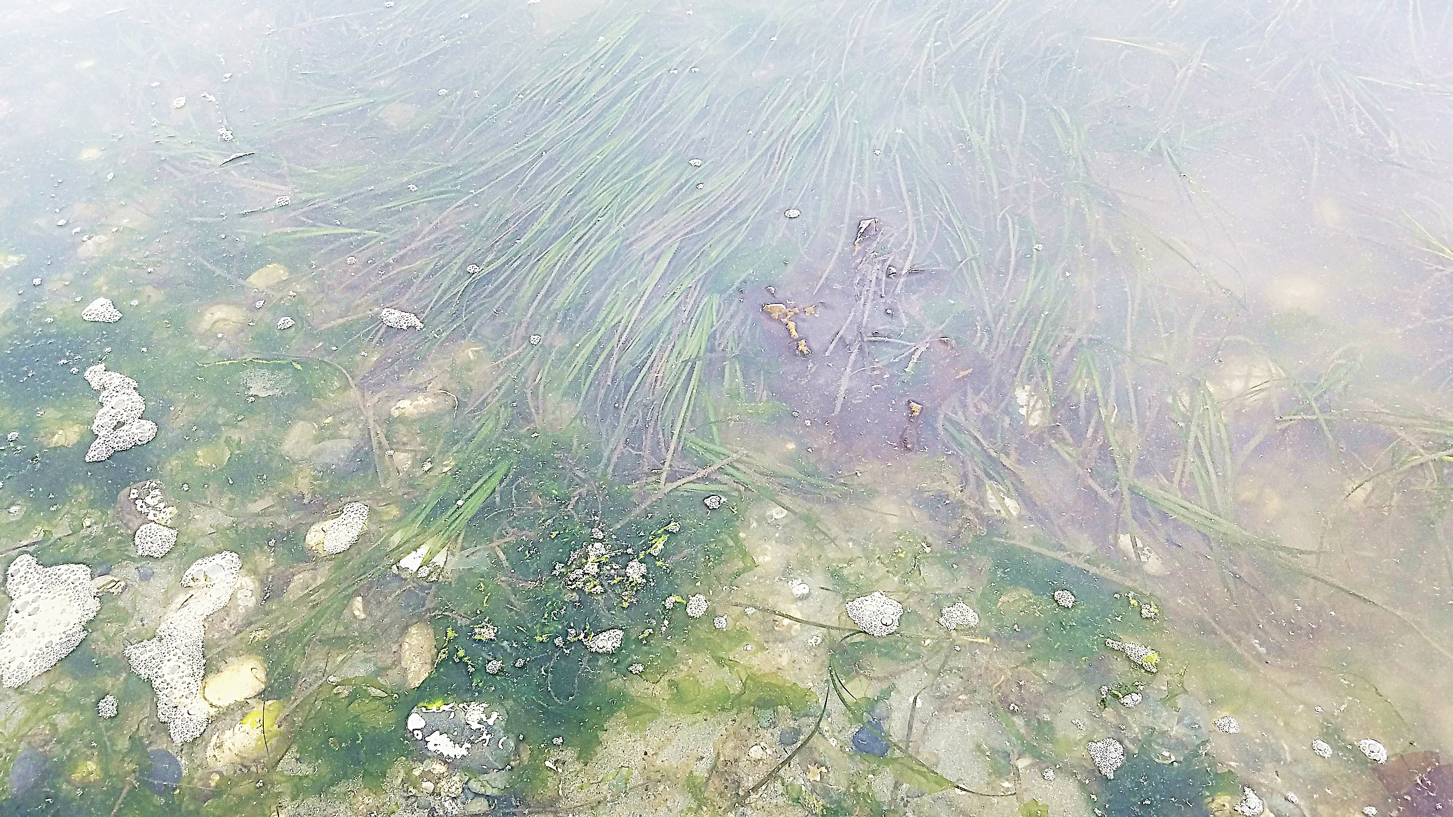

Appendix F – Background Research Using ArcGIS

