“The Blob”:
A Warm Anomaly’s Effect on Interannual Variability of Eastern Subtropical Mode Water

Bradley Bartos

University of Washington
School of Oceanography
Seattle WA 98195-5351
bbartos@uw.edu

May 23, 2017

Running Header: Warm Anomalies and Mode Water

Abstract
A high sea surface temperature (SST) anomaly occurred off the western coast of North America in the winters of 2013-2014 and 2014-2015, which scientists and journalist named the “Blob”. The region affected by this anomaly overlaps one of three areas in the North Pacific where water passes through the permanent pycnocline, and into a relatively homogenous, subsurface body of water, termed mode water. We examine the Blob’s effects on North Pacific Eastern Subtropical Mode Water (ESTMW) formation region, 15-45ºN by 125-150ºW. Multiyear averages, climatologies, of the effective subduction rate, subduction volume, and SST are determined from global, empirical datasets. In addition, we compared the climatologies to the years affected by the Blob, determined through yearly datasets and objectively mapped Argo float products. In 2014 and 2015, a SST increase of 2ºC was most prominent across the southern portion of the region. Instead of decreasing mixed-layer depth uniformly across the region, the affected years were marked by expansion of shallow 15-45 meter mixed-layers on the southern edge of the ESTMW formation site and an increase in subduction volume by 1 Sverdrup. Therefore, warm anomalies like “the Blob” could lead to temporary negative feedback on climate change by increasing subduction at mode water formation sites and increasing long-term heat storage as warmer water subducts below the surface.

Introduction
Mode water formation occurs when the water in a deep winter mixed-layer moves along isopycnals, subducts, into a region with a shallow mixed-layer. The denser water is consequently sequestered from the surface in the following years. The mixed-layer subducts throughout the year, but the process only makes it beyond the permanent pycnocline when the mixed-layer is the deepest and densest, during the transition from late winter to spring (Marshall et al., 1992). In the North Pacific, mode water is formed at three primary locations: North Pacific Subtropical Mode Water (NPSTMW) in the west, North Pacific Central Mode Water (NPCMW), and Eastern Subtropical Mode Water (ESTMW) (Qu et al., 2002). Using a high resolution general circulation model, Qu et al. (2002) found the subduction rates of NPSTMW and NPCMW to be >200 m/yr, while the subduction rate ESTMW was >75 m/yr.
The subduction that occurs in mode water formation can have a significant effect on climate. Subduction moves heat, CO₂, and nutrients away from the surface region into long-term storage below the mixed-layer. As global climate changes, the ocean has acted as a sink of heat and CO₂, temporarily mitigating their effects on atmospheric conditions. However, increased sea surface temperatures (SST), and warm anomalies could decrease subduction and decrease the amount of heat and CO₂ storage. Alterations in subduction rate or water properties of ESTMW could have a significant effect, not just on the region of the studied warm anomaly, but on a global scale.
In the winters of 2013/14 and 2014/15, the northeastern Pacific experienced SST anomalies greater than three standard deviations above the mean, caused by a high atmospheric pressure ridge over the Gulf of Alaska (Amaya et al., 2016). Recent research has shown that the event, also called “the Blob”, resulted in changes in weather patterns, CO₂ uptake, and fisheries across the North Pacific and the North American continent. Amaya et al., 2016 showed that the atmospheric ridge that formed the warm anomaly contributed to both sustained drought in California and the abnormally cold winter across the United States. Siedlecki et al., 2016 found that the increase in SST increased the partial pressure of CO₂ by 47%, which caused the region to go from a carbon sink to a carbon source to the atmosphere. The increase in gaseous partial pressure also decreased oxygen levels in the California Current System (CCS), a region that is already affected by hypoxic conditions (Siedlecki et al., 2016). Increased hypoxia negatively impacts zooplankton communities and the fish and fishing industry that depend on them. These are a few of the effects that warm anomalies like “the Blob” can produce.
ESTMW forms on the southern edge of the region directly affected by the warm anomaly: between 25-30º N and 135-140º W (Hautala and Roemmich, 1998). The occurrence of an anomalous event over a consistent mode water formation site makes this a prime opportunity to study the potential subsurface effects of anomalies like the “the Blob”. This study specifically analyzed interannual variability in ESTMW formation rate to determine if an event such as “the Blob” affected subduction rate, subduction volume, or mode water temperature.

Data and Methods
With the increase in satellite coverage and float deployment, empirical, high-resolution datasets that allow for complex calculations like subduction rate are now available. Each dataset used in this study (Table 1) exists on a grid over the study region, 15-45ºN by 125-150ºW, with resolution between quarter-degree and two-degree and is the product of satellite altimetry or mapping with Argo floats.
Table 1
Dataset  (Variable) (units) | Temporal Scale | Spatial Grid | Time Period | Source
National Centers for Environmental Prediction (NCEP)  (τ_{w}) (Nm⁻²) | Daily | 2º | 1948 - present | Kalney et al., 1996
Archiving, Validation, and Interpretation of Satellite Oceanographic data (AVISO)  (u_{g}) (ms⁻¹) | Monthly | 0.25º | 1993 - present | Morrow and Le Traon, 2012
Monthly Isopycnal and Mixed-layer Ocean Climatology (MIMOC)  (h) (m) | Monthly | 0.5º | 1970 - present | Schmidtko et al., 2013
Mixed-layer Depth  Climatology and Profiles  (h) (m) | Monthly and Profiles | 1º and Profiles | 2000 - present | Holte et al., 2016
Objectively Analyzed air-sea Flux (OAFlux)  (SST) (ºC) | Monthly | 1º | 1958 - present | Yu and Weller, 2007

The subduction rate climatology, a multiyear average, was calculated first. The datasets provided by NCEP, Aviso, and MIMOC were smoothed to a monthly temporal grid and 1º spatial grid covering the study region, 15-45ºN and 125-150ºW. Since subduction is only effective for a relatively short period of time at the end of winter, subduction rates averaged over February through April were calculated. The mean of these three months is a close-approximation for annual subduction (Marshall et al., 1993).
Both the climatology and annual rates of subduction, S, were calculated with the formula,
$S = w_{e} – (β/f)v_{g}h + u_{g}⋅∇h$ (Marshall et al., 1993). (1)
- Where w_{e}, annual mean vertical Ekman pumping, was calculated from wind stress numerical modeling provided by NCEP. Wind stress was converted to Ekman pumping through the formula, $w_{e}=-∇×{(τ}_{w}/(ρ_{o}f))$, where ρ_{o} is the standard potential density for the ocean, f is the Coriolis parameter, and τ_{w} is the wind stress.
- f, the Coriolis parameter, depends only on latitude and was calculated with the formula $f=2Ω\sin{(latitude)}$ where Ω is the rotation rate of the earth.
- β, the meridional gradient of f, was calculated as β = df/dy.
- u_{g} and v_{g}, annual mean geostrophic velocity in the formation region and its meridional component, were obtained from Aviso.
- h and ∇h, mixed-layer depth and horizontal mixed-layer depth gradient, were taken from MIMOC (Schmidtko et al., 2013) and individual Argo profile analysis by Holte et al. (2016).
To calculate the annual subduction rate for 2005 through 2015, annual wind stress and geostrophic velocity was available. To create annual mixed-layer depth, the Holte et al. (2016) binned climatology was removed from the mixed-layer depths for individual Argo profiles, and the resulting anomaly was objectively mapped (Davis, 1985) onto the same 1º grid as the subduction climatology. Because the Holte et al. (2016) climatology is the result of simple binning, the smoother climatology, MIMOC, was added back to the anomaly to obtain yearly mixed-layer depths.
To quantify total subduction rate, subduction volume, the subduction region was defined by restricting the data to areas with greater than a threshold, 50 myr⁻¹. Subduction volume was calculated for each year by multiplying subduction across the subduction region by the area of the region, using the formula:
$\int{S_{50}dxdy}=\sum{\sum{S_{50ij}Δx_{i}Δy_{j}}}$ (2)
- Where S₅₀ is the values of subduction greater than 50 myr⁻¹.
- $Δx_{i}$ is the width between grid points in the zonal direction.
- $Δy_{j}$ is the width between grid points in the meridional direction.
The same threshold of 50 myr⁻¹ was used to find the annual averages of all the components of subduction and SST within the subduction region.

Results
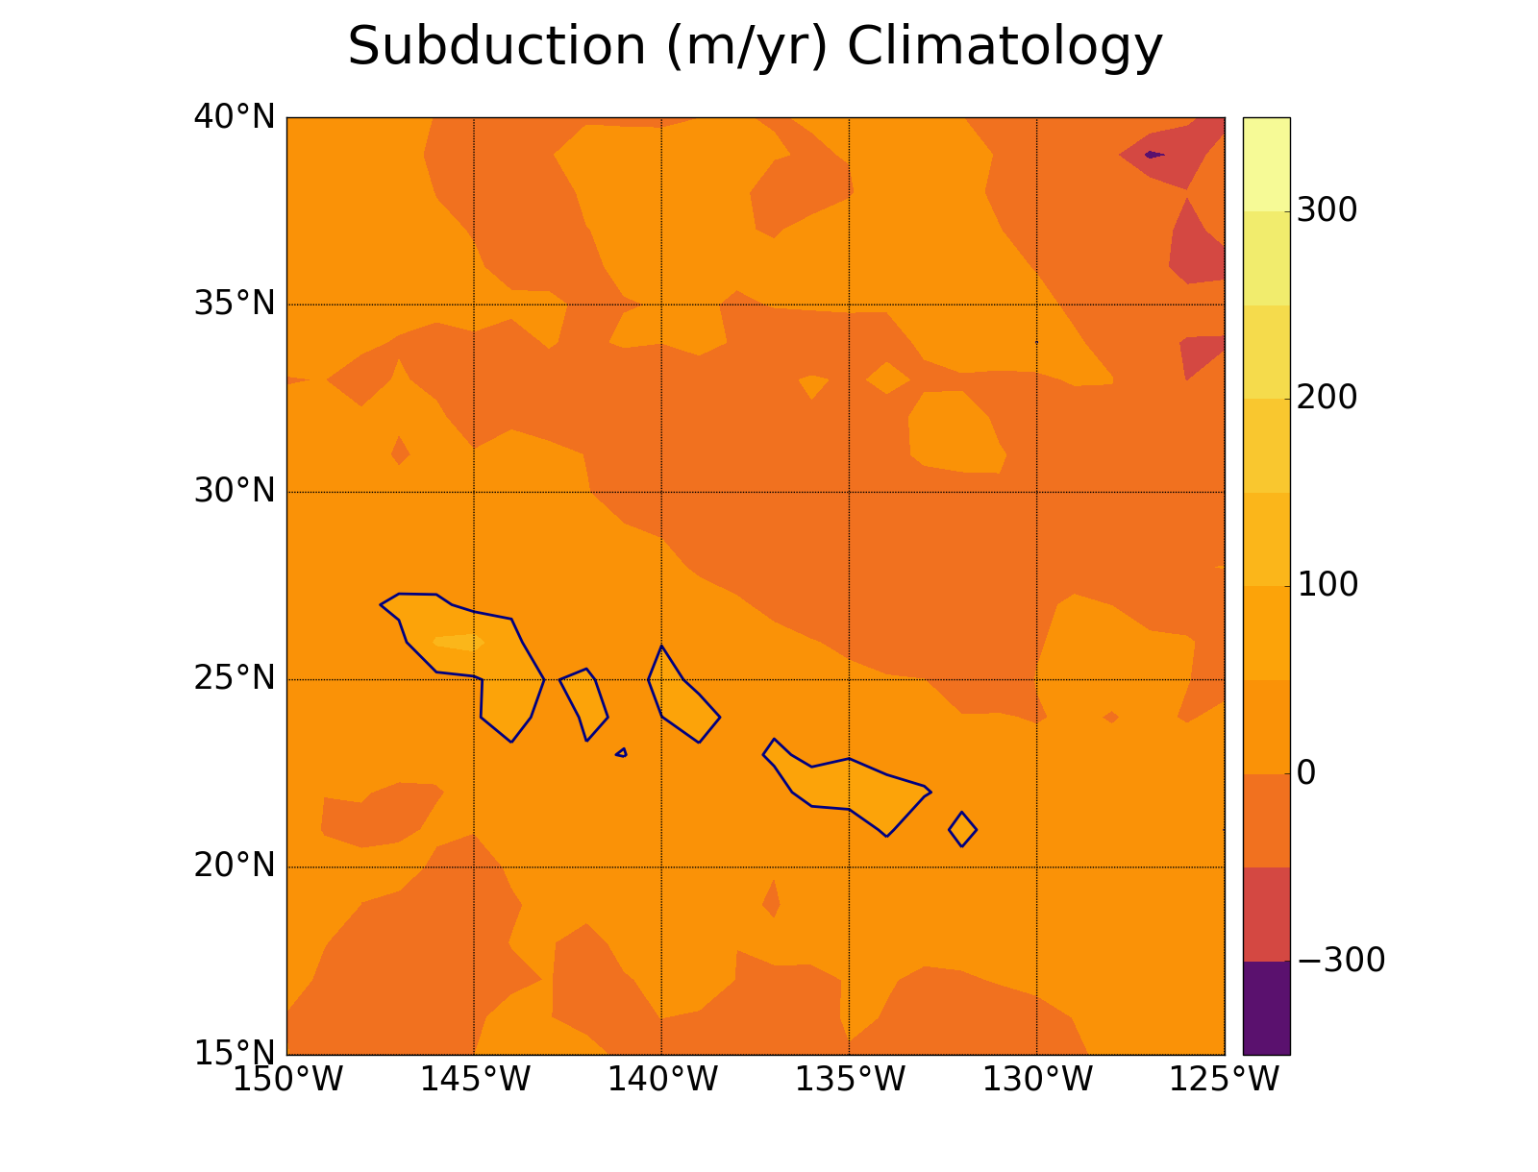
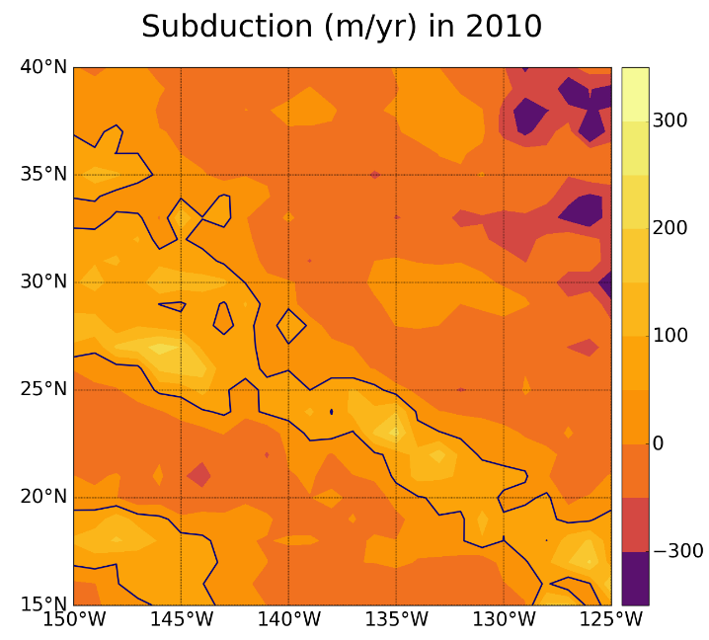
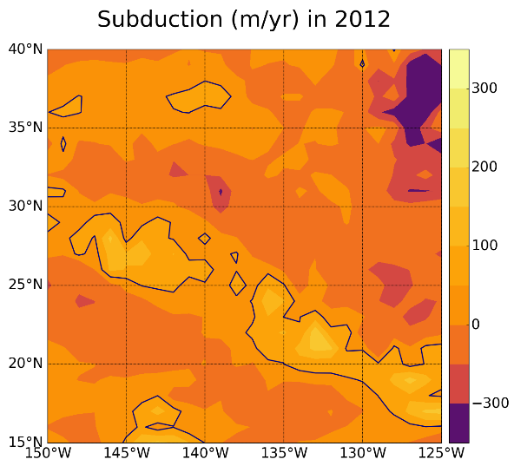
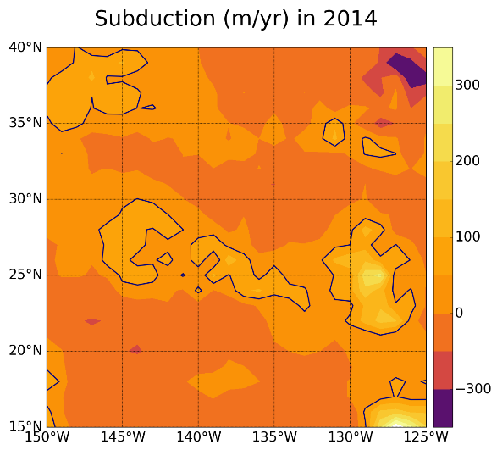
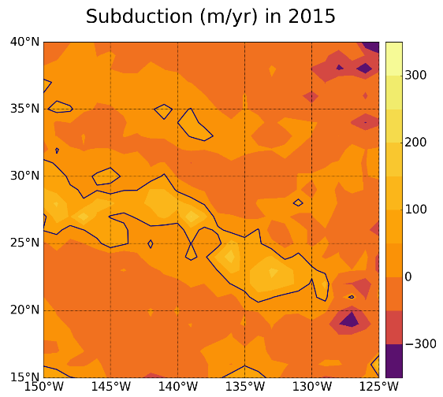
The subduction climatology (Figure 1) and yearly subduction (Figure 2) both indicate a band of mode water formation from the northwest at 30ºN and 150ºW to the southeast at 20ºN and 130ºW. The latitude of this region is consistent, though the highest subduction areas within the region shift between 130 and 145ºW. The years 2010 and 2015 are examples of a long mode water formation band, while 2012 and 2014 are examples of smaller areas with high intensity concentrated at specific points (Figure 2). In the climatology, the maximum subduction is relatively small in magnitude, only 50-150 myr⁻¹ (Figure 1). In yearly subduction products, high subduction regions have between 100-400 myr⁻¹ and occupy a larger area (Figure 2). Along with the mode water formation region indicated by high subduction rate, there are also large magnitude negative subduction rates. Negative subduction is termed obduction and quantifies the movement of water from below the permanent or seasonal thermoclines into the mixed-layer. Two primary obduction regions occur at approximately 40ºN 125ºW and 30ºN 135ºW (Figure 2). The first region appears to be larger than the second, with obduction rates >500 m/yr and 100-300 m/yr respectively, and both regions are less prominent in the climatology when compared with yearly results.
Figure 1. Subduction climatology generated from dataset climatologies. 50 m/yr contour is highlighted to mark the region of high subduction. This region is much smaller than in yearly subduction datasets.

Figure 2. Annual subduction for select years. The 50 m/yr contour is highlighted to emphasize regions of mode water formation. See Appendix 1 for entire range of years.

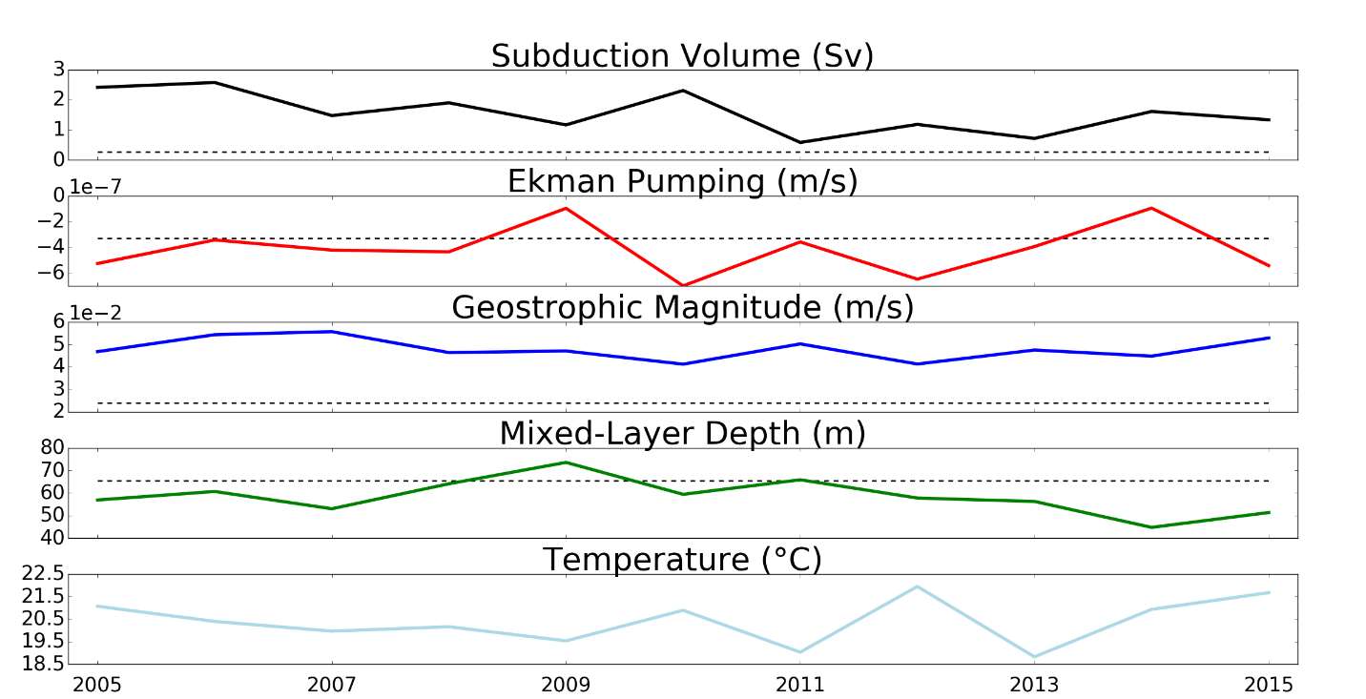
Subduction volume, Sv, was calculated to quantify the magnitude of yearly subduction and compare with the components of subduction: ekman pumping, geostrophic magnitude, and mixed-layer depth. The years 2014 and 2015 are marked by high SST and low mixed-layer depth, evidence of the effect of “the Blob” (Figure 3). In the same period, subduction volume increased by 1 Sv from the previous three years. The climatology of subduction volume was significantly lower than the annual values, similar to subduction rate (Figure 3).
Figure 3. Subduction volume and annual averages of Ekman pumping, geostrophic magnitude, mixed-layer depth and temperature in the region of subduction greater than 50 m/yr. Dashed lines indicate climatological averages within the same region.

The other yearly datasets may provide some insight into regional trends. In general, SST decreases with latitude from 26ºC at 15ºN to 10ºC at 40ºN (Figure 4). The years affected by “the Blob”, 2014 and 2015, show a shift northward in this trend, with larger areas of 26ºC in the south and a minimum of 12ºC in the north. Mixed-layer depth is more complex, though there is also some consistency between years with the deepest region around 30ºN and the shallowest region at 20-25ºN (Figure 5). In 2014 and 2015, there is a wider swath of the region around 15-45 m deep as opposed to 30-60 m deep in 2010 and 2012.
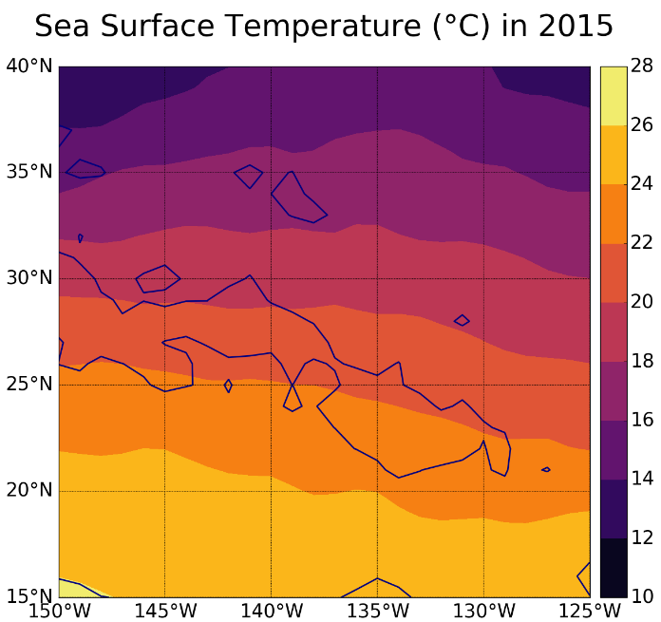
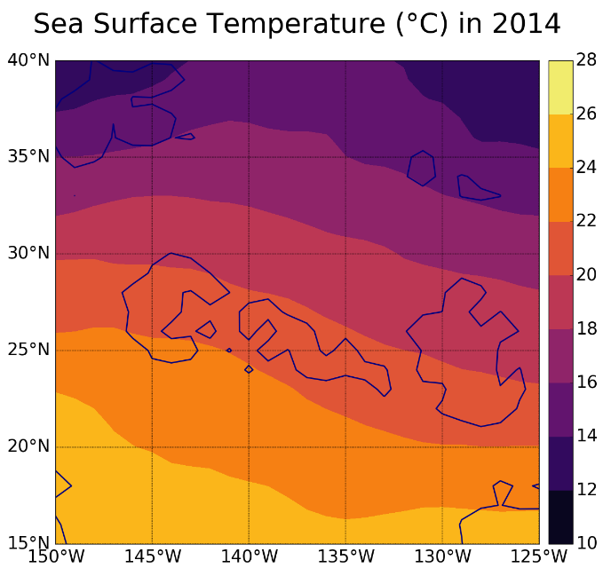
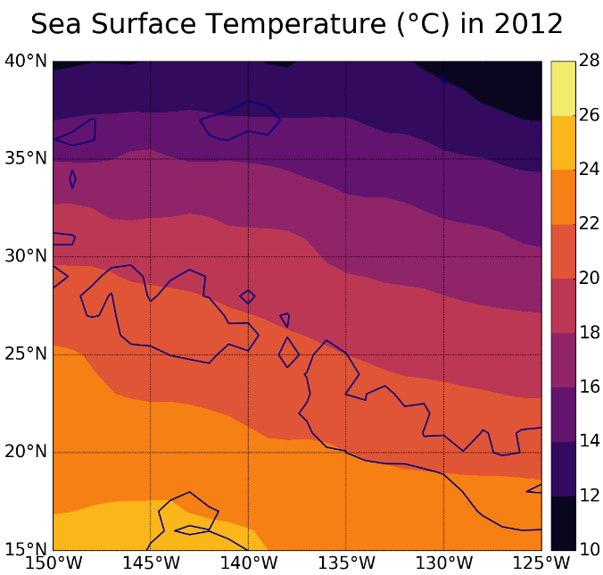
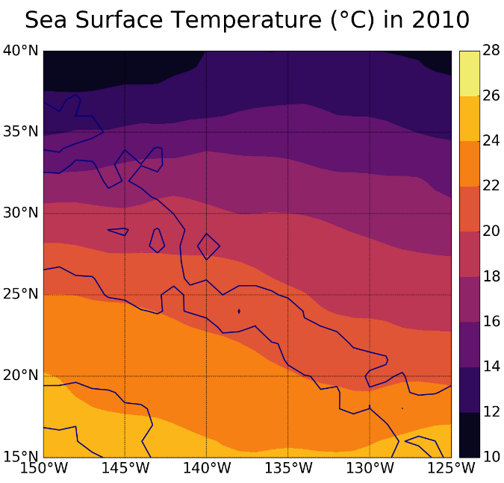
Figure 4. SST for select years. The same contour of subduction greater than or equal to 50 m/yr is outlined here for easier comparison between datasets. See Appendix 4 for complete range of years.
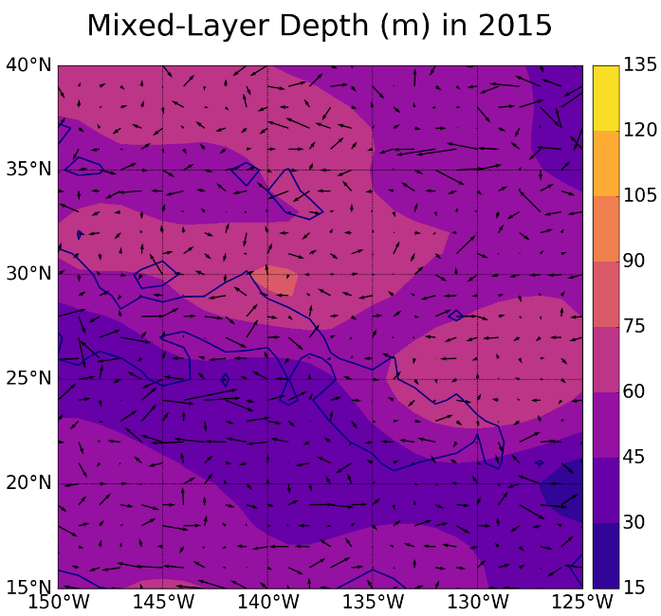
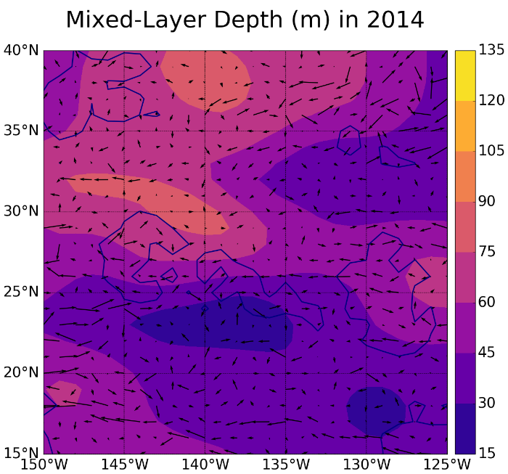
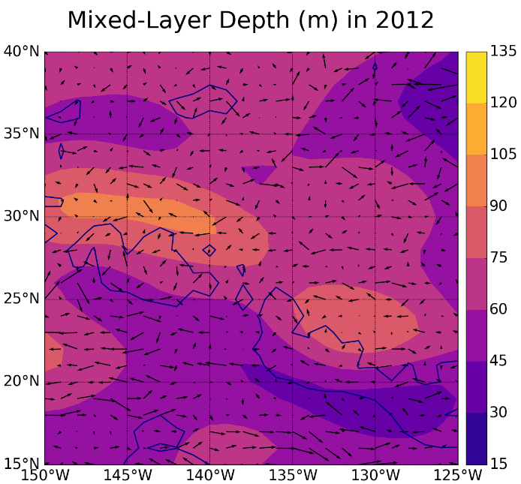
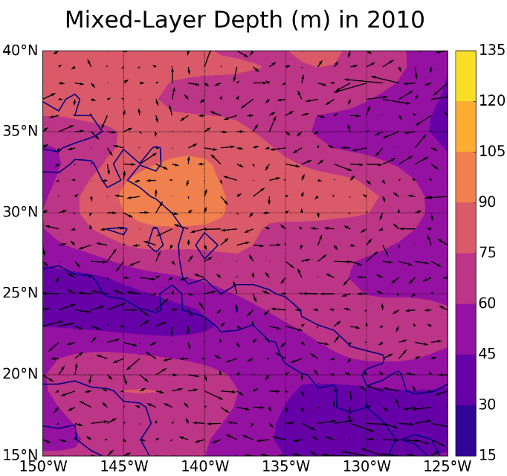
Figure 5. Mixed-layer depth for select years. High subduction, 50 m/yr, contour is marked, as well as vectors indicating magnitude and direction of geostrophic currents. See Appendix 3 for complete range of years.

Discussion
The subduction climatology is consistent with the previous studies on mode water formation. Hautala and Roemmich (1998) originally used potential vorticity from measurements along ship tracks to identify the ESTMW formation site within 25-30º N 135-140º W. Qu et al. (2002) used a general circulation model to show that ESTMW subduction rate is >75 m/yr. The subduction climatology produced here is consistent with both studies (Figure 1), indicating that it is now possible to use existing datasets based on satellite and Argo floats to determine yearly subduction within the standards of more sparse ship data and models. However, the average of a shifting maximum region significantly dampens the magnitude of subduction rate in the climatology. A climatology may not be the best representation of subduction at mode water formation sites.
Subduction volume does not vary simply with the change in any of the individual components: ekman pumping, geostrophic velocity, or mixed-layer depth (Figure 3). Subduction volume most closely resembles the annual changes in SST. Warmer SST in 2014 and 2015 (Figure 4) are associated with decreased mixed-layer depth in the southern portion of the study area (Figure 5), which may have caused increased mixed-layer depth gradient and lateral induction in the mode water formation site. Lateral induction occurs when the geostrophic current moves water from deep northern mixed layers along the isopycnals and below the increasingly shallow southern mixed-layers. The increased lateral induction accounts for the increased subduction volume in 2014 and 2015 (Figure 3). Therefore, “the Blob” and other warm anomalies could lead to an increase in mode water formation.
To further assess formation rate, a dataset of potential vorticity at the density of ESTMW could be created from individual Argo floats. Potential vorticity is a measure of isopycnal thickness and is used to determine the current volume of mode water. Yearly potential vorticity could show changes in volume of subsurface mode water to see if the increased formation rate significantly changes the subsurface signal.
Variations in temperature of water subducted may also be significant in assessing the impact of warm anomalies. If increased temperature leads to increased subduction, then mode water may be storing more heat than expected. Further study on the heat content of mode water is necessary to fully understand how warm anomalies could impact climate. Heat content may need to be assessed during the summer, when exchange with the surface has been cut off. This would require more yearly, fine-scale data at depths below the mixed layer, not just SST. As oceanographic instruments and data analysis continues to progress, annual heat content of mode water may become possible to obtain.

References
Amaya D., N. Bond, A. Miller, and M. DeFlorio. 2016. The evolution and known atmospheric forcing mechanisms behind the 2013-2015 North Pacific warm anomalies. US Clivar Variations 14, 2: 1-6.
Bond N., M. Cronin, H. Freeland, and N. Mantua. 2015. Causes and impacts of the 2014 warm anomaly in the NE Pacific. Geophys. Res. Lett. 42, 9: 3414-3420. doi: 10.1002/2015GL063306.
Davis, R. E. 1985. Objective mapping by least squares fitting. J. Geophys. Res. 90: 4773–4777, doi:10.1029/JC090iC03p04773.
Hautala, S., and D. Roemmich. 1998. Subtropical mode water in the Northeast Pacific Basin. J. Geophys. Res. 103, C6: 13,055-13,066.
Holte, J., J. Gilson, L. Talley and D. Roemmich. 2016. Argo Mixed Layers. Scripps Institution of Oceanography, UCSD. http://mixedlayer.ucsd.edu. 2016-11-20. May 2017.
Kalnay, E. et al. 1996. The NCEP/NCAR 40-year reanalysis project. Bull. Amer. Meteor. Soc., 77, 437-470. doi: 10.1175/1520-0477(1996)077<0437:TNYRP>2.0.CO;2.
Marshall, J., G. Nurser, and R. Williams. 1993. Inferring the Subduction Rate and Period over the North Atlantic. J. Phys. Ocean. 23: 1315-1429.
Morrow, R., & P.-Y. Le Traon, (2012) Recent advances in observing mesoscale ocean dynamics with satellite altimetry. Adv. Space Res., 50,1062–1076.
Qu, T., S. Xie, H. Mitsudera, A. Ishida. 2002. Subduction of the North Pacific Mode Waters in a Global High-Resolution GCM. J. Phys. Ocean. 32: 746-763.
Siedlecki S., E. Bjorkstedt, R. Feely, A. Sutton, J. Cross, and J. Newton. 2016. Impact of the Blob on the Northeast Pacific Ocean biogeochemistry and ecosystems. US Clivar Variations 14, 2: 7-12.
Schmidtko, S., G. Johnson and J. Lyman. 2013. MIMOC: A Global Monthly Isopycnal Upper-Ocean Climatology with Mixed Layers. J. Geophys. Res. 118. doi: 10.1002/jgrc.20122.
Yu, L., and R. A. Weller, 2007: Objectively Analyzed air-sea heat Fluxes (OAFlux) for the global oceans. Bull. Ameri. Meteor. Soc., 88, 527-539.

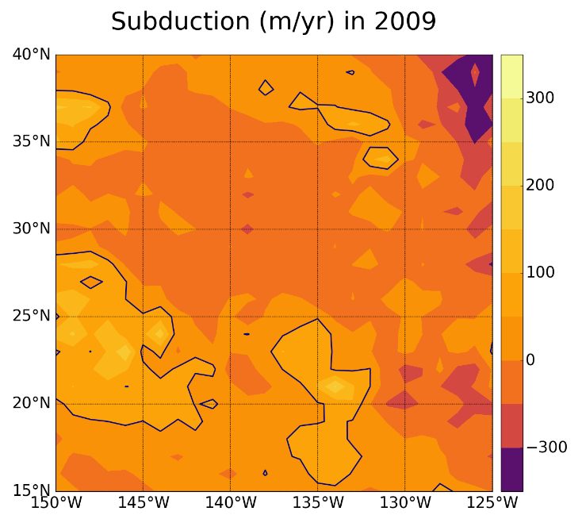
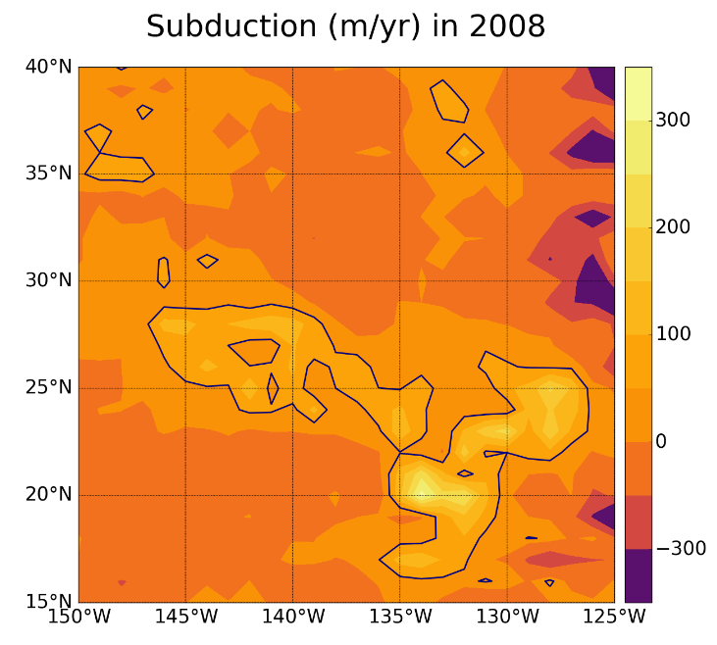
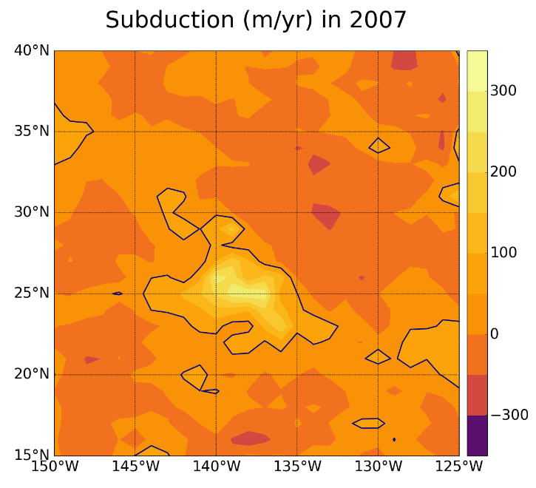
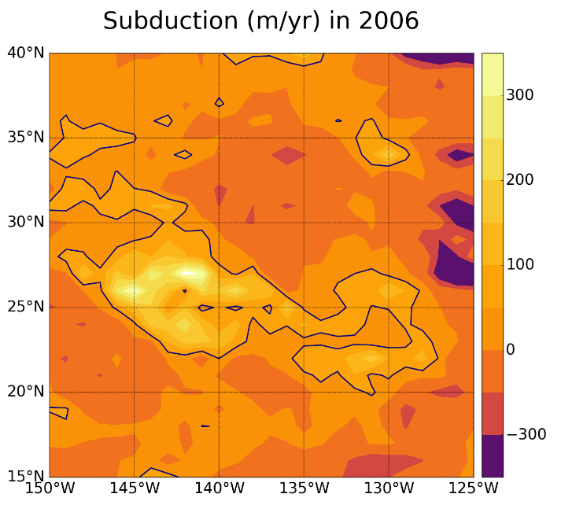
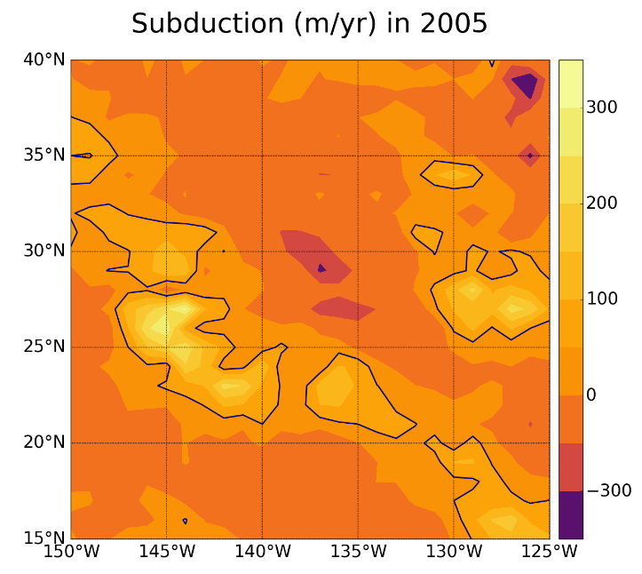
Appendix 1 – Subduction
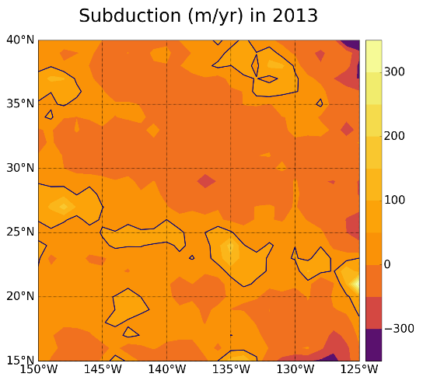
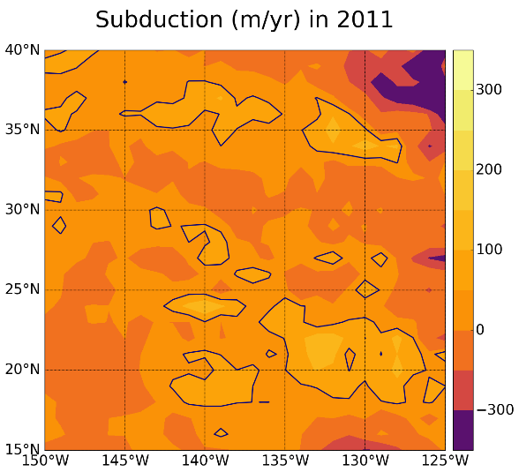
Appendix 1 – cont.

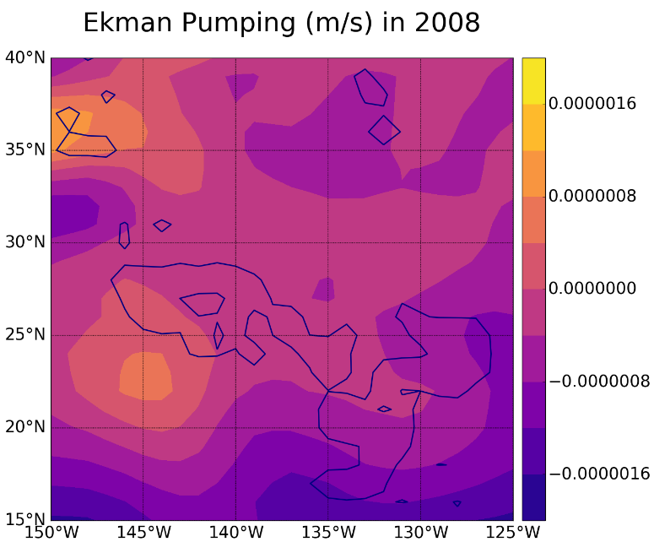
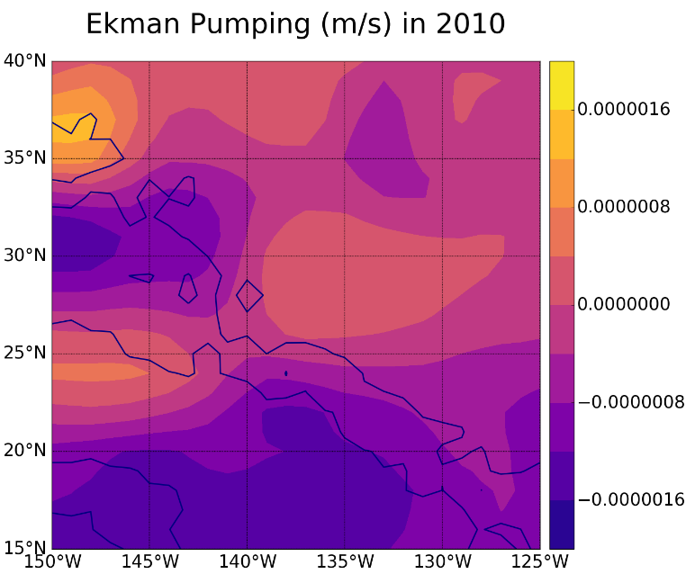
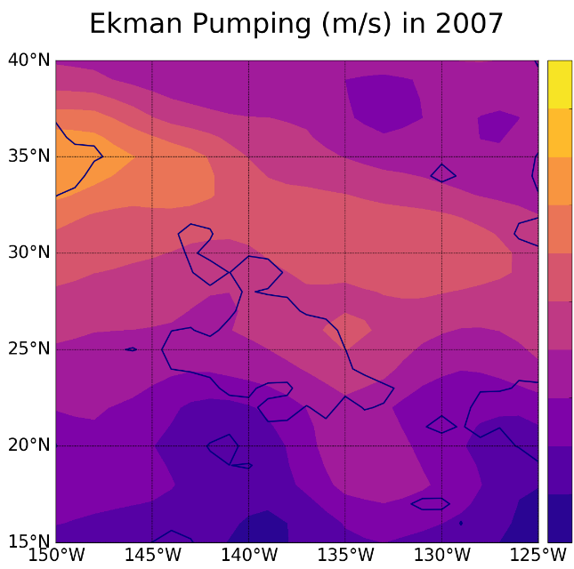
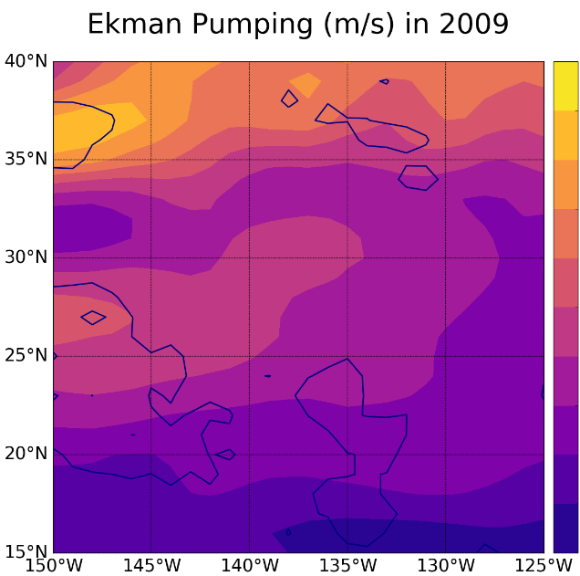
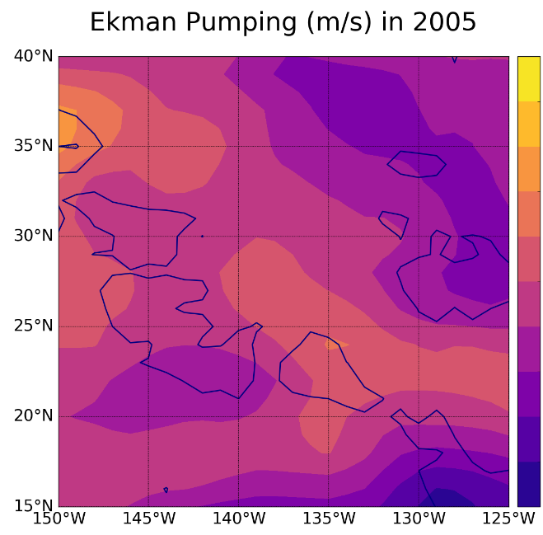
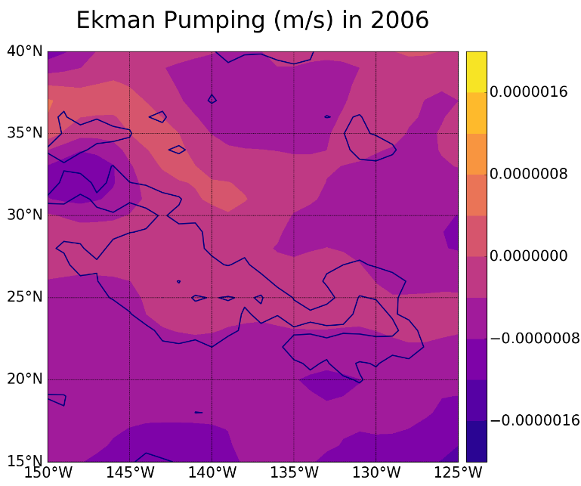
Appendix 2 – Ekman Pumping
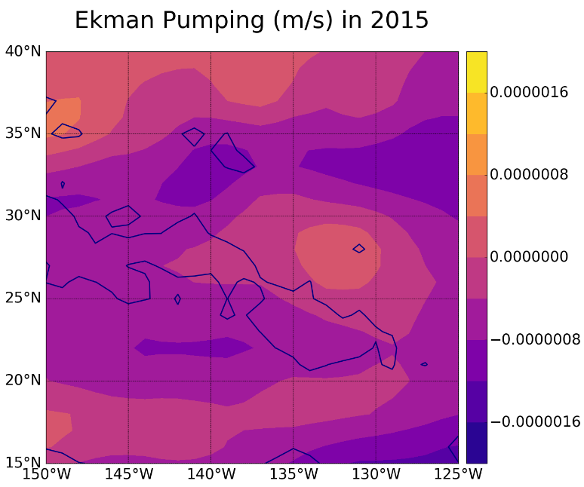
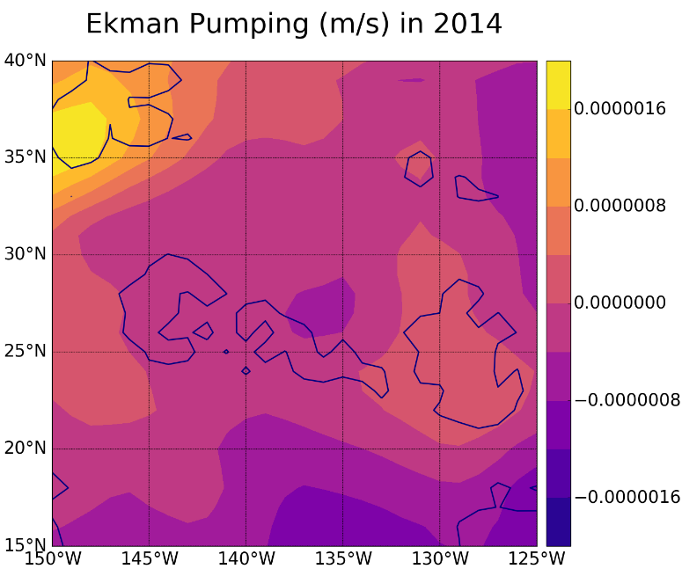
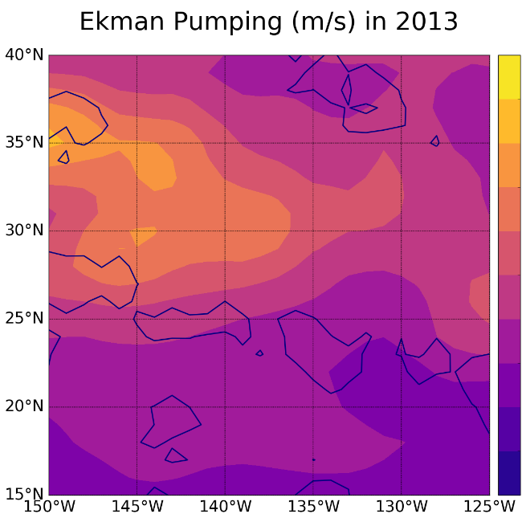
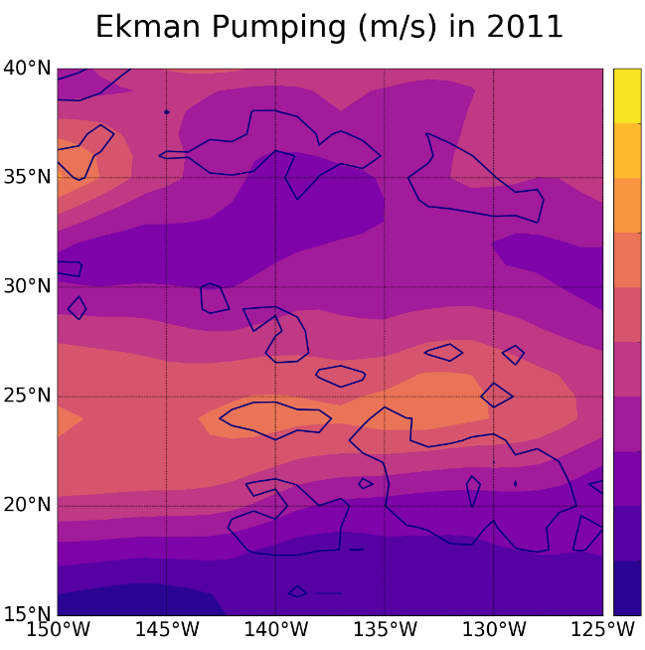
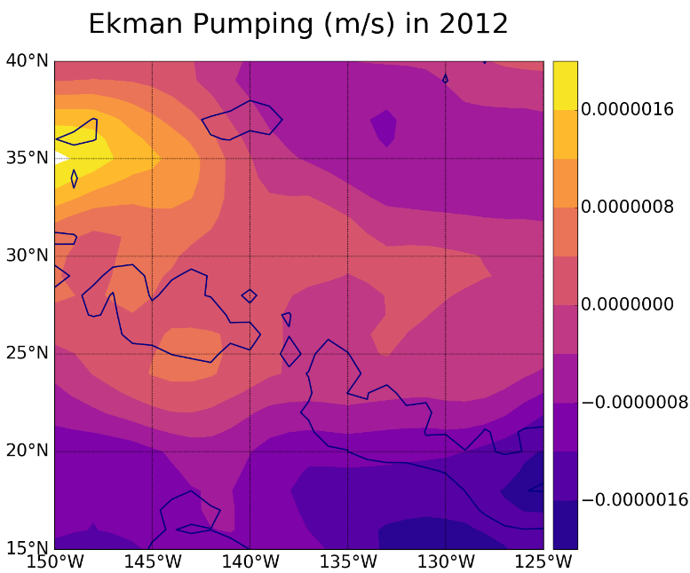
Appendix 2 – cont.
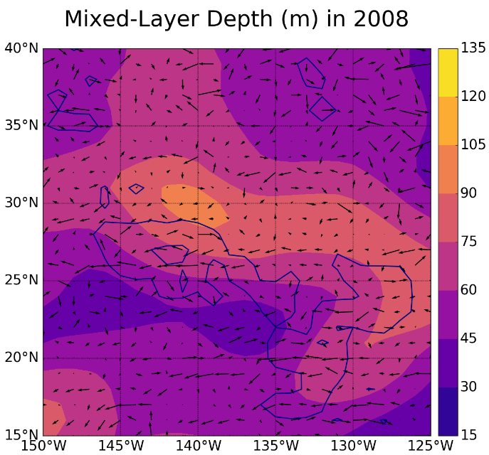
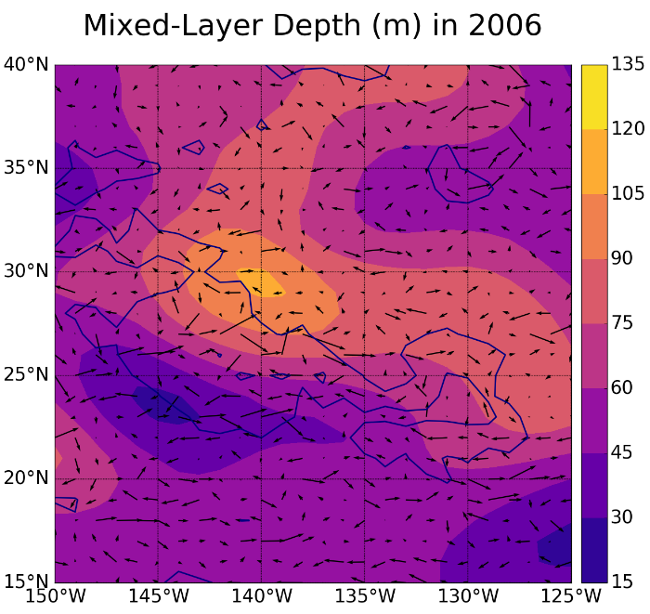
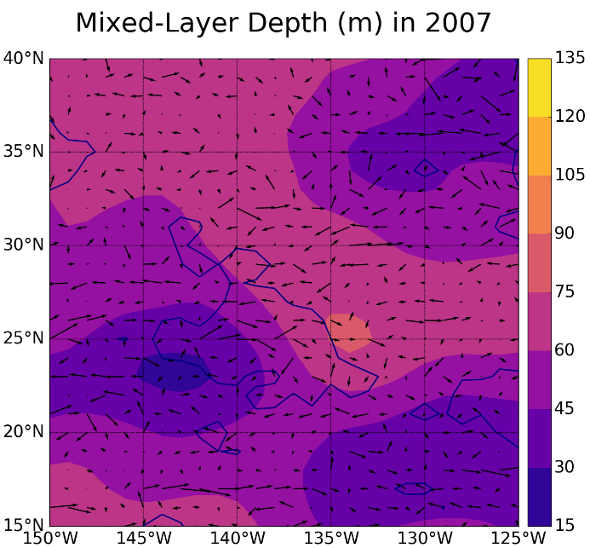
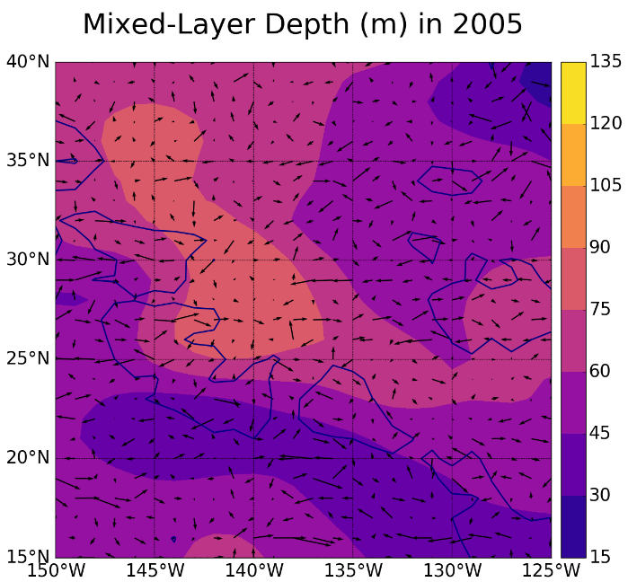
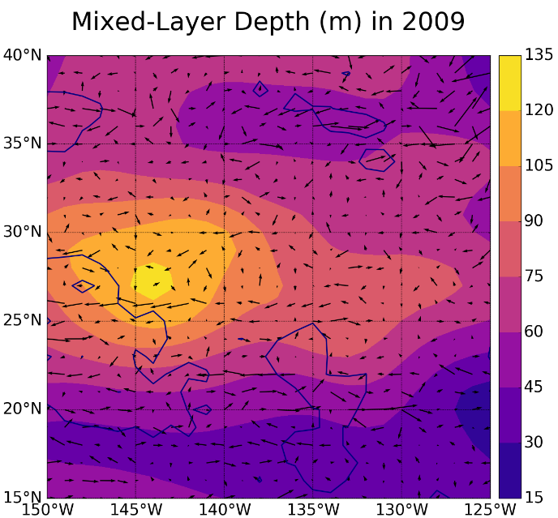
Appendix 3 – Mixed-Layer Depth with Velocity Vectors
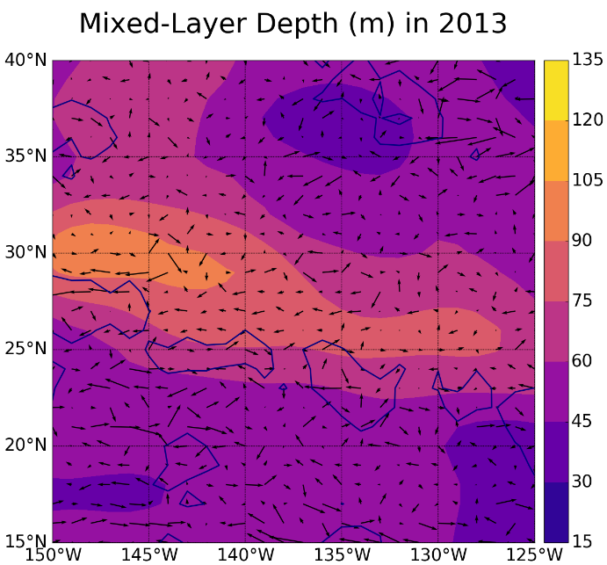
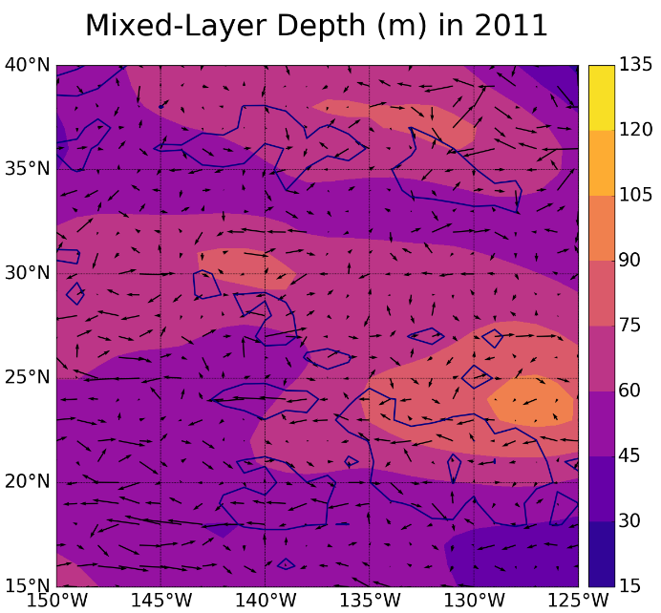
Appendix 3 – cont.
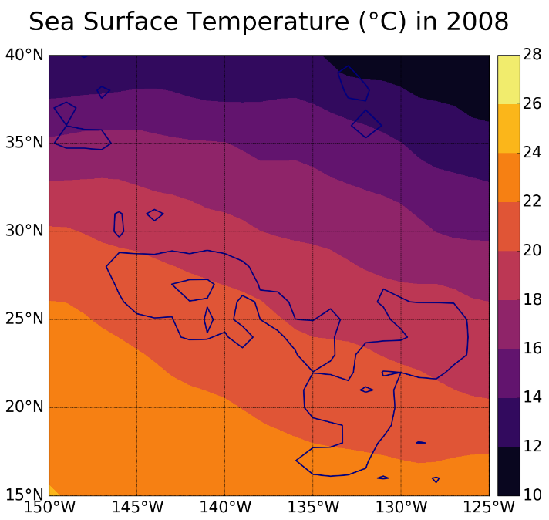
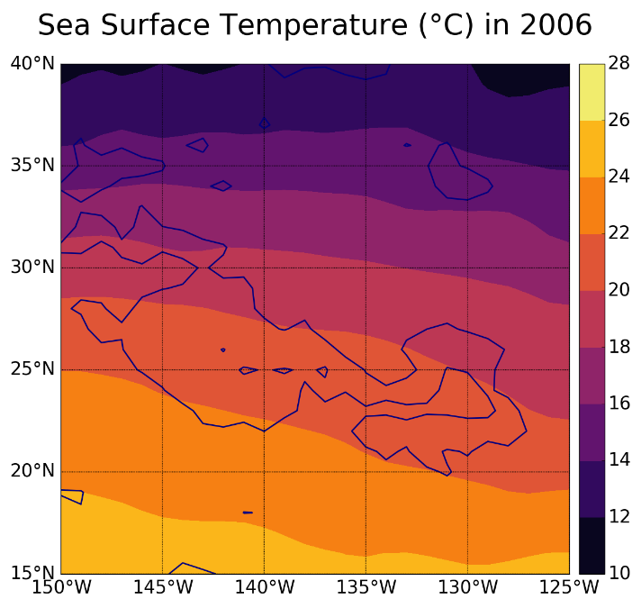
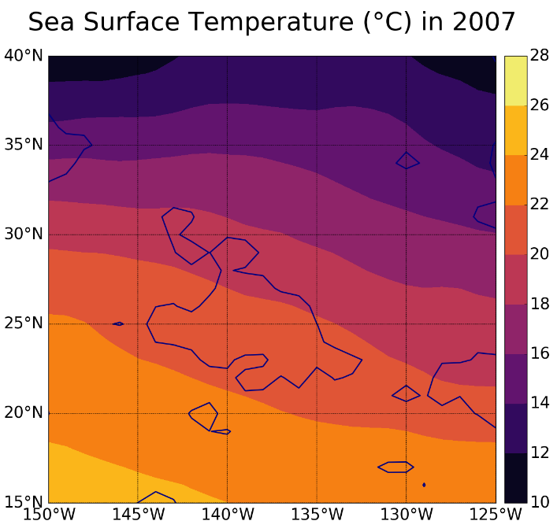
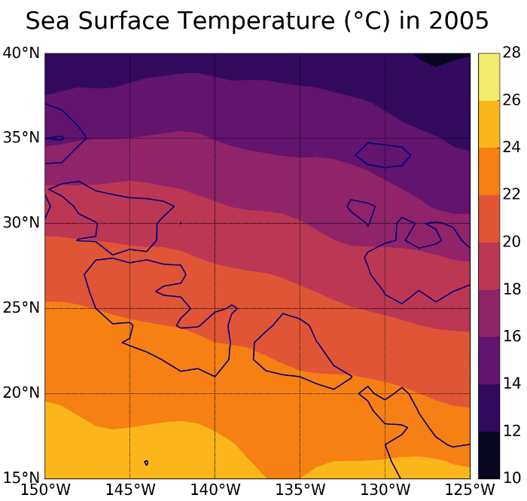
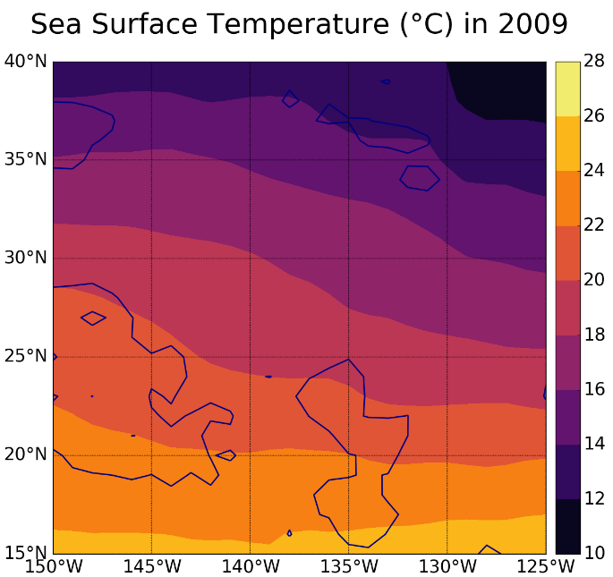
Appendix 4 – Sea Surface Temperature
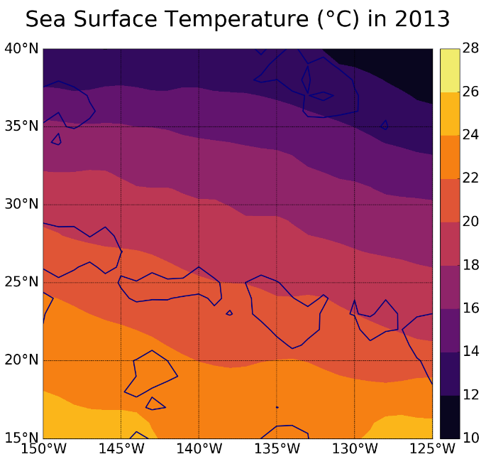
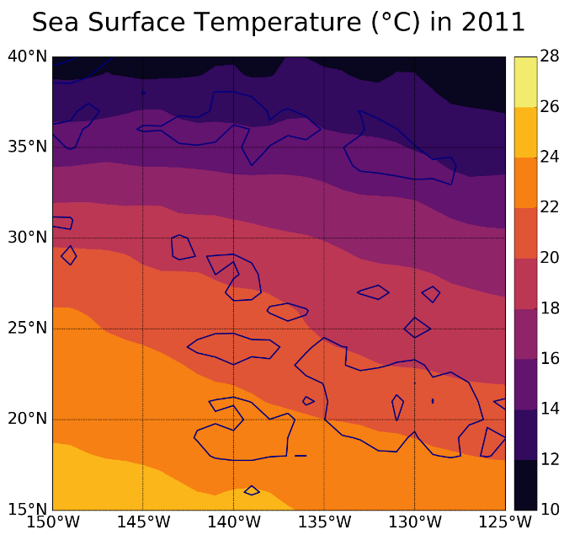
Appendix 4 – cont.

