Alkalinity increase in the Arabian Gulf
Connor Izumi¹

¹University of Washington,
School of Oceanography, Box 357940,
Seattle, Washington, 98195-7940
Cizumi19@uw.edu

- Abstract
Ocean acidification is an issue that is becoming of increasing global concern due to the dramatic impact it has on marine life wellness as well as economy. The Arabian Gulf uses pearl oysters and coral reefs as a major portion of economy and has not been studied for its carbonate chemistry since 1977. For this reason, there is motivation to study this area in particular. Despite finding total carbon and alkalinity levels that suggest CaCO₃ formation, past studies have found that there are no carbonate plankton species in the gulf. In this study, we suggest that CaCO₃ is forming in-situ similar to heterogenous CaCO₃ precipitation possibly due to desalination processes.
- Introduction:
Oceans take up roughly 30% of anthropogenic CO₂ emissions, and the current increase in those emissions is causing the ocean to acidify at alarming rates (Doney et al., 2009). There are a multitude of reasons to study this phenomenon and its future impact on marine ecosystems. For example, the Arabian Gulf uses pearl oysters and coral reefs as a large part of their economy and tourism. In this study, several samples from varying depths and locations in the Qatari Exclusive Economic Zone in the Arabian Gulf were analyzed for total inorganic carbon (DIC), total alkalinity (ALK), nutrients, and other auxiliary data. The goal was to assess the status of the ocean carbonate system in the gulf with respect to present and future impacts by ocean acidification and to use the distributions to determine the relative importance of organic matter production and CaCO₃ formation for removal of CO₂.

The Arabian Gulf is a body of water with an area of 240,000 km² and mean depth of 25m (Sugden 1963). The gulf is connected to the Arabian Sea through the Straits of Hormuz, which has a max depth of 100m and is 56 km wide and has free exchange with the Gulf of Oman (Al Ansari et al. 2015). Circulation is characterized as reverse estuarine. Lower salinity seawater enters through the Straits of Hormuz. While in the bay, the salinity and density of the water increase due to evaporation. Eventually, high salinity water exits the Straits at depth (Kampf and Sadrinasab, 2006). The gulf itself has a residence time of 2.5 years (Brewer and Dyrssen 1985). Residence time is a crucial factor in considering ocean acidification, as it is what will largely regulate the movement of CO₂ and its rate of sequestration. Supersaturation can be expected if the rate of CO₂ input to surface waters exceeds the rate at which CO₂ is sequestered to sediment/processed through biological activity. Evaporation is another crucial factor to consider when analyzing surface water’s ability to sequester and maintain CO₂. Warmer waters are able to contain less gasses, and evaporation can cause CO₂ to be released back into the atmosphere. Due to the hot and dry climate of this region, evaporation is estimated at 202.6 cm/yr for coastal waters of the central region of the gulf (Al Ansari et al. 2015).

Ocean acidification is widely recognized as an important consequence of increasing atmospheric CO₂, which has been severely amplified by anthropogenic input. As anthropogenic input increases the saturation of CO₂ in the air, we must consider the gas exchange occurring between the atmosphere and the ocean surface. When CO₂ enters the ocean, it reacts with water to form carbonic acid (H₂CO₃), which then releases hydrogen ions, creating a more acidic environment (Orr et al. 2005). These hydrogen ions readily bond to carbonate, a molecule essential to many organisms to construct CaCO₃ shells. Thus, CaCO₃ forming organisms must face more competition for their shell building resources. Due to the fact that the Arabian Gulf is of great economic and political importance, this could be a significant problem for the Qatari Exclusive Economic Zone, where pearl oysters and coral reefs contribute to the local economy, tourism, and cultural history (Brewer and Dyrssen 1985).

Surface water enters the gulf with relatively high concentrations of DIC and alkalinity. As the water flows northward CO₂ is removed. The decrease in concentrations of DIC and alkalinity can be used to determine the relative importance of CO₂ removal by primary production versus CaCO₃ formation. Brewer and Dyrssen (1985) used this approach to determine that the area of greatest carbonate loss is in the Trucial Waters (near the SW coast of the United Arab Emirates), where 125 μmol/kg of carbonate have been lost from the water. Another factor to consider is that as the water flows north some CO₂ is lost due to gas exchange. At the time of the Brewer and Dyrssen study in 1977 the Arabian Gulf was degassing CO₂. However, over the past 40 years the gradients and fluxes may have changed. Unfortunately, data regarding the progress of ocean acidification in the Arabian Gulf is sparse. Thanks to a collaboration between Qatar University (QU) and the University of Washington (UW) we have an opportunity to fill this deficiency.

The School of Oceanography at UW has become regionally and globally recognized as a leader in studying the distribution and impact of ocean acidification. The school has established an Ocean Acidification Research Laboratory at the Friday Harbor Laboratories. The best approach for studying and better understanding ocean acidification is to measure the primary capacity factors dissolved inorganic carbon (DIC) and alkalinity (ALK). In the school of Oceanography, we have state-of-the-art analytical equipment that can be used to measure these variables. These techniques are not available in Qatar; thus, this collaboration will be advantageous. DIC and alkalinity are the best set of parameters to sample and measure to calculate pH, pCO2 and carbonate ion, because they are conservative properties during mixing.
- Methods
- Sampling
Water column sampling began during late Fall of 2018 in the Arabian Gulf. 7 stations (stations 1C, 2C, 3C, 4C, 5C, 6B, 6C) were used for surface sampling along the transect East of the coast of Qatar across the EEZ (sampling site map). These samples were collected in triplicate for each station, for a total of 21 samples. Vertical profiles were collected for stations 2C, 4C, 6B, and 6C. These vertical profiles include 1 surface sample, 1 bottom sample, and 1-3 middle samples for each station. Each samples depth is noted in the data tables (table 1a, 1b, 1c). Any additional surface samples collected were used to complete the regional distribution. Sampling was completed by the ESC team from QU.

Samples were collected in 500 cm³ glass bottles with ground glass stoppers. It is imperative that these samples are sealed immediately after draw, due to the fact that CO₂ gas exchange can occur rapidly. A supersaturated sample will have tendency to release CO₂ to the atmosphere, while a undersaturated sample will have tendency to sequester CO₂ from the atmosphere. Samples were then poisoned with a mercuric chloride solution to prevent biological activity, which could affect the CO₂ concentration in the sample.
- Analysis
Once analyzed in Qatar for temperature, salinity, and nutrients; the samples were shipped to UW for DIC and ALK analysis. ALK was measured by alkalinity titration in a closed cell system. The progress of the titration was monitored using a glass electrode/reference electrode pH cell. Total alkalinity was computed from the titrant volume and e.m.f. data using either a least-squares procedure based on a non-linear curve fitting approach. The titration system used for analysis contained a pH electrode, a piston burette, and maintained temperature using a thermistor bath. The thermistor bath ensured that all samples are analyzed at the same temperature, and do not change in temperature over the course of the titration. CRM samples were used to calibrate the systems before beginning titration of the samples. The system titrated each sample to a pH of 3 at a temperature of 20°C and used the data to calculate total alkalinity. To test for DIC levels, samples were first treated with a phosphoric acid solution in a borosilicate glass stripping chamber. The solution was stripped of CO₂ by bubbling the carrier gas through a fine frit submerged in the acidified sample. Once the desired CO₂ gas had been isolated, the gas sample was analyzed using a coulometer. Every other sample was analyzed twice in order to ensure precision and quality of analysis. The DIC and ALK values have a precision of 3-4 micromoles, based on the used coulometer. Both the ALK and DIC analysis occurred in Alex Gagnon’s lab.

All analysis of data was executed using Microsoft Excel. Certain data properties were calculated using CO₂calc. This includes parameters such as pH, CO₃, and pCO₂. Several forms of data portrayal were used to create the conclusions presented in the discussion portion of this paper. This includes both graphical plots and depth profiles.

This study includes assistance from:
Mr. Mehmet Demirel: Collection of Hydrographic parameters using CTD
Dr. Ebrahim Al-Ansari: Sampling Nutrient, DO and chlorophyll samples
Dr. Oguz Yigiterhan : Sampling water samples for DIC & Alkalinity analysis
Dr. Yousria Elfaham: Provide sampling bottles and chemicals from DBES and her project.
Samples were collected and analyzed for:
- Hydrographic properties: T and S (QU)
- Nutrients (at least NO₃ but also NO₂, NH₄, PO₄, Si), Dissolved oxygen, Chlorophyll (at ESC or at another institution in Qatar (QU)
- DIC and Alkalinity analysis of samples done at. From these we calculate pH and PCO₂.(UW)
*All along the transects shown in the sampling site map
- Results:
Data collection for this project was primarily focused on carbonate and nutrient data and included ancillary data. Temperature ranged from 24.458 to 26.845 degrees Celsius and salinity ranged from 40.290 to 40.994 (Table 1a). NDIC (salinity normalized total inorganic carbon) levels ranged from 2016 to 2219, and NALK (salinity normalized total alkalinity) levels ranged from 2356 to 2582 (Table 1b). Nutrient data includes oxygen, nitrate, nitrite, phosphate, and silicon dioxide. Oxygen ranged from 176 to 202 μmol/L, nitrate from 0.57 to 2.40 μmol/L, nitrite from 0.09 to 1.44 μmol/L, phosphate from 0.06 to 0.93 μmol/L, and silicon dioxide from 0.40 to 3.65 μmol/L (Table 1a). %Transmission ranged from 70.621% to 95.530% and Fluorescence ranged from 0.209 to 1.423 (Table 1a). Chlorophyll levels ranged from 0.81 to 2.07 micrograms/Liter (Table 1a). The CTD cast measured pH to be between 8.13 to 8.22 (Table 1b). The application CO₂Calc was used to make further analysis and calculate pH from DIC/ALK and pCO₂ and CO₃ levels (https://www.usgs.gov/software/co2calc). The calculated pH ranged between 7.93 and 8.73, pCO₂ ranged between 58.36 to 582.73 micro atmospheres, and CO₃ ranged between 215.70 and 868.28 micromoles/kg (Table 1b).

- Discussion
A. Surface Water pCO₂
The pCO₂ values from the surface water samples showed higher values than current atmospheric pCO₂ levels. Modern day atmospheric pCO₂ is 400 μatm, and our surface water samples ranged from 351-583 μatm with an average of 472 μatm and a standard deviation of 93 μatm (Galbraith et al. 2015). pCO₂ was calculated using DIC and Carbonate Alkalinity using CO2Calc. However it can also be done by hand, by calculating pH from DIC and ALK, then calculating pCO2 from the following:

H₂CO₃* = K’_{H} pCO₂
α_{o} DIC = K’_{H} pCO₂
Then
pCO₂ = α_{o} DIC / K’_{H} =( (H⁺)² / (H⁺)² + H⁺K’₁ + K’₁K’₂) DIC / K_{H}
K’₁ and K’₂ are calculated from the local T and S.
H⁺ is calculated from pH., and from DIC/ALK
For pH = 8 the following approximation can be used:
pCO₂ = DIC H⁺ / K’₁ K’_{H}

Having surface water samples with such high pCO₂ levels means that the EEZ is degassing CO₂ to the atmosphere. These high pCO₂ levels are likely correlated to the coral reef abundance in this region. The coral abundance is shown in the map below (Spalding et al. 2010) (Figure 15). Coral reef areas have been shown to reflect elevated pCO₂ levels, which are controlled by cross-shelf advection of oversaturated surface water into the system and enhanced water temperatures combined with progressive evaporation, which leads to CO2 oversaturation relative to the atmosphere and a net release. This is described in the scientific study conducted by Lonborg et al (2019), in which they found similar pCO₂ values in the Great Barrier Reef region to our data from the Qatari EEZ. Although the Great Barrier Reef is much larger and has several other processes occurring compared to this region, it still stands as a good comparison point for understanding coral reefs and their effect on surrounding pCO₂ levels.
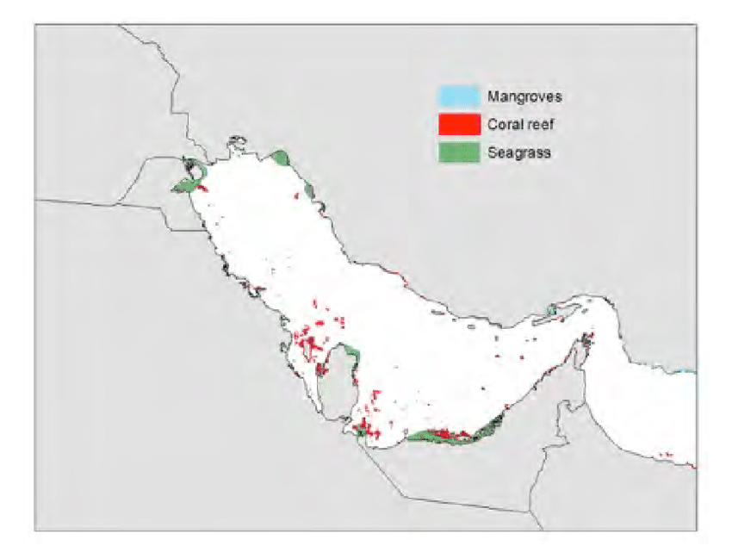
Sampling transect

If atmospheric CO₂ continues to increase at the present rate, the gradient in CO₂ across the air-sea interface will not be reversed until 2042. This was initially a surprise but given that CaCO₃ appears to be forming, the following equation explains why.
CaCO₃ + CO₂ + H₂O = Ca²⁺ + 2HCO₃⁻
When CaCO₃ precipitates the equilibrium shifts to the left, increasing CO₂.

B. Variability in DIC and ALK – CaCO₃ versus organic carbon formation
Much of the variability in DIC and ALK can be accounted for by salinity. This is because HCO3⁻ is a major ion in seawater, which means it contributes to salinity as well as the DIC and ALK because it is a species of both elementary equations shown below.
DIC = [H₂CO₃]* + [HCO₃⁻] + 2[CO₃²⁻]
ALK = [HCO₃⁻] + 2[CO₃²⁻] + [OH⁻] – [H⁺]
In the Arabian Gulf surface seawater flows in through the Strait of Hormuz with a salinity of S = 36.5 (Brewer, Dyrssen, 1985). Due to strong net evaporation, the salinity increases to over 40.5 as the water moves through the surface of the gulf. So DIC and ALK in surface waters increases from the Strait Hormuz to the Qatari EEZ due to the increase in salinity. We can remove this fraction of the variability by calculating NDIC and NALK, which are normalized to a constant salinity of 40. The resulting values of NDIC and NALK should vary only due to biogeochemical processes.
NDIC = DIC * S / 40
NALK = ALK * S / 40
We can examine the data on two scales. The first is the variability within the new data set within the Qatari EEZ. The second is the larger scale variability that reflects differences between the inflow at the Straits of Hormuz and the Qatari EEZ. We can look at these processes two ways.

1. Within the Qatari EEZ surface water flows from offshore to inshore
From stations 7 to 3 NDIC decreases but NALK has little variability (Figure 1). This suggests that there is removal of CO₂ by phytoplankton growth but no net CaCO₃ formation which would decrease NALK.
At the inner most two stations, both NALK and NDIC decrease with a slope of 2:1. This suggests that the removal ratio of CaCO3/OrgC = 2:1. We can also take a larger scale look at the changes that have occurred since the water flowed in through the Straits of Hormuz. That data point is indicated in the Figure 5 by a star symbol. Evidently the water flowing into the gulf at the Straits of Hormuz has lower DIC and ALK than those within the gulf or exiting.

Brewer and Dyrssen (1985) used this approach with the data set from 1977. For the Arabian Gulf as a whole, the ratio of CaCO₃ to OrgC removal was 2.5/1. The data table below reflects their dataset, which was extrapolated from the graph.
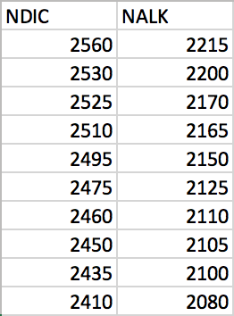

2. The second approach is to calculate the tracer Alk* (Carter et al 2014)
This tracer is defined as the deviation of potential alkalinity from conservative potential alkalinity. Potential alkalinity and conservative potential alkalinity are defined as:
A_{p} = (ALK + Nitrate) * Avg Sal/Sal
A_{cp} = Sal * ALK/Avg Sal
Alk* is a good choice for this analysis because its distribution is primarily attributable to carbonate cycling. The equations for calculation are described below:
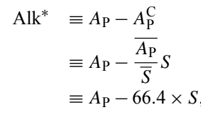
A volume-weighted surface AP(bar) (2305 µmol kg−1 ) to S(bar) (34.71) ratio of 66.40 µmol kg−1 was used from Carter et al. (2014). Values of Alk* were calculated for each data point (Table 3, colors correspond to surface, middle, and bottom depths, Figure 14). Then the change in Alk* (ΔAlk*) was calculated for the Qatari EEZ data relative to the inflow at Hormuz. For that inflowing seawater values of DIC = 2065 and Alk = 2380 were used from the study conducted by B&D, (Brewer, Dyrssen, 1985) and normalized them using the equations given above. The resulting values of ΔAlk* are negative (average = -156). This shows that CaCO3 is precipitating.

C. Could abiological formation of CaCO₃ be occurring in the Arabian Gulf?
Two approaches for the data analysis indicate that CaCO₃ is forming, removing alkalinity.
Both utilize the values of normalized alkalinity (NAlk) and DIC (NDIC) in order to remove variability due to variation in salinity and focus on changes due to biogeochemistry.

The first approach involves examination of a plot of alkalinity versus DIC, shown in Figure 5. We can compare our data from the Qatar EEZ with values for NAlk and NDIC in the surface water flowing in through the Straits of Hormuz, which is denoted with a star symbol in Figure 5 (available from Brewer and Dyrssen, 1985). The average NAlk and NDIC of our samples from the small geographic range in the Qatari EEZ is less than that of the water flowing in through the Straits of Hormuz. This suggests there is removal of CO₂ by both organic matter and CaCO₃ formation. For the Arabian Gulf as a whole, Brewer and Dyrssen (1985) calculated that the ratio of CaCO₃ to organic matter removal was 2.5/1. We can also examine changes within our smaller study region. At stations 3 to 7 NDIC decreases but there is little change in NAlk. This suggests removal of CO2 by primary production of organic matter with little or no removal by CaCO₃ formation. At stations 1 and 2 there are larger decreases in NAlk that would correspond to a CaCO₃/OrgC removal ratio of 2/1. (Figure 5)

Another approach is to calculate the nutrient corrected and salinity normalized tracer, Alk* (Carter et al., 2014) (see Methods). We can compare the individual values for Alk* for our data with the Alk* in the inflowing surface water in the Strait of Hormuz. That comparison indicates that there has been an average decrease of Alk* of -130 μmol kg⁻¹ from the Strait of Hormuz. This decrease is likely due to CaCO₃ formation in the nearshore waters between Doha and station 4.

Using two approaches for our data analysis we have indications that CaCO₃ is being formed. This is curious as two studies of plankton in the Arabian Gulf show that plankton are dominated by diatoms (70% to 89%), dinoflagellates (8% to 22%) and cryptophytes (2% to 6%) (Quigg et al., 2013; Polikarpov et al., 2016), with no evidence for coccolithophorids. This would suggest that the CaCO₃ formation that is occurring is not due to phytoplankton productivity.

One possibility is that Alkalinity reduction is due to CaCO₃ formation in local growing coral reefs. If so the changes seen in the Alk* would be due to processes at the sediment-water interface rather than within the water column. However, in a new related study of the chemical composition of net tow plankton in the Qatari EEZ, Yigiterhan et al (submitted) found that the average particulate Ca concentration (sea salt corrected) was 36,000 ppm or 3.6%. Treatment with a weak acid (HAc-HyHCl) leach (Berger et al., 2008) removed 92% of the Ca. These results suggest that a significant amount of particulate CaCO₃ is present in the water column. The form of this particulate Ca is uncertain and future studies will have to undertake microscopic analysis to establish if this is biotic or abiotic.

Next, we can test if the particulate Ca can be accounted for by input of Qatari dust. The average particulate Ca and Al equal 36,000 ppm and 1828 ppm, respectively (Yigiterhan et al., submitted). Al can be used as a tracer for the contribution of dust as Al has no known biological function. The average Ca/Al ratio in Qatari dust is 6.52/ The Al x Ca/Al = 1,828 x 6.52 = 11,918 ppm from dust. This is 3% of the total particulate Ca. This calculation supports the hypothesis that the particulate Ca does not come from dust. So, it may have formed in situ, in the water column, as the trends in NAlk versus NDIC, and Alk*, indicate.

A recent study in the Red Sea suggests that we should seriously consider the possibility that abiological production of CaCO3 is occurring. Wurgaft et al (2016) utilized new data for NAlk and NDIC in the Red Sea and the Gulf of Aqaba to conclude that heterogeneous CaCO3 precipitation (HCP) is occurring. Heterogeneous CaCO₃ precipitation is the precipitation of CaCO₃ in the water column as a result of biological processes. As HCP does not normally occur in supersaturated seawater, even with Ω (saturation state) > 5, they argued that this HCP was induced by suspended sediments from flash floods or underlying sediments or inputs of atmospheric dust. The Arabian Gulf and Red Sea are similar in that both have reverse estuarine circulation driven by an increase in salinity due to high rates of evaporation in the northern end, growth of corals in shallow waters and large inputs of atmospheric dust. Atmospheric dust is the major source of lithogenic particles to the Arabian Gulf (Yigiterhan et al., 2017 ). This dust is CaCO3 rich. But comparison of the Arabian Gulf is problematic as the Red Sea is much deeper (>2000m) than the Arabian Gulf (average depth = 25m). The apparent formation of CaCO3 in the deep waters of the Red Sea (out of the euphotic zone) was a key aspect of the argument for abiogenic HCP forming at that location.

Swart et al (2014) also made the case that abiological, nonskeletal CaCO₃ was forming in the Grand Bahama Bank, east of the Florida Straits. At that location, the input of dust from North Africa was hypothesized to play an important role as both a heterogeneous nucleation site and as a source for iron, that would stimulate nitrogen fixation and biological production in this otherwise oligotrophic region. Similarly, it is possible that the Qatari dust is providing a heterogeneous nucleation site and essential nutrients to stimulate biological productivity.

Besides from the arid environment causing high rates of evaporation, another process that can explain the high salinity levels is water desalination. The Arabian Gulf has the most desalination plants of any region in the world, with a seawater desalination capacity of over 11 million m³/day (Lattemann and Hopner, 2007). This accounts for 45% of the total desalination that is occurring globally. Such a magnitude of desalination can be expected to cause higher salinity, and thus higher alkalinity, especially when considering that the region is already prone to high salinity from the reverse estuarine water flow. Although most organisms can survive a minor deviation from optimal salinity and temperature, and possibly extreme situations for a short period of time but cannot be expected to withstand a long-term exposure to these adverse conditions. Thus, the constant input of reject streams with high salinity and temperature can be fatal to the existing marine life. This can also lead to changes in species distribution as well as abundance in the area. Because of this, many plants implement preventative measures to minimize the salinity and heat input from reject streams. Reject streams are often pre-diluted with other waste water such as power plant cooling water and run through cooling towers in order to dissipate maximum heat to the atmosphere before entering the water body. Lastly, the reject streams are setup for maximum dilution with the water body, to ensure no one area is affected too harshly. Because the Arabian Gulf is a large body of water that is constricted by a narrow strait for both its inflow and outflow, this dilution factor is hard to achieve. Aside from the fact that the Arabian Gulf has nearly half of the world’s desalination plants, the geography of the water body is prone to saturation of input properties. Thus, the increase in salinity and alkalinity is largely attributable to the desalination process that is occurring in this region. These high salinity and alkalinity values are likely linked to the CaCO₃ precipitation that is occurring. This relationship between salinity and CaCO₃ can be shown in the equation:
Ca²⁺ + 2HCO₃⁻ CaCO₃ + CO₂ + H₂O
As we can see, the decomposition of bicarbonate, a major ion that contributes to salinity, results in loss of CaCO₃ (reduced Alk) and an increase in CO₂ (increased DIC). This correlates with the data from stations 3-7 in figure 5. There is minimal change in alkalinity (no decrease because the alkalinity values have been normalized to salinity) and an increase in NDIC.
Furthermore, multi-stage flash distillers (MSF), a type of desalination plant, are known to release CO₂ and heat (Al-Rawajfeh, 2010). Continuous input of CO₂ and energy can result in CaCO₃ precipitation, which also explains the reduced alkalinity levels seen in stations 3-7.
A study published in 1994 also found evidence supporting CaCO₃ precipitation near the Trucial Coast (Anderson and Dyrssen, 1994). They also presented similar patterns in their data regarding NDIC and NALK. They found that alkalinity was having little change, while carbon levels were increasing, which suggests CaCO₃ precipitation.
Although Brewer and Dyrssen collected data that suggested CaCO₃ removal, desalination was not occurring at such a high rate in 1977 when the data was collected. This suggests that the difference we see between their data (figure 5) and ours can be attributed to desalination. Furthermore, at the current rate of brine discharge, by 2050 brine discharge will account for 2% of nearshore water volume in the Gulf. Furthermore, the heat input from desalination as well as energy production has been estimated to have increased seawater temperatures by 7-8°C which is decreasing oxygen solubility in the area (Paleologos, 2018). This also constitutes a threat to marine life.

- Conclusions
Surface pCO₂ values in the Arabian Gulf are evidently higher than atmospheric CO₂ levels by roughly 71 μatm. Thus, the gulf is degassing to the atmosphere, and the CO₂ gradient of the air-sea interface will not be reversed until 2042. Examination of Alkalinity and total carbon suggests that CaCO₃ is forming in the water column. Although one would assume that carbonate plankton are the cause, but past studies have found that there are no carbonate-based plankton in this region. One possibility is that the CaCO₃ formation is taking place at the sediment-water interface in local coral reefs. However, particulate CaCO₃ is known to be a major component of net tow particulate matter in the water column. This could simply be due to input of CaCO₃ rich atmospheric dust, but the DIC/ALK suggest that CaCO₃ formation is taking place in the water column. The calculation of particulate Ca from dust (using Ca and Ca/Al_{dust}) suggest that only 3% of the particulate Ca comes from Qatari Dust. I propose a hypothesis that abiogenic CaCO₃ formation is occurring in the water column, similar to heterogenous CaCO₃ precipitation. Furthermore I believe that desalination is playing a role in increasing alkalinity of these Gulf waters, a process that was not relevant when this area was previously studied for carbonate chemistry. Desalination is also aiding in the precipitation of CaCO₃ in-situ, because MSF distillers release CO₂ and heat. This hypothesis can be tested in future studies where particulate matter samples are examined for biogenic and abiogenic CaCO₃. A similar hypothesis for heterogenous CaCO₃ production has been proposed to occur in the Red Sea. This CaCO₃ precipitation is induced by the large inputs of nucleation sites in the form of atmospheric dust.

- Plots:
Sampling site map
Table 1a: and 1b: Data spreadsheet portraying all data with color coordinated depth sampling (surface samples are blue, in the water column is green, and bottom samples are orange)
Table 1c: ALK* data – shows ALK* for all stations as well as delta ALK* from the value for Strait of Hormuz
Figure 1: NDIC vs Distance from Doha – There is an overall increase in NDIC as distance from Doha increases, with a slight plateau at 80-120 km out
Figure 2: NALK vs Distance from Doha – There is an overall increase in NDIC as distance from Doha increases, with a slight plateau at 60-130 km out
Figure 3: O2 vs Distance from Doha – Collected oxygen data varied greatly, but there is a clear decrease in O2 levels as distance from shore increases
Figure 4: S vs Distance from Doha – There is a clear decrease in salinity as distance from shore grows. Note: important to remember that as distance from shore increases, we are looking at areas that are closer to the water source, Strait of Hormuz
Figure 5: NALK vs NDIC – Stations 1-3 from the collected data show an increase ratio of 2:1, and stations 4-7 show an increase in NDIC with very little increase in NALK. Brewer and Dyrssen’s data is also reflected on this figure.
Figure 6: NALK vs Salinity – There is a slight decrease in NALK as salinity increases
Figure 7: Temperature/Salinity plot – The first point on the left seems to be an outlier. Other than that, we have a standard TS plot depicting reasonable decreases in temperature as salinity increases.
Figure 8: Nitrate vs Phosphate – No detectable trend. However, it is important to note that there is much less phosphate variance than nitrate variance.
Figure 9: NDIC vs Salinity – There is a decrease in NDIC as salinity increases
Figure 10: Fluorescence vs Transmission – The majority of transmission was detected to be between 90-95% for all levels of fluorescence
Figure 11: pH calculated vs pH measured – quality check for pH
Figure 12: Nutrient Plots for each station – Not enough sampling to make conclusions based on nutrients
Figure 13: NALK vs NDIC plots for each station – Not enough sampling to make conclusions about NALK vs NDIC for individual stations
Figure 14: Alk* vs Station – There is a general increase in ALK*, with less of an increase between stations 3-7
Figure 15: Map of coral abundance in the Arabain Gulf
Sampling site map:
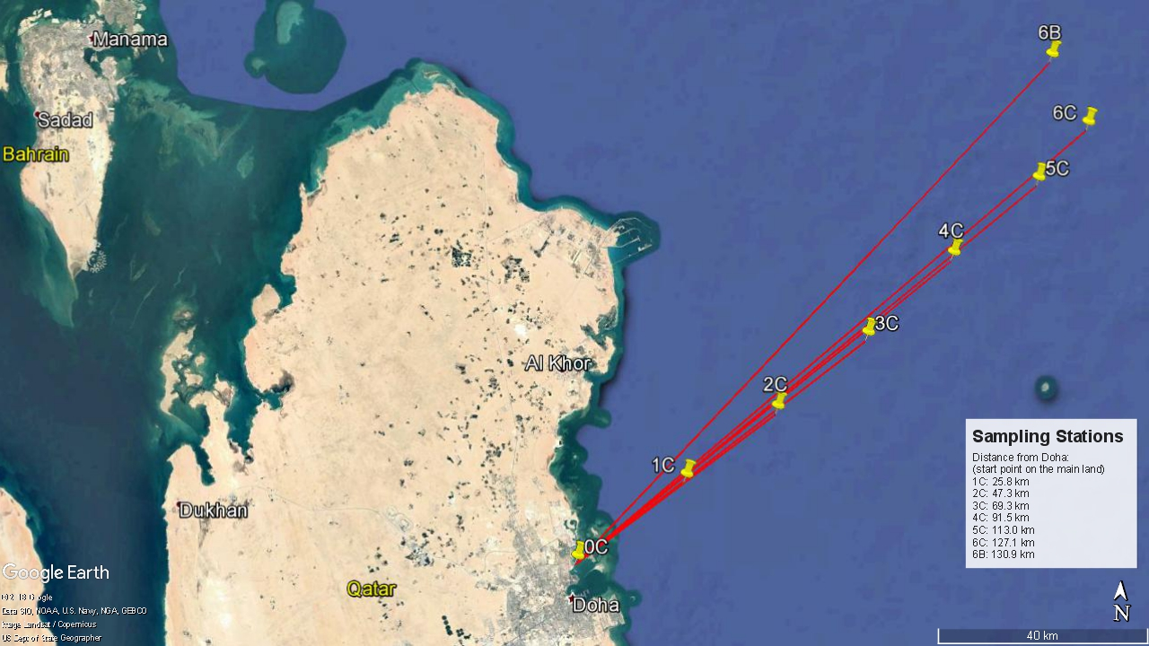

Table 1a)

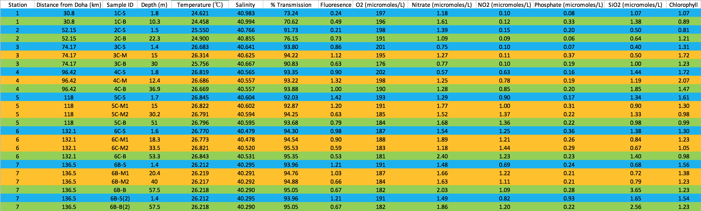

Table 1b)
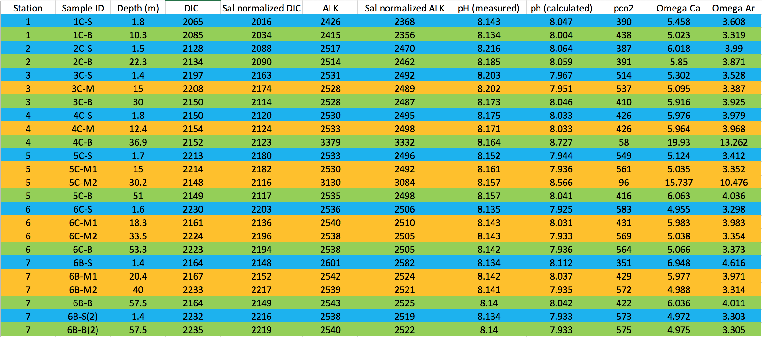
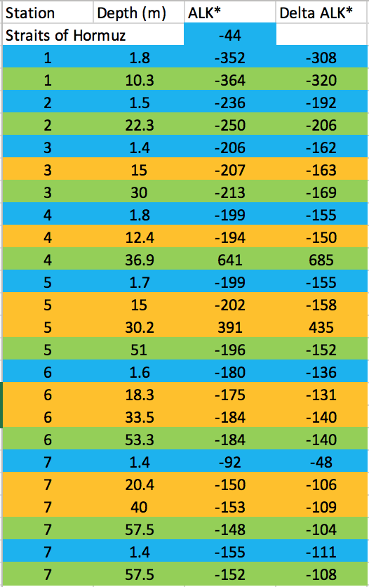
Table 1c)

Figure 1)

Figure 2)

Figure 3)

Figure 4)

Figure 5)
Stn 1
Figure 6)

Figure 7)

Figure 8)

Figure 9)

Figure 10)

Figure 11)

Figure 12)

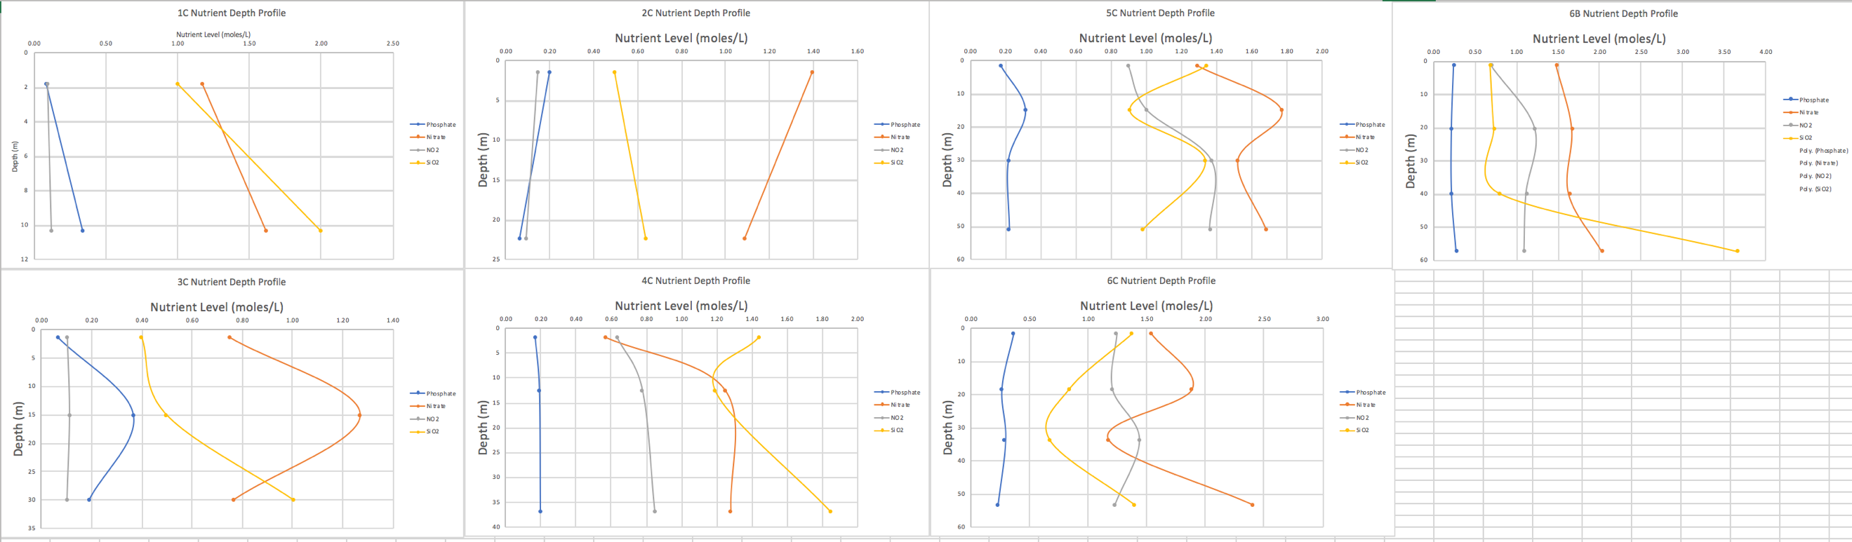

Figure 13)

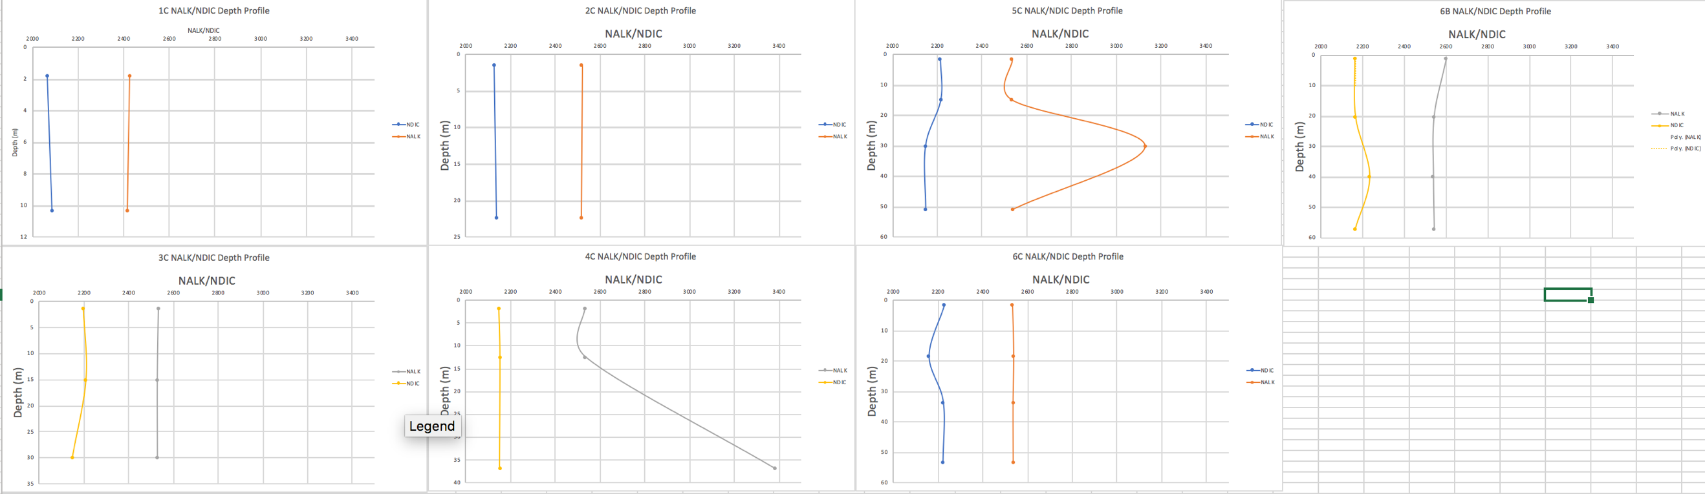

Figure 14)

Figure 15)
Sampling transect

VI. References:

Aiman Eid Al-Rawajfeh. 2010. Influence of Seawater Composition on CO2 Release and Scaling in Multi-Stage Flash (MSF) Distillers from Different Arabian Gulf Intakes

Al-Ansari E., Rowe G., Abdel-Moati M.A.R., Yigiterhan O., Al-Maslamani I., Al-Yafei M.A., Al-Shaikh I., Upstill-Goddard R. 2015. Hypoxia in the central Arabian Gulf Exclusive Economic Zone (EEZ) of Qatar during summer season. Estuarine, Coastal and Shelf Science.

Anderson Leif, Dyrssen David. 1993 “Alkalinity and total carbonate in the Arabian Sea. Carbonate depletion in the Red Sea and Persian Gulf”

Brewer, P. G. and Dyrssen, D. 1985, Chemical oceanography of the Persian Gulf. Prog. Oceanogr.

Carter, B.R., Toggweiler, J.R., Key, R.M. , and Sarmiento, J.L. 2014. Processes determining the marine alkalinity and calcium carbonate saturation state distributions. Biogeosciences.

Christian Lønborg, Maria Ll Calleja, Katharina E. Fabricius, Joy N. Smith, Eric P. 2019. Achterberg The Great Barrier Reef: A source of CO2 to the atmosphere. Marine Chemistry

Christopher L. Sabine, Richard A. Feely, Nicolas Gruber, Robert M. Key, Kitack Lee, John L. Bullister, Rik Wanninkhof, C. S. Wong, Douglas W. R. Wallace, Bronte Tilbrook, Frank J. Millero, Tsung-Hung Peng, Alexander Kozyr, Tsueno Ono, Aida F. Rios. 2004. “The Oceanic Sink for Anthropogenic CO2.”

Dickson, A.G., Sabine, C.L. and Christian, J.R. (Eds.) 2007.Guide to Best Practices for Ocean CO2 Measurements. PICES Special Publication 3.

Kampf J., Sadrinasab M. 2005. Ocean Science. The circulation of the Persian Gulf: a numerical study.

Orr J.C. et al. 2005. Anthropogenic ocean acidification over the twenty-first century and its impact on calcifying organisms. Nature.

Paleologos E K, Al-Nahyan M T, Farouk S. Risks and threats of desalination in the Arabian Gulf
Polikarpov,I., Saburova, M., Al-Yamani, F. 2016. Diversity and distribution of winter phytoplankton in the Arabian Gulf and the Sea of Oman. Continental Shelf Research.

Quigg, A., Al-Ansi,M., NourAlDin,N., Wei,C.-L., Nunnally,C.C., Al-Ansari,I.S., Rowe, G.T., oliman,Y., Al-Maslamani,I., Mahmoud,I., Youssef,N., Abdel-Moati, M.A., 2013. Phytoplankton along the coastal shelf of an oligotrophic hypersaline environment in a semi-enclosed marginal sea: Qatar Arabian Gulf). Cont. Shelf Res.

Richard A. Feely, Christopher L. Sabine, Kitack Lee, Will Berelson, Joanie Kleypas, Victoria J. Fabry, Frank J. Millero. 2004 “Impact of Anthropogenic CO2 on the CaCO3 System in the Oceans.”
Scott C. Doney, Victoria J. Fabry, Richard A. Feely, Joan A. Kleypas. 2008. Annual Review of Marine Science.

Spalding Mark, Kainuma Mami, Collins Lorna. 2010. World Atlas of Mangroves

SUGDEN, W. .1963. The hydrogology of the Persian Gulf and its significance in respect to evaporite deposition. American Journal of Science.

Swart, P.K., Oehlen, A.M., Mackenzie, G.J., Eberli, G.P. and Reijmer, J.J.G. 2014 The fertilization of the Bahamas by Saharan Dust: A trigger for carbonate precipitation. Geology.

Wanninkhof, Rik, and Wade R. McGillis. 1999. “A Cubic Relationship between Air‐Sea CO2 Exchange and Wind Speed.” Geophysical Research Letters, John Wiley & Sons
Wurgaft E., Steiner, Z., Luz, B., Lazar, B. 2016. Evidence for inorganic precipitation of CaCO₃ on suspended solids in the open water of the Red Sea. Marine Chemistry.

Yigiterhan O., Alfoldy B.Z, Giamberini M., Turner J.C., Al-Ansari E.S., Abdel-Moati M.A., Al-Maslamani I.A., Kotb M.M., Elobaid E.A., Hassan H.A., Obbard J.P., Murray J.W., 2017. “Geochemical Composition of Aeolian Dust and Surface Deposits from the Qatar Peninsula” Chemical Geology.

Yigiterhan,O. Al-Ansari, E.M.A.S., Nelson,A., Abdel-Moati, M.A.R., Turner, J., Alsaadi, H.A., Paul, B., Al-Yafei, M.A.A.A., Murray, J.W. (submitted) The Trace Element Composition of Size Fractionated Suspended Particulate Matter Samples from the Qatari EEZ of the Arabian Gulf: Biotic and Abiotic sources. Biogeosciences.

Acknowledgements:

I would like to thank my advisors James Murray, Julian Sachs, and Arthur Nowell for their guidance and patience with me through the writing process of this thesis. I would also like to thank Alex Gagnon and Dan Anderson for helping me with the lab analysis and allowing me to use their space and time for my thesis. I would also like to thank Oguz Yigiterhan, Mehmet Demirel, Ebrahim Al-Ansari, and Yousria Elfaham, along with any other Qatar University students who aided in the sampling and nutrient data processing. Lastly, I would like to thank the School of Oceanography at University of Washington for providing me this opportunity.

