2014 Mosquito Sampling Site Descriptions

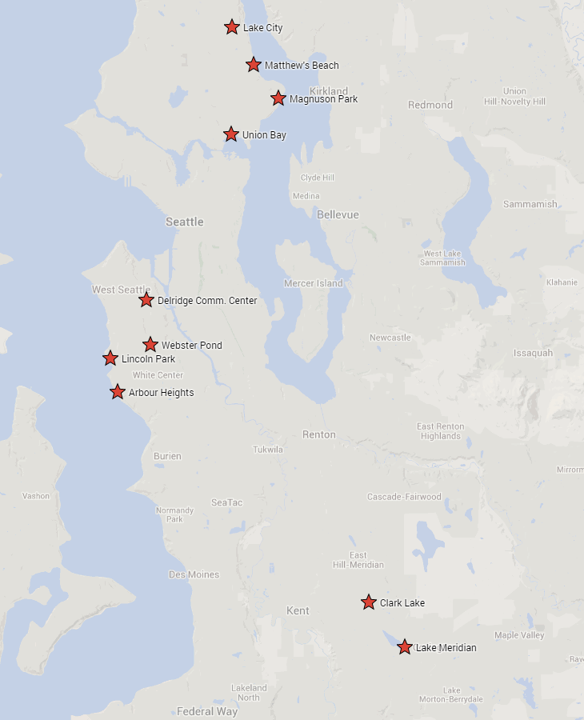

Lake Meridian Park (LM)
14800 SE 272nd St Kent, WA 98042

This site is located in the eastern side of Kent which borders the city of Covington. The park lies along state route 516 (SR 516) and directly west of state route 18 (SR 18). The park is surrounded by an active urban community living in the nearby apartments and housing arrangements.
Trap 1: N 47 21.578 W 122 08.587
The setup for this trapping location is near the northern roundabout loop at the park entrance right off SR 516. It is a lightly wooded area that primarily is used for excess storm drainage water. During this time there was little or inadequate amounts of water for mosquito larva sampling. This area is damp in the mornings and mostly dry during the afternoons. The trap was hung among a looming tree trunk that was growing towards the declining slope making it an ideal hanging point.
Trap 2: N 47 21.607 W 122 08.631
The setup for this trapping location is closer towards the lake. The flora that grow in this area include blackberry brambles, trees, and tall grass. Excess vegetation that grows around this area makes it difficult to traverse through. It is evident that there are frequent paths in this area to reach the lake on the other side and that was the decided location for this trap. This area is damp on most days since it is in close proximity with the lake. The trap was hung on various cross branches that intersect along a well walked path.
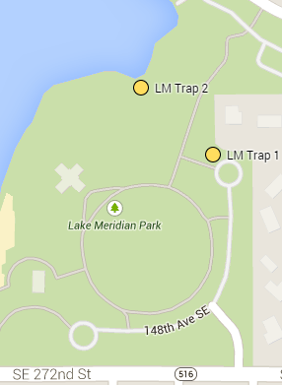
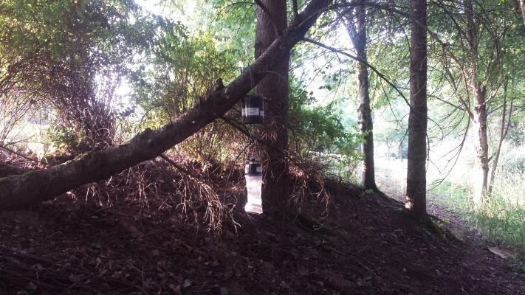
LM Trap 1
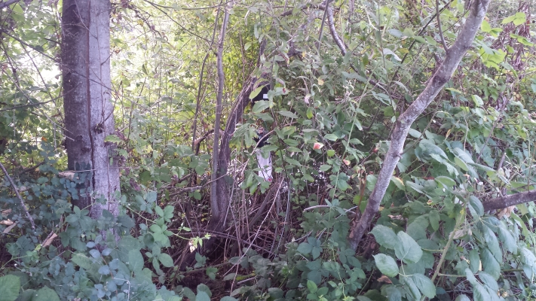
LM Trap 2

Clark Lake Park (CL)
124th Ave SE & SE 240th St Kent, WA 98031

This site is also located in eastern Kent. The park is large and heavily wooded. It features a large lake with many walking paths throughout the park. There is urban development around the park area but the trapping locations are isolated from these parts.
Trap 1: N 47 23.154 W 122 10.440
The setup for this trapping location is near the North entrance of the park along SE 240th St. It is located along the path in a lightly wooded area near a shallow creek. The site is densely shaded and provides adequate moisture from nearby water. Not much vegetation is located under the trees however there is tall grass that forms a perimeter along the trapping site. The trap was hung along a tree branch facing the West direction.
Trap 2: N 47 23.071 W 122 10.377
The trapping location is along one of the park path that is located near the Northeast corner. Again in this location there is very little vegetation except for the surrounding area. Within the same area there is a bank that has consistently been filled with water early on in the summer season. Around the fifth week the bank no longer supplies water. The trap was hung on the many broken branches that are located on the nearby tree.
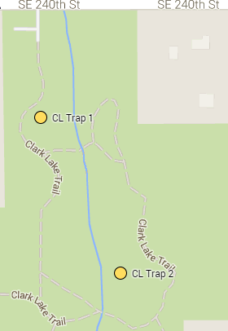
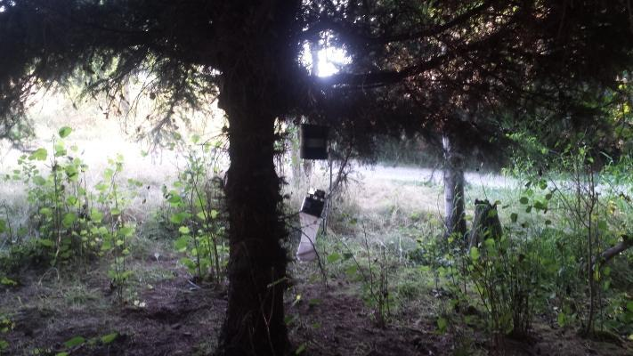
CL Trap 1
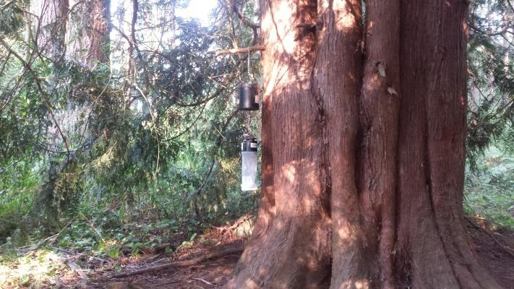
CL Trap 2

Arbor Heights (AH)
47th Ave SW & Maplewood Place SW Seattle, WA 98146

This area is the southernmost neighborhood in West Seattle. The neighborhood is almost exclusively zoned as private residential property. It is incredibly overgrown with vegetation and machetes are advised to gain easy access to the trapping locations.
Trap 1: N 47 30.481 W 122 23.395
The setup for this trapping location is along a walking path. Heavy vegetation grows in this area such as tall grass, blackberry brambles, stinging nettles, and various weeds. Not much sunlight penetrates the area so the temperature is much cooler and very dry. There is no available site for larval sampling in this area. The trap was hung among the various tree branches that run along the path after the first change to higher ground.
Trap 2: N 47 30.450 W 122 23.395
Similar to the previous area this trapping location is filled with heavy vegetation. The area is further along the path after the first stepping ladder. The trap was hung on the tree that crosses directly over the walking path.
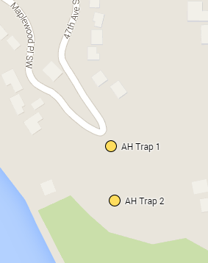
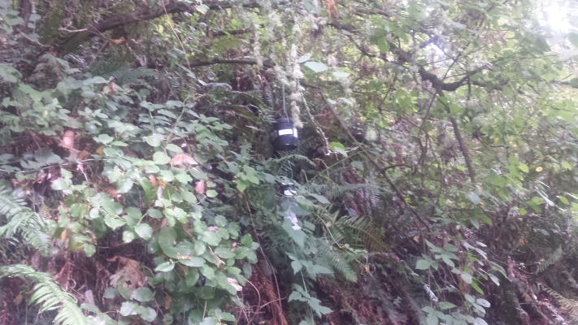
AH Trap 1
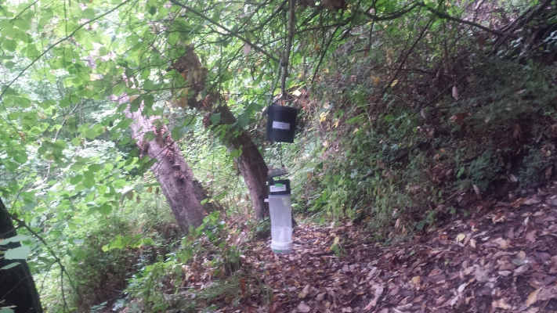
AH Trap 2

Delridge Community Center (DCC)
4501 Delridge Way SW Seattle, WA 98106

This site is located at the local community center which is very active. There are surrounding urban neighborhoods that are mostly residential areas. The pair of traps are on opposite ends of the community center grounds.
Trap 1: N 47 33.811 W 122 21.898
The trapping location is located on the edge of the tennis court near the prominent pine trees on the west end. Very little vegetation grows under the tree however there is an abundance of acorns. The trap is hung on the tree branch that faces toward the tennis courts. No available water for larval sampling.
Trap 2: N 47 33.680 W 122 21.915
The trapping location is right of the edge of the baseball field directly behind the home plate umpire. Moderate vegetation includes tall grass, blackberry brambles, and low hanging tree branches. Tree covering is adequate to provide thick shading and little moisture. No available water for larval sampling.
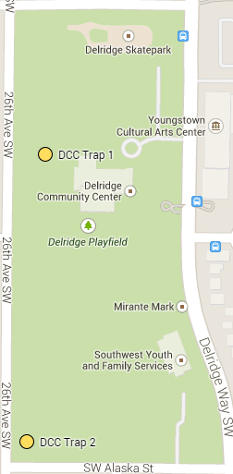
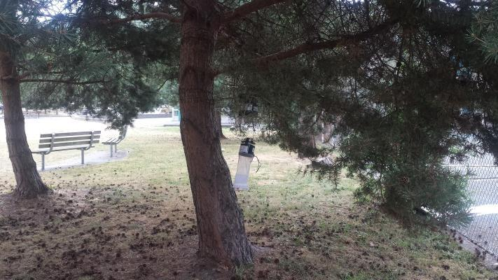
DCC Trap 1
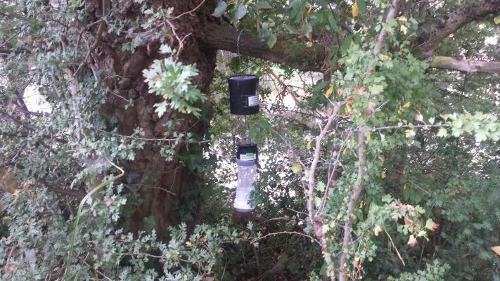
DCC Trap 2

Lincoln Park (LP)
Fauntleroy Way SW & SW Cloverdale St Seattle, WA 98136

Lincoln Park is a park in West Seattle between Fauntleroy Way S.W. and Puget Sound. The park is very busy during the summer months. The trap pair is located in the southern area of the park.
Trap 1: N 47 31.668 W 122 23.752
The location for this trapping location is located along the path going toward the northern section of the park. There is an eroded stream that prevents rainwater from flooding the area. Following that stream will lead to the trapping location that is surrounded by minimal shrubbery. The trap is hung on a branch that crosses over the stream.
Trap 2: N 47 31.629 W 122 23.735
The location for this trap setup is located on the main path to the beach from the southern parking lot. The area is closest to the beach and near the beach restrooms. The trap is located where the path branches off before reaching the beach, in an area with rhododendrons. Minimal vegetation grows in this area limited to tall grass. The trap is hung along one of the rhododendron branches.
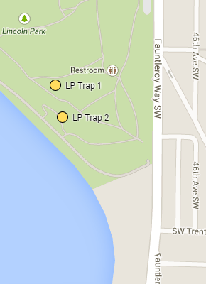

LP Trap 1
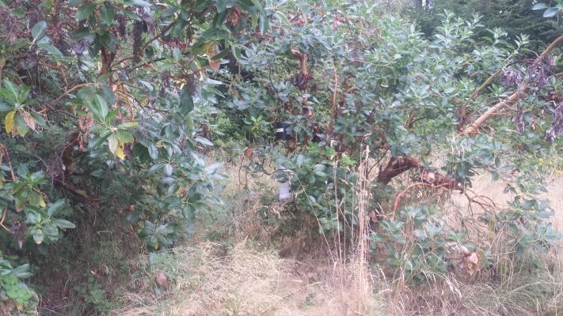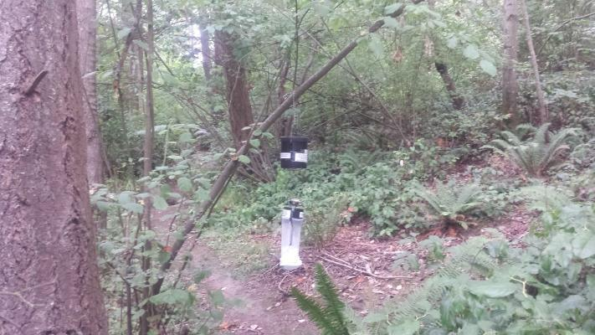
LP Trap 2

Webster Street Pond (WP)
Delridge Way SW & SW Webster St Seattle, WA 98106

This site is a detention pond that is located in a dense urban area. It is surrounded by many buildings and streets. North of the pond there is The Home Depot and Seattle Police Department situated across SW Webster St. South and West of the pond are old apartments and low-income housing units. To the East is the main street Delridge Way SW that remains active during the day. The trap pair is located on opposite ends of the pond.
Trap 1: N 47 32.110 W 122 21.770
This trap location is located near one of the paths that directly leads to the lower part of the pond. Alongside the path there is an opening surrounded by tall grass and blackberry brambles that reveals a ridge that overlooks the entire pond. There is a tree in this location that was used for the hanging of the mosquito trap.
Trap 2: N 47 32.100 W 122 21.703
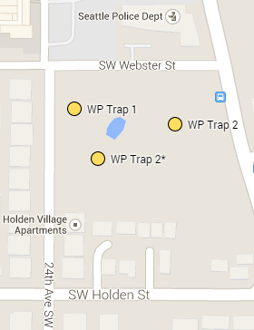
This trap location is located closer to the main street Delridge Way SW. There is a grass clearing that provides an entrance through tall weeds and other vegetation. At the end there is a tree that grows over the path and that is where the trap was hung. During the duration of this project our group encountered homeless residents that moved directly where the trap was set up. We had to move it to another location N 47 32.086 W 122 21.753. This is located by going further down the path at trap 1 in a small clump of trees.
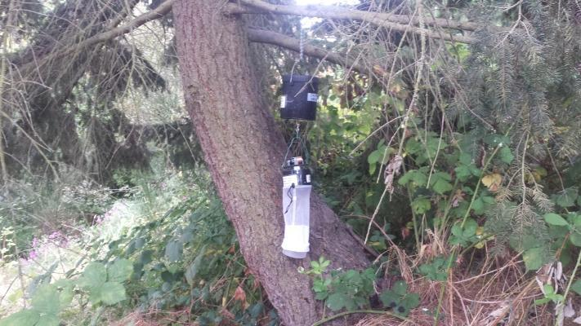
WP Trap 1
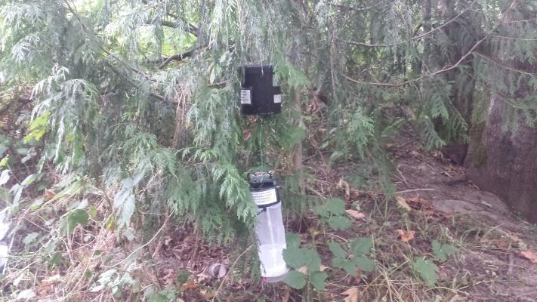
WP Trap 2
Lake City Pond (LC)
35th Ave NE & NE 125th St 98125

This site is located in the Northern side of Seattle just south of Shoreline. The park lies in between the Northgate area and the Northern side of Lake Washington, about a half of a mile East of state route 522 (Lake City Way). The pond, or retention pond, is surrounded by an active urban community living in the nearby apartments and housing arrangements. The traps are located on opposite sides of the pond, thus requiring multiple entrances.
Trap 1: N 47 43.134 W 122 17.504
This trap is located just through a locked, swinging gate just off of NE 125th St. Just next to a parking lot serving the nearby dentist office, the gate is set a few yards off the road and is surrounded by bushes. Following the hill down on the other side of the gate, while staying to the left as much as possible will lead you around the corner to a tree covered area where the mosquito trap was hung just up above he standing water below.
Trap 2: N 47 43.126 W 122 17.480
This trap is located through the leftmost locked and gated entrance on 35th Ave for the pond. Going straight through the gate will lead to a rocky area with some stepping stones and following those to the end and continuing down to the rock hill at a 45 degree angle to the right will put you just above the still water where the trap is hung by a branch.
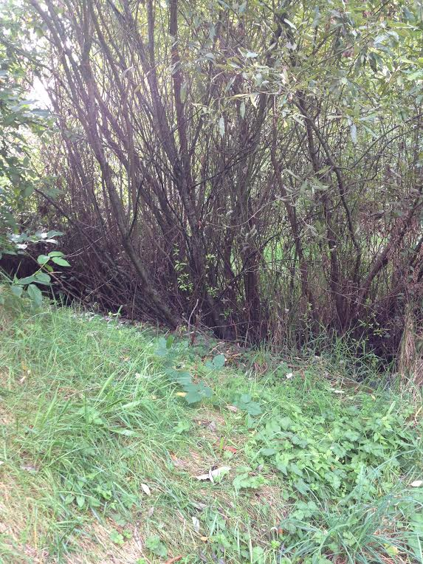

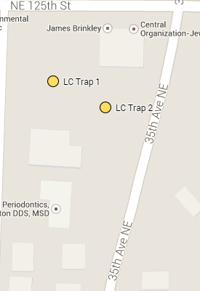

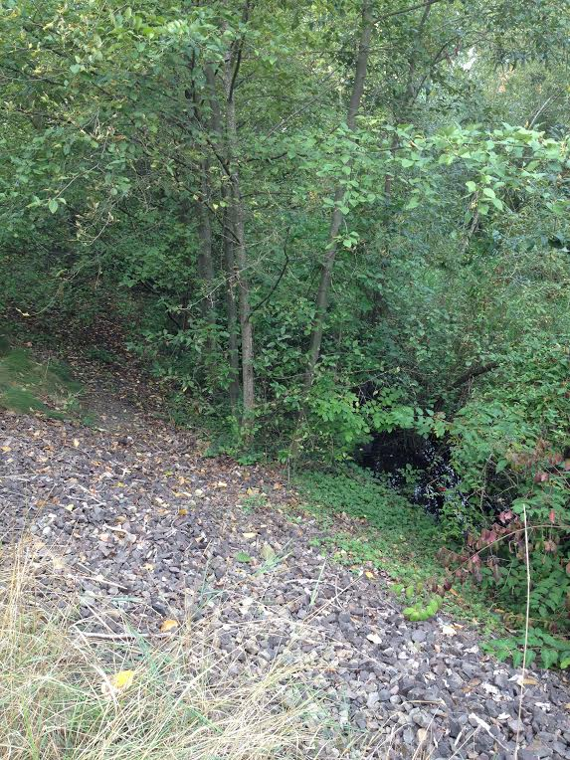

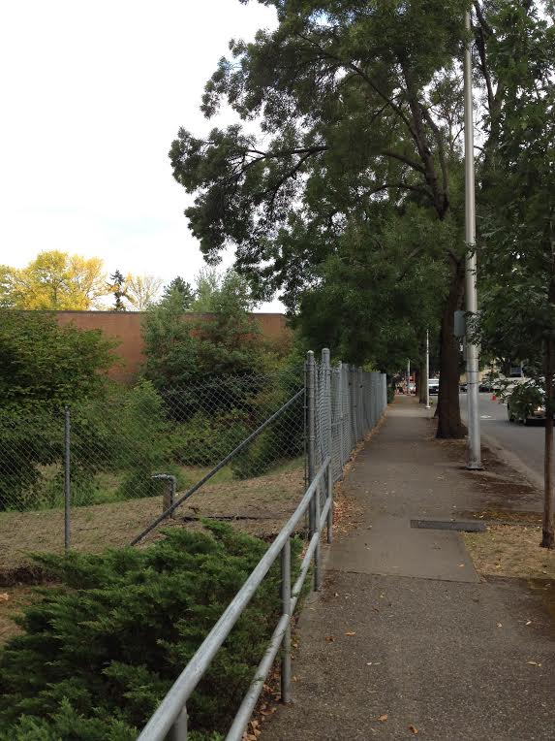

Magnuson Park (MP)
Lake Shore Dr NE 98115; Sportsfield Dr NE & Frog Pond Trail
This site is located East of Sand Point Way NE and West of Lake Washington at Warren G. Magnuson Park. The traps are located about a half of a mile apart from each other in the park.

Trap 1: N 47 40.671 W 122 15.126
After turning right off of Sand Point Way NE, follow NE 65th down into the park about 1 mile into the park. On the road exiting the boat launch area on the right side of the road the trap can be accessed by crossing the creek that leaves the pond and the rap is hung just above the bark-covered ground in the trees. Alternate access to the trap would be to walk down the path near the pond.
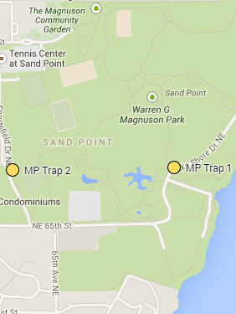
Trap 2: N 47 40.663 W 122 15.618
After turning right off of Sand Point Way NE, follow NE 65th down into the park about 1/4th of a mile a take your first left onto Sportsfield Dr NE. Not far down a baseball field will be on the right . When pulled over on the side just before the field there are a few walking paths that run N/S and E/W. Where those paths meet a few feet into the bushes is where the trap is to be hung.

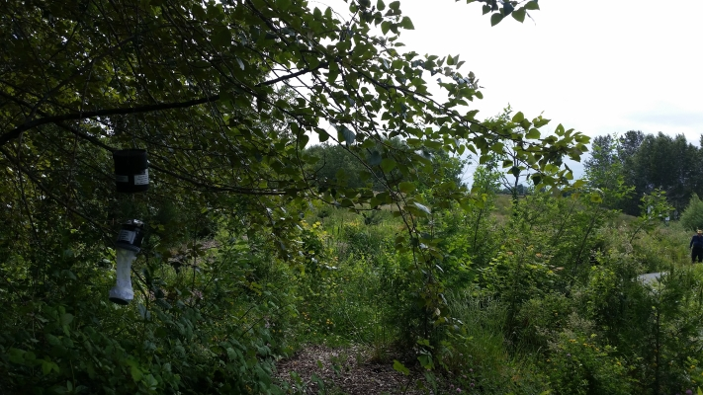
MP Trap 1
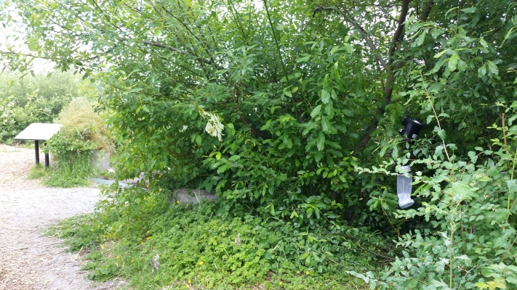
MP Trap 2

Matthew's Beach (MB)
49th Ave NE & NE 93rd St 98115
Matthews Beach is a park located just to the East of Sand Point Way NE with some shoreline on the lake and is a popular spot for people to congregate during the Summer months. Turning right onto 93rd St off of Sand Point Way and following it down will lead to the main parking lot.
Trap 1: N 47 41.843 W 122 16.376
This trap is located in the most Northeastern part of the park. The trap is hung amidst the trees closest to the water as evidenced by the picture.

Trap 2: N 47 41.810 W 122 16.494
When leaving the parking lot there should be a path that leads one to the Northwest part of the park. When followed up the incline and after taking the right fork of the path, the trap location can be found just down below the path among some ferns and alder trees and also near an area of tall reed-like grass.
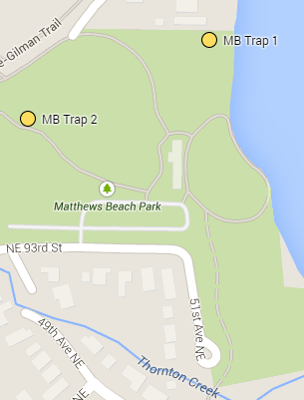
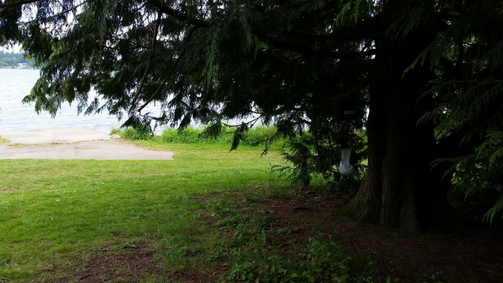
MB Trap 1
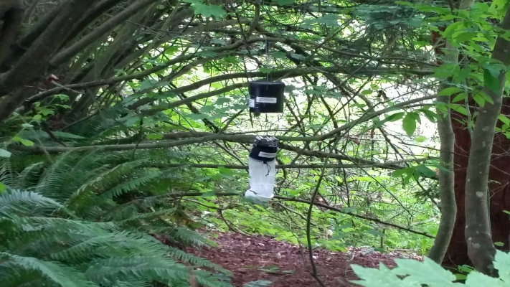
MB Trap 2

Union Bay (UB)
Union Bay Natural Area near NE 41st St, 98105
The Union Bay Natural Area is located down on the Eastern side of the University of Washington campus near the UW IMA activities fields, in the entrance to the UW Botanical Gardens between W Clark Rd and Union Bay Cir NE. This is accessed via NE 41st St which is located off of NE 45th St down below the UW IMA Athletic fields.
Trap 1: N 47 39.436 W 122 17.552
When entering the natural area between the other two aforementioned roads, keeping to the right will lead to a small parking area. Parking there will put you near a gravel walking path that leads into the woods. Part of the way down the beginning of the path where there are trees on both sides between both openings, there is a semi-open area in the trees to the right of the path and a storm drain marks the point of entry. The trap is hung down inside there amongst the trees.
Trap 2: N 47 39.396 W 122 17.587
Just farther down the path not far past where the path branches off left toward the East, is where trap two is located. just past the opening of the swampy area is where a path through the grass can be entered and this can be found just past a “Crocodile Xing” sign. A hundred or so yards into the grass and just to the left near the swamp (which will be drier ground in Summer and softer as the water comes in) is where the hanging position is located on some branches as evident in the picture.
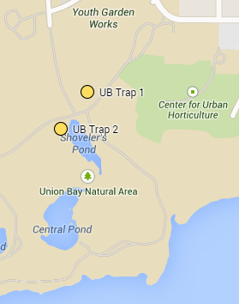
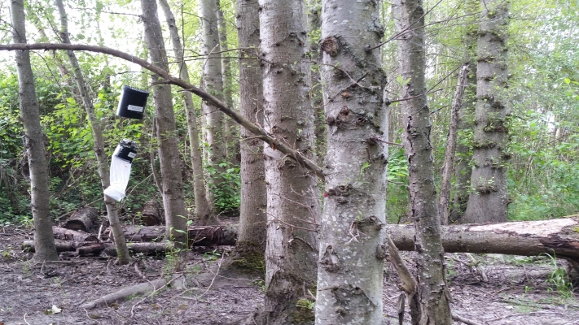
UB Trap 1

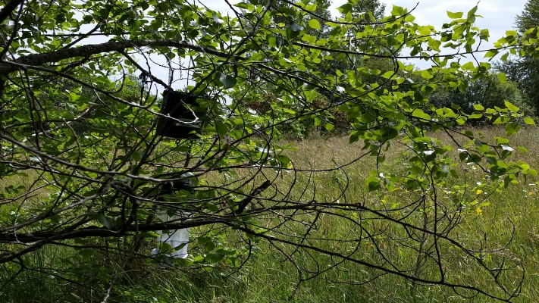
UB Trap 2

