Supplementary Information for

This PDF file includes:

Chapter 2:
Figures S1 to S5
SI References

Chapter 3:
Figures S1 to S3

Other supplementary materials for this manuscript include the following:

Descriptions of datasets S1 to S11 for chapter 2

Supplemental Material for Chapter 2

Figure S1. Age is associated with global changes in gene expression. Principal component 1 explains 55.2% of the overall variance in gene expression and is significantly associated with age (ꞵ = -0.39, p = 0.005).

Figure S2. Gene expression changes linearly and nonlinearly across aging. Autoregressive integrated moving average (ARIMA) models revealed groups of genes that followed linear and non-linear trajectories throughout aging. Top biological processes for each cluster are to the right of the heatmaps.

Figure S3. Effects of aging and exposure to Hurricane Maria on gene expression were similar in direction across a range of statistical power sensitivity thresholds. Comparison of concordance (i.e., shared directional effects) of the effects of aging and Hurricane Maria exposure across a range of significance thresholds (FDR from 0 to 1 in 0.01 increments), with bootstrapping to obtain 95% confidence intervals. Concordance is measured as the proportion of genes that either increased in expression with both age and Hurricane Maria exposure or decreased in expression with both age and Hurricane Maria exposure. The dashed line shows the fraction of concordant standardized betas that is expected by chance.

Figure S4. Protein ubiquitination pathway expression associated with aging and exposure to Hurricane Maria were highly similar. Molecular chaperones, co-chaperones, and associated proteins aid in the ubiquitination and degradation of misfolded and aggregate client proteins within the cell. (A) Aging and (B) exposure to Hurricane Maria were associated with similar changes in ubiquitination pathway gene expression (adopted from the pathview package in the R environment (1)). Blue coloration indicates lower gene expression of pathway components with the given effect, while red denotes higher expression with the given effect. Genes that were significantly differentially expressed (FDR < 10%) for either aging (A) or exposure to Hurricane Maria (B) are denoted with an asterisk.

Figure S5. Morality rate on Cayo Santiago in the decade prior to Hurricane Maria and body condition of animals sampled before and after Hurricane Maria. (A) Monthly mortality rate on Cayo Santiago from 2008-2019. While 2.75% of the population died in the month after the storm, the average age of death in the year after the storm did not differ from the average age of death in the 2 previous decades (p = 0.13), suggesting that there was no survival bias due to chronological age. (B) Body condition, as measured by weight controlled for age, sex, and sampling location (i.e., scale used), did not differ between animals sampled before and after the hurricane.

Dataset S1. Study subject information. ID, sampling date, date of birth, sex, and other sample metadata.

Dataset S2. Main model outcomes. Results from linear models of gene expression.

Dataset S3. Results of Gene Ontology categorical enrichment tests for genes more highly expressed with age.

Dataset S4. Enrichment analysis of transcription factor binding site motifs. Enrichment of TFBS sites 2 kb upstream and downstream of transcription factor start sites of genes more highly expressed with age.

Dataset S5. Enrichment results based on Gene Ontology categories for genes more lowly expressed with age.

Dataset S6. Enrichment results based on Gene Ontology categories for genes more highly expressed with exposure to Hurricane Maria.

Dataset S7. Enrichment results based on Gene Ontology categories for genes more lowly expressed with exposure to Hurricane Maria.

Dataset S8. Enrichment of TFBS sites for genes more lowly expressed with exposure to Hurricane Maria.

Dataset S9. Enrichment results of Gene Ontology categories for genes more lowly expressed with age and exposure to Hurricane Maria.

Dataset S10. Enrichment of TFBS sites of genes with lower expression with age and exposure to Hurricane Maria.

Dataset S11. Peripheral blood mononuclear cell marker genes. Marker genes were identified using Seurat (2) and monocle3 (3–6) packages in the R environments, while granulocyte genes were identified from Palmer et al. 2006 (7).

SI References

1. Luo, Weijun, Brouwer, Cory, Pathview: an R/Bioconductor package for pathway-based data integration and visualization. Bioinformatics 29, 1830–1831 (2013).
2. T. Stuart, et al., Comprehensive integration of single-cell data. Cell 177, 1888–1902 (2019).
3. C. Trapnell, et al., The dynamics and regulators of cell fate decisions are revealed by pseudotemporal ordering of single cells. Nat. Biotechnol. 32, 381–386 (2014).
4. X. Qiu, et al., Reversed graph embedding resolves complex single-cell trajectories. Nat. Methods 14, 979–982 (2017).
5. J. Cao, et al., The single-cell transcriptional landscape of mammalian organogenesis. Nature 566, 496–502 (2019).
6. L. McInnes, J. Healy, J. Melville, UMAP: Uniform manifold approximation and projection for dimension reduction. arXiv (2018).
7. C. Palmer, M. Diehn, A. A. Alizadeh, P. O. Brown, Cell-type specific gene expression profiles of leukocytes in human peripheral blood. BMC Genomics 7, 1–15 (2006).

Supplemental Material for Chapter 3

Within-individual gene expression changes reflect cross-sectional estimates
In addition to testing the correlation between within-individual DNA methylation changes and estimates from our cross-sectional model of DNA methylation, we also performed this analysis with our gene expression dataset. We used the same modeling design for gene expression as for DNA methylation – a model of gene expression as a function of age, sex, Hurricane Maria exposure, technical effects, and kinship using our entire gene expression dataset (n = 543). We compared standardized effect sizes of age to the percent of genes in repeated samples that changed in the expected direction (n individuals = 89). Similarly to DNA methylation, we found that the standardized effect size of age from the model was correlated intra-individual gene expression changes (r = 0.24, p = 4.32 x 10⁻⁹¹; Fig. S2). and this association became stronger when we tested only genes significantly associated with age (FDR < 10%) from the cross-sectional models (r = 0.45, p = 1.8 x 10⁻⁴⁰). Notably, the effects of Hurricane Maria exposure and change in gene expression between pre- and post-hurricane Maria samples were highly correlated (n individuals with pre- and post-hurricane expression = 21, r = 0.38, p = 2.68 x 10⁻²³⁸; Fig. S2), which increased among the 260 genes significantly associated with Hurricane Maria exposure (FDR<10%) in the cross-sectional model (r = 0.77, p = 5.26 x 10⁻⁵²).

Other sources of variance in DNAm
Individual’s sex can influence their DNA methylation and is thus important to control for, though this was not a focus of our study. Sex was significantly associated with DNA methylation at 12642 sites, 65.9% of which were on the X chromosome (n = 8330, n autosomes = 4310). Interestingly, sex explained only a median of 0.32% percent of the variance in our models within autosomal sites but a median of 1.11% percent variance in Y chromosome sites and 46.16% in X chromosome sites (Fig. S3).

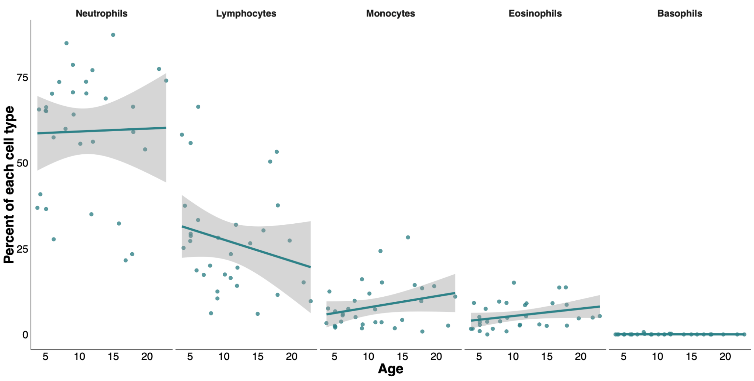
Figure S1. Percent of peripheral immune cell populations across aging. Percent cell type calculated from blood smear slides made for a subset of samples.

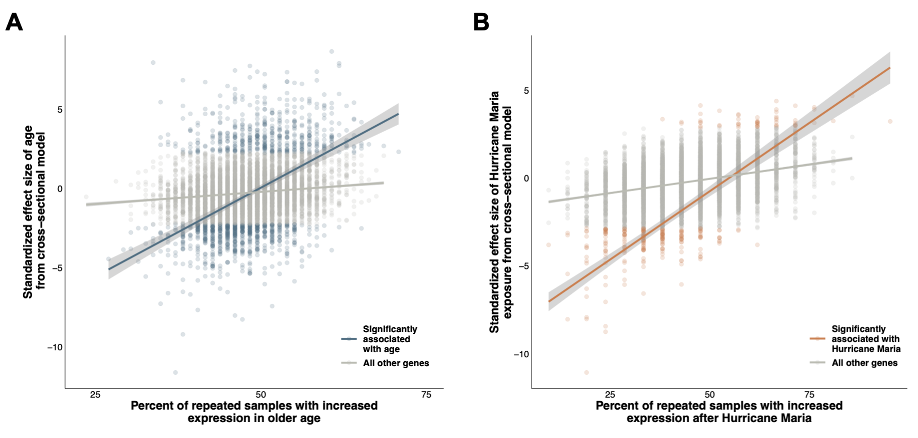
Figure S2. Cross-sectional results of age and hurricane exposure are correlated with inter-individual changes in gene expression. (A) The percent of repeated samples with higher gene expression levels at older ages versus the standardized effect size of age from the cross-sectional model. Blue points show genes significantly associated with age, while all other genes are shown in grey. The lines represent the correlation among all genes (grey) and genes significantly associated with age (blue). (B) The percent of repeated samples with more gene expression post-hurricane than pre-hurricane, versus the standardized effect size of Hurricane Maria exposure in the cross-sectional model. The orange line and points represent genes significantly associated with hurricane exposure and the grey shows all other genes.

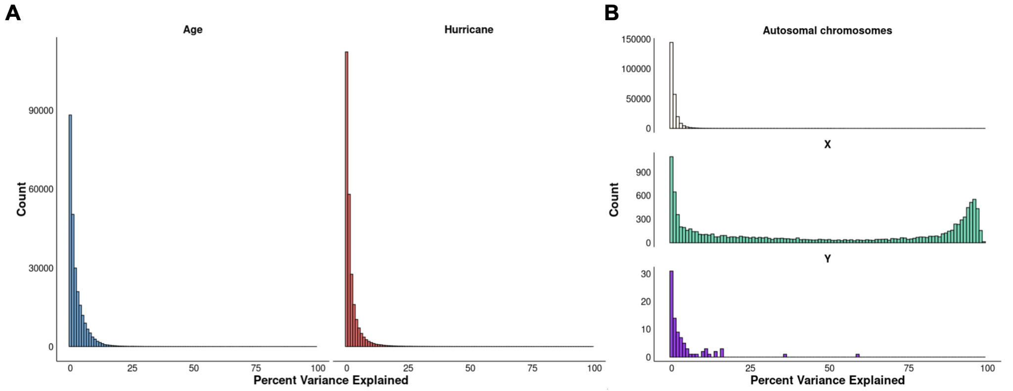
Figure S3. Percent variance explained (PVE) for coefficients in the main investigation. (A) PVE for effects of age and hurricane exposure from the main model. (B) PVE of sex effects by autosomal and sex-chromosomes.

