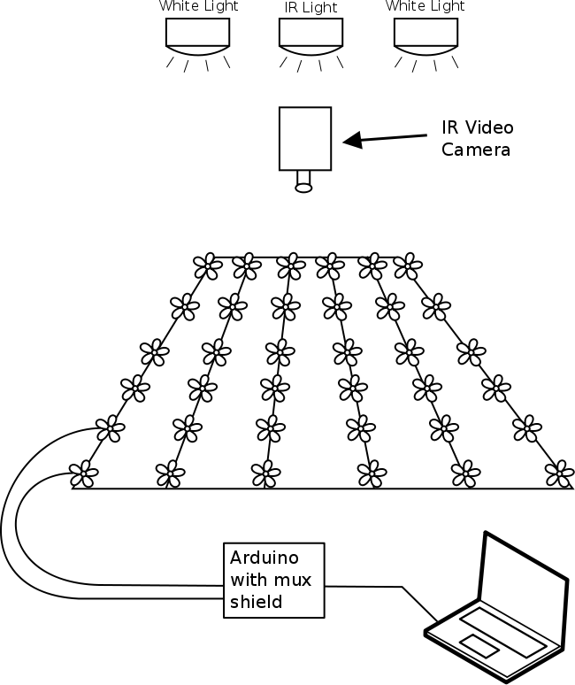
Figure S1. Line drawing depicting major elements of the first stage experimental arena. The morphological disparity of the artificial flowers populating the array is not reflected here. Each artificial flower was attached to an infrared sensor to detect when proboscis insertion into the nectary occurred at each flower, and to calculate the duration of each probing event. The signal from each flower was routed to an Arduino® microcontroller. For simplicity, only two of the flowers are shown "wired up" in this graphic.

Figure S2. The length of hawkmoth proboscis is an evolutionay conflict between plants and hawkmoths.
The data is pooled from all the trials in the second stage experiment. The gray smooth area represents 95% confidence interval for predictions of the linear model (red line). The upper panel shows the positive linear relationship between proboscis length and pollinator’s fitness measured as net rate of energy gain. The lower panel shows the negative relationship between proboscis length and plant’s fitness measured as hit counts per visit.
Table S1. The full data set of the first stage experiment
Corolla Curvature (c) | Nectary Diameter (2r0) | Sample Size | Average Visit Frequency | SEM of Visit Frequency | Average Success Rate (%) | SEM of Success Rate
-5 | 1 | 47 | 10.15 | 1.10 | 2.02 | 0.74
-4 | 1 | 24 | 8.08 | 1.42 | 9.22 | 2.58
-3 | 1 | 24 | 7.88 | 1.09 | 25.27 | 4.66
-2 | 1 | 25 | 8.08 | 0.92 | 39.51 | 5.10
-1 | 1 | 73 | 9.21 | 0.76 | 42.14 | 2.81
0 | 1 | 25 | 11.28 | 1.49 | 34.90 | 4.12
0.375 | 1 | 24 | 8.79 | 0.98 | 10.78 | 2.69
1 | 1 | 24 | 10.17 | 1.70 | 2.59 | 1.25
-5 | 1.75 | 25 | 13.16 | 1.96 | 6.82 | 2.00
-5 | 2.5 | 47 | 10.06 | 0.95 | 14.09 | 2.47
-4 | 2.5 | 23 | 7.39 | 1.00 | 25.56 | 4.65
-3 | 2.5 | 25 | 8.40 | 1.23 | 45.20 | 5.98
-2 | 2.5 | 24 | 7.42 | 1.13 | 38.85 | 5.20
-1 | 2.5 | 24 | 8.17 | 1.01 | 37.69 | 5.29
0 | 2.5 | 24 | 7.75 | 1.43 | 38.84 | 5.93
0.375 | 2.5 | 25 | 12.72 | 1.75 | 27.68 | 3.85
1 | 2.5 | 24 | 12.29 | 1.95 | 14.42 | 2.80
-5 | 3.25 | 24 | 11.54 | 1.84 | 18.75 | 3.14
-4 | 3.25 | 25 | 5.56 | 0.83 | 29.99 | 4.69
-3 | 3.25 | 25 | 6.84 | 0.88 | 36.62 | 5.81
-1 | 3.25 | 25 | 6.04 | 0.75 | 45.09 | 5.10
-5 | 5 | 25 | 10.96 | 1.82 | 23.89 | 3.12
-5 | 7 | 24 | 11.08 | 1.19 | 27.95 | 3.18
-4 | 7 | 25 | 6.96 | 1.13 | 41.80 | 5.30
-3 | 7 | 23 | 9.09 | 1.01 | 33.61 | 3.83
-1 | 7 | 24 | 7.63 | 0.96 | 39.08 | 4.88

Video S1. The video recording of two consecutive visits in the second stage experiment under infrared light
https://www.youtube.com/watch?v=lRwFIYTOWLU

Video S2. Hawkmoth visit to a flower with relatively simple morphology to exploit
https://www.youtube.com/watch?v=7AKPyyZVF9E

Video S3. Hawkmoth visit to a flower with relatively difficult morphology to exploit
https://www.youtube.com/watch?v=7wvgb0yhM4E

