Temperature mediated hypoxia tolerance in a Northeastern Pacific Crab

Abigail M. Ames
University of Washington, Seattle, WA
School of Oceanography, Box 357940
Email: aames@uw.edu
May 27, 2018
Abstract
Hypoxic events are increasing in frequency and are often linked to mass mortalities, habitat compression, and re-distribution of marine species. While organismal responses to hypoxia are a growing area of research, few studies have investigated hypoxia tolerances in the Pacific Ocean which experiences significantly lower dissolved oxygen levels than other ocean basins. In this study, I evaluated the hypoxia tolerance of graceful crab (Metacarcinus gracilis), native to the Northeastern Pacific Ocean. Lab-based respirometry experiments were used to determine the basal metabolic rate (BMR) and critical oxygen level (O₂^{crit}) of this species and were combined with field distribution and oceanographic data to calculate the metabolic index across its geographic range. These results show that, near in situ temperatures (8 C), average BMR was 4.59 mg/L/g/hr and increased to 9.89 mg/L/g/hr. To compensate for this uptick in metabolic oxygen demand, O₂^{crit} also increased from 0.48 to 1.14 mg/L. From Alaska through British Columbia to Southern California, the metabolic index of M. gracilis ranges from 11.7 to 18.4. These results indicate that this crab is tolerant of fluctuating oxygen and has lower than average O₂^{crit} for the ocean basin. In order to establish realistic predictions of biological and ecological consequences of marine deoxygenation, further studies should integrate metabolic characteristics with in situ distribution and condition data to evaluate the hypoxia tolerance of marine communities and ecosystems.

Introduction
The episodic occurrence of low dissolved oxygen concentrations (hypoxia) is a common physical feature in the world ocean. In coastal regions, seasonal hypoxia generally occurs in summer months when phytoplankton bloom and decompose, consuming large quantities of oxygen. Permanent, expansive oxygen minimum zones (OMZs) exist below the photic zone due to the continuous degradation of organic matter from the surface ocean. Hypoxic events are often linked to mass mortalities (Rabalais et al. 2002) and OMZs lead to habitat compression and re-distribution of marine species (Prince et al. 2010). Although variation in dissolved oxygen content of the ocean is documented from paleoclimate records (Stramma et al. 2008), anthropogenic pollutants such as effluent and agricultural runoff catalyze phytoplankton production and exacerbate hypoxia in coastal regions. Oxygen deficiencies are projected to grow in frequency, duration, and intensity in coming decades due to the combined effects of eutrophication and rising temperatures which both elevates the oxygen demand of metabolism and decreases the solubility of oxygen in seawater (Pörtner et al. 2017, Vaquer-Sunyer and Duarte 2011).
Hypoxia is emerging as a significant threat to coastal and open ocean ecosystems around the world, forcing affected animals to adapt, flee, or perish. Mortality events triggered by hypoxia are so extensive that they are commonly referred to as “dead zones”, barren of fish and crustaceans (Diaz and Rosenberg 2008). Organisms that survive these conditions are subjected to physiological stressors and often possess either physiological or behavioral mechanisms that ameliorate impacts on reproduction, growth, foraging, and habitat availability (Taylor and Eggleston, Prince et al. 2010, Wu 2002). Benthic organisms are particularly vulnerable to coastal hypoxia due to their isolation from oxygen supply at the surface and many taxa are secured to the bottom and unable to move when conditions are unfavorable, and as such face death (Vaquer-Sunyer and Duarte 2011). However, highly mobile organisms like fish and crustaceans are able to escape to suitable regions.
The oxygen concentrations used to characterize hypoxic environments are removed from the biological communities of the system (Siebel and Childress 2013) and do not account for basin-level differences in dissolved oxygen concentrations (Hoffman et al. 2011). Most commonly, hypoxic conditions are defined by ~2 mg O²/L (Rabalais et al. 2010) based on a body of research from the Atlantic which fails to predict species patterns in oceans with intrinsically lower oxygen content, such as the Pacific Ocean. Benthic organisms here sustain life at naturally lower oxygen levels and experience hypoxia-induced stress at much lower levels than generalized hypoxia thresholds suggest (Chu and Gale 2017). Although the relationship between metabolic oxygen demand and environmental oxygen supply has been demonstrated at length, few studies have evaluated species specific critical oxygen levels to address in situ population responses to hypoxia (Deutsch et al. 2015). Critical oxygen values are unknown for the majority of marine species (Seibel and Childress 2013) and are divorced from field abundance distributions which rarely include in situ environmental O₂ measurements. With the marked uptick in occurrences of low oxygen events, the need for biologically-grounded definitions of hypoxia is crucial to understanding ecological responses to changing ocean ecosystems.
For a habitat to be physiologically viable, ambient oxygen supply must be greater than the amount of oxygen needed for an animal to maintain basic metabolic function at rest. The lowest oxygen level (O₂) at which an animal can sustain resting metabolic rate before transitioning into anaerobic metabolism is hereby referred to as O₂^{crit}. At O₂ above this critical threshold, organisms can regulate oxygen uptake during routine activities independent of environmental O₂ fluctuations. When environmental O₂ falls below O₂^{crit}, metabolic rate declines due to depressed oxygen transport (Pörtner and Farrell 2008). The ratio of environmental O₂ to basal oxygen demand, or the species’ metabolic index, describes the capacity of the habitat to allow organisms to allocate aerobic energy to digestion, growth, and physical activities such as locomotion, predator avoidance, and prey capture. Deutsch et al. (2015) demonstrated the utility of this index to predict current and future metabolically-driven habitat constraints in several Atlantic species. While this metric has the potential to inform patterns in biogeography and the management of sensitive populations, few studies have modeled metabolic index for any species since it was introduced in 2015.
Here, I present a study from the Northeastern Pacific in which I determined the hypoxia tolerance and threshold of an ecologically and economically important crab species based on metabolic traits. The metabolism of decapod crustaceans has been extensively studied (Vaquer-Sunyer and Duarte 2008) and this diverse taxon makes up a significant amount of global benthic biomass. These crabs are highly mobile and participate in frequent burst activities such as escaping predators (Jackson and MacMillan 2000), burying in sand (McGaw 2005), and interactions with other crabs (Sneddon 1999). Graceful crab (Metacarcinus gracilis) is a small Cancrid crab that inhabits sandy and muddy shores of the United States West coast and has a relatively high routine rate of activity (Curtis et al. 2007). I combined in situ oxygen measurements, field distributions, and lab-based respirometry to estimate basal metabolic rate (BMR), O₂^{crit}, and metabolic index for M. gracilis. These results are pertinent to understand the metabolic parameters of benthic invertebrate communities of the Northeastern Pacific and their tolerance of hypoxia.

Methods
Animals
Metacarcinus gracilis were collected by scuba and maintained in flow-through seawater tanks at NOAA Northwest Fisheries Science Center (Mukilteo, WA, USA). Crabs were fed market squid weekly and starved 24 hours prior to the start of each trial to prevent elevated oxygen consumption due to gastric processes.
Biogeographic data
All available occurrences of M. gracilis were obtained from Ocean Biogeographic Information Systems (OBIS). This dataset included coordinates and depth of collection as well as oceanographic data such as temperature and oxygen. Records that did not contain both temperature and oxygen at site of collection were omitted as these values are required to calculate metabolic index.
Respirometry
Rates of oxygen consumption were determined by allowing individual specimens to deplete available oxygen in sealed containers filled with filtered seawater. Chambers were submerged in a temperature-controlled water bath to maintain constant temperature for the duration of each experiment. Chamber lids were equipped with rubber o-rings and silicone vacuum grease to prevent water and gas exchange. Fiber optic oxygen probes and temperature sensors (Precision Sensing, GmbH, Germany) were inserted into each chamber and secured through water-tight gaskets. Temperature in Celsius and oxygen as percent of atmosphere from each sensor were automatically recorded every 30 seconds for 12-24 hours.
Metabolic calculations
Oxygen measurements from experimental trials and OBIS data were converted to kPa for metabolic index computation and mg/L for reporting using oxygen solubility adapted from Garcia and Gordon (1992) using Python (Python Software Foundation. Python Language Reference, version 3.6.3). Basal metabolic rates were calculated from the slopes of each oxygen profile over time, divided by the wet weight of each crab. O₂^{crit} was determined as the point on oxygen consumption curve where the line first deviates from the basal rate of consumption. Metabolic index was calculated for each crab and averaged across the temperature treatment.
For a habitat to be physiologically viable, the rate of environmental O₂ supply (S) must exceed the rate at which an animal consumes O₂ at rest (D). The rate of O₂ supply increases with ambient O₂ pressure (PO₂) and with respiratory efficacy (Piiper et al. 1971). Thus,$S=α_{S}B^{δ}PO_{2}$ where respiratory efficacy is the product of $α_{S}$, a per-mass rate of gas transfer between water and animal and its scaling with biomass, $B^{δ}.$ Resting metabolic demand also scales with $B$ and with absolute temperature (T), according to $D= α_{D}B^{ε}exp⁡(-\frac{E_{o}}{k_{B}T})$, where $α_{D}$ is a taxon-specific baseline metabolic rate, $ε$ is its allometric scaling, $E_{o}$ is its temperature dependence, and $k_{B}$ is Boltzmann’s constant (Gillooly et al. 2001). Metabolic index ($Φ$), as defined by Deutsch et al. (2015), relates the environmental supply of oxygen to the oxygen demand of an organism at rest:
$Φ=A_{O}B^{n}\frac{{PO}_{2}}{exp⁡(-\frac{E_{0}}{k_{B}T})}$ (1)
Where $A_{O}=α_{S}/α_{D}$ is the ratio of rate coefficients for O₂ supply and metabolic rate, and n is the difference between the respective allometric scalings ($n=δ-ε$). If $Φ$ falls below the critical value of 1, organisms must either suppress aerobic activity or initiate anaerobic metabolism, which is physiologically unsustainable. Values above 1 enable metabolic rates to increase above resting rate, allowing for energetically intensive, yet critical activities such as feeding, growth, and reproduction. Thus, for a given environment, $Φ$ estimates the ratio of maximum sustainable metabolic rate to minimum rate necessary for maintenance for a given species.
Results
Figure 1 presents respirometry chamber O₂ collected from one of 7 crabs at each temperature. Although experiments ran overnight, the time needed for O₂ to reach 0 mg/L ranged from 2.7 to 15 minutes. Rates of O₂ consumption were elevated and irregular at the beginning of each experiment, but quickly stabilized around 4 mg/L for 8 C and 2 mg/L for 15 C. From these data, basal metabolic rate and O₂^{crit} were calculated.
In warmer water, both BMR and O₂^{crit} were significantly higher from those in cold water (Table 1). The BMR were 4.59 and 9.89 mg/L/g/hr at 8 and 15 C, respectively. A similar trend is reflected in O₂^{crit} values, increasing from 0.48 to 1.14 mg/L between treatments.
M. gracilis records were concentrated in the Pacific Northwest of the US, but extended south to the southernmost boundary of California (Figure 2). Across these geographic records, metabolic indices ranged from 11.7 to 18.4 spanning a temperature gradient from 7 to 11 C (Figure 2). A linear regression between O₂^{crit} and treatment temperature produced Ao and Eo as the slope and intercept (Table 2). Specimens were not evenly distributed among metabolic indices. Rather, crabs found in warmer waters tend to exhibit higher metabolic index (Figure 3).

Discussion
The metabolic rate of M. gracilis has not been formally determined previous to this study. At temperatures close to those commonly experienced by the species, BMR was 4.59 mg/L/g/hr. In much warmer water BMR increased to 9.89 mg/L/g/hr, changing by nearly two-fold (Table 1), This linear increase in metabolic rate is expected when ambient temperature is increased given no constraint by (dissolved oxygen) O₂. O₂^{crit}, mirroring increased oxygen demand from elevated BMR, more than doubled with a five degree increase in temperature. At 8 C, O₂ was 0.48 mg/L and 0.98 mg/L at 15 C. Prentice and Schneider (1979) found that Dungeness crab has a much lower metabolic rate of 11 uL/L/g/hr (~0.015 mg/L/g/hr) at 7.5 C and 25 uL/L/g/hr (~0.033 mg/L/g/hr) at 17.5 C. Similarly to the change in M. gracilis rates, Dungeness metabolic rate more than doubles in a 10 degree span. In an extensive study by Chu and Gale (2017), the O₂^{crit} of crustaceans spanning all ocean basins range between 0.13 mg/L to 7.78 mg/L. Chu and Gale (2017) demonstrated that basin-specific O₂^{crit} constrained by the O₂^{crit} of organisms in the basin varies between major oceans. O₂^{crit} in the Eastern Pacific region are markedly lower than any other body, reflecting the evolutionary history of this naturally oxygen deficient ocean. M. gracilis contributes yet another data point which suggests that the blanket hypoxia threshold of 2 mg/L does not affect all organisms equally.
Crabs are adapted to survive harsh conditions for extended periods of time. Unlike stationary organisms, crabs are highly mobile and often undertake large seasonal migrations (cite). Dungeness crab are known to forage for infaunal organisms in areas of hypoxia and move their prey to areas of adequate oxygen concentration to feed (Bernatis et al. 2007). For burying organisms like clams and annelids, fluctuations in oxygen at the sediment-water interface drive these animals to stay near the benthos to extract oxygen from the water column, putting them at risk of predation. For Dungeness, the ease of foraging for these prey items in hypoxic conditions and moving to oxygen-rich environments to handle and digest the food may be a favorable energy trade-off. Crabs also have specialized physiological controls that allow them to mediate unfavorable conditions. In addition to the ability to osmoregulate (McGaw 2006, Curtis et al. 2007, McGaw 2007), some species can modulate hemolymph circulation to prioritize oxygen delivery to the limbs, ventral nerve cord, and respiratory pump, and maintain hyperventilation to maximize oxygen uptake (Airriess and McMahon 1994). These traits allow crabs to withstand hypoxic conditions for extended periods of time and exploit habitats that are not accessible to more sensitive taxa.
Along the coast of the Western US (Fig 1), the metabolic index for field distributions of M. gracilis range from 11.7 to 18.4 (Fig 2), indicating a wide margin of “excess” oxygen in the habitats occupied by this species. This crab species ranges from intertidal to ~170 m in the field, and this depth distribution likely encompasses a range of oxygen concentrations as deep waters, especially in the Pacific, are oxygen poor. Dungeness crab, which share similar habitat and depth distributions to M. gracilis, shows strong evidence for high hypoxia tolerance and oxyindependence. Although O₂^{crit} has not been determined, studies suggest that the critical oxygen level for the species is less than 1 mg/L in their day-to-day environment (Airriess and McMahon 1994). This low oxygen threshold results in a wealth of metabolic currency that allows for the complete range of essential processes to occur, supporting increased oxygen demand during digestion and locomotion (McGaw 2008). As oceanic waters warm and their affinity for oxygen diminish, physiological relationships predict that the oxygen content of waters will diminish while metabolic demand will surge, acting to suppress metabolic index.
Conclusion
Integrating lab-based physiological experiments, field distributions, and in situ oceanographic measurements found strong hypoxia tolerance in the graceful crab, Metacarcinus gracilis. This species is abundant in the Pacific Northwest, but available data indicates its range extends from Alaska, through British Columbia, to southern California. I found the species O₂^{crit} to be 0.48 at 8 C and 1.14 mg/L at 15 C, with metabolic index across this geographic range varying between 11 and 18. Together, these results indicate that a) oxygen demand increases with increasing temperature, b) O₂^{crit} for this species is much lower than the basin-wide O₂^{crit} of 0.13-7.78 mg/L (Chu and Gale 2017), and c) this species generally occupies habitats that are oxygenated at 11 to 18 times the level needed to maintain basic physiological processes. Given the historically low oxygen levels in the Pacific Ocean, this crab is well-adapted for life in fluctuating oxygen conditions and may be resistant to future trends toward higher temperatures and lower oxygen levels as anthropogenic stressors and climate change accelerate.

Acknowledgements
I would like to acknowledge the generosity of NOAA Mukilteo and Jacqueline Padilla-Gamiño for lending space and equipment without which this study would not exist. Additionally, I would like to recognize Dr. Allison Smith for her guidance on this project through all of its obstacles. Thank you to my working group—Megumi Serdan, Surbhi Ghadia, and Lisa Burk—for their feedback on experimental design and manuscript drafts. Finally, I would like to thank the University of Washington School of Oceanography for supporting the capstone program, Arthur Nowell for his guidance, and Dr. Curtis Deutsch for his patient mentorship, encouragement, and the development of this project.
Tables
Table 1: Treatment temperatures with corresponding individual and averaged (with standard deviation) metabolic rates and critical oxygen concentrations as determined by respirometry.
 | 8 C Treatment |  |  | 15 C Treatment
Crab ID | Metabolic rate (mg/L/g/hr) | O₂^{crit} | Crab ID | Metabolic rate (mg/L/g/hr) | O₂^{crit}
1 | 5.56 | 0.51 | 8 | 8.18 | 1.17
2 | 3.54 | - | 9 | 7.4 | 1.12
3 | 3.92 | - | 10 | 19.55 | 1.36
4 | 3.72 | 0.51 | 11 | 12.04 | 1.08
5 | 4.77 | 0.47 | 12 | 6.71 | 1.03
6 | 4.09 | 0.42 | 13 | 7.61 | 0.84
7 | 6.55 | - | 14 | 7.71 | 1.36
Average | 4.59 | 0.48 |  | 9.89 | 1.14
SD | 0.76 | 0.04 |  | 4.6 | 0.18

Table 2: Parameters from the linear regression used to calculate metabolic index.
A₀ | E₀
3.7 x 10⁻¹⁶ | 0.86

Figures
Figure 1: Oxygen consumption of M. gracilis at 8 and 15 C over the course of ~5-15 minutes, 8 and 15 C treatments are represented by blue and red lines, respectively. Note time 15 C treatment elapses over 300 seconds rather than 800.

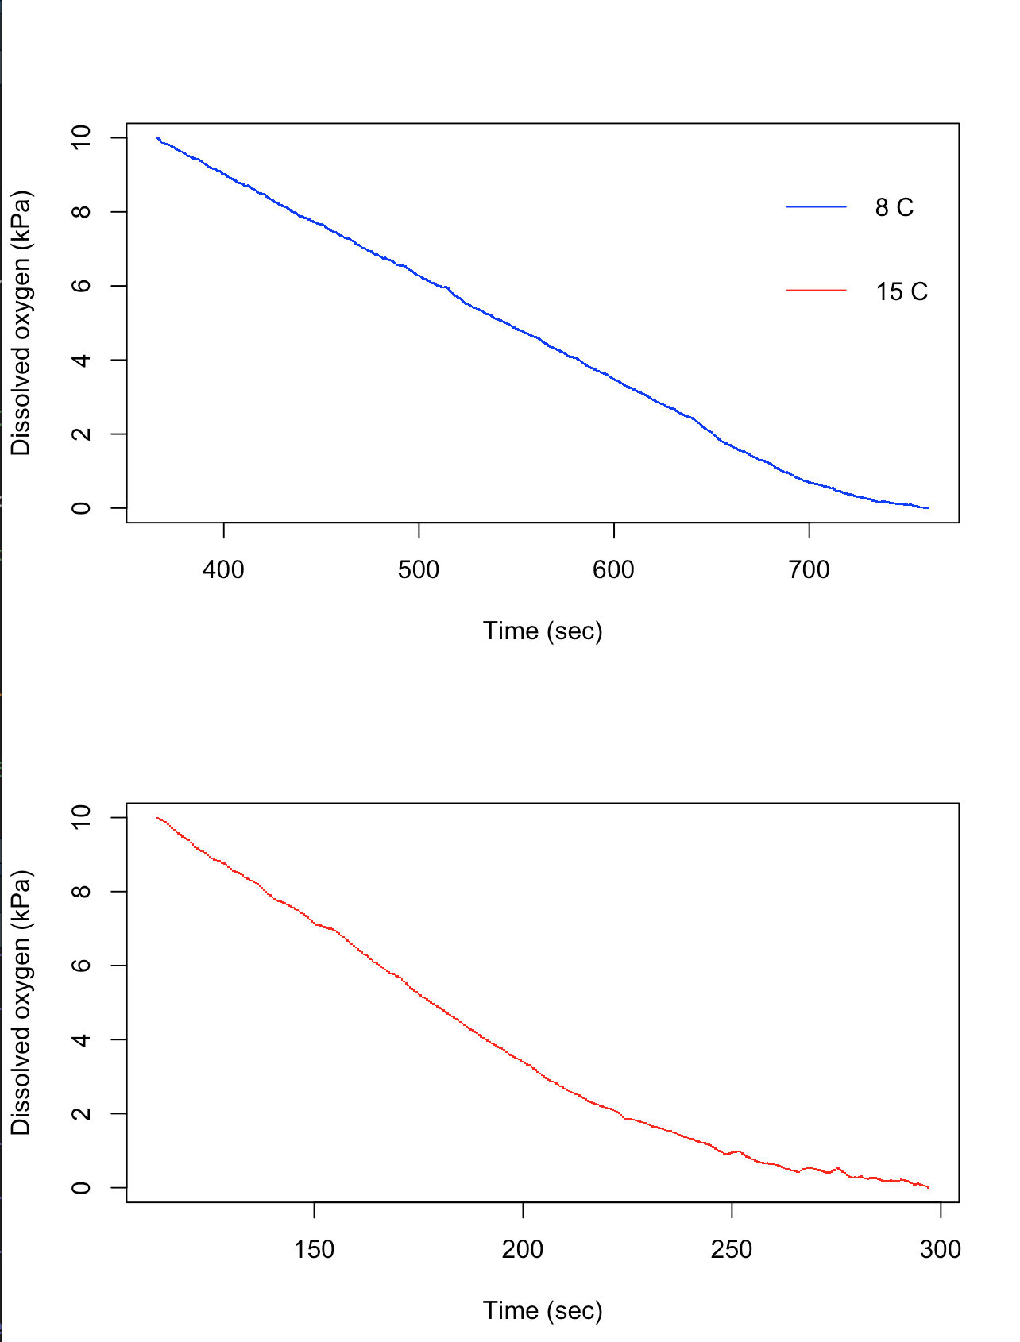

Figure 2: 35 records of Metacarcinus gracilis from Ocean Biogeographic Information System (OBIS). Inset shows the abundance-depth distribution of OBIS records used in this study.
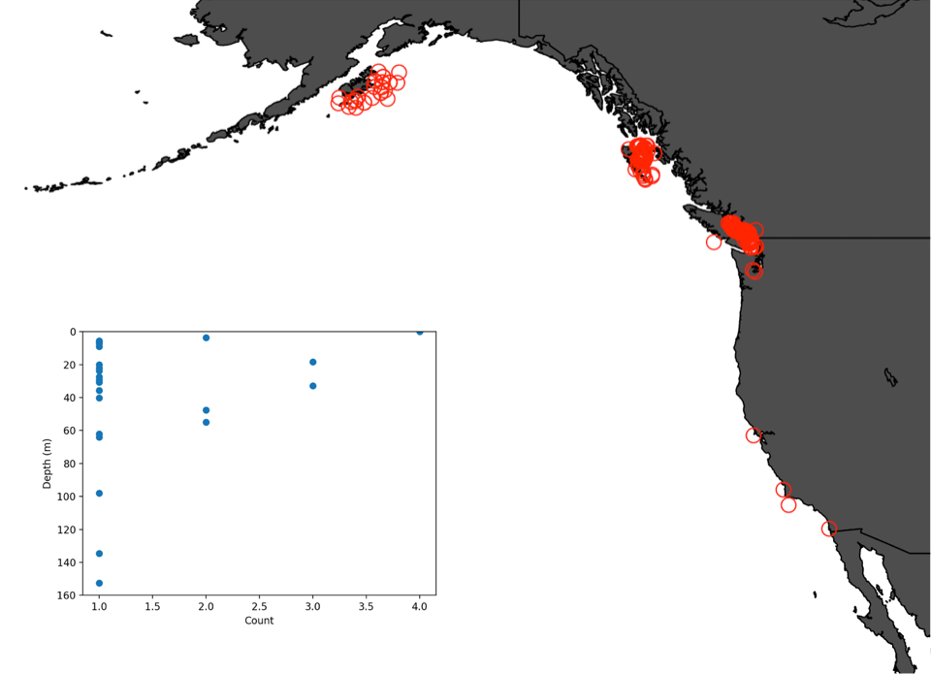
Figure 3: Metabolic index for field distribution of Metacarcinus gracilis based on in situ measurements of O₂ and temperature. Metabolic index increases as temperature increases and environmental O₂ decreases.

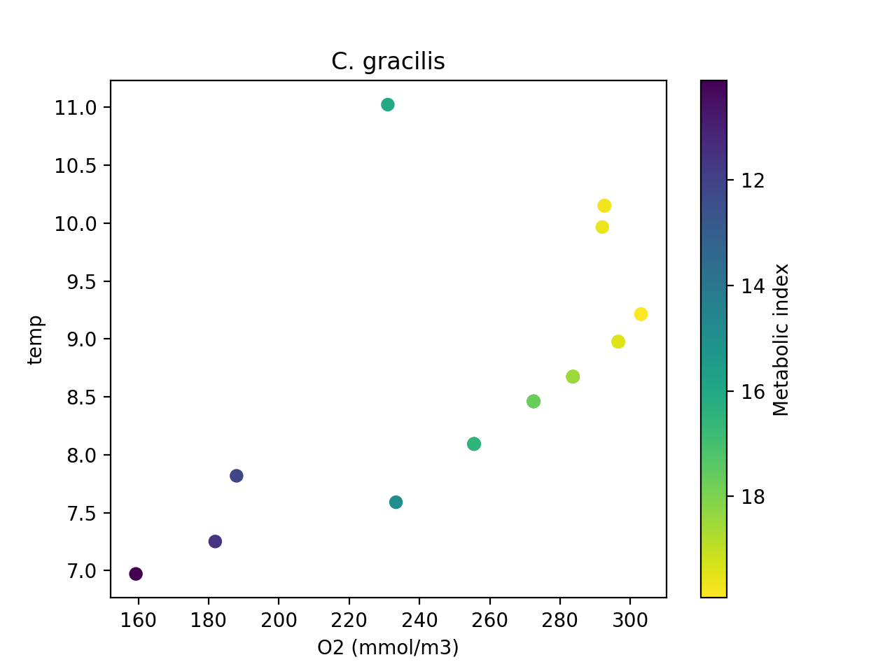
References
Airriess, C. N. and Mcmahon, B. R. (1994). CARDIOVASCULAR ADAPTATIONS ENHANCE TOLERANCE OF ENVIRONMENTAL HYPOXIA IN THE CRAB CANCER. J. Exp. Biol. 41, 23–41.
Bernatis, J. L., Gerstenberger, S. L. and Mcgaw, I. J. (2007). Behavioural responses of the Dungeness crab , Cancer magister , during feeding and digestion in hypoxic conditions. 941–951.
Chu, J. W. F. and Gale, K. S. P. (2017). Ecophysiological limits to aerobic metabolism in hypoxia determine epibenthic distributions and energy sequestration in the northeast Pacific ocean. Limnol. Oceanogr. 62, 59–74.
Curtis, D. L., Jensen, E. K. and McGaw, I. J. (2007). Behavioral influences on the physiological responses of Cancer gracilis, the graceful crab, during hyposaline exposure. Biol. Bull. 212, 222–231.
Deutsch, C., Ferrel, A., Seibel, B., Pörtner, H. and Huey, R. B. (2015). Climate change tighens a matabolic constraint on marine mabitats. Science (80-. ). 348, 1132–1136.
Gillooly, J. F., Charnov, E. L., West, G. B., Savage, V. M., & Brown, J. H. (2002). Effects of size and temperature on developmental time. Nature, 417(6884), 70-73.
Hofmann, A. F., Peltzer, E. T., Walz, P. M. and Brewer, P. G. (2011). Hypoxia by degrees: Establishing definitions for a changing ocean. Deep. Res. Part I Oceanogr. Res. Pap. 58, 1212–1226.
Jackson, D. J. and MacMillan, D. L. (2000). Tailflick escape behavior in larval and juvenile lobsters (Homarus americanus) and crayfish (Cherax destructor). Biol. Bull. 198, 307–318.
McGaw I.J. 2005. Burying behaviour in two sympatric crab species, Cancer magister and
Cancer productus. Sci Mar 69: 375–381.
McGaw, I. J. (2006). Feeding and digestion in low salinity in an osmoconforming crab, Cancer gracilis II. Gastric evacuation and motility. J. Exp. Biol. 209, 3777–3785.

Mcgaw, I. J. (2007). The Interactive Effects of Exercise and Feeding on Oxygen Uptake , Activity Levels , and Gastric Processing in the Graceful Crab Cancer gracilis The Interactive Effects of Exercise and Feeding on Oxygen Uptake , Activity Levels , and Gastric Processing in. Physiol. Biochem. Zool. 80, 335–343.
Mullowney, D., Morris, C., Dawe, E., Zagorsky, I. and Goryanina, S. (2017). Dynamics of snow crab (Chionoecetes opilio) movement and migration along the Newfoundland and Labrador and Eastern Barents Sea continental shelves. Rev. Fish Biol. Fish. 28, 1–25.
Piiper, J., Dejours, P., Haab, P., & Rahn, H. (1971). Concepts and basic quantities in gas exchange physiology. Respiration physiology, 13(3), 292-304.
Pörtner, H. O. and Gutt, J. (2016). Impacts of climate variability and change on (marine) animals: Physiological underpinnings and evolutionary consequences. Integr. Comp. Biol. 56, 31–44.
Pörtner, H.-O., Bock, C. and Mark, F. C. (2017). Oxygen- and capacity-limited thermal tolerance: bridging ecology and physiology. J. Exp. Biol. 220, 2685–2696.
Prince, E. D., Luo, J., Phillip Goodyear, C., Hoolihan, J. P., Snodgrass, D., Orbesen, E. S., Serafy, J. E., Ortiz, M. and Schirripa, M. J. (2010). Ocean scale hypoxia-based habitat compression of Atlantic istiophorid billfishes. Fish. Oceanogr. 19, 448–462.
Rabalais NN, Turner RE, Wiseman WJ (2002) Gulf of Mexico hypoxia, aka ‘‘The dead zone.’’ Ann Rev Ecol Syst 33:235–263.
Rabalais, N. N., Díaz, R. J., Levin, L. A., Turner, R. E., Gilbert, D. and Zhang, J. (2010). Dynamics and distribution of natural and human-caused hypoxia. Biogeosciences 7, 585–619.
Seibel, B. A. and Childress, J. J. (2012). The real limits to marine life: a further critique of the Respiration Index. Biogeosciences Discuss. 9, 16521–16532.
Sneddon, L. U., Taylor, A. C. and Huntingford, F. A. (1999). Metabolic consequences of agonistic behaviour : crab fights in declining oxygen tensions. 353–363.
Stramma, L., Johnson, G. C., Sprintall, J. and Mohrholz, V. (2008). Expanding Oxygen Minimum Zons in the Tropical Oceans. Science (80-. ). 320, 655–658.
Taylor, D. L., Eggleston, D. B., Taylor, D. L. and Egg, D. B. (2000). Effects of hypoxia on an interaction : foraging be interference in the blue and the infaunal clam. Mar. Ecol. Prog. Ser. 196, 221–237.
Vaquer-sunyer, R. and Duarte, C. M. (2011). Temperature effects on oxygen thresholds for hypoxia in marine benthic organisms. Glob. Chang. Biol. 17, 1788–1797.
Wu, R. S. S. (2002). Hypoxia : from molecular responses to ecosystem responses. Mar. poll 45, 35–45.

