Climate Change Impacts on Fine Scale Patch Dynamics of Lakes and Estuaries.

Benjamin Bosquet
University of Washington
School of Oceanography, Box 357940, Seattle, WA 98195-5351
bbosquet@uw.edu

May 29, 2017

Abstract:
Marine organisms such as phytoplankton and zooplankton are sensitive to the spatial and temporal patchiness of their ecosystems. Properties such as temperature can greatly influence their movement, growth, and survivability. Current efforts towards patch detection have focused on satellite, seaglider, and CTD data of open ocean hydrodynamics. This project aims to tackle an insufficiently studied area of patchiness; estuarine and lake fine scale measurements. This paper outlines the design and development of an autonomous surface water vehicle (ASV) and subsequent discoveries. Simulated data from the ASVs have been analyzed as a demonstration of sampling techniques and instrument viability. Data taken using these ASVs could be used to further research into biogeochemical cycles and their relation to fine scale estuarine and lake patch dynamics.
Introduction:
The biogeochemical processes that are continuously active within the marine waters of Puget Sound are constrained and controlled by the spatial patchiness of the outcome of these processes. The physical, chemical, and biological cycles drive the functional marine ecosystem to form relative uniform patches which support marine organisms at all spatial and temporal scales (Irlandi 1995, Russell 1992, Grober-Dunsmore et.al. 2009). Patchiness refers to the spatial and temporal variability of descriptive characteristics of key variables which define the extent of relatively homogeneous areas that differ in function from their surroundings (Forman 1995). Patches can be identified by steep gradients in specific characteristics that functional form natural barriers for an organism or process. The spatial and temporal patchiness of temperature and light availability can be easily understood as key characteristics defining marine patchiness.
Very fine scale and large scale patchiness have been studied in rivers and oceans respectively. Trogersen et. al (1999) found that thermal patchiness in the John Day River basin was associated to chinook salmon behavior. As the stream reached temperatures that were too high for chinook salmon to function properly, thermal patches in the stream where water was cooler than its surroundings served as refuge for migrating salmon. Poole et. al (2009) also studied thermal patterns in streams and the geophysical interactions between the internal structure of the stream and the distribution of heat. Thermal patchiness in streams was found to be influenced by their hydrography while were to blame for the net increase in heat. In the open ocean, density gradients as a function of temperature and salinity are found to heavily influence zooplankton distribution (Gluchowska et. al, 2016). Under the assumption that water patchiness does contribute to physicochemical and biophysical processes, urban and coastal environments need high resolution hydrographic study. Current methods of measuring and monitoring marine water patchiness are too limited in either their functionality (in situ data sampling of rivers by scientists, Trogersen et. al and Poole et. al) or their resolution of the ocean is too large, resulting in major aliasing (satellite data, Gluchowska et. al).
The characteristics of horizontal layers in the ocean and stratification has been well studied using floats, gliders, CTD’s and various other in-situ instruments. Fine scale patchiness is less well studied with much of current research interests having been put into mesoscale eddies and phytoplankton biophysical interactions (Rhines et. al, 2009). Rhines et. al used a combination of seaglider data and satellite data to parse together a more accurate representation of mesoscale eddy variability and control of phytoplankton blooms. An even larger study was done on the plankton patchiness in a Polar Front region by Gluchowska et. al using CTD measurements. This also revealed important density gradient effects on plankton but it was determined that they needed finer scale measurements to have a more accurate spatial definition of these patches and their affects.
The objective for this research and development project is to development of a measurement and monitoring solution for assessing changes in the fine scale spatial and temporal variation of marine waters of Puget Sound. Specifically, the potential for the application of swam technology is assessed and its application for better understand the impact due to climate variability on the patchiness of marine waters and its role in the regulations of primary productivity and biogeochemical processes. Swarm technology is a set of intercommunicating instruments with instrument to shore data transfer for the measurement and monitoring of changes in fine scale spatial and temporal variation of surface marine waters of estuarine and lake environments. In this project, instruments use radio frequency (RF) communication to initiate sampling of patches, transfer data onshore, and return to station when sampling is terminated. The instruments respond to their environments to control movement with a physical feedback system. Water tightness is insured only for splash exposure as they are not submerged under normal operating conditions. Installation of this swarm will give meter resolution data of estuarian patches and provide a highly customizable platform on which research can be undertaken to study any number of hydrographic characteristics.
Design and Implementation:
The design of the swarm instruments focused on 4 key objectives: (1) autonomous data and power requirements; (2) communication with individual instruments would be centralized to a shore station for data storage in order to insure data recovery; (3) geographic positions of individual instruments would serve as both navigation input for each instrument and as metadata geolocation tags for each environmental observation; and (4) cost would be kept low to encourage use at all levels of interest in ocean science and technology research.
A large portion of these expenses are the cost of personnel needed for frequent and long-term field research. To reduce the personnel, the instruments were originally designed to have independent data gathering. As a result, independency for these instruments is the primary goal. The key design parameter about this goal was the disjunction between scientists and the instruments. A major component of many instruments is the input that they receive from scientists or technicians conducting the data sampling. One example is CTD’s. While CTD’s provide large amounts of info, a significant drawback is the considerable input that technicians must perform to deploy the instruments as well as the input scientists provide to gather data from niskin bottles. Instead of a similarly time intensive instrument array, these ASVs are designed to resemble AUVs such as seagliders. Seagliders have pilots that can direct the vehicles to perform their dives when they surface with minimal time spent relative to the dives. Even these however have more input than the ASVs were designed to require. These ASVs are designed to only take the simplest instructions that constrain their search parameters for specific characteristics in the water.
For simplicity, temperature was used as the target for sampling in water. As explained in the introduction, temperature is a limiting factor for many zooplankton species as well as macro organisms. To set ASVs on the search for patchiness, several different parameters can be set, as well as several different methods. The different parameters include gradients over space and time, both apart and together. The different methods include using the ASVs as drifters once in contact with a desirable patch or actively searching and mapping gradients within surface waters. These methods accentuate the ability for the instruments to react to environmental data and, based on these data, sample surface waters accordingly with minimal input from technicians or scientists.
Communication is also key in the independence of any instrument. One may design an instrument that records data on the seafloor with extreme precision but for which the data may not be easily acquired once deployed. To avoid the need for retrieval of many instruments for their datasets, as would be necessary for a swarm of sensors with little intercommunication, the ASVs were initially designed to work with WiFi between one another and a bay station. This base station would act as commander and scribe for the swarm, directing each instrument to sample based on the information gathered by the collective swarm that it collects on an SD card. While the design for the bay station recording system, an SD storage shield on an Arduino, was kept, WiFi was determined to have too short of a range that its high data transfer did not make up for in a system designed for estuarine environments. Marine waters like estuaries and lakes can cover up to several kilometers in length and as such, radio frequency quickly outshined WiFi and Bluetooth, with low frequency radio frequencies (LoRa RF) providing up to 5 km range when unobstructed by structures.
To support the spatial and temporal analysis of patch data, the instruments sample surface water and send time-stamped and GPS-stamped data wirelessly to the base station. The GPS’s are sensitive to within 2.5 meters, insuring a reliable spatial data set for patch and pattern analysis. Accurate geo-stamping is crucial in these fine scale dynamics where previously satellites dominated despite having poor resolution of surface waters. The time is recorded using a real-time clock which is accurate to within a few minutes every year.
To provide round-the-clock sampling, on board recharging was initially to be performed by solar panels on the top most portion of the ASV. Recharging in situ, however, was ultimately decided against due to budget constraints. In lieu of this, the instruments were designed to be run by rechargeable batteries.
The platform for the electronics was constructed out of buoyant plastic panels fitted with two enclosed pontoons made of polyvinyl chloride (PVC). The platform has enough buoyancy to support the electronics, propeller, and electronics case. For accuracy, the sampling is carried out by a temperature sensor (DS18B20) hooked to the front of the platform where there is the least turbulence from the instrument itself. The propeller has a forward and reverse function with variable speed and uses information from real time sampling to make decisions about movement.
Test Methods:
The testing of the swarm instrument was conducted in four phases. The first phase was a bench test intended to test the autonomy of the instrument. Autonomy was the first concern of the project to insure minimal reliability on personnel. To ensure that autonomy was achieved, the bench test aimed to confirm its ability to rely on the environment to guide its movement. A temperature probe was hooked to a propeller and heated up and cooled down simply by holding the probe with a hand and dipping it in water respectively. Optimal results would be for differences in temperature and a specific target temperature to scale to the speed of the propeller and the sign of the temperature difference to equate to the direction of the propulsion.
Phase two focused on communication reliability and the feasibility of communication between the instruments and the base station. The first test in this phase involved the transfer of temperature data. Further tests evolved into sending GPS coordinates. Successful tests would show continuous uninterrupted data flow from the transmitting instrument to the receiving base station. They would also show complete and uncorrupted data files.
The third phase was a test of the functionality of the Global Position System. Triangulating time is the first portion of the test; testing the time it takes for GPS to triangulate upon startup. The next step is testing the GPS’s tendency to wander. Desirable results would yield a low tendency to wander and a data set that can be used to calibrate the GPS.
The fourth and final phase was the test for an individual instrument in situ. This test involved the functionality of the entire instrument. Along with the combination of the GPS, RF radio, and environmental reaction, the floatability and the impermeability of the platform. The initial test was performed on April 19th off the Marine Sciences Building dock at the University of Washington. Anticipated results were a lengthy instrument sampling period, reliable GPS coordinates, and the absence of water in the electronics case and pontoons.
Analysis methods of simulated data focused on descriptive statistics of the correlation of temperature differences of paired instruments and their spatial distance apart. A simple empirical semi-variogram was produced using the ESRI ArcGIS ver. 10.4 software to identify self-similarity in temperature values and spatial pattern.
Test Results and Discussion:
The results of the bench test were positive. When the temperature sensor was heated to approach a preset target temperature, the propeller slowed down. Once the temperature read by the sensor surpassed the target temperature, the propeller reversed direction. This implies successful physical feedback. Proving that one propeller reacts to the temperature sampled and even more importantly can be scaled to the magnitude in difference, proves that, given a properly written algorithm, estuarine environments could be well sampled for gradients.
Communication between the various instruments was also successful. Temperature and location was found to be successfully transmitted despite taking extensive amounts of time to acquire GPS fixes. The radios were found to have at least 1 transmission per second with little to no dropped transmissions except when exceeding the maximum distance for transmission. The maximum transmission distance in the city was recorded to be 330 meters even when in direct line of site without any antenna. The addition of an antenna increased distance to 580 meters, while careful positioning of the antennas towards each other increased range to >1000 meters. The city however seems to dampen the radio signal despite having line of sight between the radios. Whether 1 kilometer is the limit for open water transmission, it provides a very decent 2-kilometer diameter circle for which an ASV swarm can traverse.
GPS testing was more difficult than previously determined. Testing in OTC is not possible due to obstruction by virtue of being in the basement. When starting the GPS, triangulation could take anywhere from 20 seconds to 2 minutes. This seemed to be unrelated to either the specific GPS or the weather during triangulation. The wandering however, was minimal with less than 5 meters wander when staying still. Long triangulation intervals could be a problem in the field; successful startup of the GPS should be confirmed before sampling begins.
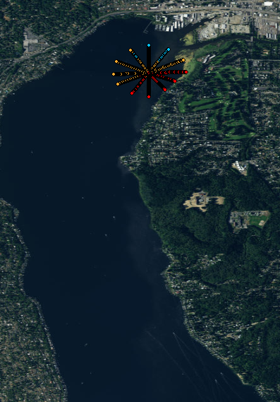
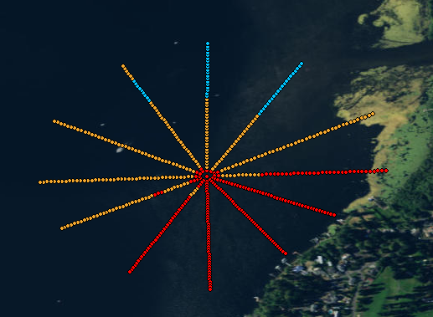
During the initial field test for the individual instrument, amid technical difficulties, the electronics case was found to be impermeable and propulsion worked as expected using physical feedback. The GPS, however, was found to have trouble triangulating possibly due to a lack of an antenna through the electronics case. The largest problem however was found to be a lack of enough power to run both the propeller and Arduino system. The propeller was found to require much more power than initially estimated. Originally a 9-volt alkaline, the battery was upgraded to two 8-cell battery packs in parallel on the front of the ASV. This extra weight led to an imbalance between the center of mass and center of buoyancy. Foam placed underneath the battery and the rest of the ASV corrected the tilt of the instrument.
Figure 1 Simulated data recorded in a radial pattern with equal angular spacing around the central mooring (a). (b) is a view including the northern part of Lake Washington and the incoming Sammamish River from the east.

Data was simulated in the north of Lake Washington near the mouth of the Sammamish River. At this location, cold fresh river water feeds into the lake causing steep gradients of temperature between the incoming plume and the resident lake water. Sampling was assumed to be taken in such a way that the current model of the ASV could perform, with a central mooring and peripheral vehicles that travel radially. Multiple transects at specific heading intervals were then interpolated to gather a complete map of the temperature in and near the river mouth.
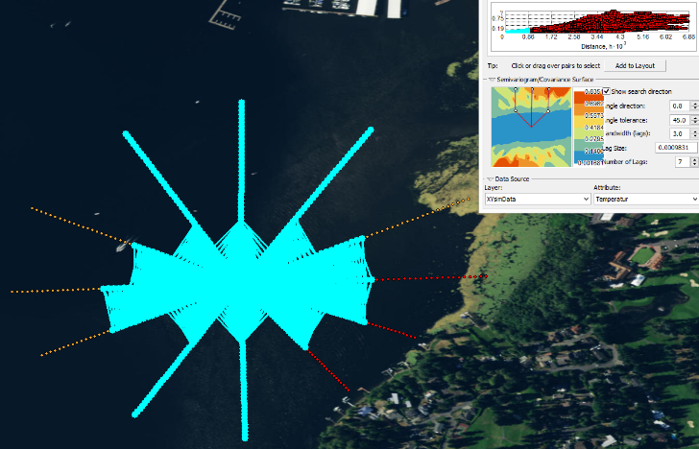
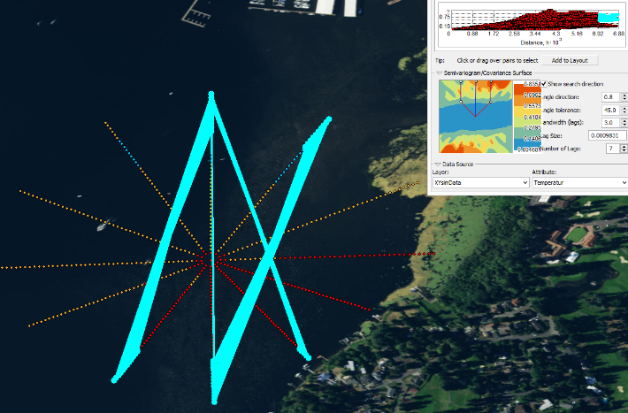
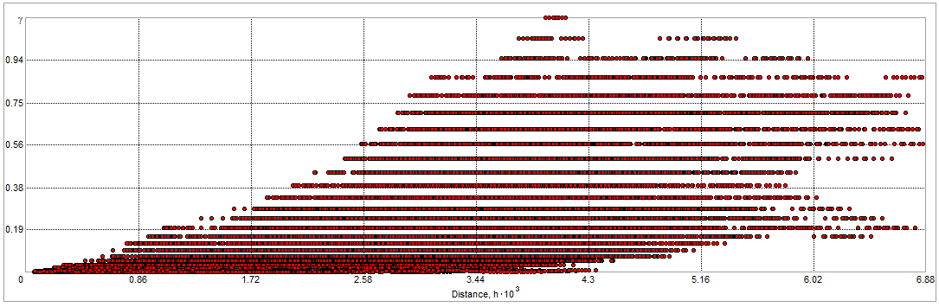
b.
c
a
Figure 2 Semi-variogram (a) with the most self-similar points highlighted in (b). The points least similar to each other are shown in (c). Highlighted points are connected by a line for each pair of points plotted in the semi-variogram.

This dataset, once run through ArcGIS can be represented using a semi-variogram (Figure 2a). This graph indicates the self-similarity of datum pairs relative to their distance apart. In highlighting various parts of the semi-variogram, a visual representation of the self-similarity of data may be produced. Figure 2b shows a smooth gradient of temperature perpendicular from the river mouth where the adjacent water would be conductively heating the river plume. Figure 2c is a representation of the large differences in temperature between the inside of the river plume and the coastal waters of the lake.
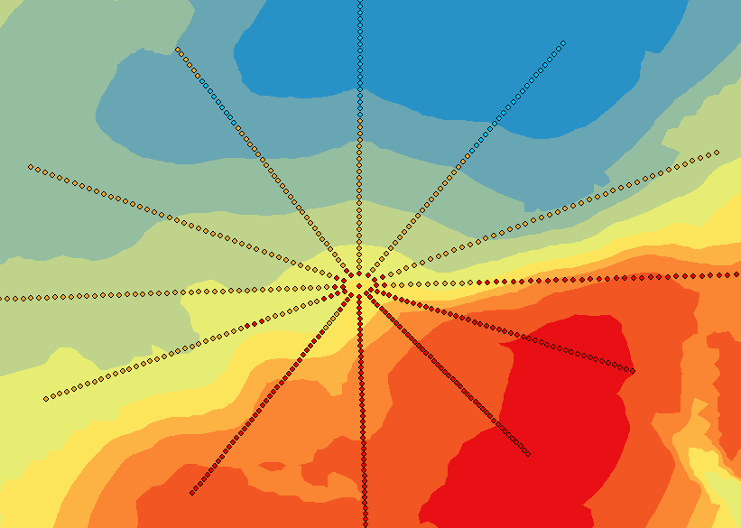
To give a clear picture of the patchiness expected to be analyzed using these datum, a predicted surface map is generated using the kriging interpolation. Kriging is a geostatistical tool used to interpolate data not only on their location but also the pertinent z value (in this case, temperature). Different constraints may be selected to bring about the most accurate representation of the situation. This map (Figure 3) was generated using a directional semi-variogram directed perpendicular to the river plume. The surface map shows a clear distinction between the patch of cold water coming from the Sammamish River, from the East Northeast direction. A warm water patch marks the coast while we see an intermingling of the two patches, the river plume and the coast, further inside the lake.
Conclusion:
ASVs have been proven through these tests to be viable as fine scale measurement solutions. Communication of temperature and location has been successfully carried out by an autonomous vehicle to an onshore base station. The resolution of such data has been proven to be more than sufficient for relevant temporal and spatial data in fine scale environments.
Large issues that have yet to be worked through include the issue with needing a large amount of batteries to satisfy the needs of the propellers on board. One proposal for this is to get high capacity rechargeable batteries like LiPo’s or hold a tether onto each swarm. The tether however would greatly minimize the mobility of the swarm. Other proposals include switching to low power propellers, and/or recharging using solar panels. Both together would greatly increase the running time of the instruments.
Another issue is a long triangulation time by the GPS. This may possibly be fixed by an antenna through a drilled hole in the lid of the electric box. The final hurdle to the ASV swarm is the adaption of the radio into both a transmitter and receiver. While the current version shows promise with clear communication to the base station, there has yet to be a response from the base station to the ASVs.
The simulated data is clear proof of concept. Even with the limitations of the current models, these ASVs could produce analyzable data helpful towards the understanding of estuarine and lake hydrodynamics. Fine scale patch dynamics can finally be studied at discernible resolutions in both time and space, no longer requiring a 16 day time interval and containing less spatial aliasing than the USGS LandSAT satellite. Once assembled, these also require minimal deployment personnel, allowing for ease of use by scientists of various means. Cost also becomes a non-factor, with instruments costing much less than your average research vessel deploying a CTD. Using these vehicles, private researchers and citizen science alike will be able to research fine scale patch dynamics with great accuracy and precision.
References:
- D’Ovidio, F., De Monte, S., Alvain, S., Dandonneau, Y., Lévy, M., & Karl, D. (2010). Fluid dynamical niches of phytoplankton types. Proceedings of the National Academy of Sciences of the United States of America, 107(43), 18366-18370. Retrieved from http://www.jstor.org/stable/25748495
- Follows, M., Dutkiewicz, S., Grant, S., & Chisholm, S. (2007). Emergent Biogeography of Microbial Communities in a Model Ocean. Science, 315(5820), 1843-1846. Retrieved from http://www.jstor.org/stable/20035908
- Forman, R.T.T. 1995. Land Mosaics: The Ecology of Landscapes and Regions. Cambridge University Press, Cambridge, UK.
- Gluchowska, Marta, Beszczynska-Moller, Agnieszka, Blachowiak-Samolyk, Katarzyna, Kwasniewski, Slawomir, Trudnowska, E, Gluchowska, M, . . . Kwasniewski, S. (2016). Plankton patchiness in the Polar Front region of the West Spitsbergen Shelf. Marine Ecology Progress Series, 560, 1-18.
- Grober-Dunsmore, Rikki, et al. "A landscape ecology approach for the study of ecological connectivity across tropical marine seascapes." Ecological connectivity among tropical coastal ecosystems. Springer Netherlands, 2009. 493-530.
- Houser, J. N., De Jager, N R, & Houser, J N. (2016). Patchiness in a Large Floodplain River: Associations Among Hydrology, Nutrients, and Fish Communities. River Research and Applications, 32(9), 1915-1926.
- Irlandi, E. A., W. G. Ambrose Jr, and B. A. Orlando. "Landscape ecology and the marine environment: how spatial configuration of seagrass habitat influences growth and survival of the bay scallop." Oikos (1995): 307-313.
- Johnson, Z., Zinser, E., Coe, A., McNulty, N., E. Malcolm S. Woodward, & Chisholm, S. (2006). Niche Partitioning among Prochlorococcus Ecotypes along Ocean-Scale Environmental Gradients. Science, 311(5768), 1737-1740. Retrieved from http://www.jstor.org/stable/3845713
- Poole, G., & Berman, G. (2009). An ecological perspective on in-stream temperature: Natural heat dynamics and mechanisms of human-caused thermal degradation. Environmental Management., 27(6), 787-802.
- Rhines, Peter B., Eriksen, Charles C., Frajka-Williams, Eleanor, Rhines, Peter B, & Eriksen, Charles C. (2009). Physical controls and mesoscale variability in the Labrador Sea spring phytoplankton bloom observed by Seaglider. Deep Sea Research., 56(12), 2144-2161.
- Russell, Robert W., et al. "Foraging in a fractal environment: spatial patterns in a marine predator-prey system." Landscape Ecology 7.3 (1992): 195-209.
- Torgersen, C., Price, D., Li, H., & McIntosh, B. (1999). Multiscale Thermal Refugia and Stream Habitat Associations of Chinook Salmon in Northeastern Oregon. Ecological Applications, 9(1), 301-319. doi:10.2307/2641187

Acknowledgments:
I would like to thank Miles Logsdon for the advice, leadership, and consistent banter. I am also extremely grateful to Fritz Stahr for the never failing down to earth advice. Finally, thank you to my family and my friends at the OTC who without I would have certainly not been strong enough.

Supplementary Information:
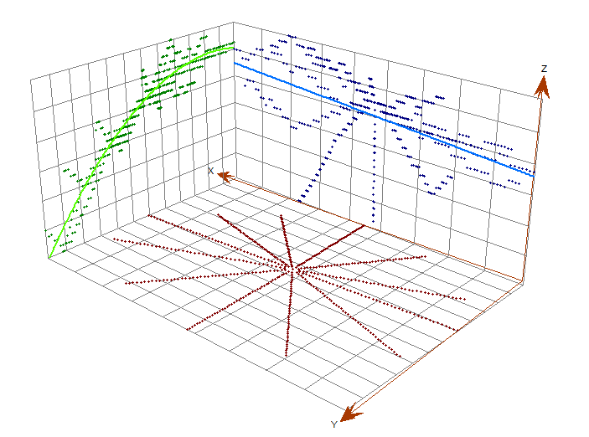
The following are a few plots and figures that may be helpful to understanding the project; its design, development and focus.
Figure 1 A three dimensional plot of the data points. On the xy-plane is a map of the data points. The yz-plane contains a North-South trendline, clearly showing the decrease in temperature as the samples are closer and closer to the interior of the river plume. The xz-plane is a cross section of the East-West temperature data, showing a slight decrease in temperature owing to a warm coastal area relative to the center of the lake.

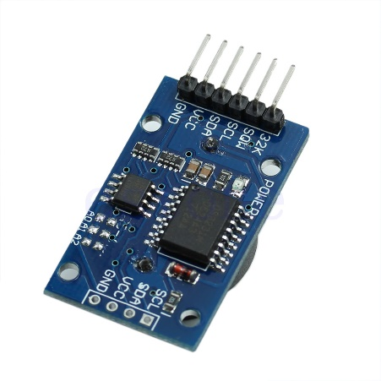
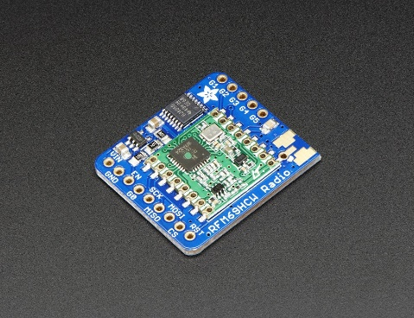
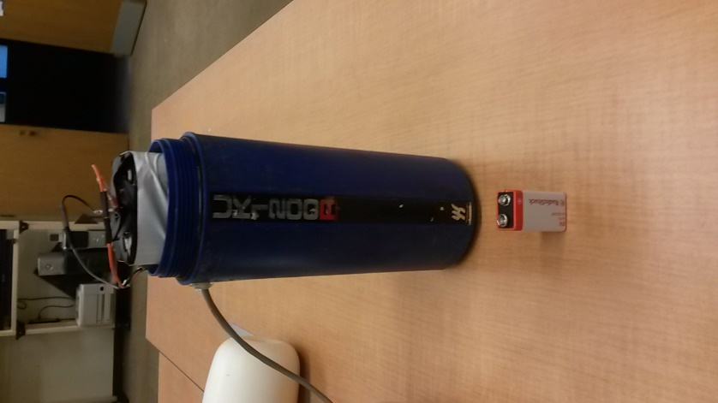
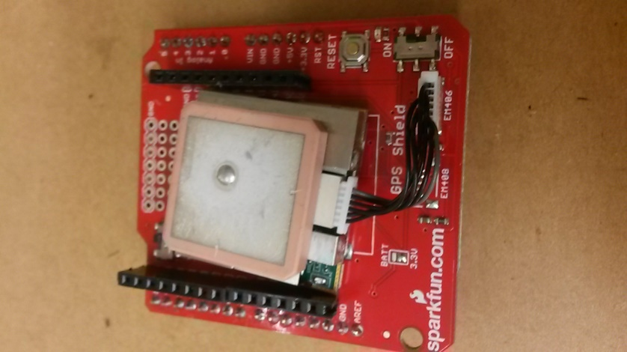
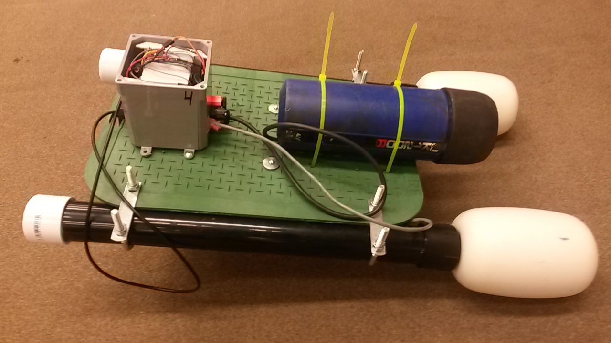
Figure 2 (a) GPS arduino shield (EM-506) 2.5 meter resolution. (b) Comparison of the 2 by 8 D cell battery pack and the 9 V alkaline battery. (c) Real Time Clock DS3231 – accurate to a few minutes per year. (d) Radio RFM69HCW – Range of 2 km line of sight.
(e) The finished ASV after its final test run. The electrical box behind the battery pack houses the radio, Arduino, GPS, ESC, and switch for turning the instrument on and off.
a
e
d
c
b
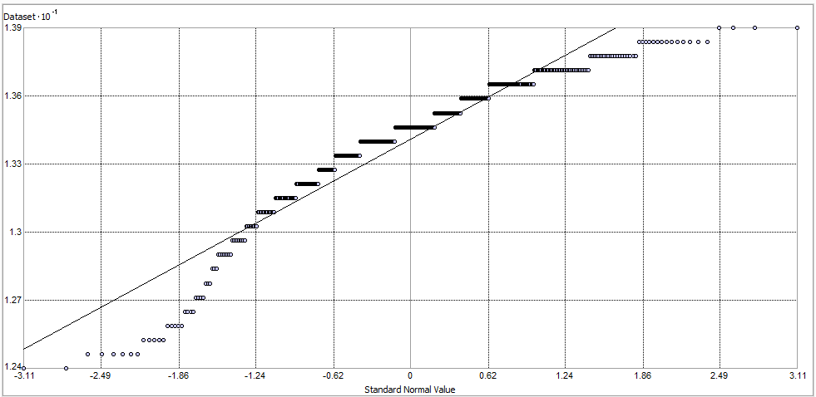
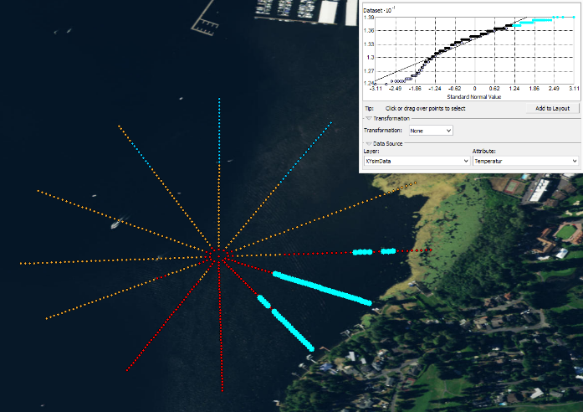
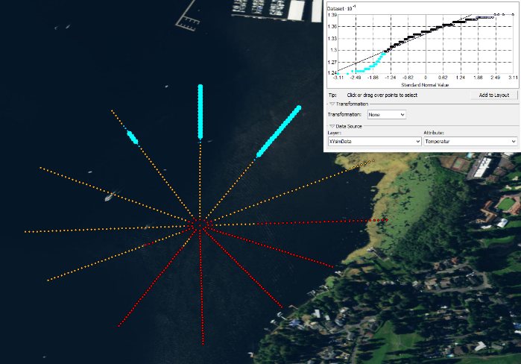
Figure 3 A Q plot showing the data with respect to an expected trend line in the data. (a) shows the points that are colder than expected near the river plume while (b) shows warmer points near the shore of the lake as expected.
a
c
b

