Effects of Low Oxygen Levels on Copepod Size Distribution with Depth in Hood Canal

Deana Crouser
The University of Washington, Seattle, WA
School of Oceanography, Box 357940
Email: dcrouser@uw.edu
5/27/2019

Abstract
Hypoxia is a condition affecting marine trophic webs throughout the world’s oceans. In Hood Canal, Puget Sound is a basin that experiences seasonal hypoxic due to its bathymetry and poor circulation. High primary productivity in this region supports a large secondary trophic level dominated by mesozooplankton. This study looks at how low oxygen levels, affect the size distribution of copepods relative to the oxygen minimum throughout the water column. Samples were collected 19th of August 2017 under normoxic conditions, and the 24th of September 2018 under hypoxic conditions in Twanoh, Hood Canal aboard the R/V Rachel Carson. Multinets were cast at night and during the day to observe diel vertical migration (DVM). Samples were processed in the laboratory and analyzed in excel. Results found oxygen concentrations did not have a significant influence on the copepod size distribution throughout the water column. Population density supported DVM under normoxic conditions and contradicted the theory that copepods use the oxygen minimum layer as predation refuge, under hypoxic conditions.

Introduction
Hypoxia, a condition in which there is a decrease in the concentration of oxygen availability below 2 mg/L (Grove & Breitburg, 2005), is an increasing issue for marine life. This condition is exacerbated by global warming through increased stratification and warming waters. Many coastal areas experience seasonal hypoxia due to high primary production as well as stratification which naturally leads to oxygen depletion as algae blooms decay in late summer and autumn. The increase in the strength of stratification, promoted through global warming is extending the length of seasonal hypoxia (Zhang et al., 2010). Incidences of coastal hypoxia, due to changes in nutrient loading, have been steadily increasing over the years. According to recent studies 415 oxygen depleted coastal systems have been identified worldwide (Eutrophication, Selman, Greenhalgh, Diaz, & Sugg, 2008). A lot is unknown about how hypoxia affects each aspect of the marine web.
Copepods are an important trophic link between marine primary production and upper trophic levels. In terms of abundance and biomass, these primary consumers that comprise the second trophic level of the marine food web, dominate mesozooplankton communities (Ekau, Auel, P̈ortner, & Gilbert, 2010). Because copepods are ubiquitous, they are active in areas that experience hypoxia and how they respond to this change will affect organisms higher in the food web. Understanding hypoxia as a contributor to the global landscape of our oceans and how low oxygen levels affect species in regions of upwelling and coastal areas, will allow us to predict how historically oxygen-rich regions introduced to these conditions for the first time may respond in the future.
Predators, like fish, can deal with the extension of seasonal hypoxic conditions by changing migration habits, avoiding low oxygen areas. Drifting organisms, like copepods, pay a higher cost to exploit adaptive mechanisms (Ekau et al., 2010) that allow to better deal with low oxygen conditions, because they are less able to move away from affected areas. One adaptation of copepods is to adjust their vertical position within the water column. An example of this adjustment is diel vertical migration, when copepods occupy depths during the day and migrate to the surface to feed at night (Patterson, 2019). If the vertical distribution of the size of copepods is significantly changed, this could affect predator/prey interactions and alter the transfer of energy throughout the marine food web (Julie E. Keister & Tuttle, 2013). Organisms have different oxygen demands so there are likely different responses not just among predators and their prey, but among the sizes of copepods as well.
In areas where hypoxia occurs both naturally and seasonally, like the Peruvian upwelling system, research has shown different species of copepod have adapted to live in these conditions. A study conducted indicated that the copepod Eucalanus can withstand 12-hour periods in anoxic areas depleted of dissolved oxygen, while other species of copepod were more likely to be found in areas of low oxygen concentration (Boyd, Smith, & Cowles, 1980).
Body size may be a structuring factor in how species adapt to low oxygen levels. There is a positive correlation between body size and respiratory surface, compared to smaller organisms. A study observed a significant increase in amphipod size with increasing oxygen. Amphipods have a limited ability to deliver oxygen via the hemocyanin pigments present in their system, which heavily influences an amphipods ability to reach their maximum size potential. How much dissolved oxygen can be delivered through hemocyanin pigments is strongly influenced by temperature and pressure (Chapelle & Peck, 2017).
It has been documented that hypoxic events can lead to mass fish kills and fishery closures (Bargmann, 2009). Subtler effects of hypoxia are reduced egg production of copepods, as observed in the coastal waters of Florida (Marcus, Richmond, Sedlacek et. al, 2004). Altered community structure of mesozooplankton in Hood Canal has also been documented, a change which will likely affect the amount energy transfer between trophic levels in the marine web (Julie E. Keister & Tuttle, 2013).
Hypoxic conditions occur seasonally in Hood Canal, a sub-basin of Puget Sound, Washington, making it a good place to study the effects of hypoxia. Hood Canal is a deep and narrow basin that makes up the entire western branch of Puget Sound. At the northern end of Hood Canal there is a long sill which limits ocean exchange and seasonality effects hypoxia (Gregg & Pratt, 2010). In fall, tidal intrusions bring in dense waters that sweep over the sill and flow into the basin. Stratification occurs as this cold dense water sinks to the bottom of the basin and displaces the less dense bottom water towards the surface of the water column. This displaced water, low in oxygen concentrations due to respiration and a lack of mixing, leads to a mid-water layer of hypoxic conditions.
The question I explicitly asked for this study was: How do oxygen levels affect the community size distributions of copepods throughout the water column? Based on the theory that larger organisms require more oxygen than smaller organisms to function, I hypothesized that copepod size composition increases with distance relative to the oxygen minimum. My goal was to determine how the size of a copepod contributes to its response and distribution throughout the water column.

Methods
Field Sampling
Samples were collected at Twanoh, Hood Canal (Figure 1) on the 19th of August 2017 and the 24th of September 2018 aboard the R/V Rachel Carson. A SeaBird Seacat 19 conductivity, temperature, and depth (CTD) sensor fitted with an annually calibrated SBE43 DO sensor was cast to determine target depths of interest. Profiles used in this study were selected based on oxygen concentrations. Levels of interest range from hypoxic conditions (DO $≤$ 2 mg/L) to severe hypoxia (DO $<$ 1 mg/L) based on previous research conducted on copepod behavior under low oxygen levels (Grodzins, Ruz, & Keister, 2016). Once target depths were identified based on the obtained oxygen profile (above, within, and below the oxygen minimum zone), oblique multinet tows were conducted day and night to observe diel vertical migration (DVM).
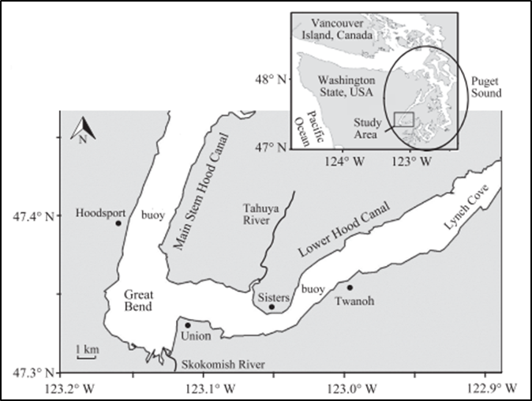

Figure 1: Hood Canal station map showing the location of landmarks and buoy (Figure 2).

To conduct our oblique net samples, we used a Hydro-Bios Multinet with a mouth opening of 0.25 $m^{2}$, equipped with a flow meter and five 200-μm nets and cod ends. The multinet (MN) was lowered to its target depth and towed obliquely through the water column at a speed of about 1.5-2 knots. Nets were opened and closed remotely as samples were collected across target depth strata. Zooplankton samples collected were preserved with 5% buffered formalin in seawater and returned to the laboratory for analysis.

Laboratory/Analytical
In the laboratory, each zooplankton sample was quantitatively diluted to about 10-13 times the settled volume, then an aliquot was taken to obtain a target of 150-250 copepods per subsample. Using an Olympus SZX7 stereo microscope, each species of copepod within a subsample was counted and classified as Calanoid, Oithona, Triconia, Harpacticoid, or Corycaeus. Depending on species abundance either 50 or 100% of each were measured and recorded. The total length (TL) was measured, then converted to prosome length (PL) for each species using PL:TL ratios determined from prior measurements of species in Puget Sound (Corycaeus: 0.68, Calanoid: 0.78, Oithona: 0.59, Triconia: 0.64).
Box plots of the frequency of length with depth, were created to observe the size distribution in the water column. A single factor ANOVA test with a value of 0.05 for alpha was then used to determine the statistical significance between the median size of copepod at each depth collected within a profile. A Tukey HSD and Q Test followed the ANOVA to identify the relationship between groups.
Code was written in RStudio to run linear regression models to determine if body size varies significantly with different water properties collected from CTD profiles: time, temperature, salinity, oxygen, depth, chlorophyll (water density profile directly corresponded to salinity profile). Length was modeled with individual covariates as well as sets of covariates. The Akaike information criterion (AIC) was used to estimate the quality of each model relative to one another and determine the most statistically significant. Once the most significant model was identified a Q-Q probability plot was created comparing sample vs. theoretical to determine if the modeled data is normally distributed.

Results
Of the two profiles selected for this study, samples for the normoxic profile were collected on 19 August 2017. The oxygen concentrations are lowest from 14-30 meters and never fell below 2.4 mg/L. Net 2 (20-30 meters) on average had the lowest oxygen concentration of 2.8 mg/L. Multinets were cast at 05:10 and 09:14 and the CTD profiles were collected at 03:30 and 07:45. Samples for the hypoxic profile were collected on 24 September 2018. Multinets were cast at 05:25 and 08:15 and the CTD profile was collected at 06:45. The oxygen minimum of 0.25 mg/L occurred at 10 meters (Figures 3-4) and on average, net 2 (10-15 meters) had the lowest oxygen concentration of 0.68 mg/L.
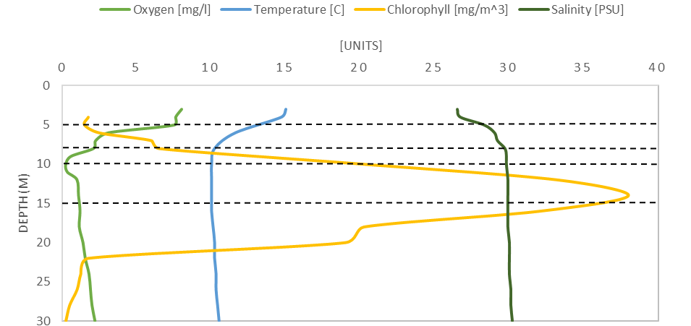
Figure 3: CTD Profile under hypoxic taken on September 24th, 2018 at 6:45 A.M. at Twanoh, Hood Canal, measuring oxygen concentration, temperature, chlorophyll and salinity. Dashed lines outline multinet depth ranges.
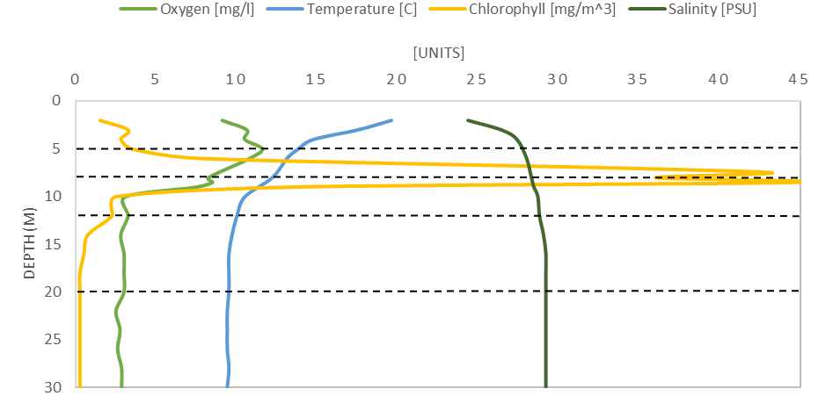
Figure 4: CTD Profile under normoxic conditions taken on August 19th, 2017 at 3:30 A.M. at Twanoh, Hood Canal, measuring oxygen concentration, temperature, chlorophyll and salinity. Dashed lines outline multinet depth ranges.

Size distribution
During the day, the smallest copepods under hypoxic conditions with a median size of 0.54 mm were found in the upper 8 meters of the water column (Table 1). Slightly larger copepods, with a median value of 0.58 mm, were found below from 8-30 meters. At night, the largest copepods with a median size of 0.62 mm were observed in the lower 10-30 meters of the water column, as well as in multinet 4 (5-8 meters). The smallest copepods were found in the upper 5 meters with a median size of 0.54 mm. The average size distribution under hypoxic conditions during the day ranged from 0.55-0.59 mm, with the largest copepods located in net 3 (8-10 meters) and the smallest observed just above in net 4 (5-8 meters). At night the mean size was slightly larger than the day and ranged from 0.60-0.64 mm. Larger copepods were found from 5-8 meters as well as from 15-30 meters at night. The smaller copepods were at the surface of the water column from 0-5 meters.
Considering the mean, during the day size distribution ranged from 0.56-0.65 mm under normoxic conditions. The largest copepods were observed between 12-20 meters in net 2, while the smallest copepods were distributed from 5-12 meters. At night the average size ranged from 0.54-0.68 mm, much like the day distribution range. The smallest copepods were between 8-12 meters, while the largest were observed in net 1 (20-30 meters). Under normoxic conditions, during the day the median size of copepod was consistent at 0.58 mm throughout the water column. At night the median size ranged from 0.54-0.62 mm. The smallest copepods were observed in net 3 (8-12 meters) and the largest copepods were found in the surface 0-5 meters as well as with depth between 20-30 meters.

Table 1: Statistics describing day and night profiles of copepod size distribution under normoxic and hypoxic conditions.
Copepod size distribution significantly differed among depth strata under normoxic conditions in both day and night (Table 2). Under hypoxic conditions sizes differed among depth strata during the day, whereas the night distribution was close to statistically significant with a probability value of 0.063.

Table 2: Results of Single Factor ANOVA used to determine if there were statistically significant differences among depths within each set of net tow under hypoxic and normoxic, day and night conditions.

Comparing size difference between individual depth strata, a Q test showed no statistical significance with probability values all over 0.05 at night under hypoxic conditions (Table 3). During the day, there were 4 pairs of groups that had p-values under 0.05 with Cohen d values ranging from 0.21-0.32 correlating to a small effect size. The differences between multinets 3 and 4 (8-10 and 5-8 m) had the largest standardized differences between means with average length differing by 0.32 standard deviations.

Table 3: Results of ANOVA follow up: Tukey HSD, Q Test for hypoxic conditions during day and night comparing significance between two groups and providing measures of magnitude.

Q test for normoxic conditions showed 6/10 pairs of groups at night shared a significant probability value with Cohen d values ranging from 0.33-0.61 signifying medium effect sizes (Table 4). The pair with the largest standardized differences between means were multinets 2 and 3 (20-12 & 12-8 m). The same pairs at night, during the day also shared p-values under 0.05. Small effect sizes were supported with Cohen d values ranging from 0.29-0.48. Multinets 2 and 3 (20-12 & 12-8 m) shared the largest difference in means among the 6 pairs.

Table 4: Results of ANOVA follow up: Tukey HSD, Q Test for normoxic conditions during day and night comparing significance between two groups and providing measures of magnitude.
At night during hypoxic conditions, most outliers were observed from 12-30 m (Figure 6). From 12-20 m the abundance of outliers drew up the average length value the gratest. Overall during the day there were less outliers were observed than at night, with most of them located in the lower 12-30 m of the water column as well. Length data is not normally distributed in most multinets during day or night, and is generally skewed to the right towards smaller copepods.
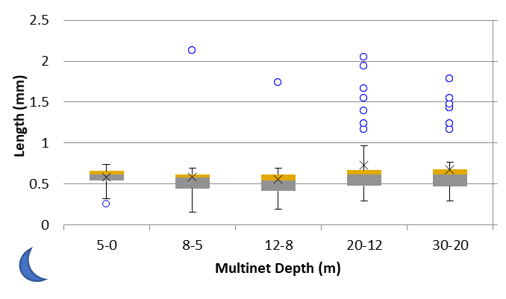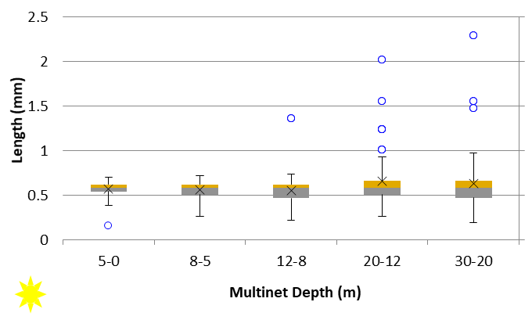
Figure 6: Normoxic box plots with outliers, day (right) and night (left), describes size distribution of copepods throughout the water column; Outliers shown as blue circles defined as copepods with a length +/- than 2.2 times the size of the first quartile. Mean = X, grey = first quartile (25% mark), median = grey/orange boundary, orange = third quartile (75% mark).
Under hypoxic conditions, numerous outliers were scattered throughout the water column at night (Figure 7). The mean value of length drawn up the most by outliers in the surface 0-5 meters. During the day there was an overall decrease in the number of outliers observed. Larger copepods shift down and out of the surface 0-5 meters during the day. Compared to normoxic conditions, the length data were more normally distributed in most multinets during day and night.
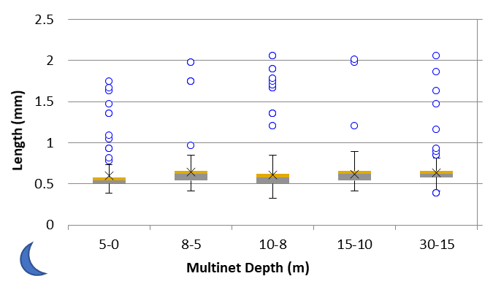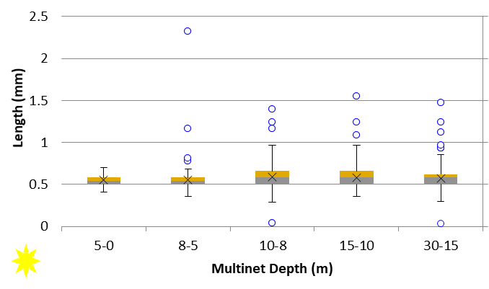
Figure 7: Hypoxic box plots with outliers, day (right) and night (left), describes size distribution of copepods throughout the water column; Outliers shown as blue circles defined as copepods with a length +/- than 2.2 times the size of the first quartile. Mean = X, grey = first quartile (25% mark), median = grey/orange boundary, orange = third quartile (75% mark).
Abundance
There was a shift in population density between night and day throughout the water column (Figure 8). Under normoxic conditions, the surface layer (0-5 m) had highest population density at night which decreased with depth. During the day, the greatest abundance shifted downward to 5-8 meters. A slightly larger density was observed in net 3 (8-12 meters) during the day, than at night. From 12-30 meters, there was little to no shift in abundance between day and night.
Under hypoxic conditions, at night the highest population density was observed in net 3 (8-10 m) with an overall symmetric distribution slightly skewed down, deeper in the water column and towards lower oxygen concentrations. During the day, net 3 shifted from having the highest copepod abundance, to having the lowest. A higher density of copepods was found in the deepest net (15-30 meters) during the day than at night under hypoxic conditions. Copepods did a surface-oriented DVM in normoxic conditions, moving down from the surface to the net tow below it, but were deeper overall when hypoxic, mostly moving from the middle net down during the day.
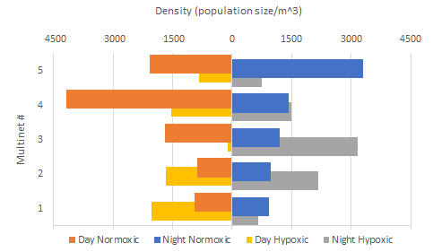
Figure 5: Copepod abundance per cubic meter with depth, during day and night under normoxic and hypoxic conditions (refer to table 1 for net depth).
Using a linear model, I was able to reject the null hypothesis that body size does not vary significantly with other independent variables such as time, oxygen, temperature, salinity, depth, chlorophyll. Of 24 different models, the best model (mod12) confirmed that length varies significantly with depth and time of day. Once the most significant model was identified, a graph of residual errors versus fitted (predicted) values confirmed mod12 followed linear assumptions (Figure 6). A Q-Q test, used to examine residual distribution and visually check the assumption of normality, established the data was not normally distributed (Figure 7). Log-transformed liner models provided the same QQ results for the distribution of data.
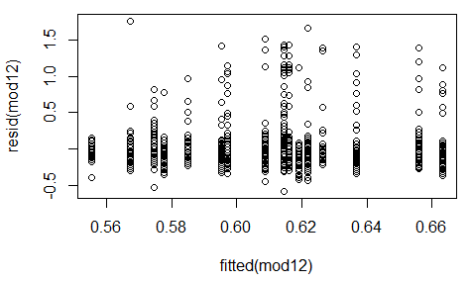
Figure 6: Graph of residual errors verus fitted (predicted) values for model 12, length with depth and time as covarites.
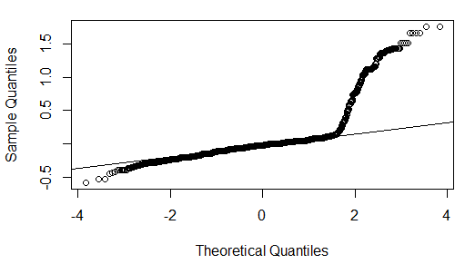
Figure 7: QQ plot of residuals, sample quantiles/standardized residuals versus theoretical quantiles.

Discussion
Size Distribution
The null hypothesis, that size does not vary with distance relative to the oxygen minimum layer, could not be rejected following the results of this research. Under hypoxic conditions the depth strata from 10-15 m, had the lowest oxygen concentrations averaging about 0.675 mg/L, followed by 8-10 m which had an average concentration of 0.9833 mg/L.
For the hypothesis to be supported, at night when light intensity has no influence on copepod size distribution, we would expect to find smaller copepods in net 2, and larger copepods as population density shifts up towards higher oxygen concentrations and the surface of the water column. The data showed variability in size throughout the water column with relatively large copepods occupying the oxygen minimum during both day and night. This data contradicts a study that observed the largest species in areas where oxygen concentrations were the highest (Chapelle & Peck, 2017). The Tukey HSD test showed no statistical difference between individual depth strata coupled with trivial differences in effect size at night, or where our hypothesis anticipated (between nets 1 and 2, and nets 2 and 3) during the day.
A study published in 2009, concluded that oxygen minimum layer (OML) in Hood Canal affected DVM, but did not prevent it (Parker-Stetter, Horne, & Langness, 2009). This research supports the assumption that at night, following DVM, overall copepod distribution is not influenced by failed migration up the water column or light intensity. It is important to note that our data represents the downward migration in the water column, as copepods transition from night to day, unlike the study in 2009 which observed an upward migration as copepods transitioned from day to night.
The consistent median value of 0.58 mm observed during the day under normoxic conditions may be driven by the dominant species present. Combined with an artifact of the net mesh, which is selective against smaller sizes, and the way we measure (to the closest micrometer unit), there may be a bias to keep in mind.
Considering the mean and median copepod size distribution between depth strata relative to the oxygen minimum, any deviations from predicted size distributions could be due to the effects of behavior on oxygen need (Ekau et al., 2010).
Abundance
Regarding DVM, under normal conditions we would expect to see copepods rise from the depths of the water column to the surface to feed (Patterson, 2019). We would expect the population density observed to be highest in the surface waters at night and lowest during the day, as copepods migrate to deeper and darker depths to avoid predation. Under normoxic conditions we found evidence to support the theory of DVM, with the highest abundance in the surface 0-5 m at night, shifting down in the water column as ambient light is introduced.
Under hypoxic conditions, population density was highest in the hypoxic layers at night and lowest during the day. This behavior observed contradicts the theory that copepods exploit the oxygen minimum as a predation refuge, similar to results found in a previous study on nekton vertical migration which utilized acoustic data collected in Hood Canal (Parker-Stetter et al., 2009).
Linear regression model confirmed that oxygen concentrations were not a driving factor of size distribution. Models show time of day (corresponding to light levels) and depth had he strongest influence on copepod size distribution. This data complements results found in another study, indicating light levels are a dominant trigger for the migration of zooplankton (Parker-Stetter et al., 2009).

Conclusion
Data obtained from this study did not support the hypothesis that size varies with depth relative to the oxygen minimum. Under hypoxic conditions larger copepods were found within the oxygen minimum layer during the day and night. Factors like average length and median length had to be taken into consideration when evaluating the size distribution.
Because oxygen concentrations fell to levels documented to significantly affect survival rates of copepods (Grodzins et al., 2016), population density of copepods had to be taken into consideration when looking at overall size distribution. Lower population densities have more outliers which skew the mean lengths observed in individual depth strata. Copepod abundance observed under hypoxic conditions contradicted previous studies theorizing copepods exploit the oxygen minimum as a predation refuge (J. E. Keister, Houde, & Breitburg, 2000).
Lower Cohen’s d values observed in tables 3 and 4, indicate necessity of larger sample size. Non-parametric test should be run for data not normally distributed per the results of the QQ normality test.

Bibliography
Bargmann, G. (2009). Poor water conditions prompt fishing closure in Hood Canal for all finfish except salmon and trout. WDFW News Release, 98501. Retrieved from https://wdfw.wa.gov/news/release-print/sep1203c/
Boyd, C. M., Smith, S. L., & Cowles, J. (1980). Grazing patterns system off Peru. Limnology and Oceanogaphy, 25(4), 583–596.
Chapelle, G., & Peck, L. S. (2017). Nordic Society Oikos Amphipod Crustacean Size Spectra : New Insights in the Relationship between Size and Oxygen Author ( s ): Gauthier Chapelle and Lloyd S . Peck Published by : Wiley on behalf of Nordic Society Oikos Stable URL : http://www.jstor.org/st, 106(1), 167–175.
Ekau, W., Auel, H., P̈ortner, H. O., & Gilbert, D. (2010). Impacts of hypoxia on the structure and processes in pelagic communities (zooplankton, macro-invertebrates and fish). Biogeosciences, 7(5), 1669–1699. https://doi.org/10.5194/bg-7-1669-2010
Eutrophication, W. Q., Selman, M., Greenhalgh, S., Diaz, R., & Sugg, Z. (2008). Eutrophication and Hypoxia in Coastal Areas: A Global Assessment of The State of Knowledge. Europe, (1), 1–6.
Gregg, M. C., & Pratt, L. J. (2010). Flow and Hydraulics near the Sill of Hood Canal, a Strongly Sheared, Continuously Stratified Fjord. Journal of Physical Oceanography, 40(5), 1087–1105. https://doi.org/10.1175/2010JPO4312.1
Grodzins, M. A., Ruz, P. M., & Keister, J. E. (2016). Effects of oxygen depletion on field distributions and laboratory survival of the marine copepod Calanus pacificus. Journal of Plankton Research, 38, 1412–1419. https://doi.org/10.1093/plankt/fbw063
Grove, M., & Breitburg, D. L. (2005). Growth and reproduction of gelatinous zooplankton exposed to low dissolved oxygen. Marine Ecology Progress Series, 301, 185–198. https://doi.org/10.3354/meps301185
Keister, J. E., Houde, E. D., & Breitburg, D. L. (2000). Effects of bottom-layer hypoxia on abundances and depth distributions of organisms in Patuxent River, Chesapeake Bay. Marine Ecology Progress Series, 205, 43–59. https://doi.org/10.3354/meps205043
Keister, Julie E., & Tuttle, L. B. (2013). Effects of bottom-layer hypoxia on spatial distributions and community structure of mesozooplankton in a sub-estuary of Puget sound, Washington, U.S.A. Limnology and Oceanography, 58(2), 667–680. https://doi.org/10.4319/lo.2013.58.2.0667
Marcus, N. H., Richmond, C., Sedlacek, C., Miller, G. A., & Oppert, C. (2004). Impact of hypoxia on the survival, egg production and population dynamics of Acartia tonsa Dana. Journal of Experimental Marine Biology and Ecology, 301(2), 111–128. https://doi.org/10.1016/j.jembe.2003.09.016
Parker-Stetter, S. L., Horne, J. K., & Langness, M. M. (2009). The influence of midwater hypoxia on nekton vertical migration. ICES Journal of Marine Science, 66(6), 1296–1302. https://doi.org/10.1093/icesjms/fsp006
Patterson, T. A. (2019). Oceanic diel vertical migrations arising from a predator-prey game. Theoretical Ecology, 12:17–29, 17–29.
Zhang, J., Gilbert, D., Gooday, A. J., Levin, L., Naqvi, S. W. A., Middelburg, J. J., … Van Der Plas, A. K. (2010). Natural and human-induced hypoxia and consequences for coastal areas: Synthesis and future development. Biogeosciences, 7(5), 1443–1467. https://doi.org/10.5194/bg-7-1443-2010

