Appendix 1. Plot images
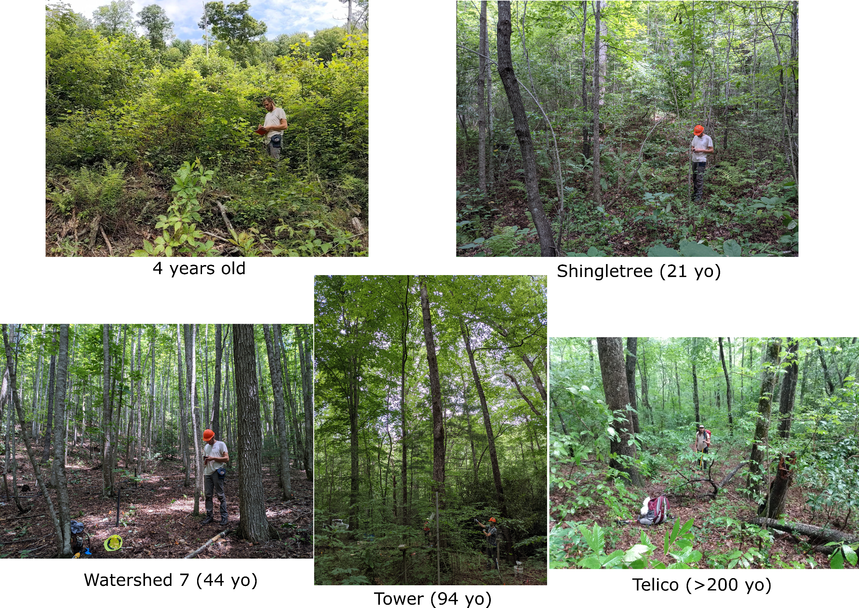
Figure A1.1. Images of stands included in this study.
Appendix 2. Additional methodological details
Leaf sample collection
Branches from targeted trees were cut using either an arborist throw-line launcher or telescopic branch cutters. Once cut, leaves were kept on branches, placed into a plastic garbage bag with wetted towels and the bag was sprayed with water periodically to minimize wilting. When possible, these bags were temporarily stored in a cooler and/or fridge. All leaves sampled within a day were processed (i.e., randomly selected, scanned, measured, pressed, and put into a drying oven; see below) later that same day at the Coweeta Research Station. During processing, all fully expanded leaves from a given individual, excluding those heavily damaged, were picked from their branches and placed back into a plastic bag. At least 10 leaves were randomly selected from each bag and constituted the sample set for that individual.
Leaf mass per area, leaf dry matter content, and leaf thickness
Before drying, leaf mass and thickness were measured using a digital scale and calipers, respectively. Fresh leaves were also digitized using a flatbed scanner, and if leaves were too large to fit on the scanner, they were cut into as minimal number of pieces required, which were scanned separately. Leaves were then dried. Leaves were pressed into plant presses and placed into drying ovens at 70° C for at least 72 hours. Leaf dry mass was subsequently measured, and dry leaves were digitized using a flatbed scanner again (although these images were not used in this study). Leaf mass and area measurements included the petiole when present. Leaflets were treated as leaves so the rachis of compound leaves were not included in any measurement.

Carbon and nitrogen stable isotopes and concentrations
Dried leaves were rinsed with deionized water and scrubbed to remove debris. Small sections of leaf (~3 cm²) were sampled midway between the apex and base of the leaf. For most pinnate leaves, this was a section from the margin to the midvein, excluding any primary veins. For lobed leaves, this section was cut from the margin to the primary vein, excluding any primary veins. The dried leaf sections were powdered and homogenized with a ball mill and weighed into tin capsules using a microbalance.
Chemical analyses were run in two separate labs at the University of Washington. The first lab was the IsoLab in the Department of Earth and Space Sciences. There, a Costech ECS 4010 Elemental Analyzer (EA), ThermoFinnigan Conflo III, and ThermoFinnigan MAT253 isotope ratio mass spectrometer in continuous flow mode were used to isolate and analyze CO₂ and N₂ gas. The second lab was the UW Facility for Compound-Specific Isotope Analysis of Environmental Samples, a joint venture of the School of Aquatic & Fishery Sciences, School of Oceanography, School of Environmental & Forest Sciences, and the Quaternary Research Center. There, a Carlo Erba elemental analyzer coupled to a ThermoScientific Delta V isotope ratio mass spectrometer in continuous flow mode was used to isolate and analyze CO₂ and N₂ gas.
Data are reported using standard delta notation, which describes the per mil deviation in the ratio of heavy to light isotope relative to accepted international standards, in this case, air and Vienna Pee Dee Belemnite for N and C, respectively, based on three in-house working standards with known ¹⁵N/¹⁴N and ¹³C/¹²C. The same in house standards were used in both labs.
Appendix 3. Tooth measurement analysis approaches.
We considered how differences in tooth measurement and analysis approaches affected subsequent results and interpretations.
First, we addressed the fact that for several leaves (n = 17) of Quercus alba and Quercus velutina, the lobe geometry was such that they qualified as very large teeth (i.e., were incised less than 25% the distance to the major vein; e.g., Fig. A3.1). These outliers then have potential to influence trends in tooth area : blade area (TA:BA), tooth couth : internal (TC:IP), and perimeter ratio. As a compromise, these teeth were prepared following the isolated tooth rule (Royer et al., 2005; Lowe et al., In Press), which effectively decreases tooth area measurements. Lastly, analyses were also run with the leaves in question excluded entirely. We found trends in TA:BA are sensitive to prep job. For example, the normal preparation approach leads to a pattern of decreasing TA:BA through succession, while the isolated and excluded approaches bring down TA:BA in the youngest two stands and the trend is no longer as strong (Fig. A3.2). However, the isolated and excluded approaches are similar. In an effort to have that data from these 17 leaves represented, we include measurements taken with an isolated tooth preparation approach as a compromise.
We also considered how interpretations are affected by the inclusion of entire-margined species in the calculation of toothed variables, by setting their TA:BA and TC:IP to 0 and perimeter ratio to 1, or by their exclusion. Note, in either case, entire margined leaves in mixed margin species-stand pairs (i.e., margin of 0.5) are always included in the calculation of their species average. The advantage of the former is it’s a better reflection of the entire community, and allows the ability for abundance weighting, but in contrast, is affected by changes in % of untoothed species, as well as changes within toothed species, which are difficult to tease apart.
The patterns are generally similar, but in one case, the decrease in TA:BA across succession discussed above is apparent for trees with untoothed species are included, but not when they are excluded (for isolated prep and excluded approaches; Fig. A3.2). This means the trend in tree TA:BA is driven mostly by the increase in untoothed species which have TA:BA of 0, and not by patterns in the toothed leaves themselves. Thus, we feel including untoothed leaves masks more informative and reliable inference seen when they are excluded, thus they were excluded in this study.
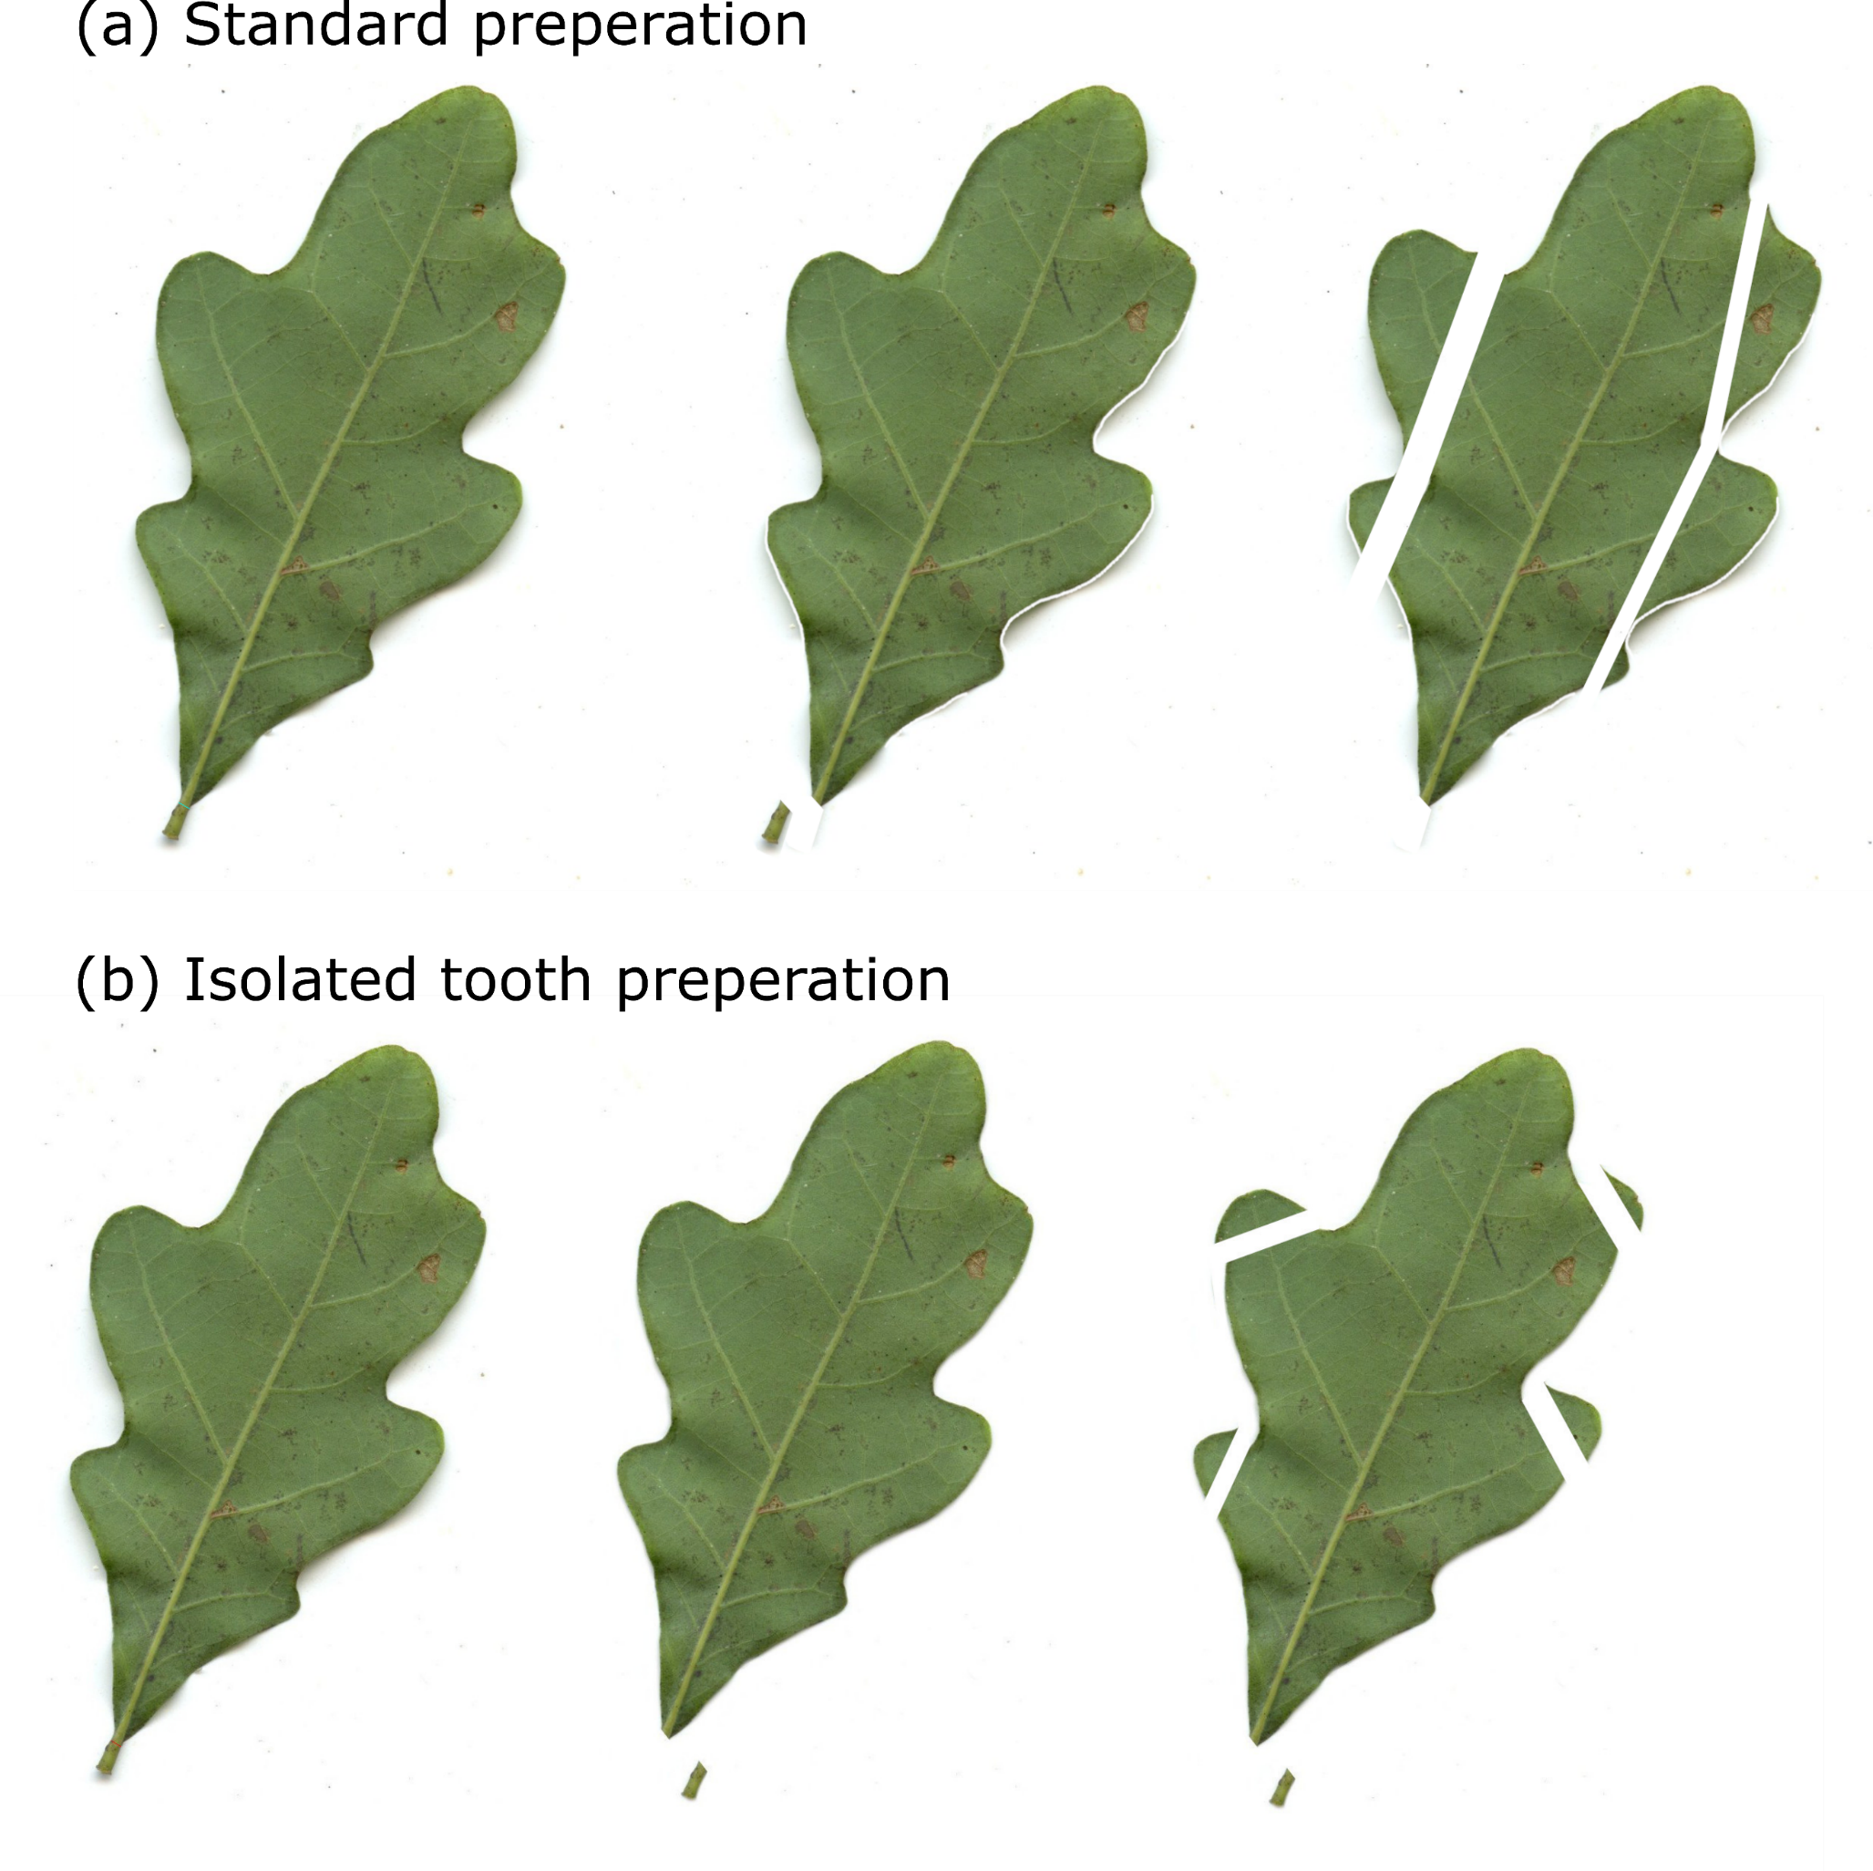
Figure A3.1. A Quercus alba leaf from the 4 yo plot as an example of the (A) standard preperation technique and the (B) isolated tooth preperation technique.
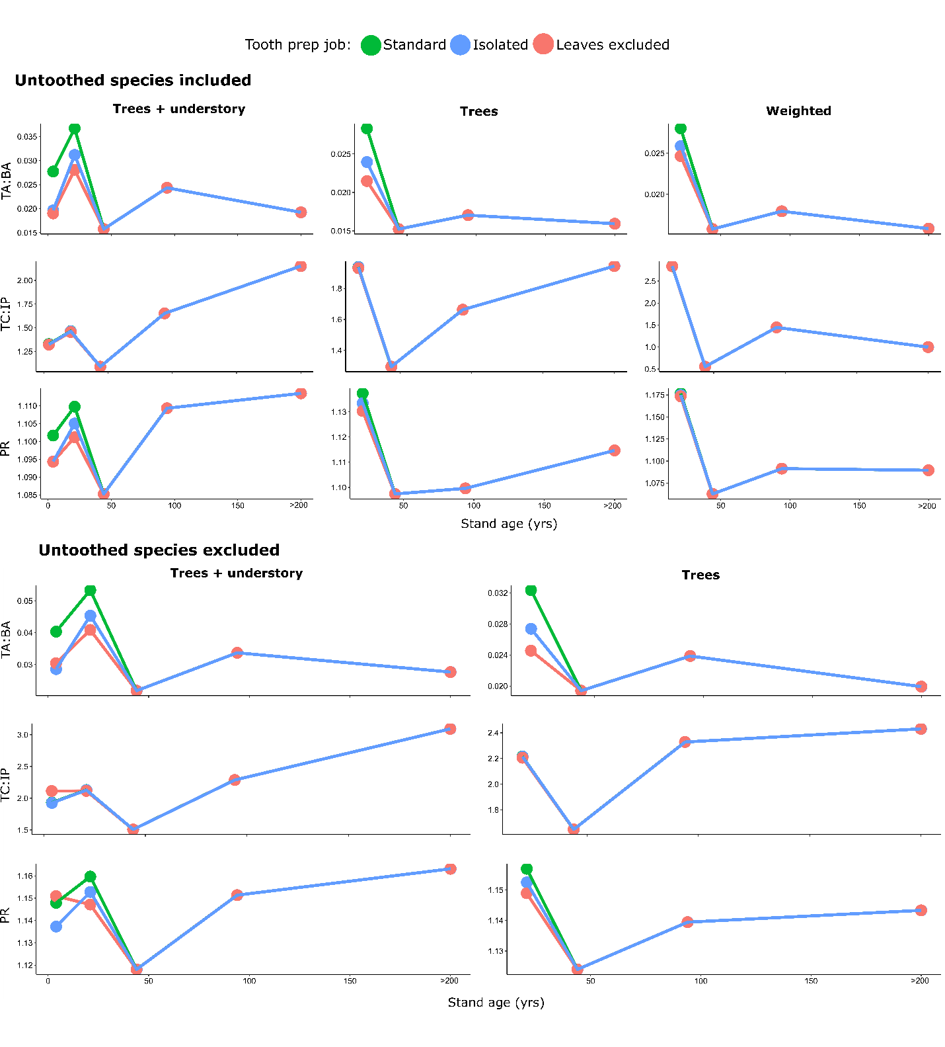
Figure A3.2. Changes in toothed variables across various aged stands when untoothed species are included vs. excluded, and when tooth preparation for 17 outliers are done following the standard protocol, done using a compromising protocol that follows the isolated tooth rule, and when the outliers are excluded completely.
Appendix 4. Species composition
Table A4.1. A list of species composition and richness for the various stands of this study. The percentage of total stem basal area that each species contributes to the stand total is reported. Species are noted as present (P) if they occur but were not represented with individuals ≥ 10 cm dbh and were not represented with DBH data. Species absent (A) from the stand are also noted. An asterisk (*) denotes species that occurred in the plot but were not sampled, either because sampling was logistically not possible or they were mistakenly missed. D= Deciduous leaf habit, E = evergreen leaf habit, W7= Watershed 7.
Stand characteristics |  | 4 year old | Shingletree | W7 | Tower | Telico
Stand age (years) |  | 4 | 21 | 44 | 94 | >200
Number of tree taxa |  | 0 | 8 | 16 | 14 | 11
Number of understory taxa |  | 16 | 8 | 4 | 4 | 13
Number of total taxa |  | 16 | 16 | 20 | 18 | 24
Taxon | D/E
Acer pensylvanicum | D | A | A | A | P | P
Acer rubrum | D | P | 6.1 | 2.7 | 8.6 | 23.8
Amelanchier arborea | D | A | A | A | A | 2.4
Betula lenta | D | P | 23.6 | 5.1 | 13.5 | 2.1
Carpinus caroliniana | D | A | A | A | 0.7 | A
Carya spp. | D | P | 31.2 | 1.2 | 3.8 | 0.2
Castanea pumila | D | A | A | A | A | P
cf. Hamamelis sp. | D | A | A | P | P | A
cf. Rhus sp. | D | P | A | A | A | A
cf. Vaccinium sp. | D | A | P | A | A | P
Ericaceae | D | A | A | A | A | P
Fagus grandifolia | D | A | A | 0.4 | 3.0 | A
Fraxinus americana | D | A | A | 0.2* | 0.5 | P
Ilex sp. | E | A | P | P | P | A
Kalmia latifolia | E | A | A | P | 0.4 | P
Liriodendron tulipifera | D | P | 6.0 | 70.1 | 24.5 | 6.0
Magnolia acuminata | D | A | A | 0.9 | A | A
Magnolia fraseri | D | A | A | 4.9 | A | P
Nyssa sylvatica | D | A | P | 0.9* | 7.8 | 0.8
Oxydendrum arboreum | D | P | 9.3 | 0.6 | 7.6 | 7.1
Paulownia tomentosa | D | P | A | A | A | A
Quercus alba | D | P | P | 2.6 | 23.5 | 13.9
Quercus coccinea | D | A | A | 0.8 | A | A
Quercus montana | D | A | P | A | A | P
Quercus rubra | D | P | 1.6 | 0.7 | 0.9 | 41.6
Quercus velutina | D | P | 6.1 | 6.2 | 1.9 | 1.9*
Rhododendron maximum | E | A | A | P | 3.3 | 0.2
Robinia pseudoacacia | D | P | 16.1 | 1.7 | A | A
Rubus sp. | D | P | A | A | A | A
Sasssafras albidum | D | P | P | A | A | P
Tilia americana | D | A | A | 1.0 | A | A
Unknown 1 | D | P | A | A | A | A
Unknown 2 | D | A | P | A | A | A
Unknown 3 | D | A | A | A | P | P
Unknown 4 | D | P | A | A | A | A
Unknown 5 | D | A | A | A | A | P
Unknown 6 | D | P | A | A | A | A
Unknown 7 | D | A | P | A | A | A
Unknown 8 | D | A | A | A | A | P
Unknown 9 | D | A | A | A | A | P

Appendix 5. Species outliers for LMA
Two high LMA evergreen species (Kalmia latifolia and Rhododendron maximum) stood out as outliers among trees (Fig. A5.1A). We explored the extent to which these two taxa drove trends across the entire dataset by comparing values when they were included (Fig. A5.1B, D) and excluded (Fig. A5.1C, E) in calculations. We do not include calculations of abundance-weighted trait values because the two species contributed very little to total stand stem basal area. These analyses demonstrate the importance of these high evergreen taxa in driving trends in both LMA mean and LMA variance across succession.
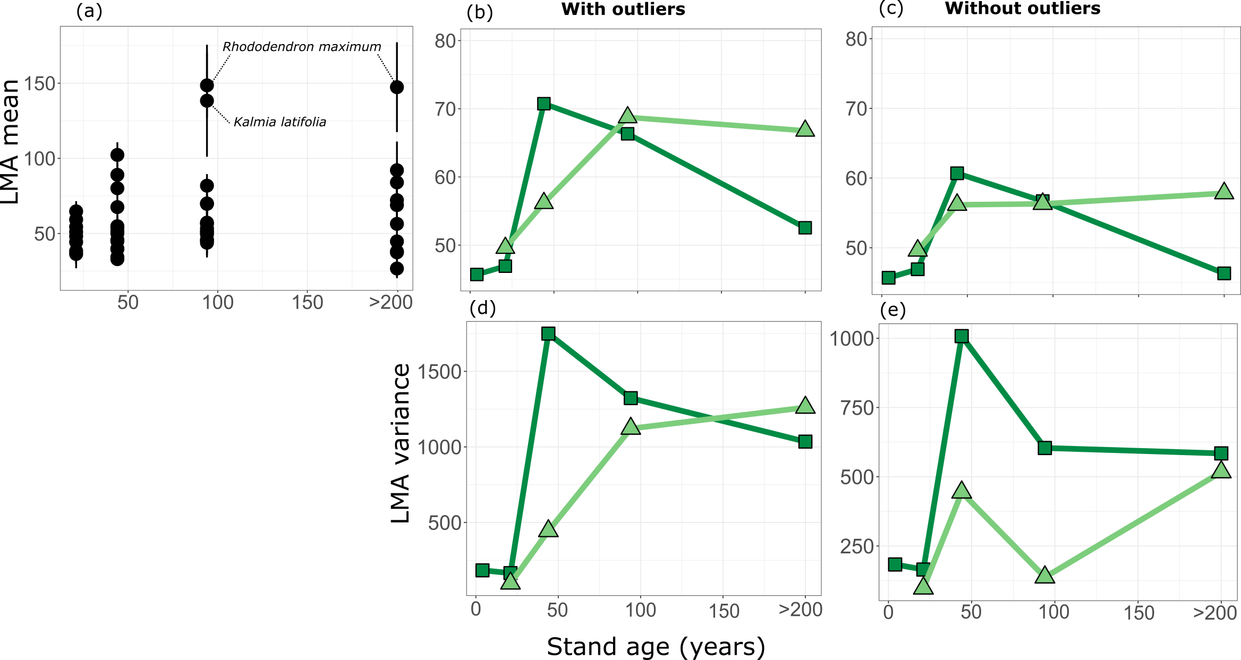
Figure A5.1. LMA outliers and their influence on interpretation of successional dynamics.

Appendix 6. Understory plant richness
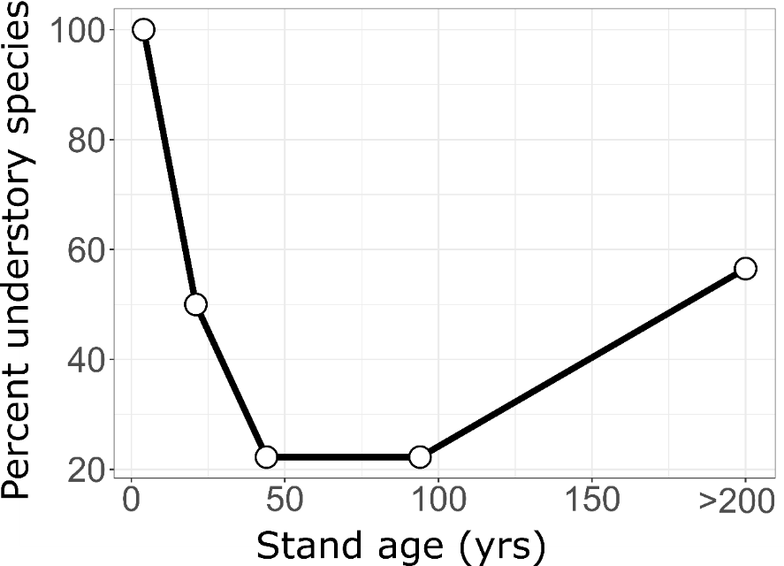
Figure A6.1. The percentage of species having no individuals with DBH ≥ 10 cm (i.e., understory species) across various aged stands.

Appendix 7. Leaf images
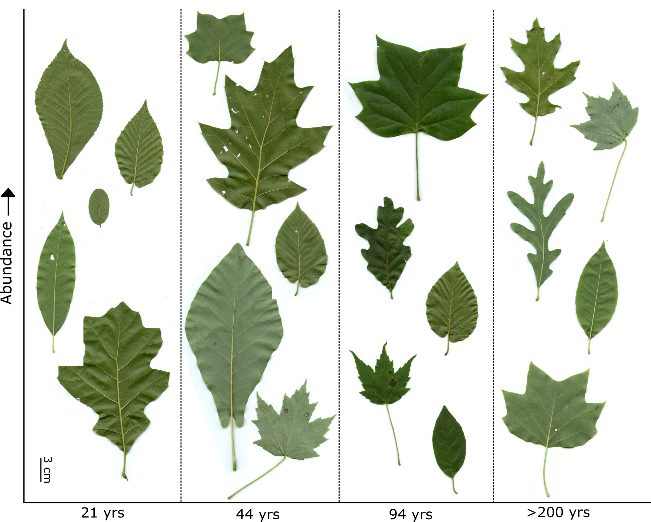
Figure A7.1. The top 5 most abundant leaves in each stand, excluding the 4yo stand where stem basal area was not measured, arranged in order of abundance.

Appendix 8. Digital leaf physiognomy calibration check
When using the digital leaf physiognomy approach, it is suggested to confirm that the sites being analyzed fall within the leaf physiognomic space of the calibration dataset (Peppe et al., 2011; Lowe et al., In Press). This was done using the dilp_cca() function in the dilp package in R (Butrim et al., 2024). Results confirm the stands of this study do fall within physiognomic space of the calibration dataset (Fig. A8.1).
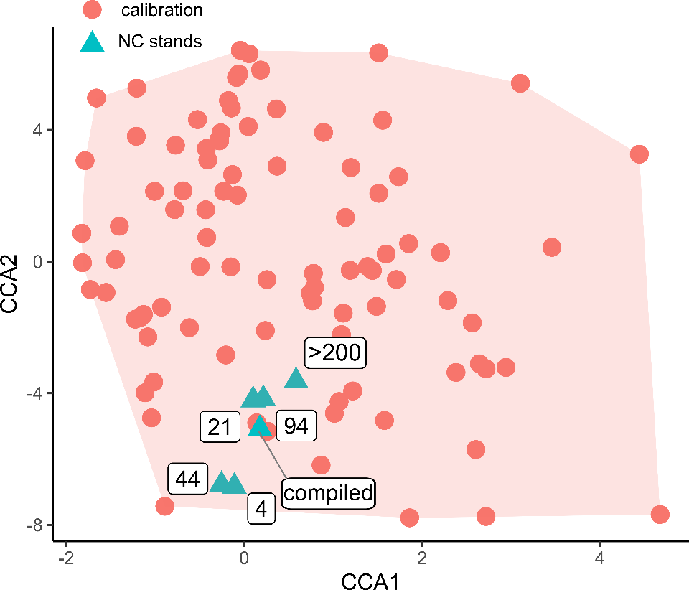
Figure A8.1. Results from a canonical correspondence analysis (CCA) passively plotting the leaf physiognomy of stands of this study with the digital leaf physiognomy calibration dataset.

Appendix 9. A lack of influence of elevation and temperature on the percentage of untoothed species.
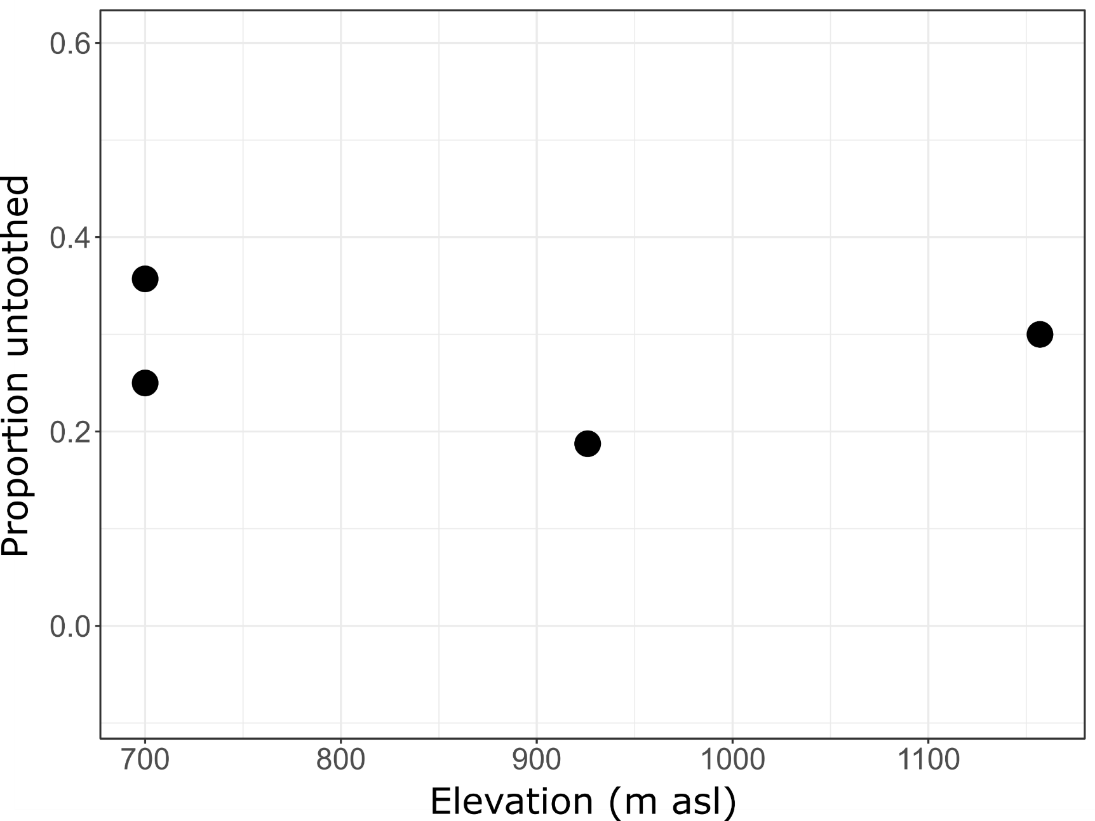
Figure A9.1. Relationship between the elevation of the stand at the proportion of species with untoothed margins (linear regression; p = 0.84; Adj-R² = -0.463).

