Design of a Stereo-RUV for Remote Study of Octopod Behavior and Ecology
Willem L. Weertman
willemw@uw.edu


Ocean Technology
Design and Build Project

The University of Washington School of Oceanography Ocean Technology Program

Abstract:
Remote underwater video recording techniques play an important role in the study of marine animals, certain natural behaviors of which may only be observed by remote instruments. Here the design, build, and testing of a stereo remote underwater video camera for the UW Psychology Gire Lab’s study of octopus den behavior is presented. The camera is designed as a field instrument to be deployed by divers. Deep Red Lights provide illumination for nocturnal observation on a spectrum octopus cannot sense. Footage from a stereo camera is recorded by a Raspberry Pi which is programmable for specific capture modes and sequences. The camera is powered by a pair of lithium ion battery packs that enable prolonged deployments. Testing of the camera demonstrated capture of high quality high frame rate stereo video, integrity of the housing, function of the lights, and safety of internal electronics for deployment by divers.

Introduction:

In the Salish Sea observation of octopus behavior in the wild is challenging. Turbid cold waters, strong currents, low visibility, and the sophisticated camouflage abilities of the octopus make it difficult to conduct effective scuba surveys of sites. Design and performance of a stereo-RUV was done as a low cost solution to enable remote acquisition of dimensional data. The strategic placement of the camera by divers will serve as an extension of researchers’ presence across time at sites of interest to Octopod behavioral and ecological research.
Octopus are known to be discriminative in their prey selection and will choose one prey type over another despite obvious benefits of latter. In Octopus rubescens prey discrimination has been shown to be a balance of ‘nutritional preference’, prey availability, and foraging time, varying widely from expected optimal energy intake foraging behavior (Onthank, Kirt L., and David L. Cowles. 2011), similar but region specific conclusions have been seen in studies of Enteroctopus dofleini. The implications of octopod foraging discrimination, metabolic rates, and their broad distribution, imply they may act as selectors of marine benthic communities, however at this time it is not clear how strong this selection is. Octopus commonly return to their dens with prey, video observation could help shed some light on this question.
Stereoscopic video for 3D tracking (Zelman, Ido et al. 2009), combined with correlation analysis is emerging as a useful tool for characterizing animal behavioral components (Wittschko, Alexander et al. 2015). Concurrently, new perspectives on octopod behavior are revealing their complex consciousness (Mather, Jennifer A. 2008, Anderson, Roland C., et al. 2010). Ecologically relevant motive behaviors may only be observed in the wild, such as the complex social behaviors observed in Octopus tetricus by (Scheel, David et al. 2017). An in situ 3D tracking system could dramatically aide in understanding their capabilities, and contribute to the ever-growing body of evidence describing the cognitive sophistication of the octopus.

Background:

Of cephalopoda, octopoda is the most enigmatic order, having been shown to have curiosity, learning (Moriyama, Tohru, and Yukio-Pegio Gunji, 1997), individual personalities, ability to manipulate objects, adaptive camouflage (Ramirez, M. D., and T. H. Oakley, 2015), adaptive motor strategies (Richter, J. N. et al. 2015. Levy, Guy et al. 2015), and complex inter octopod communicative behaviors (Scheel, David et al. 2017). Octopods have a large and complex nervous system (Williamson, Roddy, and Abdesslam Chrachri. 2004), an advanced visual system (Budelmann, Bernd U. 1996), soft bodies, and complex musculature, the sum of these parts has given rise to complex behaviors (Kroger, Bjorn et al. 2011). Given octopods high level intelligence, behavioral adaptation likely enables individuals to exploit environmental niches. Octopods are predatory generalists, and have been found across a wide range of depths to have the highest metabolic rates among benthic organisms (Seibel, B. A, and J. C Drazen. 2007), this implies they may play a significant role in marine ecosystem carbon and energy cycles.
(D. Mallet and D. Pelletier. 2014) Reviewed an exhaustive list 182 peer-reviewed papers published since the 1950s on different underwater video techniques. Since the start of the 1950s use of underwater video recorders in shallow <100m water has been steadily increasing and diversifying in complexity while the cost to quality ratio of the systems has been steadily decreasing over time as the price of integrated circuits and cameras has fallen (D. Mallet and D. Pelletier. 2014). As defined by (D. Mallet and D. Pelletier. 2014) there are four main techniques for underwater video recording, they are the following: remote underwater video (RUV), baited remote underwater video (BRUV), towed video (TOWV), and diver-operated video (DOV). The difference between an RUV and BRUV is a matter of bait, however RUVs also are commonly designed as part of an environmental conditions suite, where BRUVs are commonly deployed off the side of a boat as stand alone cameras strategically attached to a baited trap for population and diversity counts. Of these different techniques RUVs were found to be commonly the best suited as a diver free substitute for observation of conspicuous species, where BRUVs were best for sampling generalist carnivores, large predators, mobile species, and animals in regions of resource scarcity. My camera would be considered an stereo-RUV due to it being deployed remotely with no fixed addition for placement of attached bait, and its incorporation of a stereo camera.
The octopus simultaneously occupies the ecological role of a mid level predator, it is in the middle of the trophic ladder being both prey and food. Consequently the foraging strategy of the octopus evolved to optimize their sensory input from their environment while minimizing signs of their presence. The octopus has a complete visual field of surroundings, the limited overlap between the two visual fields of their eyes requires the octopus to subtly bob its head to maximize depth perception through parallax. Their chromatophore system gives them adaptive camouflage abilities enabling them to hide in plain site by changing both the color and texture of their skin. In low light conditions, they will remain largely stationary, while carefully sampling the environment surrounding them for mechanical and chemical cues with the sensory network in their arms. This strategy minimizes risk to the central nervous system, and only endangers their regenerative arms. These traits make them very difficult to find and observe, divers may be able to identify dens by observation of characteristic detritus but not find the resident octopus. Remote imaging tools deployed outside of suspected dens are a good way of determining if they are occupied.
Classical in situ observation of animals employs creation of an ethogram, an exhaustive list of an animal’s behavior which can be systematically classified as the animal behaves naturally. To effectively characterize octopus behavior, this approach is insufficient, to characterize the behavior of all eight arms and the behavior of the head and skin simultaneously is very difficult without recording and review. Much of this insufficiency can be attributed to the distributed control strategies employed to coordinate their diffused nervous system, and the symmetrical geometry of the octopus’s body. Three-dimensional behavioral acquisition combined with computer vision-based behavioral analysis can used to characterize the highly complex movement of the octopus.

Methods:

The project consisted of three distinct phases, design, build, and application.

Design Phase: Involved initial conception of the project, communication with experts, iteration of design concepts, selection of electrical components, and design of instrument housing and frame. Purchasing and testing of components. Design began during Autumn quarter and carried into early Winter quarter.
Build Phase: Involved the purchasing of components, physical assemblage of electrical components, working with an expert on build of physical housing and frame, pressure testing of housing, fire and battery safety review with build revisions to meet safety requirements, programming of instrument for dry and wet testing of instrument, dry and wet testing instrument. Build began during Winter quarter and carried on into late Spring quarter
Application Phase: Involved field exploration of potential sites for deployment of instrument, discussion with experts on method of deployment, design of a set of deployment scripts for different timed capture settings, discussion with Friday Harbor Labs for deployment of instrument as part of a student driven research project for Marine Subtidal Ecology Summer 2018, and capture of in lab preliminary 3D tracking data of O. rubescens for compare and contrast of instrument 3D tracking data while at FHL.

Method of Design:
I. Initial Concepts
II. Consultation With Cephalopod Cognition and Behavior Experts
III. Component Selection
Method of Build:
I. Prototype V 1.0
1. Build
2. Safety Review
II. Prototype V 1.1
1. Safety Review Passed
2. Build
3. Pressure Test
4. Wet Test
5. Memory
6. Cost Analysis
Method of Application:
I. Driftwood Park Survey
II. Field Deployment

Method of Design:

I began with the idea of a remote field camera for ecological research and through white paper prototyping of design, discussion with cephalopod experts, and testing of component performance evolved the design into stereo-RUV for study of octopus den behavior and ecology.

Initial Concepts:

My initial design was to build an array of field microscopes for study of planktonic organisms across time, after extensive research into lens, digital cameras, and calculation of FOV and expected individual to volume counts I came to the conclusion that the project was infeasible and unlikely to succeed.
After the failure of my initial design I evolved my idea into the design of a 360° fov remote camera platform with environmental sensors for capture of long diurnal timelapses. The design required the use of four Raspberry Pi (RPi) Zeros with wide angle RPi cameras, a fire hydrant shaped housing, a large battery pack, potted LEDs, a real time clock (RTC) and temperature, lux, conductivity, and pressure sensors.
To test the feasibility of my designs I purchased a set of RPi Zeros, a digital microscope, an OpenMV camera, lux sensor, temperature sensor, RTC, and a set of RPi cameras and began testing them. I concluded that both my designs had a high probability of failure due to over complexity of design.

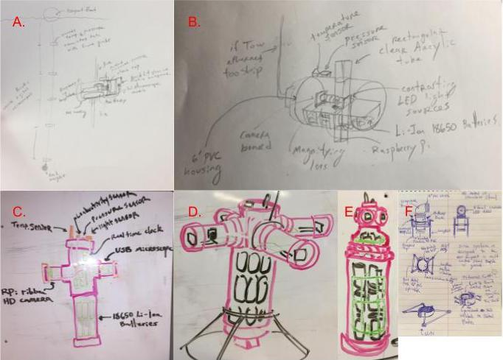
Figure 1. Concept drawings of initial designs. A. B. C. show the iteration of the microscope array. A. a chain digital microscopes to be deployed in the fashion of a sediment trap, B. a over the side of a boat pull for study of particle sizes, calculation of flow rates made this design in feasible computationally, C. hybrid of digital microscope and digital camera with environmental sensors to study both macro and micro scale of ecosystem simultaneously. D. E. F. show evolution of 360 FOV digital camera platform into a stereo camera. D. shows initial fire hydrant design with environmental sensors emerging from the head and cameras in the arms, E. shows design with a reduced size to reduce price of housing, F. shows initial design concept of stereo camera with a pvc elbow, two unions, and a large main tube for the battery pack.

Consultation With Cephalopod Cognition and Behavior Experts:

Collaboration:

During a meeting with David Gire and Dominic Sivitilli of UW Psychology at the college Inn Pub in late autumn the design of my project changed radically. There was a desire for their group to have a field instrument to do exploratory cephalopod field research. The group is building the octopus as a behavioral model and has done extensive lab work tracking how they move and sense. The group was interested in observing octopus behavior in a more natural context to generate a set of data they can use to compare lab data with to further their understanding of the behavioral emotes seen in lab animals, and building of an ethogram for the octopus. Octopus are extremely difficult to breed, so all animals that are studied by the group in lab must be caught in the wild. An interesting proposed use of the instrument would be study of an animal in the field across a significant period of time, followed by capture of the animal for behavioral studies in the lab.

Design Specifications:

There should be two cameras synced in stereo so size and motion can be captured. The resolution of the cameras should be enough to distinguish individual arms of an exposed adult Octopus rubescens at a distance of one meter. Octopus are nocturnal so the cameras should have deep red lights to not alter behavior, they lack the pigments to sense long wavelength red light. Portability, the cameras should be within a watertight housing which is carriable by two people across difficult shore terrain. When in the water a lone scuba diver should be able to maneuver the camera and with the aid of a buddy place the camera. By the nature of octopus dens the camera must be guided into place, blind deployment off the side of the boat would have almost no chance of working. The camera should not weigh more than twenty-five kilos, and have a clip in point for lift bag. The housing should have legs and enough negative buoyancy to not drift in an 4 knot current. The housing should have enough internal room for a large payload of batteries, power converters, a small computer i.e. a RPi. The housing should have an optically clear view port with enough room for cameras to be set up in stereo, with room for lights and a lux sensor. The housing, frame, internal electronics, batteries, and cameras should not cost more than a thousand dollars.

Component Selection:

With the specifications for my build described I began selecting components for the build. There were a few components from the previous design I was able to re use. The temperature sensor, lux sensor, and RTC. For computation I decided to stay with a RPi due to my familiarity with the platform, however we only needed one computer as there was now the need for only one camera. The RPi Zeros did not provide adequate computational power and were prone to crashing, so we replaced the Zeros with a RPi Model 3 B+.
The camera selection involved first research in methods on how to synchronize cameras, and time resolutions required for 3D tracking of motion. We discovered camera synchronization must be within +- 1 ms threshold which makes design of a switch for multiple USB cameras technically very difficult. However, we found that this issue could be solved by use of a stereo camera instead of two seperate synced cameras. Initially we reviewed high end drone BlackBird 3D HD FPV camera we found a fundamental flaw in their design for our use, they are made to transmit to a receiver. We then found there is a multitude of stereo cameras made for use in industrial settings, we settled on a low cost <$100 camera produced by Ailipu Technology Co. that touted high performance at a low cost. The camera output mjpeg and was capable of streaming four resolution settings at either 30 or 60FPS at a maximum output bit rate of ~80 mbp/s.
We also discovered that RPi lack a low power sleep function so to bootstrap in a low power mode we added an Arduino Mini Pro to the design. The Arduino functioned as a smart timed power switch for the RPi, it had the added benefit of being so cheap that we could buy a set of them. We could pre program each with a different power cycle, that could be quickly changed out depending upon which cycle was desired. A 3.3V power converter from the battery linked to the RPi provided unswitchable power to the Arduino.
We decided to power the lights off one battery pack and the computers and camera off another. For symmetry within the housing and simplicity of use and design we decided the battery packs should be identical with the same number of batteries batteries and the same power control boards. We also decided to use low cost low power density batteries, which could be replaced with higher cost high power density batteries. Each battery pack was to have 20 1100mAh 3.7V Li-Ion 18650 batteries, in a 5S4P configuration. This would provide enough battery life for the computer to have power for greater than two days, and the lights would have enough power to last for greater than 6 hours. Our DC/DC converters were chosen after review of the DigiKey online catalog. We chose isolated, high power efficiency, active, mechanically robust, converters with well defined specs.
The LEDs we chose were LED world 3W 660nm plant grow LED emitters with a 20mm star base. The LEDs were stand alone and could be wired up in any desired configuration. The LEDs were cheap, required 2.2 - 2.6 V and 700mA, and came with a specified spectrum. There were a number of other options found online, but LED world was the cheapest solution with a specified spectrum.

Method of Build

Build of project began when it was clear from design what the end product was to be and what it was to accomplish. We purchased components, prototyped our electronics, worked with an expert oceanographic machinist, passed a fire and electrical safety evaluation, and demonstrated function of the camera within a controlled ‘wet test’ environment.

Prototype V 1.0:

Build

Prototype V 1.0 demonstrated the function of all electronics required for the project. Two 5S4P 4400mAh 18.5V battery packs provided power to the computers and lights. Both batteries fed power to a Power Control Board (PCB) then to the electronics. A simple power circuit on a prototyping board split one of the batteries between a 3.3V regulator to an Arduino Mini Pro, and input to a PYB15-Q24 5V DC/DC Converter which then fed the Raspberry Pi power. The Arduino had a GPIO control lines to the RPi and the DC/DC converter enabling it to provide a low power ‘sleep’ for the computer and a ‘check’ for RPi power. The RPi had three I2C devices connected to it through an I2C bus, a high resolution temperature sensor, a lux sensor, and a RTC. The RPi had a GPIO control line to a PYB15-Q24 15V DC/DC converter which had a power input from the other battery pack for switching control of six Deep Red LEDs. A stereo camera was attached via USB 2.0 to the RPi.
We consulted with Tor Bjorklund for design of the PVC housing. 4” Sch 80 PVC was selected, our view port needed 4” diameter for the stereo camera to fit and Sch 80 PVC unions had been previously tested by Tor to depths of 200m and were known to be reliable when compared to the unknown performance of Sch 40 unions, this was primarily due to differences in quality of their threading. Using an extruded polyethylene political board as a mount we fitted out electronics and batteries within the housing and demonstrated function of the camera within the housing.

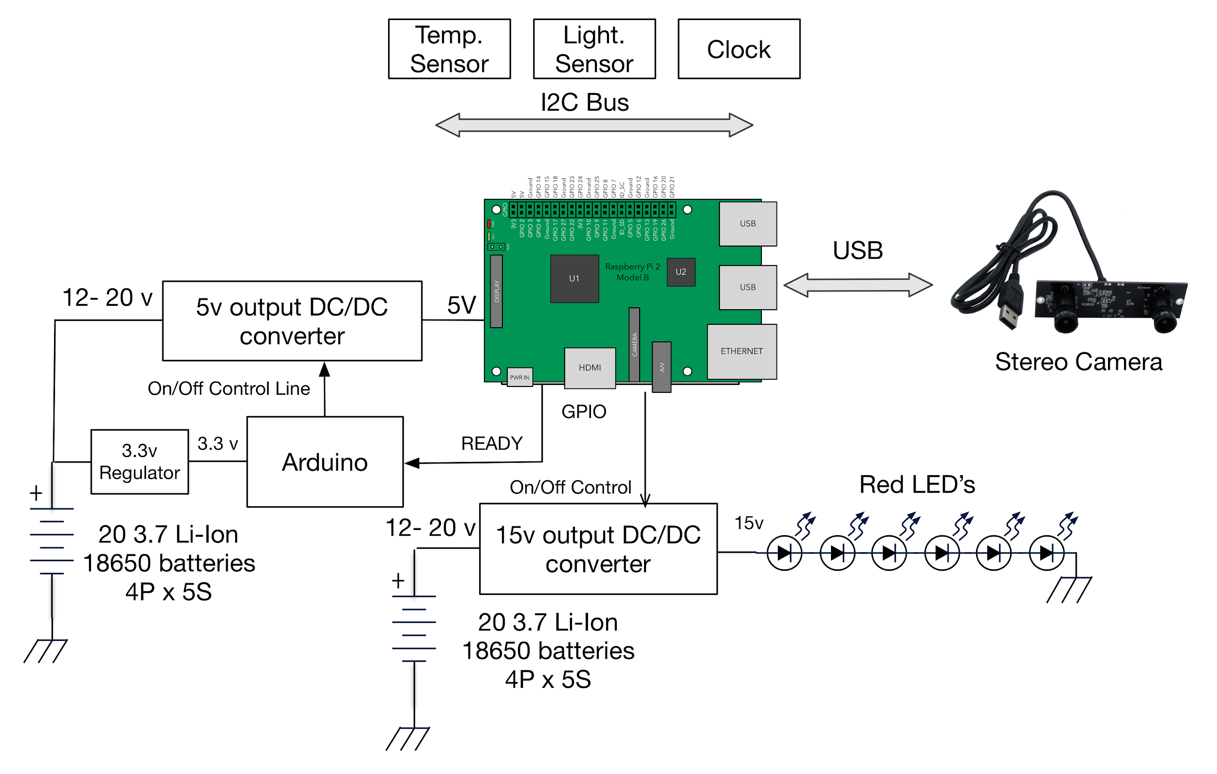
Diagram 1. Cartoon schematic of electronics of camera.
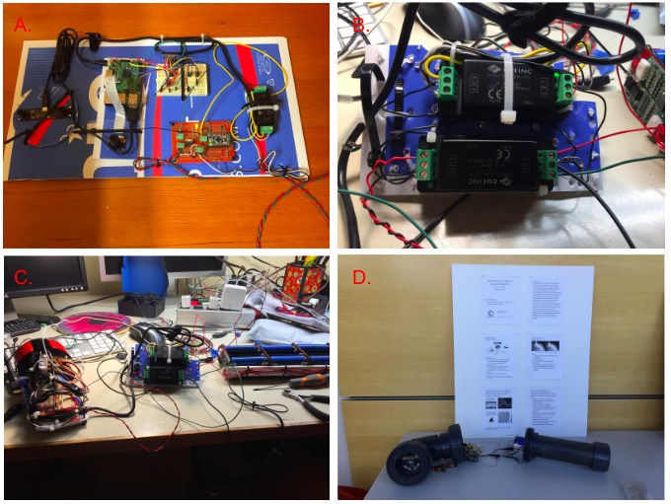
Figure 2. A. Shows electronics mount on extruded polyethylene political board for testing. B. Shows DC/DC converters with all necessary wires for function of electronics. C. The assembled electronics of the V 1.0. D. Shows assembled prototype V 1.0 within its watertight PVC housing on display for winter quarter poster session.

Safety Review

Prototype V 1.0 was put up for a fire and battery safety review by Fritz Stahr. The conclusion of the review was that the Prototype while functional had a high likelihood of failure when deployed in the field due to potential of heat concentrating around the lights, lack of sufficient stress reliefs to prevent wire slippage which could cause a short of the battery packs, adequate heat sinks for heat distribution, to small of wire gauge, and incorrect placement of the fuses for protection of electronics.
An added level of safety was desired by the reviewer due to the nature of the deployment of the instrument. If a diver is recovering the instrument and catastrophic failure has occurred and it is not identified by observation of the instrument in situ failure of the pressure housing could occur when the diver brings the instrument up from depth. To reduce the chance of this occurring the internals should be robust.

Prototype V 1.1 Build:

Safety Review Passed

The issues described in the safety review for V 1.0 were addressed. 1/16” Aluminum plates replaced the extruded polyethylene boards. Stress reliefs were added for all wiring so that it was physically difficult to disconnect any wires. Fuses were moved from GND to V+ to protect electronics. LEDs had aluminum heat sinks added and wells were designed into their 3d printed mount for heat dissipation. All power lines were changed from 22 AWG to 20 AWG, control lines, power balance lines, and I2C lines remained 22 AWG. A 3d printed plate was added to separate the DC/DC converters from the battery pack. An emergency shut-off protocol at 60°C was added to the temperature reading code. JST SM connectors with 3A rating were added for all connections other than the micro USB. The wet test proved that the internal temperature of the instrument plateaued at ~36°C with electronics active in room temperature water.

Build

The redesign of the internals significantly improved the robustness of the camera. There was little change to the design of electronics from a circuit perspective. The singular major performance upgrade was the addition of a 256GB flash drive to expand memory. From a design perspective the before and after comparison was stark. Prior to the redesign shaking of the electronics could disconnect wires, afterwards it became physically difficult to disconnect wires due to extensive strain reliefs. The internals became much easier to work with as failure due to accidental slippage of the wires was much less likely.
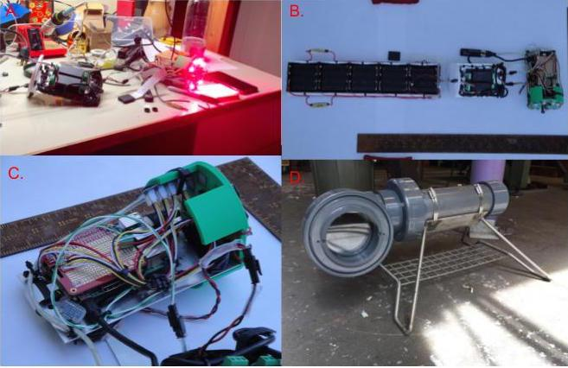
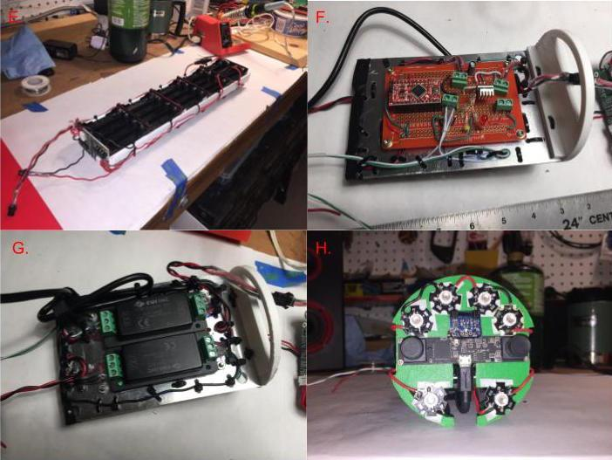
Figure 3. A. Shows the assembled electronics being dry tested on a power supply set to mimic the batteries. B, C, and E-H show images of V 1.1 electronics after rewiring for fire and battery safety review. B. Shows the assembled electronics and battery pack in the configuration they fit into the housing with. C. Shows the ‘head’ RPi and I2C bus wired with strain relief. D. The empty housing and frame made by Tor Bjorklund. E. battery pack with fuses and stress relieved 20 AWG main power lines. F. Arduino and power circuit for splitting Arduino and RPi power lines. G. Stress relieved DC/DC converters attached to the aluminum plate with high strength double sided bonding tape. H. View of the stereo camera, lux sensor, and LED halo.

Pressure Test

The housing was pressure tested twice. The first time it was dropped off the side of an Agua Verde kayak to the depth of 56 ft. The second time it was dropped off the side of MSB dock for two hours to a depth of 8m.

Wet Test
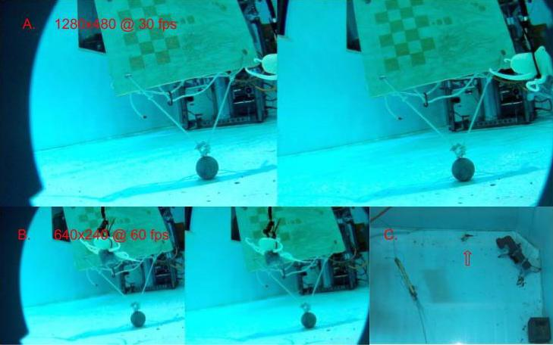
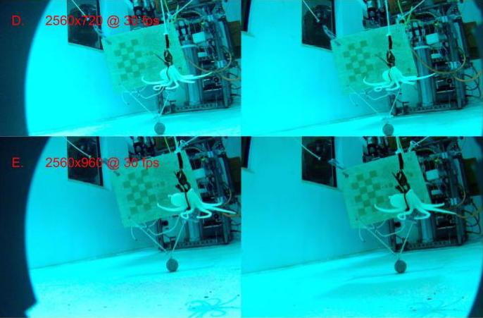
Figure 4. Wet test of camera. A, B, D, E show comparison footage of different resolution settings, in figure A and B are scaled to each other, and D and E are scaled to each other. C. shows an overhead view of the wet test, the arrow points to the octopus toy. Of all the resolutions, B 1280x480 looked the best with both D and E having some image tearing and A being very low resolution.

The wet test was done in OSB the test tank, the test ran a total of 1 hour and 40 minutes. The RPi when initialized began recording temperature and lux, and then ran a script where it went through five different video capture settings each five minutes long. This was followed by a one hour period where the lights were on to test for the internal temperature maximum. And then a fifteen minute cooldown period. During the video recording period of the test a calibration board and a toy octopus were moved in front of the camera.

Memory

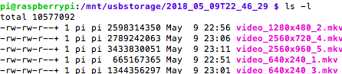
Figure 5. Memory consumption of the different video capture settings.

The memory use of the different video settings was relatively low with the maximum resolution setting 2560x960 @ 30 fps only consuming 0.68 GB/minute. At estimated 250 GB maximum storage space this would enable 6.1 hours of footage to be captured on par with the maximum lifetime predicted for the lights. There is enough memory capacity when combined with battery life to make up for the lack of motion activation.

Cost Analysis

The cost analysis does not including the price of the design phase of the project, damaged components, and electronics that did not meet the requirements of the build, i.e RPi Zeros. The analysis also include the fractional cost of use of of kits such as the JST SM connectors, and heat sinks however in net they were low cost. The largest cost for the project was the design and build of the housing and frame.
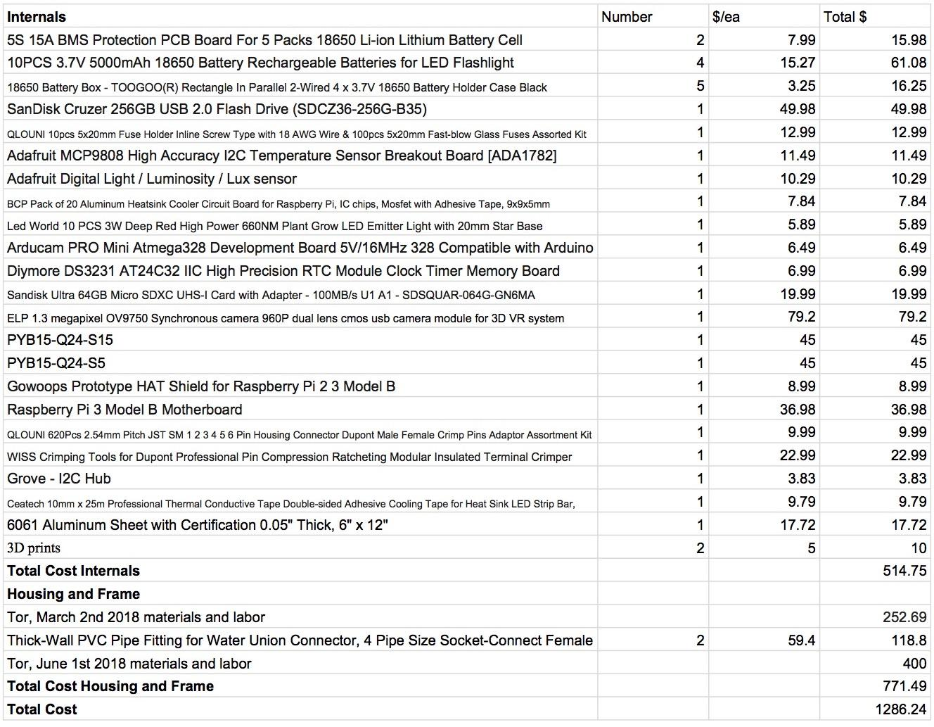
Figure 6. Summed cost off all parts for the camera, note that some of these costs are for tools and kits, none the kits purchased for the project were used in entirety.

Method of Application:

Driftwood Park Survey

Driftwood Park is a well known location for drift dive training, reliable strong currents prevail from west to east across the beach. The substrate of the site is rocky with a top layer of cobblestones protecting finer sediments beneath. At the site an accumulation of old bottles has created an abundance of dens for Octopus rubescens which are easily identified by divers. We surveyed the site on two separate occasions. On the first survey Divers Dominic Sivitilli and Chris Wells dove and found no octopus. However the diver had a major technical error, current time data from Admiralty Head was later learned to be off by ~40 minutes from our site. The divers dove in unexpected high current conditions and failed to find any dens. To compound the issue since it was a day dive only one diver had a light for inspecting the bottles O. rubescens makes its dens in. The later dive would find numerous octopus den a mere thirty to forty feet from the previous dive.
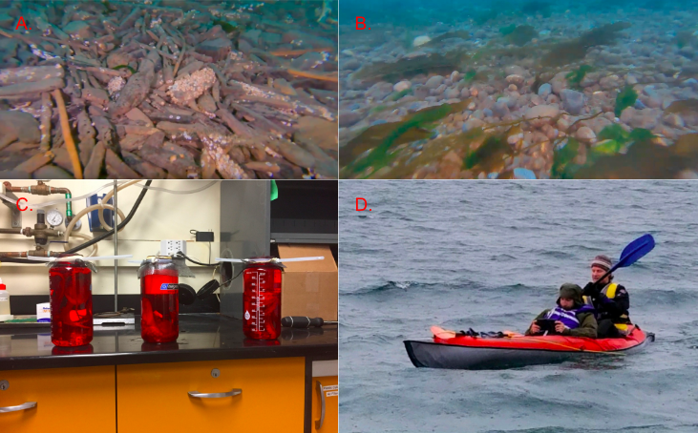
Figure 7. A. and B. show different substrates observed at Driftwood Park with ROV. A. clogged driftwood and barnacle coated bottles, with next to no fine surface sediments. B. Kelp and rocks with some visible finer sediments, the kelp all is swept in the direction of the prevailing west to east current. C. The three Octopus rubescens recovered by divers during the second survey of the site. D. Researchers using a ROV off the side of a kayak to survey the site during a flood tide prior to slack, the ROV was towed a length of the beach and observation of the seafloor helped the divers visualize the site prior to diving.

For the second survey we decided we wanted a bigger picture view of the site prior to
the divers entering the water, since the slack window is so short for collections. From the UW Ocean Technology Center we borrowed a brand new out of the box OPENrov Trident, the documentation and training protocols of which I had been working on with another student for the OTC. Using the ROV I trawled a section of the beach with the ROV. After the trawl we had a thirty minute period where the divers prepared their gear and discussed the site with me while reviewing the footage from the ROV. At slack the divers entered the water and within a twenty five minute period successfully captured three Octopus rubescens for behavioral studies by the Gire Lab. The divers also reported observing numerous brooding females which were left undisturbed. The site was determined to be of interest for deployment of the camera, it has a favorable substrate for deployment and a high density of shallow ~ 65 ft depth dens.

Field Deployment

The instrument will be used by students at Friday Harbor Labs (FHL) for the Marine Subtidal Ecology course of 2018. The Gire Lab will have a lab space at FHL for the summer, and their graduate student Dominic Sivitilli will be a fellow attached to the Marine Subtidal Ecology course. I am enrolled for the course and we are planning on deploying the camera as part of a project focused upon octopus behavior and ecology, up to two other students may be involved in the study. We plan on returning to Driftwood Park during the course with the camera, we also have plans to do deployments at Eagle Cove, and other sites depending upon advice from experts during our stay at the labs. Our goal is to observe both O. rubescens and E. dofleini dens as well as do collections for behavioral studies in 8ft tanks provided by FHL to the Gire Lab. The Lab studies will leverage Intel RealSense D435 cameras to do real time high resolution 3D tracking of octopus motion. The behaviors observed in the lab will be cross compared with stereoscopic footage from our field instrument for comparison of behavioral motives of octopods in situ and in lab conditions.
For deployment at FHL I have built a set of deployment scripts that can be called in the RPi’s bootscript and crontab. The different deployment scripts have variables that can be quickly changed to alter important parameters such as resolution, sleep time, capture time, LED time, and shutdown time. During my time at FHL I will be receiving intensive dive training for my scientific certification and may have limited time to write new scripts.
During the build phase the camera housing was designed with deployment of divers in mind. How the divers deploy the camera and its ease of positioning is a crucial component of its application. The camera has two alligator clamps that can be loosened to allow divers to alter the tilt of the camera. It also has two loops that a lift bag can be attached to so divers can control its buoyancy and attach lines onto.
There will be two main different deployment techniques, boat and shore dives. In a shore dive individuals on the beach will help the divers with the camera until both they and it are in the water. From there the divers will use a lift bag and carefully swim it out to its deployment site. When deployed from a boat the camera will be lowered into the water with a line and then divers will take over and release the line when they are comfortably in control of the camera using a lift bag.
Prior to deployment of our camera at any site divers will have conducted surveys of the location and will have already identified a desired deployment location. The camera due to its size is to never go in to a location blind. While at FHL during the first two weeks of the course I will receive a scientific diver certification. During this time Dominic will be diving for collections and deploying a set of GoPro cameras with extended batteries to survey sites, octopus dens often are hidden and deploying cameras outside suspected dens will show you if an octopus resides within. With this initial field information we will spend three weeks deploying my camera in and around the San Juan Islands.

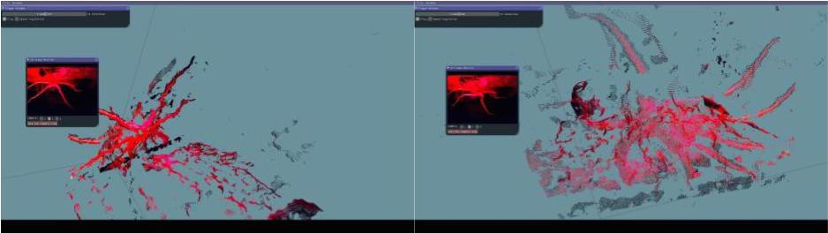

Figure 8. Example of data from D200 intel realsense cameras. The preliminary data came from the observation of the O. rubescens collected during the Driftwood Park survey. I aided in the calibration and capture of the footage, as well as design of the Deep Red Lamp used to illuminate the tank. This type of data will be cross compared with the field data from the stereo-RUV.

Results:

By first finding an interest in a type of field instrument, and then searching for a user for the instrument I was able to design a camera for a specific purpose. The camera is by design a behavioral camera, with a secondary capability of answering ecological questions due to the potential of long deployment times, and lights for diurnal studies.
Two large battery packs, a high resolution high frame rate stereo camera with programmable capture settings, high power Deep Red LEDs, a light sensor, a temperature sensor, and a low power sleep mode, these are the major functionalities we have put into the camera. The robust housing, frame, and internal wiring of the camera make it durable and capable of surviving the accidental fall or two. We have built a camera that will provide unique data from a difficult environment to operate in.Divers will deploy and recover the camera from well described locations for cephalopod research. The camera has been built from the start for this application.

Discussion:

As Gordon Moore predicted “The future of integrated electronics is the future of electronics itself. The advantages of integration will bring about a proliferation of electronics, pushing this science into many new areas.” (Moore, G.E. 1965) electronics have proliferated and dropped in cost dramatically. This explosion of low cost integrated circuits over the past decade has created a wonder of new opportunities for low cost solutions for asking basic science questions about the marine environment, and the ecology of the organisms within it. When designing our camera platform we selected our electronics to best leverage modern integrated circuits while balancing for costs and ease of design. For our computer and ‘brain’ of the platform we had the choice of using an Udoo, Odroid, BeagleBone, or Raspberry Pi (Maksimović, Mirjana., et al. 2014). We choose a Raspberry Pi 3 Model B+, a small computer that can run a variety of linux distributions, is highly programmable, and has a deep community following making it very unlikely for us to encounter an unknown error others have not encountered that could cost lots of time to solve. The RPi has a remarkably low RAM / cost ratio, expandable memory, USB 2.0, and from the computer choices we considered it the easiest to work with due to our experience with it. The RPi also met our design specs in that it was capable of handling the full bitrate output by the USB stereo camera. We did find that the RPi was not capable of both handling the output of the USB stereo camera and running a motion detection algorithm, motion detection consuming more computing power than the actual video recording. However we are unsure any of the other choices could have handled both a motion detection algorithm and 30 fps video capture.
The major challenge for high performance stereo vision is synchronization of the camera feeds. We were able to find low cost ‘off-the-shelf’ USB 2.0 stereo cameras that output highly synchronized camera feed by virtue of the design of their integrated circuit. This synchronized feed is fed to the computer through a single USB 2.0 port. This requires the end user of the video footage to extract both camera feeds for cross comparison analysis, but significantly simplifies the system by overcoming the hurdle of synchronization as well as cutting potential CPU costs in half. Once the camera is deployed and we have initial data to compare with our lab data an algorithm will have to design/modified to analyze the data.
For video capture we utilized FFmpeg an open source project which enables command-line-based processing of video. The stereo camera fed mjpeg output to the RPi with a maximum bit rate of ~80 mbp/s. Due to the size of the video files the camera outputs we mounted a 256GB USB 2.0 flash drive to the Raspberry Pi to increase total storage space, and enable fast post processing of the data, downloading data from an RPi SD card requires transferring them over wireless, the boot on the SD card hides internal storage.
A drawback of the RPi is that it lacks a low power sleep function, with signifigant resting power consumption. For our camera it may be desired for it to be deployed for examination of specific temporal periods across a time scale of up to or greater than a week, i.e dusk and dawn periods across multiple days. To solve the issue of a sleep function we use a Arduino Pro Mini, a microcontroller based on ATmega328 with digital input/output and analog read pins. The Arduino can switch power to the Raspberry Pi on after counting off specific intervals of time, acting as a bootstrapped sleep. The power consumption of the Arduino Pro Mini is a factor of ten lower than the resting consumption of the Raspberry Pi this would take ~ 500 hours of uptime to drain the battery pack. The Arduino also functions as a delayed turn on for the RPi so the housing and electronics can be assembled and sealed in a controlled environment and transported to the location of deployment without the cost of powering the RPi.
For lights six 2.5 V, 700mAh 30-40 lumen high powered Deep Red 660-665 nm LEDs were used. Control of the light is enabled by a control line on the 15V output DC/DC converter. A lux sensor placed in the viewport of the housing allows the Raspberry Pi to ‘sense’ the intensity of natural light and based on a predetermined threshold activate the LEDs. Deep Red LEDs were chosen due the inability of octopods to sense Deep Red wavelength (Ramirez, M. D., and T. H. Oakley. 2015). The lights consume a significant amount of power and for this reason we built a separate battery pack for them, at 2.5V and 700 mA consumption we estimate a ~6.8 hour window of power for the lights. This could be significantly improved with controlled pulsing of the lights to coincide with a timelapse. Power for the RPi and camera is predicted to significantly outlast that of the lights at ~50 hours at maximum clock rate. We found that the heat sinks on our LEDs were not doing an adequate job of dissipating their heat, so we added two 10 ohm resistors in parallel to the chain to drop the voltage across the LEDs.
In lab observation of octopus behavior under the LEDs showed limited reaction to their presence. Pupil reactions were seen when six of the LEDs were held within a few inches of O. rubescens indicated that the tail ends of the LEDs spectrum may go into the visible spectrum of the octopus. However this reaction appeared to be minimal, and may be non-present at distances of observation expected when the instrument is deployed in the field. It is possible that a different brand of LED, or the addition of a film filter may tighten the spectrum of the LEDs. We did not test the spectrum of the LEDs, O. rubescens may also be able to see deeper in the red spectrum than expected. Octopus only have one photosensitive pigment, rhodopsin which cannot absorb light greater than ~600 nm (H. Ruth, 1969). Our LEDs were purchased from amazon, which we have learned from this project has an epidemic of ‘fake’ electronics for sale. It is not possible to determine from our own visual inspection of the LEDs to determine if they have orange in their spectrum, images with cameras do not appear to have any apparent light other than red.

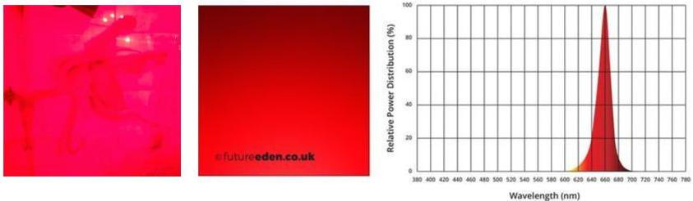

Figure 9. Example of iphone camera sensor super saturated by red light when imaging O. rubescens in lab under deep red LED lamp. Specified spectrum of our deep red LEDs and associated color gradient.

To track time we used an RTC, RPi do not have dedicated independent battery powered clocks however through I2C, we can add real time clocks to them. With the addition of a DS3231 we expect a time accuracy of ±2 ppm from 0°C to +40°C. With this, if time was synced before a million second long deployment, roughly eleven and a half days the Raspberry Pi will have a time accuracy of ±2 seconds. This time accuracy is good enough for the planned use of the instrument
An internal temperature sensor enables a degree of system diagnostics, and a catastrophic failure shutdown switch. MCP9808 I2C Temperature sensor with an accuracy of ±0.25°C over a range -40°C to 125°C range was used as the internal temperature sensor. Within the housing it is placed away from high thermal output components such as the LEDs so that it can sense the mixed internal temperature of the housing. The Raspberry Pi is programmed to shut down if the temperature sensor reads a temperature of >60°C, this temperature is 10°C below the point at which electronics are expected to start failing. The Raspberry Pi can track and record the temperature across time, once calibrated an internal external equilibrium reached across the housing wall can give an indication of external temperature across time. In our ‘wet test’ while in room temperature water the internal temperature with the LEDs active equilibrated at ~36°C safely below failure temperature.
Power is supplied by two independent battery packs, the lights, and the RPi + Arduino have independent packs. Each battery pack consists of twenty 18650 3.7V Li-Ion batteries in five cells of four strung together in series. The battery packs are power balanced, and rechargeable through the use of low cost power control boards. 18650 batteries come in a range of qualities, (Muenzel, V., et al. 2015) found that the majority of ‘budget cells’ tested at <20% of rated capacity. Because of the variability of cost and quality of 18650 batteries, desired power capacity of our power pack can vary by a factor of ~3x and the cost can vary by a factor ~5x depending upon the choice of batteries. We purchased budget batteries that sold for $1.60/ea and were rated for 5000 mAh at 3.7V, but when tested by reviewers actually only had a capacity of ~1100mAh. We reached out to ‘batterybro.com’ an accredited supplier of quality batteries for a quotation for 3000mAh batteries, which after tax and shipping came out to be $8.00 / ea. The budget batteries had a mAh/$ of 687.5 while the quality batteries had a mAh/$ of 375. Our battery packs have 4400mAh at 18.5V capacity, which after power calculations was enough for our goals. We estimate ~50 hours of power for RPi at maximum clock rate, and ~6.8 hours of power for the LEDs.
The isolated converters were high quality ~$45/ ea with shipping, had an input voltage range of 9~36V, a control line, heat sink, exceptionally good power conversion efficiency ~90%, noise dampened, and are mechanically robust. The DC/DC converters are a crucial part of the design of our camera and we purposely balanced the quality:cost towards quality. There are a large number of DC/DC converters available upon the market we decided to buy from DigiKey a reliable vendor. Given the choice we would reuse the same converters again they worked exactly as described and had a low heat signature.
The housing and frame for the camera was a construction of Tor Bjorklund, it works well. I approached Tor with an idea for the housing and he worked with me to develop the design. The PVC housing design was my own. However when it came to the design of the frame he knew more than I did and ultimately the design of the legs was his own. The frame and housing ended up being the single greatest cost of the project.
The cost of the build of the camera went over budget by roughly 28%. I do not believe the electronics could have been built more cheaply, $500 was quite cheap. The housing however could have been built more cheaply, the largest unnecessary cost was excessive consultation of Tor Bjorklund on the design. This avoidable, but I knew nothing about housing and frame design and talking to Tor ultimately took my designs which were not very practical and developed them into something that have a much better chance of working. For future projects, design of the housing should defined specifically before reaching out for professionals for help in manufacturing.

Conclusion:

A stereo-RUV was developed for use in octopus behavioral studies. The development consisted of consultation with a group interested in use of a remote imaging instrument, design specification, component selection, building, and testing of the instrument. The Gire Lab has expressed interest in development of a more advanced system that leverages the Intel RealSense camera platform, my camera for them is a first generation prototype. Lessons learned from the deployment and design of the stereo-RUV will be used for their next generation of instrument. For the goals of the MSE Summer 2018 course at FHL, the camera will perform exceptionally for its designed purpose. Octopus are a black box, their behavior sprouts from the divergent evolution of a complex nervous system from our own. The Gire Lab is planning a holistic bottom up approach for understanding their behavioral emotes and cognition, field studies will play a vital role in this approach. This instrument will provide valuable preliminary data for the Gire Lab, and assist in our understanding of octopus behavior in the wild.

Acknowledgements:

I would like to thank the University of Washington Ocean Technology Center for use of their resources, and guidance. In particular I would like to thank my advisor Miles Logsdon for his support, Fritz Stahr for his technical advice on making electronics mechanically robust, and Tor Bjorklund for his masterful craftsmanship and advice, I learned so much about oceanographic instruments in my short time working with Tor. The UW Psychology Gire Lab for their advice, excitement, and funding of the project. And above all others my father for spending many a long night teaching me his deep knowledge of computer programming and electronics, without him my project would not have been possible.

References:

Zelman, Ido, et al. “Nearly Automatic Motion Capture System for Tracking Octopus Arm
Movements in 3D Space.” Journal of Neuroscience Methods, vol. 182, no. 1, 2009, pp.
97–109., doi:10.1016/j.jneumeth.2009.05.022.

Ramirez, M. D., and T. H. Oakley. “Eye-Independent, Light-Activated Chromatophore Expansion
(LACE) and Expression of Phototransduction Genes in the Skin of Octopus
Bimaculoides.” Journal of Experimental Biology, vol. 218, no. 10, 2015, pp. 1513–1520.,
doi:10.1242/jeb.110908.

Wiltschko, Alexander B., et al. “Mapping Sub-Second Structure in Mouse Behavior.” Neuron,
vol. 88, no. 6, 2015, pp. 1121–1135., doi:10.1016/j.neuron.2015.11.031.

Mather, Jennifer A. “To Boldly Go Where No Mollusc Has Gone before: Personality, Play,
Thinking, and Consciousness in Cephalopods*.” American Malacological Bulletin, vol.
24, no. 1, 2008, pp. 51–58., doi:10.4003/0740-2783-24.1.51.

Scheel, David, et al. “A Second Site Occupied by Octopus Tetricus at High Densities, with Notes
on Their Ecology and Behavior.” Marine and Freshwater Behaviour and Physiology, vol.
50, no. 4, 2017, pp. 285–291., doi:10.1080/10236244.2017.1369851.

Kroger, Bjorn, et al. “Cephalopod Origin and Evolution: A Congruent Picture Emerging from
Fossils, Development and Molecules.” BioEssays, vol. 33, no. 8, 2011, pp. 602–613.,
doi:10.1002/bies.201100001

Richter, J. N., et al. “Octopus Arm Movements under Constrained Conditions: Adaptation,
Modification and Plasticity of Motor Primitives.” Journal of Experimental Biology, vol.
218, no. 7, 2015, pp. 1069–1076., doi:10.1242/jeb.115915.

Levy, Guy, et al. “Arm Coordination in Octopus Crawling Involves Unique Motor Control
Strategies.” Current Biology, vol. 25, no. 9, 2015, pp. 1195–1200.,
doi:10.1016/j.cub.2015.02.064.

Anderson, Roland C., et al. “Octopuses (Enteroctopus Dofleini) Recognize Individual Humans.”
Journal of Applied Animal Welfare Science, vol. 13, no. 3, 2010, pp. 261–272.,
doi:10.1080/10888705.2010.483892.

Moriyama, Tohru, and Yukio-Pegio Gunji. “Autonomous Learning in Maze Solution by Octopus.”
Ethology, vol. 103, no. 6, 1997, pp. 499–513., doi:10.1111/j.1439-0310.1997.tb00163.

Seibel, B. A, and J. C Drazen. “The Rate of Metabolism in Marine Animals: Environmental
Constraints, Ecological Demands and Energetic Opportunities.” Philosophical
Transactions of the Royal Society B: Biological Sciences, vol. 362, no. 1487, 2007, pp.
2061–2078., doi:10.1098/rstb.2007.2101.

Onthank, Kirt L., and David L. Cowles. “Prey Selection in Octopus Rubescens: Possible Roles
of Energy Budgeting and Prey Nutritional Composition.” Marine Biology, vol. 158, no. 12,
2011, pp. 2795–2804., doi:10.1007/s00227-011-1778-4.

Williamson, Roddy, and Abdesslam Chrachri. “Cephalopod Neural Networks.” Neurosignals, vol.
13, no. 1-2, 2004, pp. 87–98., doi:10.1159/000076160.

Budelmann, Bernd U. “Active Marine Predators: The Sensory World of Cephalopods.” Marine
and Freshwater Behaviour and Physiology, vol. 27, no. 2-3, 1996, pp. 59–75.,
doi:10.1080/10236249609378955.

Moore, G.E. “Cramming More Components Onto Integrated Circuits.” Proceedings of the IEEE,
vol. 86, no. 1, 1998, pp. 82–85., doi:10.1109/jproc.1998.658762. Reprinted from Gordon
E. Moore, “Cramming More Components onto Integrated Circuits,” Electronics, pp.
114–117, April 19, 1965.

Maksimović, Mirjana., et al. “Raspberry Pi as Internet of Things Hardware: Performances and
Constraints.” Proceedings of 1st International Conference on Electrical, Electronic and
Computing Engineering, IcETRAN , 5 June 2014, doi:ISBN 978-86-80509-70-9 .

Muenzel, V., et al. “A Comparative Testing Study of Commercial 18650-Format Lithium-Ion
Battery Cells.” Journal of the Electrochemical Society, vol. 162, no. 8, 2015,
doi:10.1149/2.0721508jes.

Intel® RealSense™ Depth Camera D400-Series Datasheet. September 2017. Revision 0.7
https://www.mouser.com/pdfdocs/Intel_D400_Series_Datasheet.pdf

Mallet, Delphine, and Dominique Pelletier. “Underwater Video Techniques for Observing Coastal
Marine Biodiversity: A Review of Sixty Years of Publications (1952â2012).”Fisheries
Research, vol. 154, 2014, pp. 44–62., doi:10.1016/j.fishres.2014.01.019.

Hubbard, Ruth. “Absorption Spectrum of Rhodopsin: 500 Nm Absorption Band.” Nature, vol.
221, no. 5179, 1969, pp. 432–435., doi:10.1038/221432a0.

