Feces Volume and Body Volume of Abarenicola pacifica at Various Distances from Shore at False Bay
Amanda Riedlinger
FHL 470: Research in Marine Biology
May 27, 2022

Abstract
Abarenicola pacifica is a species of deposit feeding lugworm that is often dominant in its environment and alters the sediment in ways that influence the other species that settle nearby. Because of their importance in the ecosystem, we investigated the relationship between the body size, fecal production and location of A. pacifica. We performed this survey at False Bay on San Juan Island, Washington. We hypothesized that there would be an inversely proportional relationship between distance from shore and body volume as well as the ratio of feces volume to body volume because of the distribution of organic matter towards the head of the bay. We sampled 120 worms across the length of the A. pacifica zone. We measured the volume of each fecal deposit via displacement of water in a graduated cylinder, then dug up the worm in its burrow and measured the body volume. The data show a significant proportional relationship between distance from shore and body volume, which is the opposite of what was hypothesized. We found no correlation between the feces volume and body volume or between the ratio of feces to body volume and tidal height. There are several factors such as age, predation, depth, moisture level of sand, and sediment nutrient levels that might impact the volume of both the feces and body of the worm. We conclude that lower tidal heights in the A. pacifica zone at False Bay are more conducive to the growth of the worms.
Introduction
Lugworms are a family of deposit-feeding polychaete that create and live in U-shaped burrows in sandy sediment. If conditions are favorable, these worms will stay in the same burrow for up to weeks at a time before moving (Wells, 1945). They feed by digesting organic matter from the sediment at one end of their burrow and defecating at the surface at the other end in a characteristic spiral pattern (Crane & Merz, 2017). While feeding, lugworms flush water through their burrow from the back end to the head end. This loosens the sediment they are feeding on and creates adequate ventilation for oxygen uptake (Riisgard & Banta, 1998). Lugworms are known to be ecosystem engineers because this process of burrowing and feeding affects the sediment in numerous ways. Creation of the burrows increases permeability and oxygenation of the sand, while the sediment turnover and flux of water through the burrow aids in decomposition of organic materials and alters the nutrients levels of the sediment (Montserrat et al., 2011; Kristensen & Blackburn, 1987; Hüttel, 1990). All these conditions affect the organisms that are able to coexist with lugworms.
Many lugworm exclusion experiments have shown that in the absence of lugworms, the other species present shift (Volkenborn & Reise, 2006). In plots where lugworms are excluded, tube-dwelling species often begin to reside. Changes to the sediment once lugworms are removed, along with the presence of tubes in the sand, produce a cascading effect on the organisms living in lugworm exclusion plots. Tubes create habitat for algae to settle, which in turn causes an increase in the populations of bivalves Mya arenaria and Macoma balthica (Volkenborn et al., 2009). Lugworms are also important in many food webs, being common prey for fish, crustaceans, and shorebirds (Jumars et al., 2015). In most areas where lugworms are present, they are a dominant species. Their biomass accounts for more than the cumulative biomass of all other worms present in the flats of the Dutch Wadden Sea (Retraubun et al., 1996).
We studied our local lugworm species, Abarenicola pacifica, sampling them at False Bay on San Juan Island, Washington. We investigated the relationship between distance from shore and body volume as well as the ratio of feces volume to body volume. We hypothesized that worms closer to the shore would be larger and have larger feces to body volume ratios because of the distribution of organic matter towards the head of the bay, creating a larger food source.
Methods
To investigate the relationship between distance from shore and the fecal and body volumes of A. pacifica, we laid a transect perpendicular to the shore through the zone in which their fecal castings were present (Figure 1). In each 25-meter section, we selected ten fecal piles closest to the transect to sample, skipping large puddles of water where feces were absent. We repeated this on both the north and the south sides of False Bay. Both sides had an A. pacifica zone stretching for 170m with approximately 20m of unsampled tide pools. We sampled sixty worms from each transect.
For each fecal deposit sampled, we recorded its distance from shore. We then carefully scraped the pile with a knife and placed it in a graduated cylinder, measuring its volume via water displacement. We used a shovel to dig near the area where the feces were located and found the A. pacifica that inhabited the area. We measured its body volume by water displacement and replaced the worm and sand back in the hole.
Once all data were collected, we created scatterplots of the distance from shore vs body volume, as well as distance from shore vs the ratio of feces to body volume. We made scatterplots with all data collected as well as with the data separated by transect. A linear regression analysis was performed on these scatterplots, producing a line of best fit, R squared and p values to help us understand the relationship between feces volume, body volume, and distance from shore of A. pacifica. Further analysis (through a scatterplot and linear regression) was done to check for a relationship between feces volume and body volume. We also made a box plot to display the distribution of A. pacifica volume for each transect sampled.
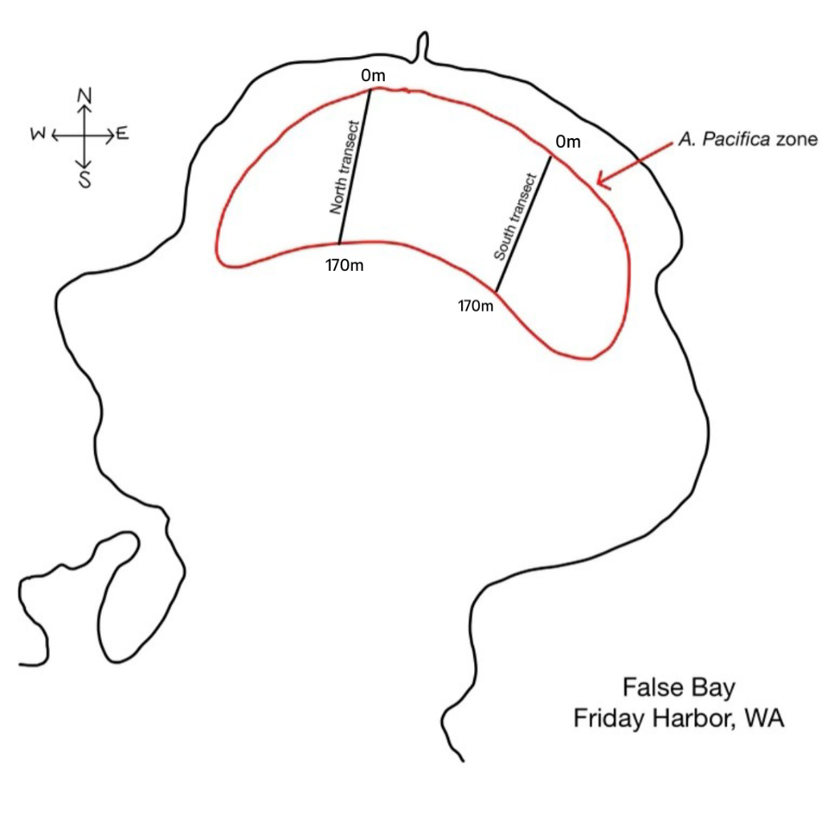
Figure 1: Diagram of False Bay, showing the location of the transects.

Results
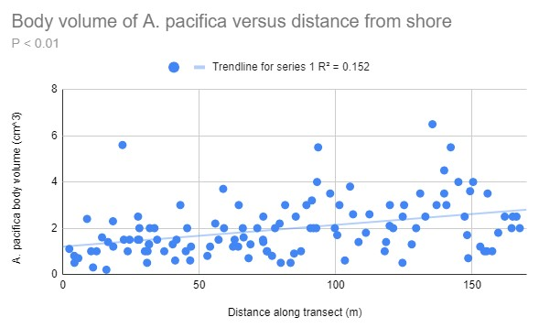
Figure 2: Scatterplot with line of best fit showing the body volume of worms sampled at all different distances from shore.
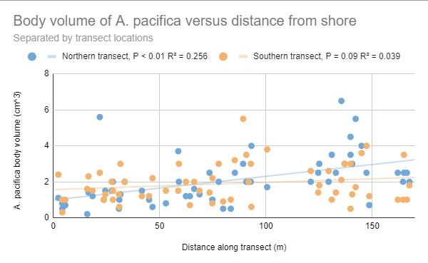
Figure 3: Scatterplot with lines of best fit showing the body volume of worms sampled at different distances from shore, separated by transect.
We found a significant correlation between body volume and distance from shore in the data from the north transect (P < 0.01), as well as in the data from both transects combined (P < 0.01). We found no significant relationship in the data collected along the south transect (P = 0.09). In the data from both transects combined, 15.2% of body volume variation is explained by the distance from shore. In the data from the north transect, 25.6% of body volume variation is explained by distance, and 3.9% is explained in the data from the south transect.
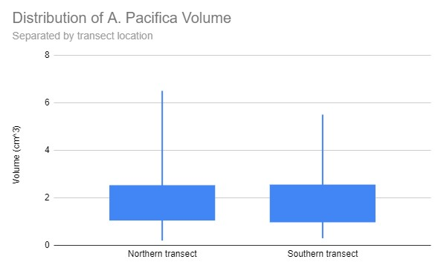
Figure 4: Box plot of body volumes of worms sampled by transect.
The median 50% of worms on both transects have nearly the same volume range (Figure 4). Variance in body volume was greater in the worms sampled along the northern transect.
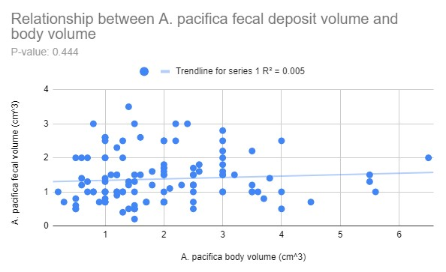
Figure 5: Scatterplot with line of best fit showing the feces volume compared to the body volume for all worms sampled on both transects.
We found no evidence of a significant relationship between the feces volume and body volume of the A. pacifica we sampled (Figure 5). There is a 44.4% chance that the results we collected could be found if there is no relationship between the volume of feces and body. Less than 1% of the variation in feces volume can be explained by the volume of the worm.
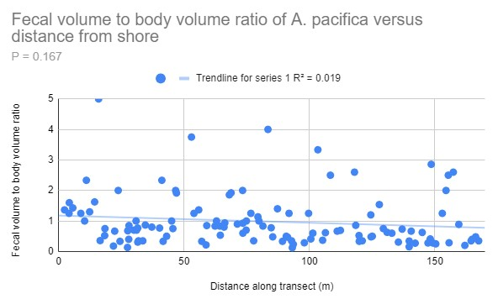
Figure 6: Scatterplot with line of best fit showing the ratio of feces to body volume of all worms sampled at different distances from shore.
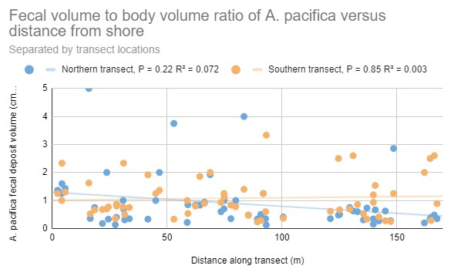
Figure 7: Scatterplot with lines of best fit showing the ratio of feces to body volume of worms sampled at different distances from shore by transect.
We found no significant relationships between feces to body volume ratio and distance from shore (Figures 6 and 7; P = 0.22 for north transect, P = 0.85 for south transect). Little of the variation in fecal to body volume ratio is explained by the variation in distance from shore (R^2 = 0.072 for north transect, R^2 = 0.003 for south transect).
Discussion
We found a proportional relationship between distance from shore and worm volume. A similar pattern was observed in a survey of another lugworm species Arenicola marina and their fecal castings in the UK (Retraubun et al., 1996). Even though we found a significant correlation between the worm volume and the distance from shore, little of the variation in volume was explained by distance. Distance from shore is not a good predictor for worm size. Longer periods of water cover in worms further from the shore might have some impact on their growth, but many other factors such as age, predation, burrow depth, and nutrient concentrations of the sediment could also impact the size of the worms. Other studies have found that growth rates of deposit feeders reliably correlate well with protein levels in the sediment, so this could directly impact the size of the worms (Taghon & Greene, 1990). We did not sample worms in pools of water, since fecal deposits were absent, presumably having been dispersed by the water This is unlikely to influence our data; other studies have found no effect of tide pool immersion on body volumes of populations of lugworms (Retraubun et al., 1996).
We found no relationship between feces and body volume, differing from results of the UK study previously mentioned. The study found a correlation between lugworm body and fecal cast size, though the study was measuring diameter rather than volume of the feces pile (Retraubun et al., 1996). The lack of correlation in this data may be attributed to sampling error and the difficult nature of measuring feces volume. It is possible that we might have collected extra sand along with the feces, and feces in areas with wetter sand may have larger volumes since we did not dry the fecal piles before measuring the volume. There are many aspects that might influence fecal volume as well, which makes these results difficult to interpret.
We found no relationship between the ratio of feces to body volume and distance from shore. Ratios tend to behave poorly under regression analysis. A separate study performed on A. pacifica found that young worms had highest feeding rates when organic concentration was high, while larger worms had highest feeding rates when organic concentration was low (Linton & Taghon, 2000). This attribute of lugworm feeding would complicate the feces to body volume ratio for worms of varied sizes. In sediment with high organic content, large worms would produce smaller feces (small ratio) and small worms would produce larger feces (large ratio). Meanwhile, in sediment of low organic content, small worms would produce smaller feces and larger worms would produce larger feces, generating mid-range ratios for worms of all sizes. This complex relationship between feces and body volume could be part of the reason we found no correlation.
The results of this experiment do not support our hypothesis; the data show that A. pacifica size and distance from shore have a proportional relationship. Our hypothesis was based on the distribution of organic material in the sediment, but there are likely many other factors influencing body volume. We can conclude that lower tidal heights in the lugworm zone are more conducive to A. pacifica growth in False Bay. No correlations were found between feces and body volume or between the ratio of feces to body volume and the distance from shore. It is unclear if the ratio of feces to body volume is a good indicator of lugworm body condition because there are so many factors contributing to the volume of each. Like most ecological studies, the indirect effects of all combined environmental conditions are difficult to reveal.
Literature Cited
Crane, R. L., & Merz, R. A. (2017). Mechanical properties of sediment determine burrowing success and influence distribution of two lugworm species. The Journal of Experimental Biology, 220(Pt 18), 3248–3259.
Hüttel, M. (1990). Influence of the lugworm Arenicola marina on porewater nutrient profiles of sand flat sediments. Marine Ecology Progress Series, 62, 241–248.
Jumars, P. A., Dorgan, K. M., & Lindsay, S. M. (2015). Diet of worms emended: an update of polychaete feeding guilds. Annual Review of Marine Science, 7(1), 497–520.
Kristensen, E., & Blackburn, T. H. (1987). The fate of organic carbon and nitrogen in experimental marine sediment systems: Influence of bioturbation and anoxia. Journal of Marine Research, 45(1), 231–257.
Linton, D. L., & Taghon, G. L. (2000). Feeding, growth, and fecundity of Abarenicola pacifica in relation to sediment organic concentration. Journal of Experimental Marine Biology and Ecology, 254(1), 85–107.
Montserrat, F., Suykerbuyk, W., Al-Busaidi, R., Bouma, T. J., van der Wal, D., & Herman, P. M. J. (2011). Effects of mud sedimentation on lugworm ecosystem engineering. Journal of Sea Research, 65(1), 170–181.
Retraubun, A. S. W., Dawson, M., & Evans, S. M. (1996). Spatial and temporal factors affecting sediment turnover by the lugworm Arenicola marina (L.). Journal of Experimental Marine Biology and Ecology, 201(1–2), 23–35.

Riisgard, & Banta, G. (1998). Irrigation and deposit feeding by the lugworm Arenicola marina, characteristics and secondary effects on the environment. A review of current knowledge. Vie et Milieu (1980), 48(4), 243–257.
Taghon, G. L., & Greene, R. R. (1990). Effects of sediment-protein concentration on feeding and growth rates of Abarenicola pacifica Healy et Wells (Polychaeta: Arenicolidae). Journal of Experimental Marine Biology and Ecology, 136(3), 197–216.
Volkenborn, N., & Reise, K. (2006). Lugworm exclusion experiment: Responses by deposit feeding worms to biogenic habitat transformations. Journal of Experimental Marine Biology and Ecology, 330(1), 169–179.
Volkenborn, N., Robertson, D. M., & Reise, K. (2009). Sediment destabilizing and stabilizing bio-engineers on tidal flats: cascading effects of experimental exclusion. Helgoland Marine Research, 63(1), 27–35.
Wendelboe, K., Egelund, J. T., Flindt, M. R., & Valdemarsen, T. (2013). Impact of lugworms (Arenicola marina) on mobilization and transport of fine particles and organic matter in marine sediments. Journal of Sea Research, 76, 31–38.

