Are Warming Ocean Temperatures Altering Photosynthesis and Respiration in Nereocystis luetkeana?
Leta Morgan Dawson
FHL 470 Research in Marine Science
Friday Harbor Labs, University of Washington
Terrie Klinger

Abstract
Kelp plays important roles in marine ecosystems as primary producers and ecosystem engineers. As climate change accelerates due to anthropogenic stressors like greenhouse gasses, many are looking for a natural source of climate mitigation. Kelp has grown in popularity because of its ability to act as a carbon sink, drawing carbon dioxide out of our atmosphere and sequestering it in deep ocean basins. Yet increases in warming ocean temperatures, ocean acidification and increasing frequency of marine heatwaves proving to detrimental kelps ability to act as a true carbon sink. This study looked at the physiological effects of increasing ocean temperatures in Nereocystis luetkeana. We found increases in temperature affected rates of photosynthesis and growth, suggesting that temperature plays a role in the ability of kelp to draw down carbon. Respiration rates showed a slight positive increase as temperature increased, but was not significant, which differed from previous researchers’ findings. Future management and policy should take into consideration rising ocean temperatures and increases in frequency of MHWs, when looking to kelp for climate mitigation.

Introduction
Due to climate change caused by anthropogenic stressors there has been an increase in warming ocean temperatures that have led to the decline of kelp forest cover as well as range shifts (Duarte et al. 2018). Because of the increases in our need for climate mitigation a call to action for direct and indirect changes, like the restoration of wetlands and kelp forests because of their natural ability to act as a carbon sink, has become increasingly popular (Gallagher, Shelamoff, Layton 2022).
Kelp forests are threatened by warming ocean temperatures, with their ability to adapt to temperature thresholds relying on adaptation and plasticity in response to thermal events (Gauci et al. 2022). The ability of kelp to adapt can take many generations (Gauci et al. 2022), while increasing temperatures affect this ability and their metabolic functions (Green-Gavrielidis & Thornbur 2022). As the ocean warms, canopy forming kelps may decline in health, leading to decreased growth and increased mortality. This leads to a loss in carbon sequestration potential (the capture and storage of carbon from our atmosphere by algae for ~100 plus years) resulting in an increase in kelp respiration rates, a loss of carbon fixation and Net Primary Production (NPP) (Gao et al. 2021).
This study looked at the physiological effects of increasing ocean temperatures in Nereocystis luetkeana. The expected outcome was that increasing ocean temperatures would drive an increase in kelp respiration rates and decrease carbon fixation rates through photosynthesis.
Methods and Materials
N. luetkeana was collected from Turn Rock (GPS: 48.535394, -122.964596), adjacent to San Juan Island. A total of 30 blades were collected and cut to 40 cm from the base of the blade and placed into a bucket of seawater. Six tanks were set up in the Ocean Acidification (OA) Lab, and blades were evenly distributed between the 6 different treatments. Each treatment contained an aquarium pump, a large container with mesh siding. Each tank was assigned a treatment temperature of 10, 13, 16, 18, 20, and 22 ºC. Treatments 16, 18, 20, and 22 included aquarium heaters. The 10-degree treatment was chilled using a freshwater coil, and ambient sea water temperature (13 ºC) was left alone. All seawater was UV treated to reduce the influence of phytoplankton
Beginning at 17:00 hours, each treatment was raised by 2 ºC every hour until reaching its target temperature (16, 18, 20 and 22 ºC). Blades were acclimated at those temperatures for 36 hours. LED lights were hung over each tank and set to be on from 7 am to 9 pm allowing 14 hours of simulated daylight. Light levels over the tanks were equal to 250 micromoles/ m/sec of photosynthetically active radiation (PAR).
Blades from each treatment were placed into 1.5 L chambers and acclimated for 10 minutes in either light or dark conditions before each measurement period. Initial dissolved oxygen and temperature readings were taken using Pyro Science Sensor Technology O₂ Robust Oxygen Probe. The blades were left to respire for a total of 30 minutes while covered with a large black trash bag and tank lid. Final oxygen concentrations were measured after 30 minutes using the same probe, shaking chambers before each measurement. Photosynthesis was measured using the same technique as respiration, with the difference that blades during photosynthesis were exposed to LED light for a 10-minute acclimation period. Following acclimation, chambers were left under light for a 30-minute period to induce photosynthesis. During the 10-minute acclimation period and the 30-minute measurement periods, large aquarium pumps were used to generate movement of chambers in the tanks so that kelp blades experienced constant motion and minimized boundary layer effects.
After chamber incubations, each blade was measured to the nearest centimeter to record growth and then placed in foil packets for drying. To calculate respiration and photosynthesis rates per unit dry mass, blades dried were in a drying oven at 64 degrees Celsius for roughly 54 hours. Data analysis was performed in R using an ANOVA and TukeyHSD. Respiration and photosynthesis rates were calculated via change in O2* chamber volume/ dry mass of each kelp blade.
Results
Photosynthesis rates significantly decreased as temperature increased (ANOVA, P<0.001). Additionally, there was a significant difference in photosynthetic rates between some of the treatment temperatures ( A, AB, B, BC, C ; Tukey HSD pairwise comparisons P<0.05). Respiration showed a positive response as temperatures increased, but was not significant (P<0.09)
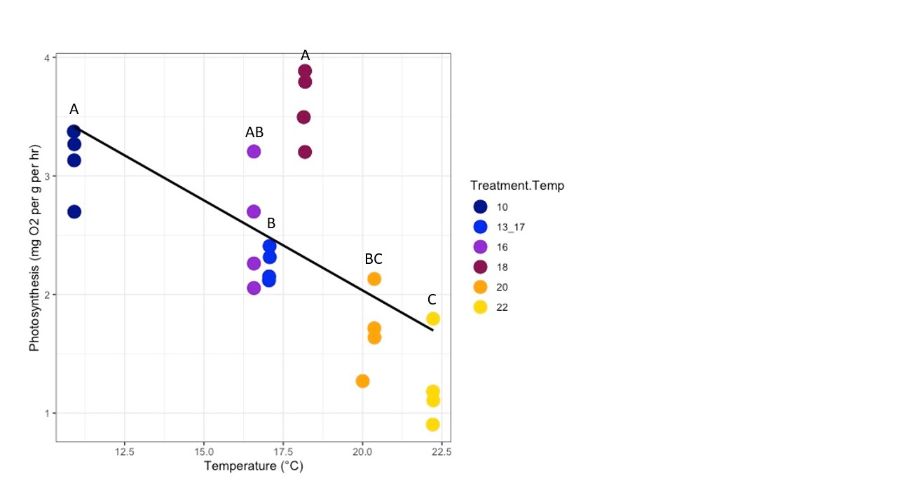
Figure 1 Photosynthetic rate versus temperature. Differences between treatments are significant (p<0.001)
When comparing photosynthesis and respiration rates at 22 ºC, photosynthesis rates were lower than that of respiration which had greater variation among blade replicates. This could be due to some of the 22 ºC treatment blades showing signs of physical deterioration.
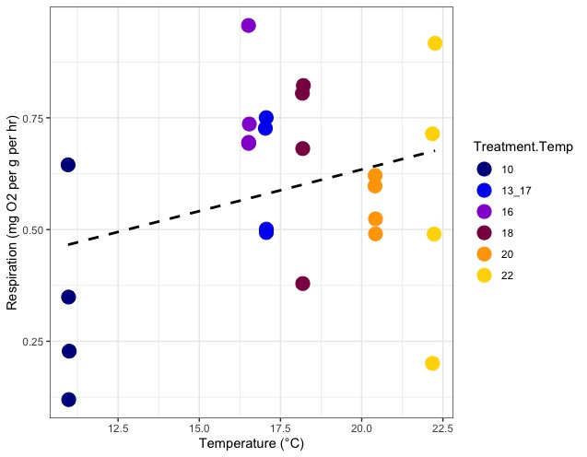
Figure 2 Respiration rate versus temperature. Differences between treatments are not significant (ANOVA, P<0.0941)

Additionally, growth rates saw a significant decrease with increasing temperature (Figure 3, ANOVA, P<0.000178). For the ambient temperature treatment (13/17 ºC) growth rates were relatively high suggesting that growth rates were due to the original acclimation temperature of 13 ºC and that photosynthetic rates were driven by the increased temperature of that occurred by demonic intervention of 17 ºC on the day of the experiment. As temperature increases, N. luetkeana’s photosynthetic ability increased, as did growth rate (Figure 3).
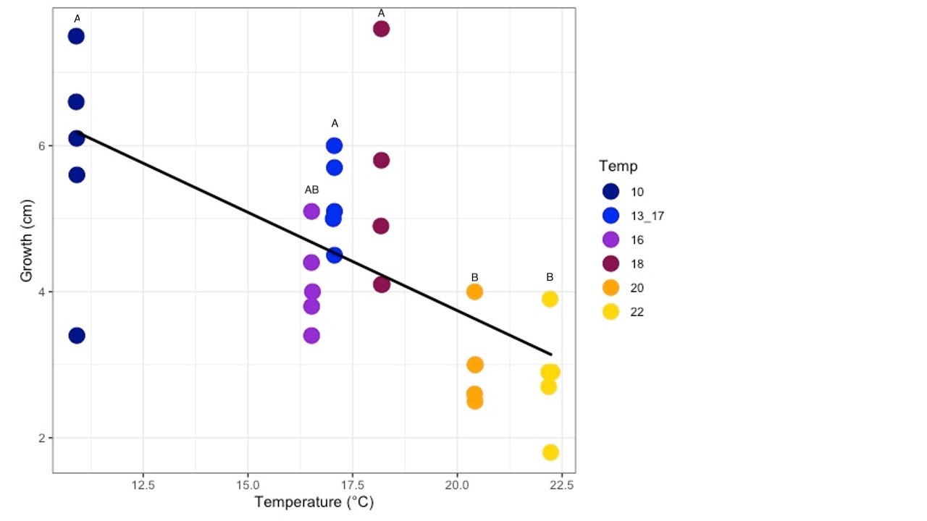
Figure 3 Growth of N. luetkeana over a 38-hour period, showing a negative response to temperature (P<0.000178).

Discussion
We hypothesized that as water temperature increased, photosynthesis rates would decrease, and rates of respiration would increase in N.luetkeana. Our results showed that as temperature increased, photosynthesis decreased. Respiration rates showed a positive change as temperature increased but was not significant (P<0.094). Kelp populations are impacted thermally and that thermally associated factors, both seasonal changes in temperature and random thermal events like ENSO and MHWs cause deterioration of canopy forming kelp and loss habitat (Sanchez-Barredo et al. 2020).
Studies have found strong links between increases in temperature and the NPP of kelp, suggesting that as temperatures increase, photosynthesis decreases and rates of respiration increase, until optimal temperatures for performance and growth are passed, leading to deterioration (Smale et al.2020). MHWs and warming SST have a negative influence in growth rates for macroalgae species, down-regulating photosynthesis which is necessary for growth to occur and increasing biomass (Gao et al 2021). Over a 38-hour period, we found that as water temperature increased, growth rates decreased, with very little growth occurring in the 22 ºC treatment, and blades beginning to deteriorate. We found that higher temperatures not only aid in the decline growth rates but also aids in decreasing of photosynthetic ability.
Along with decreases in photosynthesis and growth rates, we found that respiration rates did not show a significant difference within our experiment. This differs from previous experiments that found warming could enhance respiration rates (Gao et al. 2021). We believe that this could be due to our 30-minute blade incubation time for respiration, as respiration changed the seawater O₂ concentrations less than photosynthesis. By increasing the respiration measurement period to 1 hour, this could allow for a better signal of O₂ drawdown in future experiments.
For the ambient temperature treatment N. luetkeana blades were left to acclimate for roughly 30 hours at 13 ºC. On the day of testing, ambient seawater temperatures had risen to 17 ºC. This suggests that the blades were photosynthesizing at the 17ºC temperature and that growth rates were based on the original acclimation temperature of 13 ºC. This finding could be important for future management of marine ecosystems due to the reality of temperature anomalies that are occurring more often in a warming ocean (Biskup et al. 2014).
Based on these data it is possible that the use kelp as a natural solution to climate mitigation is not the answer, we all had hoped for. But that policy could make shifts from the primary focus of fishing regulations, and instead focus on a framework that would allow for strategies that would combat climate driven shifts in ocean ecosystems by a using novel framework known as Resist-Accept-Direct (RAD). The RAD framework is currently being used used in Northern California to address the continuing collapse of kelp forests caused by warming ocean temperatures and MHWs (Rodgers-Bennett, Yang, Mann 2021).

Acknowledgements
I would like to acknowledge and thank my mentors Dr. Brooke Weigel and lab technician Sadie Small. I would also like to acknowledge Dr. Aaron Ninokawa helping with use and set up of the Friday Harbor Labs Ocean Acidification Lab, and a huge thanks to Washington State Kelp Conservation Fund, Proviso for funding.

Literature Cited
Duarte B, Martins I, Rosa R, Matos AR, Roleda MY, Reusch TBH, Engelen AH, Serrão EA, Pearson GA, Marques JC, Caçador I, Duarte CM, Jueterbock A (2018) Climate Change Impacts on Seagrass Meadows and Macroalgal Forests: An Integrative Perspective on Acclimation and Adaptation Potential. Frontiers in Marine Science.
Duarte CM (2017) Reviews and syntheses: Hidden forests, the role of vegetated coastal habitats in the ocean carbon budget. Biogeosciences 14:301–310.
Duarte CM, Losada IJ, Hendriks IE, Mazarrasa I, Marbà N (2013) The role of coastal plant communities for climate change mitigation and adaptation. Nature Climate Change 3:961–968.
Gallagher JB, Shelamoff V, Layton C (2022) Seaweed ecosystems may not mitigate CO2 emissions. ICES Journal of Marine Science 79:585–592.
Gao G, Zhao X, Jiang M, Gao L (2021) Impacts of Marine Heatwaves on Algal Structure and Carbon Sequestration in Conjunction With Ocean Warming and Acidification. Front Mar Sci 8:758651.
Gauci C, Bartsch I, Martins N, Liesner D (2022) Cold Thermal Priming of Laminaria digitata (Laminariales, Phaeophyceae) Gametophytes Enhances Gametogenesis and Thermal Performance of Sporophytes. Frontiers in Marine Science 9.
Green-Gavrielidis LA, Thornber CS (2022) Will Climate Change Enhance Algal Blooms? The Individual and Interactive Effects of Temperature and Rain on the Macroalgae Ulva. Estuaries and Coasts.
Liu C, Zou D, Liu Z, Ye C (2020) Ocean warming alters the responses to eutrophication in a commercially farmed seaweed, Gracilariopsis lemaneiformis. Hydrobiologia 847:879–893.
Rogers-Bennett L, Yang G, Mann J. (2021) Using the Resist-Accept-Direct management framework to respond o climate-driven transformations in marine ecosystems. Fisheries Manag Ecol .1-14
Sánchez-Barredo M, Sandoval-Gil JM, Zertuche-González JA, Ladah LB, Belando-Torrentes MD, Beas-Luna R, Cabello-Pasini A (2020) Effects of Heat Waves and Light Deprivation on Giant Kelp Juveniles (Macrocystis pyrifera, Laminariales, Phaeophyceae). Journal of Phycology 56:880–894.
Smale DA, Pessarrodona A, King N, Burrows MT, Yunnie A, Vance T, Moore P (2020) Environmental factors influencing primary productivity of the forest-forming kelp Laminaria hyperborea in the northeast Atlantic. Sci Rep 10:12161.
Steneck RS, Graham MH, Bourque BJ, Corbett D, Erlandson JM, Estes JA, Tegner MJ (2002) Kelp forest ecosystems: biodiversity, stability, resilience and future. Environmental Conservation 29:436–459.
Wernberg T, Thomsen MS, Tuya F, Kendrick GA, Staehr PA, Toohey BD (2010) Decreasing resilience of kelp beds along a latitudinal temperature gradient: potential implications for a warmer future. Ecology Letters 13:685–694.

