Edge of Eden: Epifaunal Biodiversity of Eelgrass Patches in False Bay

Monica Groth, BMEE Fall 2021, Friday Harbor Laboratories

Abstract

The epifaunal community of an eelgrass patch is biodiverse and affected by multiple variables. The mechanism of edge effects in the marine environment remains uncertain and experiments investigating the relationship between epifauna and edge proximity have yielded contradictory results. The results of this experiment highlight species-specific preferences within eelgrass beds based on bed location (small and large patches) and bed character (edge versus center). We found greater species diversity at bed edges in patches regardless of size and location, and discuss how resource availability, competition, and species behavior may influence significant abundance differences between centers and edges of eelgrass beds in False Bay. We found great variability in species abundance across sampling dates but observed consistent edge to center relationships and found magnified differences between edge and centers in the larger patch. The average size of two observed taxa also varied significantly by location and/or bed character.
Keywords: eelgrass, epifauna, edge-effects

Acknowledgements
The researcher gratefully acknowledges Drs. Wendel Raymond, Brooke Sullivan, Megan Dethier, Alan Trimble, and Sandy Wyllie-Echeverria for advisement, Adam Nguyen, Wendel Raymond, Karen Looney-Patterson, and Brooke Sullivan for assistance collecting eelgrass samples, Tom Schultz for permitting snorkelers to use his property as ingress to eelgrass beds,
Rob Mclean Hoekendorf for providing mapping analyses, students Lucy Kramer, Milly Marriot-Green, Adam Nguyen, Jamie Andersen Fields, Ben Holzman, Dominick Dickerson, and Mariah Josten for assistance in the lab, students Jazzy Shepard, Aiden Cox, Nicole Frederick, and Ryan Pittsinger for assistance with statistical analyses, and experts Richard Strathmann, Craig Staude, Dianna Padilla, Megan Dethier, and Jeff Cordell for assistance identifying regional taxa.

I hope I never have to pick another eelgrass sample, Amen.

Background
Epifaunal Importance
Seagrass ecosystems form foundational and productive habitat in estuaries across the globe (Ha and Williams 2018). In addition to being primary producers, seagrasses dampen waves and stabilize the seabed while creating complex environments in which a diversity of organisms thrive (Larkum et al 2006). Zostera marina, or eelgrass, is the most common seagrass on North America’s Pacific coast, and its beds host a community of epiphytic algae and the epifauna which graze upon it (Wyllie-Echeverria 2010). Since the second half of the 20th century, researchers have recognized that eutrophication caused by nutrient runoff can increase eelgrass-dwelling epiphytic algae, which shade out the sun and hinder eelgrass’ ability to photosynthesize (Williams and Ruckelshaus 1993; Hily et al. 2004). Anthropogenic stressors including eutrophication have contributed to worldwide eelgrass decline, making Z. marina the target of conservation and restoration efforts especially where it continues to provide critical habitat for economically valuable fish (Duffy et al. 2015; Wylie Echeverria et al 2010).
Researchers have taken a keen interest in the strong top-down control that grazers exert on epiphytic biomass, finding that epifaunal feeding influences epiphyte load more strongly than does the bottom-up effect of nutrient loading (Heck and Valentine 2007; Whalen 2013; Duffy et al. 2015; Reynolds 2015). Grazing epifauna, which consume algae and diatoms biofouling eelgrass blades while rarely consuming eelgrass itself, increase photosynthetic capabilities of the eelgrass and increase seagrass biomass (Heck and Valentine 2007). Epifaunal presence and abundance may also increase the genetic diversity of eelgrass beds and help make them more resilient to perturbations (Hughes et al. 2010). The benefits of epifaunal grazers may contribute to eelgrass regrowth and resilience, making them crucial organisms to study in areas where eelgrass populations are in decline. Because the species richness and biodiversity of epifauna have been linked to the health and wellbeing of Zostera marina beds, studying the epifaunal communities of specific, often threatened, eelgrass meadows using repeatable experiments is of paramount importance (Jaschinski et al. 2009).
The diversity and behavior of grazers has been studied in a variety of locations with unique community structure (Hily et al. 2004; Thormar et al. 2016). Beds worldwide differ greatly in size, shape, shoot density, tidal influence, position, and orientation—all aspects of the habitat believed to impact epifaunal colonization (Carr 2011; Stoner 1980; Whippo 2018; Voigt and Hovel 2019; Tanner 2009). The biodiversity of eelgrass beds varies temporally as well as spatially, changing with season, temperature, and tide, as with latitude and environment (Duffy et al. 2015; Carr 2011). Though eelgrass beds are widespread throughout the Northern Hemisphere, the epifaunal species present in disparate beds varies greatly, as do species’ abundances, behaviors, and relative benefits (Duffy et al. 2015; Lewis and Boyer 2014; Duffy and Harvilicz 2001).
Meadow Fragmentation
Eelgrass bed fragmentation can have deleterious effects on eelgrass population size and epifaunal biodiversity. In a 2018 study, Whippo et al. concluded that epifaunal biodiversity is a function of processes that operate across as well as within meadows, suggesting that the severance of areas from one another impacts their epifaunal diversity (2018). Species richness does not vary greatly throughout and within meadows, which may reach a biodiverse carry capacity and “share” communities; however, different abundances of shared species were observed between beds (Boye 2017; Whippo 2018). Metacommunity dynamics may exist in eelgrass meadows, where processes including dispersal connect patches on a landscape-scale (Leibold 2014; Whippo et al. 2018). This means that smaller meadows and patches can contain a high level of biodiversity on par with their larger neighbors only if the seagrass meadows of their region remain healthy and unfragmented (Whippo et al. 2018). Greater fragmentation means less connectivity and the collapse of spatially wide-sustained biodiversity.
As the degree of fragmentation increases, the quantity of the habitat exposed to its edge also increases (Bologna and Heck 2002). Organisms that require interior habitats may be disturbed when bed fragmentation forces them closer to the edge, while organisms preferring edges might find themselves in competition with other species as they are pushed interiorly by the edge’s recession. Varying hypotheses exist as to how biodiversity changes as a function of distance from the habitat edge (Tanner 2009; Bologna and Heck 2002). Within the eelgrass environment, it has been observed that epiphytes tend to be plentiful on older plants, which often grow toward the center of a patch, rather than on younger, less established plants that are rooted farther away from early eelgrass clones; this suggests that grazers will find food (but not necessarily space) most plentiful deep within a bed (Best 2012; Murphy et al 2021; Duffy et al 2015). Conversely, observed epiphyte load may signify the paucity of epifauna in bed centers, though hydrodynamics, temperature, and nutrients have been shown to influence the inverse relationship between epiphytic and epifaunal biomass (Duffy et al 2015; Lewis and Anderson 2012). Interestingly, Stoner (1980) and Voigt and Hovel (2019) and observed that epiphyte biomass was inversely related to epifaunal biomass only in areas with high shoot density—a factor usually present in the center of a patch.
While epiphyte abundance and shoot density influence epifaunal community composition, the threat of predation may affect the distribution of organisms within a habitat. Eelgrass bed edges create an environment in which epifaunal organisms are more susceptible to predation and wave action, becoming vulnerable as their shelter ends (Tanner 2009; Lewis and Anderson 2012). Tanner explains that recent studies highlighting the increased predation risk associated with habitat edges in terrestrial environments have lent negative regard to the concept of “edge” in conservation science, though dynamics may be different in marine systems (Tanner 2009). Eelgrass bed centers have therefore been hypothesized to exhibit higher epifaunal species richness and abundance than their edges due to the age and high shoot density of bed centers and the dangerous qualities of patch edge (Tanner 2009).
However, though shoot density and seagrass biomass are observed to be greater on the inside of seagrass beds, epifauna including gastropods, amphipods, and polychaetes have been found in greater abundance and diversity on bed edges, possibly due to recruitment events and passive deposition of poor-swimming larvae (Bologna and Heck 2002). Acknowledging that their results appeared to contradict previously observed trends, Bologna and Heck also hypothesized that mobile fauna might travel between patches and seek the “nearest refuge” before moving on, thus congregating at edges for temporary shelter but rarely moving interiorly (2002). Therefore, edge effects within eelgrass beds may exist independent of shoot density but depend upon both the mobility of organisms and the passage of time.
False Bay
This study aims to investigate patterns in the biodiversity of grazers in the ecosystem of False Bay, San Juan Island, WA, USA where eelgrass beds have recently been in decline (Wyllie-Echeverria 2010). Since the 1970’s the spatial distribution of the eelgrass in False Bay has changed greatly and the ecosystem has faced many stressors including nutrient and soil runoff, disease, and climate change (Ruckelshaus 1994; MacDonald and Raymond 2021). Recent data shows a decline in eelgrass population over the past five years, and a 2016 survey revealed nearly 50% of the eelgrass population to be infected with the opportunistic pathogen Labyrinthula (Groner et al. 2016; Wyllie-Echeverria 2010). The 2016 survey also found that epiphyte biomass ranked high in False Bay when compared with other eelgrass beds in the San Juan Islands, though shoot density and length were comparatively low (Groner et al 2016). Preliminary observations within False Bay indicate the existence of epifauna including gastropods, gammaridean and caprellid amphipods, copepods, isopods, polychaetes, bubble snails, and the opisthobranch Phyllaplysia zostericola. The eelgrass beds of False Bay are reportedly patchy and vary in size, shape, shoot density, position, and orientation, and these variables may cause differential epifaunal biodiversity (Ruckelshaus 1994; Coiner 1972; Carr 2011; Stoner 1980; Whippo 2018; Voigt and Hovel 2019; Tanner 2009) (See Figure 1). Epiphytic and epifaunal density was historically greatest at the center of each of three beds near the mouth of False Bay (Coiner 1972). The edge of a large patch was observed to have the lowest concentration of fauna, but the only edge sampled was that facing the Bay’s mouth, where tide and wave action differ from head-facing edges (Coiner 1972). Little research has been done investigating the biodiversity of additional bed edges in False Bay.
Debate still exists over how epifaunal organisms respond to the dimensional edges of their seagrass habitats. Habitat edges are important locales of trophic transfer in food webs but their complexities in the marine ecosystem remain understudied (Bologna and Heck 2002; Lewis and Anderson 2012). In so dynamic an environment as False Bay, eelgrass beds shrink, merge, and fragment, changing shape and modifying the number of shoots exposed to their perilous edges. As eelgrass beds in False Bay and elsewhere continue to change, understanding how epifaunal diversity and abundance relate to distance from bed edges is an interesting and significant question.
In this study, our primary objective was to identify the species richness and biodiversity of a large and small patch in False Bay, specifically observing if and how community composition varies between patch edge and center, and if the relationship between edge and center in affected by patch size. I focus on the effect the characteristics of “edge” and “center” have upon epifauna. I hypothesized that biodiversity and species abundance would be greater in the large eelgrass patch and greater at its center than its the edge.

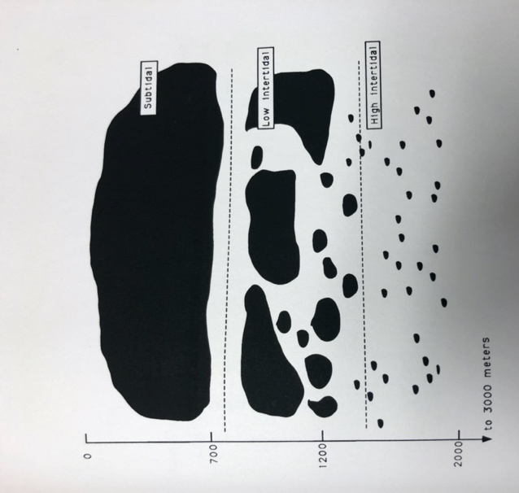
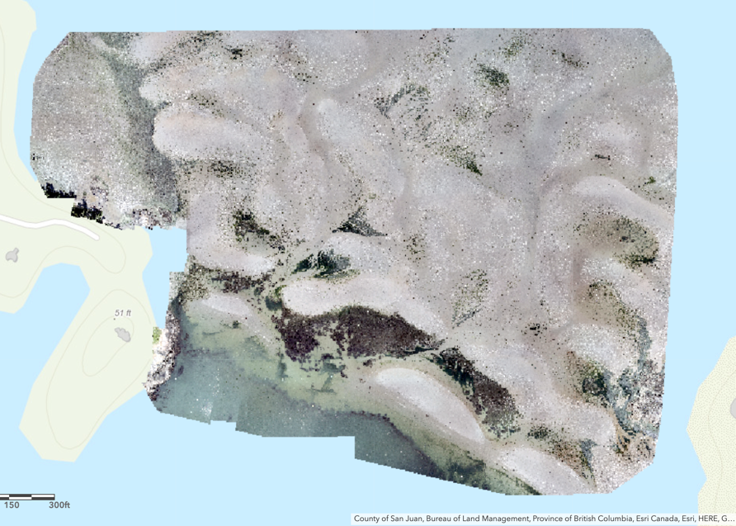
Figure 1: (left) The size of eelgrass patches in False Bay vary greatly with distance from the bay’s head to mouth through high intertidal, low intertidal, and subtidal zones (image courtesy of Ruckelshaus 1994). (right) Drone imaging of the mouth of False Bay shows swaths of large, interspersed patches at mouth and smaller patches on tidal channels inside Bay in the summer of 2021 (image courtesy of Drew Harvell, FHL)

Methods

Sampling

Epifaunal biodiversity was sampled in patches of the eelgrass population of False Bay, San Juan Island, Washington, USA by snorkeling at low tide during calm weather conditions. Subtidal beds were always submerged at time of sampling (Figure 2; details adapted from Ha and Williams 2018; Whippo 2018). Once a fragment of the meadow was located, its GPS location was recorded, and its perimeter taken. Two patches of small and large size were chosen for my study (Figure 2). One “edge” sample and one “center” sample were gathered at each location. The snorkeler dove beneath the surface and plucked an eelgrass shoot at the eelgrass-sediment interface, careful not to uproot the plant. A 1mm mesh bag was pulled, mouth open, behind the snorkeler to gather any organisms surrounding where the blade was plucked while the plucked blade was placed inside the mesh bag (adapted from Whippo et al. 2018 and Murphy et al. 2021). Anemones of the species Epiactus prolifera were often found at the base of eelgrass blades and may have been missed in a few cases. Snorkelers visually assessed the shoots and were careful to collect all organisms they did observe. Though it is possible that mobile organisms were able to escape this collection process, the successful collection of fast-moving invertebrates such as amphipods indicate that epifauna loss was minimal (Whippo et al 2018). The snorkeler then kicked twice, travelling a distance of approximately 2m, and dove again, repeating the process. Along the obvious edge of the bed, the snorkeler targeted areas with the quality of “edge”, meaning blades came from shoots specifically adjacent to open water. When sampling in the bed’s center the characteristic of “center” was defined as blades at least 2m (one swimmer-length) from the perceivable edge (Figure 3). When sampling the center, the swimmer took a sample anywhere in the bed that met the characteristic of the “center,” sometimes taking samples at variable distances from each other. The snorkeler attempted to collect the same number of shoots for each edge and center sample, though this was not always possible and was accounted for by measuring eelgrass biomass (Whippo et al 2018). Sampling was performed by four different snorkelers on various days and it is possible that techniques varied slightly by the diving method snorkelers employed. Every effort was made to minimize inconsistency. Three pairs of replicates were taken at both sites, amounting to twelve total sample bags. Bags were kept damp and stored in seawater at Friday Harbor Laboratories, San Juan Island, WA, USA (Whippo et al 2018; Groner et al. 2016).
The large patch in False Bay is 23240 square feet; the small patch is 1974 square feet and the distance between the two sampling sites is approximately 70 meters from edge to edge. It should be noted that sampling at these two locations took place over the course of five dates (11/1, 11/2, 11/11, 11/12, and 11/17) over which there was variable weather and tidal height. A remarkable storm causing increased freshwater flow into False Bay preceded collection on 11/17.

Processing
Within a day of collection, the samples were processed in the lab. Each blade was individually handled as it was removed from the bag and visible epifaunal organisms and egg masses were removed and sorted (Ha and Williams 2018). Grazing scars and signs of disease upon blades were also observed, though not quantified (Lewis and Anderson 2012). The eelgrass blades were then cleaned and rinsed into a glass pan to remove smaller and attached epifauna (Whippo 2018). The mesh bag was also rinsed into the pan to remove attached epifauna. The collected water was run through a 1mm sieve to remove epifaunal organisms. Organisms were set aside for identification and identified to the lowest possible taxonomic level—to species whenever possible (method adapted from Murphy et al 2021). Following the removal of epifauna, eelgrass blades were scraped of epiphytes using a glass slide with a hard, sharp edge (adapted from Jaschinski 2009; Groner et al 2016). Cleaned eelgrass and epiphytic algae were then dried and weighed separately to calculate eelgrass and epiphyte biomass. Samples were dried in a 60°C oven for 48 hrs (Whippo et al. 2018; Lewis and Anderson 2012).
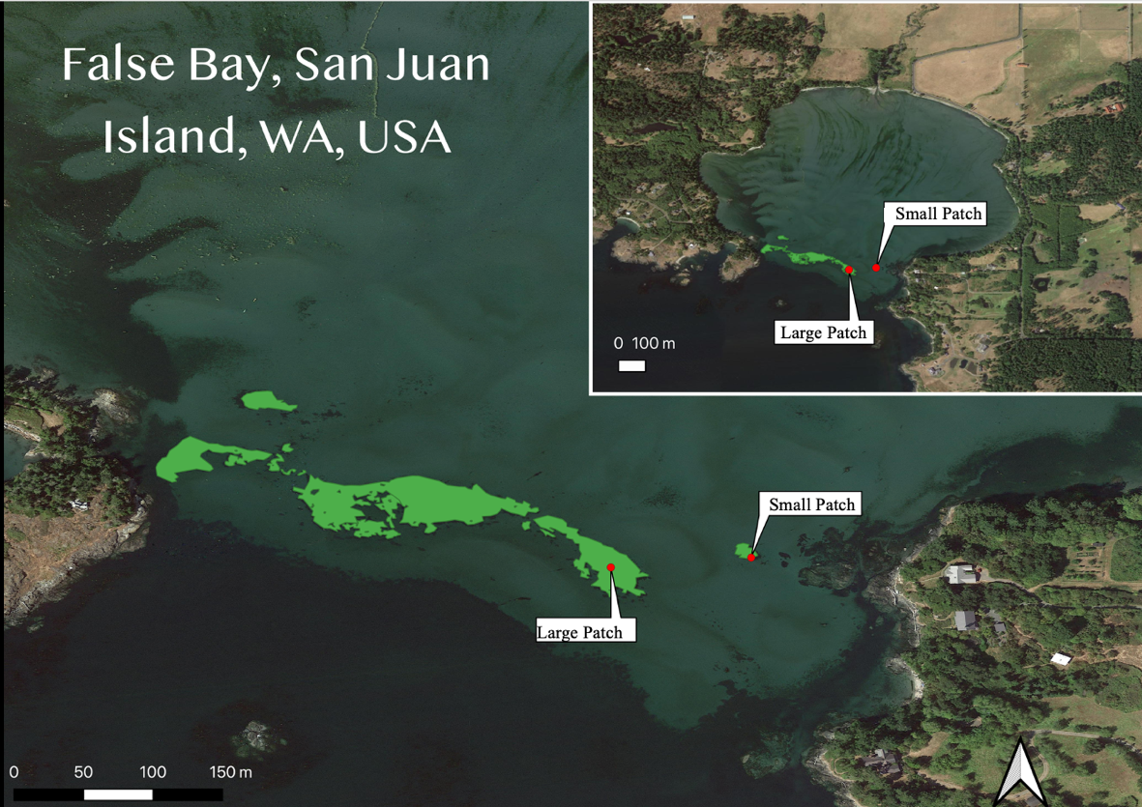
Figure 2: Map of False Bay and the location of the Large and Small eelgrass patches from which three pairs of samples each were collected

Analysis
The data of species richness and abundance were analyzed using the statistical tools of R for graphic and principal component analysis. Species richness and relative species abundance were compared between large and small patch and edge and center samples to determine whether statistically significant differences existed. Linear models were created for the abundances of each species, which averaged over its three replicates, and assessed the power of location and character. ANOVAs were performed for each taxa and statistically significant results were recorded. Models and ANOVAs were also run on the size data of five appropriate taxa. Principle component analysis (PCA) was performed using the twelve unique samples collected as principle components measured to account for abundance variation.

v
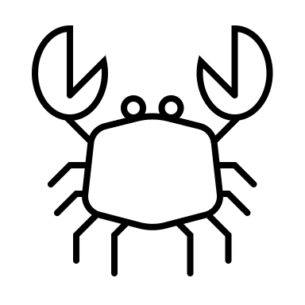
v


v

v

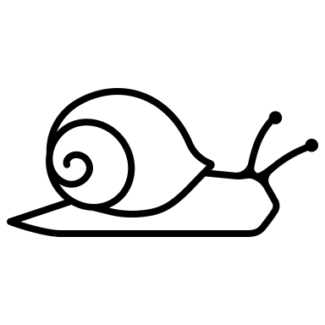

Figure 3: Example of sampling method performed by snorkeler, gray dots representative of eelgrass shoots plucked and collected around and throughout the bed, blue lines representative of approximated 2 m distances.

Results and Discussion

Results

Species richness, overall abundance, diversity, and evenness

Small Patch
In the small patch, I counted 5,477 individuals of 15 different species in 2821.68g of eelgrass (1.94 organisms/gram). The average species richness was greater at the small patch’s center (12) than its edge (11.3). The Shannon Weiner index for species diversity was higher at the patch’s edge (1.1014725) than its center (0.8077692). The evenness of species was greater at the patch’s edge (0.3810833) than at its center (0.2794690).

Large Patch
In the large patch, we counted 7,554 individuals of 19 different species in 3658.24g of eelgrass (2.06 organisms/gram). An Aeolid nudibranch, a valviferan isopod of the genus Synidotea, the carinate dovesnail Alia carinata, and the parasitic Bivalve flatworm Pseudosylochus ostreophagus accounted for the four species found only at the large patch (for our purposes, P. ostreophagus was analyzed under flatworms, and Alia carinata was excluded from abundance analyses). The average species richness of the large patch was higher at its center (14.3) than its edge (9.3). The Shannon Weiner index for species diversity was higher at the patch’s edge (1.2065692) than at its center (1.0118036). The evenness of species was greater at the patch’s edge (0.4174443) than its center (0.3500600).

The large patch had greater evenness, diversity, and richness than the small patch, but the same relative relationship in evenness, diversity, and richness between bed centers and edges existed in both patches (See full species list-Table 4).

Abundances

Variability
Community abundance exhibited great variability across samples. However, analysis of sample contents by date revealed consistent relative relationships between edge and center and large and small patches despite great numeric differences (Figure 1; averages represent qualitative results though standard deviation was too great to plot error bars).

Location
Caprellid amphipods, Lacuna snails, and the copepod Porcellidium sp. were the most abundant organisms at both sites. The abundances of five taxa, Lacuna sp., Epiactus prolifera, Lottia alveus parallella, Phyllaplysia taylori, and Pugettia sp. were found to vary significantly with patch location. Lacuna, Epiactis, Lottia, and Phyllaplysia were found in significantly greater abundance at the large patch. Kelp crabs of the genus Pugettia were found in greater abundance at the small patch. P-values shown in Table 1.

Table 1
Epiactis proflifera | Lacuna sp | Lottia alveus pelta | Phyllaplysia taylori | Pugettia richii
0.005521 | 0.0013891 | 0.0331 | 0.04965 | 0.03801
Character
The abundances of two taxa, Lacuna sp. and Gammaridean amphipods, were found to vary significantly with patch character, both being found more frequently at patch edges in both locations. P-values shown in Table 2.

Table 2
Lacuna sp. | Gammaridae
0.0001231 | 0.03345

Location and Character
The abundances of three taxa were found to be more abundant at different patch characters at different patches. The specialist amphipod, the sea lettuce sea flea Ampithoe lacertosa, was found in greater abundance at the edge of the small patch than at its center, but existed in greater abundance at the center of the larger patch than at its edge. The pacific eelgrass limpet, Lottia alveus parallella, was found in greater abundance in the center of the small patch, but existed in greater abundance at the edge of the large patch than at its center. Of the two polychaete worms identified in eelgrass samples, those of the order Phyllodocidae were of greater abundance at the center of the small patch, but existed in greater abundance at the edge of the large patch.

Size Variation

Size
The size Phyllaplysia taylori was found to vary significantly with location, and with patch character. Phyllaplysia were significantly greater average size at the edge of the small patch. P-values shown in Table 3.

Table 3
Species | Location | Character
Phyllaplysia taylori | 0.0061658 | 0.00004053

Taxa (scientific) | Taxa (common) | Number of Samples (12) in which present
Aeolidida | Nudibranch | 1
Alia carinata | Carinate dovesnail | 1
Ampithoe lacertosa | Sea lettuce sea flea | 7
Caprella laeviscula | Caprellid amphipod | 12
Epiactis prolifera | Brooding sea anemone | 10
Gammaridae | Gammaridean amphipod | 12
Haminoea vesicula | White bubble snail | 4
Lacuna sp. | Lacuna snail | 12
Lacuna sp. egg mass | Lacuna snail egg mass | 12
Lottia alveus parallella | Pacific eelgrass limpet | 10
Nereididae | Nereid worm | 10
Pagurus sp. | Hermit crab | 3
Pentidotea resecata | Eelgrass isopod | 11
Phyllaplysia taylori | Eelgrass sea slug | 9
Phyllodocidae | Phyllodocid worm | 10
Phylloplana viridis | Green Flatworm | 2
Porcellidium sp. | Harpacticoid copepod | 12
Pseudostylochus ostreophagus | Bivalve Flatworm | 1
Pugettia producta | Northern kelp crab | 1
Pugettia richii | Cryptic kelp crab | 10
Synidotea sp. | Brown isopod | 3

Table 4: Full Species List; note that Pugettia sp. were grouped together in presence/abundance analysis, as were Polycladida (flatworms). Lacuna sp. includes the snails Lacuna vincta and Lacuna variegata due to difficulty differentiating between the two at small sizes. Aeolid nudibranch believed to be of the genus Hermissenda or Cuthona.

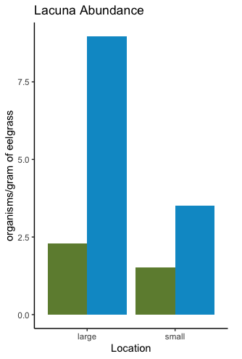
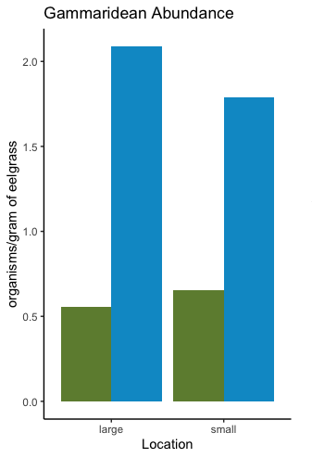
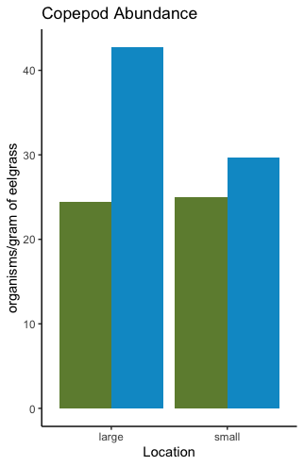
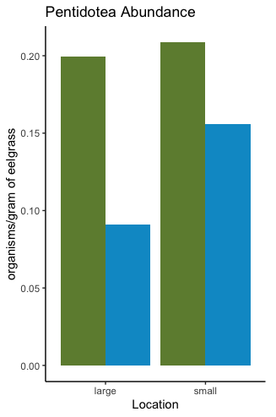
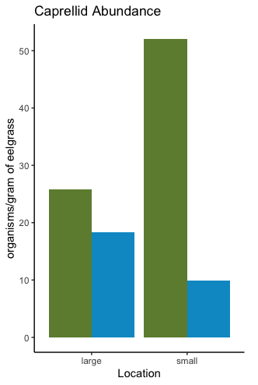
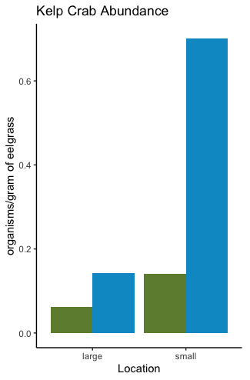
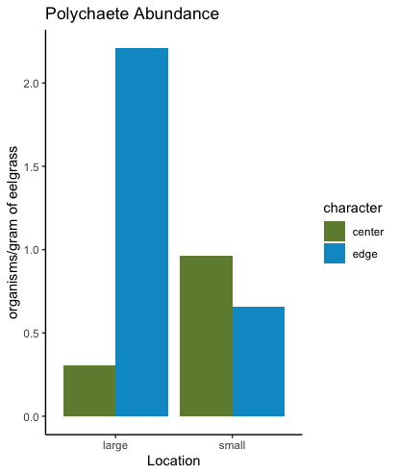
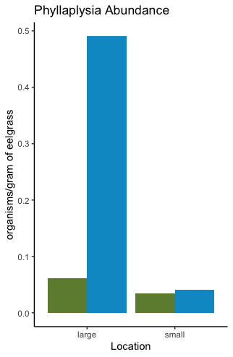
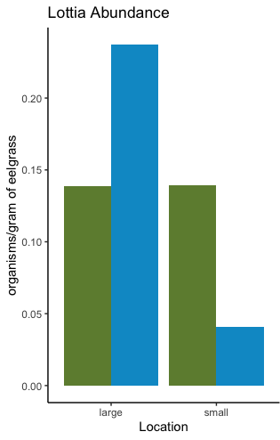
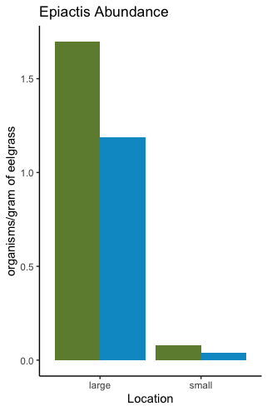

Figure 4: Relative abundances of ten dominant taxa; though data showed extreme variability by date and sample number, the relationship between edge and center and large and small patch remained acceptably consistent for these taxa. Caprellid amphipods, Epiactis prolifera, and Pentidotea resecata were found in greater abundances at bed edges while Copepods, Lacunas, Gammarids, Phyllaplysia and Kelp crabs were found in greater abundances at bed edges. Lottia and Polychaetes (Nereid and Phyllodocid) were found in greater abundances at the edges of the large patch and at greater abundances at the center of the small patch.

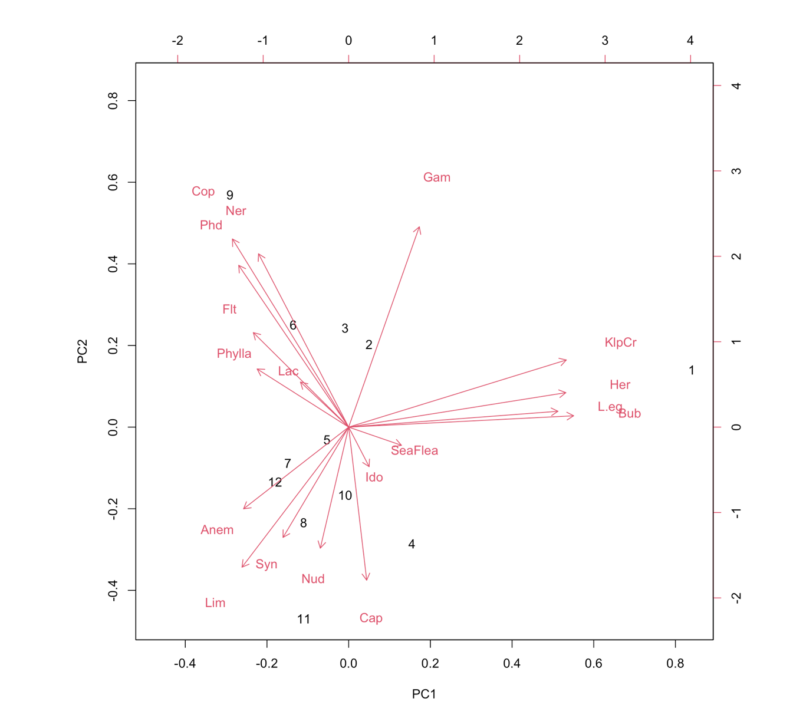
Edge

Center
Small Patch

Large Patch
1
9
11
12
10
8
7
6
5
4
3
22
Figure 5: PCA analysis of species by count/gram of eelgrass in the 12 samples taken; note key. Vectors labeled by species: Anem=Anemone, Bub=Bubble snail, Cap=Caprellid, Cop=Copepod, Flt=Flatworm, Gam=Gammarid, Her=Hermit crab, Ido=Eelgrass isopod, KlpCr=Kelp crab, Lac=Lacuna, L.eg=Lacuna egg mass, Lim=Limpet, Ner=Nereid, Nud=Nudibranch, Phd=Phyllodocid, Phylla=Phyllaplysia, SeaFlea=Ampithoe, Syn=Synidotea isopod.

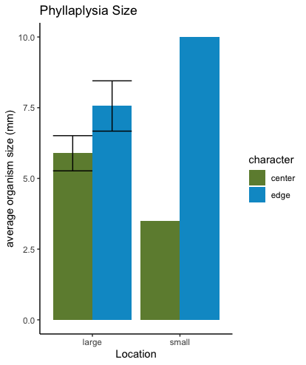
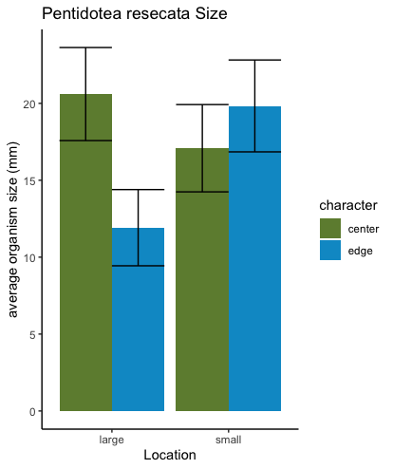
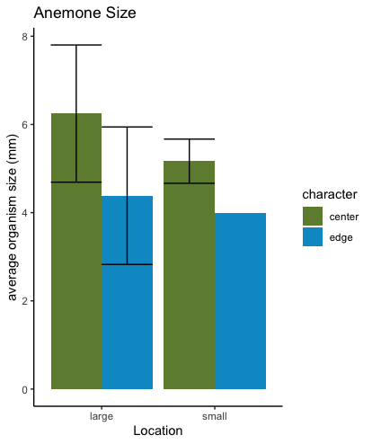

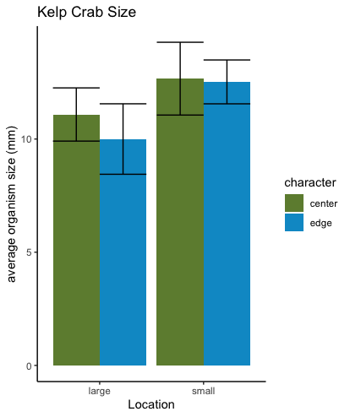
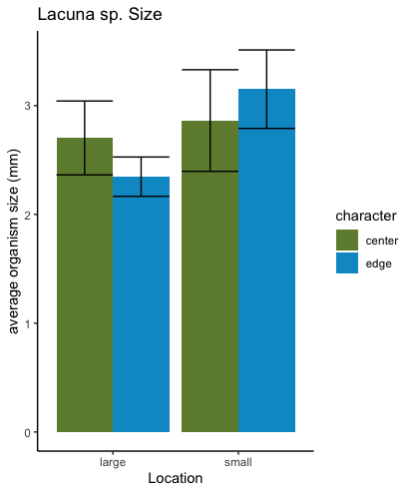

Figure 6: Size distributions for five taxa; statistically significant differences exist for Phyllaplysia taylori (error bars on natural log scale, absent for low sample sizes)
Discussion
Epifaunal communities inhabiting Zostera marina patches exhibit great variation due to patch size and within-patch character. Studies have hitherto yielded contradictory results regarding epifaunal responses to patch edges, but scholarship largely suggests that edge-effects are species-specific, with some species exercising preference for patch edges or interiors (Bologna and Heck, 2002; Arponen and Bostrom, 2012; Bender et al 1998). Because patch size reportedly effects within-patch differences, we analyzed the abundances and sizes of specific species at patches of different sizes to determine how the variables of patch identity and patch character effect species (Kallen et al 2012). Results signify interesting species interactions relating to competition, behavior, and environment.
Species Richness, Diversity, and Evenness
Our study found that greater species richness existed in the large patch, which served as home to four unique species not present in the small patch. This result confirms our hypothesis and is supported by earlier research (Kallen et al 2012). Island biogeography theory suggests that an increase in habitat area will naturally be accompanied by an increase in its number of species; larger beds will exhibit higher abundances and richness due to immigration rates being greater than extinction rates (Anderson, 1998; Hirst and Attrill, 2008). It is also posited that larger seagrass beds exhibit greater heterogeneity of habitat, providing more varied “microhabitats” suited to more varied species (Anderson, 1998; Hirst and Attrill, 2008). This is likely also the reason why species richness was highest at bed centers, where structural complexity and shoot density is greater. Moreover, the large patch took up 12 times the area of the small patch; because eelgrass impacts the physical domain by reducing current speeds, trapping nutrients, and acting as a buffer, it may simply attract more and varied organisms as it preforms more if these tasks due to its greater area (Kallen et al 2012). This may also be attributed to the fact that the large bed in this study is part of an “elder” patch within False Bay and has been established longer than the small bed; therefore, the bed may have recruited more and varied organisms over time (Warry et al 2009; Hoekendorf 2021). It is important to note, however, that despite its lesser species richness, the small bed in our study exhibited comparable organism density to the large patch. Small patches are capable of sustaining high density and diversity and the small patch in our study, given its similar epifaunal density and community composition, likely benefits from connectivity with the larger beds (Hirst and Attrill, 2008; Whippo, 2018).
Species diversity and evenness were found to be greater at bed edges at both small and large eelgrass patches in False Bay. Though this result is anomalous with some other studies, it may be accounted for by edge-effects that exist strongly where species mutually and temporarily occupy space in both sand and eelgrass habitats (Kaller et al, 2012, Laurence, 2008; Bologna and Heck 2002; Warry et al 2009). Individuals are hypothesized to make brief stops at the nearest eelgrass “refuge” while moving through the marine environment to pursue foraging or mating opportunities (Bologna and Heck 2002; Moore, 2010). The transient nature of species activity at bed edges may mitigate the effects of competition and crowding, allowing for greater evenness and diversity but less species richness. Principal component analysis shows that “edge-loving” species including bubble snails, hermit crabs, and kelp crabs, were positively correlated; varying with the same forces, these species do not compete at edges. Polychaete worms, kelp crabs, hermit crabs, bubble snails, gammaridean amphipods, and isopods known to move easily and frequently between the sand and eelgrass habitats and between eelgrass patches likely accounted for the perceived diversity in our study (Whippo 2018).
The permanence of the more sessile species, including anemones and caprellids, which exist in high abundance at bed centers, may mean that centers’ species richness and relative species abundances change less frequently. This may result in the observed lesser evenness of center populations. The center of the patch is likely to be of greater age than its edge, possibly allowing its most fit populations to progress towards domination (Warry et al, 2009). Conversely, increased evenness at bed edges reveals that frequent changes in the community prevented certain species from dominating, allowing edge-dwellers to exist in comparable abundances. Edge evenness does, however, change during recruitment cycles, when large numbers of larvae or juveniles may settle at patch edges (Bologna and Heck, 2002). While mobile species will move when they mature, sessile species will stay at bed edges. The evenness of patch edge likely varies with season, as recruitment and reproductive cycles may affect the relative abundances of species at edges (Bologna and Heck 2002).
Larger patches were found to exhibit magnified differences between edge and center abundances. Patch size has also been observed to cause this heightening of character distinction most notably in a study of eelgrass epifauna in a South African estuary (Kallen et al. 2012). This observation held true for 8 of the 13 taxa considered to have large enough sample sizes in our study and seven of the ten taxa highlighted in Figure 4. As a bed’s radius increases and the distance between bed center and edge increases. The area classified as edge might extend only half a meter into a bed, while the rest of the bed’s depth is classified as center (Warry 2009). Given that center character and isolation from the edge would become more pronounced as distance from the edge increases, it stands to reason that large beds would exhibit more pronounced differences between edge and center abundances.
Lastly, as is made clear in Figure 4, abundances exhibited significant variation for many taxa. This suggests that the eelgrass ecosystem of False Bay is exceedingly dynamic and variable. The abundances of species found within the bed change greatly even within areas ascribed the same character. Therefore, this study also concludes that great inner-patchiness exists within “center” and “edge” characters of both large and small eelgrass beds in False Bay. Multiple similar epifaunal surveys reported abundance variability in sampling (Moore et al 20120; Murphy et al 2010; Warry et al 2010). The year of 2021 did exhibit anomalous summer temperatures and record winter rainfall, which may have impacted the epifaunal communities in ways not yet known. While this variation is likely partially attributed to temperature, tidal condition, and weather (which varied among our five sampling days), it is also likely a feature of the eelgrass environment.
Lacuna sp. and Epiphyte Connections

Snails of the genus Lacuna, including species Lacuna vincta and Lacuna variegata, were the most abundant gastropod found at both the small and large patch. The abundance of Lacuna snails in False Bay eelgrass varied significantly by patch and patch character, being found in overall greater abundance in the large patch and at patch edges. Though numeric abundance varied greatly by sampling day, the relationship between patch edge and center remained constant in both patches regardless of the date they were sampled, suggesting within-patch character strongly effects Lacuna abundance. Egg masses of both species were also found in greater abundance at bed edges in both patches (Figure 7).
Analysis of Lacuna in this study supports results relating abundant grazers to epiphyte load (Nelson and Waaland 1997). A negative correlation has been reported between Lacuna snails and epiphyte load in the San Juan Archipelago, (Nelson and Waaland, 1997). In this study, we found that epiphyte load was lowest at the larger bed, where Lacuna were more abundant; however, Lacuna abundance was also greatest at bed edges, where epiphyte load on the larger bed was slightly higher than at its center. The higher abundance of the epiphytic algae Smithora at bed edges was unexpected. I had hypothesized that bed centers would possess the highest number of epiphytes due to their typically greater age. However, it is possible that the water movement and hydrodynamics of the eelgrass patch edge promotes epiphyte growth (Warry et al). The abundance of epiphytes at the edge of the large patch is certainly not the result of low abundance of grazers including Lacuna snails, limpets, and Phyllaplysia.
Lacuna were observed to be smallest where they were most abundant, though this relationship was not statistically significant. An inverse relationship between size and population density has been observed in fish and other organisms (Jenkins et al 1999). As intraspecific competition rises, organism size decreases due to forced sharing of space and food supply. However, as average size of the organisms was very small (2.5 mm) at the edge, snails at bed edges may be juveniles recently hatched. Their dominance at bed edges may follow from the abundance of eggs laid at edges as well and their size may be attributed to youth rather than competition. Eelgrass patch edges also provide an immediate barrier to larval veligers; increased abundance accompanied by low size may be the result of the increased recruitment of organisms at bed edges (Bologna and Heck 2002; this study).

Edgy Amphipods

Gammarids are fast swimmers which move between the vegetated and unvegetated matrices of the seabed. Often found in male-female pair in our samples, gammarids varied in size and species. Our study found that though the abundance of Gammaridean amphipods did not vary significantly by patch location, it did vary significantly by patch character and Gammarids were more abundant at patch edges.
Gammaridean abundance at edges is likely the result of the crustaceans’ mobility and identity as habitat generalists able to navigate both sand and eelgrass environments. As detritivores, gammarids may lurk at patch edges to eat detritus and food “caught” in the structure of the seagrass matrix (Zimmerman et al., 1979). Similar edge-effect studies have found Gammarideans at higher abundances at seagrass edges than patch centers; studies also reported high gammarid presence in sand habitat and high water depth (Tanner, 2005; Murphy et al 2010; Kallen et al, 2012; Meysick et al 2019). Gammarids likely move throughout the bed and between eelgrass and open water; their prevalence at bed edges may therefore be the result of the species propensity to move through the “middle ground” of the seagrass/sand boundary on their way from the protection of the eelgrass to the open water and vice versa (Apronen and Bostrom, 2012). Abundances were highly variable, however; Murphy et al. found similar variability in the magnitude of the edge response of gammarids depending on surrounding matrix, hydrodynamics, and current in an Australian bay (Murphy et al 2010).
The PCA analysis shows the factors responsible for Gammarid variation differ greatly from those of all other species. Small patch edges influenced Gammarid abundance greatest, and given the interconnectivity of eelgrass habitats, it is likely that Gammarids move between as well as among patches.
The amphipod Ampithoe lacertosa was analyzed separately from gammaridean and caprellid amphipods because of its size and vegetative specialization. The sea lettuce sea fleas identified in the lab were vivid green or brown, and ranged from 5-36 mm. Ampithoe provides us with an interesting case study to contrast with Gammaridae. Its coloration and observed behavior betray its preference for a vegetative habitat. While the gammarids observed in the lab ranged from sandy brown, to gray, the white, Ampithoe lacertosa was a bright vivid green or green-brown. Though it is also a mobile swimmer with similar feeding habits, unlike the gammarid, Ampithoe is a specialist which prefers vegetated environments to sand. Like Gammarids, A. lacertosa was found in greater abundance at the edge of the small patch; however, unlike its gammarid cousin, it was found in higher abundance at the center of the large patch. Principle component analysis suggests A lacertosa abundance is greatly influenced by center samples. While the small patch may be a transient stop in its movement, the large patch’s verdant refuge may provide more long-term protection for this intermediate dynamic amphipod (Bologna and Heck 2002).
Caprellid amphipods were considered in this study as a taxa independent from Gammarids and Ampithoe due to their distinctive morphology and feeding strategy (Moore et al 2010). Caprellids were the single most abundant taxa in our sampling, numbering in the thousands per bag collected. Caprellids were observed hanging tightly to eelgrass blades in the field, where they visibly number in over fifty per blade. Caprella laeviscula, the caprellid species most common to the San Juan Archipelago, varied in size but tended to be around 10 mm in length.
The principle component analysis showed the caprellid amphipods to be negatively correlated with abundant gammarids. Unlike edge-dwelling gammarids, caprellids were found in greatest abundance at bed centers, though not significantly. Unlike other epiphytic grazers, which eat what is deposited on the eelgrass blades, Caprellids sweep the water column with enlarged gnathopods, foraging particulates (Moore 2010). They grasp the blades tightly and, unlike gammarids, are poor swimmers with limited mobility.
Though other studies have hypothesized that bed edges are superior particulate barriers and thus provide better habitat for caprellids, it is possible that the higher shoot density at bed centers allows eelgrass fronds to sweep particulates out of the water column, which then filter down towards waiting caprellids. However, given their negative correlation with gammarid abundance, caprellid abundance at bed centers may be the result of competition with other invertebrates. Copepods and Gammarids were both found in greater abundances at bed edges. Though caprellids forage differently, they may nevertheless compete for space and food with gammarids and copepods within eelgrass beds. Due to their superior swimming abilities, gammarids could outcompete water-column foraging caprellids. Competition may be greater in the small bed than the large bed also due to space and would explain the greater difference in abundance between edge and center in the small patch. Where other epifaunal researchers have found caprellids in higher abundance at bed centers, or highly variable among patches, both systems also had copepods and gammaridean competitors (Moore et al, 2010, Murphy et al, 2010).
It is interesting that the few oviparous caprellids observed in these samples came from bed edges (Figure 8). Like other eelgrass species, caprellids lack a planktonic larval stage and therefore don’t travel far from their maternal population after emerging from brood pouches (“Visualizing” Evergreen University). This may explain why they were so dense in samples. If brooding caprellid mothers do prefer bed edges this may be because more epiphytes and less intraspecific aggression exist in edge habitats. In their epifaunal survey, Murphy et al likewise reported more edge dwelling caprellids at larger beds, perhaps due to higher numbers of oviparous females. We also observed more caprellids at the edge of the larger patch than the smaller (Murphy 2010). Interesting further study might be pursued considering bed edges as novel areas of mating, brooding, or broadcasting.
Competition:Pentidotea and Synidotea

An instance in which species competition was expected but was not evidenced is showcased in the abundances of Pentidotea and Synidotea. Eelgrass isopods of the species P. resecata were observed in highest abundance at bed centers in both patches. The specialist isopod was observed in two colorations, vivid green and dark brown, and like Ampithoe lacertosa, has evolved to blend in with eelgrass. Individuals ranged from 4mm (infantile) to 42 mm in length.
The abundance results of this study contradict those of others in which isopods were observed to exist in greater abundance at patch edges (Meysick et al 2019). Studies of Idotea baltica, a similar species known to inhabit eelgrass, found the isopod preferred eelgrass as other forms or lack of shelter, suggesting it likes the protection and structure of the eelgrass habitat (Bostrom and Mattila 1999). Idotea were observed to trade the shelter of clean eelgrass blades for epiphytic food (Bostrom and Mattila 1999). This may explain why Pentidotea resecata, a mobile grazer known to move as it seeks new food (rather than deplete present epiphytes like Lacuna sp.) was more abundant in the smaller patch, where epiphyte load was greatest.
The high abundance of Pentidotea resecata in the small patch raises questions about intraspecific aggression and competition, which may increase as smaller patch size leads to crowding. Though Idotea baltica was observed to feed often upon the same leaf as conspecifics, Pentidotea resecata murdered their own kind when placed together in the laboratory (this behavior may differ between natural and laboratory environments) (Bostrom and Mattila 1999). The other isopod in this study, Synidotea, inhabited areas of high Pentidotea abundance and was not negatively correlated with the eelgrass isopod. There were also few Synidotea observed in our sampling and the isopod is not an eelgrass specialist. The two isopods may be found in greatest abundance in similar habitat character and thus exhibit little competition with each other. Pentidotea resecata size was not found to vary significantly in either patch, suggesting that competition did not minimize resource availability or Pentidotea growth.
Because the eelgrass isopod is both a specialist and a mobile species, it may exhibit little preference for edge or center but occupy both habitats. Juvenile Pentidotea, the smallest and most vulnerable of the population, were observed indiscriminately in both bed edges and centers.

Porcellidium sp. and Predation

Copepods of a yet unspecified species are found abundantly through the San Juan Islands and were reported in great abundance in historic epifaunal surveys in False Bay (Jeff Cordell, personal communication; Coiner 1972). Procellidium individuals, measuring approximately 1mm in length, were found to exhibit sexual dimorphism: males are black and females are rose colored (Figure 9). Individuals were typically found attached in pairs, presumably mating, and appeared to prefer the bases of young eelgrass blades at the tight spaces where new blades separated from the base of the shoot (Figure 9).
Porcellidium copepods were found in great quantities at both small and large patches at both bed edges and centers. However, the copepods were found in highest abundances at the large patch and at bed edges, though not significantly. A high number of polychaete worms were also found in edge samples and have been positively correlated with copepod abundance (Murphy et al 2010; Figure 5) Copepod and polychaete abundances have been correlated with predator presence/absence (Murphy et al 2010; Warry et al 2009). Though predation has been hypothesized as the foremost deterrent to edge occupation, in environments where predation pressure is low, a prey species may exhibit unique edge-effects. The low observation of fish in False Bay along with reportedly higher predation in False Bay sandflats than eelgrass beds, suggests that edges are not hostile environments for copepods or polychaetes (Tanner 2005; Parker 2019; Nguyen 2021).

Edge-Preference and Low Competition: Haminoea, Kelp Crabs, Hermit Crabs

The bubble snail, Haminoea vesicula, the cryptic kelp crab, Pugettia richii, and the hermit crab of the genus Pagurus, were positively correlated and covaried most with small patch edge samples (Figure 5). All three of these species were found in overall greater abundance in the small patch and all three were also observed in greater abundance at patch edges. Pugettia richii, which were observed balancing agilely on eelgrass blades, ranged from 1.5-29mm in carapace length, and decorated their carapace with ulva “hats” and bits of algae (Figure 10). Like hermit crabs, which were found solely at edges, kelp crabs were also seen in sandflat habitats (Nguyen 2021).
The edge of the eelgrass patch would allow kelp crabs access to prey on the sandflats and areas of protection to escape their own predators within the bed (video footage, Nguyen 2021). Kelp crabs of the genus Pugettia eat bull kelp and reportedly feed also upon algae, eelgrass, and Lacuna snails (Bear Magallanes and Padilla, 2015). If the crabs do indeed eat Lacuna, which are found in highest numbers at the edges, it makes sense for them to congregate at edges as well. The coexistence of Haminoea, Pugettia, and Pagurus at bed edges supports my theory that bed edges are areas of high diversity because they are areas of low competition between mobile predators.
However, Haminoea was observed to experience competitive pressure from the eelgrass-bound grazer Lacuna. Though Haminoea were not found upon eelgrass blades at bed edges, they were found covering the diatom-darkened sand immediately adjacent to the patch’s edge. Adult Haminoea and Haminoea egg masses were found in False Bay in the fall, but all the individuals on the eelgrass during November collection were small, ranging from 6-7mm. Especially at this small size, the bubble snails appear to be outcompeted for eelgrass space and food at bed edges where the gastropod Lacuna sp. was extremely abundant. Haminoea and other snail species have been observed to compete for food and space in other estuarine environments (Kaller et all 2012). As shown in the PCA plot, Lacuna and Bubble Snails are negatively correlated. More Lacuna were observed upon the eelgrass blades in the large bed edges, where Haminoea were forced into the sand. It is possible that, in the absence on predators, the bubble snail prefers the diatoms of the sand to the competition on the eelgrass blades. A few Haminoea were observed at the center of patches where the sand does not provide an alternative food supply and the blades offer better habitat with fewer Lacuna snails.

A Case of Immobility: Epiactis prolifera

In contrast with mobile isopods, gammarids, and crabs, the anemone Epiactus prolifera, was found in high abundance in patch centers and was significantly more abundant in the large patch. As the anemone is sessile and cannot escape predation or disturbance as mobile fauna can, it appears to be most abundant in protected eelgrass bed interiors. Like caprellid amphipods, which share this preference and an immobile nature, anemones catch prey and organic particulates as they move through the water column. As anemones were observed more often at the base of eelgrass blades, where their weight was best supported, they likely trap decaying, fallen matter and rely on hydrodynamics to transport food.

Interestingly, anemones were observed to be of greatest size in bed centers, suggesting that brooding matriarchs at the large bed’s center may release their brood (Figure 6). A higher number of brooding mothers were observed in center samples. When expelled, the young anemones, as small as 1-3 mm in basal diameter, settle further from the center realm which their mothers occupy, pushing out closer to the patch edge.

Patch Size differences; Lottia alveus parallella

Unlike aforementioned taxa, which exhibited the same character preference for both beds, the limpet Lottia alveus parallella (often misidentified and a subspecies of the eelgrass Lottia alveus, now extinct) varied in character abundance based on patch size. Like Lacuna sp., Lottia was found in greater abundance at the edge of the large patch, but unlike the other gastropods sampled, it was found in greater abundance at the center of the small patch. The abundance of Lottia at the centers of both patches is nearly equal, while its abundance at the edge varies greatly by patch. The abundance of limpets on the edge of the large patch is seven times that of limpets on the edge of the small patch.
Whippo et al observed the species Lottia pelta in Vancouver island in low abundance compared to other epifauna, but found them most often in locations with high species aggregation (Whippo 2018). Limpet aggregation has been observed as protection against predation and desiccation, both of which may be present at the isolated intertidal bed (Coleman 2004; Bertness and Leonard 1997). Such dangers may result in the significantly higher abundance of Lottia in the large subtidal patch but does not explain its preference for the bed center at the small patch.
Ampithoe lacertosa and Phyllodocidae polychaete worms also exhibited difference in character abundances at different patches. Further research into those species which exhibited differences in character abundance due to patch size is important and has implications for restoration efforts. As patch sizes decrease, the preferential habitat of epifaunal organisms within the bed may change. As patch size decreases, limpets may prefer to move to centers from edges, though the reasoning for this preference remains unknown.

Phyllaplysia taylori
The reproductive cycle, phenotype, and feeding behavior of the specialist sea slug, Phyllaplysia taylori (also known as Phyllaplysia zostericola) have co-evolved with Zostera marina (Hughes 2010). A gastropod of the family Aplysiidae, P. taylori grazes on epiphytic diatoms and algae and camouflages exceptionally with eelgrass blades (McCauley 1949, Figure 10). P taylori have been observed to increase in abundance relative to eelgrass populations and directly develop on their substrate in contrast to other Opisthobranchia (Bridges 1973). The symbiosis between Phyllaplysia and Zostera is mutually beneficial and the presence of Phyllaplysia has been positively linked to the health and genetic diversity of eelgrass beds (Hughes 2010). Because the presence of P. taylori is associated with genotypic resilience in eelgrass meadows, the sea slugs have been recommended in eelgrass restoration efforts and continue to be studied as indicators of seagrass community health (Tanner 2018).
Phyllaplysia were not originally suspected to be found so late in the year in False Bay beds. However, our sampling yielded over two dozen of the eelgrass specialist. All Phyllaplysia were small, ranging from 3-11 mm, and exhibited a distinct patterning different from the classic dark black, zebra stripes of those collected in Picnic Bay, San Juan Island (Figure 10).
This time of year typically represents the second birthing period of the Phyllaplysia and a previous study also found individuals in the size range described during the early winter months (Bridges, 1973).
Unlike the broadcast spawners, limpets and snails, which were also found in greater abundance in the large patch, Phyllaplysia directly develop from eggs lain on blades. They rarely move through the water column but have been observed to move between adjacent eelgrass blades. Observations of Phyllaplysia behavior were made through several experiments conducted in the laboratory. The sea slug did not exercise preference for the side of a drip Y-maze that was filled with eelgrass and/or conspecifics. This may suggest that given their linear lifestyle, individuals have lost strong chemosensory abilities, having no need to relocate a habitat they rarely leave. Phyllaplysia were also observed in the lab to exercise no preference for eelgrass over tape or the glass/plastic sides of their tanks. This likewise suggests that rather than sense eelgrass itself, the sea slug may sense space disruption or verticality similarly to other opisthobranchs capable of magnetic orientation (Lohmann Lab). Phyllaplysia were observed to remove their anterior bodies from the surface and wave their heads in search of a new substrate, tentacles waving and rhinophores everted. In a few cases, Phyllaplysia using this searching behavior abandoned eelgrass for tape. Given this lack of preference for the substrate to which it is so well camouflaged, P. taylori were suspected to experience limited predation pressure. Indeed, in the lab, no predator-prey behaviors were observed when Phyllaplysia were placed in a tank with hermit crabs and kelp crabs. Despite the likely existence of historic predation, which presumably gave rise to this coloration, current predation pressure upon Phyllaplysia is low in False Bay. However, it is also possible that coloration serves a purpose other than camouflage.
Our study found that the Phyllaplysia of False Bay exhibited coloration and patterning consistently different from that of Phyllaplysia gathered from Picnic Cove, Shaw Island. Given that the development cycle of the opisthobranch already limits its dispersal and the relative isolation of the Bay further limits its contact with other populations, the False Bay Phyllaplysia may indeed be a distinct color morph. The False Bay slugs visibly lack the lateral lines seen on the sides of other “zebra-patterned” slugs. I observed the combination of lateral lines and bare lateral tissue in a few slugs (most very young 3-4 mm in length) and tested the hypothesis that lateral patterning was environmentally controlled. False Bay Phyllaplysia were kept in the mesocosm in which the Picnic Bay population thrived and were kept in the same environmental condition for eight days. No coloration or patterning change was observed. McCauley's 1949 Thesis on Phyllaplysia gathered from Mitchell Bay describes a color pattern similar to that seen on the False Bay Phyllaplysia. It is possible that different color patterns are observed on different islands or that both color morphs exist in the San Juan Islands but do not mix due to geographic barriers. It is also possible that lateral lines appear through maturation or are a response to stressors other than predation. Though color and pattern variation in other opisthobranchs has been observed, it has not always been related to genetic difference (Valdes et al 2013). Further DNA analysis should be done to determine whether speciation by genetic isolation has occurred.
Phyllaplysia were found in greater abundance in the larger patch along with Lottia, Lacuna, and Epiactus. In contrast to the species found in greater abundance at the small patch, Pugettia richii, these four species are slow-moving or sessile soft-bodied organisms which do not like sand environments. Phyllaplysia were found most often at the edge of the large patch. Given that they, like copepods, experience low predation pressure in False Bay, they may not perceive the edge as a dangerous place but rather benefit from edge effects. As previously mentioned, increased water flow at bed edges may explain the increase in microalgal growth there; leaf-bound grazers like Lacuna and Phyllaplysia thus find food and nutrients trapped at this interface (Warry 2009)

Unlike Haminoea, which were observed on diatom-rich sand at bed edge but rarely upon edge blades, Phyllaplysia do not appear to face competition from Lacuna. Indeed, our PCA analysis suggests they are positively correlated. However, individuals were also of the lowest average size at the edge of the large patch, a difference deemed statistically significant. However, it is unlikely that decreased Phyllaplysia size is due to intraspecific competition. A greater diversity of sizes was found at bed edges, where individuals from 3-5mm were found in addition to larger individuals 7-12mm in length. The greater abundance of organisms meant that a greater diversity of sizes was found while sampling, and the average size of individuals at the centers of both patches remained alike while the average size of individuals at populous bed edges varied greatly.

Conclusion and Future Research

The study I performed of eelgrass beds in False Bay sets the groundwork for future students and researchers to test hypothesis regarding epifaunal communities. I researched the relationship between species abundances, patch size, and edge effects and found significant species-specific responses to both patch size and presence at patch edge. However, greater investigation should be made into the abiotic and physical parameters which cause “cascading edge effects” from environment, to eelgrass, to interacting species (Warry 2009). This study awakened unexpected new hypothesis regarding the nature of mobile species competition at bed edges, which deserves further testing. Though mobile species may appear to exhibit little competition at bed edges, blade-occupying gastropod epifauna exhibit competitive interactions. While eelgrass Edens provide rich habitat for great abundance and diversity of species, the interactions between species themselves as well as each species relation to its environment should be studied in more detail. Likewise, correlations between crab species abundance and patch size are reportedly seasonal, and epifaunal abundances vary with season, tidal height, temperature, and weather (Hovel and Lipciius 2001). Given the diversity of juvenile and brooding species in this study, there is much greater research to be done on how recruitment events effect edge assemblages. Studying epifaunal responses to seagrass fragmentation allows researchers to gather information with which they can improve management policy and contribute to the restoration of eelgrass beds and communities.

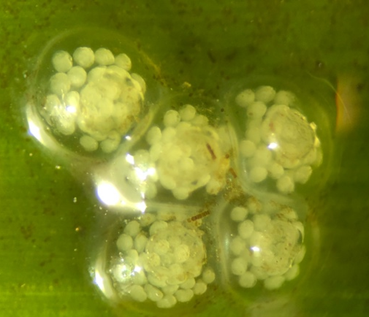

Figure 7: The egg masses of Lacuna variegeta were found on eelgrass blades, and can be distinguished from those of Lacuna vincta in that they appear “muffin” rather than
“donut” shaped, lacking the hole present in ring-like egg masses. Masses found in this study ranged in diameter from 4-6 mm. Identification courtesy of Dr. Diana Padilla.

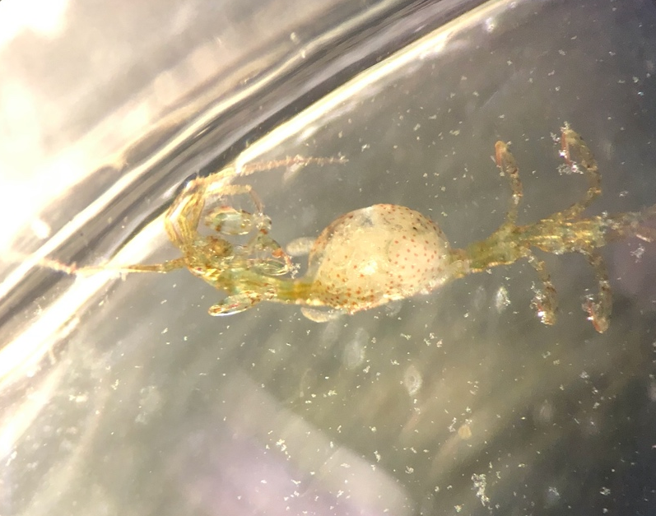
Figure 8: Oviparous Caprella laeviscula with brood pouch found at edge of the large patch (10X).

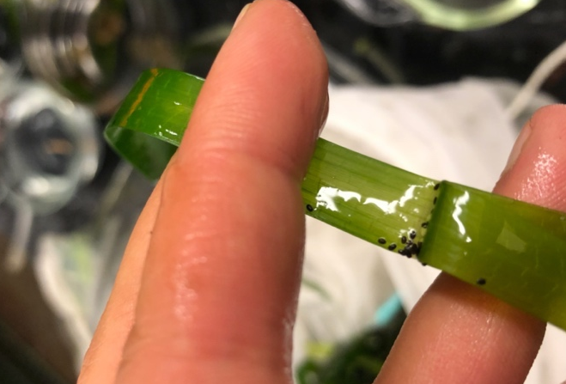
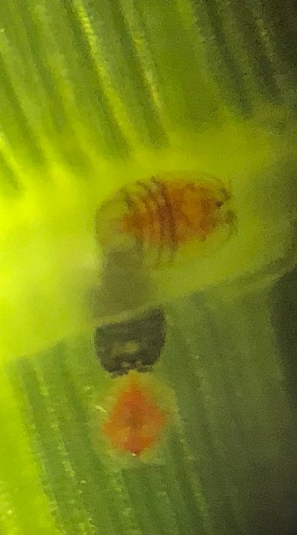
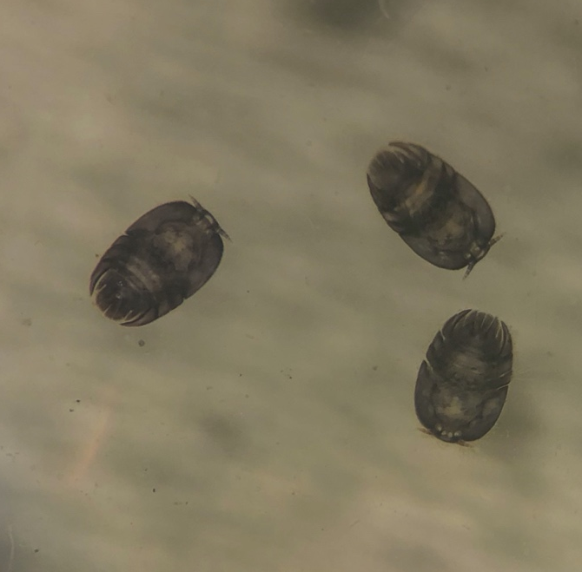
Figure 9: Male (black, left) and female (rose, middle) Porcellidium sp. at 10X. Right image shows the copepods preferred location on eelgrass blade.

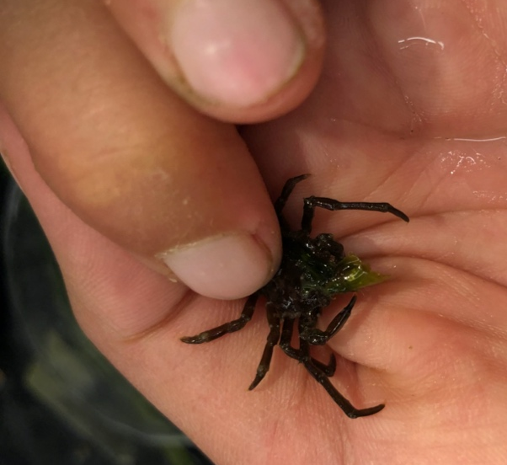

Figure 10: Cryptic Kelp Crabs, Pugettia richii, decorate with ulva.

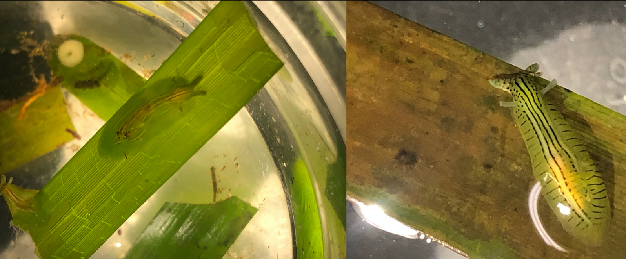

Figure 11: Phyllaplysia taylorii sourced from False Bay (left) display patterning different from those sourced from Picnic Cove, Shaw Island (right). Note the lack of lateral lines on the Phyllaplysia from False Bay. Pictured slugs are 7 mm in length. Picnic Cove Phyllaplysia obtained courtesy of Dr. Sandy Wylie-Echeverria.

References

Anderson, M. 1999. Effects of Patch Size on Colonisation in Estuaries: Revisiting the Species-Area Relationship Oecologia, Vol. 118, No. 1, pp. 87-98
Apronen, H and C. Bostrom, 2012 Responses of mobile epifauna to small-scale seagrass patchiness: is fragmentation important? Hydrobiologia 680:1–10 .
Bear Magallanes, Sara E, and Dianna Padilla. 2015. Predator-prey interactions of Pugettia gracilis (Dana, 1851) and Leptasterias spp. (Verrill, 1866) and two species of Lacuna (Turton, 1827). UW Student Research Papers.
Bender, D. et al. 1998. Habitat Loss and Population Decline: a Meta-Analysis of Patch Size Effect. Ecology, 79(2), pp. 517–533.
Bertness, M. and G. H. Leonard. 1997. The role of positive interactions in communities: Lessons from intertidal habitats. Ecology, 78
Best, R. J. 2012. Ecological and Evolutionary Determinants of Diversity in Communities of Seagrass Mesograzers. Dissertation, UC Davis.
Bologna, Paula A. X. and Kenneth L. Heck. 2002. Impact of Habitat Edges on Density and Secondary Production of Seagrass-associated Fauna. Estuaries Vol 25:5, 1033-1044
Bostrom, C and Jennifer Mattila. 1999. The relative importance of food and shelter
for seagrass-associated invertebrates: a latitudinal comparison of habitat choice by isopod grazers. Oecologia (1999) 120:162-170
Boye A., et al. 2017. Constancy despite variability: local and regional macrofaunal diveristy in intertidal eelgrass beds. Journal of Sea Research 130:107-122.
Bridge, C. 1973. Larval development and lif elopment and life history of Phyllaplysia ta y of Phyllaplysia taylori dall ylori dall (Opistobranchiata: anaspidea). Univeristy of the Pacific Thesis.
Carr, L.A. et al. 2011. Spatial patterns of epifaunal communities in San Francisco Bay eelgrass (Zostera marina) beds. Marine Ecology 32:88-103.
Coiner, S. 1972. The Comparison of Faunal and Other Characteristics of Zostera Blades found in Beds at False Bay. UW FHL Advanced Invertebrate Zoology 533 (1972).
Coleman, R. 2004 Aggreation as a defense: Limpet tenacity changes in response to simulated predator attack. Ecology, 85(4), 2004, pp. 1153–1159
Duffy, J. Emmett et al. 2015. Biodiveristy mediates top-down control in eelgrass ecosystems: a global comparative-experimental approach. Ecology Letters 18: 696-705
Duffy, J. Emmett, Annie Harvilicz. 2001. Species-specific impacts of grazing amphipods in an eelgrass-bed community. Marine Ecology Progress Series Vol 223: 201-211.
Frost et al. 1999. Effect of habitat fragmentation on the macroinvertebrate infaunal communities associated with the seagrass Zostera marina Aquatic Conserv: Mar. Freshw. Ecosyst. 9: 255–263.
Groner, Maya L. et al. 2016. Plant characteristics associated with widespread variation in eelgrass wasting disease. Disease of Aquatic Organisms Vol. 118, 159-168.
Ha, Grace and Susan Williams. 2018. Eelgrass community dominated by native omnivores in Bodega Bay, California, USA. Bulletin of Marine Science 94:4
Harvell, Drew. False Bay Orthomosaic 2021. Drone Image.
Hayne, Parker, 2019. How Edge Effects in Eelgrass Habitats Impact Organism Abundance and Diversity in the Puget Sound. UW Student Project.
Heck, K. and J. F. Valentine. 2007. The Primacy of Top-Down Effects in Shallow Benthic Ecosystems. Estuaries and Coasts, Vol 30:3
Hily, C. et al. 2004. In vitro experimental assessment of the grazing pressure of two gastropods on Zostera marina L. epiphytic algae. Aquatic Botany 78: 183-195
Hirst, A. M. Attrill 2008. Small is beautiful: An inverted view of habitat fragmentation in seagrass beds. Estuarine, Coastal and Shelf Science 78 (2008) 811–818
Hovel, K. A. & R. N. Lipcius, 2001. Habitat fragmentaton in a seagrass landscape: patch size and complexity control blue crab survival. Ecology 82: 1814–1829.
Hughes, A. R. et al. 2010. Genotypic diversity and grazer identity interactively influence seagrass and grazer biomass. Marine Ecology Progress Series Vol. 403: 43-51.
Jaschinski, S. et al. 2009. Grazer diversity effects in an eelgrass-epiphyte-microphytobenthos system. Oecologia 159: 607-615
Jenkins T. et al 1999. Effects of Population Density on Individual Growth of Brown Trout in Streams. Ecology, 80(3), 1999, pp. 941–956
Kallen, J. et al 2012. Seagrass-epifauna relationships in a temperate South African estuary: Interplay between patch-size, within-patch location and algal fouling. Estuarine, Coastal and Shelf Science 113 (2012) 213-220
Laurance, W. F., 2008. Review. Theory meets reality: how habitat fragmentation research has transcended island biogeo- graphic theory. Biological Conservation 141: 1731–1744.
Larkum, Anthony W.D. et al. 2006. Seagrasses: Biology, Ecology, and Conservation. Springer
Leibold, M.A. et al. 2014. The metacommunity concept: a framework for multi-scale community ecology. Ecology Letters 7:606-613.
Lewis, Godfrey T. and Katharyn Boyer. 2014. Grazer Functional Roles, Induced Defenses, and Indirect Interactions: Implications for Eelgrass Restoration in San Francisco Bay. Diversity 6: 751-770
Lewis, L. and Todd Anderson. 2012. Top-down control of epifauna by fishes enhances seagrass production. Ecology Vol. 93, No. 12, pp. 2746-2757
McCauley, J. 1949. The morphology of Phyllaplysia taylori Dall. University of Washington Masters Thesis.
McDonald, S. and Wendel Raymond. 2021. Washington Seagrant Program Development Proposal. Shared reserve
Meysick, L. et al. 2019. Context-dependent community facilitation in seagrass meadows along a hydrodynamic stress gradient. Journal of Sea Research, Vol. 150-151. August 2019, Pages 8-23.
Moore, E. and K Hovel, 2010. Relative influence of habitat complexity and proximity to patch edges on seagrass epifaunal communities. Oikos, 119: 1299–1311.
Murphy H et al, 2010. Response of fauna in seagrass to habitat edges, patch attributes and hydrodynamics. Austral Ecology (2010) 35, 535–543
Murphy C.E. et al. 2021. Habitat Primarily Structures Seagrass Epifaunal Communities: a Regional-Scale Assessment in the Chesapeake Bay. Estuaries and Coasts 44: 442–452
Nelson, T and J Waaland 1997. Seasonalityof eelgrass,epiphyte, and grazer biomassandproductivity in subtidal eelgrass meadowssubjectedto moderatetidal amplitude. AquaticBotany56(1997)51-74
“Nueroethology of Magnetic Orientation in Sea Slugs”. Lohmann Lab-University of North Carolina. https://lohmannlab.web.unc.edu/sea-slug-neuroethology/
Raymond, Wendel et al, 2021. Testing the generality of sea otter-mediated trophic cascades in seagrass meadows. Oikos, 00: 1–14.
Reed, B and K. Hovel. 2006. Seagrass habitat disturbance: how loss and fragmentation of eelgrass Zostera marina influences epifaunal abundance and diversity. Mar Ecol Prog Ser, Vol. 326: 133–143, 2006
Reynolds, Laura et al. 2015. Evidence of grazer control on nitrogen fixation by eelgrass epiphytes in a temperate coastal bay. Marine Ecology Progress Series Vol 526:11-19
Ruckelshaus, Mary H. 1994. Ecological and genetic factors affecting population structure in the marine angiosperm, Zostera marina L. Dissertation, University of Washington.
Spiesman, B. J., A. P. Stapper, and B. D. Inouye. 2018. Patch size, isolation, and matrix effects on biodiversity and ecosystem functioning in a landscape microcosm. Ecosphere 9(3)
Stoner, A. W. 1980. Perception and choice of substratum by epifaunal amphipods associated with seagrasses. Mar Ecol Prog Ser 3:105–111
Tanner, R. 2005. Edge effects on fauna in fragmented seagrass meadows. Austral Ecology 30:2, 210-218.
Tanner, R. 2018. Predicting Phyllaplysia taylori (Anaspidea: Aplysiidae) presence in Northeastern Pacific estuaries to facilitate grazer community inclusion in eelgrass restoration. Estuarine, Coastal and Shelf Science 110-119
Thormar, J. et al. 2016. Eelgrass (Zostera marina) Food Web Structure in Different Environmental Settings. PLoS ONE 11(1): e0146479.
Valdes et al. 2013. Color Pattern Variation in a Shallow-Water Species of Opisthobranch Mollusc. Biol. Bull. 224: 35–46.
Valentine, J. and J. Emmett Duffy. 2006. “The Central Role of Grazing in Seagrass Ecology” in Seagrasses: Biology, Ecology, and Conservation. ed by Larkum et al. Springer
Visualizing Microbial Seascapes--Spring: Caprellidae. 2021. Evergreen University. https://sites.evergreen.edu/vms-spring/skeleton-shrimp-or-caprellidae/
Voigt, E. and Kevin Hovel. 2019. Eelgrass structural complexity mediates mesograzer herbivory on epiphytic algae. Oecologia 189: 199-209
Warry et al, 2009. Integrating edge effects into studies of habitat fragmentation: a test using meiofauna in seagrass. Oecologia 59:883–892.
Whalen, M. J. E. Duffy, James Grace. 2013. Temporal shifts in top-down vs. bottom-up control of epiphytic algae in a seagrass ecosystem
Whippo, Ross, et al. 2018. Epifaunal diversity patterns within and among seagrass meadows suggest landscape-scale biodiversity processes. Ecosphere 9:11
Williams, S. and Mary Ruckelshaus. 1993. Effects of Nitrogen Availability and Herbivory on Eelgrass (Zostera marina) and Epiphytes. Ecology 74:3, 904-918
Wyllie-Echeverria, Sandy et al. 2010. Genetic Structure and Diversity of Zostera marina (Eelgrass) in the San Juan Archipelago, Washington, USA. Estuaries and Coasts 33:811-827.
Zimmerman, R. et al 1979. Herbivory and detritivory among gammaridean amphipods from a Florida seagrass community. Marine Biology 54, 41–47

