Are online norms-based alcohol interventions efficacious for college students with higher social anxiety?
Katherine Walukevich-Dienst¹, Scott Graupensperger¹, Marilyn L. Piccirillo², Kirstyn N. Smith-LeCavalier², Jessica Acolin¹, & Mary E. Larimer¹

¹Center for the Study of Health and Risk Behaviors, Department of Psychiatry and Behavioral Sciences, University of Washington, Box 357238, Seattle, WA 98195-7238, USA
²Department of Psychology, University of Washington, Seattle, WA 98195-7238, USA

Author statement: Data collection and analysis was supported by grants from the National Institute on Alcohol Abuse and Alcoholism (NIAAA) to Mary E. Larimer: grants R37AA012547 and T32AA07455. Manuscript preparation was supported by the following grants from the NIAAA: K23AA031034 (PI: Walukevich-Dienst), K99029459 (PI: Piccirillo), and T32AA07455 (PI: Larimer), as well as from the National Institute on Drug Abuse (NIDA): F31DA057796 (Smith-LeCavalier). The content of this manuscript is solely the responsibility of the author(s) and does not necessarily represent the official views of NIAAA, NIDA, or the National Institutes of Health. Portions of these findings in a preliminary form were submitted for presentation at the Annual Meeting of the Research Society on Alcoholism in June 2024.

Correspondence concerning this article should be addressed to: Dr. Katherine Walukevich-Dienst, University of Washington, Department of Psychiatry and Behavioral Sciences, Center for the Study of Health and Risk Behaviors, Box 356560, Seattle, WA, 98195; email: kwd1@uw.edu
Abstract
Background: Undergraduates with higher social anxiety are at greater risk for co-occurring substance misuse, heavier drinking in certain contexts, and more negative alcohol-related consequences. Among undergraduates, alcohol-focused online norms-based interventions provide consistent and cost-effective reductions in alcohol use and related risks. However, research on norms-based interventions for undergraduates with higher social anxiety symptoms is limited, and less is known about the longitudinal impacts of social anxiety symptoms on the efficacy of online, norms-based alcohol interventions.
Methods: Secondary analyses were conducted on data from a large RCT with undergraduates who reported past-month heavy episodic drinking and were randomized to assessment-only control or norms-based intervention. Generalized linear models tested whether baseline social anxiety symptoms moderated the efficacy of receiving norms-based intervention versus attention control at 3-, 6-, and 12-month follow-up.
Results: Social anxiety symptoms moderated treatment efficacy on the number of typical drinks consumed and descriptive norms at 3-months, as well as injunctive norms at 3- and 12-months. However, these effects appeared to be primarily driven by the individuals with higher social anxiety symptoms in the attention control group. Overall, norms-based interventions demonstrated efficacy in reducing the number of typical drinks consumed, descriptive and injunctive norms, and negative consequences up to 12 months later, regardless of social anxiety symptoms.
Conclusions: Results demonstrated that online norms-based interventions were similarly efficacious for reducing drinking, negative consequences, and normative beliefs for undergraduates, regardless of social anxiety symptoms. Further, effects were maintained up to 12 months. Thus, existing alcohol-focused brief interventions deliver an efficacious impact even without adaptation for social anxiety-specific concerns. As individuals with higher social anxiety symptoms in the assessment control group demonstrated notable variability in drinking behaviors and beliefs, future research should examine psychosocial factors contributing to this among this high-risk group.

Keywords: personalized feedback intervention, alcohol, normative beliefs, social anxiety, undergraduates

Are online norms-based alcohol interventions efficacious for college students with higher social anxiety?
Social anxiety, or the fear of being negatively judged or evaluated by others in social situations, is a frequently reported concern among young adults. Estimated prevalence rates of social anxiety disorder among young adults range from 9.1 to 36% (Jefferies & Ungar, 2020; Kessler et al., 2005; NIMH, 2023), and problems with social anxiety typically onset during late adolescence as youth undergo critical social transitions that define early adulthood (e.g., forming new peer groups, entering new academic or work settings, initiating romantic or sexual relationships; Kessler et al., 2005). Both clinical and subclinical levels of social anxiety symptoms are associated with significant functional impairment, including high rates of co-occurring substance misuse (Fehm et al., 2008). Although trait levels of social anxiety are typically negatively associated with drinking frequency and quantity (Schry & White, 2013), higher levels of social anxiety are positively associated with heavier drinking in certain contexts (e.g., pregaming, intimate or date contexts), particularly among those who endorse drinking to cope or drinking to facilitate socialization (Buckner et al., 2020; Hurd et al., 2020; Terlecki & Buckner, 2015; Walukevich-Dienst et al., 2022). Importantly, even subclinical symptoms of social anxiety are associated with more negative alcohol-related consequences among college students, including impairments in academic and emotional functioning (Villarosa-Hurlocker & Madson, 2020) and alcohol use disorder (Crum & Pratt, 2001). Accordingly, young college-enrolled adults experiencing social anxiety symptoms are a priority group for prevention and intervention via brief alcohol-focused interventions.
Brief alcohol-focused interventions are evidence-based, short (i.e., ≤5 hours of contact time; Tanner-Smith & Lipsey, 2015), and demonstrate consistent and cost-effective prevention of alcohol-related risks among young adults and undergraduates (Dotson et al., 2015; Larimer et al., 2004, 2023; Lewis et al., 2007; Neighbors et al., 2004; Tanner-Smith & Lipsey, 2015). Social norms are often a key component of such brief interventions. Social norms, including both descriptive (i.e. perceptions of peer drinking behavior) and injunctive (i.e. perceptions of peer approval of drinking behavior), are consistently strong predictors of drinking behaviors. Furthermore, young adults commonly overestimate their peers’ approval and use of alcohol. Consequently, brief alcohol-focused interventions typically provide psychoeducation to correct baseline misperceptions of drinking norms, or personalized normative feedback (PNF). Modifying normative misperceptions via PNF effectively decreases unhealthy alcohol use and related negative consequences and is posited to be a primary mechanism of behavior change.
Yet, the associations between social anxiety symptoms, perceived norms, and drinking outcomes are not well understood (Buckner et al., 2011; Ham & Hope, 2005, 2006; LaBrie et al., 2008; Linden et al., 2012; Neighbors et al., 2007). Results from previous research provide conflicting evidence depending on the type of social anxiety endorsed (i.e., interaction fears specifically or social anxiety broadly), type of perceived norms assessed (i.e., injunctive or descriptive), the average amount of drinking reported by the population sampled (i.e., all undergraduates or a subsample who endorse current drinking), the specific drinking outcome examined (i.e., frequency, quantity, heavy episodic drinking), or whether other contributing cognitive factors are tested (e.g., drinking motives). Accordingly, it is unclear whether existing norms-based interventions effectively address the needs of individuals with higher levels of social anxiety, given conflicting evidence regarding their patterns of drinking. For instance, college students with higher social anxiety may be more responsive to norm-correcting feedback given fears of being negatively evaluated or judged for drinking more heavily than their peers (e.g., LaBrie et al., 2008; Neighbors et al., 2007). Alternatively, the briefest versions of norms-based interventions do not include information on addressing negative alcohol consequences that appear to better characterize the drinking patterns of some young adults with higher levels of social anxiety.
Indeed, there is mixed evidence as to whether online norms-based interventions are similarly efficacious towards reducing risky drinking among undergraduates with higher levels of social anxiety (Terlecki et al., 2011, 2012). Specifically, in one study (Terlecki et al., 2011), undergraduates were randomized to control or a face-to-face Brief Alcohol Screening and Intervention for College Students session (BASICS; Dimeff, 1999), a widely used, brief norms-based intervention that aims to reduce high-risk drinking and associated negative consequences through motivational interviewing and provision of personalized feedback on drinking and descriptive norms. Undergraduates with higher levels of social anxiety (versus lower levels of social anxiety) reported increased alcohol consumption 1-month post-BASICS (Terlecki et al., 2011), in part due to smaller changes in descriptive norms from baseline to follow-up among individuals who received BASICS versus assessment-only control (Terlecki et al., 2012). In fact, changes in descriptive norms moderated the association between baseline social anxiety symptoms and follow-up alcohol consumption, such that higher social anxiety symptoms were positively associated with alcohol consumption at 1-month follow-up among those with smaller (versus larger) changes in descriptive norms (Terlecki et al., 2012). Therefore, further longitudinal investigation into drinking outcomes for young adults with higher social anxiety is warranted to clarify conflicting evidence from cross-sectional literature and initial investigations of norms-based intervention efficacy with short-term follow-up (Terlecki et al., 2011, 2012).
Present study
The present study sought to build upon prior work by examining the longitudinal impacts of baseline social anxiety symptoms on the efficacy of online, norms-based alcohol intervention up to 12-months post-intervention. We conducted a secondary analysis among a large, multisite sample of undergraduates (N=1,137) who were randomized to one of four online, norms-based interventions or an attention control (for main outcomes see Larimer et al., 2023). We tested whether baseline levels of social anxiety symptoms moderated the association between treatment and control conditions (i.e., norms-based intervention vs. attention control) and changes in typical weekly drinking, alcohol-related negative consequences, descriptive norms, and injunctive norms at 3-, 6-, and 12-month follow-ups.
Method
Participants and Procedures
We conducted a secondary analysis to examine the moderating effect of social anxiety symptoms on efficacy of norms-based interventions compared to an attention control condition that provided non-alcohol specific feedback. Data collection for the parent study occurred from 2010 to 2011. Detailed procedures are reported in Larimer et al., 2023; below, we briefly describe procedures relevant to the present study.
A random sample of 5,998 undergraduate students from two West Coast universities were mailed and emailed invitations to participate in a study on alcohol use and college drinking perceptions. Invitations included a link to an online screening survey. Approximately 46.1% of those invited (Campus 1 n=1,521, Campus 2 n=1,246) completed the screening survey and 54.0% (n=1,494) met inclusion criteria for the larger study (i.e., at least one occasion of heavy episodic drinking in the past month; 4+/5+ drinks on a single occasion for females/males). Eligible participants were invited to enroll in the study after completing an online baseline questionnaire that assessed substance use behaviors and related psychosocial factors. Participants were randomized to a minimal assessment control group, an attention control group, or one of the four norms-based intervention conditions, which were delivered online immediately after completion of the baseline assessment. Participants completed follow-up surveys 3-, 6-, and 12-months after baseline. Moreover, the minimal assessment control condition did not complete a 3-month follow-up, so this condition was not included in the present analyses; however, previous research demonstrated that the attention control did not display treatment reactivity when contrasted to the minimal assessment condition (Graupensperger et al., 2022). Thus, the analytic sample (N = 1,137) comprised of 226 participants in the attention control group and 911 participants in the active treatment group (see Table 1).
On average, participants were 20.13 years old (SD=1.36; range 18-24) and 62.2% identified as female. Regarding race and ethnicity, 62.6% identified as non-Hispanic White, 12.1% non-Hispanic Asian, 7.5% non-Hispanic multiracial, 2.2% non-Hispanic Black/African American, 1.6% non-Hispanic Hawaiian/Pacific Islander, and 0.3% non-Hispanic American Indian/Alaskan Native; 1.2% provided their own response. A range of class years were represented (14.6% 1st year, 20.2% 2nd year, 25.6% 3rd year, 39.6% 4th year+). Average adherence across the three follow-up assessments was high (91.2%). All study procedures were approved by the university institutional review boards at both campuses.
Intervention Conditions
Attention Control
Participants in the attention control condition viewed generic feedback on non-drinking behaviors (i.e., hours spent texting, downloading music, and playing video games in a typical week) online. Participants viewed a bar graph displaying (a) participant’s own behavior and (b) actual behavior for a typical student on their campus and text describing their percentile rank compared to other students on their campus.
Intervention Conditions
Participants in the intervention conditions received one of four online interventions: (1) descriptive norms only (i.e., text and bar graphs of one’s own drinking behavior, perceived drinking behavior of typical same-gender students, and actual campus-specific drinking norms of typical students + percentile rank), (2) injunctive norms only (i.e., text and bar graphs displaying perceived and actual acceptability of drinking behaviors), (3) both descriptive and injunctive norms, or (3) a multicomponent PFI, which included both descriptive and injunctive norms, as well as alcohol-related psychoeducation (e.g., standard drink size, effects of alcohol at different blood alcohol content levels, protective behavioral strategies) and additional personalized feedback on several domains (e.g., negative consequences, financial costs of drinking, alcohol tolerance). For the present study, we combined the four intervention conditions as they displayed minimal differences in efficacy between conditions (Larimer et al., 2023) and all provided corrective feedback on personal and perceived norms; the combined active intervention conditions will be collectively referred to as “norms-based intervention” hereafter. For a detailed description of each intervention condition, please see Larimer et al., 2023.
Measures
Social Interaction Anxiety Scale (SIAS; Mattick & Clarke, 1998) was used to assess baseline levels of social anxiety symptoms. The SIAS is a 20-item measure that asks participants to rate the extent to which they experience anxiety related to different social situations measured (from 0=Not at all to 4=Extremely). The current study removed the 3 reverse-scored items, given concerns they detract from validity (Rodebaugh et al., 2011), and summed the scores from the remaining items to produce a total score. Total SIAS scores greater than 28 are indicative of clinically-elevated social anxiety symptoms (Rodebaugh et al., 2011). For the analytic models, the SIAS total score was computed as a total score ranging from 0-4 as this better handles item-level missingness, enhances interpretability, and is otherwise mathematically equivalent to sum scoring within regression models (Widaman & Revelle, 2023). Descriptive statistics (including clinical cutoffs) present the SIAS total score (i.e., 0-68). Internal consistency was excellent in the current sample (α=.94).
An adapted version of the Drinking Norms Rating Form (DNRF; Baer et al., 1991) was used to assess descriptive and injunctive drinking norms at baseline and all follow-ups. Participants reported on their perceptions of the number of drinks consumed on each day of the week by a typical student on their campus (descriptive norms) as well as the number of drinks a typical student on their campus would view as acceptable to consume on each day of the week (Krieger et al., 2016). Responses for each day were summed to create composite scores for descriptive and injunctive norms, respectively.
At baseline and all follow-ups, typical alcohol quantity was assessed using the Daily Drinking Questionnaire (DDQ; Collins et al., 1985), which asked participants to consider a typical week in the past month, and for each day of the week, report the number of standard drinks they typically consumed. Responses were summed to create a composite score of the total number of standard drinks per week.
A modified version of the Rutgers Alcohol Problem Index (RAPI) was used to assess the frequency of 25 alcohol-related negative consequences in the past three months (0 = Never to 4 = 10 or more times) at baseline and all follow-ups. Two items were added to the original RAPI, as done in prior work (Geisner et al., 2018): “Drove shortly after having two or more drinks” and “drove shortly after having four or more drinks.” Responses were summed, with higher scores indicating a greater number of negative consequences experienced. For all time points, internal consistency was strong (α = .90–.94).
Data Analytic Strategy
Primary analyses examined the extent to which baseline social anxiety symptoms (measured continuously using the SIAS) moderated the efficacy of norms-based interventions, relative to the attention control using a generalized linear mixed-effects models (GLMM). As we sought to examine the potential moderation at each of the 3-, 6-, and 12-month follow-ups, we specified time as a categorical covariate (i.e., Time 0 = Baseline). The main effect of condition was estimated by a Condition × Time product term that reflects the difference between conditions at a given follow-up, relative to the difference between conditions at baseline, and thereby factors in participants’ starting scores on a given outcome prior to the intervention (i.e., between conditions at a given follow-up among those with SIAS scores of 0). These main effects are already reported (Larimer, 2023), but must be included when adding the three-way interactions testing the extent to which social anxiety moderated treatment efficacy (i.e., significant reductions in alcohol outcomes). These are estimated by the addition of a SIAS × Condition × Time product term, with separate estimates at each follow-up. These three-way interactions reflect the extent to which differences between conditions at a given follow-up relative to differences at baseline vary as a function of social anxiety symptoms. Marginal effects from the three-way interactions were then plotted to aid interpretation (McCabe et al., 2022).
GLMMs account for repeated assessments nested within participants and account for the overdispersed count outcomes ( i.e., Poisson model with additional observation-level random effect to account for overdispersion; Harrison, 2014). In these models, covariates are connected to outcomes through a natural logarithm link function and coefficients are exponentiated to yield rate ratios (RR), whereby RRs of 1 indicate no effect and RRs smaller or larger than 1 indicate percentage reductions or increases in the outcome, respectively. GLMMs controlled for age, birth sex, and campus, and were fit using the ‘glmmTMB’ package in R (Brooks et al., 2017), and the marginal effects were estimated and plotted using the ‘sjPlot’ package (Lüdecke et al., 2023).
Results
Descriptive statistics for outcome variables, stratified by condition, are shown in Supplementary Table 1. In an initial step, we fit regression models estimating associations between SIAS scores and baseline drinks per week, baseline negative consequences and baseline perceived norms (Table 1). Social anxiety was inversely associated with baseline drinks per week, indicating those with higher social anxiety reported lower levels of drinking at baseline. However, social anxiety was positively associated with negative consequences (even when controlling for weekly number of drinks), indicating those with higher social anxiety symptoms reported more negative consequences despite drinking less, on average. Social anxiety symptoms were not significantly associated with perceived norms.
Social Anxiety Moderating Treatment Effects
The GLMMs shown in Tables 2 and 3 estimated moderation effects of social anxiety symptoms on treatment efficacy. Specifically, the focal estimates in these models are the three-way interactions at each follow-up. We did not interpret the main effects of the intervention (see Larimer et al., 2023 for main outcomes).
Typical Drinks per Week. Social anxiety symptoms significantly moderated the effect of condition (i.e., treatment vs. assessment only control) on drinks per week, but only significantly so at the three-month follow-up (Table 2). As demonstrated in the upper half of Figure 1, the plotted marginal effects show that those who received a norms-based intervention reported decreases in drinking at 3-months regardless of social anxiety symptoms. However, participants with lower social anxiety symptoms who received attention control saw an initial increase in drinking at 3-months, while participants with higher social anxiety symptoms in the control group exhibited a relatively steep decrease in drinks per week at 3-months. Thus, the moderation effect of social anxiety on treatment efficacy appears driven by the variability in drinking at 3-months among participants who received the attention control. Taken together, it appears that the norms-based intervention was efficacious at reducing typical drinks per week, regardless of social anxiety.
Negative Consequences. Social anxiety symptoms did not significantly moderate the effect of intervention on negative consequences at 3-, 6-, or 12-month follow-up (Table 2), as shown in the lower half of Figure 1.
Descriptive Norms. Social anxiety symptoms significantly moderated the effect of intervention on descriptive norms at 3-months (Table 3). The plotted marginal effects show that participants who received a norms-based intervention exhibited a decrease in descriptive norms, regardless of the level of social anxiety. Interestingly, participants with higher social anxiety who received attention control also reported a decrease in descriptive norms at 3-months (Figure 2).
Injunctive Norms. Social anxiety symptoms significantly moderated the effect of condition on injunctive norms at 3- and 12-month follow-up (Table 3). Again, the plotted marginal effects show that participants who received a norms-based intervention exhibited similar decreases in injunctive norms, regardless of social anxiety (Figure 2). Yet, participants who received the attention control demonstrated relative consistency in ratings of injunctive norms but those with higher social anxiety reported a slight decrease in injunctive norms at 3- and 12-months.
Discussion
The purpose of the present study was to test the moderating effect of social anxiety symptoms on the efficacy of online, norms-based interventions for reducing college student drinking. In contrast to prior work on an in-person norms-based intervention (Terlecki et al., 2011, 2012), results suggest that online norms-based interventions were similarly efficacious for reducing drinking, negative consequences, and normative beliefs for college students, regardless of social anxiety symptoms. The significant moderation effects of social anxiety symptoms observed at 3-month follow-up appeared to be driven largely by variability in drinking outcomes among those who did not receive the norms-based intervention. For example, students with lower levels of social anxiety who received the attention control demonstrated stability or modest increases in drinking/descriptive norms from baseline to 3-months. In contrast, students with higher levels of social anxiety who received the attention control demonstrated decreases in drinking outcomes that were often comparable in size to their peers with similar levels of higher social anxiety who received the active intervention. Overall, online norms-based interventions demonstrated utility in decreasing drinking, normative beliefs, and drinking-related negative consequences among students with higher social anxiety, suggesting that existing brief alcohol-focused interventions delivers an efficacious impact even without adaptation for social anxiety-specific concerns.
Data from participants with higher social anxiety who did not receive a norms-based intervention provides much needed insight into the longitudinal relationships between social anxiety and drinking norms/behaviors. The naturally occurring variability in drinking outcomes suggests that these individuals may be more susceptible to changing their drinking behaviors and normative beliefs over time, perhaps as a function of experience and context. In line with the theories of self-presentation of social anxiety (Schlenker & Leary, 1982) and social learning (Bandura & Walters, 1977), undergraduates with social anxiety who believe that other students’ drink more than they do may occasionally drink more in an attempt to make a good impression with peers (Buckner & Matthews, 2012; Sharp & Getz, 1996). If these attempts to manage impressions through drinking backfire (i.e., result in negative consequences; Buckner & Matthews, 2012; Martin & Leary, 2001), people may seek to change their drinking behaviors and beliefs to avoid negative consequences and perceived negative judgements from others. For example, college students with higher social anxiety symptoms who reported greater fears of negative evaluation were more likely to report more serious harm reduction protective behavioral strategies (e.g., use a designated driver) and endorsed fewer alcohol-related consequences (Villarosa-Hurlocker et al., 2018). However, changes in drinking depend on contextual factors, for instance, if individuals want to drink to fit in with others or cope with negative emotions, particularly in situations when they are feeling socially anxious, unfamiliar social settings, personal/intimate contexts, or struggling to make strong social connections within a group (Caumiant et al., 2023; Goodman et al., 2018; Graupensperger et al., 2021; Terlecki & Buckner, 2015).
Additionally, norms-based interventions proved efficacious for reducing injunctive norms among all participants. Among undergraduates with higher social anxiety symptoms, injunctive norms (i.e., higher perceived acceptability) are associated with greater drinking (LaBrie et al., 2008) and more alcohol-related negative consequences (Buckner et al., 2011) though results are inconsistent across studies (e.g., Linden et al., 2012). However, higher injunctive norms appear to be a particularly strong predictor of heavy episodic drinking among students with higher social anxiety (Linden et al., 2012). The vast majority of brief interventions for alcohol tend to include descriptive norms, but not injunctive norms (Miller et al., 2013), even though previous work suggests that incorporating injunctive norms into brief alcohol interventions may improve intervention outcomes (Prince et al., 2015) beyond descriptive-norms only feedback (Larimer et al., 2023). Despite these mixed cross-sectional findings, results from the present study suggest brief norms-based interventions hold value for reducing perceived acceptability of drinking among high-risk individuals, such as those with elevated social anxiety.
Clinical Implications
The present study found that existing brief online norms-based interventions demonstrated utility for reducing drinking among undergraduates with higher social anxiety. This finding is particularly important for several reasons. First, prior work demonstrated that person-delivered norms-based interventions were not efficacious for reducing drinking for students with higher social anxiety symptoms; thus, it may be useful to continue to explore whether online-delivered norms-intervention produce better outcomes compared to person-delivered interventions and identify mechanisms underlying these differences (e.g., perceived judgement, social interaction). Second, given similar effects on drinking-related outcomes regardless of social anxiety symptoms, it may be unnecessary to include additional integrated treatment components that focus specifically on social anxiety and drinking for online norms-based interventions. Third, existing online norms-based interventions may have an important role in preventing progression to alcohol use disorder among this high-risk group, as some research indicates that people with social anxiety disorder are at particularly high risk for developing an alcohol use disorder (e.g., Buckner et al., 2008; Crum & Pratt, 2001; Rosenström & Torvik, 2023; Torvik et al., 2019). It will be important for future work to test this explicitly.
However, rates of treatment seeking are relatively low among people who are diagnosed with comorbid social anxiety disorder and alcohol use disorder (e.g., Schneier et al., 2010), and students with higher social anxiety/mood symptoms and hazardous drinking tend to be more interested in seeking treatment for social anxiety/mood symptoms than their drinking (Capron et al., 2018; Tran et al., 2004). Although findings from the present study suggest that existing alcohol-focused, norms-based interventions may be a reasonable and effective starting point to reduce alcohol-related risk, existing online norms-based interventions for alcohol are easily and widely disseminated and may therefore be a possible “point of entry” to additional interventions or resources for co-occurring mental health concerns that impact drinking. It is possible that providing specific tailored resources (e.g., contact information for on-campus mental health services) or optional intervention components (e.g., integrated PFI that concurrently targets drinking and co-occurring mental health problems; Paulus et al., 2021; Lebeaut et al., 2023; Buckner, Zvolensky, et al., 2020) to individuals with higher social anxiety may provide additional broader benefits.
Limitations and Future Directions
As the current sample was comprised of people who engaged in past-month heavy episodic drinking, results may not generalize to socially anxious students who drink less heavily; thus, researchers should test if findings extend to preventative or earlier intervention. Although 18.5% of our sample reported clinically elevated levels of social anxiety, future work may want to replicate findings among a more clinically severe sample. Further, social anxiety symptoms were assessed at baseline only; it would be prudent for future work to consider whether the variability in social anxiety severity over time also influences drinking outcomes.
Conclusions
In sum, online, norms-based alcohol-focused interventions demonstrated utility for reducing drinking, negative consequences, and norms among college students with higher social anxiety. Furthermore, individuals with higher social anxiety who did not receive an active intervention demonstrated notable variability in drinking behaviors and beliefs. Future work should consider identifying psychosocial factors contributing to the variability in drinking behaviors/beliefs among undergraduates with higher social anxiety.

References
Baer, J. S., Stacy, A., & Larimer, M. (1991). Biases in the perception of drinking norms among college students. Journal of Studies on Alcohol, 52(6), 580–586. https://doi.org/10.15288/jsa.1991.52.580
Bandura, A., & Walters, R. H. (1977). Social learning theory (Vol. 1). Englewood cliffs Prentice Hall.
Brooks, M. E., Kristensen, K., Van Benthem, K. J., Magnusson, A., Berg, C. W., Nielsen, A., Skaug, H. J., Mächler, M., & Bolker, B. M. (2017). Modeling zero-inflated count data with glmmTMB [Preprint]. Ecology. https://doi.org/10.1101/132753
Buckner, J. D., Ecker, A. H., & Proctor, S. L. (2011). Social anxiety and alcohol problems: The roles of perceived descriptive and injunctive peer norms. Journal of Anxiety Disorders, 25(5), 631–638. https://doi.org/10.1016/j.janxdis.2011.02.003
Buckner, J. D., Lewis, E. M., Terlecki, M. A., Albery, I. P., & Moss, A. C. (2020). Context-specific drinking and social anxiety: The roles of anticipatory anxiety and post-event processing. Addictive Behaviors, 102, 106184. https://doi.org/10.1016/j.addbeh.2019.106184
Buckner, J. D., & Matthews, R. A. (2012). Social impressions while drinking account for the relationship between alcohol-related problems and social anxiety. Addictive Behaviors, 37(4), 533–536. https://doi.org/10.1016/j.addbeh.2011.11.026
Buckner, J. D., Timpano, K. R., Zvolensky, M. J., Sachs-Ericsson, N., & Schmidt, N. B. (2008). Implications of comorbid alcohol dependence among individuals with social anxiety disorder. Depression and Anxiety, 25(12), 1028–1037. https://doi.org/10.1002/da.20442
Capron, D. W., Bauer, B. W., Madson, M. B., & Schmidt, N. B. (2018). Treatment Seeking among College Students with Comorbid Hazardous Drinking and Elevated Mood/Anxiety Symptoms. Substance Use & Misuse, 53(6), 1041–1050. https://doi.org/10.1080/10826084.2017.1392982
Caumiant, E. P., Fairbairn, C. E., Bresin, K., Gary Rosen, I., Luczak, S. E., & Kang, D. (2023). Social anxiety and alcohol consumption: The role of social context. Addictive Behaviors, 143, 107672. https://doi.org/10.1016/j.addbeh.2023.107672
Collins, R. L., Parks, G. A., & Marlatt, G. A. (1985). Social determinants of alcohol consumption: The effects of social interaction and model status on the self-administration of alcohol. Journal of Consulting and Clinical Psychology, 53(2), 189–200. https://doi.org/10.1037/0022-006X.53.2.189
Crum, R. M., & Pratt, L. A. (2001). Risk of heavy drinking and alcohol use disorders in social phobia: A prospective analysis. The American Journal of Psychiatry, 158(10), 1693–1700. https://doi.org/10.1176/appi.ajp.158.10.1693
Dimeff, L. A., & Baer, J. (1999). Brief Alcohol Screening and Intervention for College Students (BASICS): A Harm Reduction Approach. Guilford Press.
Dotson, K. B., Dunn, M. E., & Bowers, C. A. (2015). Stand-Alone Personalized Normative Feedback for College Student Drinkers: A Meta-Analytic Review, 2004 to 2014. PLOS ONE, 10(10), e0139518. https://doi.org/10.1371/journal.pone.0139518
Fehm, L., Beesdo, K., Jacobi, F., & Fiedler, A. (2008). Social anxiety disorder above and below the diagnostic threshold: Prevalence, comorbidity and impairment in the general population. Social Psychiatry and Psychiatric Epidemiology, 43(4), 257–265. https://doi.org/10.1007/s00127-007-0299-4
Geisner, I. M., Mallett, K., Varvil-Weld, L., Ackerman, S., Trager, B. M., & Turrisi, R. (2018). An examination of heavy drinking, depressed mood, drinking related constructs, and consequences among high-risk college students using a person-centered approach. Addictive Behaviors, 78, 22–29. https://doi.org/10.1016/j.addbeh.2017.10.022
Goodman, F. R., Stiksma, M. C., & Kashdan, T. B. (2018). Social Anxiety and the Quality of Everyday Social Interactions: The Moderating Influence of Alcohol Consumption. Behavior Therapy, 49(3), 373–387. https://doi.org/10.1016/j.beth.2017.10.002
Graupensperger, S., Schultz, N. R., Lewis, M., Kilmer, J., & Larimer, M. (2022). Repeated Assessment of Alcohol Use and Perceived Norms Among College Students Who Drink: Comparisons to a Minimal Assessment at 12-Month Follow-Up. Journal of Studies on Alcohol and Drugs, 83(4), 588–595. https://doi.org/10.15288/jsad.2022.83.588
Graupensperger, S., Turrisi, R., Jones, D., & Evans, M. B. (2021). Dynamic characteristics of groups and individuals that amplify adherence to perceived drinking norms in college club sport teams: A longitudinal multilevel investigation. Psychology of Addictive Behaviors, 35(3), 351–365. https://doi.org/10.1037/adb0000654
Ham, L. S., & Hope, D. A. (2005). Incorporating social anxiety into a model of college student problematic drinking. Addictive Behaviors, 30(1), 127–150. https://doi.org/10.1016/j.addbeh.2004.04.018
Ham, L. S., & Hope, D. A. (2006). Incorporating Social Anxiety Into a Model of College Problem Drinking: Replication and Extension. Psychology of Addictive Behaviors : Journal of the Society of Psychologists in Addictive Behaviors, 20(3), 348–355. https://doi.org/10.1037/0893-164X.20.3.348
Harrison, X. A. (2014). Using observation-level random effects to model overdispersion in count data in ecology and evolution. PeerJ, 2, e616. https://doi.org/10.7717/peerj.616
Hurd, L. E., Ham, L. S., Melkonian, A. J., Zamboanga, B. L., & Jackson, K. K. (2020). Context Matters for the Socially Anxious: Moderating Role of Drinking Context on Alcohol Outcome Expectancies. Substance Use & Misuse, 55(8), 1257–1268. https://doi.org/10.1080/10826084.2020.1735435
Jefferies, P., & Ungar, M. (2020). Social anxiety in young people: A prevalence study in seven countries. PLOS ONE, 15(9), e0239133. https://doi.org/10.1371/journal.pone.0239133
Kessler, R. C., Berglund, P., Demler, O., Jin, R., Merikangas, K. R., & Walters, E. E. (2005). Lifetime Prevalence and Age-of-Onset Distributions of DSM-IV Disorders in the National Comorbidity Survey Replication. Archives of General Psychiatry, 62(6), 593–602. https://doi.org/10.1001/archpsyc.62.6.593
Krieger, H., Neighbors, C., Lewis, M. A., LaBrie, J. W., Foster, D. W., & Larimer, M. E. (2016). Injunctive Norms and Alcohol Consumption: A Revised Conceptualization. Alcoholism, Clinical and Experimental Research, 40(5), 1083–1092. https://doi.org/10.1111/acer.13037
LaBrie, J. W., Hummer, J. F., & Neighbors, C. (2008). Self-consciousness moderates the relationship between perceived norms and drinking in college students. Addictive Behaviors, 33(12), 1529–1539. https://doi.org/10.1016/j.addbeh.2008.07.008
Larimer, M. E., Cronce, J. M., Lee, C. M., & Kilmer, J. R. (2004). Brief intervention in college settings. Alcohol Research & Health: The Journal of the National Institute on Alcohol Abuse and Alcoholism, 28(2), 94–104.
Larimer, M. E., Graupensperger, S., Lewis, M. A., Cronce, J. M., Kilmer, J. R., Atkins, D. C., Lee, C. M., Garberson, L. A., Walter, T., Ghaidarov, T. M., Hummer, J. F., Neighbors, C., & LaBrie, J. W. (2023). Injunctive and descriptive normative feedback for college drinking prevention: Is the whole greater than the sum of its parts? Psychology of Addictive Behaviors: Journal of the Society of Psychologists in Addictive Behaviors, 37(3), 447–461. https://doi.org/10.1037/adb0000893
Lewis, M. A., Neighbors, C., Oster-Aaland, L., Kirkeby, B. S., & Larimer, M. E. (2007). Indicated prevention for incoming freshmen: Personalized normative feedback and high-risk drinking. Addictive Behaviors, 32(11), 2495–2508. https://doi.org/10.1016/j.addbeh.2007.06.019
Linden, A. N., Lau-Barraco, C., & Braitman, A. L. (2012). Social anxiety among young adult drinkers: The role of perceived norms and drinking motives. Journal of Drug Education, 42(3), 293–313. https://doi.org/10.2190/DE.42.3.c
Lüdecke, D., Bartel, A., Schwemmer, C., Powell, C., Djalovski, A., & Titz, J. (2023). sjPlot: Data Visualization for Statistics in Social Science (2.8.15) [Computer software]. https://cran.r-project.org/web/packages/sjPlot/index.html
Martin, K. A., & Leary, M. R. (2001). Self-presentational determinants of health risk behavior among college freshmen. Psychology & Health, 16(1), 17–27. https://doi.org/10.1080/08870440108405487
Mattick, R. P., & Clarke, J. C. (1998). Development and validation of measures of social phobia scrutiny fear and social interaction anxiety. Behaviour Research and Therapy, 36(4), 455–470. https://doi.org/10.1016/s0005-7967(97)10031-6
McCabe, C. J., Halvorson, M. A., King, K. M., Cao, X., & Kim, D. S. (2022). Interpreting Interaction Effects in Generalized Linear Models of Nonlinear Probabilities and Counts. Multivariate Behavioral Research, 57(2–3), 243–263. https://doi.org/10.1080/00273171.2020.1868966
Miller, M. B., Leffingwell, T., Claborn, K., Meier, E., Walters, S., & Neighbors, C. (2013). Personalized feedback interventions for college alcohol misuse: An update of Walters & Neighbors (2005). Psychology of Addictive Behaviors, 27(4), 909–920. https://doi.org/10.1037/a0031174
National Institute of Mental Health (NIMH). (n.d.). Social Anxiety Disorder. Retrieved March 7, 2024, from https://www.nimh.nih.gov/health/statistics/social-anxiety-disorder
Neighbors, C., Fossos, N., Woods, B. A., Fabiano, P., Sledge, M., & Frost, D. (2007). Social Anxiety as a Moderator of the Relationship Between Perceived Norms and Drinking. Journal of Studies on Alcohol and Drugs, 68(1), 91–96. https://doi.org/10.15288/jsad.2007.68.91
Neighbors, C., Larimer, M. E., & Lewis, M. A. (2004). Targeting misperceptions of descriptive drinking norms: Efficacy of a computer-delivered personalized normative feedback intervention. Journal of Consulting and Clinical Psychology, 72(3), 434–447. https://doi.org/10.1037/0022-006X.72.3.434
O’Grady, M. A., Cullum, J., Tennen, H., & Armeli, S. (2011). Daily Relationship Between Event-Specific Drinking Norms and Alcohol Use: A Four-Year Longitudinal Study. Journal of Studies on Alcohol and Drugs, 72(4), 633–641. https://doi.org/10.15288/jsad.2011.72.633
Prince, M. A., Maisto, S. A., Rice, S. L., & Carey, K. B. (2015). Development of a face-to-face injunctive norms brief motivational intervention for college drinkers and preliminary outcomes. Psychology of Addictive Behaviors, 29(4), 825–835. https://doi.org/10.1037/adb0000118
Rodebaugh, T. L., Heimberg, R. G., Brown, P. J., Fernandez, K. C., Blanco, C., Schneier, F. R., & Liebowitz, M. R. (2011). More Reasons to be Straightforward: Findings and Norms for Two Scales Relevant to Social Anxiety. Journal of Anxiety Disorders, 25(5), 623–630. https://doi.org/10.1016/j.janxdis.2011.02.002
Rosenström, T. H., & Torvik, F. A. (2023). Social anxiety disorder is a risk factor for alcohol use problems in the National Comorbidity Surveys. Drug and Alcohol Dependence, 249, 109945. https://doi.org/10.1016/j.drugalcdep.2023.109945
Schlenker, B. R., & Leary, M. R. (1982). Social anxiety and self-presentation: A conceptualization model. Psychological Bulletin, 92(3), 641–669. https://doi.org/10.1037/0033-2909.92.3.641
Schneier, F. R., Foose, T. E., Hasin, D. S., Heimberg, R. G., Liu, S.-M., Grant, B. F., & Blanco, C. (2010). Social anxiety disorder and alcohol use disorder co-morbidity in the National Epidemiologic Survey on Alcohol and Related Conditions. Psychological Medicine, 40(6), 977–988. https://doi.org/10.1017/S0033291709991231
Schry, A. R., & White, S. W. (2013). Understanding the relationship between social anxiety and alcohol use in college students: A meta-analysis. Addictive Behaviors, 38(11), 2690–2706. https://doi.org/10.1016/j.addbeh.2013.06.014
Sharp, M. J., & Getz, J. G. (1996). Substance Use as Impression Management. Personality and Social Psychology Bulletin, 22(1), 60–67. https://doi.org/10.1177/0146167296221006
Tanner-Smith, E. E., & Lipsey, M. W. (2015). Brief alcohol interventions for adolescents and young adults: A systematic review and meta-analysis. Journal of Substance Abuse Treatment, 51, 1–18. https://doi.org/10.1016/j.jsat.2014.09.001
Terlecki, M. A., & Buckner, J. D. (2015). Social anxiety and heavy situational drinking: Coping and conformity motives as multiple mediators. Addictive Behaviors, 40, 77–83. https://doi.org/10.1016/j.addbeh.2014.09.008
Terlecki, M. A., Buckner, J. D., Larimer, M. E., & Copeland, A. L. (2011). The Role of Social Anxiety in a Brief Alcohol Intervention for Heavy-Drinking College Students. Journal of Cognitive Psychotherapy, 25(1), 7–21. https://doi.org/10.1891/0889-8391.25.1.7
Terlecki, M. A., Buckner, J. D., Larimer, M. E., & Copeland, A. L. (2012). Brief motivational intervention for college drinking: The synergistic impact of social anxiety and perceived drinking norms. Psychology of Addictive Behaviors, 26(4), 917–923. https://doi.org/10.1037/a0027982
Torvik, F. A., Rosenström, T. H., Gustavson, K., Ystrom, E., Kendler, K. S., Bramness, J. G., Czajkowski, N., & Reichborn-Kjennerud, T. (2019). Explaining the association between anxiety disorders and alcohol use disorder: A twin study. Depression and Anxiety, 36(6), 522–532. https://doi.org/10.1002/da.22886
Tran, G. Q., Anthenelli, R. M., Smith, J. P., Corcoran, K. J., & Rofey, D. L. (2004). Alcohol use, cognitive correlates of drinking and change readiness in hazardous drinkers with high versus low social anxiety. Journal of Studies on Alcohol, 65(6), 715–724. https://doi.org/10.15288/jsa.2004.65.715
Villarosa-Hurlocker, M. C., & Madson, M. B. (2020). A latent profile analysis of social anxiety and alcohol use among college students. Addictive Behaviors, 104, 106284. https://doi.org/10.1016/j.addbeh.2019.106284
Villarosa-Hurlocker, M. C., Whitley, R. B., Capron, D. W., & Madson, M. B. (2018). Thinking while drinking: Fear of negative evaluation predicts drinking behaviors of students with social anxiety. Addictive Behaviors, 78, 160–165. https://doi.org/10.1016/j.addbeh.2017.10.021
Walukevich-Dienst, K., Blayney, J. A., Fairlie, A. M., Jaffe, A. E., & Larimer, M. E. (2022). Social Anxiety and Pre-Party Motives Are Associated With Alcohol-Related Negative Consequences During College Students’ Most Recent Pre-Party Occasion. Journal of Studies on Alcohol and Drugs, 83(6), 820–828. https://doi.org/10.15288/jsad.21-00434
Widaman, K. F., & Revelle, W. (2023). Thinking thrice about sum scores, and then some more about measurement and analysis. Behavior Research Methods, 55(2), 788–806. https://doi.org/10.3758/s13428-022-01849-w

Table 1. Generalized linear models estimating associations between social anxiety symptoms (SIAS) and alcohol use outcomes at baseline, among all participants.
 |  | DRINKS PER WEEK  (DDQ) |  |  |  | NEGATIVE CONSEQUENCES (RAPI) |  |  |  | PERCEIVED  DESCRIPTIVE NORMS |  |  |  | PERCEIVED  INJUNCTIVE NORMS
 |  | RR | 95% C.I. | p |  | RR | 95% C.I. | p |  | RR | 95% C.I. | p |  | RR | 95% C.I. | p
(Intercept) |  | 28.58 | [13.49, 60.41] | <.001 |  | 10.08 | [3.31, 30.58] | <.001 |  | 21.49 | [13.26, 34.79] | <.001 |  | 20.98 | [12.56, 35] | <.001
Age at baseline |  | 0.97 | [0.94, 1.01] | .111 |  | 0.98 | [0.93, 1.03] | .386 |  | 0.99 | [0.97, 1.01] | .448 |  | 1.01 | [0.99, 1.04] | .320
Birth Sex (M = 0, F = 1) |  | 0.58 | [0.53, 0.64] | <.001 |  | 0.80 | [0.69, 0.92] | .002 |  | 0.93 | [0.88, 0.99] | .029 |  | 0.87 | [0.81, 0.92] | <.001
Campus (Public = 0, Private = 1) |  | 1.06 | [0.96, 1.17] | .242 |  | 1.08 | [0.94, 1.25] | .290 |  | 1.09 | [1.02, 1.16] | .008 |  | 0.99 | [0.93, 1.06] | .770
SIAS Score |  | 0.94 | [0.88, 1.00] | .044 |  | 1.10 | [1.01, 1.2] | .026 |  | 0.99 | [0.95, 1.03] | .597 |  | 1.00 | [0.96, 1.05] | .823
Note: SIAS = Social Interaction Anxiety Scale

Table 2. Generalized linear mixed-effects models estimating the extent to which social anxiety symptoms (SIAS) moderate treatment effects of brief norms-based interventions on 3-, 6-, and 12-month follow-up outcomes.
 |  | DRINKS PER WEEK (DDQ) |  |  |  | NEGATIVE CONSEQUENCES (RAPI)
 |  | RR | 95% C.I. | p |  | RR | 95% C.I. | p
(Intercept) |  | 33.46 | [15.96, 70.17] | <.001 |  | 14.57 | [4.71, 45.09] | <.001
Age at baseline |  | 0.95 | [0.92, 0.98] | .003 |  | 0.93 | [0.88, 0.98] | .004
Birth Sex (M = 0, F = 1) |  | 0.64 | [0.58, 0.70] | <.001 |  | 0.88 | [0.77, 1.02] | .088
Campus (Public = 0, Private = 1) |  | 1.09 | [0.99, 1.20] | .066 |  | 1.15 | [1.00, 1.33] | .053
SIAS Score at baseline |  | 0.96 | [0.83, 1.10] | .532 |  | 1.19 | [0.96, 1.47] | .115
Time: 3-months |  | 1.28 | [1.16, 1.42] | <.001 |  | 1.12 | [0.96, 1.30] | .161
Time: 6-months |  | 1.09 | [0.98, 1.21] | .115 |  | 1.07 | [0.92, 1.25] | .369
Time: 12-months |  | 0.97 | [0.87, 1.08] | .552 |  | 1.00 | [0.85, 1.18] | .968
Condition (Assessment Only Control = 0, Active Treatment = 1) |  | 1.02 | [0.80, 1.29] | .897 |  | 1.11 | [0.78, 1.60] | .560
Two-way Interactions
Condition × Time: 3-mo. |  | 0.69 | [0.61, 0.77] | <.001 |  | 0.87 | [0.73, 1.03] | .103
Condition × Time: 6-mo. |  | 0.79 | [0.70, 0.89] | <.001 |  | 0.78 | [0.65, 0.93] | .005
Condition × Time: 12-mo. |  | 0.80 | [0.71, 0.91] | <.001 |  | 0.80 | [0.67, 0.96] | .016
SIAS × Time: 3-mo. |  | 0.80 | [0.74, 0.86] | <.001 |  | 0.92 | [0.84, 1.01] | .099
SIAS × Time: 6-mo. |  | 0.94 | [0.88, 1.01] | .098 |  | 1.03 | [0.94, 1.13] | .518
SIAS × Time: 12-mo. |  | 1.01 | [0.94, 1.08] | .882 |  | 0.96 | [0.87, 1.06] | .426
Condition × SIAS |  | 0.95 | [0.81, 1.11] | .490 |  | 0.89 | [0.70, 1.12] | .315
Three-way Interactions
SIAS × Condition × Time: 3-mo. |  | 1.23 | [1.14, 1.34] | <.001 |  | 1.10 | [0.99, 1.22] | .080
SIAS × Condition × Time: 6-mo. |  | 1.07 | [0.99, 1.16] | .084 |  | 1.05 | [0.95, 1.16] | .337
SIAS × Condition × Time: 12-mo. |  | 1.04 | [0.96, 1.13] | .311 |  | 1.07 | [0.96, 1.19] | .249
Note: SIAS = Social Interaction Anxiety Scale; In these models, the main effect is operationalized as a Condition × Time product term; thus, the three-way interactions show the moderation effect of SIAS on treatment efficacy at a given follow-up, relative to baseline. Refer to Figure 1 for plots of interaction marginal effects.

Table 3. Generalized linear mixed-effects models estimating the extent to which social anxiety symptoms (SIAS) moderate treatment effects of brief norms-based interventions on 3-, 6-, and 12-month follow-up outcomes.
 |  | PERCEIVED  DESCRIPTIVE NORMS |  |  |  | PERCEIVED  INJUNCTIVE NORMS
 |  | RR | 95% C.I. | p |  | RR | 95% C.I. | p
(Intercept) |  | 22.95 | [14.95, 35.23] | <.001 |  | 22.77 | [14.82, 34.97] | <.001
Age at baseline |  | 0.98 | [0.96, 1.00] | .031 |  | 1.00 | [0.98, 1.02] | .875
Birth Sex (M = 0, F = 1) |  | 0.98 | [0.93, 1.04] | .491 |  | 0.87 | [0.82, 0.92] | <.001
Campus (Public = 0, Private = 1) |  | 1.14 | [1.08, 1.21] | <.001 |  | 0.97 | [0.92, 1.03] | .352
SIAS Score at baseline |  | 1.06 | [0.97, 1.15] | .193 |  | 1.05 | [0.96, 1.14] | .262
Time: 3-months |  | 1.05 | [0.96, 1.15] | .307 |  | 1.14 | [1.06, 1.23] | <.001
Time: 6-months |  | 1.02 | [0.92, 1.12] | .742 |  | 1.11 | [1.02, 1.20] | .010
Time: 12-months |  | 0.99 | [0.90, 1.09] | .861 |  | 1.16 | [1.07, 1.25] | <.001
Condition (AOC = 0, Active Treatment = 1) |  | 1.05 | [0.91, 1.21] | .530 |  | 1.14 | [0.99, 1.31] | .065
Two-way Interactions
Condition × Time: 3-mo. |  | 0.75 | [0.68, 0.84] | <.001 |  | 0.65 | [0.60, 0.71] | <.001
Condition × Time: 6-mo. |  | 0.78 | [0.70, 0.87] | <.001 |  | 0.72 | [0.66, 0.79] | <.001
Condition × Time: 12-mo. |  | 0.83 | [0.75, 0.93] | <.001 |  | 0.69 | [0.63, 0.75] | <.001
SIAS × Time: 3-mo. |  | 0.89 | [0.84, 0.95] | <.001 |  | 0.92 | [0.88, 0.97] | .001
SIAS × Time: 6-mo. |  | 0.95 | [0.89, 1.01] | .103 |  | 0.98 | [0.93, 1.03] | .406
SIAS × Time: 12-mo. |  | 0.93 | [0.87, 0.99] | .023 |  | 0.92 | [0.87, 0.97] | .002
Condition × SIAS |  | 0.93 | [0.85, 1.02] | .123 |  | 0.95 | [0.87, 1.04] | .283
Three-way Interactions
SIAS × Condition × Time: 3-mo. |  | 1.11 | [1.04, 1.19] | .003 |  | 1.10 | [1.04, 1.16] | <.001
SIAS × Condition × Time: 6-mo. |  | 1.04 | [0.97, 1.12] | .239 |  | 1.01 | [0.95, 1.07] | .709
SIAS × Condition × Time: 12-mo. |  | 1.07 | [0.99, 1.14] | .070 |  | 1.11 | [1.04, 1.17] | <.001
Note: SIAS = Social Interaction Anxiety Scale; In these models, the main effect is operationalized as a Condition × Time product term; thus, the three-way interactions show the moderation effect of SIAS on treatment efficacy at a given follow-up, relative to baseline. Refer to Figure 2 for plots of interaction marginal effects.

Supplementary Table 1. Descriptive statistics stratified by condition.
 |  | Attention Only Control  (n = 226) |  |  | Norms-Based Intervention  (n = 911)
 |  | Mean or % | 95% C.I. |  | Mean or % | 95% C.I.
Age |  | 20.2 | [20.0, 20.4] |  | 20.1 | [20.0, 20.2]
Female Birth Sex |  | 63.2% | [56.5, 69.2] |  | 63.2% | [60.1, 66.4]
Baseline SIAS |  | 22.1 | [20.4, 23.8] |  | 23.8 | [22.9, 24.7]
Drinks per Week (Baseline) |  | 12.0 | [10.4, 13.7] |  | 10.7 | [10.1, 11.3]
Drinks per Week (3-month) |  | 11.8 | [10.2, 13.5] |  | 9.2 | [8.7, 9.8]
Drinks per Week (6-month) |  | 11.9 | [10.2, 13.6] |  | 9.3 | [8.9, 9.9]
Drinks per Week (12-month) |  | 11.7 | [9.9, 13.5] |  | 9.0 | [8.4, 9.6]
Consequences (Baseline) |  | 6.7 | [5.6, 7.8] |  | 6.5 | [6.0, 7.0]
Consequences (3-month) |  | 6.8 | [5.5, 8.1] |  | 6.4 | [5.8, 7.0]
Consequences (6-month) |  | 7.6 | [6.1, 9.1] |  | 6.0 | [5.5, 6.6]
Consequences (12-month) |  | 6.3 | [4.8, 7.8] |  | 5.3 | [4.7, 5.8]
Descriptive Norms (Baseline) |  | 18.6 | [17.2, 20.0] |  | 17.4 | [16.8, 18.0]
Descriptive Norms (3-Month) |  | 16.7 | [15.4, 18.1] |  | 13.4 | [12.8, 13.9]
Descriptive Norms (6-Month) |  | 17.3 | [15.8, 18.8] |  | 13.4 | [12.9, 13.9]
Descriptive Norms (12-Month) |  | 16.9 | [15.7, 18.2] |  | 13.9 | [13.4, 14.5]
Injunctive Norms (Baseline) |  | 24.4 | [22.6, 26.1] |  | 24.9 | [23.9, 25.8]
Injunctive Norms (3-Month) |  | 24.9 | [22.7, 27.0] |  | 18.8 | [18.1, 19.6]
Injunctive Norms (6-Month) |  | 25.5 | [23.3, 27.8] |  | 19.5 | [18.7, 20.3]
Injunctive Norms (12-Month) |  | 25.3 | [22.8, 27.8] |  | 20.1 | [19.2, 21.0]
Note: SIAS = Social Interaction Anxiety Scale
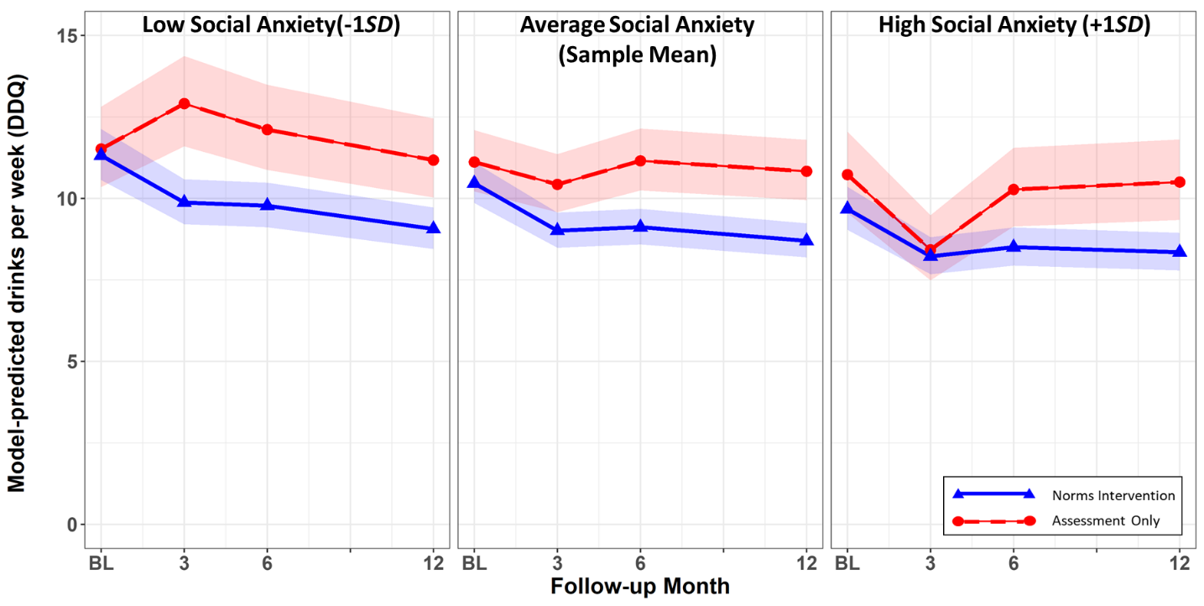
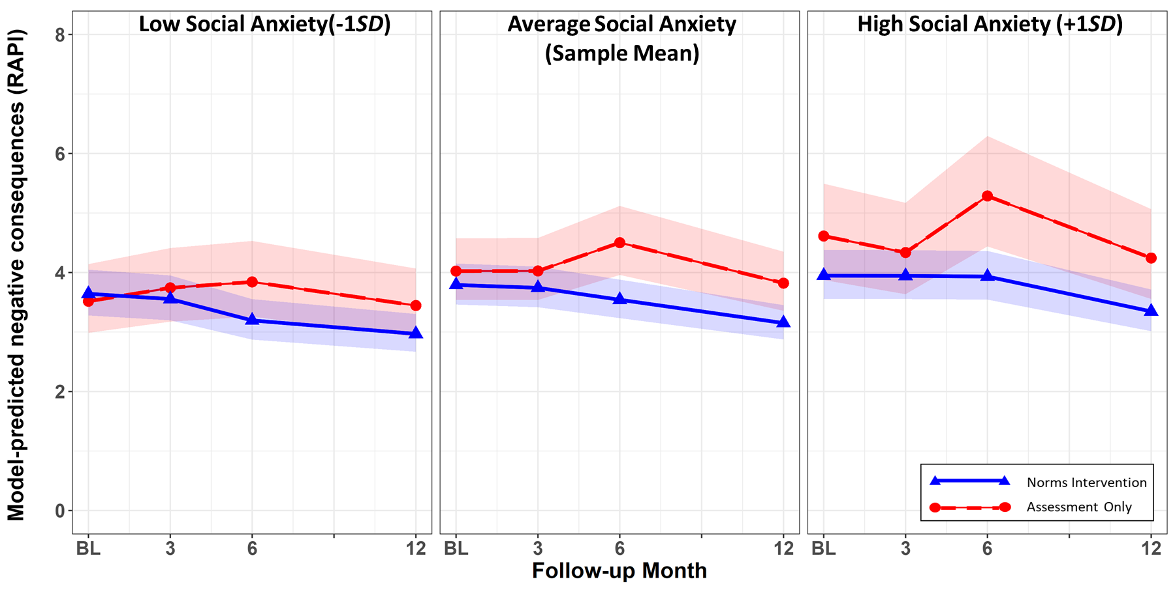

Figure 1. Marginal effects plots of the three-way interactions shown in Table 3.

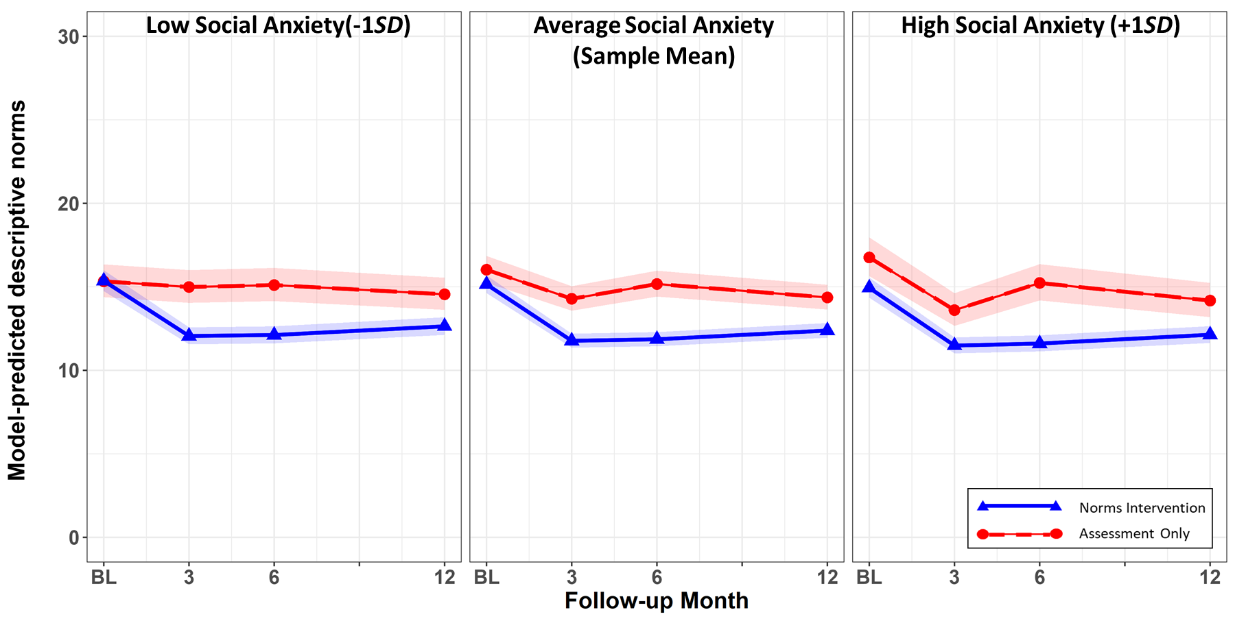
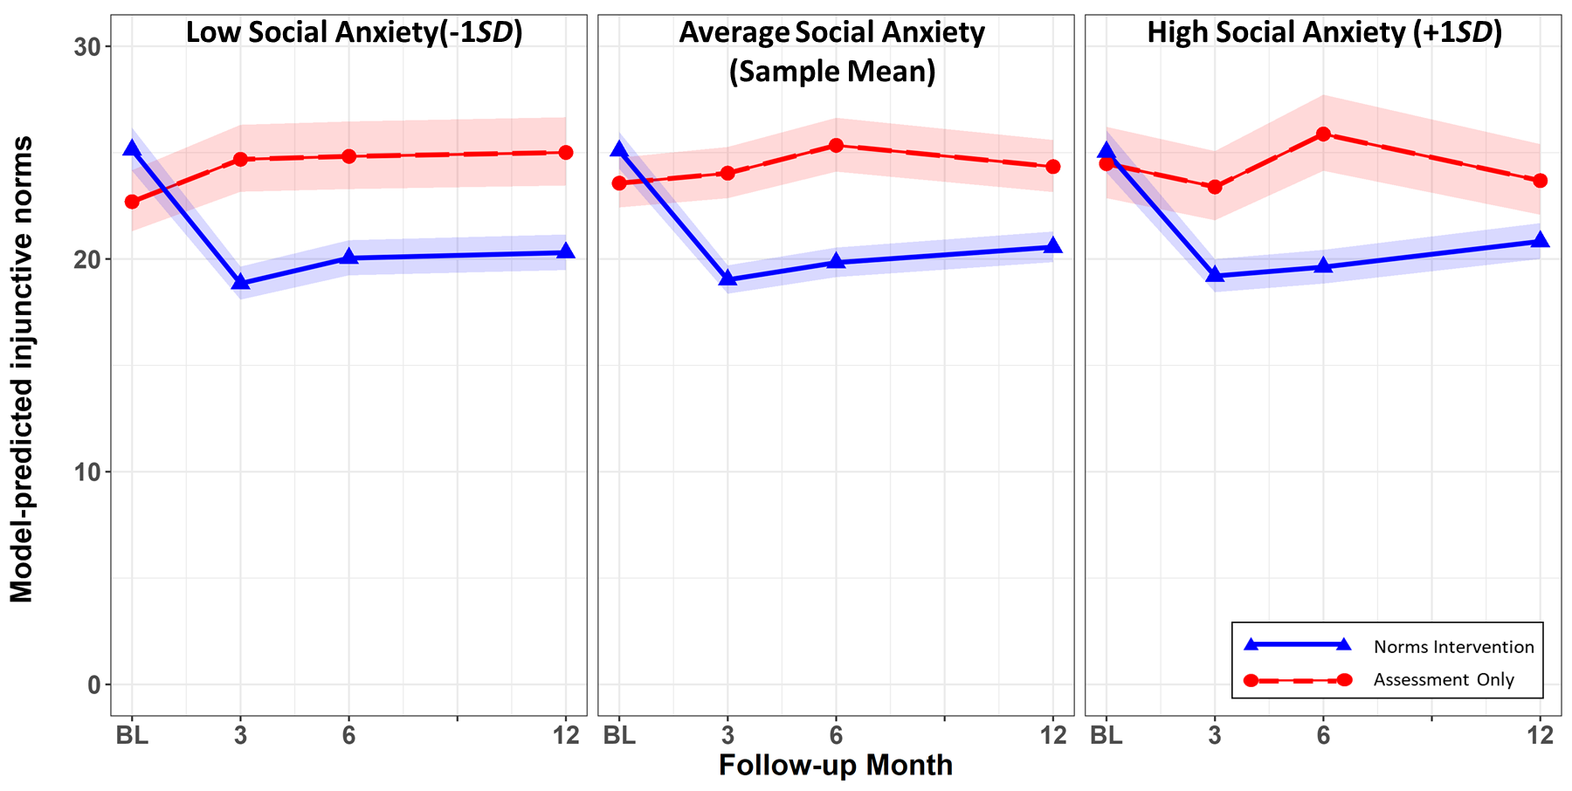
Figure 2. Marginal effects plots of the three-way interactions shown in Table 4.

Note that the main outcomes paper (Larimer et al., 2023) used a zero-inflated modeling approach for these outcomes, but this adds numerous complexities to interpreting the interactions estimated herein; thus, we did not use a zero-inflated approach for these secondary analyses.

