Assessment of wintertime carbon flux direction in the fjord system of Hood Canal in Washington.

Timothy Tang
University of Washington, Seattle, WA
School of Oceanography, Box 57940
timtang@uw.edu
5/27/2018

Acknowledgements
My thanks first and foremost go to Dr. Julian Sachs for his invaluable experience and guidance in the subject and development of this thesis through precise feedback as my advisor. I would also like to thank Dr. Arthur Nowell for his encouragement and organization throughout the process, Kathy Newell for her instruction and assistance with both lab and fieldwork, Susanna Michael for providing help and feedback across every part of the process, Dave Thoreson for his patience and successful navigation of the R/V Welander, Kathy Krogslund for the prompt analysis of nutrient data, and Dr. Alex Gagnon, Marta Wolfshorndl and Isaiah Bolden for both opening up their lab for DIC and alkalinity analysis as well as providing helpful instruction and maintenance crucial to completing this study. Sincerest thanks to my partner Xiaodi Yin, who worked alongside me since the beginning and shared honest feedback through close communication and excellent organization of our data. Finally, thanks goes to the University of Washington School of Oceanography and the entire class of 2018 for a successful year in scientific exploration.

Abstract
The relationship between carbon dioxide and the mechanisms behind its exchange between the ocean and atmosphere benefits the study and understanding of climate change given Carbon dioxide’s behavior as a greenhouse gas and its sequestration and release in fjordlike estuaries. This study was held along the center of Hood Canal, Washington, USA in a total of ten stations during the Winter of 2018, to measure total carbon in the estuary and determine the direction of carbon flux between the water and local atmosphere. Mean carbon flux as CO2 was determined to be 24.94 mmol C / m² / day out of the ocean, contributing to the local atmosphere as a source. Biological implications can be drawn given supporting data such as the low dissolved oxygen saturation of 67.7%.

Introduction
Climate change is a critical topic in today’s scientific discussion and large concerns are rising from the rate in which carbon dioxide generation is increasing. This focus on carbon dioxide comes from the idea that it is a greenhouse gas with a sharp increase is attributed to anthropogenic input. To reduce humanity’s impact on the Earth’s atmosphere, changes are required in our production to mitigate the effects this greenhouse gas will have on the current environment.
Due to its vast size, the uptake of CO2 by the ocean accounts for approximately half of the anthropogenic CO2 produced, as it is always in consistent contact with the atmosphere (DeVries, 2017). This flux is particularly well documented and studied across the scope of the open ocean. However, coastal waters and inlets are significantly less observed and occupy only a little over 7% of the seafloor and less than 0.5% of the ocean volume, yet play a major role in oceanic biogeochemical cycling (Chen and Borges, 2009).
Per unit area, fjord organic carbon burial rates are one hundred times as large as the global ocean average, and fjord sediments contain twice as much organic carbon as biogenous sediments underlying the upwelling regions of the ocean (Smith et al, 2015). Despite this, fjords and other coastal elements are severely understudied given their contribution toward the carbon cycle. Understanding the scale of organic carbon that is taken in by fjords and other coastal estuaries ultimately helps predict how much carbon ends up sequestered into the sediment and set aside when considering atmospheric concentrations of carbon with regards to climate change.
Hood Canal spans approximately 104 km in length along a bend to its most inland end. Historically, Hood Canal has experienced several instances of hypoxia due to eutrophication and algal blooms, which can greatly impact marine life in the area (Louchouarn, 2011). Hypoxic conditions can lead to reduced respiration and ties back to the carbon cycle and concentration, which can be a factor in determining the direction of carbon flux between the surface water and atmosphere. This study focuses on the northern half of Hood Canal, starting at 47°31.1'N, -123°02.6'W and routes towards 47°41.0'N, -122°46.2'W, under Dabob Bay. These stations are numbered 11 to 20. Xiaodi Yin was also onboard to sample her stations and those are indicated by the stations labeled 1 to 10. (Figure 1)
A similar study was conducted by University of Washington graduates Claire Knox, Una Miller, and Genevieve Hinde, in the fjord systems of Canada’s Nootka Sound. Similar temperature and windspeed values were expected in Hood Canal given the geographical proximity and similar climate.
To determine the direction of carbon flux in Hood Canal, it is imperative to measure alkalinity and dissolved inorganic carbon (DIC) to ultimately calculate the pCO2 of the ocean. With the ocean pCO2 and atmospheric pCO2, the difference in pCO2 can be found and used to calculate the rate of flux at each sampling location after measuring wind speed, temperature and salinity.
Methods
10 samples were collected on January 20-21, 2018 abord the R/V Welander. A second set of stations along southern bend of Hood Canal were examined by Xiaodi Yin in an identical manner. Each of the sampling stations were prepared with the intention of collecting DIC, alkalinity, dissolved oxygen, and nutrient data. The stations plot in a linear order along the length of Hood Canal and aim to be representative of any change along the course toward the entrance into Puget Sound. (Figure 1)
Sampling
For each sampling site, salinity, temperature, and oxygen were initially measured with the YSI Model 85 handheld CTD device deployed over the side of the boat for 2 minute intervals or until the readings were stable. Wind speed was also sampled via a digital anemometer at the same time. As these measurements were being conducted, a Scotty Niskin bottle was deployed over the side of the boat to trap 3 liters of water from the top 5 cm of the water. The filled Niskin was brought aboard and used to fill two 125 ml bottles for measuring dissolved oxygen, one 300 ml bottle for DIC and alkalinity samples, and a single 60 ml bottle for nutrient analysis. Each bottle was stoppered and stored immediately to prevent further interaction with the atmosphere. Samples intended for DIC and alkalinity measurements were taken ashore at the end of the day and poisoned with 120 μl MgCl₂ for each 300 ml bottle to eliminate biological activity. These bottles were stoppered with grease and further sealed with rubber bands to ensure each sample was secure in transit and storage and that no gas exchange occurred between the sample water and atmosphere. Oxygen samples were fixed with 1 ml MnCl₂ and 1 ml of NaOH-NaI per each 125 ml bottle and later analyzed via Winkler titration using a Dosimat 665 autoburette on January 24th, 2018. Atmospheric CO₂ was initially measured onboard, but due to the potential unreliability of the handheld CO₂ sensor, atmospheric CO2 data was instead drawn from the NANOOS ORCA buoy stationed at Twanoh. (NANOOS ORCA, https://www.pmel.noaa.gov/co2/story/Twanoh)
DIC and Alkalinity Analysis
DIC and alkalinity measurements were taken on March 15th, 2018 in Professor Alex Gagnon’s laboratory in UW Oceanography building. A Marianda VINDTA 3D coulometer was used to determine the amount of DIC in the samples (Heuvan, 2007). Alkalinity was measured using a Metrohm AG 876 Dosimat titrator.
Carbonate System Calculations
F = k * S * ΔpCO₂ sw-atm
ΔpCO₂ sw-atm = pCO₂ sw – pCO₂ atm
k = (0.222*U² + 0.333*U)(Sc/600)^{-0.5}
The above equations were used in calculating the rate of flux (F) of carbon dioxide in or out of the ocean. ΔpCO₂ sw-atm is the difference between the partial pressures of the water samples (pCO₂ sw) and the atmosphere (pCO₂ atm). The k term represents the gas transfer velocity of CO₂ and is calculated with wind speed (U) and the Schmidt number (Sc) determined as the ratio of kinematic velocity and mass diffusivity (Nightingale, 2000). The S term represents solubility of CO₂ in the water. PCO₂ sw and CO₂ flux were both calculated using the CO2calc application (Robbins et al, 2010). PCO₂ was calculated using K1 and K2 constants from Mehrbach et al, refit by Dickson and Millero (1987), as well as a boron concentration constant from Uppstrom (1974).

Results
All data referenced in the Results can be found referenced in Table 1 except for the Nutrient data which is recorded in Table 2. Stations 1 to 10 are from Xiaodi Yin’s observations which are analyzed and discussed as a part of her thesis. This study focuses on the collected data from stations 11 to 20.
Temperature along Hood Canal was between 8.6 to 9.2 degrees Celsius, averaging at 9.0 degrees Celsius. Salinity in the same area ranged from 23.9 to 26.9 with an average of 25.7. Overall, salinity appears to decrease the further a station is from the mouth of Hood Canal (Figure 8). There was no clear difference in temperature when comparing station distance from the mouth.
Dissolved oxygen saturation was below saturation throughout each of the recorded locations at a mean saturation of 67.7 % (Figure 7).
Dissolved Inorganic Carbon in the Hood Canal sampling sites were on average 1850 umol/L, with values ranging from 1749 umol/L to as high as 1915 umol/L. The total Alkalinity measured an average of 1898 ueq/L, with values ranging from 1761 ueq/L to 2093 ueq/L.
Wind speed varied between a low of 3.5 m/s and a high of 8.6 m/s, averaging 5.3 m/s.
Difference in pCO₂ between seawater and atmosphere for the observed partition of Hood Canal had a mean ΔpCO₂ of 334.51 μatm, ranging from -270.15 uatm to 499.49 uatm. Only Station 13 was calculated to have a negative ΔpCO₂ value (Figure 6).
CO₂ flux rate calculated from both ΔpCO₂ and wind speed combined averaged 24.94 mmol/m2/day out of the water and into the atmosphere, with values ranging from -8.70 to as high as 47.50 mmol/m2/day.
Five nutrients were measured (Table 2). PO₄ values ranged from 2.05 to 2.26 μM with an average of 2.16 μM. Si(OH)₄ values ranged from 59.53 to 73.62 μM with an average of 64.20 μM. NO₃ values ranged from 21.09 to 24.08 μM with an average of 22.93 μM. NO₂ values ranged from 0.25 to 0.27 μM with an average of 0.26 μM. NH₄ values ranged from 0.29 to 0.64 μM with an average of 0.41 μM.

Discussion
Salinity along Hood Canal follows the expected pattern of increasing toward Puget Sound. There were only a handful prominent riverine inputs along the observed stretch of Hood Canal such as the Duckabush and Dosewallips rivers (Figure 1), giving rise to the low salinity average of 25.73 compared to the average ocean salinity of 35. (NOAA, 2017)
The DIC and Alkalinity for each corresponding station were plotted against each other to identify their relationship (Figure 3). Apart from one station outlier, the plotted stations follow the linear trendline closely, with a slope of 0.8509. A change in alkalinity implies a process other than CO₂ flux is occurring, given that only DIC values would only change. CaCO₂ precipitation is a likely process considering the following chemical reaction:
Ca²⁺ + 2 HCO₃⁻ -> CaCO₃ + CO₂ + H₂O
which affects both DIC and alkalinity. It is important to note that CaCO₂ precipitation has an expected ratio of change of 1:2 for DIC to alkalinity (Zeebe, 2008), which the Hood Canal trendline slope does not reflect closely. As such, CO₂ flux or some other process must also have a significant effect on the slope to further skew the slope off the 1:2 ratio considered by CaCO₂ precipitation alone.
Hood Canal had a clear net positive flux of CO₂ out of the water and into the atmosphere recorded for every station visited with the exception of the third station (Figure 6). This station had a significantly higher alkalinity measurement compared to all other stations, despite having similar recordings in Total CO₂ to all other stations. This is likely due to an isolated case of error in measuring alkalinity given the large degree of difference it has against the alkalinity values of other stations and the effects of it expressed when the alkalinity is used to calculate changes in PCO₂ and flux. Overall size of the CO₂ flux was largely determined by the wind speed at each location, as stations with a slightly higher windspeed and equivalent differences between CO₂ pressure of seawater and atmosphere have significantly larger CO₂ flux rates. Direction of flux however is largely determined by the difference in PCO₂ of the atmosphere and water.
The fact that dissolved oxygen was undersaturated all throughout the fjord indicates that oxygen is being consumed in the upper portion of the water column in Hood Canal. (Figure 7). This study was conducted in the winter, when processes like photosynthesis are restricted by the lack of access to solar radiation and thus cannot produce oxygen. As such, oxygen is taken up normally via respiration and as organisms perish and decompose, while insufficient inputs from the atmosphere and primary producers represent the recorded saturation of 67.7%, even in the surface. This lack of photosynthesis reduces Hood Canal’s overall capacity to uptake CO₂ and instead can result in an oversaturation of CO₂ in the water, leading Hood Canal to be a source of atmospheric CO₂. Provided that this carbon saturated water resides in the estuary for a prolonged period of time, CO₂ can build up and further encourage Hood Canal’s behavior of sourcing CO₂, even during the Summer. This interaction contrasts with Torres’ (2011) observations on Patagonian Fjords which had experienced a supersaturation of oxygen but negative ΔpCO₂ values during the austral winter.
There was very little nutrient variation across stations spanning the waterway with the exception of Si(OH)₄ (Figure 4, Figure 5). However, given the distribution of nitrogen in each station of NO₃, NO₂, and NH₄, as well as the amount of phosphorus measured in PO₄, a standard ratio of nitrogen to phosphorus ends up being 11:1, far below the Redfield Ratio of N:P of 16:1 (Redfield et al, 1963). Nitrogen may be a limiting nutrient within Hood Canal’s ecosystem, and may also contribute to the decrease in effective primary production via photosynthesis alongside the shorter daylight cycle experienced in January. However, if ample nitrogen and phosphorus supply the current rate of photosynthesis given the low exposure to solar radiation, then perhaps nutrients do not play a significant role in controlling primary production.
Error
The titration setup for recording alkalinity was the source of several issues as the main point of calculating CO₂ flux was heavily dependent on alkalinity readings. The titrator needed repairs and throughout initial testing had provided suspicious results with a lack of precision. While the majority of alkalinity tests conducted on the station samples were recorded well within reasonable degrees to one another, the alkalinity reading for Station 3 was more than 100 units off the others and consequently the only station to have calculated both a negative flux and change in PCO₂, which is a remarkable outlier in and of itself.

Future Considerations
The acquisition of data from endpoints in Hood Canal, such as the Puget Sound and the Skokomish River would be helpful to better identify the degree of transition between the fjord’s freshwater source and its immediate resting location outside of Hood Canal. In addition, stations should be plotted towards Dabob bay and past the Bangor military base towards the Hood Canal Bridge in order to help identify changes in carbon and oxygen along a further stretch of the estuary. While these results show Hood Canal to be a source of atmospheric CO₂ that can be attributed to primary production activity, measurements taken at depths beyond the surface water can illustrate other factors of carbon interaction, such as a higher residence time due to stratification or rate of decomposition with regards to depth. Revisiting Hood Canal throughout the year and measuring chlorophyll can also assist in illustrating the changes in primary production and help link its effects on carbon sequestering or release.

References
Baker, et al. “Temporal Variations in the Concentration and Settling Flux of Carbon and Phytoplankton Pigments in a Deep Fjordlike Estuary.” Estuarine, Coastal and Shelf Science, vol. 21, no. 6, 1985, pp. 859–877.
Carroll, J.,Bellerby, R. G. J., et al. “Carbon Flux and Ecosystem Feedback in the Northern Barents Sea in an Era of Climate Change: An Introduction.” Deep Sea Research., vol. 55, no. 20-21, 2008, pp. 2143–2153.
Chen, & Borges. (2009). Reconciling opposing views on carbon cycling in the coastal ocean: Continental shelves as sinks and near-shore ecosystems as sources of atmospheric CO 2. Deep-Sea Research Part II, 56(8), 578-590.
DeVries, T. (2017). Recent increase in oceanic carbon uptake driven by weaker upper-ocean overturning. Nature., 542(7640), 215-218.
Dickson, AG & Millero, FJ 1987, 'A comparison of the equilibrium constants for the dissociation of carbonic acid in seawater media' Deep Sea Research Part A, Oceanographic Research Papers, vol 34, no. 10, pp. 1733-1743. DOI: 10.1016/0198-0149(87)90021-5
Eaton, Andrew D., et al. Standard Methods for the Examination of Water and Wastewater. 19th ed. 1995. ed., American Public Health Association, 1995.
Emerson, S., & Hedges, John. (2008). Chemical oceanography and the marine carbon cycle. Cambridge: Cambridge University Press.
Heuven, S., & Baar, Hein de,. (2007). Alkalinity and Dissolved Inorganic Carbon (DIC) measurements during ARK-XXII/2, Originator’s Protocol for Data Acquisition and Analysis. British Oceanographic Data Centre. https://www.bodc.ac.uk/data/documents/nodb/309081/
Louchouarn, Patrick,Crecelius, Eric A., Brandenberger, Jill M, Louchouarn, Patrick, & Crecelius, Eric A. (2011). Natural and Post-Urbanization Signatures of Hypoxia in Two Basins of Puget Sound: Historical Reconstruction of Redox Sensitive Metals and Organic Matter Inputs. Aquatic Geochemistry., 17(4-5), 645-670.
Mortimer, C. H. “The Oxygen Content of Air-Saturated Fresh Waters, and Aids in Calculating Percentage Saturation: With 2 Tables and 5 Figures in the Text.” SIL Communications, 1953-1996, vol. 6, no. 1, 1956, pp. 1–20.
NANOOS ORCA buoy at Twanoh (47.37°N, 123.01°W), Plots of surface water and atmospheric CO2. Retrieved from https://www.pmel.noaa.gov/co2/story/Twanoh
NOAA. (2017). Why is the ocean salty? National Ocean Service website, https://oceanservice.noaa.gov/facts/whysalty.html
Nightingale, P.D., G. Malin, C.S. Law, A.J. Watson, P.S. Liss, M.I. Liddicoat, J. Boutin, R.C. Upstill-Goddard. (2000). In situ evaluation of air-sea gas exchange parameterizations using novel conservative and volatile tracers. Global Biogeochem. Cy. 14(1): 373-387.
Redfield, A C., Ketchum, B. H., and Richards, F. A. (1963). The influence of organisms on the composition of sea water. The Sea, (2), 26-77
Robbins, L.L., M.E. Hansen, J.A. Kleypas, and S.C Meylan. (2010). CO2calc: A User-Friendly Seawater Carbon Calculator for Windows, Mac OS X, and iOS (iPhone). United States Geological Survey (USGS). Retrieved from https://pubs.usgs.gov/of/2010/1280/
Smith, R., Bianchi, T., Allison, M., Savage, C., & Galy, V. (2015). High rates of organic carbon burial in fjord sediments globally. Nature Geoscience, 8(6), 450-453.
Torres, R., Pantoja, S., Harada, N., González, H., Daneri, G., Frangopulos, M., . . . Fukasawa, M. (2011). Air‐sea CO 2 fluxes along the coast of Chile: From CO 2 outgassing in central northern upwelling waters to CO 2 uptake in southern Patagonian fjords. Journal of Geophysical Research: Oceans, 116(C9), N/a.
Uppström, Leif R. “The Boron/Chlorinity Ratio of Deep-Sea Water from the Pacific Ocean.” Deep-Sea Research and Oceanographic Abstracts, vol. 21, no. 2, 1974, pp. 161–162.
Zajączkowski, M., Nygård, H., Hegseth, E., & Berge, N. (2010). Vertical flux of particulate matter in an Arctic fjord: The case of lack of the sea-ice cover in Adventfjorden 2006–2007. Polar Biology, 33(2), 223-239.
Zeebe, R, E,. & Wolf-Gladrow, D, A. (2008). Carbon Dixoide, Dissolved. (ocean). Encyclopedia of Paleoclimatology and Ancient Environments, Ed. V. Gornitz, Kluwer Academic Publishers, Earth Science Series. Retrieved from http://www.soest.hawaii.edu/oceanography/faculty/zeebe_files/Publications/ZeebeWolfEnclp07.pdf

Figure 1:
Map of Washington State and Hood Canal. Stations 1-10 for Xiaodi Yin and 11-20 for Timothy Tang have been marked, as well as the Duckabush and Dosewallips rivers.

Figure 2:
Temperature (°C) plotted against salinity. Each point represents a single station with both results.

Figure 3:
Dissolved Inorganic Carbon (μmol/L) plotted against Total Alkalinity. A trendline and its equation are also displayed.

Figure 4:
Nutrient data for PO₄, NO₂, and NH₄ (μmol) plotted by distance from the Hood Canal mouth (km).

Figure 5:
Nutrient data for Si(OH)₄ and NO₃ (μmol) plotted by distance from the Hood Canal mouth (km).

Figure 6:
Difference in carbon dioxide between seawater and atmosphere (μatm) (ΔpCO₂) at each station.

Figure 7:
Percent dissolved oxygen saturation at each station.

Figure 8:
Salinity at each station.

Figure 1
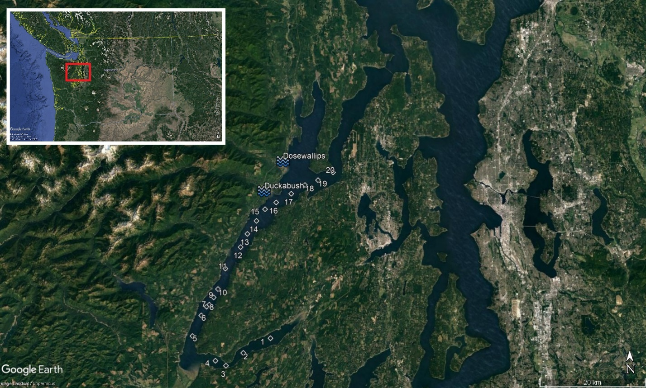
Figure 2
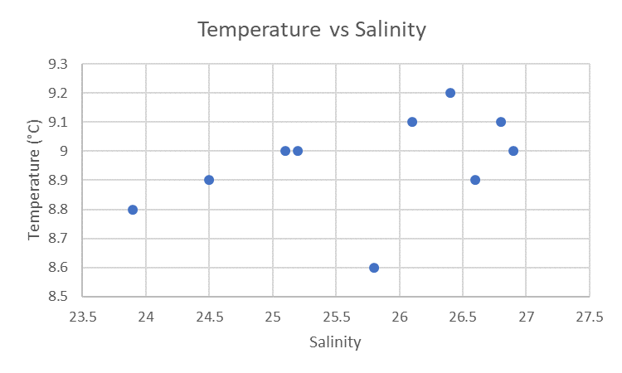
Figure 3

Figure 4
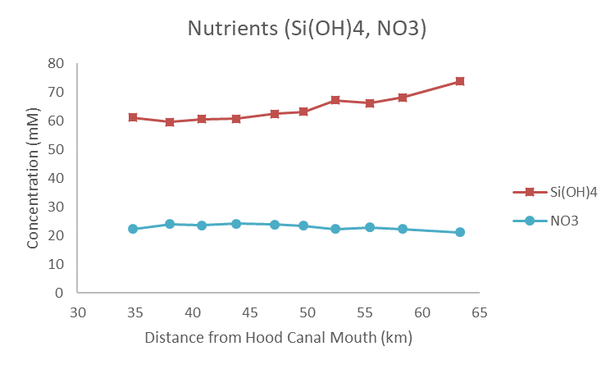
Figure 5
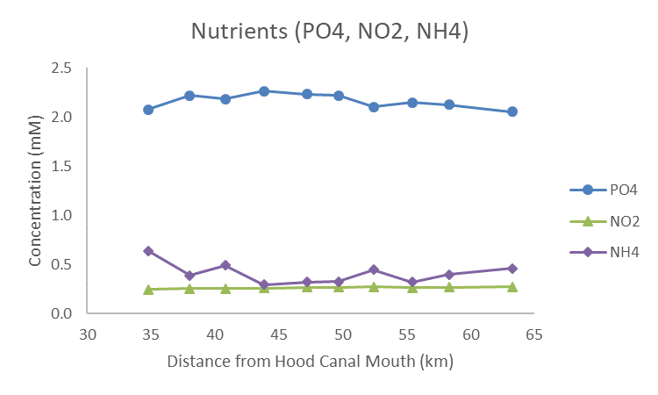
Figure 6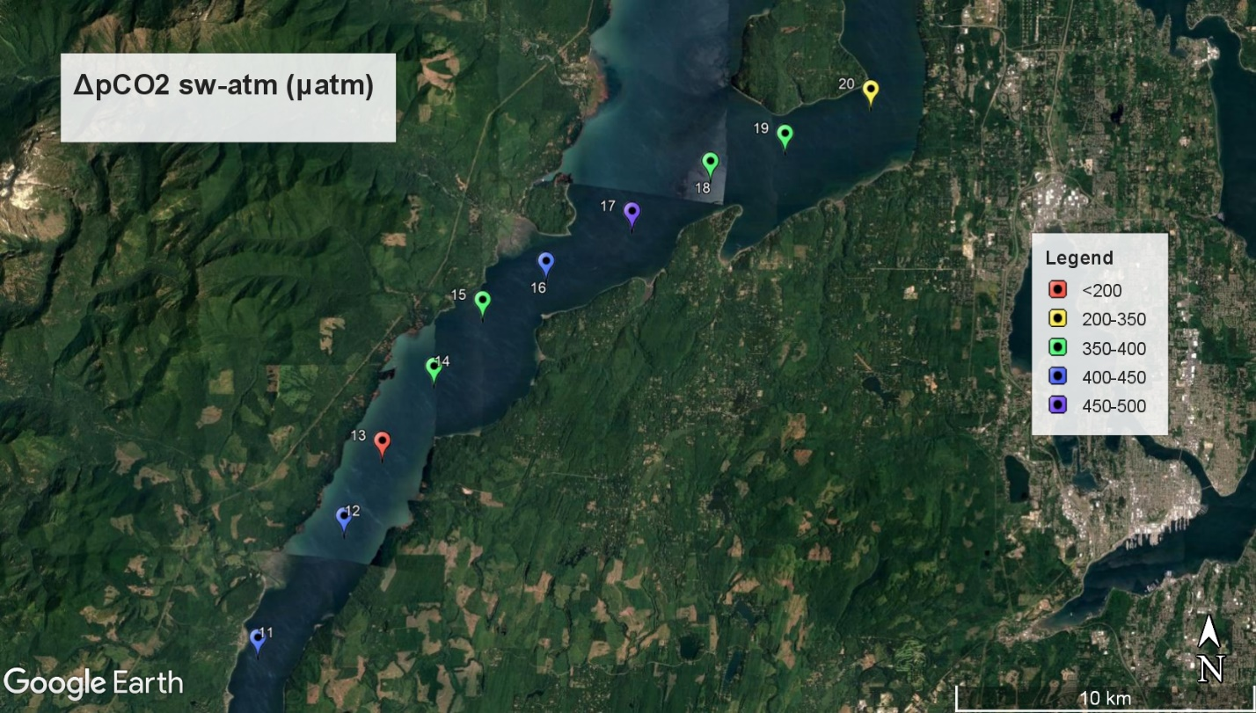
Figure 7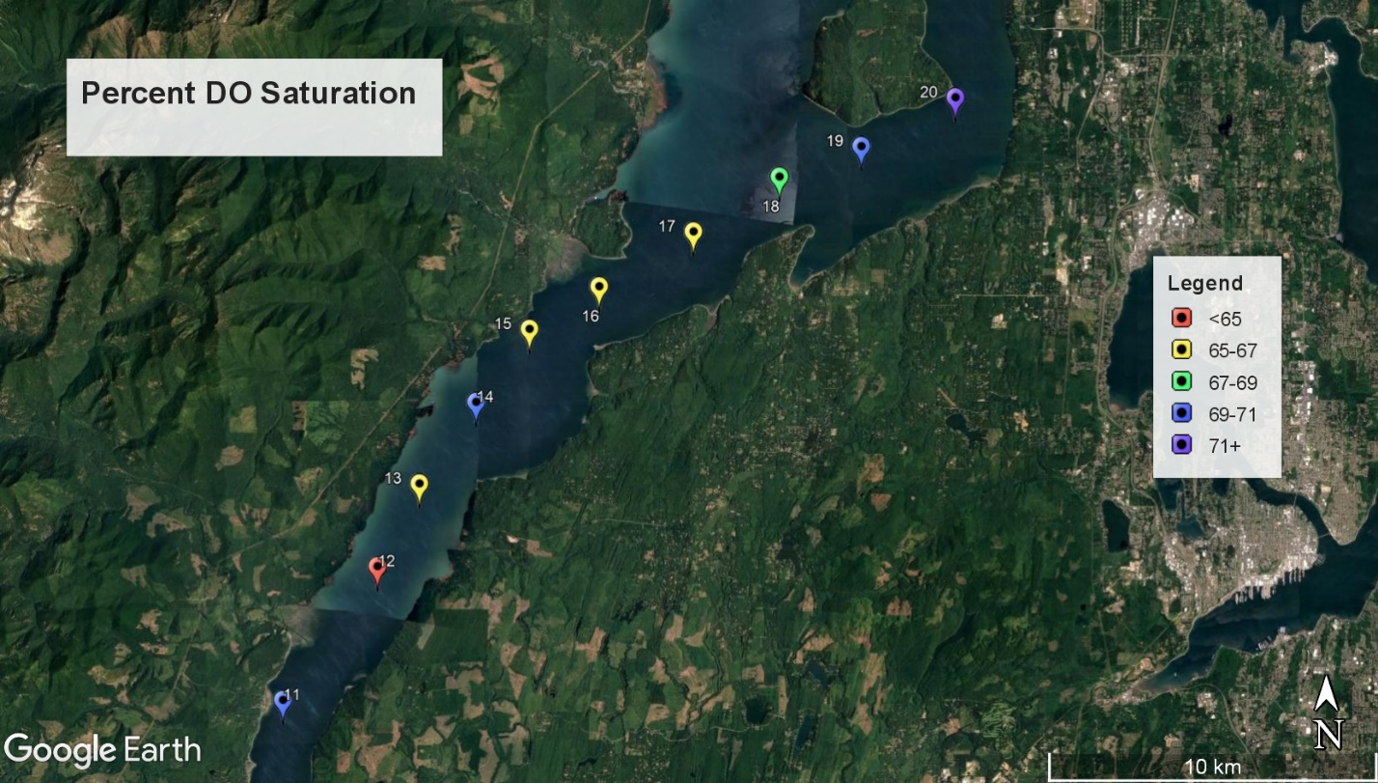Figure 8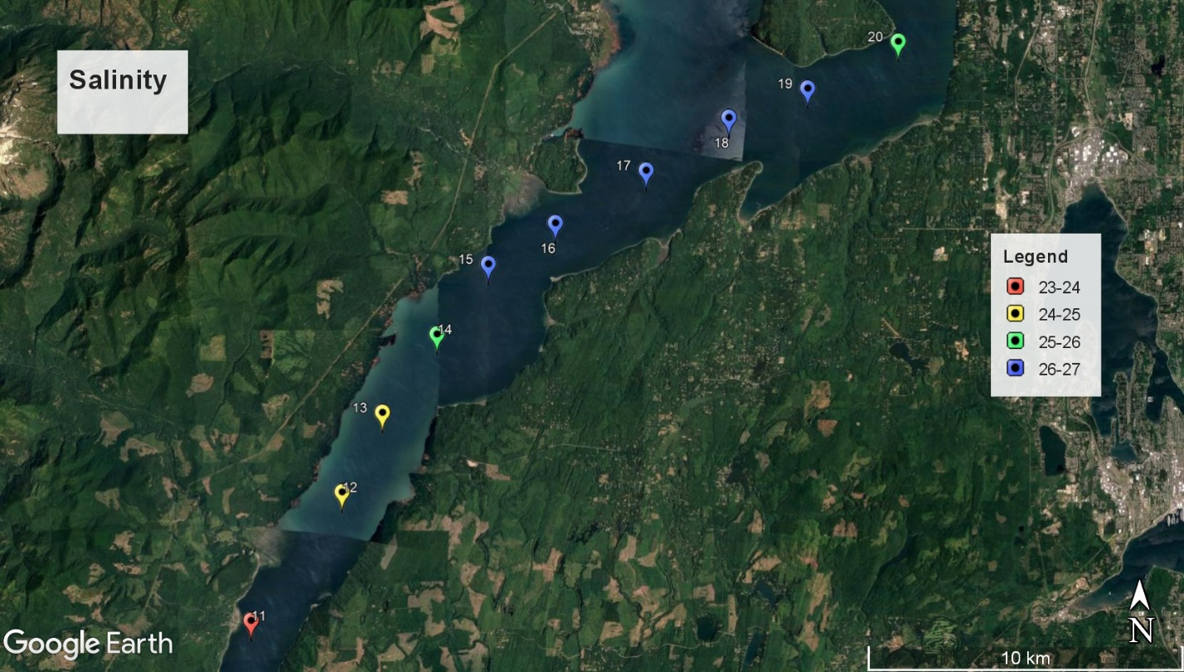

Table 1:
Station | Latitude | Longitude | Wind Speed (m/s) | Salinity | Water Temp (deg C) | O2 Saturation (mg/L)
1 | 47°24.0'N | 122°55.7'W | 1.1 | 18.7 | 8.8 | 9.23
2 | 47°22.5'N | 122°59.8'W | 0.0 | 16.4 | 6.6 | 9.49
3 | 47°21.2'N | 123°02.4'W | 1.0 | 16.2 | 6.8 | 9.64
4 | 47°21.7'N | 123°04.0'W | 0.8 | 11.8 | 6.6 | 9.99
5 | 47°24.2'N | 123°07.5'W | 1.3 | 22.9 | 6.6 | 8.58
6 | 47°26.3'N | 123°06.2'W | 1.9 | 22.8 | 6.9 | 8.21
7 | 47°27.2'N | 123°05.4'W | 3.3 | 24.5 | 7.6 | 7.59
8 | 47°27.4'N | 123°05.0'W | 2.7 | 23.9 | 8.1 | 7.60
9 | 47°24.2'N | 123°04.6'W | 3.8 | 22.5 | 8.3 | 8.14
10 | 47°29.0'N | 123°03.7'W | 3.4 | 22.6 | 8.8 | 7.82
11 | 47°31.1'N | 123°02.6'W | 4.8 | 23.9 | 8.8 | 8.08
12 | 47°33.3'N | 123°00.3'W | 5.5 | 25.1 | 9.0 | 7.47
13 | 47°34.66'N | 122°59.28'W | 3.5 | 25.2 | 9.0 | 7.56
14 | 47°36.0'N | 122°57.9'W | 4.8 | 24.5 | 8.9 | 8.12
15 | 47°37.2'N | 122°56.6'W | 3.8 | 26.1 | 9.1 | 7.62
16 | 47°37.9'N | 122°54.9'W | 6.9 | 26.4 | 9.2 | 7.56
17 | 47°38.8'N | 122°52.6'W | 4.3 | 26.8 | 9.1 | 7.60
18 | 47°39.7'N | 122°50.5'W | 5.2 | 26.6 | 8.9 | 7.96
19 | 47°40.2'N | 122°48.5'W | 5.7 | 26.9 | 9.0 | 8.02
20 | 47°41.0'N | 122°46.2'W | 8.6 | 25.8 | 8.6 | 8.50

Table 1 Continued:
DO Percent Saturation | DIC (umol/L) | Alkalinity (umol/L) | pCO2 Water (uatm) | ΔpCO2 sw-atm (uatm) | CO2 Flux (mmol/m²/day)
79.46 | 1559 | 1560 | 770.3 | 353.52 | 1.95
77.41 | 1330 | 1318 | 726.8 | 310.07 | 0.10
78.98 | 1345 | 1337 | 687.4 | 270.64 | 1.32
81.45 | 1127 | 1112 | 625.7 | 208.94 | 0.74
69.94 | 1500 | 1542 | 451.5 | 34.78 | 0.23
67.47 | 1651 | N/A | N/A | N/A | N/A
63.46 | 1757 | 1760 | 891.7 | 474.98 | 13.83
64.33 | 1745 | 1747 | 905.3 | 488.52 | 10.27
69.23 | 1682 | 1688 | 827.3 | 410.51 | 15.32
67.28 | 1715 | 1720 | 861.6 | 444.85 | 13.76
69.52 | 1750 | 1762 | 833.4 | 416.67 | 23.17
64.57 | 1824 | 1842 | 841.5 | 424.83 | 30.11
65.35 | 1825 | 2094 | 146.6 | -270.15 | -8.70
70.03 | 1789 | 1808 | 812.1 | 395.42 | 21.91
66.03 | 1873 | 1901 | 802.1 | 385.38 | 14.07
65.71 | 1895 | 1920 | 844.6 | 427.86 | 45.85
65.90 | 1914 | 1932 | 916.2 | 499.49 | 22.53
68.69 | 1887 | 1916 | 806.4 | 389.73 | 24.78
69.33 | 1903 | 1935 | 794.0 | 377.31 | 28.20
72.78 | 1845 | 1880 | 715.3 | 298.56 | 47.50

Table 2:
Station | PO4 (uM) | Si(OH)4 (uM) | NO3 (uM) | NO2 (uM) | NH4 (uM)
1 | 1.69 | 94.36 | 17.31 | 0.31 | 1.15
2 | 1.41 | 102.30 | 14.88 | 0.22 | 0.77
3 | 1.42 | 102.95 | 14.76 | 0.21 | 0.76
4 | 1.16 | 112.65 | 13.10 | 0.17 | 0.75
5 | 1.75 | 94.83 | 17.51 | 0.23 | 0.87
6 | 1.96 | 82.80 | 19.60 | 0.25 | 0.56
7 | 2.11 | 73.54 | 21.23 | 0.26 | 0.32
8 | 2.10 | 74.63 | 20.98 | 0.27 | 0.33
9 | 1.98 | 79.25 | 19.80 | 0.27 | 0.57
10 | 2.00 | 76.91 | 20.18 | 0.28 | 0.47
11 | 2.05 | 73.62 | 21.09 | 0.27 | 0.46
12 | 2.13 | 68.13 | 22.28 | 0.27 | 0.40
13 | 2.15 | 66.02 | 22.88 | 0.27 | 0.32
14 | 2.10 | 67.04 | 22.23 | 0.27 | 0.45
15 | 2.22 | 63.06 | 23.39 | 0.27 | 0.33
16 | 2.23 | 62.29 | 23.76 | 0.27 | 0.32
17 | 2.26 | 60.71 | 24.08 | 0.26 | 0.29
18 | 2.18 | 60.49 | 23.53 | 0.26 | 0.49
19 | 2.22 | 59.53 | 23.90 | 0.25 | 0.39
20 | 2.07 | 61.09 | 22.19 | 0.25 | 0.64

