Food Preference of Strongylocentrotus droebachiensis
By Alicia Hili
FHL 470
May 27, 2022

Abstract
Sea urchins are a prominent herbivore along the Pacific coast and can devastate kelp beds that are home to many species. Urchin barrens are of concern to ecologists and aquaculture groups, especially along the Pacific Coast. Much of the current literature on sea urchins and their feeding preferences refers to Strongylocentrotus purpuratus (purple urchins) and their effects on kelp forests. I wanted to determine if Strongylocentrotus droebachiensis (green urchins) have a preferred food and how this could contribute to the current problem of urchin barrens. Bycollecting S. droebachiensis from the Friday Harbor Lab dock, as well as three different kelps that are abundant in the area, I was able to determine which kelp S. droebachiensis favors as food. For 5 days, every 24 hours, in 3 tanks, I would feed the sea urchins Nereocystis luetkeana, Saccharina latissima, and Costaria costata. After every 24 hours, I would weigh the leftover kelp and determine the amount of each consumed. I found that the S. droebachiensis favored the N. luetkeana which is important because that is an abundant ecological engineer along the Pacific coast and is highly affected by urchin barrens.

Introduction
The intricate relationships between organisms both within and outside of subtidal communities can determine the stability of a marine community. These relationships have been a central focus in ecology, especially regarding kelp forests and their residents. Kelp forests like Nereocystis luetkeana can be home to a wide range of organisms, cycle nutrients through detritus, and are a vital food source for many organisms. Such kelps are ecosystem engineers and can change the abiotic environment (nutrients, light, water flow), provide structure, and are biotic engineers (through structural or abiotic changes) (Layton et al. 2019). They also can reduce coastal wave strength, benefit fisheries, and support locals who harvest kelps (Finger et al. 2021). Kelps are also a primary food source for sea urchins, who typically hide in crevices and are passive feeders, eating drift kelp on the ocean floor. However, recently there have been many reports of urchin barrens caused by sea urchins becoming active feeders (Rogers-Bennett and Catton 2019).
Many ecologists have been interested in why urchin barrens have been occurring more over the past decade. Researchers have been focusing on the relationship between kelp, Enhydra lutris (sea otters), Pycnopodia helianthoides(sunflower sea star), and Strongylocentrotus spp. (sea urchins). The sea urchins who live within the kelp forests use it as shelter and a food source. The sea stars and sea otters feed on the sea urchins keeping them at bay and allowing the kelp forests to flourish. In 2013 sea star wasting disease (SSWD) caused mass casualty of more than 20 species of Asteroidea, including Pycnopodia helianthoides, along the Pacific coast from Alaska to Mexico (Harvell et al. 2019). The other dominant predator of sea urchins is the Enhydra lutris which was severely depleted during the fur trade in the eighteenth and nineteenth centuries. Although Washington state’s population has been increasing over the past 40 years the sub-regions along the coast still have small populations (Hale et al. 2022). Because of smaller populations of sea otters and SSWD decreasing the population of P. helianthoides, sea urchins are becoming more active feeders due to the lack of predators causing urchin barrens (Eisauirre et al. 2020).
Between 2013 and 2014 a marine heat wave (MHW) hit the Pacific coast and after this, kelp forests, like bull kelp, started to decline (Rogers-Bennett and Catton 2019). The reduction of kelp beds negatively affects all the various organisms that rely on them for shelter and food. Kelp forests play a vital role in coastal ecosystems. Most research talks about bull kelp and Strongylocentrotus purpuratus devastating those forests. The motivation behind this research was drawn from the increase in urchin barrens and the minimal research on how Strongylocentrotus droebachiensis could fit into this equation. The goal of this research is to determine if Strongylocentrotus droebachiensis, which are abundant in temperate marine systems, have preferred kelp to feed on. I hypothesized that Strongylocentrotus droebachiensis do not have a preference between kelp species. This is because they are typically passive feeders.

Methods
To conduct this experiment, I collected 30 S. droebachiensis from Friday Harbor Labs dock. Once collected I weighed the sea urchins and put seven in each of my three tanks and made sure the total weight was within a few grams for each tank. After letting the sea urchins acclimate for about 24 hours I collected Nereocystis luetkeana, Saccharina latissima, and Costaria costata. Then the blades were cut into smaller pieces and weighed out to 25 grams of each species for each tank. Once all the kelp was weighed each species was placed in each tank and left for 24 hours. The next morning the remaining kelp was removed and weighed to determine how much the urchins eat of each species. This was repeated over 5 days producing data from 5 trial periods.
After all the data was collected, I entered it into an excel sheet. Then I used a one-way ANOVA to find the statistical significance of the data.

Results
I found that over five days the urchins ate more Nereocystis than the other 2 species of kelp. As shown in figure 1, the total amount of Costaria consumed each day was lower than both Saccharina and Nereocystis for 4 of the 5 days.
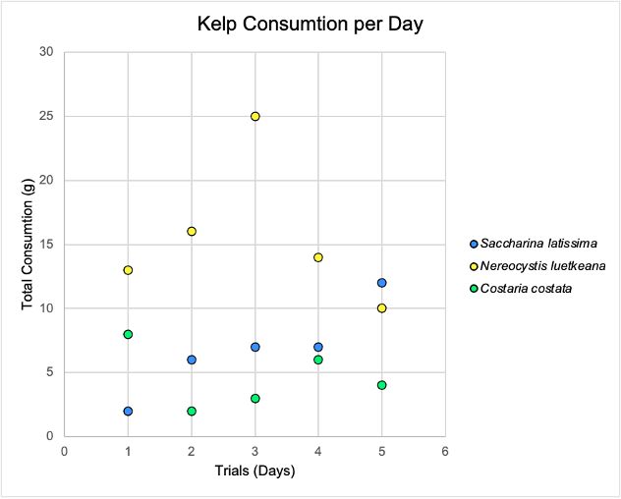
Figure 1 grams of kelp consumed in each of the 5 trial days.

Over the 5 trials, I found that the sea urchins, on average, ate more Nereocystis than the other two species (p-value 0.00090). The data also showed there was a variance in consumption between the three species of kelp.

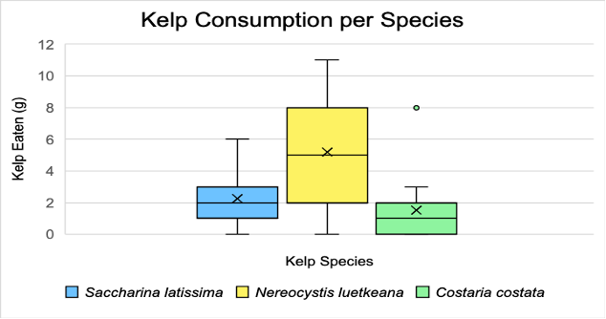
Figure 2 average consumption of the 3 kelp species as well as the highest and lowest consumption. ‘X’ represents the mean consumption of each species.

Discussion
From the analysis of the data, there is statistical evidence that green sea urchins do favor Nereocystis luetkeana over the other two kelps they were fed. This does not support my hypothesis that there would be little variation in the amount of each kelp that the sea urchins consumed. Figure 2 shows that on average the sea urchins ate three more grams of N. luetkeana than either of the other kelps and figure 1 shows that over the 5 days of trials there was only 1 day where N. luetkeana was not the highest total consumed kelp. This data is statistically significant (p-value 0.00090). Canopy-forming kelp, like N. luetkeana, is an important habitat for sea birds, invertebrates, marine mammals, and fishes, and bull kelp is dominant along the Pacific coast from California to Alaska (García-Reyes et al. 2022). Kelp forests also take up CO₂ from the ocean making them of interest to individuals fighting climate change and rising CO₂ levels (Chung et al. 2013).
Within temperate marine ecosystems, S. droebachiensis is one of the dominant grazing species and is notably an abundant species along the Pacific coast (Angles d’Auriac et al. 2014). Within Puget Sound, the main predators of green sea urchins are Pycnopodia helianthoides and a small population of sea otters. Both species currently have small populations compared to historical records, meaning a lack of top-down control (Eisaguirre et al. 2020). This is cause for concern because fewer predators allow urchins to come out more often, grazing on kelp and wiping out entire forests. (Smith et al. 2020). Also, constant grazing on algae limits the recruitment of kelps and other algae which in turn affects future kelp populations (Gagnon et al. 2004).
For kelp forests to become more abundant and healthier there must be control over the sea urchin populations. In a study done in urchin barrens found in the Mediterranean Sea, it was found that 36 months after an urchin culling there was much more algal coverage on once bare surfaces (Guarnieri et al. 2020). Researchers along the Pacific coast also have been looking into the idea of urchin culling, mostly in California, to allow for Kelp forests to recover from overgrazing (Williams et al. 2021).
The relationship between the abundant sea urchin and the diminished prey and predators of the said organism is an important topic within ecology. Further research within this field and looking at how each of the different native sea urchin species affects different kelp beds is necessary. As well as how their predators are helping control or not control these populations. This research would allow scientists to determine how to better manage the overgrazing of kelp by sea urchins. Also determining the main species of kelp affected by urchin barrens could influence current aquaculture regarding kelp farming and restoration. Without further research, we are only solving a small portion of a very large problem.

Works Cited

Anglès d'Auriac, Hobæk, A., Christie, H., Gundersen, H., Fagerli, C. W., Haugstetter, J., & Norderhaug, K. M. (2014). New microsatellite loci for the green sea urchin Strongylocentrotus droebachiensis using universal M13 labelled markers. BMC Research Notes, 7(1), 699–699. https://doi.org/10.1186/1756-0500-7-699

Chung, Oak, J. H., Lee, J. A., Shin, J. A., Kim, J. G., & Park, K.-S. (2013). Installing kelp forests/seaweed beds for mitigation and adaptation against global warming: Korean Project Overview. ICES Journal of Marine Science, 70(5), 1038–1044. https://doi.org/10.1093/icesjms/fss206

Eisaguirre, Eisaguirre, J. M., Davis, K., Carlson, P. M., Gaines, S. D., & Caselle, J. E. (2020). Trophic redundancy and predator size class structure drive differences in kelp forest ecosystem dynamics. Ecology (Durham), 101(5), e02993–n/a. https://doi.org/10.1002/ecy.2993

Finger, McPherson, M. L., Houskeeper, H. F., & Kudela, R. M. (2021). Mapping bull kelp canopy in northern California using Landsat to enable long-term monitoring. Remote Sensing of Environment, 254(C), 112243. https://doi.org/10.1016/j.rse.2020.112243

García-Reyes, M., Thompson, S. A., Rogers-Bennett, L., & Sydeman, W. J. (2022). Winter oceanographic conditions predict summer bull kelp canopy cover in northern California. PLoS ONE, 17(5), e0267737. https://link.gale.com/apps/doc/A702605747/AONE?u=wash_main&sid=bookmark-AONE&xid=ba5317c9

Gagnon, Himmelman, J., & Johnson, L. (2004). Temporal variation in community interfaces: kelp-bed boundary dynamics adjacent to persistent urchin barrens. Marine Biology, 144(6), 1191–1203. https://doi.org/10.1007/s00227-003-1270-x

Guarnieri, Bevilacqua, S., Figueras, N., Tamburello, L., & Fraschetti, S. (2020). Large-Scale Sea Urchin Culling Drives the Reduction of Subtidal Barren Grounds in the Mediterranean Sea. Frontiers in Marine Science, 7. https://doi.org/10.3389/fmars.2020.00519

Hale, Laidre, K. L., Jeffries, S. J., Scordino, J. J., Lynch, D., Jameson, R. J., & Tim Tinker, M. (2022). Status, trends, and equilibrium abundance estimates of the translocated sea otter population in Washington State. The Journal of Wildlife Management, 86(4), n/a–n/a. https://doi.org/10.1002/jwmg.22215

Harvell, Montecino-Latorre, D., Caldwell, J. M., Burt, J. M., Bosley, K., Keller, A., Heron, S. F., Salomon, A. K., Lee, L., Pontier, O., Pattengill-Semmens, C., & Gaydos, J. K. (2019). Disease epidemic and a marine heat wave are associated with the continental-scale collapse of a pivotal predator ( Pycnopodia helianthoides ). Science Advances, 5(1), eaau7042–eaau7042. https://doi.org/10.1126/sciadv.aau7042

Layton, Shelamoff, V., Cameron, M. J., Tatsumi, M., Wright, J. T., & Johnson, C. R. (2019). Resilience and stability of kelp forests: The importance of patch dynamics and environment-engineer feedbacks. PloS One, 14(1), e0210220–e0210220. https://doi.org/10.1371/journal.pone.0210220

Rogers-Bennett, & Catton, C. A. (2019). Marine heat wave and multiple stressors tip bull kelp forest to sea urchin barrens. Scientific Reports, 9(1), 15050–15059. https://doi.org/10.1038/s41598-019-51114-y

Smith, Tomoleoni, J., Staedler, M., Lyon, S., Fujii, J., & Tinker, M. T. (2021). Behavioral responses across a mosaic of ecosystem states restructure a sea otter-urchin trophic cascade. Proceedings of the National Academy of Sciences - PNAS, 118(11), e2012493118. https://doi.org/10.1073/pnas.2012493118

Williams, JP., Claisse, J., Pondella II, D., Williams, C., Robart, M., Scholz, Z., Jaco, E., Ford, T., Burdick, H., & Witting, D. (2021). Sea urchin mass mortality rapidly restores kelp forest communities. Marine Ecology. Progress Series (Halstenbek), 664, 117. https://doi.org/10.3354/meps13680

