Heavy metal contamination in Puget Sound and Lake Washington sediments and benthic invertebrates; a focus on the influence of road material on extent of metal concentration

Andrew Mandovi
University of Washington
School of Oceanography,
1501 NE Boat St, Seattle, WA 98195
Phone: (440) 478-7929
mandovi@uw.edu
18 May 2019

Abstract
Heavy metallic elements are found naturally in nature, but have been released into soils, rivers, and bodies of water due to anthropogenic activity, increasing concentrations to levels potentially harmful to human and environmental health. Metals have been found to enter marine sediments though point sources such as mining, aquaculture, and shipping activity. Transportation runoff, including worn road material and brake dust, is a potential source of metal contamination that has not been studied to a great extent, particularly in the Puget Sound region. In this study, surface sediments from Lake Washington, the Lake Washington Ship Canal, and South Puget Sound were analyzed for heavy, relating samples to proximity to roads, with control sites chosen at locations further from road activity and runoff. Elevated metal contamination was found in all sampling sediments, particularly in copper, lead, and selenium, with Lake Washington and Shipping Canal sites exceeding those in Puget Sound. Benthic invertebrate matter was also analyzed; elevated nickel, lead, arsenic, and chromium were found, but with less consistency between sites. This study further emphasizes that heavy metals have permeated the sediments and benthic invertebrates of the region, though the degree to which road material influences this contamination remains inconclusive.

Introduction
The Puget Sound is an estuarine system in western Washington State connected to the Pacific Ocean by way of the Strait of Juan de Fuca. By virtue of being an estuary in a temperate climate, the ecology of Puget Sound is heavily influenced by proximity to human influence, primarily its densely-populated eastern shore consisting of the metropolitan centers of Seattle, Tacoma, Everett, and Olympia. A fjord system of flooded glacial valleys, Puget Sound has a lower salinity than the ocean due to the input of freshwater through surrounding rivers and is vulnerable to anthropogenic runoff. Lake Washington, a freshwater lake adjacent to Seattle and tributary of Puget Sound, is similarly surrounded by urban development and faces similar pollution threats.
Anthropogenic impact is variable, sourcing from nutrient runoff, invasive species transfer, release of plastics, among others; as is the extent to which these issues have been studied. For instance, nitrogen input, sourced from livestock and agricultural fertilizer, has been found to contribute to eutrophication of surface waters and acidification of sediments and has been studied for decades (Schindler et al, 2006). However, the ever-increasing issues with plastics is a relatively new area of research; plastic accumulation is an issue that encompasses more than what we see on the surface in the form of entanglement and ingestion, but also as a vector for invasive species transfer (Gregory, 2009). The monitoring of sediment metal contamination is not new to the Puget Sound region, but there has not been extensive research done on the source of metal contamination in Puget Sound, where runoff of road- and automobile-sourced metals may be a factor. Moreover, it is difficult to compare sediment contamination results with those from other regions due to variation in sediment types, not to mention inconsistencies in methodology (Hubner et al., 2009). For the purposes of this study, however, research done in other regions of the world will be referenced when appropriate due to a lack of local analysis. Metal contamination in marine and aquatic sediments have been studied in locations including China (Pan and Wang, 2011), South Korea (Duong and Lee, 2010), and Greece in the context of road-sourced contamination (Christoforidis and Stamatis, 2009).
Heavy metals enter freshwater and marine environments from multiple anthropogenic sources, including mining activity, shipping, and industrial runoff (Pan and Wang, 2011). A 2010 study in South Korea of road dust metal contamination found that the road material used had an impact. Concrete roads were shown to release higher concentrations than asphalt roads of cadmium (Cd), copper (Cu), lead (Pb), nickel (Ni), and to a lesser extent zinc (Zn) (Duong and Lee, 2010). While asphalt roads have lower concentrations of metals, they require greater proportions of hydrocarbons in their composition. In the Puget Sound region, roads can either be rigid (concrete), and generally longer-lasting designed to last 20 years, or flexible, which can be asphalt or chip seal and last 16.5 years and 6-8 years, respectively, in Western Washington (Figure 1, WSDOT, 2007). Metal dust is a result of friction on brake pads and the road itself, so the extent of road-sourced dusts is influenced by driving patterns such as average speed and breaking frequency. Additionally, most vehicular brake systems release metal dust, particularly Cu and Ni, and in higher quantities in areas with frequent stopping such as metropolitan centers. Areas of higher average vehicular speed were also found to have higher amounts of metal contamination in road dust (Duong and Lee, 2010). In the Puget Sound region, tire chains and studs are required to cross the mountain passes in winter, which wear down the road. Because of the added friction and degradation of the roads, they and are only permitted during certain times of the year. The added road dust from tire chains enters the watershed when snow melts in the spring.
The metals cadmium, copper, lead, and nickel are metals of interest due to their presence in road material, and various harmful properties (Duong and Lee, 2010). Cadmium is released to the environment through its use in a broad range of industrial practices such as mining, smelting, electroplating and in paints and batteries. A micronutrient for phytopklankton at low concentrations (Sunda et al., 2000), it is a harmful metal to biological macromolecules and can disrupt functions in the lungs, brain, and liver (Stohs and Bagchi, 1994). Copper, a byproduct of both road dust and brake pads, is an essential reagent in plant metabolism in trace amounts but can be toxic in higher concentrations (Nagajyoti, et al., 2010). Chromium is known to be a carcinogen to animals and can cause allergic dermatitis (Stohs and Bagchi, 1994). It is also an industrial byproduct, primarily through metal production and finishing of woods, metals, and painted surfaces. Lead is a known environmental toxin which can cause many ailments in humans including but not limited to neurological, gastrointestinal, and hematological damage (Stohs and Bagchi, 1994). Lead is expected to be found in the region due to its history in piping and other major contacts with water. Nickel is known to be a carcinogen for the respiratory tract by way of damaging DNA. Though heavy metals related to road material are the focus of this study, other metals will be observed due to the capabilities of the laboratory being utilized. Selenium and Arsenic will be points of emphasis due to their harmful potential to human health. Oddly enough, Selenium prevents some of the carcinogenicity of cadmium by halting the induction of metallothionein (Wahba et al., 1993), but has also shown a relationship with reproductive failure in sensitive fish (Lemly, 2004).
When discharged to the environment, metals disperse through air and water as well as living organisms, which makes tracking the source of contamination difficult. Establishing a connection between site and source of metal contamination is important for implementing remediation and, if necessary, assigning fault. However, previous studies have found metal contamination to vary more from grain size distribution rather than actual proximity to contamination source (Bloom and Crecelius, 1987). Still, a 2009 study in Greece found roadside soils to be nearly as contaminated with heavy metals as the road dust itself, suggesting that metals are easily transported into the environment from roads (Christoforidis and Stamatis, 2009). This study found that metal contamination levels were higher in urban and industrial soils than in peripheral and control sites, citing automobile brake abrasion and lubricants as a source for Cu and Zn introduction.
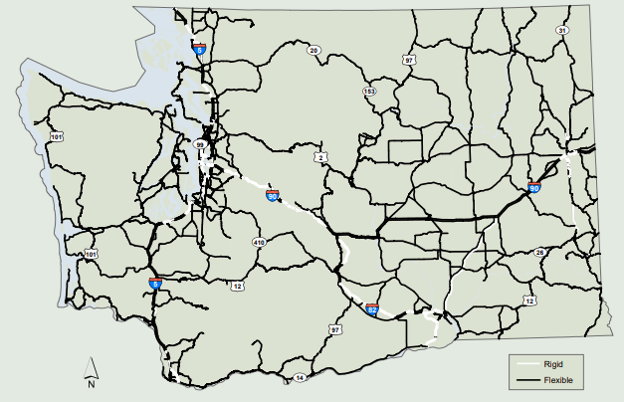
Figure 1- Map of Road Type in Washington State; Rigid corresponds to concrete and Flexible to asphalt (WSDOT 2007)
Sediment analysis is not the only way of measuring metal contamination; benthic invertebrates can also give us a proxy to metal contamination in the environment. The Mussel Watch Project has studied concentrations of metals and hydrocarbons in sediments and the tissues of mussels and oysters across the United States to determine the status of chemical concentrations in coastal and estuarine communities. Mollusks are powerful indicators of local metal contamination due to their filter feeding survival strategy; they concentrate the chemicals from the water in their tissues and typically do not travel much throughout their lifespan (O’Connor, 2002). Despite this, a 2002 study of USA mollusk contamination distribution found that the maximum concentrations of Cd, Hg, Pb, and Ni were observed to be an order of magnitude lower in mollusks (as well as Cu and Zn in mussels, not found in oysters) than levels corresponding to adverse effects on survival, growth and reproduction (O’Connor, 2002). However, this study is almost twenty years old, and begs that newer research be done to assess contamination levels. Due to their ability to accumulate toxins through filter feeding without adverse effects, mollusks can be a dangerous vector for human toxicity when consumed, which is an issue of economic importance in the Puget Sound region.
The goal of this study is to determine the presence and pattern of heavy metal contamination in benthic sediments and invertebrates and to explore the connection to road activity. Copper, chromium, nickel, lead, and zinc, metals associated with road material and harmful in high doses, will be metals of interest in this study. Other harmful metals, such as arsenic and selenium, will also be investigated due to their toxicity to humans (Mandal and Suzuki, 2002). In this study, benthic sediment samples were taken from locations with road influence in Lake Washington, Portage Bay, and Puget Sound as well as control samples farther from the influence of road activity and road runoff. We will consider grain size in the analysis of metal contamination, as metals accumulate more easily in finer sediments than coarse (Bloom and Crecelius, 1987). We hypothesize that we will see elevated metal content near areas of road runoff influence, and lower content in the control sites farther from road influence.

Methods
Sample Collection
Sample sites were chosen based on proximity to road-sourced runoff (figure 2). Sites AM02, AM09, and SB02 were in close proximity to populated shorelines and the major highway floating bridges. Site AM04 was within the shipping canal between Lake Union and the Ballard Locks, and underneath SR-99. This location was very heavily urbanized and was expected to yield very high metal contamination due to surface runoff as well as shipping activity. AM05 was near the Nisqually River Delta. A major freshwater source to South Puget Sound, the Nisqually River cuts beneath sections of I-5. Sites AM08 and AM06 correspond to Budd and Henderson Inlets, which are inlets of South Puget Sound and are within local watersheds exposed to the runoff of downtown Olympia and residential areas, respectively. Site locations and their descriptions can be seen in Table 1 and Figure 2.
Three of the experimental sites were within Lake Washington near the SR-520 and I-90 bridges, one within the Lake Union ship canal, and three in South Puget Sound near the Nisqually river delta, Henderson Inlet, and Budd Inlet. Control sites were chosen to be farther away from road runoff within the same catchments of Lake Washington (near St. Edward State park) and South Puget Sound (within Case Inlet).
Sediment samples were collected from the R/V Rachel Carson at the chosen sites on January 11-13, 2019 through use of Shipek grab which brought up the top ~10 cm of benthic sediment. A subsample of each grab was taken for metal and grain size analyses, and stored in labelled Ziploc bags in the on-board freezer. The remainder of the sediment from each site was sieved through 64 um filters to separate invertebrate samples. Invertebrate specimens were rinsed with DI water and stored in the on-ship freezer under guidance of Kathy Newell.
Table 1- Sample Site Locations and Descriptions
Site | Location | Latitude | Longitude | Sampling depth
AM01 | Lake Washington Control – St. Edward State Park | 47.731 N | 122.265 W | 20 m
AM02 | Lake W. NW 520 Bridge | 47.642 N | 122.274 W | 57 m
SB02 | Lake W. SE 520 Bridge | 47.635 N | 122.246 W | 37 m
AM04 | Shipping Canal – under I-99 | 47.647 N | 122.347 W | 12 m
AM05 | South Sound – Nisqually R. Delta | 47.109 N | 122.704 W | 29 m
AM06 | S. Sound – Henderson Inlet | 47.156 N | 122.834 W | 14 m
AM07 | S. Sound – Case Inlet | 47.236 N | 122.847 W | 80 m
AM08 | S. Sound – Budd Inlet | 47.087 N | 122.921 W | 19 m
AM09 | Lake W. I-90 & Mercer Is. | 47.580 N | 122.201 W | 12 m

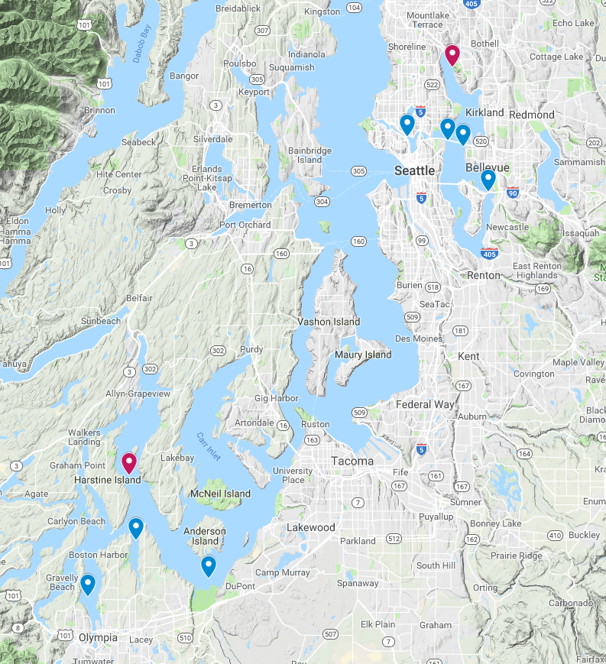
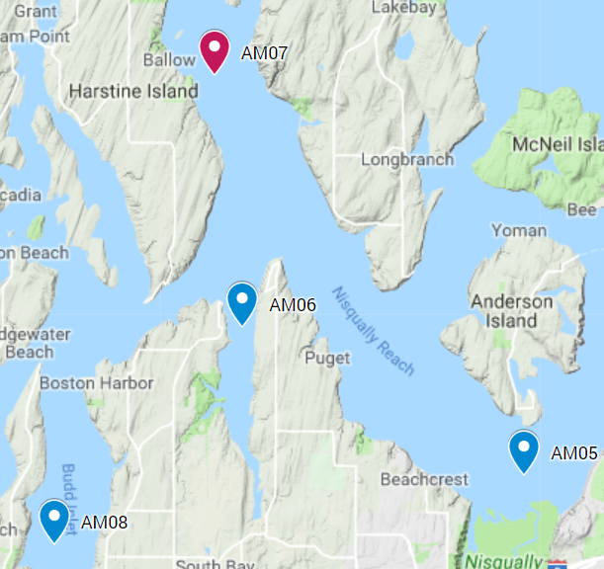 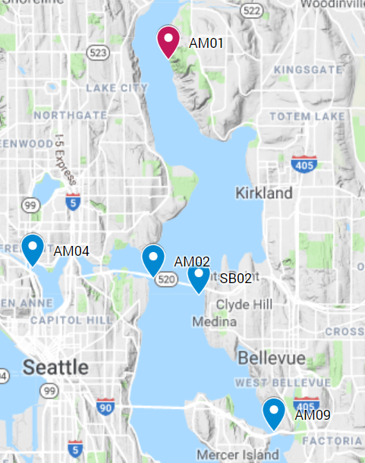Figure 2 - Site Locations in Puget Sound region

Grain Size Analysis
Two samples of 4 g and 1 g were removed from each site’s collected sediment sample. These were then sonicated for 30 minutes with a dispersant solution of 0.05% sodium hexametaphosphate ((NaPO3)6). Sediment was then filtered through 63 um sieve into a pre-weighed glass bottle using DI water. Samples of 4 g were placed in a Coulter Counter at the University of Washington for grain size distribution of silt and clay particles. The 1 g samples were split between sand particles trapped in the 63 um sieve and sand-silt particles which fell through. These samples were oven dried at 60°C in pre-weighed containers, and then re-weighed to calculate dry weight distribution of sand and non-sand (silts and clays). With percent sand from dry weight measurement of the 1 g samples and percent silt and percent clay measured from the Coulter Counter, 3-bin grain size distribution for the eight sites.
Metal Contamination Analysis
20 mL samples of sediment from each site were oven dried at 60°C for 72 hours before being ground with mortar and pestle into a very fine, near-homogenous sediment. Similarly, invertebrate samples from the sites with enough biomass were treated with oven drying and ground into a fine powder. Samples were sent to Dr. Xue’s metal analysis lab in School of Forestry to analyze metal content in units of µg/g. Samples were digested in acid in accordance with the EPA 3050B method to be analyzed through plasma-atomic emission spectrometry (ICP-AES) for the following metals: Al, As, B, Ba, Ca, Cd, Cr, Cu, Fe, K, Mg, Mn, Mo, Na, Ni, P, Pb, S, Se, Zn, Si, and Ag. Metals found between the detection limit and quantitative limit were deemed to have been found in trace amounts, and beneath the detection limited were noted as ‘not detected’ (Table 2). Metal concentrations (µg/g) were calibrated relative to naturally-occurring abundance relative to Aluminum levels in samples (Table 3) through Equation 1,
$$Equation 1: EF={(C}_{M}/C_{Al})exp⁡/ (C_{M}/C_{Al})avg$$
where EF is the enrichment factor, $C_{M}$ is the concentration of the metal, $C_{Al}$ is the concentration of Aluminum, and the ratio between them at experimental sites is divided by the $C_{M}/C_{Al}$ earth-shale average (Brumsack, 2006).
Table 2 - Metal Concentration (µg/g) in samples with quantitative and detection limits (control sites highlighted) *ND = not detected (beneath detection limit); ^TR = trace (above detection limit but below quant limit); +Marine Sediment Quality Standard for Washington State (EPA 2013)
Site | Al | As | Cd | Cr | Cu | Ni | Pb | Zn | Se
AM01 | 5149 | ND* | ND | 22.60 | 12.78 | 32.45 | 52.24 | 31.18 | 102.2
AM02 | 8702 | ND | ND | 38.52 | 37.89 | 44.05 | 118.60 | 111.42 | 160.0
SB02 | 14975 | ND | TR^ | 53.74 | 66.72 | 71.50 | 248.38 | 219.52 | 309.8
AM04 | 6770 | ND | ND | 45.94 | 176.93 | 48.24 | 191.25 | 263.78 | 186.2
AM05 | 2854 | ND | ND | 13.26 | 10.04 | 12.06 | 30.42 | 16.35 | 71.36
AM06 | 10022 | TR | ND | 33.03 | 29.63 | 37.89 | 85.40 | 60.30 | 188.6
AM07 | 9469 | ND | ND | 32.95 | 27.90 | 39.30 | 81.35 | 59.70 | 186.2
AM08 | 17529 | ND | ND | 41.33 | 48.57 | 46.19 | 115.23 | 86.44 | 257.0
AM09 | 8651 | 35.34 | TR | 45.56 | 35.72 | 62.20 | 178.11 | 137.25 | 316.4
AM06 (INV) | 845 | ND | ND | 32.45 | 17.76 | 24.71 | 100.93 | 96.58 | 101.2
AM07 (INV) | 3751 | 38.84 | ND | 0.00 | 32.29 | 33.05 | 0.00 | 87.99 | TR
WA State Standard+ |  | 57 | 5.1 | 260 | 390 |  | 450 | 410
Quantitative Limit | 0.13 | 0.11 | 0.15 | 0.14 | 0.06 | 0.03 | 0.23 | 0.10 | 0.49
Detection Limit | 0.039 | 0.032 | 0.046 | 0.042 | 0.019 | 0.008 | 0.070 | 0.029 | 0.147

Results
Enrichment factors (EFs) were calculated using Equation 1 for key metals (Pb, Ni, Cu, Cr, and Zn) which were found above trace concentrations (Table 3). Sediments from each site displayed elevated enrichment factors of these metals relative to enrichment factors found in average earth-shale (Brumsack, 2005). An enrichment factor greater than 1.0 corresponds to a higher metal concentration than in average earth crust. Invertebrate enrichment factors were calculated against previous studies which measured metal content (μg/g) in soft tissues and shells of the South East Asian snail Indothais gradata and Black Sea mussel Mytilus galloprovincialis (Proum et al., 2016; Demina et al., 2015).
Lead was found to exceed average earth concentrations by two to three orders of magnitude; this remained true at control sites as well, though they exhibited generally-lower concentrations. Arsenic was not detected at most sites, but was found with an enrichment factor of 37.1 in Lake Washington near the I-90 Bridge and Mercer Island. The ship canal sample saw higher metal enrichment factors in all metals than nearly all other samples, particularly lead (113.0), zinc (35.4), and copper (51.2). Copper was found at enrichment factors greater than 1.0 throughout the sampling, averaging 6.8 not including the highly-enriched shipping canal sample. Selenium was not initially a metal of interest, traditionally being sourced from industrial mining and having little relation to road material. However, the observed concentrations of selenium was very high; selenium concentrations rarely exceed 0.1 ug/g in sedimentary rocks and only reported in this observed triple-digit range in black shales and some phosphatic rocks (Fordyce, 2007). With an enrichment factors 4 orders of magnitude higher than average shale (Figure 4), selenium appears to be a highly-concentrated contaminant in the region’s sediments (Turekian and Wedepohl, 1961). Tables 4 and 5 lists simplified enrichment factor ranges of these metals in sediments and invertebrates, respectively, along with their average and observed range.
Grain size distribution was calculated through the Coulter Counter which produced quantitative distribution of incremental grain size bins. These bins were simplified into three bins for the grain diameters corresponding to sand, silt, and clay particles. Despite efforts to choose sites with finer grain diameters (i.e. more silts and clays than sands), sediment grain size was not uniform throughout the sample sites. The sites with the greatest distribution of coarse sediment were the ship canal and Nisqually River Delta sites. Mean and standard deviation of grain size varied between sites, adding some complexity to direct comparison of metal contamination. For instance, despite the coarser sediment, the ship canal sample exhibited the greatest contamination of metals. Figure 3 below demonstrates the respective enrichment factors of metals of interest and grain size distribution by sampling site.

Table 3 - Enrichment Factors, relative to metal:Al ratio in average earth-shale. Control sites highlighted
Site # | Location | As |  |  | Cr | Cu | Ni | Pb | Zn | Se
AM01 | L. Wash. St. Edwards St. Park | N/A |  |  | 4.30 | 4.87 | 8.19 | 40.58 | 5.51 | 2647
AM02 | L. Wash: NW 520 Bridge | N/A |  |  | 4.34 | 8.54 | 6.57 | 54.52 | 11.64 | 2452
SB02 | L. Wash: SE 520 Bridge | N/A |  |  | 3.52 | 8.74 | 6.20 | 66.35 | 13.33 | 2758
AM04 | Ship Canal | N/A |  |  | 6.65 | 51.24 | 9.25 | 112.99 | 35.42 | 3336
AM05 | Niqually River Delta | N/A |  |  | 4.55 | 6.90 | 5.49 | 42.63 | 5.21 | 3334
AM06 | Henderson Inlet | N/A |  |  | 3.23 | 5.80 | 4.91 | 34.09 | 5.47 | 2509
AM07 | Case Inlet | N/A |  |  | 3.41 | 5.78 | 5.39 | 34.37 | 5.73 | 2622
AM08 | Budd Inlet | N/A |  |  | 2.31 | 5.43 | 3.42 | 26.29 | 4.48 | 1955
AM09 | L.Wash – I-90 Bridge | 37.14 |  |  | 5.16 | 8.10 | 9.34 | 82.35 | 14.42 | 4876
AM06 (INV) | Henderson Inlet |  | N/A | 6.05 |  | 2.01 | 11.77 | 32.88 | 0.78 | 844.7
AM07 (INV) | Case Inlet |  | 6.44 | 0.03 |  | 3.66 | 15.74 | 0.08 | 0.71 | ND

Table 4 - Metal Enrichment Factor Ranges, bold for emphasis
Metal | EF Range (N=8) | EF mean | EF median | EF Standard Deviation | Notes
Cr | 2.31-6.65 | 4.16 | 4.30 | 1.19 | Trace Cr found in inv-control sample
Cu | 4.87-51.2 | 11.71 | 6.90 | 14.04 | High outlier – ship canal
Ni | 3.42-9.33 | 6.53 | 6.20 | 1.91 | Higher EF in control site
Pb | 26.3-113.0 | 54.91 | 42.63 | 26.43 | Trace Pb found in Inv-control sample
Zn | 4.48-35.42 | 11.25 | 5.73 | 9.30 | High outlier – ship canal
As | 37.14 | 37.14 | 37.14 | N/A | Only found in 1 sed/1 inv sample
Se | 1955-4876 | 2980 | 2647 | 818.6 | Extremely high amounts found at all sites

Table 5 - Invertebrate Enrichment Factors
Metal | Invertebrate Range (N=2) | Notes
Cr | 0.02-6.05 | High Cr found at Henderson Inlet
Cu | 2.01-3.66 | Higher Cu found at control site (Case Inlet)
Ni | 11.77-15.74
Pb | 0.078-32.88 | High Pb found at Henderson Inlet, low concentration at control
Zn | 0.71-0.78 | Low Zn in both locations
As | 0-6.44 | Only found at control site
Se | 0-844.7 | Only found at Henderson Inlet
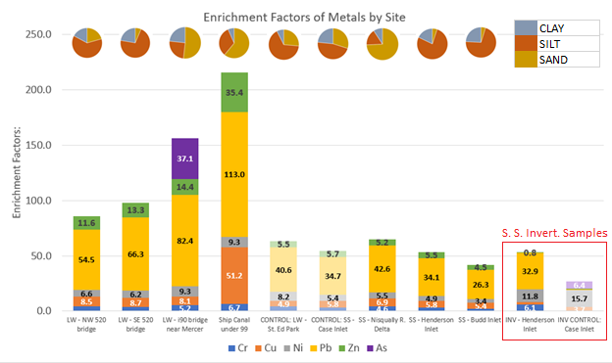
Lake W. & Canal (fresh w.)
South Sound (salt w.)
Figure 3- Site Enrichment Factors and Grain Size Distribution (LW = Lake Washington, SS = South Sound)

S. S. Invert. Samples
Figure 4- Selenium Enrichment Factors (LW = Lake Washington, SS = South Sound)

Discussion
The results of this experiment tell us, broadly, that heavy metals are pervasive in the benthic sediments of the aquatic and estuarine environments of lowland western Washington. Metals such as lead and selenium were found in high enough concentrations that suggest a business-as-usual approach to runoff and wastewater management will not be enough to prevent ecological, economic, or potentially human health harm.
Sediment Metal Contamination
In comparison to earth shale average concentrations (Brumsack 2006), metal enrichment factors were found well above 1.0 for every key metal analyzed from sediment at every site, indicating a strong amount of metal contamination in Lake Washington and south Puget Sound (Table 3). The freshwater sediments from Lake Washington and the shipping canal were more contaminated than those in South Sound, which agrees with the relative amount of urban development between the two areas (Table 3, Figure 3). The sites with the highest amounts of metal contamination overall were the shipping canal underneath the Interstate-99 Bridge and Lake Washington near the Interstate-90 Bridge and Mercer Island (Figure 3). When considering grain size distribution, the shipping canal site appears to exhibit even greater metal contamination; this site had the greatest proportion of sand-sized sediment particles and still exhibited the highest degree of metal concentration. Under this context, this site exhibited even greater metal contamination relative to the other sites. As a high-volume shipping canal in an urban setting, this is not a surprise. However, if the city of Seattle considers the metal pollution of its shipping canal to be of concern, then this could be important for them to consider.
Other sites with relatively coarse grain size distribution, thus higher relative metal contamination, include the Nisqually River Delta (AM05, 74.3% sand) and Lake Washington Mercer Island (AM09, 51.8% sand) sites. The toxic metal Arsenic that is easily engrained in food webs, was found in extremely high abundance at the Mercer Island site with an enrichment factor of 37.1. Arsenic was however not found in any other sediment sample. A naturally-occurring toxin, arsenic was previously used as a pesticide, and continues modern use as an industrial alloying agent and in the production of glass, metals, pigments, and ammunition and is a byproduct of copper and coal mining. This site was likely contaminated from bridge construction or from the nearby Mercer Slough which carries runoff from Bellevue to Factoria. Other toxic metals, such as copper (EF = 11.7), nickel (EF = 6.5), and lead (EF = 54.9), were found to have high mean enrichment factors well above 1.0 at each site. Control sites saw lower Cu and Pb concentration relative to experimental sites, supporting the hypothesis that samples farther from influence of road runoff would exhibit lower levels of these road-based contaminants.
Selenium, while not an initial target of this study due to its lack of connection to road materials, was found in such high quantities (4 orders of magnitude above earth shale average) that it should be emphasized as a toxic problem in our community, considering its harmful potential to human health. One possible explanation for the high selenium content is the high concentration of selenium in igneous rock, a common rock type in the Pacific Northwest (Malisa, 2001). Selenium content may source from the Cascade Mountains and have been transferred to the region via weathering processes and rivers. Mining activity in the mountains may have also contributed; selenium can be found in concentrations up to 12 mg/L in mining wastewater (Santos et al., 2015), so the history of mining in the region may have contributed to the high concentrations found in sediment samples. Selenium has also been associated with constructed wetlands, oil transport and refining, and feedlot waste (Lemly, 2004). It would be useful to compare selenium concentrations in the sediment with water column measurements; reduced mining activity in recent years should coincide with reduced selenium content in the water if mining is indeed the primary source.
The observed metal concentrations, though high relative to average earth shale, are still beneath the Washington State Marine Sediment Quality Standard for the elements arsenic, cadmium, chromium, copper, lead, and zinc (Table 2). These concentrations are deemed those which will result in “no acute or chronic adverse effects on biological resources and no significant risk to humans” (EPA Sed. Mar. Qual. Stan., 2013). This could suggest that the standard is lax on metal contamination or that contamination in the region is not at concerning levels.
Invertebrate Metal Contamination
Invertebrate samples were collected from 4 of the 9 sites, but only in sufficient masses (> 0.1 g dry weight) at 2 sites: Henderson Inlet and the control site at Case Inlet, both in South Sound. The collected and tested organisms were unidentified brittle stars (class Ophiuroidea). With such a small sample, only able to be analyzed at two sites, it is difficult to draw meaningful conclusions. The control site invertebrate tissue saw elevated nickel (EF = 15.7) and arsenic (EF = 6.4) when compared to the Henderson Inlet experimental site (EF = 11.8 and not detected, respectively). Yet the experimental site saw heightened lead (EF = 32.9) and chromium (EF = 6.1), neither of which were detected at the control site. These effective enrichment factors were calculated with respect to metal contamination of invertebrate tissue found in previous studies (Demina 2015, Proum 2016). This stark contrast in metal concentration could be indicative of the relative isolation of the control site. Case Inlet, sandwiched between Harstine Island and southern Kitsap Peninsula, receives surface water from the surrounding rural lands dominated by agriculture, a potential source of the arsenic found in the invertebrate tissue. Henderson Inlet, however, is closer to a watershed which includes sections of I-5, and is closer to the more industrial and ship-trafficked waters of Olympia.
Previous studies have delved into heavy metal contamination in marine organisms and the resulting effect on the food web. In a 2011 review of studies concerning metal contamination in bivalves along China’s coast (Pan and Wang, 2011), researchers compiled data from previous studies where bivalves were tested for the presence of Cd, Zn, Cu, Pb, Ni, Cr, and Hg to determine the degree of contamination and differences in metal accumulation between species. The degree of metal contamination varied by species of organism and type of metal, so the issue of determining the extent of contamination is complex. Having only a few classes of organisms to analyze makes it difficult to claim anything more than broad observations of contamination. Bioavailability of metals has been found to depend on processes such as chemical speciation, competition between sediment metals for uptake, and influence by bioturbation, salinity, and pH (Bryan and Langston, 1991). Some heavy metals, such as cadmium and lead, have been found to be widely toxic to marine organisms as well as humans (Storelli, 2008). However, cadmium has been found to have a biological role in marine diatoms during a period of low available zinc, so it is important to consider how intertwined with ecology the presence of a metal may be, and not to assume that all traces are anthropogenic (Lane and Morel, 2000).
Connection to Road Runoff
This study hypothesized that elevated metal concentration would be observed near sources of road input relative to control sites farther away. To a general extent, this was observed, however there are more factors to consider before either fully supporting or refuting the hypothesis. Proximity to shipping activities and industry in general provide other sources of metal input which generally coincide with the spatial arrangement of roads. However, it is difficult to confirm whether these differences are due to road-sourced metal contamination. Spatial analysis of watershed dynamics would be an impactful addition to this study to make for a more accurate and precise conclusion, while also considering the processes which govern the influence of other source pollutants.
Conclusion
The findings of this study suggest that metal content in Puget Sound and Lake Washington sediments may be of concern to the local ecology and potentially human health. Lead content was elevated by one to two orders of magnitude over earth-shale averages, which could be an issue that needs to be addressed by policy makers. Elevated nickel content of greater than an order of magnitude in both invertebrate samples, as well as elevated nickel in all sediments, suggest that nickel is a metal that is contaminating local waters similarly to lead, albeit to a lesser degree. Sites such as the shipping canal appear to be so contaminated with heavy metals that more hyper-focused studies should be done to assess the extent of contamination and mitigation strategies. Despite these findings relative to earth-shale averages, all samples were beneath the Washington State Marine Sediment Quality Standard set in 2013 (EPA, 2013).
Though road runoff appears to be correlated with copper, lead, and nickel entering marine and aquatic sediments, the streams, rivers, lakes, and canals which make up the Puget Sound watershed form a dynamic system that is difficult to make concrete conclusions about. More research needs to be done on the runoff pathways and circulation patterns in the region in order to produce a more precise assessment of metal contamination sources.

Acknowledgements
I would like to thank the captain and crew of the R/V Rachel Carson for their expert navigation, implementation of machinery, and accommodation for our science cruise. Special thanks as well to science advisor Julian Sachs and faculty Kathy Newell for their assistance throughout the data collection, analysis, and writing portions of this research. Fellow senior oceanography students James Scukas, Monique Bell, and Signe Bergman for collaboration on this process through overlapping sampling, ship time, and analysis. Thank you to the Ogston Lab at the School of Oceanography, University of Washington for use of their Coulter Counter, and Robin McLachlan for assistance with the instrument. Thank you to Dr. Dongsen Xue of the School of Forestry, University of Washington for performing the trace metal analysis. Finally, thank you to the School of Oceanography as a whole for providing the means and the opportunity to perform undergraduate research.

References:

Bloom NS, Crecelius EA, 1987. “Distribution of silver, mercury, lead, copper, and cadmium in central Puget Sound sediments.” Mar. Chem. 21(4): 377-390.

Brumsack H, 2006. “The trace metal content of recent organic carbon-rich sediments: Implications for Cretaceous black shale formation.” Palaeogeography, Palaeoclimatology, Palaeoecology 232: 344-361.

Bryan GW, Langston WJ, 1991. “Bioavailability, accumulation and effects of heavy metals in sediments with special reference to United Kingdom estuaries: a review.” Environmental Pollution 76: 89-131.

Chapman P, Wang F, 2001. “Assessing sediment contamination in estuaries.” Environmental Toxicology and Chemistry 20: 3-22.

Christoforidis A, Stamatis N, 2009. “Heavy metal contamination in street dust and roadside soil along the major national road in Kavala’s region, Greece.” Geoderma 151: 257-263.

Demina, L., et al., 2015. “Trace metal accumulation in carbonate biominerals of the Atlantic Ocean.” Oceanology 56: 131-136.
Duong T, Lee B, 2010. “Determining contamination level of heavy metals in road dust from busy traffic areas with different characteristics.” Journal of Env. Management 92: 554-562.

EPA, 2001. “Trace Elements in Water, Solids, and Biosoilds by Inductively Coupled Plasma-Atomic Emission Spectrometry.” Revision 5. United States Environmental Protection Agency.

EPA 2013. “Sediment Management Standards” Department of Ecology, State of Washington. United States Environmental Protection Agency. Chapter 173-204 WAC.

Fordyce F, 2007. “Selenium Geochemistry and Health.” Ambio 36: 93-97

Gregory M, 2009. “Environmental implications of plastic debris in marine settings—entanglement, ingestion, smothering, hangers-on, hitch-hiking and alien invasions.” Philosophical Transcations of the Royal Society B 364: 2013-2025.
Hubner R, et al., 2009. “Comparison of sediment quality guidelines (SQGs) for the assessment of metal contamination in marine and estuarine environments.” Journal of Environmental Monitoring 11: 713-722.
Lane TW, Moral MM, 1999. “A biological function for cadmium in marine diatoms.” Proc. Natl. Acad. Sci. 97: 4627-4631.

Lemly AD, 2004. “Aquatic selenium pollution is a global environmental safety issue.” Ecotoxicology and Environmental Safety 59: 44-56.

Malisa, EP, 2001. “The behavior of selenium in geological processes.” Environmental Geochemistry and Health 23: 137-158.

Mandal B, Suzuki K, 2002. “Arsenic round the world: a review” Talanta 58: 201-235.
Nagajyoti PC, Lee KD, Sreekanth TVM, 2010. “Heavy metals, occurrence and toxicity for plants: a review.” Environ Chem Lett 8: 199-216.
O’Connor T, 2002. “National distribution of chemical concentrations in mussels and oysters in the USA.” Marine Environmental Research 53: 117-143.

Pan K, Wang W, 2011. “Trace metal contamination in estuarine and coastal environments in China.” Science of the Total Env. 421-422: 3-16.

Proum S, et al., 2016. “Metal accumulation in the tissues and shells of Indothais gradata snails inhabiting soft and hard substrata in an acidified tropical estuary (Brunei, South East Asia)” Regional Studies in Marine Science 8: 487:497.
Santos S, et al., 2015. “Selenium contaminated waters: An overview of analytical methods, treatment options and recent advances in sorption methods.” Science of the Total Environment 521-522: 246-260.
Schindler D, et al., 2006. “A review of anthropogenic sources of nitrogen and their effects on Canadian aquatic ecosystems.” Biogeochemistry 79: 25-44.

Storelli MM, 2008. “Potential human health risks from metals (Hg, Cd, and Pb) and polychlorinated biphenyls (PCBs) vis seafood consumption: Estimation of target hazard quotients (THQs) and toxic equivalents (TEQs).” Food and Chemical Toxicology 46: 2782-2788.
Sunda WG and Huntsman SA, 2000. “Effect of Zn, Mn, and Fe on Cd accumulation in phytoplankton: Implications for oceanic Cd cycling.” Limnology and Oceanography 45(7): 1501-1516.
Turekian K and Wedepohl K, 1961. “Distribution of the Elements in Some Major Units of the Earth’s Crust.” Geological Society of America 72: 175-192.
Wahba ZZ, et al., 1993. “Protective effects of selenium on cadmium toxicity in rats: Role of altered toxicokinetics and metallothionein.” J. Toxicol. Environ. Health 38: 171-182.
WSDOT, 2007. “Highway System Plan Chapter – Pavement”

