An Assessment of Noise Pollution Propagated by WSDOT Ferries in the Puget Sound

Jenna Barrett

School of Oceanography
Box 355020
University of Washington
Seattle 98195, USA

Barrej6@uw.edu

Abstract
Increasing ferry traffic in the Puget Sound and Salish Sea raises concern for marine mammals due to noise pollution. This is not a topic of major environmental concern in the design process for future ferry generations. The factors of vessel type that influence noise levels are not known, and thus not used as a means of minimizing noise pollution. For the sake of sustaining future marine mammal populations in an environment of growing vessel traffic, this project tested the levels of noise pollution from two class of ferries in the Puget Sound. Multiple linear regressions with interactions and ANOVAs determined the relationships between continuous and categorical variables. Results determined one or more categorical variables influence SPL and kinetic variables that influence SPL are acceleration and range. These data are useful in quantifying the current acoustic overlap for different marine mammal groups and in minimizing the noise levels of new ferries.

Introduction
Today most people reside and cities function within proximity to water (Small and Nicholls, 2003). As populations continue to grow, cities will expand inland while people continue to develop coastlines for residency. The demand for public transportation has grown as a cheap, and often quicker alternative to driving through busy towns and cities. Particularly among coastal regions, technological advances have utilized water as an added mode of public transportation. In the United States, the rate of gross domestic product spent each year on water transportation was about $0.67 billion in 1995 (U.S. Department of Commerce). As of 2016, water taxis and ferries provide commute routes for over 100 billion people in the U.S. and the demand is increasing every year (U.S. Department of Transportation). Although convenient, this upward trend in use of ferries raises the concern of two major environmental concerns: carbon emissions and noise pollution.
A review of technical reports (i.e. new designs, long-term plans) demonstrated lack of mention of noise pollution as environmental concerns (Laughlin 2015; Radan; Hendrix and Ayers 2018). In reports where the topic is addressed, statements regarding minimizing noise levels are not supported by statistical summaries and limited compared to the extent at which carbon emissions were supported. This suggests a demand for acoustic sampling so that all possible detrimental anthropogenic impacts are properly mitigated. In this case, discontinuities in environmental consulting puts marine mammals at risk of being subject to noise pollution impacts. Groups of cetaceans and pinniped are commonly found in proximity to commercial vessel traffic and are especially vulnerable to harm from noise levels due to their reliance on audition as their primary sensory mechanisms (Merchant et al. 2013, Deeke 2010).
It is relevant to quantify the noise pollution impact from ferries on cetaceans (toothed whales, baleen whales, and pinnipeds) because they are examples of ecologically, culturally, and economically valuable groups. Ecologically, groups like toothed whales are often labeled as top predators in their ecosystems which subjects an equilibrized food web to top-down trophic cascades (Ford et al. 2006). Other groups, such as baleen whales are key players in facilitating the biological pump (Roman and McCarthy 2010). Toothed whales are often a focus in traditional cultures and can be the foundation of an individuals’ livelihood. For example, Orcinus orca, or killer whales, hold cultural and spiritual meaning in many First Nations tribes in the Pacific Northwest and south-eastern Canadian regions (First Nations). On an economic scale, all groups of cetaceans partake in supporting tourist economies, especially in locations where the resident groups are rare (EPA and Ford et al. 2006). In a report on Southern Resident Killer Whales published by the Environmental Protection Agency (EPA), whale watching and wildlife watching produced an approximate $1.78 billion in profits and maintained about 22,000 jobs from 1998-2001. Overall, the importance of sustaining cetacean populations is directly associated with maintaining traditional culture and ecosystem stability while also supporting tourist economies.
Chronic noise effluent from ships can cause behavioral and/or physiological responses in cetaceans by producing SPLs which overlap with respective third-octave critical bandwidths (Richardson et al. 1995; Erbes 2001; Jensen et al 2009). The critical bandwidth, or “range of best hearing” within one-third bands varies by group (i.e. toothed whales, pinnipeds, baleen whales); the relative minimum and maximum frequency values are defined by the relative quotient or product of center frequency and 2^{1/6} (Richardson 1995). Richardson et al (1995) compiled experimental pure-tone hearing tests to define four zones of marine mammal acoustic impact: 1) The zone of audibility refers to perceived sound levels that are detectable, 2) the zone of responsiveness is the sound level which causes a behavioral or physiological response (i.e. stress levels), 3) the zone of masking is defined as the sound levels that partially or entirely overlap with the critical bandwidths, and 4) the zone of injury which equates to a sound level high enough to cause physical harm. Modified source pressure levels to TOLs (eq. 1) will identify the cetacean group that is vulnerable to ferries and may be experiencing behavioral or physiological responses such as increased stress levels or abnormal dive patterns (Williams et al, 2009, Madsen et al. 2006, Holt and Noren 2008). These data can be used as baseline estimates in future field studies to refine biological thresholds in different cetaceans.
Marine mammal vulnerability to noise pollution is positively associated with high vessel traffic (Jensen et al 2009) and will likely increase without variable controls. This study was conducted in the Puget Sound where cetaceans are prominent and ferry traffic, among other commercial and recreational categories, is trending upwards. A recent assessment of the background sound levels produced by ferries in the Puget Sound determined the 50% Cumulative Distribution Function third-octave RMS levels that correspond to marine mammal functional hearing groups (Laughlin 2015). Whereas the direct function of these values was unclear, other studies have used similar values against pre-determined audiograms and defined the SPLs at which the noise pollution is partially or fully interfering with signal reception, or potentially causing harm (Madsen et al 2006). It was concluded from Laughlin (2015) that ferries make up most of the background noise in the Puget Sound and now the Washington State Department of Transportation (WSDOT) has recently published a detailed report of their 20-year plan to reinvent the ferry fleet. This report presents an opportunity to modify the influence of ferries on background sound levels and explicitly states the intention to reduce noise pollution. Studies such as this one will ensure similar plans have defined loudness thresholds as guidelines upon which to design environmentally friendly ferries. Currently, the ferry system is the largest in the United States and transports more than twenty-two million passengers every year. It is already known that ferries comprise most of underwater ambient background noise in the Puget Sound (Laughlin 2015) and these levels will likely increase to accommodate increasing travel demands. Thus, the relevance of a detailed acoustic analysis will aid in mitigating marine mammal impacts from noise pollution.
Acoustic samples fixed for transmission loss (eq. 1) are used as source power levels. These work to derive associations between source power levels and continuous variables and identify significantly different interactions between categorical variables. Based on relative literature about vessel noise, two independent variable groups with multiple levels have the potential to influence sound power levels: categorical ship attributes (i.e. size, shape, # of engines) (Lurton 2010; Mckenna et al. 2011; Hicks and Hubbard 1947; McKenna et al. 2011; Houghton et al. 2015) and kinetic variables (i.e. range, speed) (Lurton, 2010, McKenna et al. 2011). The level of influence each factor has on the source power levels can be statistically summarized and the range will determine the extent of harmful noise pollution. Future generations of ferries will be modified in these terms just as carbon emissions statistics have led to designing innovative carbon efficient vessels.
This project aims to quantify the noise pollution produced by WSDOT ferries in the Puget Sound. The variances among classes will be used to gather more detail regarding key factors influencing high SPL. This project surveyed two different vessel classes, Jumbo and Olympic. A single hydrophone will be deployed off the stern of R/V Rachel Carson at about 10 m depth as it drifts approximately 100 m from ferry transects. Approximately 22 minutes of acoustic recordings from two Jumbo crossings at the Edmonds-Kingston terminal and one Olympic crossing at the Mukilteo-Clinton terminal was taken over the course of two days. The first hypothesis is that class will influence the SPL of ferries; on average Jumbo class ferries will be significantly higher than the Olympic class. Under the condition that hypothesis one is true, it is hypothesized that range will have the most significant influence on received sound levels. Finally, also under the condition of accepting hypothesis one, the it is hypothesized that acceleration, speed, then propeller type, number of engines, and finally levels of horsepower will be the order for significance in influencing SPL.
Methods
Data collection
This project surveyed three different vessel classes, from largest to smallest, these are: Jumbo class, Olympic class, Kwa-di Tabil class. A single hydrophone was deployed off the stern of a stagnant R/V Rachel Carson at about 10 m depth. The hydrophone is an early model of the Cetacean Research™ nano Remote Underwater Digital Acoustic Recorder (nRUDAR-mk2™) developed by the Cetacean Research Lab and was calibrated to 200 Hz. Records of four departures for a total of eight crossings were taken over the course of two days at the Mukilteo-Clinton (Olympic Class), Edmonds-Kingston (Jumbo Class), and Point Defiance-Tahlequah (Kw-di Tabil Class) ferry terminals. The weather for both days was fair, with low wind speeds and some misty rain for the final recording. As recordings were being taken, ferry location and speed, as well as our own location was simultaneously recorded every 10-15 seconds using Cruise Mode on Ocean Explorer software. The R/V Carson was stagnant, but not anchored throughout recording with all main engines turned off. The only activated part of the R/V Carson was the hydraulic generators.
Starting at 8:55 AM on January 6, recording began at the Point Defiance-Tahlequah transect. The R/V Carson was centered at Dalco Pass (47”19.681’ N 122”30.549’ W) 0.23 NM from the Chetzmoka as it was departing the Tahlequah terminal; the measurements were recorded for the entire travel duration, ending 0.92 NM from the Carson. About 4 hours later, measurements began for two travel durations at the Edmonds terminal. The Carson was positioned offshore (47”48.924’ N 122”23.484’ W) nearest the Edmonds terminal about 0.68 NM from the WSF Spokane as it departed. Records were taken for 10 minutes until the ferry was 2.09 NM from the R/V Carson, and the closest measurement was taken at 0.34 NM. Beginning 8 minutes later, records of the WSF Walla Walla began 0.8 NM from the Carson as it approached the Edmonds terminal. Records were taken for 7 minutes and the closest distance reached was 0.28 NM. One hour later, the R/V Carson was positioned approximately midway through the Mukilteo ferry transect (47”58.408’ N 122”20.898’ W). The following information regarding the WSF Kittitas was not recorded by the hydrophone, but the speed and positions were still recorded and used for reference further in data analysis. The WSF Kittitas was recorded for 9 minutes from departure at about about 0.65 NM away, to arrival, at about 1.29 NM distance; the closest recorded distance was 0.21 NM. About 15 minutes later, the WSF Kittitas was recorded again along the same transect back to where it first departed. This time, the WSF Suquamish was running as well, but given the lack of recorded sound this was not an inconvenience. The next morning, January 7, 2019 at 10 am, the WSF Suquamish was recorded at the Mukilteo terminal. The R/V Carson was positioned in nearly the same spot along the transect (47”57.173’ N 122”18.787’ W). Recording occurred for 7 minutes as the WSF Suquamish was 0.6 NM away and traveling toward the Mukilteo terminal; the closest record was taken at 0.23 NM away.
Data analysis
Acoustic Data
The mp3 files containing the ship recordings were uploaded to the open-source digital audio editor and recording application software, Audacity. Since the R/V Carson could not be fully silent during recordings and background noise was being recorded, a 5-second sample of ambient background noise was used in the absence of ferries via the Noise Reduction effect in Audacity to eliminate non-ferry produced noise from acoustic signatures. To determine the viability of the acoustic data, the same effect was applied to the same background noise sample. The resulting intensity levels were used as a baseline for the acoustic data: any intensities below approximately -50 dB and ranges greater than 2 km were determined to not contain the target ferry and were eliminated from the data set. It is noted that this eliminated all data collected for vessels WSF Kittitas and WSF Chetzmoka; thus, this reduced the number of groups in the categorical class variable. However, based on the relative sizes and ranges, this did provide insight to the spatial extent of noise pollution from those classes.
Instantaneous intensity levels were derived from the recordings using fixed time intervals that were calculated per minute based on the number of screenshots taken for each recording session (e.g. if there were five screenshots taken in one minute, the intensity and frequency would be transcribed every 10 seconds within that relative minute). Using the number of screenshots per recording session and the duration of the session, these values at a given moment was translated to a spreadsheet (table 1). The screenshots obtained from the navigation software were also used to transcribe the relative ship, its class, its attributes (i.e. size, number of engines, horsepower), it’s traveling speed, and position relative to the R/V Carson to the same spreadsheet. The acceleration of each ferry was calculated and added to the table. Range, speed and acceleration were converted to units of meters and seconds to be used for acoustic equations. Lack of precision is noted for this method.
Source Pressure Level
An equation derived from the transmission loss in shallow water equation is used to eliminate the influence of distance on noise levels (Albers 1965).
I_{r} = I₀ – 20log(r) - ɑr + 10log∆f (equation 1)
Sound pressure level (SPL) (I₀) at 1 m distance is manipulated after undergoing spherical attenuation (20log(R)) and absorption (ɑ). The frequency bandwidth of the hydrophone (10log∆f) further fixes the SPL to finally determine the sound levels at any given range (I_{R}). Algebraic rearrangement of this formula provided the estimated source sound power level at any given range. For the purpose of this project, absorption due to an aqueous medium was not factored into transmission loss; absorption is the energy lost from heat production as sound waves travel. This effect is only relevant for frequencies above about 100 kHz (Albers 1965), thus not relevant for the sounds recorded for this project. The equation for transmission loss given in Albers (1965) was not compatible with the physical conditions in the Puget Sound during sampling. The general coefficient for shallow water attenuation was too small to fix I₀, so it was derived from the slope of a logarithmic linear regression and supported by a model that checked the influence of physical conditions over the depth and range. Only vessels with viable data were used in the regression (n=3). The slope was given using a summary function in R of the linear regression of each class which represented the rate of attenuation on a logarithmic scale. The Jumbo class data was statistically significant (F-statistic of 39 and p-value of 1.55 e^-7); thus, the slope derived from the logarithmic simple linear regression was used to produce a coefficient of -44.5. This value was much larger than the rate given as the coefficient in Albers’ transmission loss equation. The values for the absorption and frequency bandwidth terms were eradicated due to insignificant impacts on the magnitude of I₀ under these physical conditions. The improved transmission loss equation provided adequate SPL data (figure 3).
I₀ = I_{R} + 44.5log₁₀(r) (equation 2)
This project consulted a physical oceanographic expert, Eric D’Asaro to determine why the attenuation of sound was so much greater than spherical spreading rates. It was found that the difference in coefficients was due to reflection. A model populated with the physical water conditions and acoustic samples found sound speed variations between the vessels were determined to be very small, increasing slightly with pressure in an environment where the ranges were much longer than the water depth (D’Asaro). Essentially, the spherical spreading nature of the shallow-water coefficient is not applicable here because the sound is travelling in a cylindrical path. Thus, reflection against the sea surface and bottom causes greater attenuation of sound than spherical spreading.
Typically, an underwater acoustic analysis would include more variables when solving for SPL. These variables are absorption (eq. 1), bubbles, and refraction. It was already noted that the effect of absorption on sound with frequencies lower than 100 kHz is irrelevant (Albers, 1965). Bubbles have the potential to incorporate additional acoustic data towards a recording via bubbles produced from propellers or bubbles produced in the surface layer from wind and rain (Hicks and Hendricks 1947). The weather conditions during data collection were fair with no rain and very mild winds, so the effect from weather would most likely be insignificant. The effect from bubbles produced by propellers most likely would have most likely been significant, although the data was not available for the project. With this data, conclusions could have been drawn about the influence propellers have on noise pollution levels. Lastly, refraction was not used to determine source sound levels. Among the level of difficulty in finding fine-scale refraction degrees and the influence it has on sound velocity in terms of attenuation, there was a lack of data to attempt fixing the received sound levels by refraction. This data requires small resolution pressure, temperature, wave action, and sediment (i.e. scale and pattern) data that this project was unable to collect.
Kinetic Variables
A one-way ANOVA was used to test the influence class has on SPL. The statistical significance was determined by relative f-value and p-value. A boxplot demonstrated the influence class has on SPL as a proxy for size (fig. 4). Then, a linear regression with was performed to test for the influence range has on received sound level. This analysis was run on all classes given that attenuation rates are a function of the physical environment. The boxplot results will support the differences in magnitudes of received sound levels. Further intuitive inferences were made about the possible rate of attenuation for the omitted classes based on ranges and relative class size. A multiple linear regression with interactions was used to test the interaction between class and either speed or acceleration on SPL (fig. 5. If the interactions were significant, then the effect of acceleration or speed on SPL would be modified by the class category. If the interactions were insignificant, a multiple linear regression without interactions was run on class and either speed or acceleration to further test for independent associations between measured variables and SPL. The interaction t-value and p-value were used to determine the statistical significance of interactions; a t-value way larger than 0 along with a small p-value is significant.
Ship Attributes
To test for potential categorical independent variables which influence noise propagation, a one-way ANOVA will determine the difference in average SPL based on their associated variable. Statistical significance was determined by the f-value along with p-value. Furthermore, variables that proved to have association were used in a two-way factorial ANOVA test with a significant variable and class to determine the difference in mean SPLs between variables that share class. If the f-values and p-values were significant, it could be determined that the effect of a variable like weight on source sound levels is modified by class. It is noted that this method is limited by a lack of viable acoustic data. The decrease in sample size of varying classes limited the levels of each categorical group and would deter the test from depicting associations. The lack of variation between vessels within the same class also limited the statistical tests.
Results
Source Pressure Levels
The transmission loss equation that was fit with the calculated coefficient provided SPL (dB) that were not influenced by range. On average, Jumbo Class vessels produce 98.8 dB at 1 m distance, and Olympic Class vessels produce about 80.3 dB at 1 m distance (figure 5). A one-way ANOVA determined the difference in these averages was statistically signified by the class (f-value = 121 and p-value = 2.61e⁻¹⁶).
Kinetic variables
The influence of range on received sound levels is insignificant when tested for dependence on class, and is cannot be accepted nor rejected when tested independently. The simple linear regression determined that range dependent on class significantly produces point estimates based on a given value (p-value = 0.038, se = 0.003), but that assumption only accounts for 5% of the variance (figure 6). Jumbo vessels, when associated independently, significantly estimate predicted values (p-value = 9.931e⁻⁸, se = 0.003). This group still has an insignificant r² that explains 50% of the data, but a relatively high f-statistic of 41.19. The Olympic class concluded less of an association between range and received sound levels; only 11% of the variance is due to the range and the relatively high p-value of 0.078 was concluded with a low f-value of 3.47. The statistically significant standard error (0.004) accompanying the Olympic linear regression provided some relief to the insignificant f-value and p-value. Overall, these results cannot be accepted.
A multiple linear regression with interaction used on the source sound levels and acceleration with class determined that the effect of acceleration on source sound levels is slightly modified by class (figure 7a). The interaction is significant (p-value = 0.002), although the standard error and t-value is high (se = 96.69, t-value = 3.194). Independently, acceleration and class influence SPL, but class has a far greater effect when comparing p-values (8.48e⁻¹¹ vs. 0.003) and standard error (1.929 vs 43.151) The same multiple linear regression performed on speed determined that speed most likely does not interact independently of (t-value of 1.34 and p-value of 0.19), or dependently with class to modify SSL (t-value of -0.15 and p-value of 0.854) (figure 7b). Just as with acceleration, class plays a greater statistical influence on SSL (t-value of -2.59 and p-value of 0.012) independently. Overall, the effect of acceleration on SPL may be modified by class, the effect of speed is not, and the effect of class independently on SPL is greater than any influence speed and acceleration hold.
Ship Attributes
One-way ANOVAS were performed on potential categorical independent variables to determine the association between SPL and attributes like size, number of engines, and horsepower. However, lack of different classes recorded and lack of variable variation within classes gave inadequate results. This limitation lead to all variables tested against SPL to “cause” the same degree of influence (table 2). It is clear that at least one variable influences SPL; a one-way ANOVA of any variable determines a highly significant association with SSL (f-value of 121.1 and p-value of 2.61e⁻¹⁶). This is equally potentially due to the number of engines per vessel, the horsepower, size, or propulsion type of a vessel (figure 8). The strong difference in mean SPL between classes (figure 5) suggests that finding the variable(s) with the strongest association is feasible with a proper dataset. The method to perform that test is by a factorial ANOVA using vessel categories and the appropriate ship attribute(s). Upon running a two-way factorial ANOVA with the data available, statistical significance of association between vessels (f-value of 9.26 and p-value of 0.003) and any attribute category (f-value of 136.98 and p-value of <2e⁻¹⁶) was produced.
Discussion
The first hypothesis is accepted for the effect of class on SPL: The average differences from just two different classes were very significant suggesting that some underlying factors are playing undefined roles in the noise production.
The second hypothesis cannot be accepted or rejected. Range concluded a mixture of significant and insignificant results. In this case, the linear model was able to reproduce significant point estimates and standard errors when range was tested dependent on and independent of class, except for an insignificant p-value for Olympic class by 0.02. However, these models were paired with very low R² values, suggesting weak associations. This trend may suggest the data set proposed accurate values, but the small sample size did not allow the linear trend to be properly recognized. This is further supported by the differences in significance levels when testing Jumbo independently of Olympic. The Jumbo results produced more significant results when tested independently. Although the R² value is still insignificant (0.50), it increased by 10-fold. The independent Olympic results are mostly insignificant (including p-value) when tested alone, apart from the still low standard error. Considering the Olympic is reaching the received sound level limits which would have excluded the data from being used, it is most likely that the Olympic data was collected near the edge of detectability, so the signal was low. Given the small sample size, poor Olympic signal, and consistently small standard errors, it can be assumed the effect of range on receive sound levels is modified by class.
The third hypothesis cannot be accepted nor rejected. Due to the lost data sets and, therefore, small sample sizes, no further associations can be drawn about SPL and categorical variables beyond the class. The variables between classes are different, but since there are only two classes these categorical values hold the same level of significance. To be able to test a two-way factorial ANOVA, samples with increased class numbers with variances among categorical variables must be collected. It is apparent, however that one or more of these factors are influencing SPL. A two-way factorial ANOVA testing the significance of horsepower and vessel on SPL indicates that the difference in mean SPL between Olympic vessels and Jumbo vessels is significant (p-value = <2e⁻¹⁶, f-value = 136.9). Within the parameters of this study, this result is true for number of engines as well as propellers. However, it is theorized that an increased sample size will lead to conclusions of levels of influence on SPL by vessel.
The kinetic variables are still testable against class, seeing as they are continuous. The hypothesis that acceleration interacts with class to modify SPL is accepted, but it is rejected for speed. Just like with range, the results for acceleration are partly insignificant, but may be due to uncontrollable factors regarding the sample size. Acceleration produced significant interaction p-values and varied linear model values which conclude that the change in source sound level from acceleration is different for Jumbo vessels than it is for Olympic vessels. The standard error is high (96.69) and the t-value is slightly high as well (3.194). Unlike range, the relationship between acceleration and noise is less intuitive and under studied. Therefore, it is difficult to interpret why these values may have been produced. It is possible that the p-value is false due to the t-value and standard error even though the linear relationships are significantly different. It may be possible that acceleration plays a very significant role, but the data were not representative of that. For example, the differences in horsepower and/or size between the Jumbo and Olympic classes were too alike to produce a stronger association. The lack of relationship detected between speed and class are supportive of this theory. According to the results speed does not play any role in influencing the SPL, nor is it closely associated with class. A greater data set would resolve this issue and it is theorized that acceleration would then produce more significant results as interacting with class to modify SPL.
Conclusions would be better drawn if the sample size was not reduced to only two classes, three vessels, and three transects. About 60% of the data collected was unusable because it was not detectable. This resulted in the elimination of the smaller vessel, belonging to the class Kwa-di Tabil. Thus, the leftover viable data belonged to the two classes that were most similar in all variable aspects. Still, some conclusions can be drawn from this event about range of detectability which can be used for spatial analysis of noise pollution. The Chetzemoka vessel within the Kwa-di Tabil class, was the smallest class recorded for the study. They are respectively one and two levels below the size of Olympic class. The Chetzemoka vessel did not offer any usable data within the minimum range, which was about 370 m from the hydrophone. This suggests that the range of noise extended from the smaller vessels is likely less than about 350 m. Received sound levels from the Olympic vessel, one size smaller than Jumbo, depicted a weak linear association with range, as mentioned above. So, it was theorized that the vessel was near the edge of detectability. Its average distance from the hydrophone was about 650 m, suggesting the range of attenuation is most likely slightly larger than that. The Jumbo vessel produced clear, strong data except for ranges above 1500 m. Thus, the range must be close to that value. A stronger data set would provide the means accurately model the spatial ranges of noise pollution by class as well as fill in the gaps regarding key players in SPL influence.
Results of speed are inconsistent with previous studies, which indicate an effect on SPL and sound exposure levels. However, these effects are only significant when modeled with other variables. When regressed by vessel type as a proxy for size, speed showed significant influences (Mckenna et al, 2012). This study was performed on vessels with a wide range in size, from tankers to container ships. Similar results were produced by Houghton et al which signified speed when modeled with the number of propellers and length. Unlike Mckenna, the vessels in this study were not so varied by size. This would suggest that speed only has an indirect influence on SPL due to number of propellers. Even though Mckenna et al (2012) and Houghton et al () signify speed through different parameters, the effect due to size (Mckenna et al, 2012) may be indirectly due to increased number of propellers. It is known that vessels with more propellers reach faster speeds, thus there may be an increased SPL due to speed in terms of the number of propellers. This would explain why the present study was not able to identify any associations with speed and SPL. Since our study did not independently signify speed and did not have a sample size varied enough to relate speed indirectly to SPL. Another approach of relating speed to propagated sound is suggested in Jensen et al (2009): Speed not only influences SPL, but frequency bands as well. This is likely considering increased speeds are accompanied by increased propeller rotation which, by the Doppler Effect will increase frequencies. These conclusions merit further analyses in future studies. These studies among the others reviewed as references did not indicate whether acceleration has any influence on SPL. Thus, the results drawn for acceleration in this study are not supported nor denied by other results and will be added as a significant factor of noise propagation.
Although no conclusions could be drawn for categorical variables in the present study, relative literature and differences in value of variables between Olympic and Jumbo classes can be used to interpret the hypothesis. It is known that one or more variables contribute to SPL that is different between Jumbo and Olympic classes because of the statistical significance in the difference in mean SPLs. It is likely that the size has little to do with these differences. The weight of Olympic vessels is only 10% less than Jumbos, and their length is only 17% less. However, the differences in the horsepower, number of engines, and number of propellers is a 100% increase from Olympic to Jumbo. Therefore, the variables that hold the greatest influence is most likely the number of engines, horsepower, and number of propellers.
Mammals
If the hypotheses above were tested properly, the results would offer parameters to focus on in designing new ships. Theorized quieter designs could be used in a model that would estimate the SEL and relative ranges at which the ship would affect marine mammals. The methods used in Mckenna et al (2012) are an example of how to define marine mammal thresholds. Known critical bandwidths and experimented hearing tests have offered audiograms of perceived sound levels. By modifying the theorized new design SPL to represent a third-octave RMS sound level (TOL) passed through a high-pass filter, the generation of new ships will have minimized noise pollution. Currently, the third-octave noise levels added to background sound levels by ferries (~108 dB) is on average just below the threshold for pinnipeds and killer whales (~120 dB) (Laughlin 2015). It is important that levels do not begin to exceed thresholds, especially since traffic will increase over time causing higher TOLs anyways (Jensen et al 2009) and since these numbers do not consider the added effect of vibratory pile-driving that will accompany more terminals.
Conclusions
Due to lacking data, the results could not support most of the hypotheses proposed. However, the trends that were nearly significant for such lacking data suggest the results could be found upon another trial. It was concluded that class significantly influences SPL. The conclusion as to the variables that cause these differences requires a more adequate sample size. The same is true to define the influences that acceleration and speed have. A larger sample size will also produce precise attenuation rates that will help determine the zones of audibility, masking, responsiveness, and (if applicable) harm. Based on results of similar studies and the importance in sustaining marine mammal populations in Puget Sound and the Salish Sea, a continuation of the study should be performed.

References

Deecke V. B., Barrett-Lennard L. G., Spong P., Ford J. K. B., 2010. The structure of stereotyped calls reflects kinship and social affiliation in resident killer whales (Orcinus orca). Springer-Verlag 97:513-5184
Erbe C., 2001. Underwater noise of whale-watching boats and potential effects on killer whales (Orcinus orca), based on an acoustic impact model. Report for Fisheries & Oceans Canada
First Nations. (May 2019). Canisius Ambassadors for Conservation. http://www.conservenature.org/learn_about_wildlife/orca_salmon_forest/first_nations.htm
Foote A. D., and Nystuen J. A., 2007. Variation in call pitch among killer whale ecotypes. Acoustical Society of America. 123:1747-1752
Ford, J. K., Ellis, G. M., Olesiuk, P. F., & Balcomb, K. C. (2009). Linking killer whale survival and prey abundance: food limitation in the oceans' apex predator?. Biology letters, 6(1), 139-42.
Herinickx, T. and Ayers, W. 2018. Jumbo Mark II Class- Hybrid System Integration System. Washington State Ferries. 17102-070-0. Washington State Ferries. Elliot Bay Design Group.
Hicks C. W., and Hubbard H. H., (1947) Comparision of sound emission from two-blade, four-blade, and seven blasé propellers. National advisory committee for aeronautics. 1354
Holt M. M., and Noren D. P., 2008. Speaking up: killer whales (Orcinus orca) increase their call amplitude in response to vessel noise. The Journal of the Acoustical Society of America. https://doi.org/10.1121/1.3040028
Houghton, J., Holt, M. M., Giles, D. A., Hanson B. M., Emmons C. K., Hogan J. T., Branch T. A., and VanBlaricom G. R., 2015. The relationship between vessel traffic and noise levels received by killer whales (Orcnius orca). PLoS ONE 10(12): e0140119. doi:10.1371/journal.pone.0140119
Jensen F.H. et al. 2009. Vessel noise effects on Delphinid communication. Marine Ecology Progress Series. 395:161-175.
Laughlin, Jim. 2015. Compendium of background sound levels for ferry terminals in Puget Sound. Washington State Department of Transportation. Office of Air Quality and Noise.
Leal N., Leal E., and Sanchez G., 2015. Marine vessel recognition by acoustic signature. ARPN Journal of Engineering and Applied Sciences 10.
Lurton, X., 2010., An introduction to underwater acoustics- principles and applications. ISBN: 978-3-540-78480-7
Madsen, P. T. 2005. Marine mammals and noise: Problems with root mean square sound pressure levels for transients. Journal of Acoustic Society of America. 117.
Madsen, P. T., Wahlberg, M., Tougaard, J., Lucke, K., Tyack, P. 2006. Wind turbine underwater noise and marine mammals: implications of current knowledge and data needs. Marine ecology progress series. 309:279-295
McKenna M. F., Ross D., Wiggins S. M., and Hilldebrand J. A., 2011. Underwater radiated noise from modern commercial ships. Acoustical Society of America. 131:92-103
Merchant N.D., Pirotta E., Barton T.R., Thompson P.M. 2014. Monitoring ship noise to assess the impact of coastal developments on marine mammals. Marine Pollution Bulletin. 78:85-95.
NOAA West Coast Regions (2016). Marine mammal acoustic thresholds. NOAA fisheries.
Radan, Damir. Power electric converters for ship propulsion electric motors. Marine Cybernetics-Energy Management Systems.
Reinhall, Per, G. and Dahl, Peter, H. 2011. An investigation of underwater sound propagation from pile driving. WA-RD 781.1. Washington State Department of Transportation. Research Office.
Richardson, J. W., Greene, C. R. Jr., … Thomson, D. H. 1995. Marine Mammals and Noise. Science Direct. https://doi.org/10.1016/C2009-0-02253-3
Roman, J. and McCarthy, J. J. 2010. The whale pump: marine mammals enhance primary productivity in a coastal basin. PLoS ONE 5(10): e13255.
Small C. and Nicholls R.J. 2003. A global analysis of human settlement in coastal zones. Journal of Coastal Research. 19(3):584-599.
Smith, K. S., Yacamini, R., and Williamson, A. C. Cycloconverter drives for ship propulsion. Trans IMarE 105:23-52.
Preisig J., 2007. Acoustic propagation consideration for underwater acoustic communications network full development. ACM SIGMOBILE Mobile Computing and Communications Review. 11(4):2-10
U.S. Department of Commerce, Bureau of Economic Analysis, Industry Economic Accounts, Interactive tables, available at http://www.bea.gov/industry/index.htm as of Mar. 28, 2017.
U.S. Department of Transportation, Bureau of Transportation Statistics, National Census of Ferry Operators 201t6, Appendix A, Table 1, available at www.bts.gov as of October 2017
Williams, Rob, Bain, D. E., Smith, J. C., Lusseau, D. 2009. Effects of vessels on behavior patterns of individual southern resident killer whales, Orcinus orca. Endangered species research. 6:199-209

A)
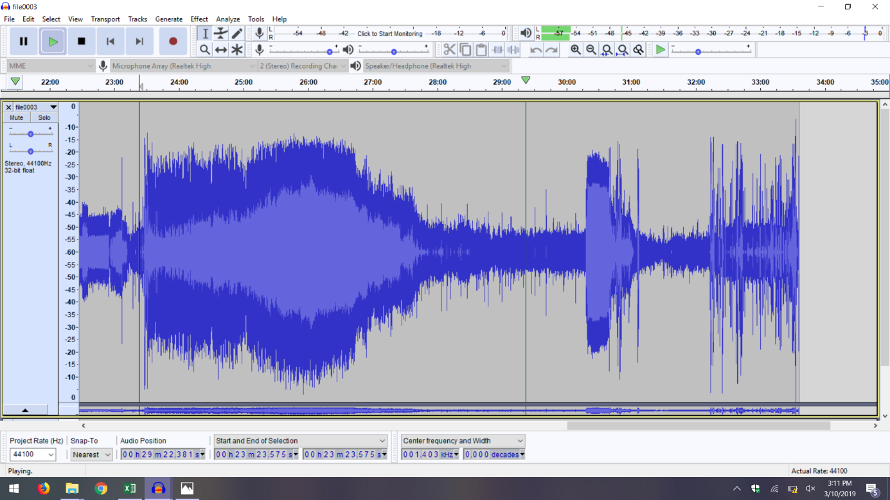
B)
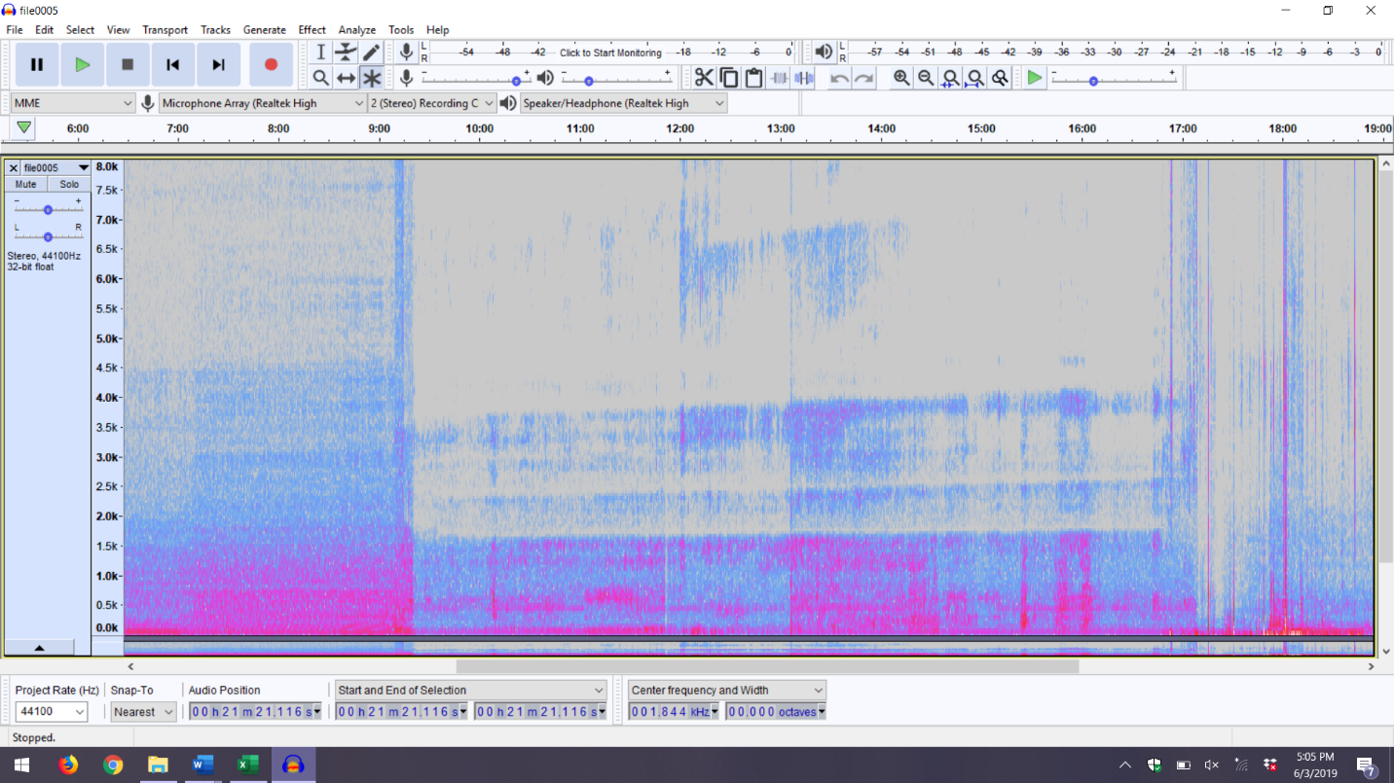
Figure – Olympic audio as a representation of Audacity as waveform (a) and spectrogram (b).

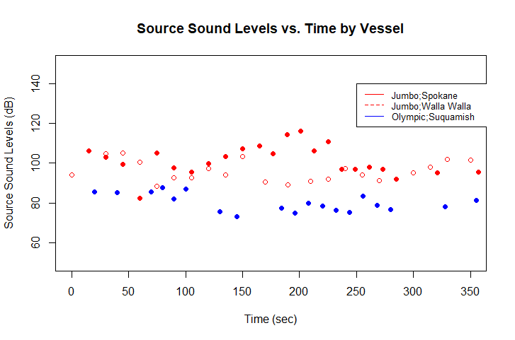
Figure 2- Received sound levels of Jumbo (red) and Olympic (blue) vessels fixed for transmission loss (SPL) by vessel as a function of time.

A)
B)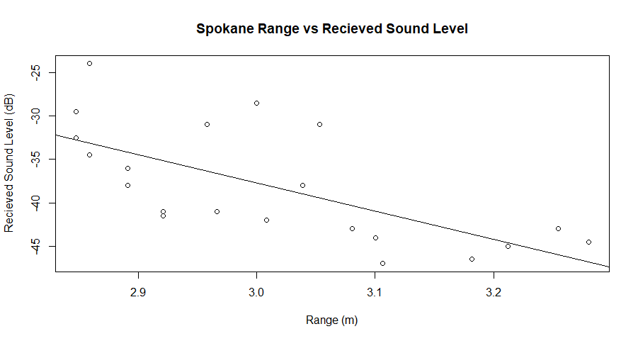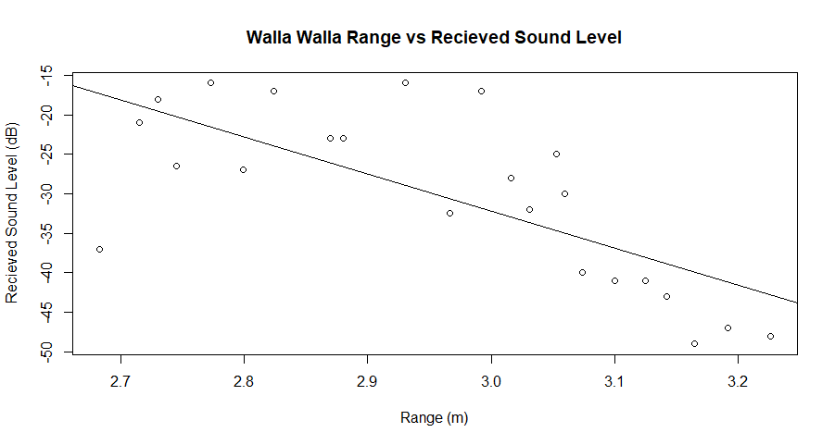
C)
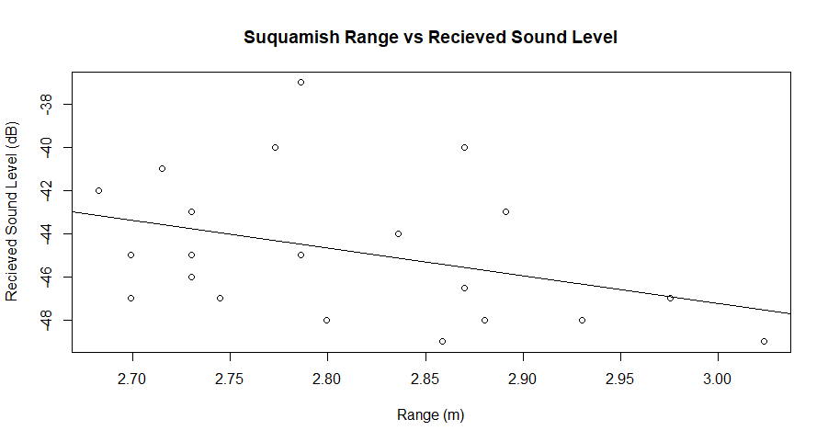
Figure 3- Logarithmic linear regression models of Spokane (a), Walla Walla (b), and Suquamish (c) vessels over range as a representation of derived transmission loss coefficient.
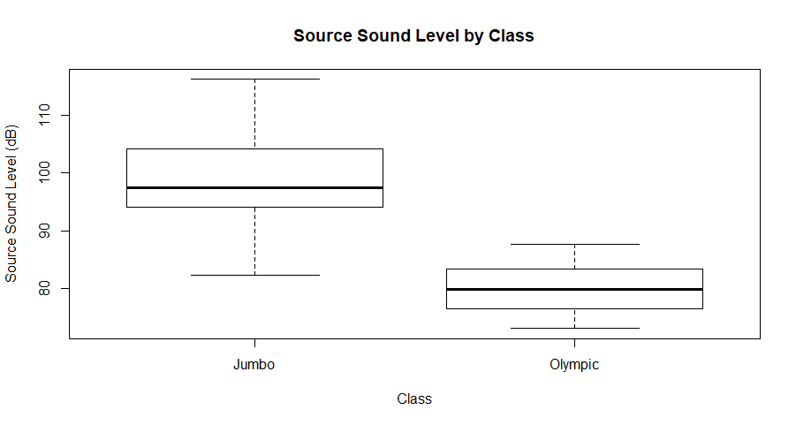
Figure 4- Average SPL of each class.

A)
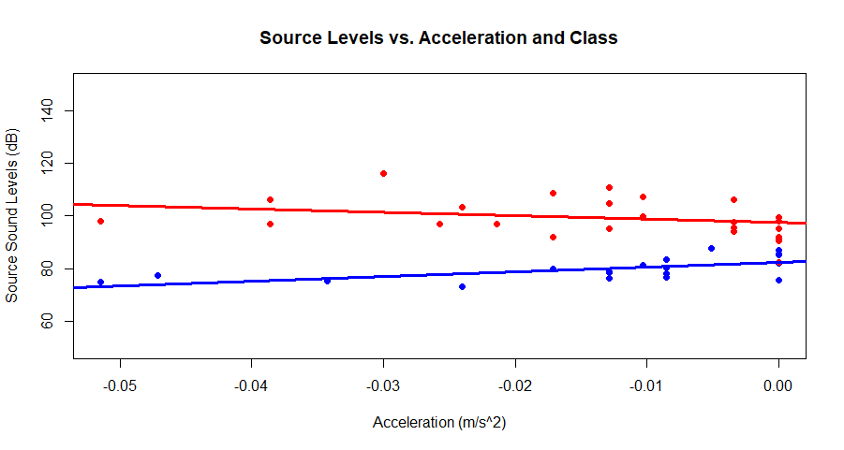
B)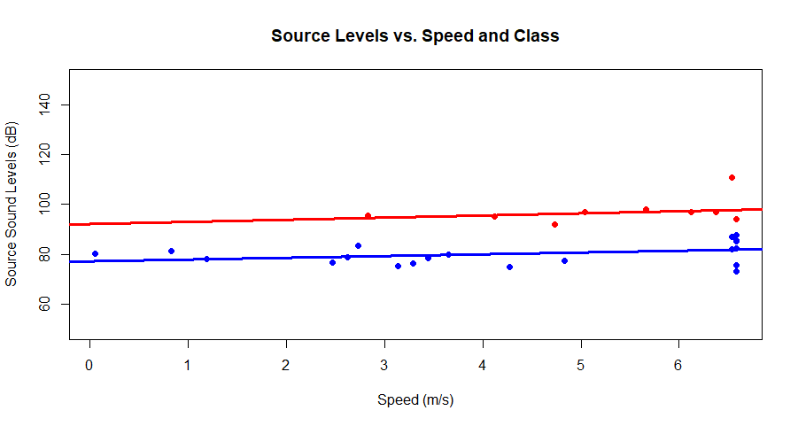
Figure 5- Multiple linear regressions with interactions of acceleration (a) and speed (b) to demonstrate significance of interactions. Parallel lines represent insignificant results.

B)
A)
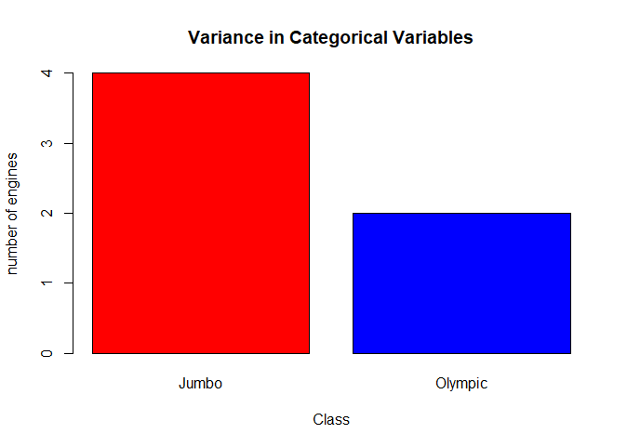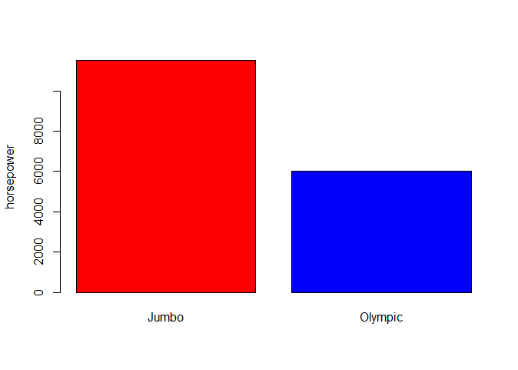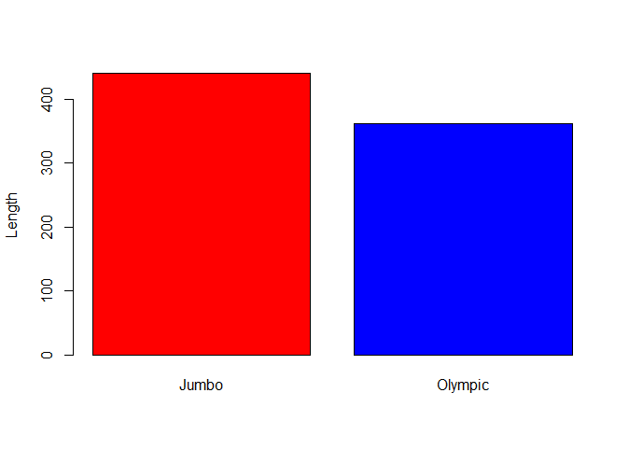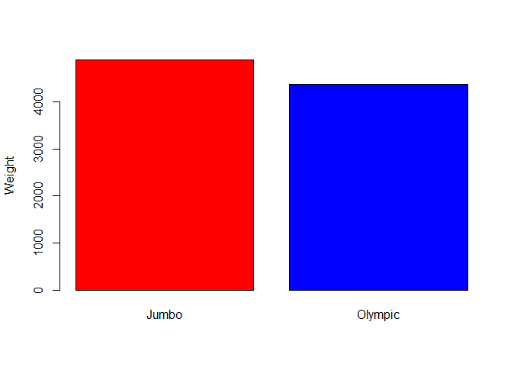
D)
C)
Figure 6- Visual of differences in values of categorical variables between Jumbo (red) and Olympic (blue) vessels. Shown is the number of engines (a), the horsepower (b), the length (c), and weight (d).

