Staghorn Sculpin (Leptocottus armatus) Size and Abundance as a Function of Tidepool Conditions in False Bay, San Juan Island, WA

Amaya M. Berge

Biodiversity and Monitoring of Estuarine Ecosystems
(Fall 2021)

Friday Harbor Laboratories, University of Washington, Friday Harbor, WA 98250

Contact Information:
Amaya M. Berge
University of Washington
College of the Environment
Marine Biology
aberge@uw.edu
amberge33@gmail.com

Keywords: sculpin, size, abundance, False Bay, tidepools, predation, refuge, estuary

ABSTRACT

The physical and biological variations in tidepools are essential to the survival of intertidal organisms. These fluctuating sub-habitats provide a refuge for juvenile fish during extended periods of low tide, offering them a place to grow and forage on smaller invertebrates. I examined the effects of these various tidepool conditions on the abundance and size of sculpin (family = Cottoidea) in six different tidepools in the tidal flat of the False Bay Estuary on San Juan Island, WA. The aim of this study was to examine the trends in our results and use them to advise future research into the abundance of fish as an indicator of habitat quality in the estuary. Previous research demonstrated the importance of studying bioindicator species such as sculpin in an effort to examine the health of various ecosystems and the biochemical structures within them. Using net tows and a YSI meter, I quantified the various tidepools conditions: temperature, salinity, dissolved oxygen, Ulva spp. cover, and prey abundance. I found a significant relationship between water temperature and both sculpin size and abundance. Mean sculpin size increased with water temperature while sculpin abundance decreased with water temperature. The standard deviation of sculpin size was significantly increased with salinity. Lastly, the abundance of sculpin was significantly related to the abundance of prey. Additional research should be conducted to further examine fish abundance across larger areas of False Bay over a longer time period to build a more holistic view of the estuary. Supplemental research should also be done into nutrient inputs from False Bay Creek and Forest Creek to determine if agricultural nutrients contribute to any of the variables examined in this study.

INTRODUCTION

Habitat conditions in tidepools are critical to many organisms during the hypoxic conditions characteristic of extended low tide periods (Russell, DJ, et al. 1983). These temporary pools act as productive fish refuges, offering protection from desiccation and predators as well as providing abundant food and ideal conditions for the development of juvenile fish (Chargulaf, C et al. 2011, Russell DJ et al. 1983). The unpredictability and variation in tidepool conditions offers many potential avenues for understanding the impact of habitat fluctuations on the survival of juvenile fish in these ecosystems.
The False Bay estuary, located on the Southwest coast of San Juan Island, WA, boasts an ecosystem rich in biodiversity as well as habitat diversity. As one of the most fluctuating sub habitats, tidepools serve as isolated ecosystems during low tide, providing a rich habitat for organisms from small invertebrates such as spionid worms to larger vertebrates including sculpins (family = Cottoidea). These tidepools can act as nurseries to juvenile fish, promoting the growth of younger individuals that later contribute to the larger adult population in the ecosystem (Chargulaf, C et al. 2011). The abundance and size of fish in tidepools can be a good indicator of the quality of an environment. However, the specific tidepool environmental conditions that support or limit fish size and abundance are not well understood. Tidepools in False Bay are unique from the rocky intertidal as they exist in the soft sediment tidal flat. While rocky intertidal pools are permanent fixtures in the ecosystem, the pools in False Bay are relatively shallow depressions that shift in location and physical conditions over time as a function of sediment movement and tidal flux. The novel monitoring of fish abundance trends in relation to tidepool conditions in False Bay is important as the findings can be used to advise habitat restoration projects in addition to future research into the impacts of nutrient outflows in the ecosystem.
Staghorn sculpins (Leptocottus armatus), a euryhaline species that exists in highest abundance in sheltered intertidal regions, are one of the most common fish species found in False Bay tidepools (Yoklavich, Mary et al. 1990). These fish are easily identified by their characteristic antler-like (pre-opercula) spines that protrude from their gill covers that are used as a defense mechanism against predators (Beardsley, AJ et al. 1973). Behaviorally, these fish forage during low light intensities and respond to light by rapidly burying themselves in the sediment to possibly improve water flow over the gills (Wagner, Sara 1990). Overall, they exhibit a skittish behavior and have grayish markings on their backs that act as a camouflage in shallow tidepools (Tabor, Rodger et al. 1998). The majority of the species inhabit nearshore bays and estuaries, specifically shallow and muddy sand sediments (Yoklavich, Mary et al. 1991, Shi, X. et al. 2017).
In previous studies examining the size of sculpin, the average size of sculpin (family = Cottoidea) in estuarine habitats was found to range from 0.5 cm to 22 cm with the majority consisting of juvenile sculpin (Hughes, Brent et al. 2014). While sculpins are a euryhaline species, their size has been observed to have a direct positive relationship with salinity (Mace, Pamela M. 1983). In addition, dissolved oxygen was found to be an excellent predictor of sculpin survival and adequate habitat conditions (X, Shi et al. 2017). Lastly, temperature was found to have an inverse relationship with sculpin size and abundance and had a significant impact on their survival (Jeppesen, Rikke et al. 2016).
Sculpin abundance and species richness can be positively related to the number of invertebrate burrows in tidepool habitats (Meager, J. et al. 2005) as these invertebrates are an important food source in tidepool habitats. In an experiment determining predator responses by sculpin, it was found that Ulva spp. not only acted as a refuge for sculpin, but also harbored many of the primary prey species of sculpin such as isopods and amphipods (X, Shi et al. 2017). In relation to these findings, a possible influence of top-down control could explain these relationships and may be occurring in the tidepools of False Bay. Top-down control is difficult to prove empirically but is a valuable ecosystem dynamic that occurs in estuaries around the world (Ruetz III, Carl et al. 2004). Specifically, predation helps to maintain the stability of food web dynamics in addition to having indirect and direct impacts on lower trophic levels in an environment. To quantify this, previous literature has examined the relationship of temperature and salinity linked with the consumption of marine organisms by generalist predators (Whalen, Matthew et al. 2020).
Despite their numerous ecosystem functions, sculpins are often overlooked as indicators of environmental conditions as research focuses more intently on economically important species such as salmonids to advise ecosystem management (Adams, Susan et al. 2007). As a top predator in the intertidal, sculpin have the potential to have a significant impact on the ecology of an area. From small terrestrial and aquatic invertebrates to juvenile crabs and fishes, sculpins are a generalist in the intertidal (Whitney, Emily et al. 2017). Sculpin species are vulnerable to environmental changes and are considered to be an indicator species of ecosystem health and variation (Khan, R. et al. 2010, Adams, Susan et al. 2007).
The primary objective of this study was to identify tidepools with sculpin prevalence and to quantify the physical (abiotic) and biological (biotic) conditions of the tidepools that could influence sculpin size and abundance in the pools. I surveyed 6 sites throughout False Bay and focused on the role of five factors on sculpin size and abundance: salinity, dissolved oxygen, percent Ulva cover, prey abundance, and water temperature. I hypothesized that increases in salinity, dissolved oxygen, percent Ulva cover, and prey abundance would individually correlate with increased sculpin size and abundance. In addition, I hypothesized that as water temperature increased, sculpin size and abundance would decrease. A secondary objective of the study was to quantify the relationship between the area and depth of the tidepools with sculpin size and abundance. I hypothesized that across tidepools, larger and deeper tidepools would have sculpin of greater size and in greater abundance compared with smaller and shallower tidepools.

MATERIALS & METHODS

False Bay Estuary
False Bay (48.4865 N, -123.0680 W) is a University of Washington biological preserve located in the Southwest coast of San Juan Island, WA. False Bay is a unique, soft-sediment intertidal habitat that opens to the Haro Strait which runs along the west side of the San Juan Island group and reaches depths up to 275 meters. Due to tidal fluctuations, the bay can fill almost completely at high tide and subsequently empties at varying levels at low tide based on air pressure and wave action. During these low tides, a variety of unique sub-habitats are exposed, from sand bars to tidal channels and tidepools. The long periods of exposure at low tide throughout the tidal flat provide an ideal sample site to examine hypoxic conditions and the importance of tidepools to juvenile demersal nearshore fish species. To determine the size and abundance of sculpin in False Bay, I conducted an observational study in randomly selected tidepools. A total of 6 tidepools were randomly selected and the latitude and longitude of each site was recorded (Fig. 1).
Sample Collection
To determine the dimensions of the tidepools, I calculated the area and depth of each pool (Chargulaf, C et al. 2011). Area was calculated using a 50 meter transect tape to measure the length and width of each pool (in meters). The end of the transect tape was tied to a garden stake that was embedded in the sediment at the edge of each pool (Fig. 2). I then walked the length and the width of each tidepool and recorded the values in our field notebook. Next, I calculated the depth (in cm) for each tidepool by placing a ruler at five different randomly chosen locations within each tidepool and taking the average of the five measurements. The five depths were determined as such: two depths on each edge and one depth in the middle. This was done to offer a more holistic view of the tidepool and infer depth distributions across the sample sites. Both the area depth of each tidepool was calculated twice during the study (Chargulaf, C et al. 2011).
After calculating the dimensions of each selected tidepool, I collected data on the variations in the abiotic conditions across the selected tidepool using a YSI meter (Fig. 3). I measured the water temperature (℃), salinity (ppt), and dissolved oxygen (mg/L) in each tide pool (Rikke, Jeppesen, et al. 2016). The YSI meter was submerged in the tidepool parallel with the bottom of the pool for 60 seconds, after which the values were recorded. During the minute the YSI was submerged, the device was constantly kept moving to ensure that the water was moving through the sensor in order to improve the accuracy of the reading. To determine whether there was a correlation between sculpin abundance and the presence of a refuge, I estimated the percent cover of Ulva sp. in each tidepool. These values were taken and recorded for all eight replicates.
Next, I examined the diversity of infauna in the sediments as well as the diversity of invertebrates in the water column of each tidepool to determine the prey diversity available for sculpin in the tidepools. For all eight replicates, three sediment infauna samples were collected from each tidepool. A trowel was used to dig a three-inch hole into the sediment which was then deposited in labeled Ziploc bags. Back in the lab, I sieved each infauna sample through a 1mm sieve. The invertebrates remaining in the sieve were placed in a clear dish filled with salt water and examined under a microscope. Each organism was identified to the genus and recorded. For the water column invertebrates, I dragged a small net tow (~400 um) with a 10 cm diameter PVC pipe at the opening through each tidepool (Giblin, Anne et al. 1970). For each tidepool, I dragged the net tow back and forth through the pool for 20 seconds (Fig. 3). One bag was used for each tidepool (n = 6). After each bag was used, I removed the PVC, cinched the bag closed, and then placed the PVC on a fresh net for the next tidepool. Back at the lab, each bag was carefully turned inside-out over a small Pyrex container in the sink. I then poured freshwater over each bag and carefully examined the bags to ensure that no small invertebrates remained trapped in the mesh. Once the bags had been cleaned of all organisms, I meticulously went through the Pyrex dish and searched for all organisms contained in the dish with tweezers. For each bag, the organisms were removed from the Pyrex dish and placed into a labeled 20 mL vial filled halfway with a 75% isopropyl alcohol solution until they could be examined. Once the vials could be examined, I removed the organisms from each vial and placed them in a petri dish to be identified under a microscope. Each organism was identified to the genus and recorded. This process was repeated for each of the replicates.
Lastly, I measured the size and abundance of the sculpins in each tidepool through an observational study. To collect this data, I walked through each sample site with a light and counted the total number of sculpins in each pool. Each tidepool was walked through for 10 minutes. Every time a sculpin was found I measured its size and recorded the species. I placed a small transparent ruler above the fish to estimate the size to the nearest centimeter. This process was repeated across all eight replicates.

Data and Statistical Analysis
All analyses were conducted in RStudio (RStudio 2021.9.0.351). As Staghorn sculpin were the most abundant species in my study, I focused the statistical analysis on this species. The sizes of the sculpin were averaged across each pool for all the replicates in addition to calculating their standard deviations. The standard deviations of the size of sculpin were used as an alternative way to characterize the sculpin community in the tidepools and their relationship with salinity. I used a multiple linear regression analysis to test for the effects of the tidepool parameters against trends in size and abundance of the sculpin in each tidepool. The regression examined the additive effects of salinity, dissolved oxygen, prey diversity, and percent Ulva sp. cover on the size (mean length and standard deviation of length) and abundance of the sculpin. Upon examining these variables, I interpreted the p values to determine significance.
Water and sediment prey were summarized across each pool for the replicates. The prey was grouped by taxa and all taxa that were not found in the tidepools (denoted by a value of 0) were removed from the data to better examine the quantities in the analysis. The total prey abundance was then merged with the sculpin abundance data in one data frame. Once this data frame was formed, I compared the total prey abundance with the total sculpin abundance using a multiple linear regression analysis. Upon examining these variables, I interpreted the p-values to determine the significance of these relationships.
The tidepool dimensions were summarized across the two replicates. I then merged the data frame with the sculpin size and abundance data frame in order to run a linear regression analysis. The analysis examined the additive effects of tidepool area, average depth, and volume against sculpin size and abundance. Upon examining these variables, I interpreted the p-values to determine significance.
Additionally, I used Akaike’s information criteria (AICc) to evaluate the relative importance (fit) of the physical and biological conditions of the tidepools to predict the size and abundance of sculpin in the pools. There were two global models, one for sculpin size and the other for sculpin abundance. The first model was: sculpin size ~ temperature + salinity + dissolved oxygen + Ulva spp. cover + water prey + sediment prey. The second model was: sculpin abundance ~ water temperature + salinity + dissolved oxygen + Ulva spp. cover + water prey + sediment prey. From the global model, I sequentially fit reduced models and compared model fits with the AICc (Groner, Maya et al. 2016).

RESULTS

Temperature
I examined the relationship between the tidepool water temperature (degrees Celsius) and the abundance of average size of sculpin in the tidepools across the eight replicates (Fig. 4). For the abundance of sculpin, the best fit model to describe the data was the water temperature of the tidepools. Upon running a multiple linear regression for abundance, I found strong evidence that water temperature had a negative effect on sculpin abundance (p < 0.001). For the average sculpin size, the best fit model to describe the data was the water temperature of the tidepools. After running a multiple linear regression for size, I found evidence that water temperature had a positive relationship with the average size of sculpin (p < 0.001).

Salinity.
Sculpin were found in salinities ranging from 2.7 ppt to 30.6 ppt across the six tidepools and eight replicates. Using the standard deviation of sculpin size, I examined their relationship with the salinity of the tidepools (Fig. 5). Using an AICc model, the salinity of the tidepools was found to be the best fit model to describe the standard deviation of the lengths of the sculpin. A linear regression revealed that salinity had a moderately strong positive effect on the standard deviation of the size of sculpin (p = 0.007).

Prey Abundance
I sought to describe the relationship of the abundance of prey from both the water column and sediment of the tidepools with sculpin abundance (Fig. 6). A linear regression model revealed that there is strong evidence that prey abundance had a negative relationship with sculpin abundance (p = 0.002). I found a wide range of prey species summarized in Fig. S1. Spionids were the most abundant organisms in the sediment across the six tidepools with the greatest quantity in tidepool site 4 (n = 159). The second most abundant organisms were the Capitellids with the greatest quantity in tidepool site 3 (n = 38). Lumbrinerids were the third most abundant organism with the greatest quantity in tidepool site 1 (n = 50). In supplemental figure 2 (Fig. S2), Gammaridae were the most abundant organisms in the water column across the six tidepools with the greatest quantity in tidepool site 2 (n = 111). The second most abundant organisms were the Harpacticoids with the greatest quantity in tidepool site 6 (n = 36). In a few of the tidepools, fish larvae were found in the water column.

DISCUSSION

Results Analysis

The results from this study provide multiple lines of evidence that tidepool conditions had measurable effects on sculpin size and abundance in False Bay.
Upon analyzing my results, I found there to be no significant correlation between the dissolved oxygen, percent Ulva sp. cover, and tidepool size with sculpin size and abundance. I did find, however, that water temperature positively affected sculpin size and negatively affected sculpin abundance. Both relationships were significant. This suggests that sculpins occupy tidepools in response to temperature variations in the False Bay estuary, possibly to optimize certain physiological processes or to occupy a thermal refuge. The fluctuations of temperature over the study period and between tidepools could be attributed to the tidal fluctuations in False Bay. These findings were consistent with those of Edwards et al. (2007) in which the researchers found that water temperature was significantly correlated with the abundance and distribution of slimy sculpin (Cottus cognatus). In addition, these results reflect the findings of Ottersen et al. (2001) in which water temperature was significantly correlated with the growth of juvenile fishes. Temperature has previously been identified as the key abiotic factor influencing important physiological, biological, and life-history processes of estuarine fish (Beitinger and Fitzpatrick 1979, Childs et al. 2007, Marshall et al. 2002).
An unexpected finding from this analysis was the strong positive correlation between the standard deviation of the sculpin length and the salinity of the tidepools. This suggests that there was a greater variation in the size of sculpin as the salinity of the tidepools increased. These findings could have important implications for understanding the species diversification of sculpin across different environments. Future research could analyze the genetic makeup of sculpin in different environments with varying salinities to determine whether they represent distinct populations (Arújo, M et al. 2014). A genetic analysis could also advise a further understanding of the dynamics of top predators within environment and their diversities across different ecosystems. These findings are consistent with those of Arújo et al. (2014) in which researchers found a positive correlation between salinity and variation in body size of the Southern Molly (Poecilia vivipara) (Arújo et al. 2014, Gomes et al. 2008). Additionally, my findings reflect those of Neves (2003) in which both body shape and size variation of the Southern Molly (Poecilia viviapara) were positively correlated with the salinity (Neves et al. 2003, Gomes et al. 2008).
My study did identify, however, that the abundance of prey decreased significantly as abundance of sculpin increased. This suggests that there is possible activity of top-down predation due to the observed trend of decreased prey abundance correlating with increased sculpin abundance. Evidence of top-down predation of fish on invertebrates is difficult to prove (Ruetz III et al. 2004). A strong selection of fish to occupy areas of optimal resource availability, specifically prey, was suggested for rockfishes (Sebastes sp.) (Matthews et al. 1990). By examining the diets of sculpin using dissections or other more in-depth techniques, future researchers may be able to glean important trends in the feeding activity and food web dynamics throughout the estuary. Another important trend to note is the possible relationship between top-down predation and climate. Previous research has identified that the feeding activity of generalist predators was closely linked with the temperature and salinity of various environments (Whalen, Matthew et al. 2020). Food web dynamics and feeding activity could be further examined in the context of freshwater flow into the False Bay ecosystem which would provide a new dimension into the understanding of the tidal flat (Whitney et al. 2017). Future research could build upon the baseline set forth by Whitney (2017) in which the authors found possible linkages between terrestrial and estuarine food webs by examining Staghorn sculpin diets.

Limitations
The reliability of the results was constrained by both temporal and spatial variables. Spatially, only a small proportion of the tide pools in False Bay could be examined as I was limited with the number of man-hours available. As a result, a finite area of the tidal flat could be studied which restricts the generalizability of the data. In addition, the variability of the soft-sediment tidal flat of False Bay likely had areas of tidepools similar to those studied that contained sculpin. Unfortunately, the presence of these areas was not identified and thus the results could be unrepresentative of trends in sculpin size and abundance in False Bay. I recognize that the observational nature of the study may have hindered my ability to explicitly demonstrate mechanisms that may have contributed to the trends in sculpin size and abundance. Specifically, the accuracy of counting and measuring the size of the sculpin could be skewed by possible error in overcounting abundance or rounding to the nearest centimeter of size. Additional research should be conducted using a more exact method of measuring and counting the sculpin such as small minnow traps (Jeppesen, Rikke et al. 2018).
Temporally, I was limited by the time available in which to collect samples and conduct the observational study. As a result, trends in the physical and biological variables were examined over a short time frame rather than over several seasons or several years. Further analyses should be done over a larger area of False Bay to increase the generalizability of the bay’s tidepool conditions. In addition, the small spatial scale limited the ability to infer the presence of top-down control. However, the strength of the relationships described here suggest that the relationships between size and abundance with temperature are likely to continue, at least in False Bay. Further research should be done across a larger area of the estuary and across more tidepools to offer more insight into this pattern. These analyses should also be conducted over a longer time period, especially over several seasons to gain a more holistic view of trends in sculpin size and abundance annually in the tidal flat. The accuracy of the tidepool measurements was limited by the time and resources available. Upon measuring the area of the tidepool using only length and width, it was likely that the measurements were not completely representative of the true areas. As a result of limited time, I was only able to measure these values twice for analysis which may have constrained the results as the relative fluctuations in the size and depth of the tidepools were likely underrepresented by only two measurements. A different method that could be used to calculate these values could be calculating surface area using the geometric shapes method proposed by Brehna-Nunes (2016).
Despite these limitations, I believe the results are relevant because I examined a breadth of observational variables, both biological and physical, in the tidepools to get the most comprehensive profiles of the tidepools studied. In addition, I identified multiple significant relationships between these tidepool conditions and the size and abundance of sculpin. Most importantly, sculpin significantly occupied pools with lower temperatures in False Bay.

Freshwater Inputs
As a function of their widespread distribution, high abundance and low mobility, further research should be promoted to quantify additional factors that impact populations of sculpin within tidal environments and the role they play in estuarine food webs. Fish, specifically those that occupy estuaries, demonstrate great resilience to changes in estuarine conditions as a result of freshwater runoff (Whitney, Emily et al. 2017). In a study that examined the feeding ecology of Staghorn sculpin, researchers determined there was an important interaction between fluctuations in freshwater discharge into estuaries and the diversity and abundance of prey available to sculpin during different seasons (Whitney, Emily et al. 2017). Freshwater inputs, such as those from False Bay Creek, could have variable impacts on the biochemical interactions of the environment such as the temperature and salinity of the water and its impacts on the growth and behavior of estuarine organisms in False Bay.

Agricultural Contamination
Human-related disturbances such as agricultural practices can raise the temperatures of bodies of water. From my findings, sculpin abundance in False Bay could act as a bioindicator of increased water temperature as a result of increased agricultural inputs. Previous research had determined that the quantity of nutrients and nitrogen loading by invertebrates at low tides varied due to the isolation of tidepools (Bracken et al. 2004). In 2010, researchers conducted a study of contaminant concentrations in the freshwater fish Reticulated Sculpin and Three Spined Sticklebacks to examine the significant contaminants impacting fish in the False Bay watershed (Barsh et al. 2010). This was done to encourage the restoration of salmonid populations in the watershed. From his findings, he recommended the restoration of summer instream flows, increased management of runoff from county roads, increased vegetation in riparian corridors, and reduced use of all pesticides and herbicides.

Future Research
Going forward, this study could provide a valuable baseline on which to conduct research into the feeding behaviors of sculpin and what indications this may offer to the health and structure of the False Bay ecosystem. The findings presented above could be examined in the future in the False Bay estuary to determine whether the fluctuation of tidepool conditions have any correlation with possible nutrient runoff from False Bay Creek (Bracken, Matthew et al. 2004). I recommend an annual examination of the impact of temperature, salinity, and prey abundance on sculpin as this could provide valuable information that reflects on polluting inputs into False Bay throughout the year (Kennish et al. 2002). Finally, further research should be conducted to build upon Barsh’s findings in relation to the contaminant concentrations in freshwater fish species in the False Bay watershed to advise upon salmonid restoration and the impact of agricultural practices.

CONCLUSION
My study identified the effects of physical and biological factors of tidepools in False Bay on the size and distribution of sculpin in the pools. Upon finding that water temperature was the key factor influencing both the size and abundance of sculpin, I recommend future research into examining these trends over a greater temporal and spatial scale in False Bay. The results agree with previous studies that temperature was the factor that best explained the trends in fish size and abundance.
Additionally, research should expand to include other potential influencing factors including freshwater discharge from False Bay Creek, contaminant concentration inputs, and agricultural nutrient runoffs. Upon examining these factors over greater time scales to supplement the conditions studied here, research can expand to provide a more holistic view of the complex and fluctuating system of False Bay and its impacts on the distribution of various organisms in the ecosystem.

ACKNOWLEDGEMENTS

I would like to thank my professors, Wendel Raymond, Brooke Sullivan, and Megan Dethier for their guidance throughout the research project. Special thanks to Alan Trimble for the many meals spent discussing projects and for his helpful insights into improvements for my study. I would also like to thank Mariah Josten, Milly Marriott-Green, Monica Groth, Ryan Pittsinger, and James Fitzpatrick for their contributions to the fieldwork required for the project. Additionally, I would like to thank Robert Hoekendorf for his contribution to the mapping of the sample sites using QGIS and I would also like to thank Nicole Frederick for her assistance with the statistical analyses using RStudio. Lastly, I would like to thank Friday Harbor Laboratories for providing the equipment, facilities, and other essential resources needed to carry out this project.

REFERENCES
Adams, Susan B, and David A Schmetterling. “Freshwater Sculpins: Phylogenetics to Ecology - USDA.” Transactions of the American Fisheries Society, American Fisheries Society, 2007, https://www.srs.fs.usda.gov/pubs/ja/ja_adams013.pdf.
Araújo, M.S., Perez, S.I., Magazoni, M.J.C. et al. Body size and allometric shape variation in the molly Poecilia viviparaalong a gradient of salinity and predation. BMC Evol Biol 14, 251 (2014). https://doi.org/10.1186/s12862-014-0251-7
Barsh, R., et al. “[PDF] False Bay Creek (San Juan Island, WA) Freshwater Fish and Their Prey: Significant Contaminants and Their Sources: Semantic Scholar.” Research Gate, KWIAHT Center for Historical Ecology in the Salish Sea, 1 Jan. 1970, https://www.semanticscholar.org/paper/False-Bay-Creek-(San-Juan-Island%2C-WA)-Freshwater-Barsh-Bell/595b2a516aa6961bf2e058cbd379f878303229fe.
Beitinger, Thomas, and Lloyd Fitzpatrick. “ Physiological and Ecological Correlates of Preferred Temperature in Fish.” Academic.oup.com, American Zoology, 1979, https://academic.oup.com/icb/article/19/1/319/174414.
Beardsley, Alan, and Carl E Bond. “Field Guide to Common Marine and Bay Fishes of Oregon” Oregon State University, Agricultural Experiment Station, 1973.
Bracken, Matthew, and Karina Nielsen. “Diversity of Intertidal Macroalgae Increases with Nitrogen Loading by Invertebrates.” Ecological Society of America Journals, Ecological Society of America, 2004, https://esajournals.onlinelibrary.wiley.com/doi/pdf/10.1890/03-0651.
Chargulaf, C. A., et al. “Community Structure of Soft Sediment Pool Fishes in Moreton Bay, Australia.” Wiley Online Library, John Wiley & Sons, Ltd, 13 Jan. 2011, https://onlinelibrary.wiley.com/doi/10.1111/j.1095-8649.2010.02866.x.
Childs, A.R., et al. “Do Environmental Factors Influence the Movement of Estuarine Fish? A Case Study Using Acoustic Telemetry.” Estuarine, Coastal and Shelf Science, Academic Press, 1 Jan. 2008, https://www.sciencedirect.com/science/article/pii/S0272771407005422#bib7.
Cunha, Francisca Edna de Andrade, et al. “Temporal and Spatial Variations in Tidepool Fish Assemblages of the Northeast Coast of Brazil.” Biota Neotropica, Instituto Virtual Da Biodiversidade | BIOTA - FAPESP, 1 Jan. 1970, https://www.scielo.br/j/bn/a/mwmhStXNCZM4dYKTYjLCKHx/?lang=en.
“Draft Oregon Dungeness Crab Fishery Management Plan.” Oregon Department of Fish and Wildlife Marine Resources Program, Sept. 2021, https://www.dfw.state.or.us/MRP/shellfish/commercial/crab/docs/2021/Dungeness_Crab_FMP_Public_Draft.pdf.
Edwards, Patricia A, and Richard A Cunjak. “Influence of Water Temperature and Streambed Stability on the Abundance and Distribution of Slimy Sculpin (Cottus Cognatus).” Research Gate, Environmental Biology of Fish, 29 July 2006, https://www.researchgate.net/publication/225588232_Influence_of_water_temperature_and_streambed_stability_on_abundance_and_distribution_of_slimy_sculpin_Cottus_cognatus.
Giblin, Anne, et al. “PIE LTER Zooplankton Surveys Using Plankton Tows along Transects in the Plum Island Sound Estuary, Massachusetts.” Plum Island Ecosystems, Marine Biological Laboratory University of Chicago, 1 Jan. 1970, https://pie-lter.ecosystems.mbl.edu/content/zooplankton-surveys-using-plankton-tows-along-transects-plum-island-sound-estuary.
JOSÉ L. GOMES, LEANDRO R. MONTEIRO, Morphological divergence patterns among populations of Poecilia vivipara (Teleostei Poeciliidae): test of an ecomorphological paradigm, Biological Journal of the Linnean Society, Volume 93, Issue 4, April 2008, Pages 799–812, https://doi.org/10.1111/j.1095-8312.2007.00945.x
Groner, Maya, et al. “Plant Characteristics Associated with Widespread Variation in Eelgrass Wasting Disease.” Research Gate, Diseases of Aquatic Organisms, Feb. 2016, https://www.researchgate.net/publication/290210593_Plant_characteristics_associated_with_widespread_variation_in_eelgrass_wasting_disease.
Hughes, Brent, et al. “(PDF) Nursery Functions of U.S. West Coast Estuaries: The State of Knowledge for Juveniles of Focal Fish and Invertebrate SpeciesB.” Research Gate, The Nature Conservancy, Jan. 2014, https://www.researchgate.net/publication/269691111_Nursery_functions_of_US_west_coast_estuaries_the_state_of_knowledge_for_juveniles_of_focal_fish_and_invertebrate_species.
Jeppesen, Rikke, et al. “Effects of Hypoxia on Fish Survival and Oyster Growth in a Highly Eutrophic Estuary.” Springer Link, Estuaries and Coasts, 2018, https://link-springer-com.offcampus.lib.washington.edu/article/10.1007/s12237-016-0169-y.
Kennish, M. (2002). Environmental threats and environmental future of estuaries. Environmental Conservation, 29(1), 78-107. doi:10.1017/S0376892902000061
Khan, R. A. “Chronic Exposure and Decontamination of a Marine Sculpin (Myoxocephalus Scorpius) to Polychlorinated Biphenyls Using Selected Body Indices, Blood Values, Histopathology, and Parasites as Bioindicators.” Archives of Environmental Contamination and Toxicology, Springer-Verlag, 18 June 2010, https://link.springer.com/article/10.1007/s00244-010-9547-9.
Krück, Nils C., et al. “Early Post-Settlement Habitat and Diet Shifts and the Nursery Function of Tidepools during Sillago Spp. Recruitment in Moreton Bay, Australia.” Marine Ecology Progress Series, Centre for Marine Studies, University of Queensland, 29 May 2009, https://www.int-res.com/abstracts/meps/v384/p207-219/.
Mace, Pamela M. “Predator-Prey Functional Responses and Predation by Staghorn Sculpins (Leptocottus Armatus) on Chum Salmon Fry (Oncorhynchus Keta).” Open Collections, University of British Columbia, 1 Jan. 1983, https://open.library.ubc.ca/soa/cIRcle/collections/ubctheses/831/items/1.0095873.
Matthews, K. “(PDF) An Experimental Study of the Habitat Preferences and Movement Patterns of Copper, Quillback, and Brown Rockfishes (Sebastes Spp.).” Research Gate, Environmental Biology of Fishes, Nov. 1990, https://www.researchgate.net/publication/227320328_An_experimental_study_of_the_habitat_preferences_and_movement_patterns_of_copper_quillback_and_brown_rockfishes_Sebastes_spp.
Marshall, S., and M. Elliott. “Environmental Influences on the Fish Assemblage of the Humber Estuary, U.K.” Estuarine, Coastal and Shelf Science, Academic Press, 25 May 2002, https://www.sciencedirect.com/science/article/pii/S0272771497902687.
Meager, J.J., Williamson, I. & King, C.R. Factors affecting the distribution, abundance and diversity of fishes of small, soft-substrata tidal pools within Moreton Bay, Australia. Hydrobiologia 537, 71–80 (2005). https://doi.org/10.1007/s10750-004-2308-x
Naman, S. M., et al. “Abundance and Body Condition of Sculpin (Cottus Spp.) in a Small Forest Stream Following Recolonization by Juvenile Coho Salmon Oncorhynchus Kisutch.” Wiley Online Library, John Wiley & Sons, Ltd, 11 Feb. 2013, https://onlinelibrary.wiley.com/doi/full/10.1002/rra.2643.
Neves, Felipe Marcel and Leandro Rabello Monteiro. “Body shape and size divergence among populations of Poecilia vivipara in coastal lagoons of south‐eastern Brazil.” Journal of Fish Biology 63 (2003): 928-941.
Brenha-Nunes, Marina R., et al. “A Protocol for Measuring Spatial Variables in Soft-Sediment Tide Pools.” Zoologia (Curitiba), Sociedade Brasileira De Zoologia, 29 Apr. 2016. https://doi.org/10.1590/S1984-4689zool-2015016.
Ottersen, G., Planque, B., Belgrano, A. et al. Ecological effects of the North Atlantic Oscillation.Oecologia 128, 1–14 (2001). https://doi.org/10.1007/s004420100655
Ruetz III, Carl, et al. “Weak top-down control of grazers on periphyton by slimy sculpins in a cold water stream.” The North American Benthological Society, June 2004.
Russell, DJ Garrett RN (1983) Use by juvenile barramundi, Lates calcarifer (Bloch), and other fishes of temporary supralittoral habitats in a tropical estuary in Northern Australia. Marine and Freshwater Research 34, 805-811. https://doi.org/10.1071/MF9830805
Shi, X., et al. “The Angular Position of a Refuge Affects Escape Responses in Staghorn Sculpin Leptocottus Armatus.” Wiley Online Library, John Wiley & Sons, Ltd, 2 Apr. 2017, https://onlinelibrary.wiley.com/doi/full/10.1111/jfb.13306.
Tabor, Roger A, et al. “The effect of light intensity on predation of sockeye salmon fry by prickly sculpin and torrent sculpin.” US Fish and Wildlife Service, May 1998, https://www.fws.gov/wafwo/fisheries/Publications/FP137.PDF.
Wagner, Sara Anne. “Response to Hypoxia in the Staghorn Sculpin, (Leptocottus Armatus).” ScholarsArchive@OSU, Oregon State University, 2 Nov. 1990, https://ir.library.oregonstate.edu/concern/graduate_thesis_or_dissertations/ks65hf738.
Whitney, Emily J, Anne H. Beaudreau & Douglas H. Duncan (2017) Spatial and Temporal Variation in the Diets of Pacific Staghorn Sculpins Related to Hydrological Factors in a Glacially Influenced Estuary,Transactions of the American Fisheries Society, 146:6, 1156-1167, DOI: 10.1080/00028487.2017.1341852
Whalen, Matthew A et al. “Climate drives the geography of marine consumption by changing predator communities.” Proceedings of the National Academy of Sciences of the United States of America vol. 117,45 (2020): 28160-28166. doi:10.1073/pnas.2005255117

Yoklavich, Mary, et al. “Temporal and Spatial Patterns in Abundance and Diversity ...” Research Gate, Estuaries and Coasts, Dec. 1991, https://www.researchgate.net/profile/Gregor-Cailliet/publication/227071573_Temporal_and_Spatial_Patterns_in_Abundance_and_Diversity_of_Fish_Assemblages_in_Elkhorn_Slough_California/links/0912f512304b3475af000000/Temporal-and-Spatial-Patterns-in-Abundance-and-Diversity-of-Fish-Assemblages-in-Elkhorn-Slough-California.pdf

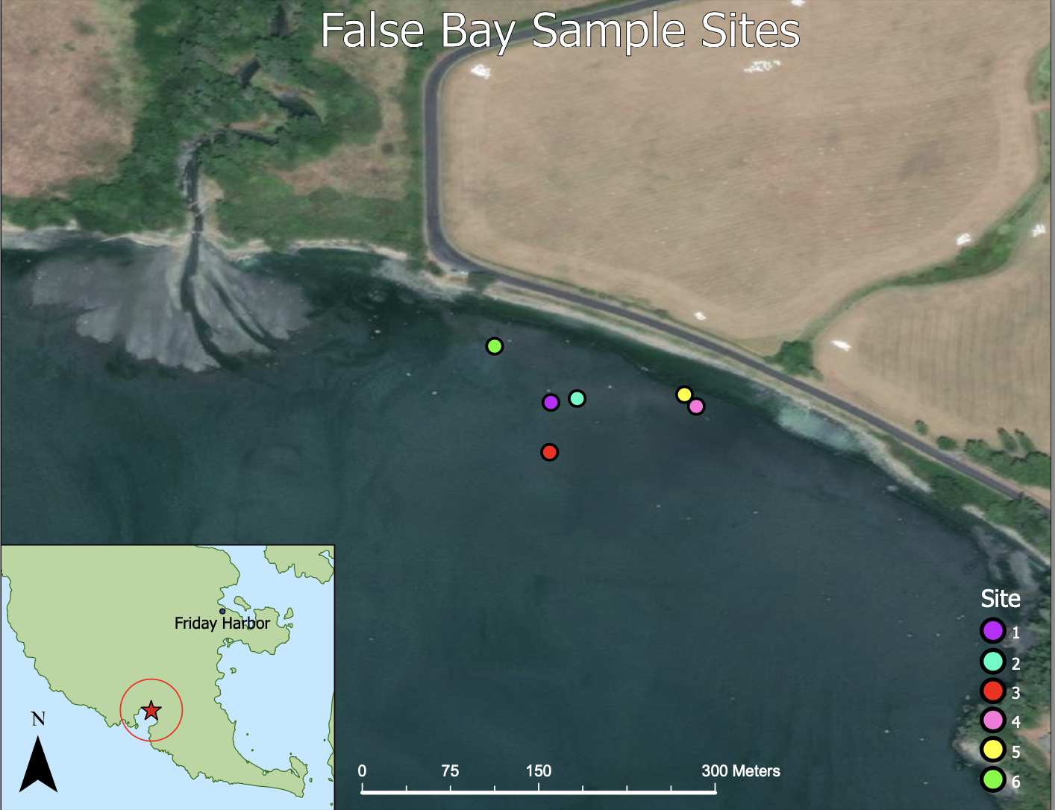
FIGURES
False Bay Creek
Fig. 1 Sample sites (tidepools) in which the observational study was conducted. The water outflow on the left is False Bay Creek and the road that runs parallel to the sample sites is False Bay Road. Each site is represented by a color shown in the key on the left.

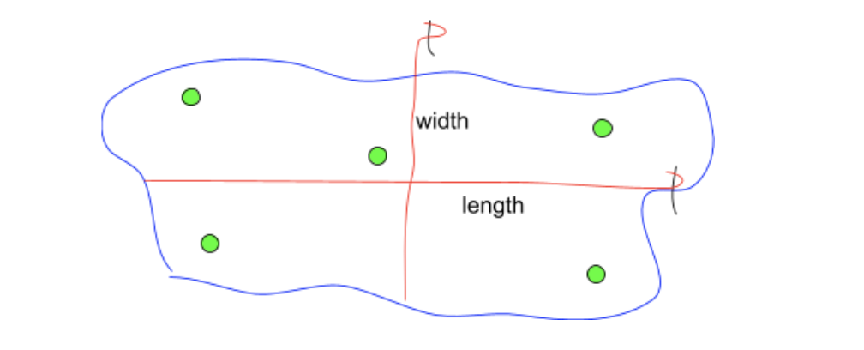
Fig. 2 Visual representation of method used to measure length, width, and depth of each tidepool. Red lines represent the transect tapes and the black lines represent the garden stakes the tapes were wrapped around. Each measurement was taken concurrently so the figure represents how both width and length were taken using one transect tape. The five green circles represent the approximate random locations at which depth was taken in each tidepool.

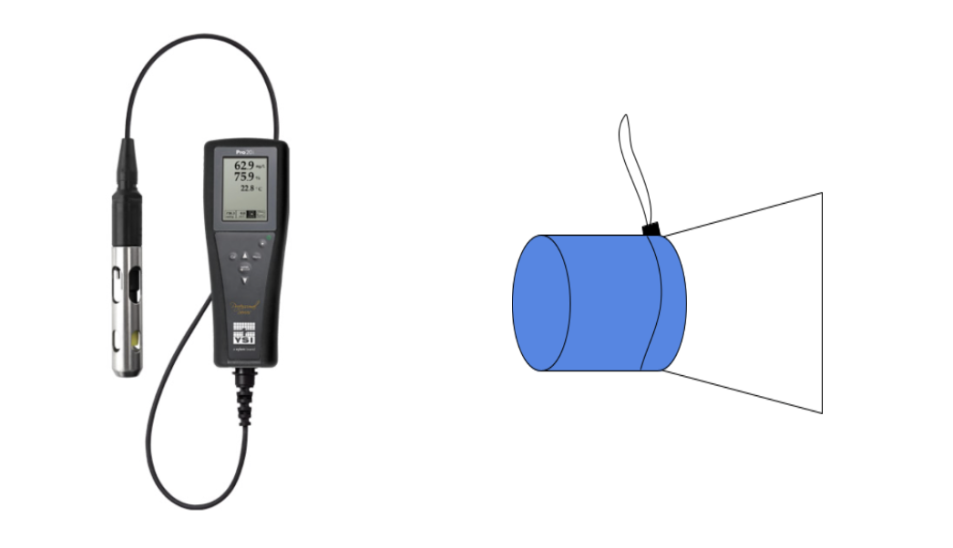
Fig. 3 The image on the left is YSI meter used to measure water temperature, salinity, and dissolved oxygen for this study. The values are shown on the screen while the cylindrical meter on the left is submerged in the water. The meter must be completely submerged and held parallel to the bottom of the pool. The image on the right is a rough sketch of net tow used to collect water column invertebrate samples (n = 6). The blue cylinder represents the PVC pipe at the opening of the mesh bag. The white trapezoid represents the mesh bag that is cinched around the PVC pipe. The water will enter through the PVC pipe and the mesh bag will filter out the water, leaving only the invertebrates behind.

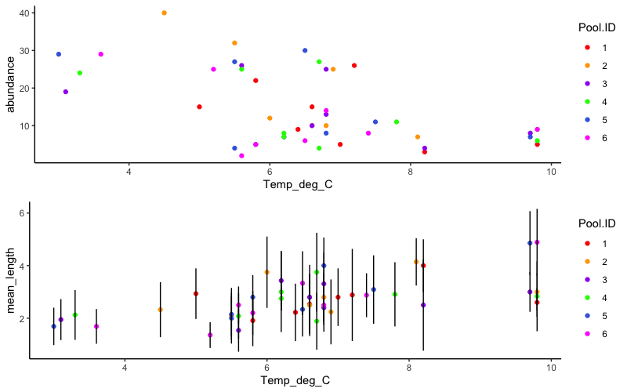
Average Sculpin Size (cm)
Temperature (℃)
Temperature (℃)
Fig. 4 A- The relationship between the abundance of sculpin in the tidepools and tidepool water temperature (deg C). There is a moderate negative correlation between the two variables. Each color represents a tidepool. There are 8 points for each tidepool, one to represent each replicate of the study (p < 0.001). B- The relationship between the average size (cm) of the sculpin in each tidepool and water temperature of the tidepools. There is a moderate positive correlation between the variables. Each color represents a different tidepool. There are 8 points for each tidepool, one to represent each replicate of the study (p < 0.001). The black bars represent the standard deviations of the sculpin lengths.

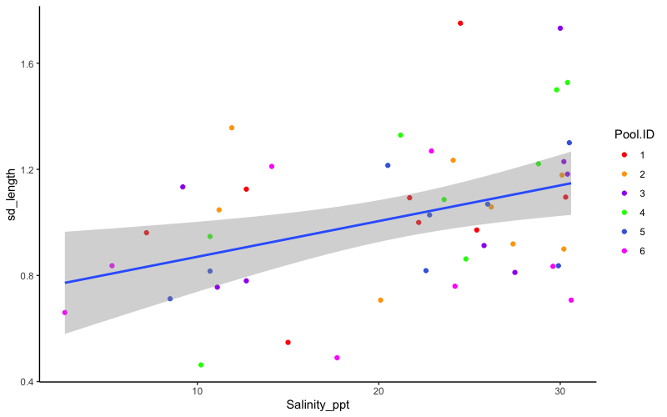
Standard Deviation of Sculpin Length
Salinity (ppt)
Fig. 5 The figure above represents the relationship between the standard deviation of the length of the sculpin and the salinity of the tidepools. There is a moderate positive correlation between the two variables. Each color represents a tidepool. There are 8 points for each tidepool, one to represent each replicate of the study (p = 0.007). The linear regression has an R squared value of 0.1491 (R^2 = 0.1491). The shaded region of the graph illustrates the variance or the spread of values in the data set.

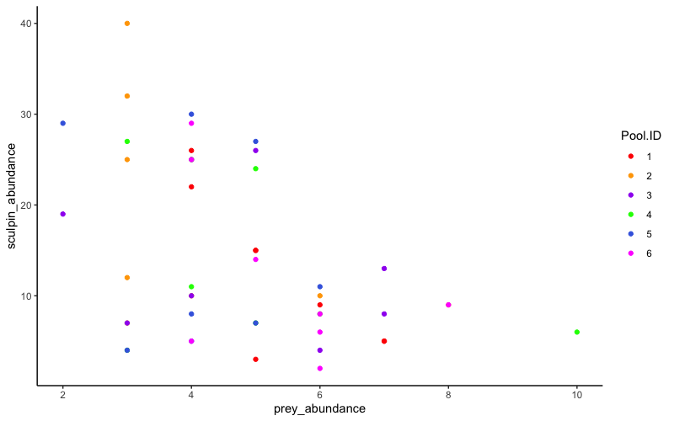
Total Sculpin Abundance
Total Prey Abundance

Fig. 6 The figure above represents the relationship between the total abundance of sculpin and the total abundance of prey (sediment and water column) in the tidepools. Each color represents a tidepool. There are 8 points for each tidepool, one to represent each replicate of the study (p = 0.0015).

SUPPLEMENTAL FIGURES
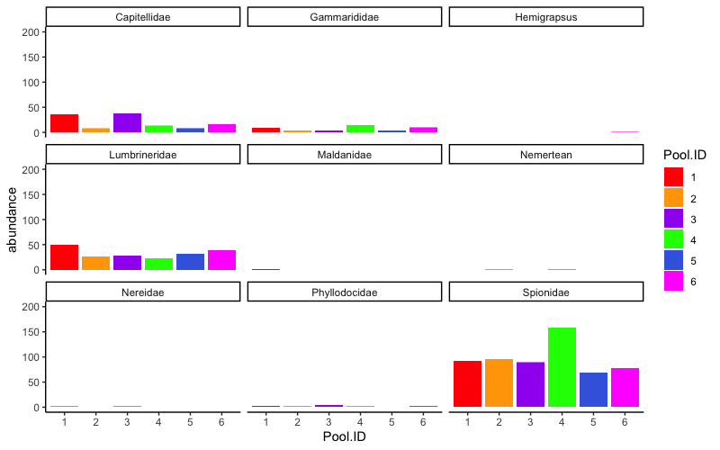
Gammaridae

Fig. S1 The figure above depicts the total abundance of each taxa found in sediment samples collected from the tidepools. Each color represents a tidepool. The data collected was summarized across all 8 replicates.

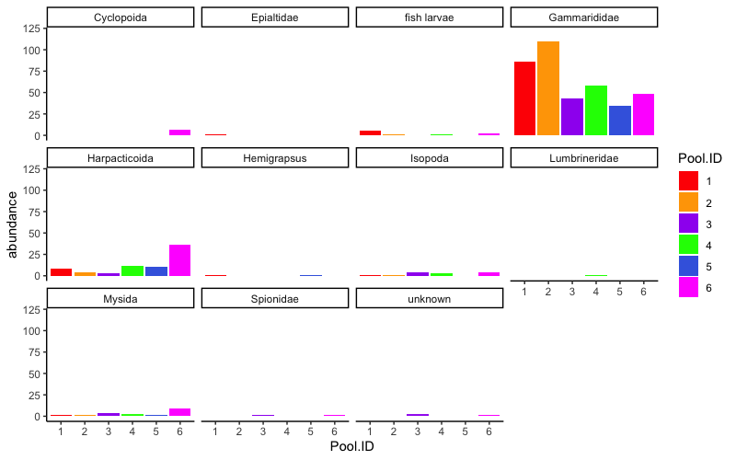
Gammaridae

Fig. S2 The figure above depicts the total abundance of each taxa collected from the water column of the tidepools. Each color represents a tidepool. The data collected was summarized across all 8 replicates.

