The effect of Crassostrea gigas size on survival following Pacific Northwest heat dome
Brittany Miller

FHL 470: Research in Marine Botany
May 27, 2022

Friday Harbor Labs, University of Washington

Abstract
Following a heat dome event in late June- early July 2021, mass shellfish mortalities were reported in Washington State. It is important to study this mortality event given the economic and ecological value of shellfish, particularly in the context of climate change. We chose to contribute to this research by surveying Crassostrea gigas in San Juan Island, Washington, to estimate percent mortality and to investigate a relationship between size and survival following the heat dome. We surveyed four sites on San Juan Island, sampling 70 at each. We recorded whether each individual was living or recently dead, and measured total shell length. We compiled the data and generated a logistic regression to model the relationship between size and survival, and calculated percent mortality between the 4 sites and overall. We found a positive association between greater length (cm) and predicted probability of the individual being alive. We calculated an overall percent mortality of 8.57%, which is consistent with other estimates following the heat dome. While these data suggest that the heat dome was a major contributor to the observed shellfish mortality in Washington State, investigations into other potential factors characteristic of “summer mortalities” would contribute to a broader understanding of these events.
Introduction
Shellfish hold an often-unrecognized importance in our lives, both economically and ecologically. The commercial shellfish industry in Washington state alone produces roughly $150 million in revenue (Washington Sea Grant, 2015) and 2710 jobs annually (Northern Economics, 2013). A majority of this production and employment comes from oysters (Northern Economics 2013). Additionally, oysters filter nutrients and particles in the water, thereby contributing to the overall health of the ecosystem (Rice, 2001; NOAA Fisheries, 2022). Because of this value, it is essential to consider how these organisms will fare under the conditions of a changing climate. The Pacific Oyster, Crassostrea gigas, is one of the most abundant and economically significant shellfish in Washington State, and therefore the focus for our study.
Between late June and early July 2021, the US Pacific Northwest and western Canada experienced a period of record-breaking high temperatures reaching over 40℃ (Lin et.al, 2022). High atmospheric pressures and dry conditions contributed to this “heat dome” event (Thompson et.al, 2022). These temperatures were well above the optimal temperature range for C.gigas, which is between 4-24℃ (Shatkin et.al, 1997). Large shellfish mortalities were reported following this event (WSG & WDFW, 2021)..
We specifically chose to investigate the scale of C.gigas mortality in San Juan Island, Washington following the heat dome event, as well as the relationship between survival and size. We hypothesized that C.gigas survival is positively associated with greater shell size.
Methods

Data were collected during low tide at 4 sites in San Juan Island, Washington: Friday Harbor Labs Beach, False Bay, Beaverton Cove, and Griffin Bay (Figure 1). The first 70 individuals encountered were selected for data collection using the following criteria: The individual must be either (a) living and firmly attached to the substrate, and of a size indicative of presence during summer of 2021 (~> 5cm), or (b) recently dead, as characterized by a missing right valve and internal body, left valve attached to the substrate, and little to no signs of shell degradation. This last criterion was established to allow for more accurate representation of the community that was present during the heat dome. Omission of individuals not meeting this criterion was intended to exclude those oysters that were already dead or not yet present at the time of the heat dome. For each individual we recorded whether the oyster was living or dead, and measured total length across the longest axis using digital calipers (cm).
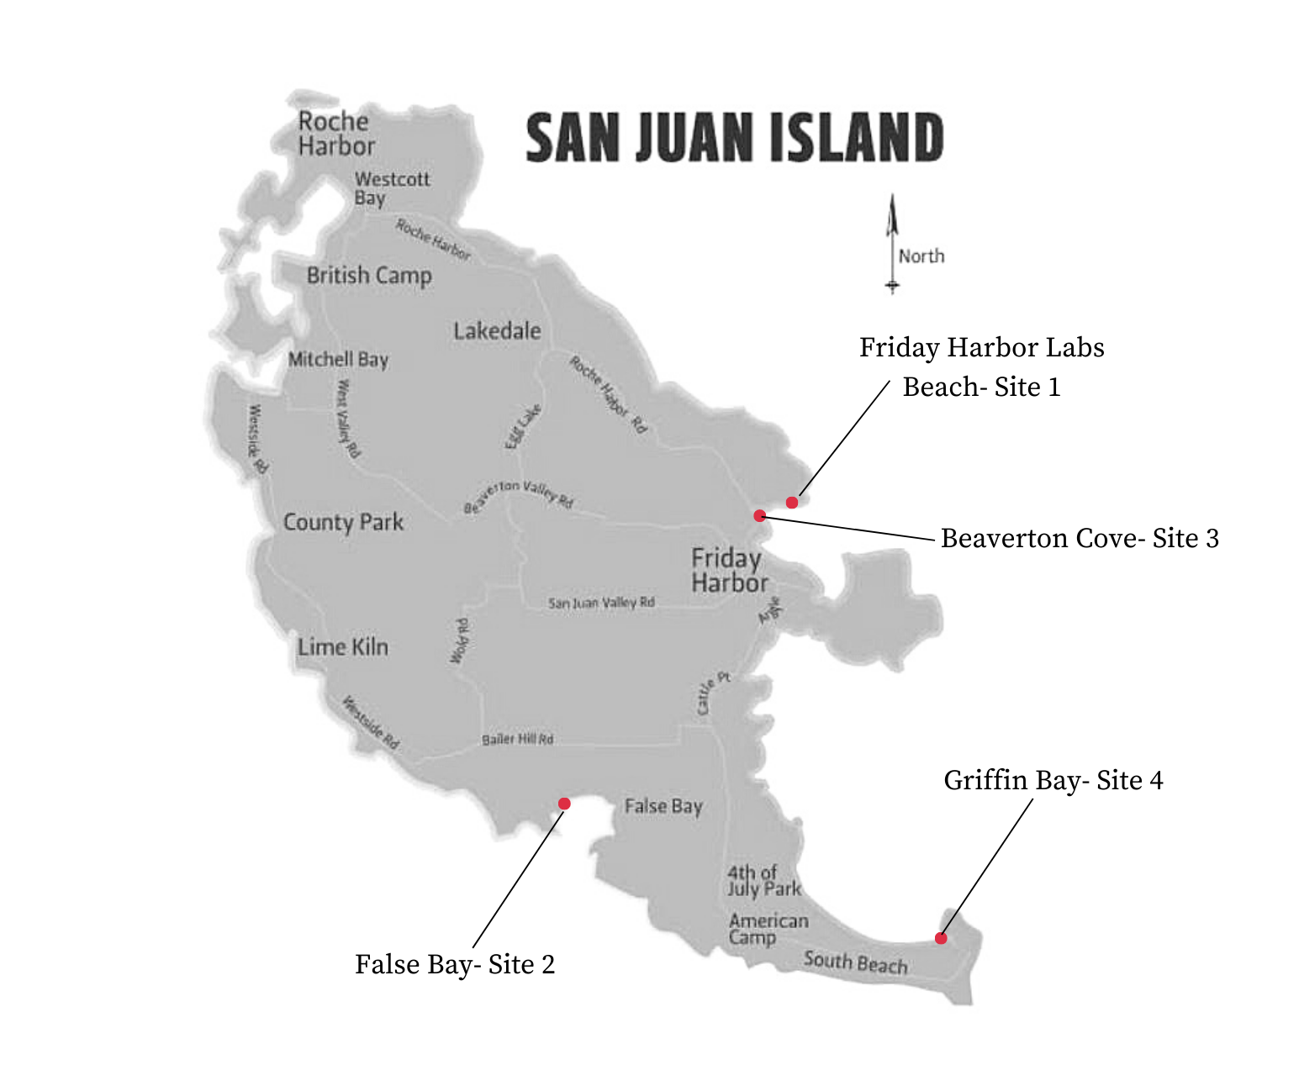
Figure 1. Map of survey sites on San Juan Island, Washington, including: Friday Harbor Labs Beach (48.54635°N, 123.00981°W), False Bay (48.48307°N, 123.07452°W), Beaverton Cove (48.54509°N, 123.01579°W), and Griffin Bay (48.46271°N, 122.97286°W).

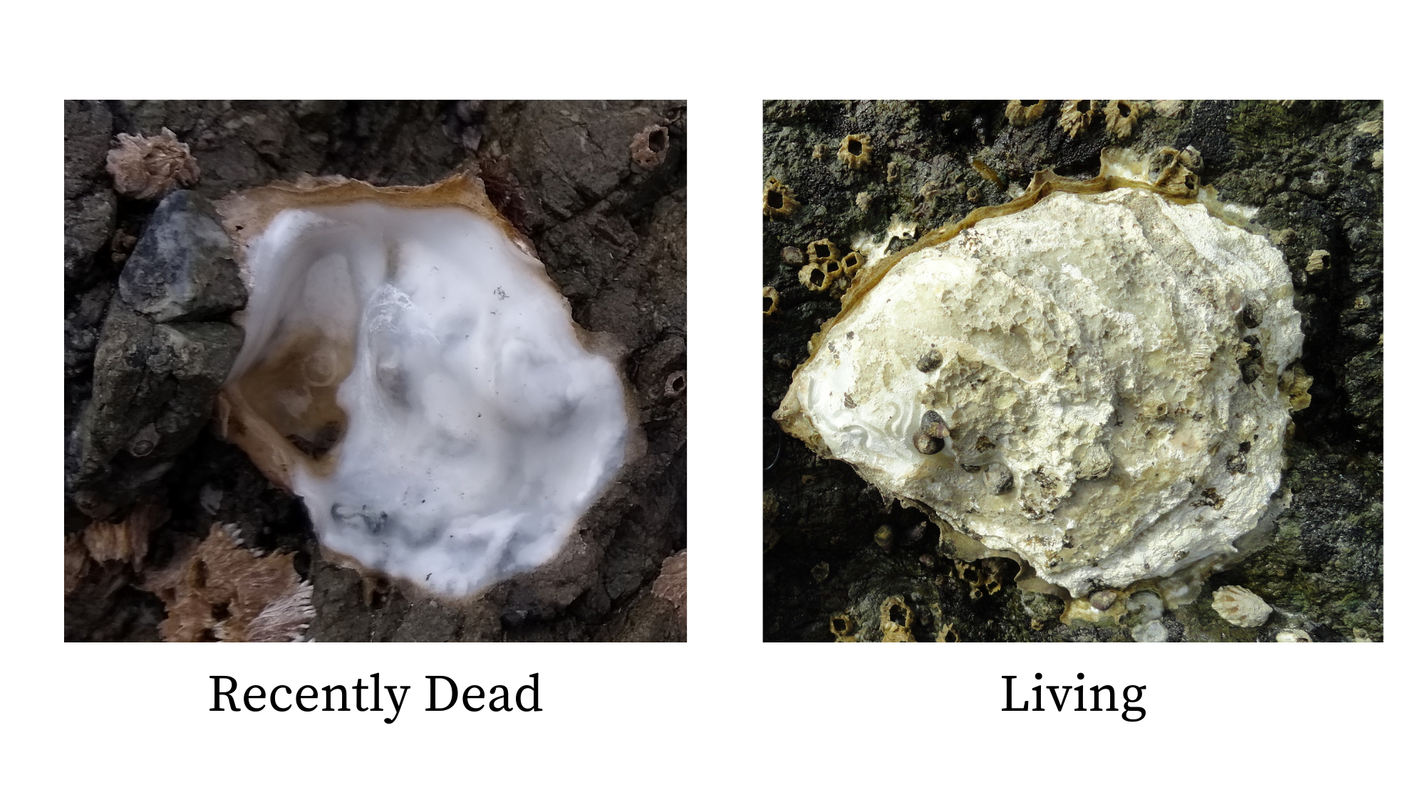
Figure 2. Visual example of survey criteria. Recently dead individuals were included in the data when the criteria were met such that: the right valve and internal body was absent, the left valve is attached to substrate, little to no signs of shell degradation are observed. Living individuals were included in the data when the criteria was met such that: the individual is well established on the substrate with both valves present, and the individual's size indicates a presence in summer 2021 (~ >5cm).
The data collected were imported into Rstudio to perform a logistic regression to model the probability of mortality given size and site. The binary mortality data (total living-total dead) was used to estimate the percent mortality at each of the 4 sites and in total ((total dead/total individuals)*100).
Results
The logistic regression model shows that length is a significant factor in predicting the probability of an individual being alive or dead (p value= 0.00421), within a 95% confidence interval. Every 1cm increase in length is associated with an increase in the odds of an oyster being alive. The model does not suggest a significant difference in this association between the 4 sites (p values > 0.1).
The calculated percent mortalities across the 4 sites range between 4.29%-14.29%. The overall percent mortality was 8.57%.
 | Estimate | Standard Error | Z value | P value
(Intercepts) | -0.93684 | 1.12871 | -0.830 | 0.40654
Length | 0.31486 | 0.11000 | 2.862 | 0.00421
Site: False Bay | 0.92577 | 0.72019 | 1.285 | 0.19863
Site: Friday Harbor Labs Beach | -0.06466 | 0.55106 | -0.117 | 0.90659
Site: Griffin Bay | 0.88971 | 0.67301 | 1.322 | 0.18617
Table 1. Coefficients summary of logistic regression model. Length is a significant predictive factor (p-value = 0.00421), where every 1cm increase in C.gigas length is associated with an increase in the odds of an oyster being alive. Sites FB (False Bay), FH (Friday Harbor Labs Beach), and GB (Griffin Bay) were tested against Beaverton Cove, where no significant difference was found (p-values= 0.198, 0.907, 0.186).

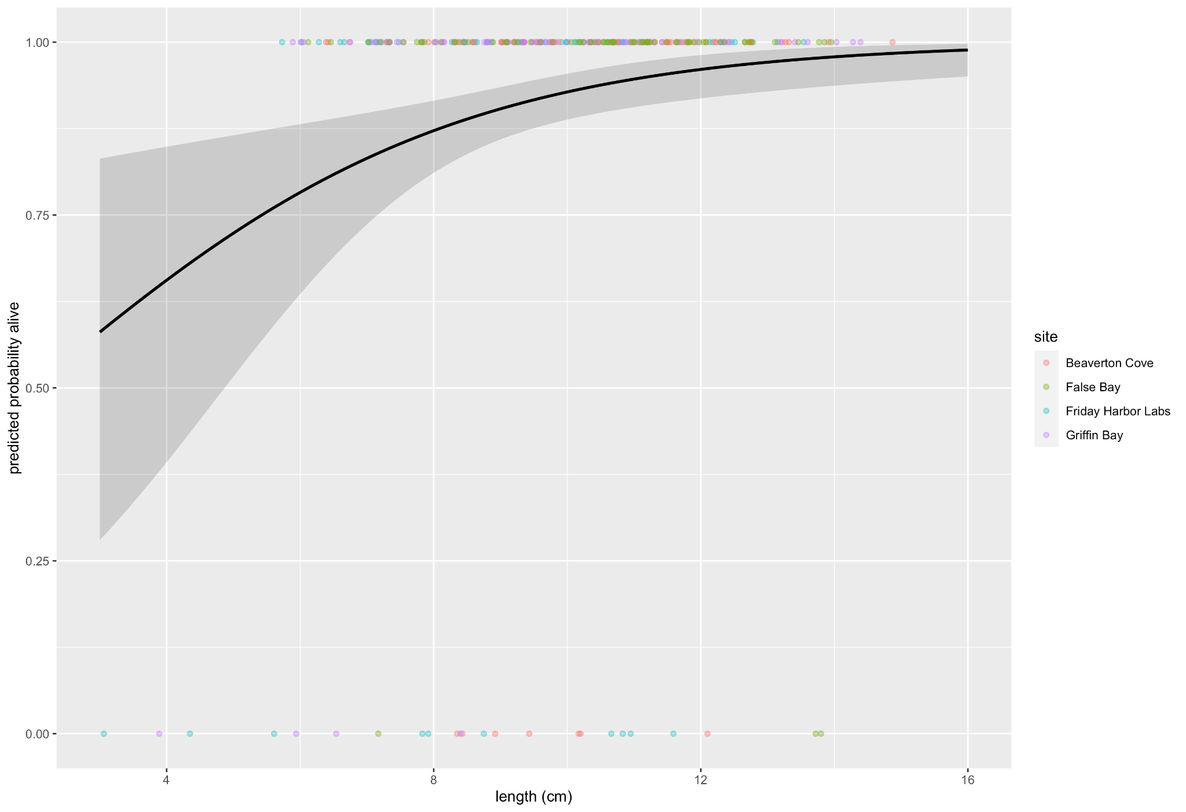
Figure 3. Plot of logistic regression model across 4 sites, showing a 95% confidence interval in the shaded region.. There is a positive association between C.gigas length (cm) and predicted probability of individual being alive as shown by the line. There is no significant difference in the assocation between sites.

Table 2. Percent mortality in C.gigas, as calculated using survey data across 4 sites and in total. Values determined by (total dead/total individuals)*100.
Discussion
The data show that C.gigas individuals of greater length were more likely to be alive. This suggests that the individuals that survived the summer 2021 heat dome were of greater length than those which did not. When under repeated exposure to marine heatwaves, it was found that Pearl Oysters, Pinctada maxima, showed decreases in thermal stress response, indicating an ability to rapidly acclimate to marine heatwaves (Xu et. al, 2021). Given this, the older and larger Pacific Oysters may have been better able to survive the 2021 heat dome due to prior exposure to high temperatures.
Given the lack of significant difference in the data between the 4 sites, we can more confidently conclude that this positive association between greater length and survival is representative of the surveyed areas. We cannot extrapolate this data to represent San Juan Island in a larger sense, however. Our 4 survey sites were located on the southern half of the island, and therefore did not adequately represent the northern half in our data.
The overall percent mortality of 8.57% is consistent with what other recent studies suggest. Some estimates for oyster mortality following the heat dome event are as high as 30%, whereas others range from 5-18% (Royal, 2022).
The recent cases of high shellfish mortality are being attributed to the heat dome of summer 2021, with high atmospheric pressures, dry conditions, and midday extreme low tides as the major contributors (Thompson et.al, 2022; WSG, 2021). Shellfish mortalities in the summer months are not uncommon, however. The term “summer mortalities” (King et.al, 2018) is used to encompass large shellfish die-offs caused by a number of factors including infectious agents, temperature, eutrophication, salinity, and the genetics and physiology of the affected oysters (Malham et.al, 2009). Whether the mortality event following the summer 2021 heat dome was abnormal in the context of these summer mortalities is still unclear, though the prolonged high temperatures appear to be a major contributing factor. It is unclear what greater ecological effects these mortality events might have. Investigation into potential effects of these mortality events at lower trophic levels (WSG & WDFW, 2021), or of heat waves at varying bivalve life-history stages would contribute to our understanding of this developing issue (Xu et.al, 2021).

Literature Cited
King, William L., et al. “Characterisation of the Pacific Oyster Microbiome during a Summer Mortality Event.” Microbial Ecology, vol. 77, no. 2, 10 July 2018, pp. 502–512., https://doi.org/10.1007/s00248-018-1226-9. Accessed 24 May 2022.
Lin, Hai, et al. “The 2021 Western North American Heatwave and Its Subseasonal Predictions.” Geophysical Research Letters, vol. 49, no. 6, Mar. 2022, https://doi.org/10.1029/2021gl097036. Accessed 24 May 2022.
Malham, Shelagh K., et al. “Summer Mortality of the Pacific Oyster, Crassostrea Gigas, in the Irish Sea: The Influence of Temperature and Nutrients on Health and Survival.” Aquaculture, vol. 287, no. 1-2, 1 Feb. 2009, pp. 128–138., https://doi.org/10.1016/j.aquaculture.2008.10.006. Accessed 24 May 2022.
NOAA Fisheries. “Oyster Reef Habitat.” National Oceanic and Atmospheric Administration, U.S. Department of Commerce, 4 Feb. 2022, https://www.fisheries.noaa.gov/national/habitat-conservation/oyster-reef-habitat#:~:text=Oysters%20are%20a%20crucial%20component,and%20protecting%20productive%20estuary%20waters.
Northern Economics, Inc. The Economic Impact of Shellfish Aquaculture in Washington, Oregon and California. Pacific Shellfish Institute, Apr. 2013, https://www.pacshell.org/pdf/Economic_Impact_of_Shellfish_Aquaculture_2013.pdf.
Rice, Michael. “Environmental Impacts of Shellfish Aquaculture: Filter Feeding to Control Eutrophication.” Jan. 2001, https://www.researchgate.net/publication/258235340_Environmental_Impacts_of_Shellfish_Aquaculture_Filter_Feeding_to_Control_Eutrophication.
Royal, Tiffany. “Heat Dome Found to Be Deadly for Some Shellfish Species, but Not for Others.” Northwest Treaty Tribes, 10 Jan. 2022, https://nwtreatytribes.org/heat-dome-found-to-be-deadly-for-some-shellfish-species-but-not-for-others/.
Shatkin, Greg, et al. “Considerations Regarding the Possible Introduction of the Pacific Oyster, Crassostrea Gigas, to the Gulf of Maine: a Review of Global Experience.” Journal of Shellfish Research, vol. 16, Jan. 1997, pp. 463–477.
Thompson, Vikki, et al. “The 2021 Western North America Heat Wave among the Most Extreme Events Ever Recorded Globally.” Science Advances, vol. 8, no. 18, 4 May 2022, https://doi.org/10.1126/sciadv.abm6860. Accessed 24 May 2022.
Washington SeaGrant. Shellfish Aquaculture in Washington State. Final Report to the Washington State Legislature. Dec. 2015, https://app.leg.wa.gov/ReportsToTheLegislature/Home/GetPDF?fileName=WSGShellfishResearchFinalReportRevised_f6498d40-24b7-491e-8e1f-297faeef6a53.pdf.
Washington SeaGrant, and Washington Department of Fish and Wildlife. Impacts from the Summer 2021 Heatwave on Washington Shellfish. 21 July 2021, https://wsg.washington.edu/impacts-from-the-summer-2021-heatwave-on-washington-shellfish/.
Xu, Yang, et al. “Impacts of Marine Heatwaves on Pearl Oysters Are Alleviated Following Repeated Exposure.” Marine Pollution Bulletin, vol. 173, Dec. 2021, https://doi.org/10.1016/j.marpolbul.2021.112932.

