Growth Rate of Alaria Marginata and its Relationship with Temperature and Salinity

Junxi Yang

FHL 470 A Research in Marine Biology Course
University of Washington
Friday Harbor Laboratory
Friday Harbor, WA 98250
yjx1201@uw.edu
May 2022

Running Header: Alaria Marginata Growth Rate Variation with Temperature and Salinity

Abstract
Kelp can be widely found along the west coast of the US and plays an important role as the primary producer in many marine food webs. Recent publications indicate the climate change that affects the ocean conditions can also influence the kelp growth. To better understand the influence of climate change, we investigated how two abiotic factors, temperature and salinity can affect the growth rate of one specific kelp, Alaria marginata. We hypothesized that higher temperature and higher salinity would both lead to a higher growth rate of A. marginata. To conduct our experiment, we used four outdoor tanks and set up the conditions with different temperature and salinity. Observations and measurements were performed every morning over a continuous five-day period. These results are consistent with our expectation of higher growth rate at higher temperature. We found no effect of salinity on growth rate.

1. Introduction
Climate change has become one of the growing issues that influences the marine habitats. Warming associated with climate change now causes an increase in seawater temperature and melting glaciers can potentially decrease the salinity of seawater in coastal regions. According to relevant studies, the nutrient level (NO₃, oxygen) in the seawater will be lower with a higher water temperature (Broch an Slagstad 2012). Without sufficient nutrients, primary producers in the marine food web may be negatively impacted in certain marine habitats and cause negative impacts to other marine organisms.
Kelp, which is a major primary producer, plays a vital role in the marine environment and relevant food webs. Alaria marginata, known as the winged kelp, is one of the most common kelps along the west coast of the US. A. marginata is considered a major contributor to marine intertidal habitats. Previous studies indicate that kelp productivity and population variation can not only affect the marine ecosystem but also influence the economy related to these habitats. However, most of the literature focuses on other kelp species such as Nereocystis leutkeana and Saccharina latissimi and their potential effects on various aspects (Barta et al 1981; Meng et al 2020). Therefore, in this study we chose to investigate the growth pattern of A. marginata and to discern factors that will potentially change its growth rate.
Because of the complexity of climate change, we can hardly include all the different variables in this experiment. Hence, this study aims to explain (1) how temperature will affect the growth rate of A. marginata and (2) whether salinity can influence the growth rate of A. marginata. Also, we cross compare (3) whether there is an interaction between temperature and salinity. With the data collection, we can investigate the growing pattern of A. marginata and analyses the prospect influence in the marine environment.
2. Methods
2.1 Algae Collection
All A. marginata were collected from the tires attached to the FHL floating dock (48.545°N, -123.012°W) and were randomly selected. We removed the holdfast of each individual blade and measured the initial thallus length. A plastic tube connector was used to punch two 2.5-mm diameter holes on the blade. The first hole was made at a 5-cm interval from the base of the blade, and the second hole remained a 5-cm interval from the first hole (Fig. 1). This method will indicate the growing pattern of the meristem part of kelp (Mann and Kirkman 1981). We also recorded the length of the blade and tied them in order on a rope.
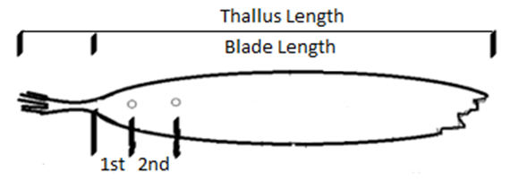
Figure 1. Diagram of where the measurements were taken on A. marginata.

2.2 Experimental Design and Analysis
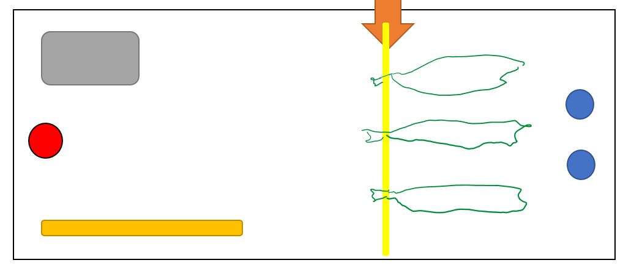
We set up four different treatments with different conditions. Besides the treatment group 1 which was the ambient group with ambient temperature - ambient salinity, the other three treatment groups were treatment group 2 with high temperature - ambient salinity, treatment group 3 with high temperature - high salinity and treatment group 4 with ambient temperature - high salinity. Aquarium heaters were used to increase the temperature by 3-°C (ambient temperature in average is 12-°C) and we also used rock salt to increase the salinity by 2-‰ ppm (ambient salinity is 31-‰ ppm). We measured the salinity by using a portable refractometer in each tank two times per day at 8 a.m. and 8 p.m. to determine if we need to add more salt to the high salinity tank. The outflow rates in all tanks were adjusted to be equivalent. Each tank included a rope with eight A. marginata plants in a row and binder clips were used to prevent the kelp from floating toward either heaters or salt (Fig. 2). Four thermometers were put in each of the tanks to keep track the temperature every day.
Figure 2. Tank setup. Red hole indicates the inflow location and blue holes are the outflow locations. Salt is placed in the grey box and orange tube is the water heater if applicable. Orange arrow shows where the binder clip is placed, and yellow line is the rope.

A two-way Anova test was used to make comparisons between the mean growth rate of the four different groups. The alpha value of 0.05 was set to test whether associations occurred among these variables. We also used the Tukey’s post-hoc test to test for significance of the data differences.

3. Results
The ambient temperature in this experiment was 12-°C on average and by using the aquarium heater, we increased the temperature by approximately 3-°C on average in the high temperature treatment groups. The mean ambient salinity was 31-‰ppm and the high salinity treatment groups had the salinity measured at 33-‰ppm. All treatments showed a growth pattern except three out of eight thalli in the ambient temperature - high salinity group presented a signal of erosion throughout the entire blade, causing a high standard deviation in the meristem growth measurement and a negative blade length growth rate.
Alaria Marginata Growth Rate Data
Group | Blade Length Growth (%) |  | Meristem Growth (cm)
-T-S (1) | Mean | 0.032 | Mean | 1.88
12-°C & 31-‰ppm | SD | 0.028 | SD | 0.69
^T-S (2) | Mean | 0.044 | Mean | 2.31
15-°C & 31-‰ppm | SD | 0.024 | SD | 0.65
^T^S (3) | Mean | 0.115 | Mean | 3.31
15-°C & 33-‰ppm | SD | 0.060 | SD | 0.59
-T^S (4) | Mean | -0.032 | Mean | 1.31
12-°C & 33-‰ppm | SD | 0.071 | SD | 1.98
Table 1. Blade length growth rate and meristem growth measurement for all four tanks. – represents ambient value and ^ indicates high value.

We found that there is an association between the temperature and the blade’s growth rate of A. marginata. The data (Fig. 3) show that temperature has a significant influence on the growth rate of the blades (f=20.247, p<<0.05), whereas the salinity does not influence the results (f=0.031, p=0.86). And the interaction between two variables is also significant (f=14.674, p<<0.10). The Tukey’s post-hoc test also presents the significant differences among four treatment groups except the difference between the ambient treatment group and the high temperature – ambient salinity group.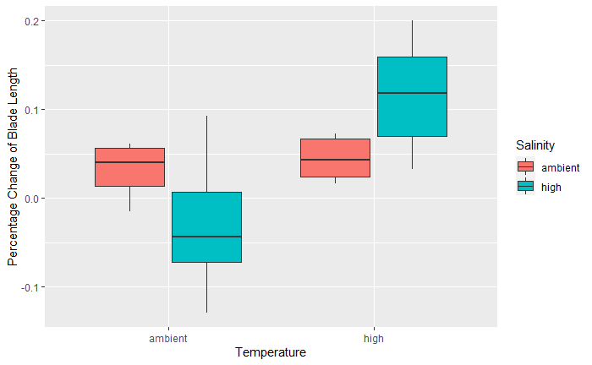Figure 3. Blade length percentage growth comparison in all four treatments.

The data of the meristem part (Fig. 4) shows a statistically significant association between the temperature and meristem growth (f=9.171, p<<0.05). Salinity still does not show its relevance to the meristem growth (f=0.295, p=0.59) and the interaction between temperature and salinity is still significant (f=3.768, p=0.062). A Tukey’s post-hoc test is presented and reveals a significant difference between each pair of the four treatment groups.
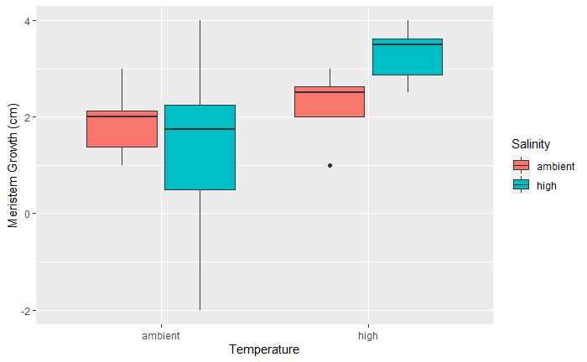
Figure 4. Meristem growth comparisons in all four treatments.

4. Discussion
The growth rate of A. marginata responds to the temperature. The overall growth rate of blade length is lower in both tanks with ambient temperature and the meristem growth rate is also slightly higher when the temperature is higher. Previous studies have shown that A. marginata would not be affected by temperature (Munoz 2021) and the optimal growing temperature for A. Marginata is between 10 and 12-°C (Kjeldse and Phinney 1972). However, a prior study showed that temperature is the predominant variable affecting growth in Alaria esculenta (Fredersdorf et al 2009). Because both kelps belong to the phylum Alaria, our expectation is that the elevated temperatures can positively affect the growth rate of the kelp. And our results indeed indicate that both the blade and meristem growth rate can be increased by a 3-°C rise in the temperature (from 12-°C to 15-°C). Therefore, we can conclude that even a small increment in the seawater temperature can significantly affect the growth of A. marginata.
The salinity has no significant effect on the growth rate of A. marginata. A prior study indicated that the optimal salinity for A. marginata is between 30 and 35-‰ ppm (Kjeldsen and Phinney 1972). Both the ambient salinity and high salinity treatment groups had the salinity values within this range, which shows the possibility that our treatment groups would not be significantly affected by the salinity variations. However, interaction effect was presented in our experiment. The salinity will influence the growth rate of A. marginata when temperature differences are displayed.
A longer experiment could have provided more concrete results. Five days only present how A. marginata can respond to temperature and salinity in a short-term period and a longer duration for this experiment is suggested. Erosion will occur under high exposure situation (Simonson et al 2015), and we also observed the accumulated diatoms in all treatment groups. Therefore, we also suggest including other variables that can potentially affect the kelp growth with the effect of time and increasing the range of the manipulated variables. Other species of kelp have optimal growth under different temperature and salinity (Raymond 2020), and we propose to introduce other kelp species to provide a more substantial conclusion.
Making observations on how ocean conditions affect the growth pattern of kelp is important because kelp are the main primary producers in the marine ecosystem. Kelp forests are now threatened by a variety of human impacts and consequently affect the marine ecosystem (Krumhansl 2016). The elimination of kelp forests can result in a decreased abundance of other marine organisms that feed on kelp and possible marine migrations. Our findings indicate that the growth of kelp is related to the seawater temperature and even a small elevation of temperature can help with the kelp growth. The benefits of this experiment include the ability to monitor the temperature and salinity for kelp growth, allowing for flexibility to provide strategies that can protect kelp in the variable marine environment.

Acknowledgement
First and foremost, I would like to show my deepest gratitude to Professor Terrie Klinger and Joe Duprey who provided me with valuable guidance and helpful comments in every stage of the writing of this paper. I shall extend my thanks to my partner Shawn Nigel Canonizado who worked with me to accomplish this experiment. My sincere appreciation also goes to all my friends and classmates for their encouragement and support.
Literature Cited

A.E.T. Raymond. 2020. Life Cycles of the Kelps Saccharina latissimi and Alaria marginata: Implications for Mariculture and Ecology in Alaska. University of Alaska Fairbanks, Ann Arbor.

Barta, E.S., Branen, A.L. and H.K. Leung. 1981. Nutritional Analysis of Puget Sound Bull Kelp (Nereocystis luetkeana). J. Food Sci. 46: 595-597.

Broch, O.J. and D. Slagstad. 2012. Modelling seasonal growth and composition of the kelp Saccharina latissima. J Appl Phycol. 24: 759-776.

Diehl, N., Karsten, U. and K. Bischof. 2020. Impacts of combined temperature and salinity stress on the endemic Arctic brown seaweed Laminaria solidungula J. Agardh. Polar Biol 43: 647–656.

Fredersdorf, J., Müller, R., Becker, S., Wiencke, C. and K. Bischof. 2009. Interactive effects of radiation, temperature and salinity on different life history stages of the Arctic kelp Alaria esculenta (Phaeophyceae). Oecologia. 160: 483-92.

Kjeldsen, C.K. and H. K. Phinney. 1972. Effects of variation in salinity and temperature on some estuarine macro-algae. Proceedings of the International Seaweed Symposium. 7: 301-308.

Krumhansl, K. A., Okamoto, D. K., Rassweiler, A., Novak, M., Bolton, J. J., Cavanaugh, K. C., Connell, S. D., Johnson, C. R., Konar, B., Ling, S. D., Micheli, F., Norderhaug, K. M., Pérez-Matus, A., Sousa-Pinto, I., Reed, D. C., Salomon, A. K., Shears, N. T., Wernberg, T., Anderson, R. J., Barrett, N. S. …and J.E. Byrnes. 2016. Global patterns of kelp forest change over the past half-century. Proceedings of the National Academy of Sciences of the United States of America, 113(48): 13785–13790.

Mann, E.H., and H. Kirkman. 1981. Biomass Method for Measuring Productivity of Ecklonia raidata, with the Potential for Adaptation to Other Large Brown Algae. Marine and Freshwater Research. 32(2): 297-304.

Meng, C. and T. Mumford. 2020. Patterns of Growth and Erosion of blades of the kelp Saccharina latissima. Friday Harbor Laboratories Student Research Papers.

M. Munoz. 2021. Temperature Effects on Growth of Alaria marginata, Saccharina latissima, and Costaria costata. Friday Harbor Laboratories Student Research Papers.

Simonson, E.J., Scheibling, R.E. and A. Metaxas. 2015. Kelp in hot water: I. Warming seawater temperature induces weakening and loss of kelp tissue. Marine Ecology Progress Series. 537: 89–104.

