Delineation of Watershed Regions Supplying
Spirit Lake at Mount St. Helens, WA

Cameron Marshall
University of Washington, Tacoma Undergraduate
GIS Certificate Program

Lakes in many environments, urban to alpine, provide important research opportunities to better understand how various natural processes work. Researching these lakes allow for better sustainability and an overall understanding of how to best manage and conservation our local fresh water supplies. As the demand for fresh water continues to grow, the need for such protection and management also increases. Studying urban lakes can show how anthropogenic influences alter the dynamics of a lake. Conversely, the study of alpine lakes can also explain anthropogenic influences on lake systems by removing the human interaction with the lake. Some alpine environments offer unique opportunities to study both the lack of anthropogenic influences, but also the recovery of lakes from natural disasters. At Spirit Lake near the Mount St. Helens volcano, the 1980 eruption drastically altered the lake and surrounding landscape. By adding approximately 60m of sediment to the lake bottom, raising the lake, creating a shallower southern shoreline, an overall larger surface area, and changing the overall dynamics of the nutrient cycle within the lake, Spirit Lake is a system that is trying to be understood.
Nutrients cycle in lakes due to many different factors including, but not limited to, the availability of nutrients (like phosphorus or nitrogen), temperature, pH, morphological and hydrological conditions, and the flora and fauna in the lake area. At Spirit Lake, these processes were disturbed and altered due to the eruption that enriched the lake with volcanic nutrient material (Larson 1994). Few studies were conducted on Spirit Lake or around Mount St. Helens prior to the 1980 eruption. However, many studies have been conducted since. Water quality monitoring was conducted for several years following the blast, with a noticed and remarkable increase in water quality within three to six years after, returning the lake to high water quality levels seen only several years before the eruption (Larson et al. 2006). Ultimately, lakes are influenced not only by their own morphology and processes but also by the surrounding landscape.
Watersheds, areas of land determined by the topography surrounding lakes, rivers, wetlands, and any other sink of water, are tracts of land that catch rainfall and runoff and act like a funnel to direct water into the final catchment. It is becoming even more critical to learn and understand watersheds and their role in water quality and the overall health of an ecosystem. Several GIS models have been built for research of watersheds as they pertain to flood prediction measures (Cesur 2007), aiding in restoration efforts and represent landscape and water quality (Strager et al. 2008), predict nutrient loads in wetlands and showed a high correlation with the model and ground truthing efforts (Evans et al. 2008), and also estimating surface water flows (Patil et al. 2008). These only represent a small fraction of the research being conducted using GIS on watersheds.
However, the research being conducted at Mount St. Helens, including this project, has less to do with extending GIS research and more to determine the overall nutrient cycling in Spirit Lake and extend the research previously conducted at Mount St. Helens and other alpine lakes. As most of the research conducted on Spirit Lake ended, or has not been continuous, for about 20 or so years ago, the current nutrient cycling research marks a new step in understanding the natural processes around Mount St. Helens. By understanding nutrient cycling in an alpine lake, the link between lake processes and anthropogenic influences, more commonly seen in urban environments, can be established and more fully understood.
As nutrient cycling occurs for many reasons, the purpose of this research is then to delineate the watershed regions surrounding Spirit Lake in an effort to better understand the influence of surface water on this cycling. In this way, the flow over a given area, based on streamflow measurements, can be attributed to watershed regions and used to estimate flow in other unmeasured areas of the region. This project seeks to establish the initial watershed regions for a given point in time, understanding that flow will change over time but the watershed areas will not change unless the landscape changes. Finally, these watershed regions can be used to estimate nutrient loading from surface waters, once water quality parameters are known, as part of the overall nutrient cycling model for Spirit Lake. This first step in the overall project will aid future research at Spirit Lake.

Methods and Results

Basic methods were found through the Washington Department of Ecology (DOE) for the development of watersheds over a given landscape (Pelleteir 1999). However, these methods were written in Arc 3.1, which was a more heavily scripted environment than more recent versions of ArcGIS. With the inception of these versions of ArcGIS (i.e. 9.x), hydrology tools (within the Spatial Analyst toolbox) were created to alleviate the need for much of this scripting. The WA DOE instructions were used as a general project outline for the creation of watersheds around Spirit Lake.
The first step of this process was to download the data to be used. These data included digital elevation models (DEM) for the Spirit Lake region [USGS quadrangles at 24K] and, from the WA DOE, hydrology network, lake polygons, and state county basemap. Primary data collected in the field during the summer of 2008 were the stream measurement points to be used as pour points in the watershed tool, discussed later. From here, the entire watershed can be established.
To initiate the steps in GIS, the DEM quadrangles had to first be combined as a mosaic in order to run the remaining processes seamlessly and with one file (Figure 1). In order to define the study area, the DEM was created into a hillshade layer, to better visualize the peaks and valleys of the lake’s surrounding landscape. An arbitrary boundary was manually drawn on the outside of these peaks to confine the subsequent processes to a smaller extent than could be run on the DEM files together (Figure 2).

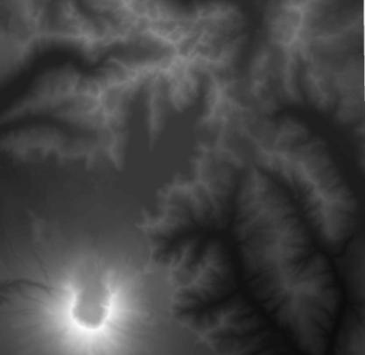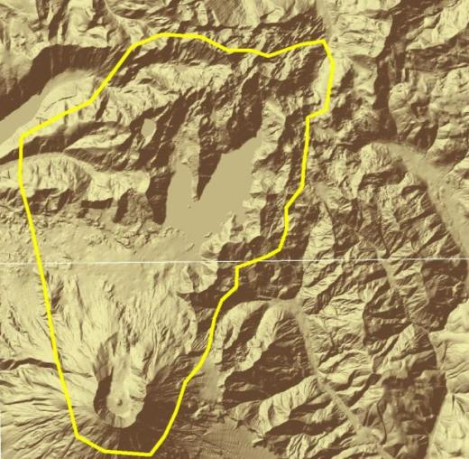
Figure 1 – Mosaic of USGS 24K DEM Figure 2 – Hillshade generated from DEM’s with arbitrary research boundary established

The stream layer, obtained from DOE, was overlaid and clipped to the research boundary (Figure 3). The streams and lake were converted to rasters. Masking was performed to remove the lake from the DEM so that the hydrology tools will not use the lake as part of the watershed model. The stream raster was given the values of 1 or NoData, depending on if there was a stream cell present or not, and was used in order to perform the subsequent steps, the DEM must be exaggerated (actual elevations absurdly increased) with the streams maintained at the elevation of the original DEM. In other words, the streams in this step would have the original DEM value, while surrounding cells would be exaggerated, say by 10000. This process is known as “burning-in” the streams. Theoretically speaking, this would “force” water to flow from high elevations into the much lower stream elevation. This would ensure that the following flow tools would put water into the streams and end, eventually, in the final sink, Spirit Lake.
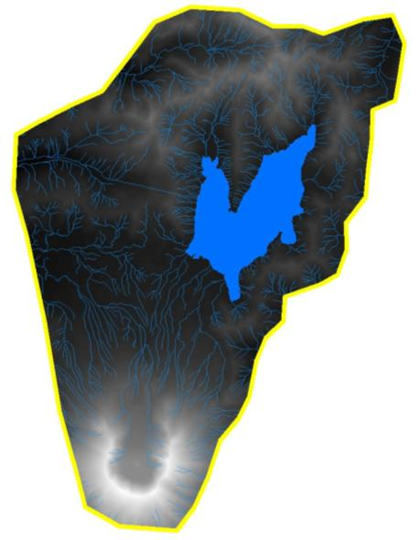
Figure 3 – Stream and lake layer added to research boundary

The DEM must first be exaggerated (raster calculator: MSH_DEM_Plus10000 = [MSH_DEM] + 10000)and then used in the burn-in process. The raster calculator syntax used for the stream burn-in procedure was as follows: StreamBurnIn = con(IsNull([MSH_streams_Val1_Raster]), [MSH_DEM_Plus10000], [MSH_DEM10]). In this step, for every cell in the stream raster layer, if there is a value found, the original DEM elevation will be used. However, if there is a NoData field found, the elevation from the exaggerated DEM will be used. This is essentially a merge procedure of the original DEM and exaggerated DEM, using the stream layer as a conditional statement. The output of this process can be seen in the combined Figure 4. The image on the right is a 3D model to depict the exaggeration that occurs between the stream elevation (the slumps in the DEM) and the new DEM surface layer. The underlying 2D DEM layer in the Figure 4 3D image is included as reference.
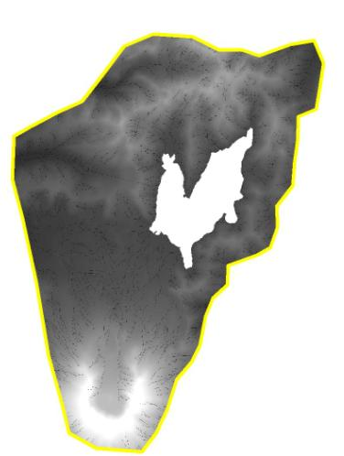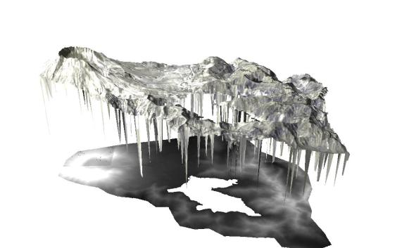

Figure 4 – Exaggerated DEM (+ 10000) with streams burned-in at actual elevation. Right image depicts exaggeration of DEM on 3D scale.

Following this important exaggeration step, the flow direction tool (Figure 4) and the flow accumulation tool (Figure 5) were used. The flow direction tool creates a grid of cells showing which direction one cell will flow into another, using the exaggerated DEM as its main input, and forces the flow into the streams. The flow accumulation tool creates a grid of cells to depict where the water flow will accumulate in the region. As expected, this means that flow will accumulate in the streams of the region, as shown by the white areas in Figure 5.

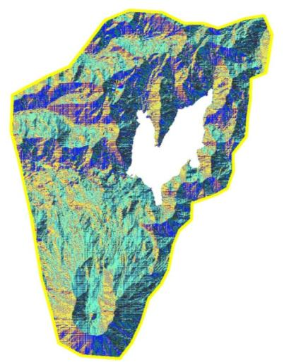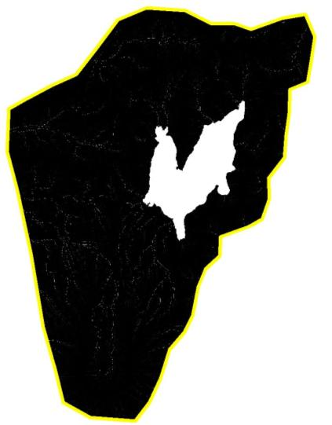
Figure 4 – Flow direction tool used to create grid Figure 5 – Flow accumulation tool used to create accumulation grid

Once these direction and accumulation layers were created, the stream measurement points were moved to correspond with the stream layer. If this step is not done, watersheds would be created which are much smaller and likely do not correspond to the actual stream watersheds. For this reason, stream points must line up with the lower points of the streams. Figure 6 shows the stream measurements that were made at various times during the summer of 2008. These measurement points, collected by GPS, can be seen to not correspond directly to the stream layer provided by the WA DOE. These measurement points were moved and filtered based on measurement date to place one point on the closest stream (Figure 7).

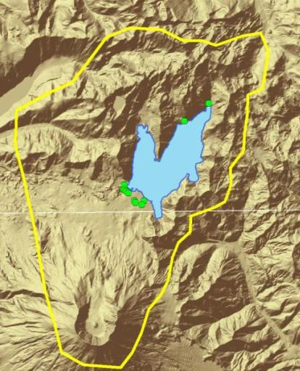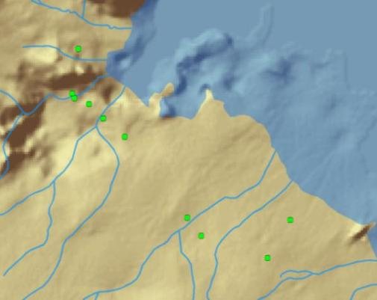

Figure 6 – Shown here, all stream measurement points taken over course of summer; which do not correlated to stream layer

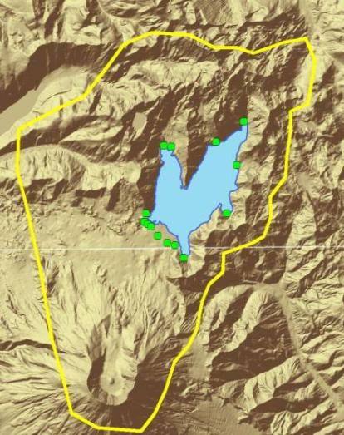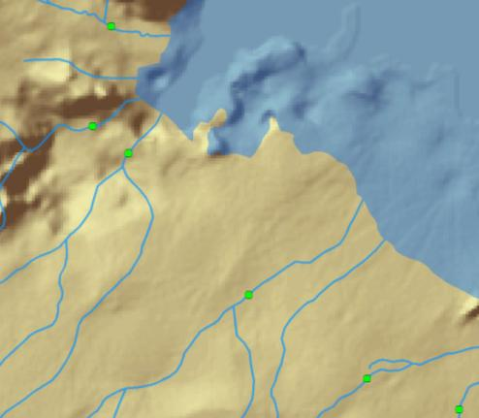

Figure 7 – Stream measurement points moved to fit actual stream layer and added to ungaged areas

Having measurement points now corresponding to only one stream area, the final step was to use the watershed tool to generate watershed regions with the measurement points as pour points (thinking of pouring water through the landscape and aggregating at each measurement point). Discharge per area was then calculated for each watershed, either through actual measured values or from regression analysis of watershed area compared to measured discharge. Regression analysis revealed a moderately high correlation coefficient (R² = 0.895) where surface water discharge is 0.00000001 times that of the overall area. These watershed regions were categorized and overlaid on the basemap to show the distribution and area flow supplying Spirit Lake (Figure 8). A 3D map was also generated to show the watershed region in a more dynamic fashion for display on the poster and presentation created for this project, but is not shown here.

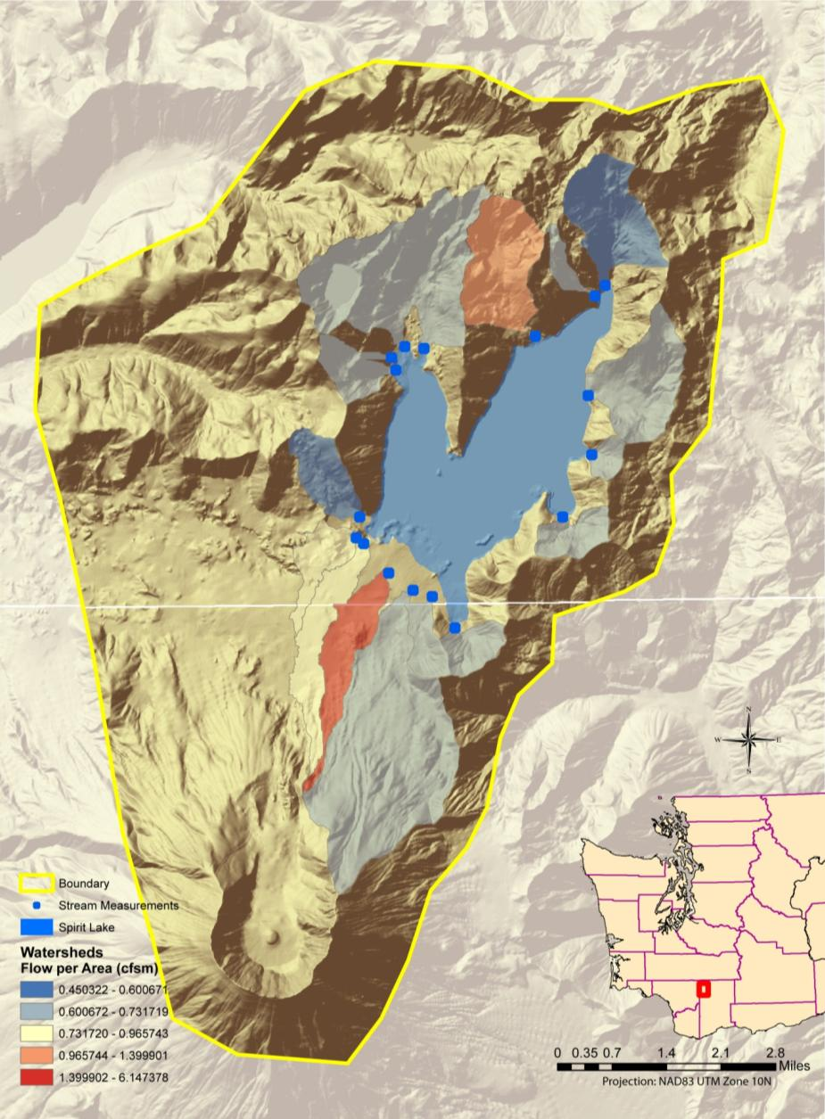

Figure 8 – Final map layout of the watersheds developed for the Spirit Lake region

Discussion and Future Research

This final map (Figure 8) portrays the watersheds surrounding Spirit Lake and acts as a snapshot for one point in time, August 15, 2008. This does not impact the area of each watershed, but will affect the area discharge (cfs per mile) for different dates and flow characteristics. To further investigate the relationship of discharge and area or to further prove the watershed areas created in this project, future measurements and ground-truthing should be conducted. The nature of the surrounding geology of Spirit Lake, especially the southern shoreline closest to Mount St. Helens, is made up of pumice. This pumice plain is highly susceptible to shifting streambeds and dynamic changes. With this in mind, pour points (discharge measurement sites) will likely differ from season to season and year to year. The best available science is to either remap streams around Spirit Lake or use the best data available for analysis. In this case, pour points were moved to correspond to the most recent stream layer that was obtained from the WA DOE. The shifting nature of the streams must be considered when analyzing these final maps for accuracy.
Stream measurements also come with error attached to them. The measurements used for these maps, from August, were all mostly poor measurements (by USGS standards) as they contained fewer than 20 sections, had very shallow depths, and each section was only measured for 20 seconds, not the standard 40 seconds. This means that stream measurements are off by about 10-15%, likely, and will thus effect the final area flow shown in the final map layout (Figure 8).
The overall procedure for this project was not difficult, especially with the advancement of the hydrology toolset; however, it was time consuming. Some of the processes that were run took, at times, several hours to run. Also, when trying to follow steps that were setup in Arc 3.1, the changes that need to be made for Arc 9.x were profound. Many of the tools that were created in the Pelleteir (1999) report were either created already or could be run using the raster calculator. It is likely that the advancement of processing power and program ability and function allowed for quicker run-times and accuracy during this project.
The flow accumulation layer was not actually used during the watershed development process, but could have been when using different tools. The Snap Pour Point tool uses the accumulation layer as an input and moves the pour point to the nearest cell of highest flow accumulation within a specified distance. This tool could have been run instead of manually moving the pour points, but would not have likely changed the watershed regions or area significantly. A more detailed watershed analysis could be conducted using the Basin, Sink, and stream tools to gain a more comprehensive and less subjective view of any given area. The Basin and Sink tools define the drainage basin and areas of internal drainage, respectively. These tools should be looked into further for future work conducted at Spirit Lake.
Future studies should also include the use of LiDAR (light detection and ranging) data, when more detailed data becomes available. The current LiDAR data available is no finer resolution than the DEM data for public use. Due to the increase in computing power, the use of LiDAR data for this project is indispensible and should not be a burden on most systems of today. LiDAR has been found to be highly effective, especially in less gradient slopes, when conducting watershed analysis (Jones 2008).
Another major portion of this project will need to encompass average geology, seasonality, and precipitation, including snowmelt, for inclusion in the nutrient cycling model for Spirit Lake. Water quality measures can then be applied over the watersheds, based on surface water measurements, to estimate the influence and contribution of surface water flow on nutrient cycling. More measurements should also be taken around Spirit Lake to ground-truth the watershed regions and estimations made. With this, more watersheds and more accurate data can be produced to aid in the creation of a nutrient cycling model for Spirit Lake at Mount St. Helens, WA.

References

Cesur, D. 2007. GIS as an information technology framework for water modeling. Journal of Hydroinformatics 9.2: 123 – 134.
Evans, B.M., D.W. Lehning, K.J. Corradini, G.W. Petersen, E. Nizeyimana, J.M. Hamlett, P.D. Robillard, and R.L. Day. A Comprehensive GIS-based modeling approach for predicting nutrient loads in watersheds. Journal of Spatial Hydrology 2(2): 1-18.
Jones, K., G.C. Poole, S.J. O’Daniel, L.A.K. Mertes, and J.A. Stanford. 2008. Surface hydrology of low-relief landscapes: Assessing surface water flow impedance using LIDAR-derived digital elevation models. Remote Sensing of the Environment 112: 4148-4158.
Larson, D.W. 1994. A Case of Natural Restoration of an Aquatic Ecosystem. Lake Line (Dec.) 26-31.
Larson, D.W., J. Sweet, R.R. Petersen, and C.M. Crisafulli. 2006. Posteruption response of phytoplankton and zooplankton communities in Spirit Lake, Mount St. Helens, WA. Lake and Reservoir Management 22(4):273-292.
Patil, J.P., A. Sarangi, O.P. Singh, A.K. Singh, and T. Ahmad. 2008. Development of a GIS interface for estimation of runoff from watersheds. Water Resource Management 22:1221-1239.
Pelleteir, G. 1999. Spatial hydrology of the Chehalis river and Grays Harbor using ArcView GIS. Washington Department of Ecology.
Strager, M.P., J.T. Petty, J.M. Strager, and J. Barker-Fulton. 2009. A spatially explicit framework for quantifying downstream hydrologic conditions. Journal of Environmental Management 90:1854-1861.

