Washington State Regions of High Population Density and Air Pollution from Point and Mobile Sources
With Detailed King & Pierce Counties Schools and Parks

Introduction
There are various forms of air pollution. Some of the most common are caused by human activities. Some types of air pollution are from point sources and from mobile sources. Point sources of air pollution are places that are stationary, usually major industrial facilities that put out a certain amount of pollutants each year. Mobile sources include automobiles such as cars, trucks and buses. Automobiles have been closely linked with increasing levels of air pollution in urban areas (Bhandari, et al. ND) where large populations are exposed to high levels of air pollution from traffic exhaust (Hansen et al. 2008). Air pollution in busy streets can attribute as much as 80 to 90% of the pollution levels (Jensen, ND). The most common form of traffic pollution is carbon monoxide and nitrogen oxides (scorecard.org).
Increasing traffic volume and air pollution can lead to population health problems (Afshar and Delvar, 2007). Specifically, people who live in areas that are exposed to high levels of these pollutants are at risk for increased respiratory related illnesses. Respiratory illnesses usually affect children and the elderly with the most common being allergies and asthma. People with respiratory allergies can be more sensitive because the air pollution irritates the lining of the air passages. Nitrogen oxides, specifically nitrogen dioxide increase the level of antibodies in the immune system, which can prompt an allergic reaction (Batchelder, 2006). Several past studies have shown a relationship between air pollution and increased rates of morbidity in asthmatics (Hansen et al. 2008).
The objective of this project is to determine what regions in Washington State have the highest population density and are exposed to high levels of traffic pollution, and point source carbon monoxide and point source nitrogen oxides? For more detailed inquiry into high population and high pollution where in King and Pierce counties are their high population, high pollution areas? In addition, what percentages of these areas have public places where people are there a lot such as schools and parks?

Planning
The planning and implementation of this project took some forethought. Scale was an issue as well as what data was available and what made sense to manipulate and display. There were several years of available of data but none that matched between each dataset therefore the closest years were used for comparative purposes. For the point source air pollution, traffic pollutants of carbon monoxide and nitrogen oxides were characterized.

Methods
Population data came from the Census website. This included Washington State census tracts and population density table. To begin the map making process the projection was defined for the census tracts shapefile. The population total numbers attributed was joined to the Washington State census tracts shapefile. In the attributes table area was in sq feet, this was converted to sq miles using add field and field calculator. Population density was calculated by dividing total number of people per census tract by the area. Using “feature to point” (centroids) converted each census tract polygon to a point. Next IDW was run and “extract by mask” resulting in a raster layer. The population density was then reclassified with quantile and 12 classes based on the population density field.
The transportation lines shapefile is from the Washington State Department of Transportation (figure 2). The file has the average annual traffic volumes for major highways and roads in Washington State for the year 2005. To begin the map-making process each traffic segment in the traffic lines shapefile was converted to a point using “feature to point”. Next IDW was run based on the annual average daily traffic field and then the “extract by Mask” using the census tracts basemap created a raster of traffic pollution. The raster was reclassified with 12 classes (quantile).
Point source air pollution is generated from facilities. The EPA website had a list for Washington State for the annual output of air pollution from facilities in Washington State for the year 2002 (figure 1). Each facility had latitude and longitude coordinates. This table was converted to a points shapefile via “add xy data” with projection defined as NAD 1983 prj. Each point then had a 2-mile buffer based on the approximation of how far an air pollution that each facility generated would travel. Each overlapping polygon was then converted to individual polygons using “multipart to single part”. Next “spatial join” was done between the facility points shapefile and the individual buffer polygons so the attributes of the facilities shapefile is combined to the buffer polygon. In the attributes table the area was converted from sq. feet to sq. miles using field calculator. The value of each pollutant (carbon monoxide and nitrogen oxides) was divided by the area resulting in pollutant density per buffer area. This was then converted to points using “feature to point”. IDW was run based on the field for pollutant density. “Extract by Mask” with the Washington census tracts shapefile. This raster was then reclassified with 12 classes, quantile. This process was done for each pollutant, carbon monoxide and nitrogen oxide. Final results include two rasters one for CO pollution and the other for NOx pollution.
Master map includes population density raster layer, traffic raster layer, and two pollution raster layers (figure 3). Using the reclassified fields and “raster calculator” found the areas where there is high traffic pollution, point source air pollution and population density. Next added a Washington basemap shapefile, counties and cites shapefile.
For a more detailed analysis focused on King and Pierce, two counties in Washington State. For both King and Pierce counties added schools points shapefile and park points shapefile. Then clipped the Washington raster to Pierce or King counties basemap. The counties raster was reclassified with 8 classes. Using add field and select by location the percentage of schools and parks located in each high population, high pollution range was calculated. Table one shows the sources of data used.
2000 WA census Tracts Shapefile | www.census.gov
2000 Population Table | www.census.gov
2000 Population Table | Personal contact-Washington State Department of Transportation
2002 Point Source Air pollution Table | www.epa.gov
Washington Base Map | www.ecy.wa.gov
Pierce and King Co. Parks and Schools | www.wagda.lib.washington.edu
Washington State cities and counties | www.wsdot.wa.gov
Table 1: Sources of data used in this project.

Assumptions
There were several assumptions that were made for displaying the data. First for the traffic line shapefile there was no actual number of pollutant being produced therefore the assumption was that the higher the traffic volume on a given road the higher amount of pollutant being produced. Therefore the pollutant level was based on the volume of traffic. The traffic shapefile was only for major highways and roads in Washington State and did not include the arterial roadways. For the point sources of air pollution the pollution being produced will generally have higher volumes of pollutant the closer you are to the location. However for this project a 2 mile buffer was put around each point source and this assumes there is an equal amount of pollutant throughout the entire 2 mile area. This is not as accurate as air pollution generally is released well above the ground and can be dispersed quickly by air currents before it can sink.
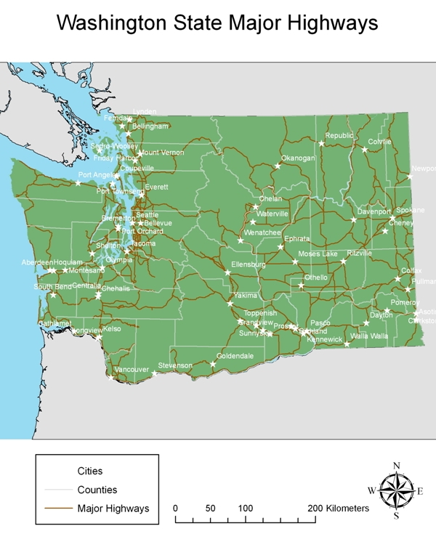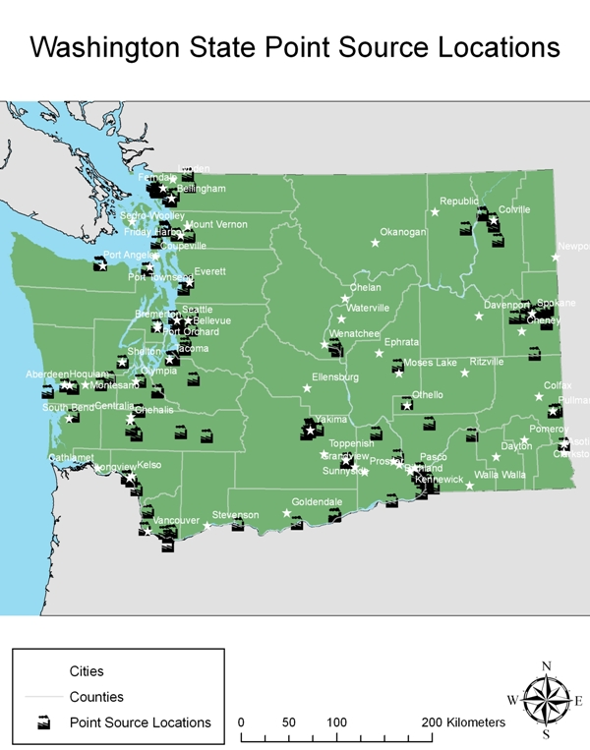
Figures 1 and 2

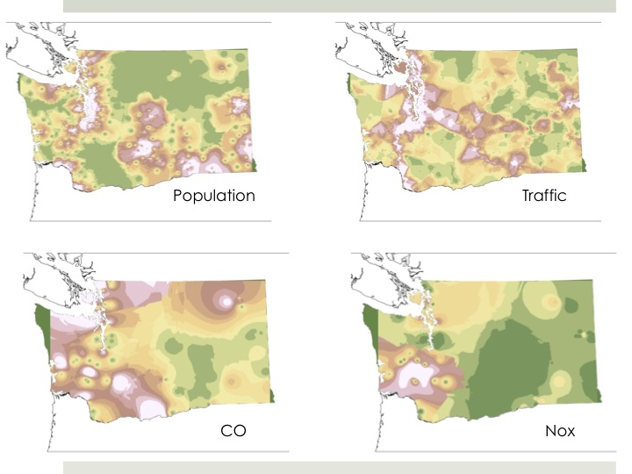
Figure 3

Results/Discussion
The areas that have high Point Source pollution tend to be area where there is also high population density (figure 4). This is mostly in major cites and the city ports. Cities that are “danger zones” are along the I-5 corridor that includes, Bellingham, Everett, Seattle, Tacoma, Olympia, Chehalis and Longview-Kelso and Vancouver (figures 5,6). Along the coast is Port Angeles and Montesano. In Eastern Washington State hot spot cities are Yakima, Wenatchee (figure 8), Kennewick, Walla Walla (figure 7), Spokane and Colville (figure 9).
Port cites such as Port Angeles, Seattle, Tacoma and Olympia have a lot of industry that is located on the waterfront and this is what probably what contributes to such high pollution values. Colville is not one of the major cites and is a mountain town with lumber industry. It is unclear why Colville would be a hot spot.
In Pierce county a third of the schools and parks are located in high population, high pollution regions (Figure 10). Majority of the schools and parks are located in regions of medium pollution (table 2). In King County about a fourth of the schools and parks are located in high population, high pollution regions (figure 11).
Pollution | Pierce Co. Schools | Pierce Co.  Parks | King Co.  Schools | King Co.  Parks
Low | 9 | 12 | 5 | 6
Medium | 58 | 54 | 76 | 80
High | 34 | 35 | 19 | 14
Table 2: Results from Pierce and King county of percentage of schools and parks in population and pollution regions.
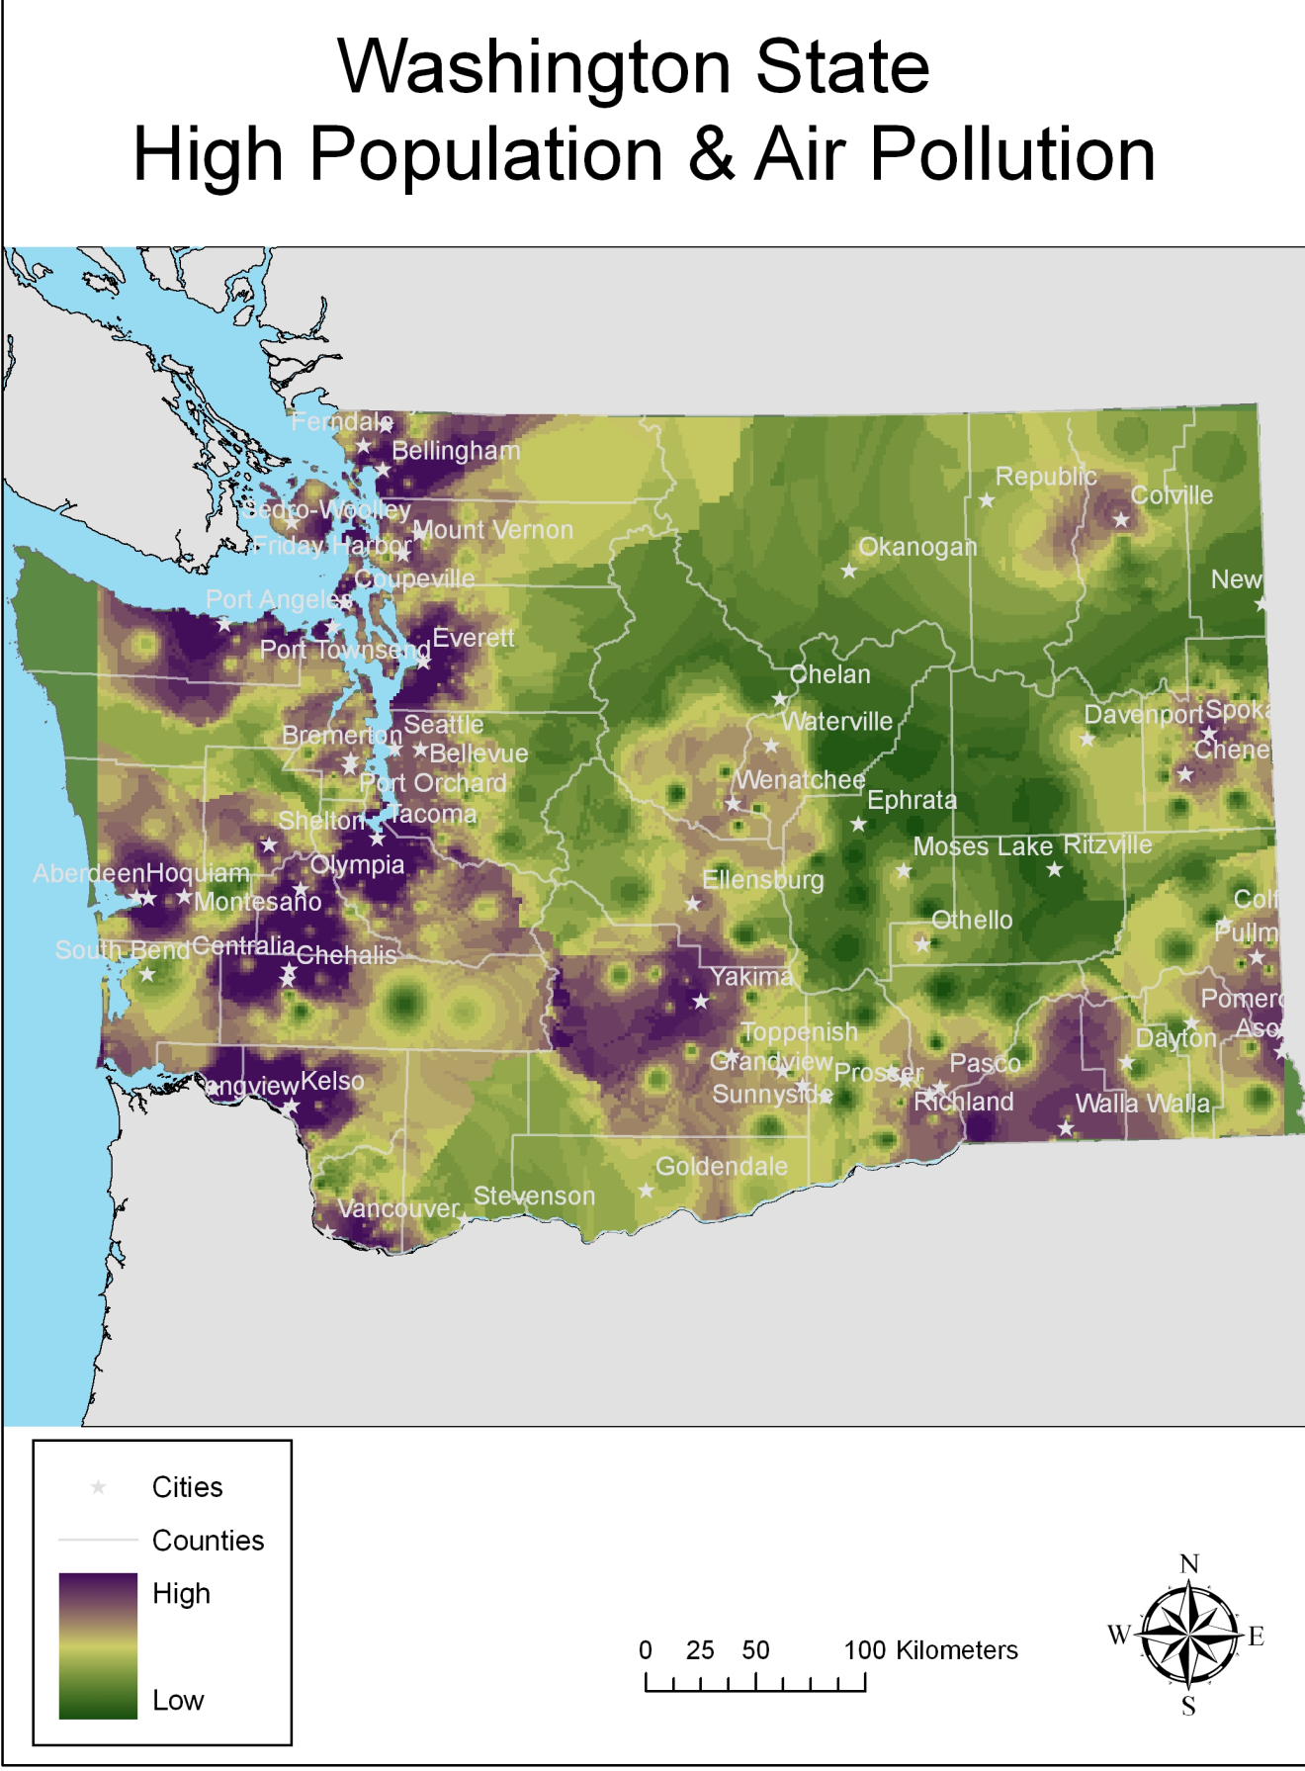
Figure 4: Mastermap of Washington State with high population and high pollution areas in purple and low in green.
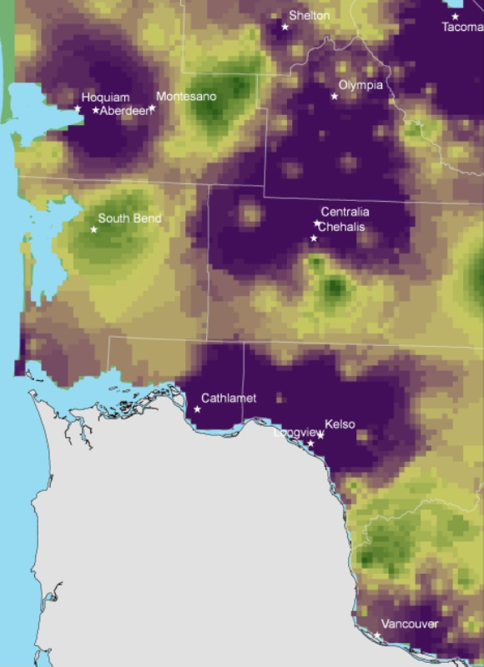
Figure 7
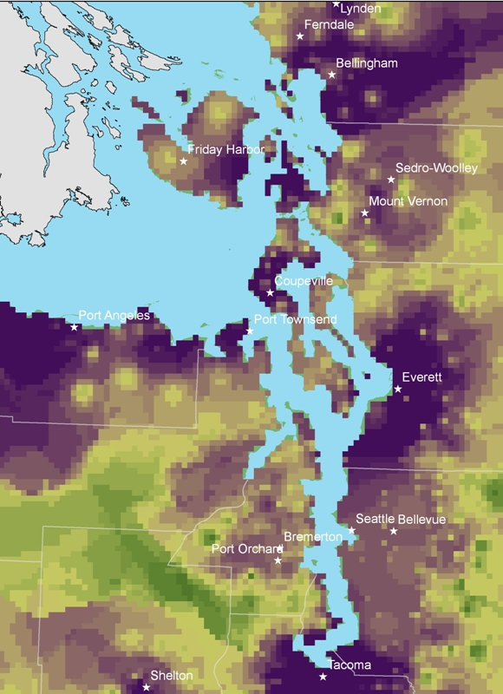
Figure 6
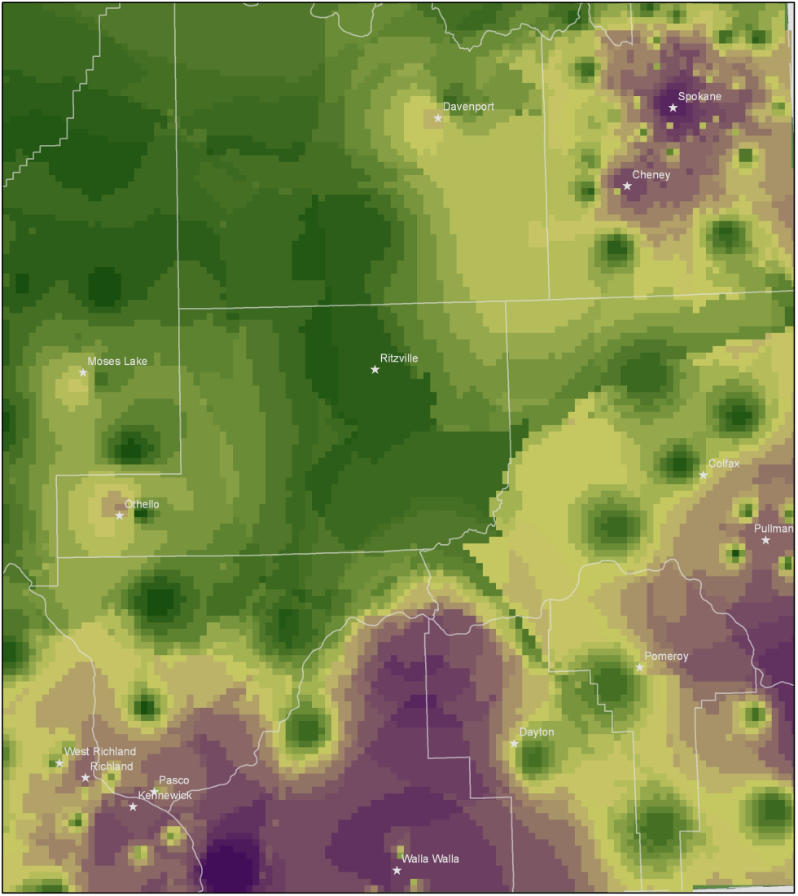
Figure 7: Walla Walla at the bottom and Spokane in the upper right corner.

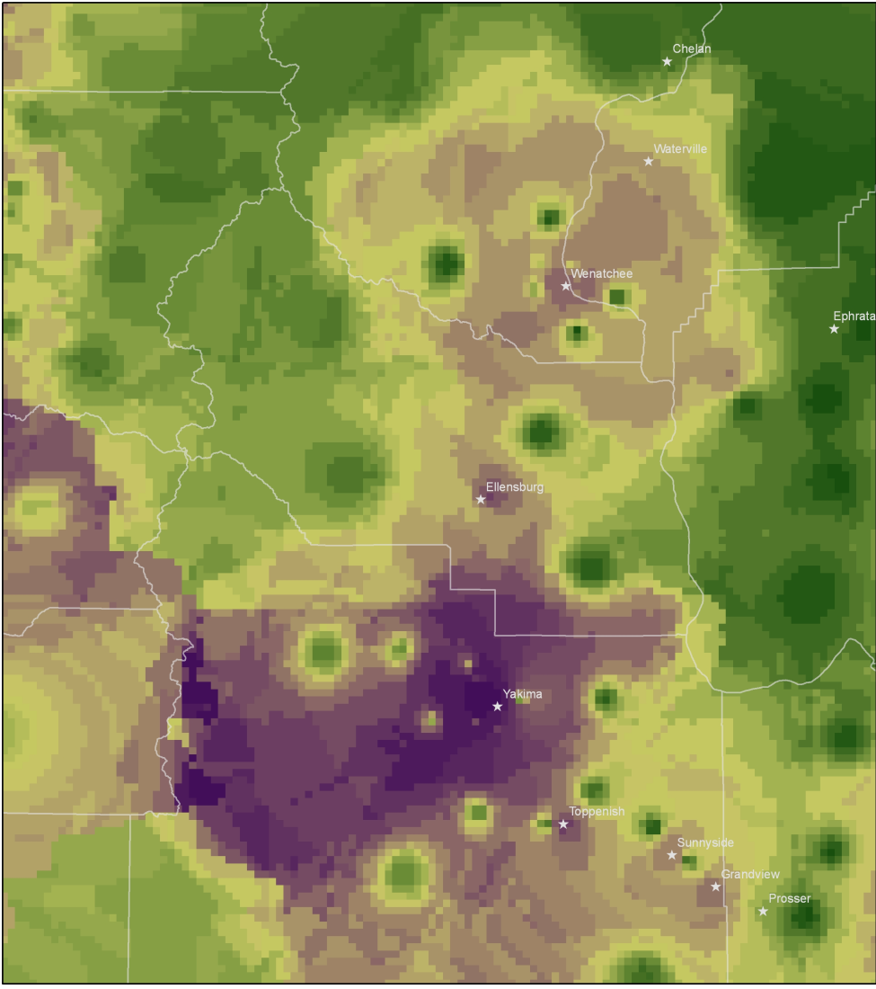
Figure 8: Yakima the darker purple and Wenatchee above.

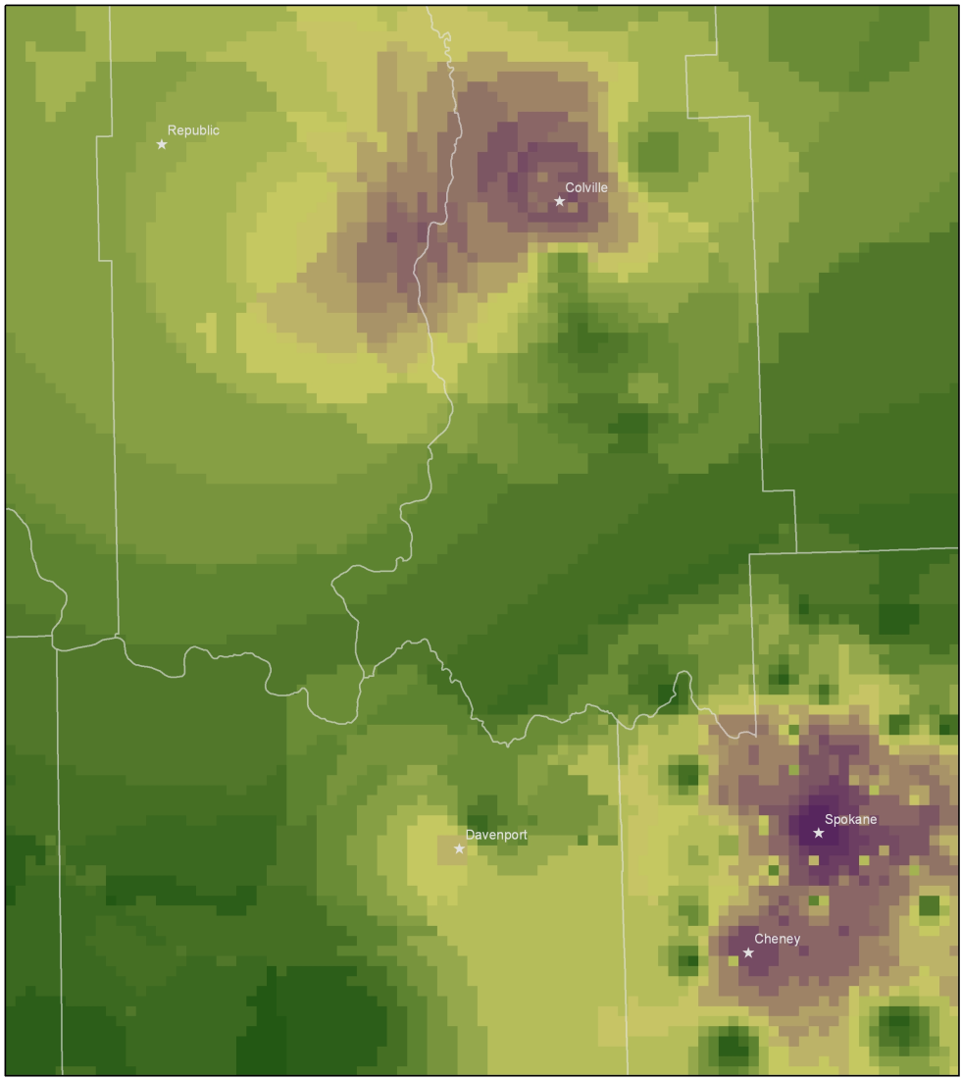
Figure 9: Colville above and Spokane to the right.

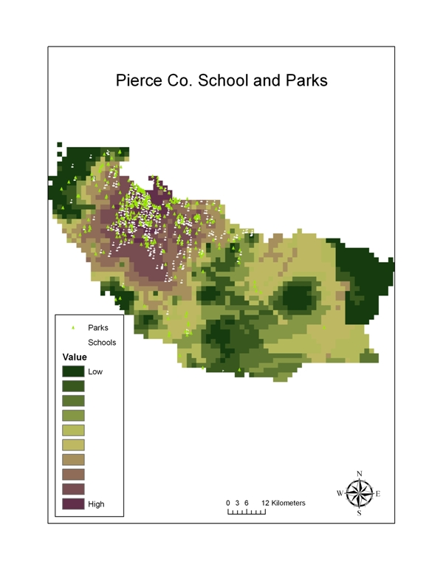
Figure 10
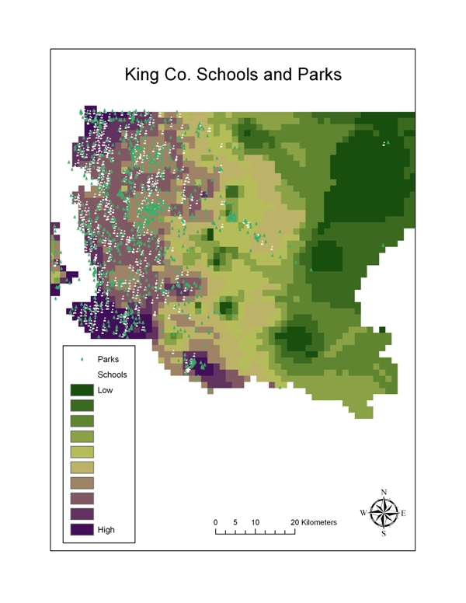
Figure 11

Conclusion
There does appear to be a strong relationship between area of high air pollution and areas of high population density. Specifically, areas of highest population density, point source air pollution and traffic pollution along the I-5 corridor, Spokane area and southeastern Washington State. This is not unexpected as urban areas have high pollution and high populations. Pierce County has high values at the City of Tacoma. King County has high values along the water.
A high percentage of schools and parks in Pierce and King County are located in areas that have high population and medium air pollution from mobile and point sources (figures 11, 12). Pierce County has more schools and parks located in high pollution regions than King County. For both counties there were very few schools and parks located in the low pollution areas (Table 1).

Future Work
There are several more parameters that can be included in this project to make a more accurate assessment of population exposure to air pollution. First, meteorological data, such as wind patterns may have an affect on the amount of pollutant suspended in air and distributed. Second, to consider different demographics of the population instead of encompassing the entire population. Also, most of the data used in this project was generalized. More specific or defined study area and or data perhaps would provide a more informative or useful analysis.

Works Cited

Afshar, H., Delavar, M. 2007. A GIS-based Air Pollution Modeling in Tehran. Environmental Informatics Archives: (5) 557-566
Batchelder, Tim. 2006. Remote Sensing, Information systems and allergies. Online article

Bhandari, K. Rao, P. Shukla, A. ND. GIS applications in air pollution modelling. Online article, GIS development.

Hansen, C., Jensen, S., Baelum, J., Sherson, D., Skadhauge, L., Siersted, H.C., Hertel, O.,
Omland, Ø., Thomsen, G., Sigsgaard, T. 2008. Individual traffic-related air pollution and new onset adult asthma: A GIS-based pilot study. National Environmental Research Institute, University of Aarhus, Denmark. 23 pp - NERI Technical Report No.665. http://www.dmu.dk/Pub/FR665.pdf .

Jensen, Steen. ND. Mapping Human Exposure to traffic air pollution using GIS. Journal of Hazardous Materials 61 1998 385 – 392.

