Wallowa and Bald Mountain Batholiths

Wallowa and Bald Mountain Batholith QTQt model results

Below, we present results from QTQt models. For all samples, we show the best-fit time temperature model with 95% credibility interval, shown by maroon lines, and the weighted mean in blue. Predicted and observed ages also shown.
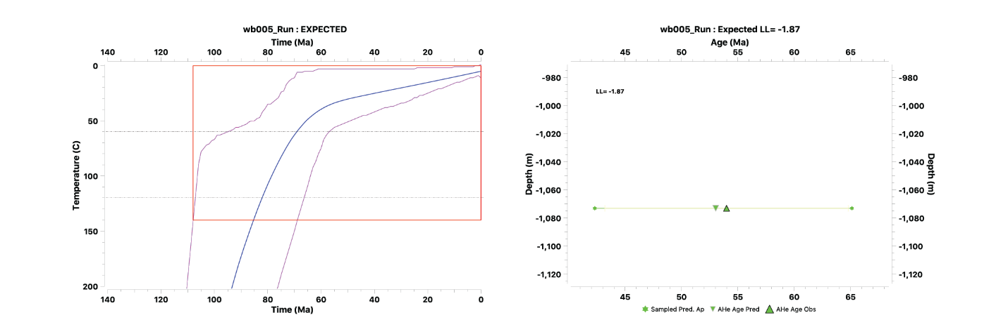
Figure 1. Time-temperature plot and predicted age plot for sample WB005.
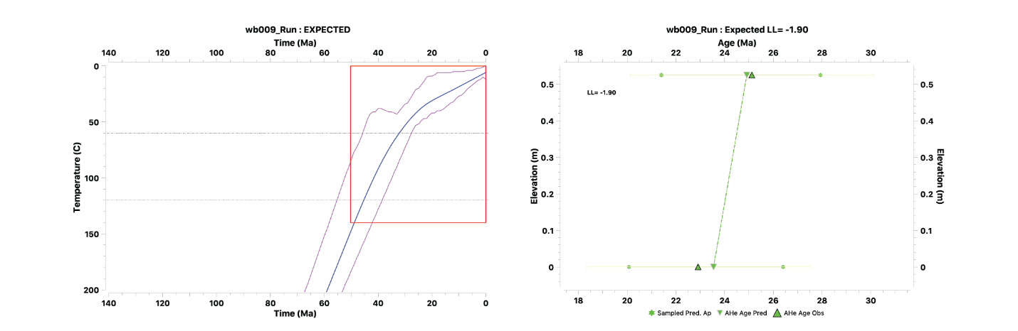
Figure 2. Time-temperature plot and predicted age plot for sample WB009.
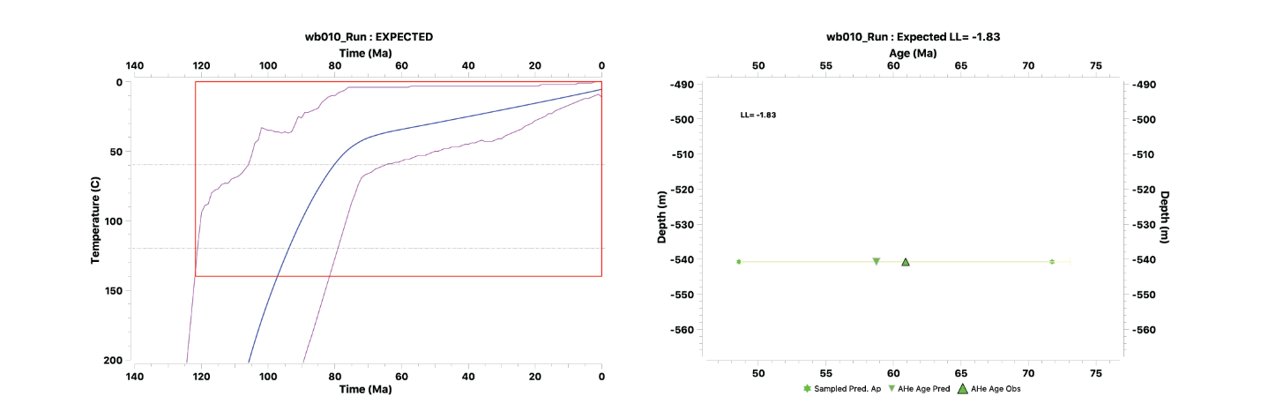
Figure 3. Time-temperature plot and predicted age plot for sample WB010.
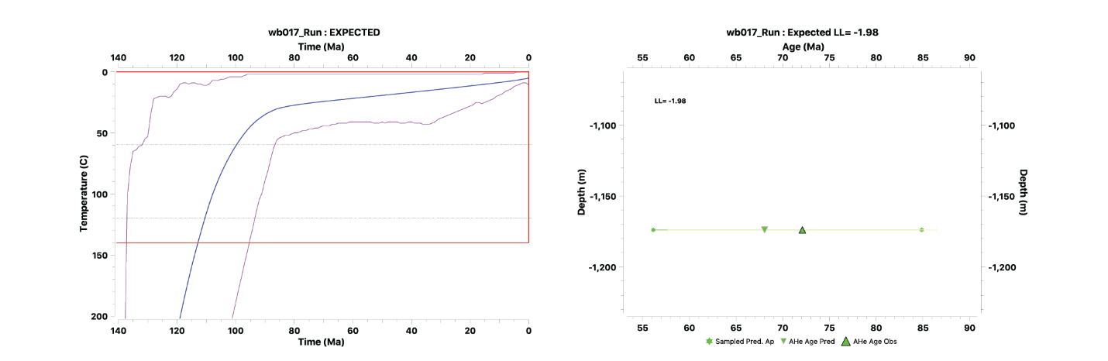
Figure 4. Time-temperature plot and predicted age plot for sample WB017.
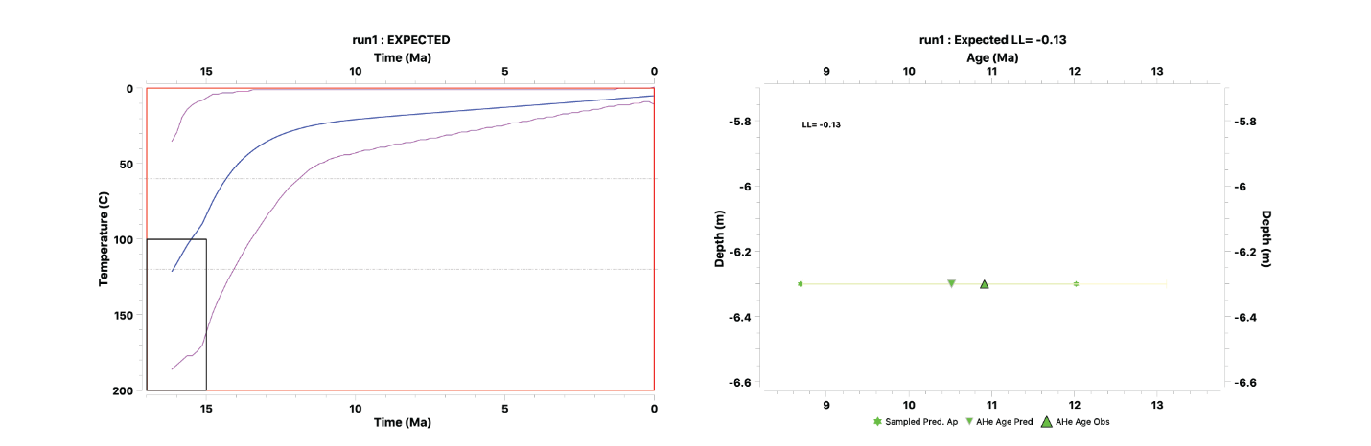
Figure 5. Time-temperature plot and predicted age plot for sample WB034.

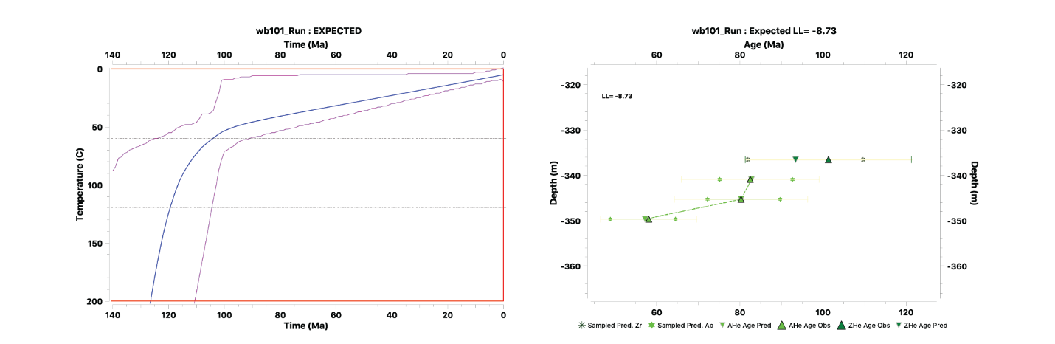
Figure 6. Time-temperature plot and predicted age plot for sample WB101.

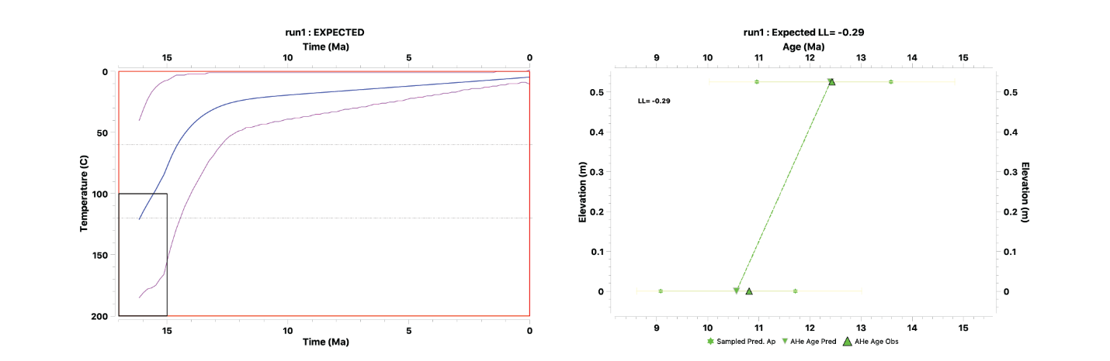
Figure 7. Time-temperature plot and predicted age plot for sample WB104.
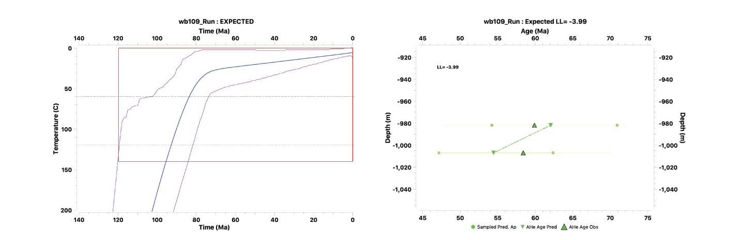
Figure 8. Time-temperature plot and predicted age plot for sample WB109.
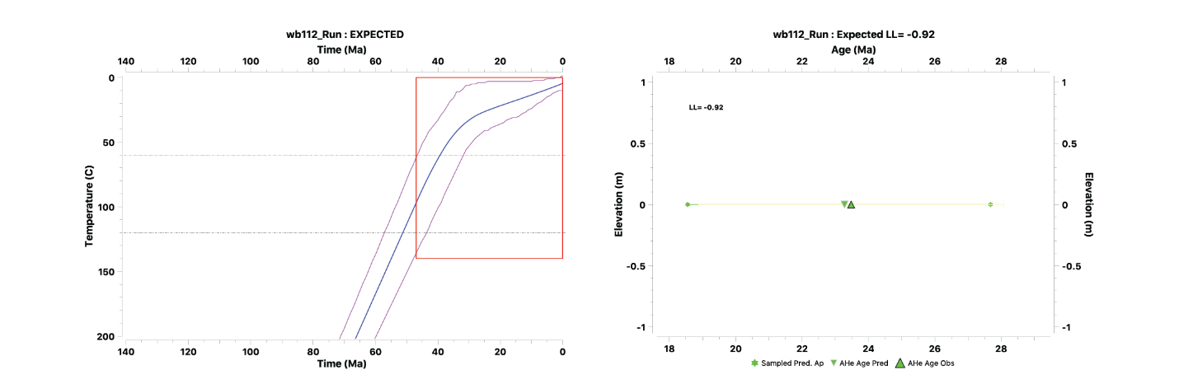 Figure 9. Time-temperature plot and predicted age plot for sample WB112.

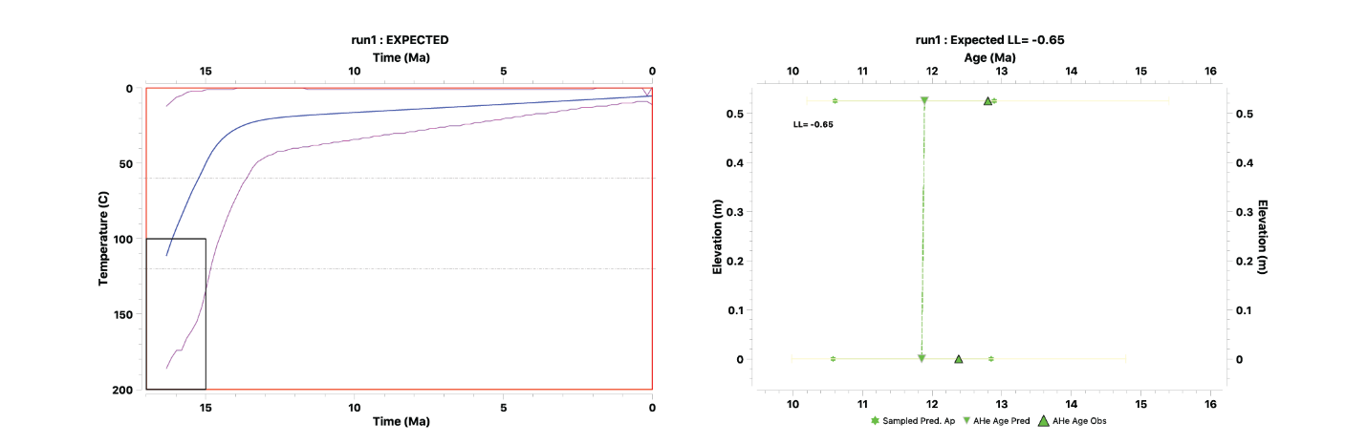
Figure 10. Time-temperature plot and predicted age plot for sample WB118.
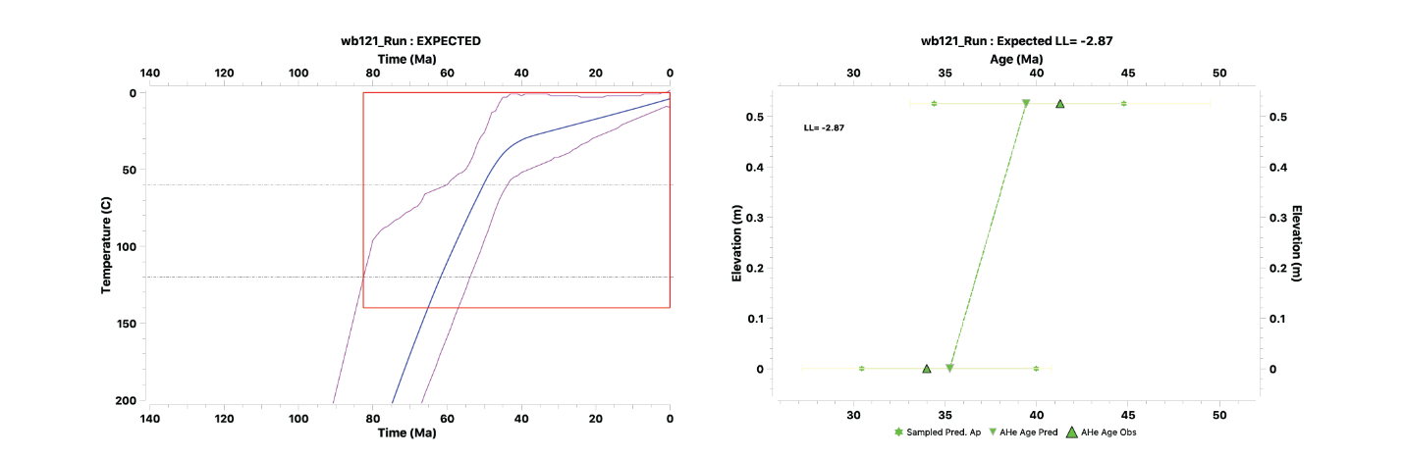
Figure 11. Time-temperature plot and predicted age plot for sample WB121.
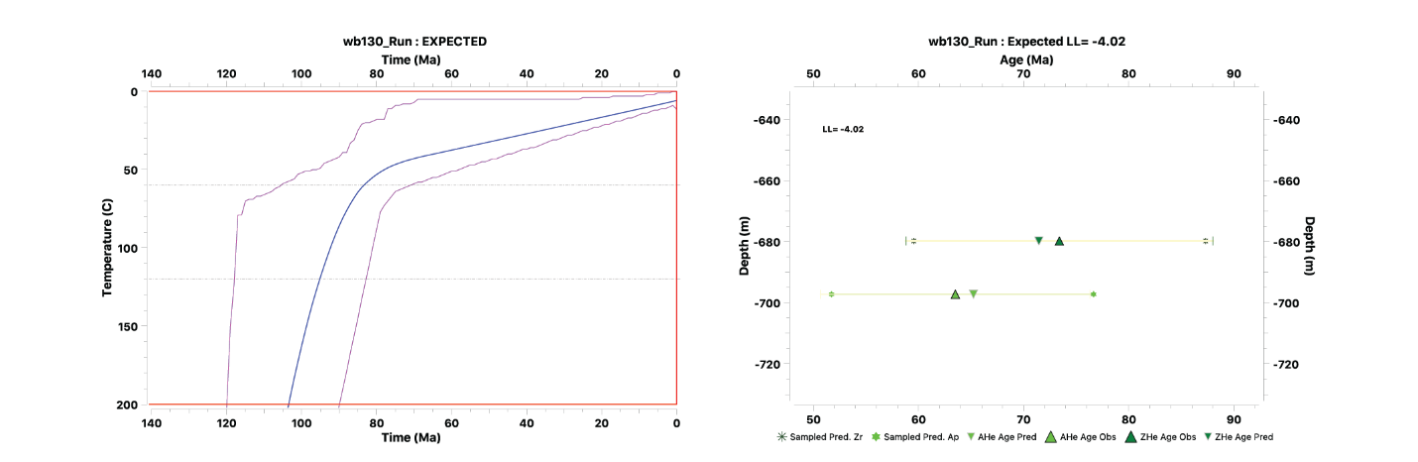
Figure 12. Time-temperature plot and predicted age plot for sample WB130.
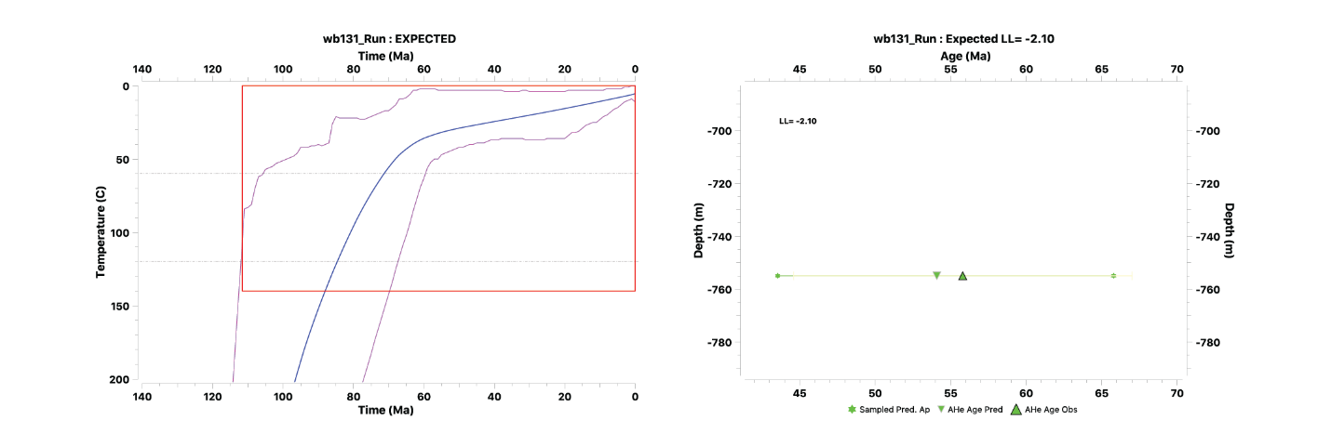
Figure 13. Time-temperature plot and predicted age plot for sample WB131.
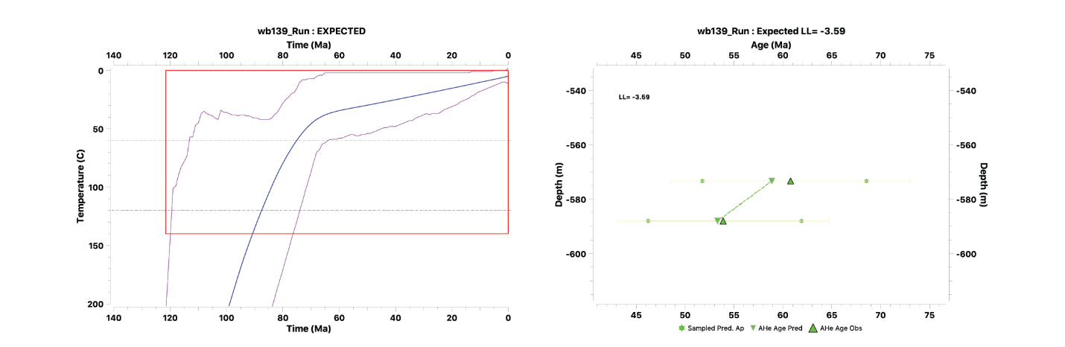
Figure 14. Time-temperature plot and predicted age plot for sample WB139.
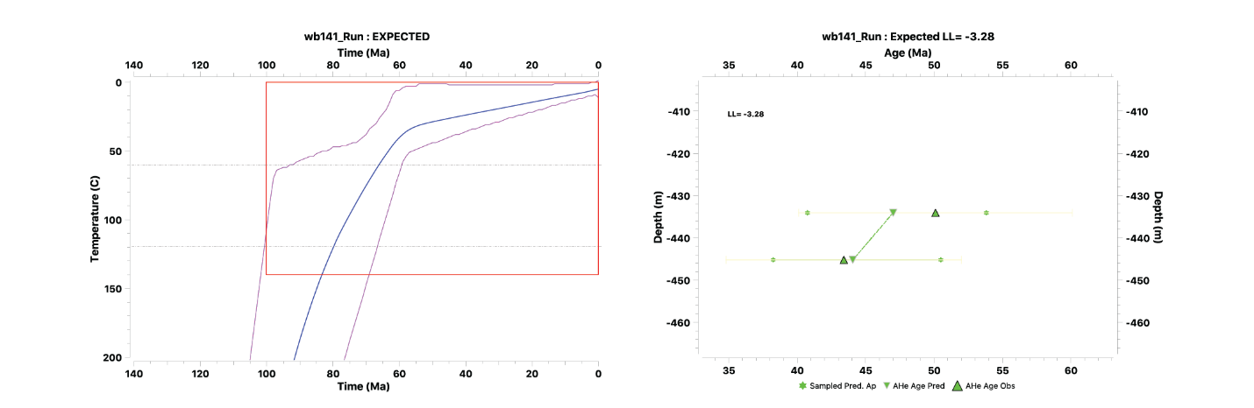
Figure 15. Time-temperature plot and predicted age plot for sample WB141.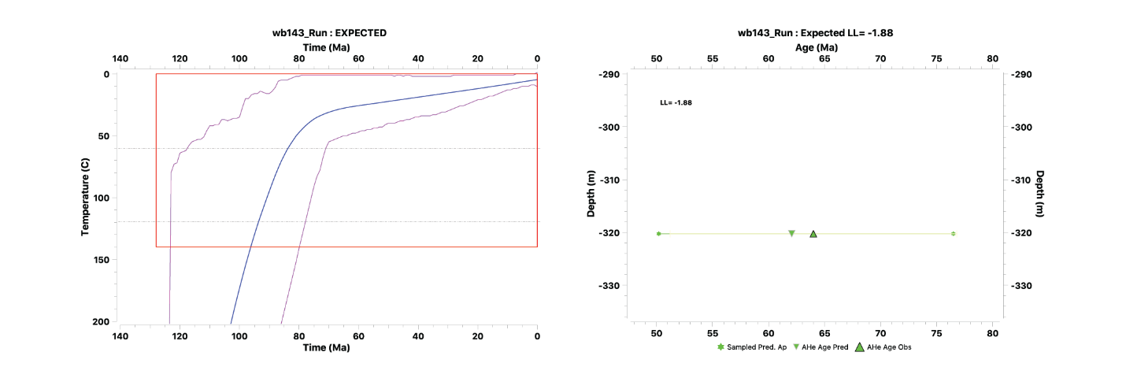
Figure 16. Time-temperature plot and predicted age plot for sample WB143.
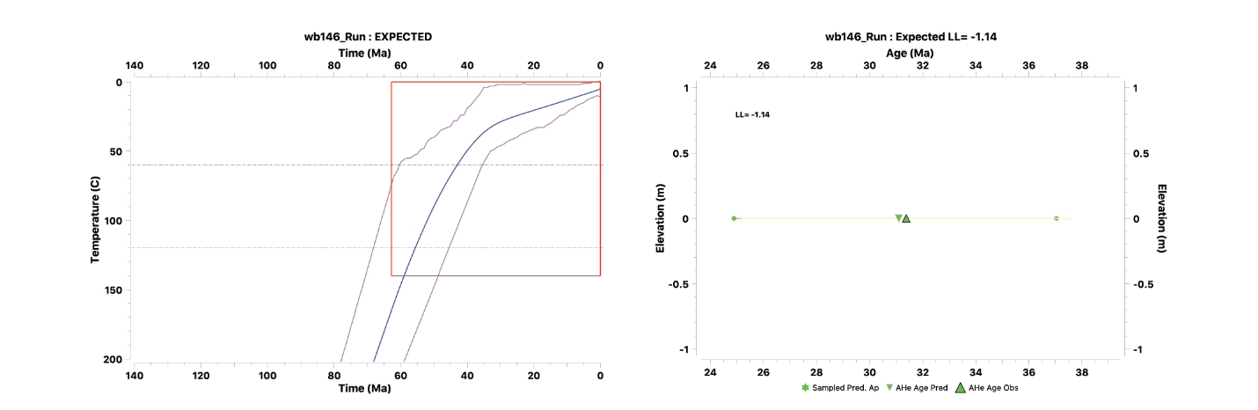
Figure 17. Time-temperature plot and predicted age plot for sample WB146.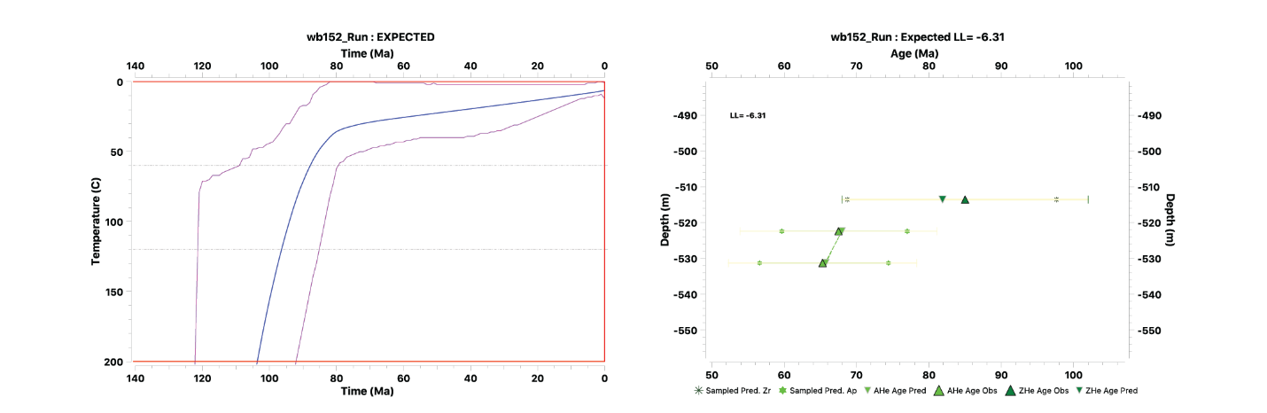
Figure 18. Time-temperature plot and predicted age plot for sample WB152.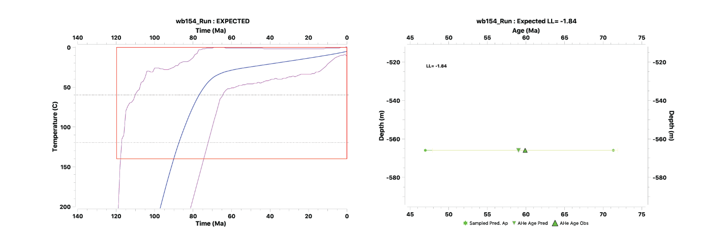 Figure 19. Time-temperature plot and predicted age plot for sample WB154.
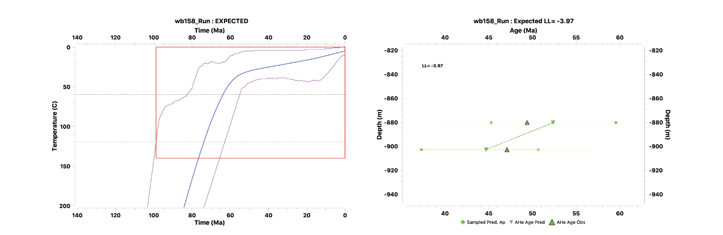
Figure 20. Time-temperature plot and predicted age plot for sample WB158.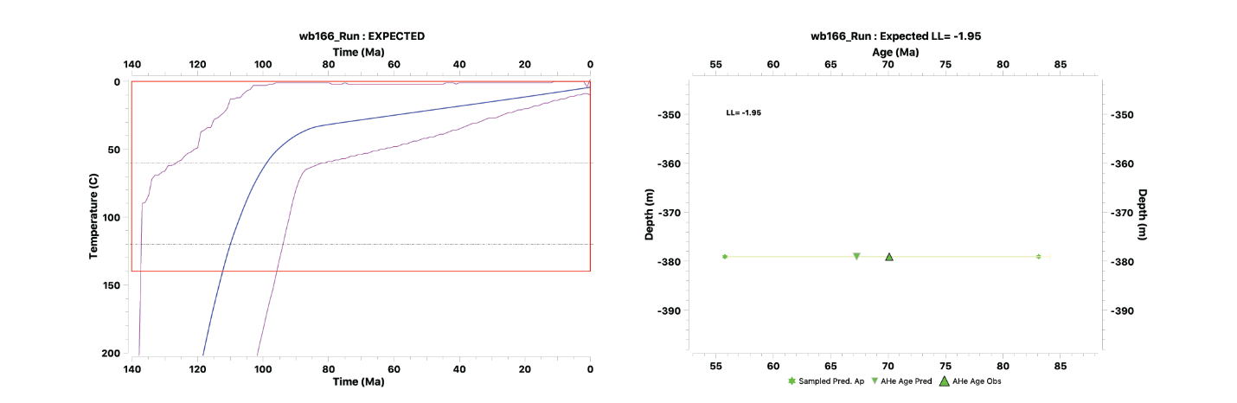
Figure 21. Time-temperature plot and predicted age plot for sample WB166.
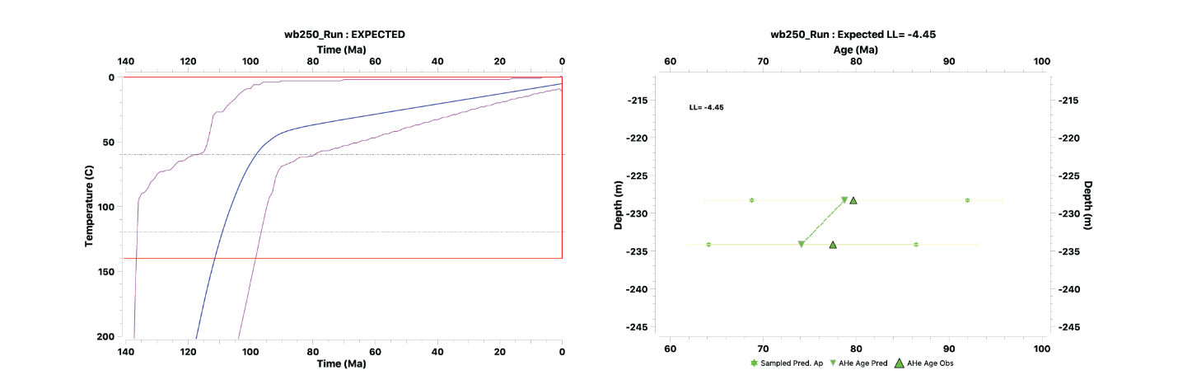
Figure 22. Time-temperature plot and predicted age plot for sample WB250.
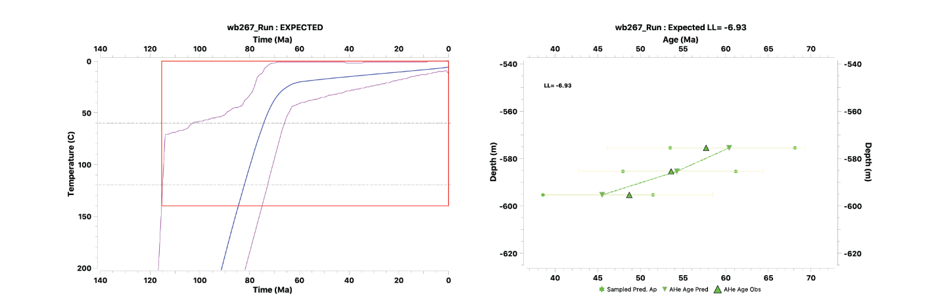
Figure 23. Time-temperature plot and predicted age plot for sample WB267.
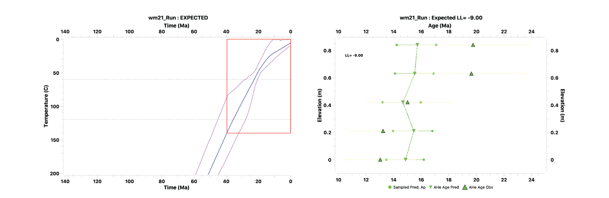
Figure 24. Time-temperature plot and predicted age plot for sample WM21.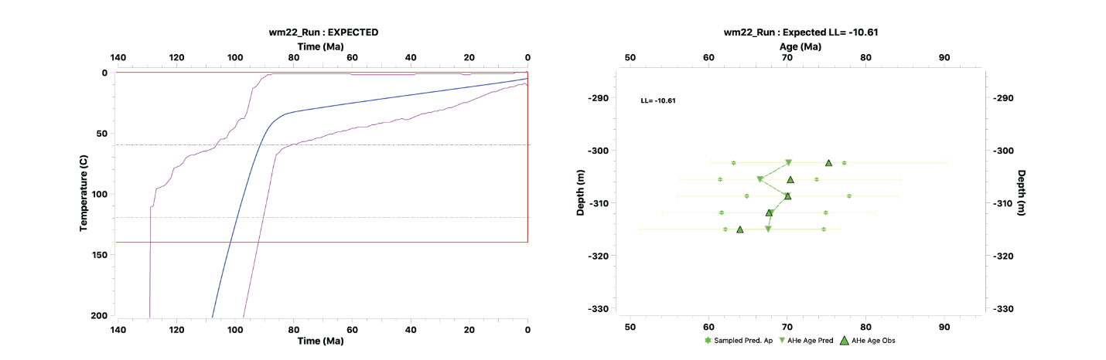 Figure 25. Time-temperature plot and predicted age plot for sample WM22.
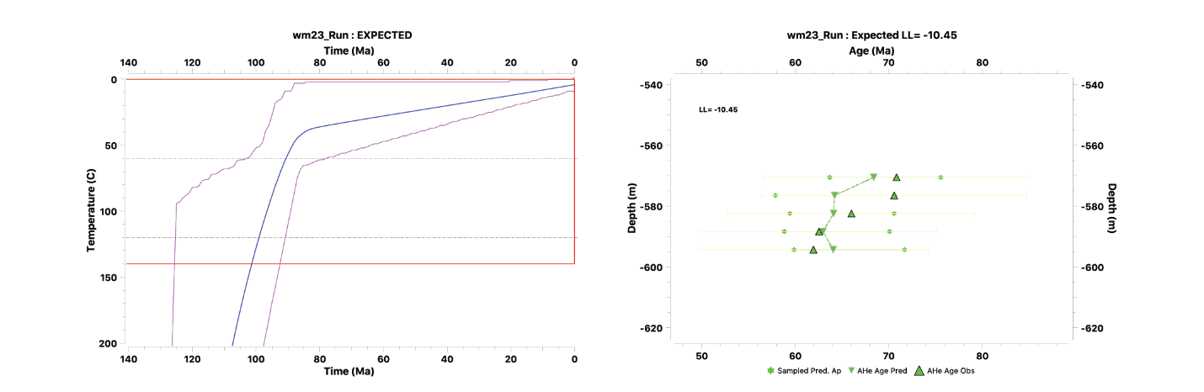
Figure 26. Time-temperature plot and predicted age plot for sample WM23.
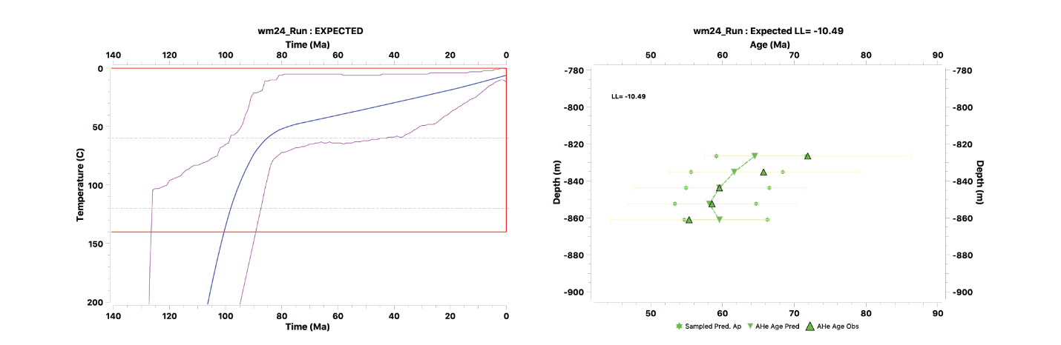
Figure 27. Time-temperature plot and predicted age plot for sample WM24.
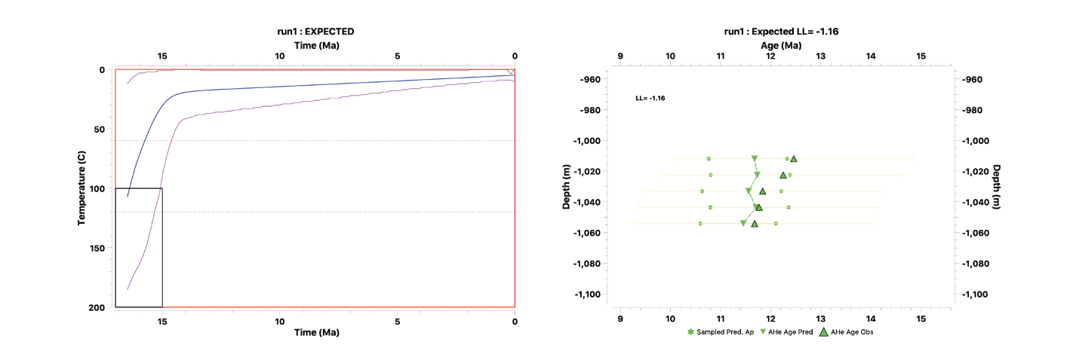
Figure 28. Time-temperature plot and predicted age plot for sample WM25.
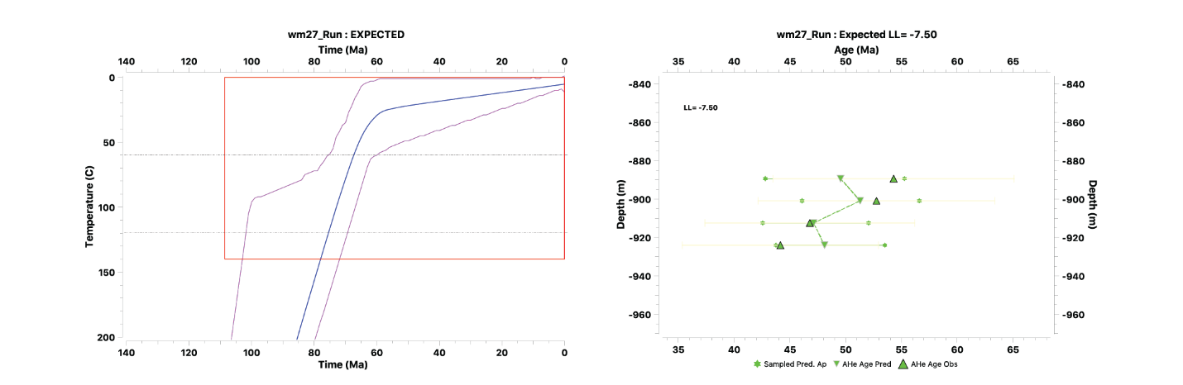 Figure 29. Time-temperature plot and predicted age plot for sample WM27.
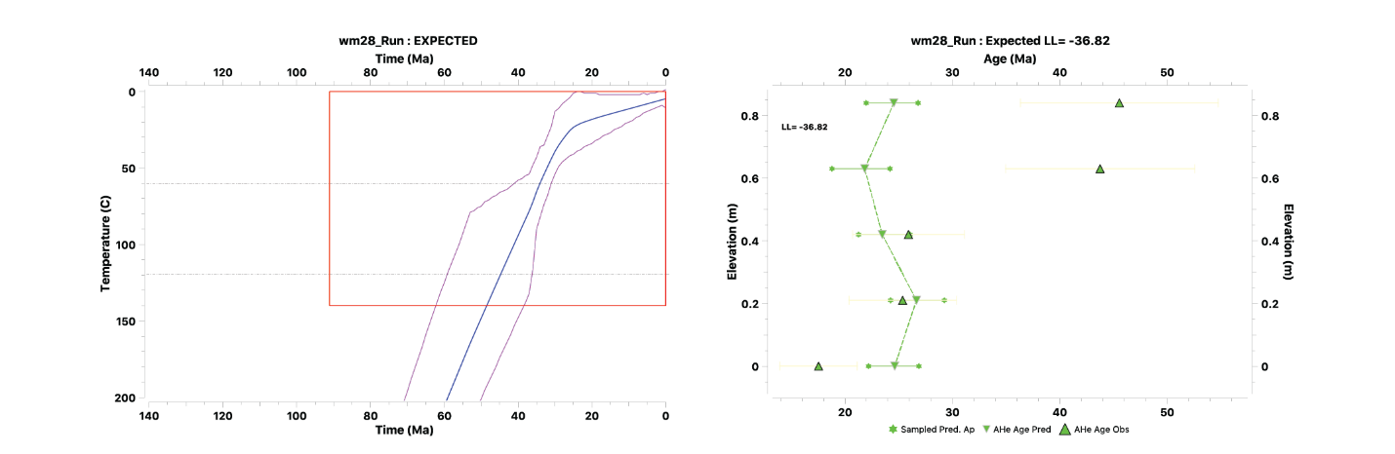
Figure 30. Time-temperature plot and predicted age plot for sample WM28.
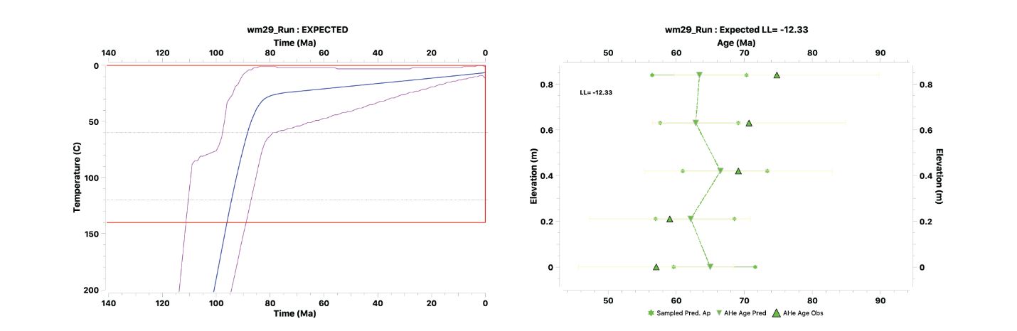
Figure 31. Time-temperature plot and predicted age plot for sample WM29.
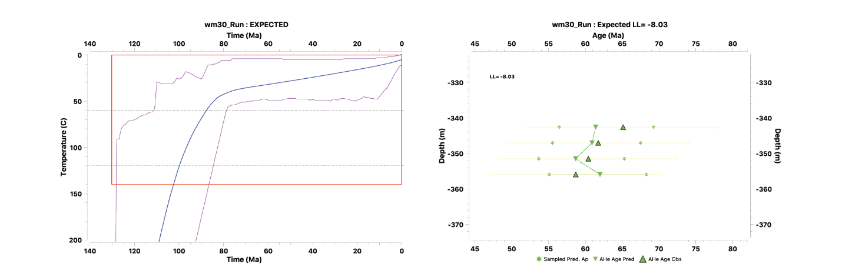
Figure 32. Time-temperature plot and predicted age plot for sample WM30.
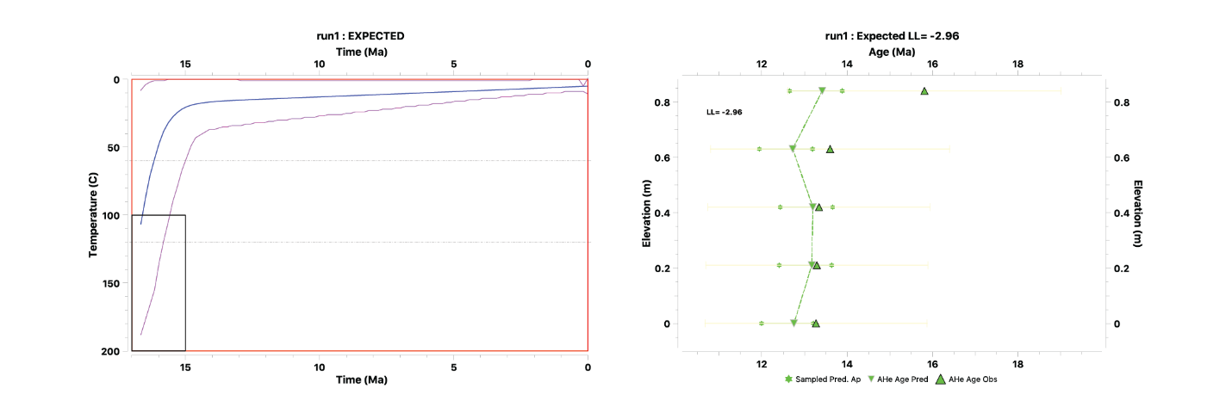
Figure 33. Time-temperature plot and predicted age plot for sample WM31.

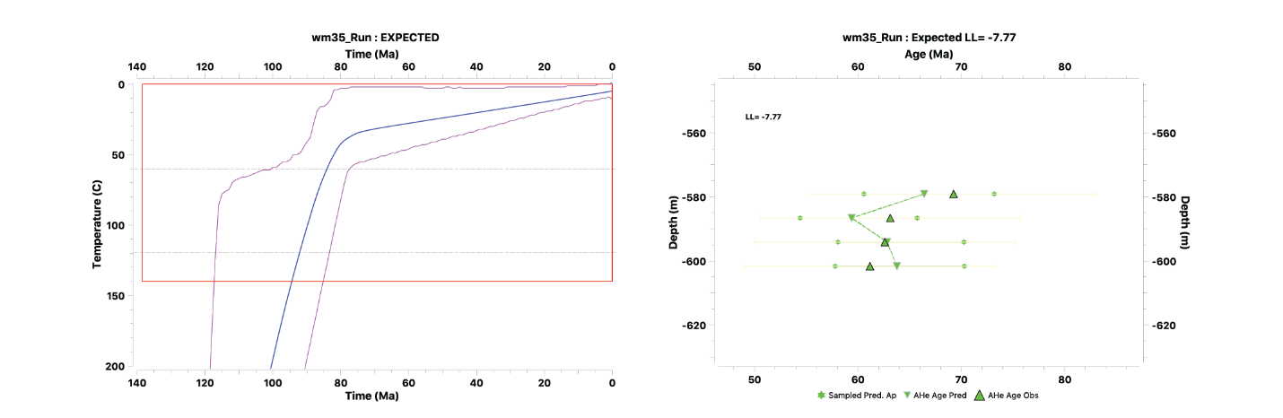
Figure 34. Time-temperature plot and predicted age plot for sample WM35.
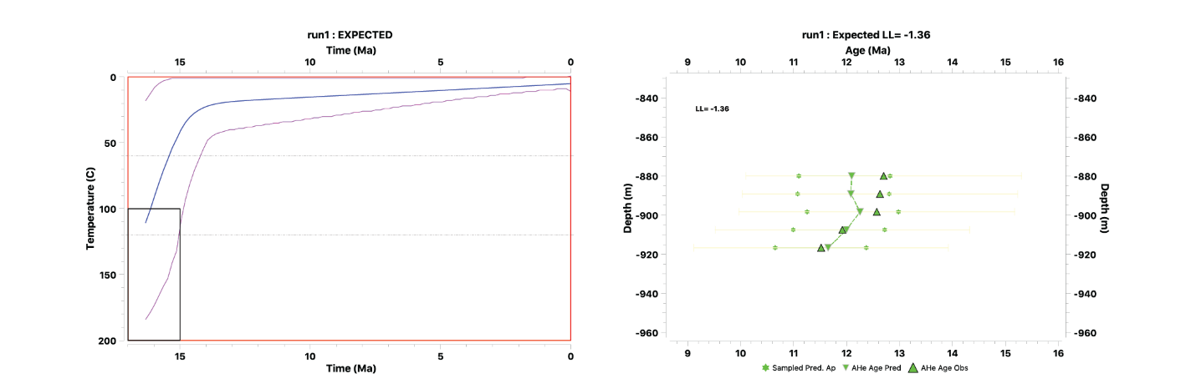
Figure 35. Time-temperature plot and predicted age plot for sample WM39.
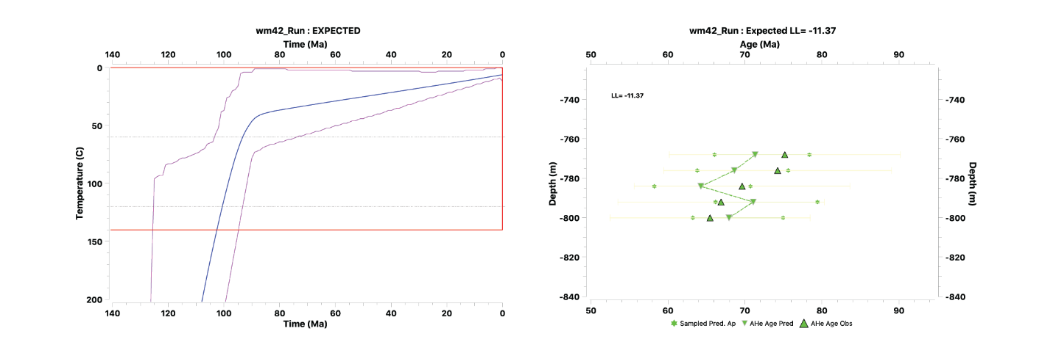 Figure 36. Time-temperature plot and predicted age plot for sample WM42.
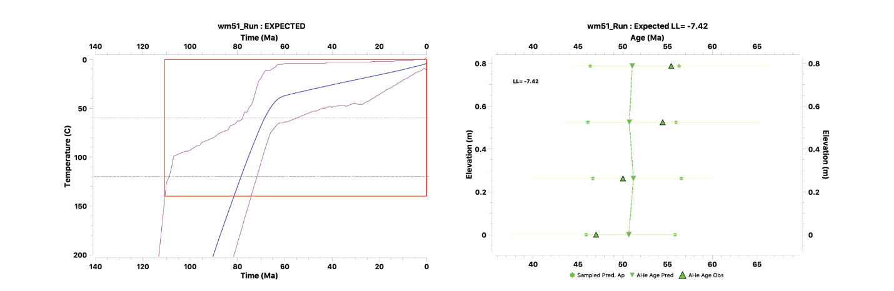
Figure 37. Time-temperature plot and predicted age plot for sample WM51.
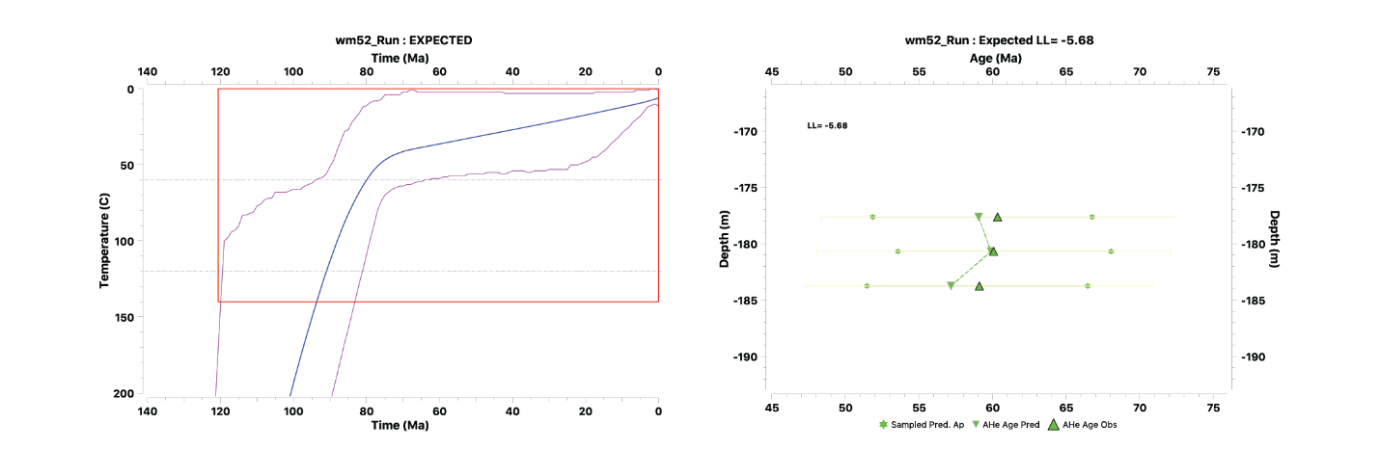
Figure 38. Time-temperature plot and predicted age plot for sample WM52.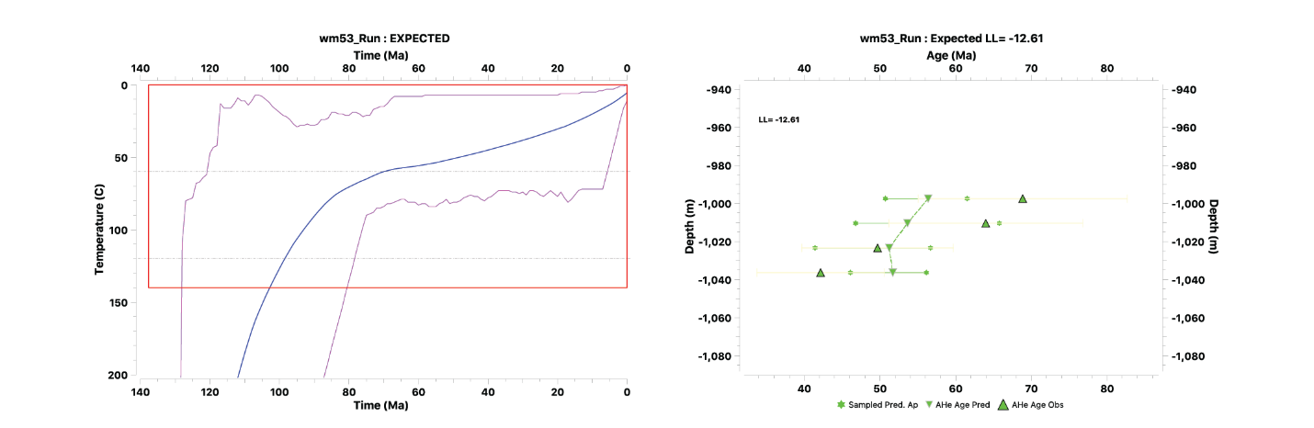 Figure 39. Time-temperature plot and predicted age plot for sample WM53.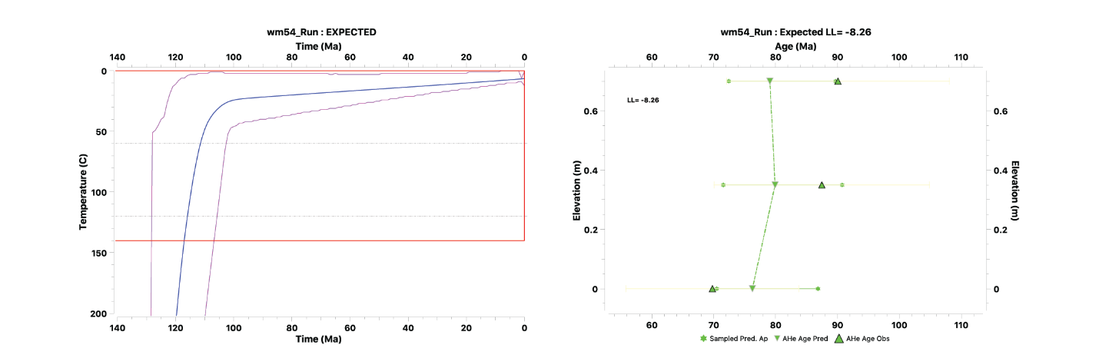 Figure 40. Time-temperature plot and predicted age plot for sample WM54.

Haida Gwaii

Haida Gwaii QTQt model results

Below, we present results from QTQt models. For all samples, we show temperature probability heat map over the time which our data provides constraint. Hotter colors indicate higher probability for a given time-temperature point. Probability plot shows 95% credibility interval, shown by black lines enveloping time-temperature path, the model that best fits posterior probability (in olive), the best-fit single time-temperature path (maroon), weighted mean (black), and mode (white) results. We also provide a predicted vs. observed age plot for each model.

Barry Inlet Vertical Transect
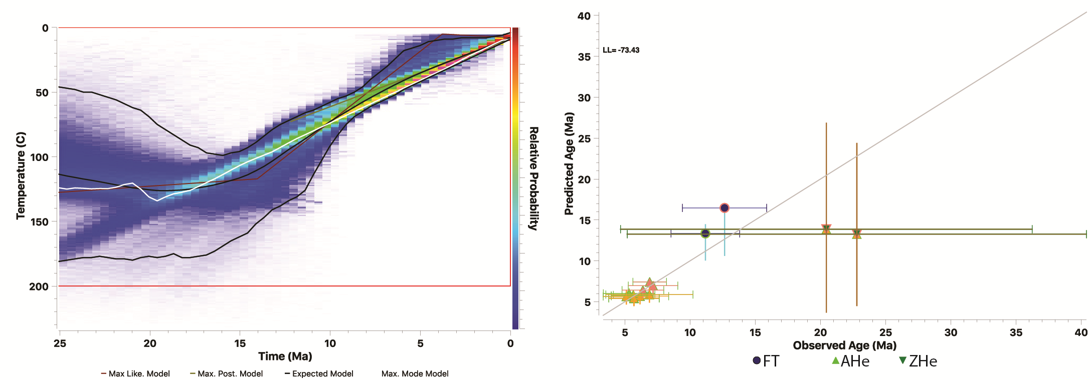
Figure 41. Time-temperature probability plot for sample HG04, the lowest sample in Barry Inlet Vertical Transect as well as predicted vs. observed age plot for model run.

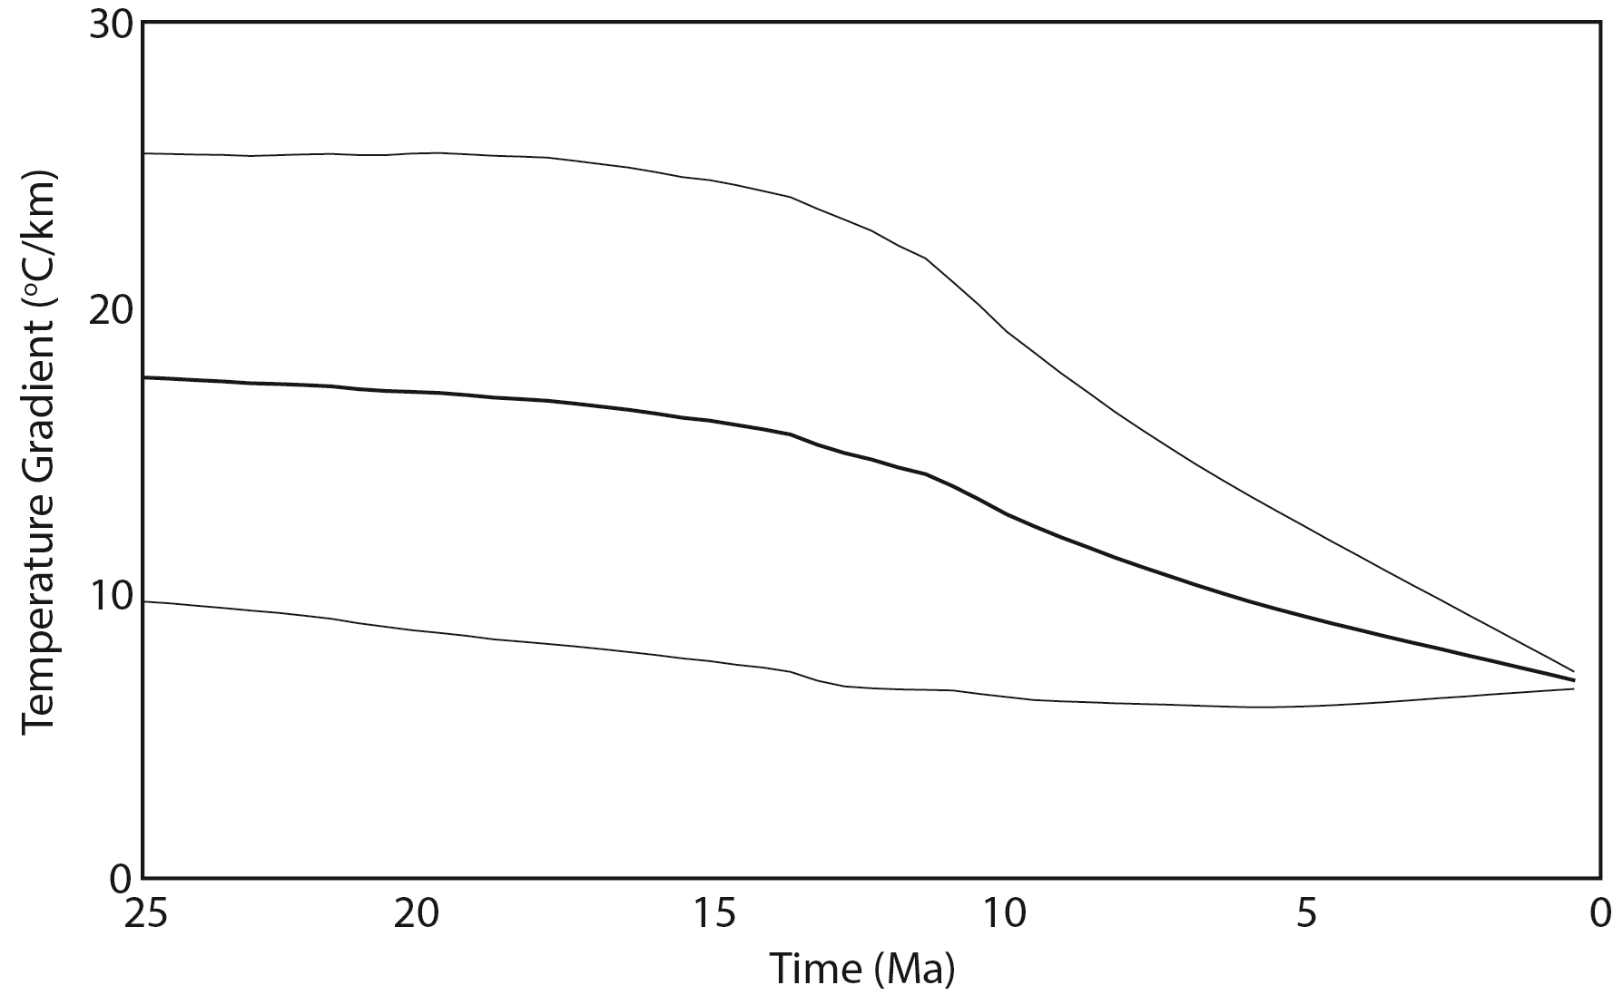
Figure 42. Estimated geothermal gradient for Barry Inlet Vertical Transect. Predicted geothermal gradient of ~20ºCkm⁻¹ agrees well with our chosen gradient for exhumation estimates.

HG02
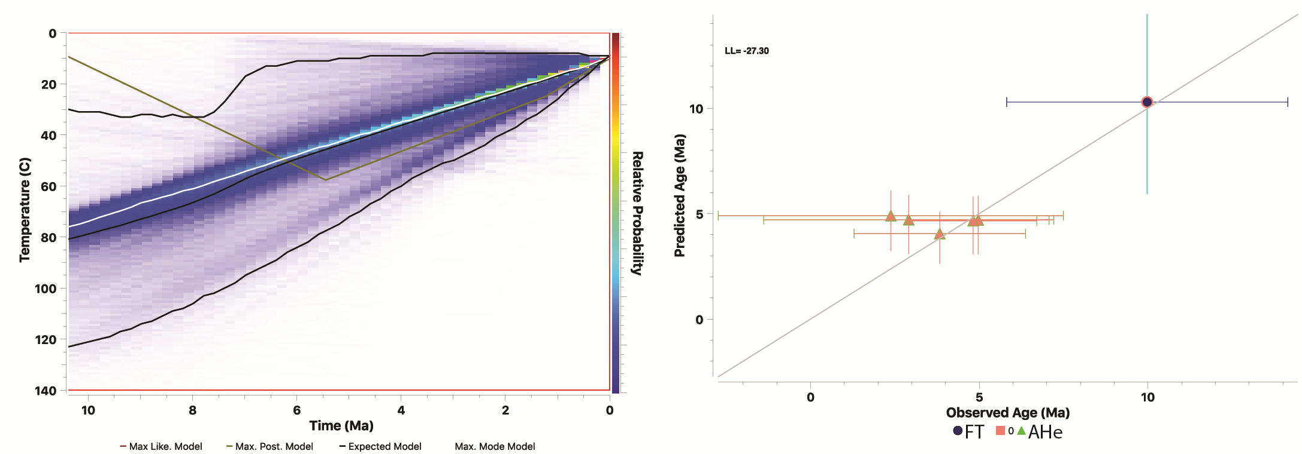

Figure 43. Time-temperature probability plot for sample HG02 as well as predicted vs. observed age plot for model run.

HG12
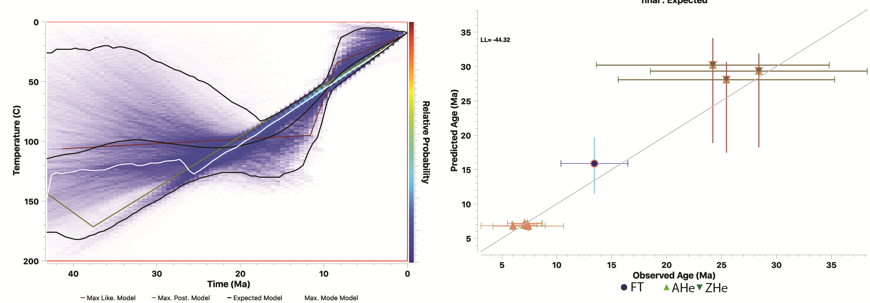
Figure 44. Time-temperature probability plot for sample HG12 and predicted vs. observed age plot for final model run.

HG19
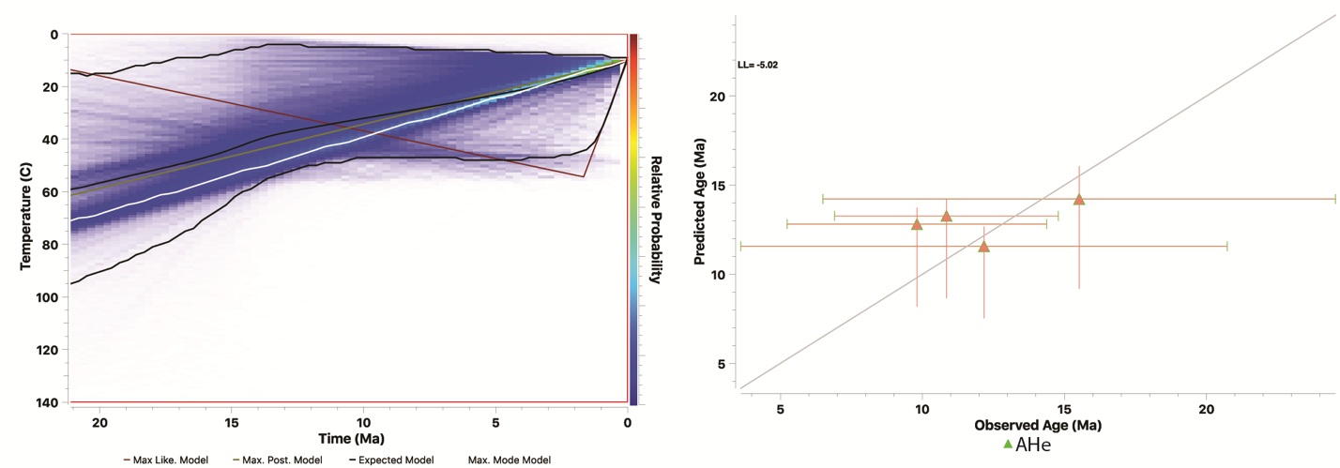
Figure 45. Time-temperature probability plot for sample HG19 and predicted vs. observed age plot for final model run.

HG28
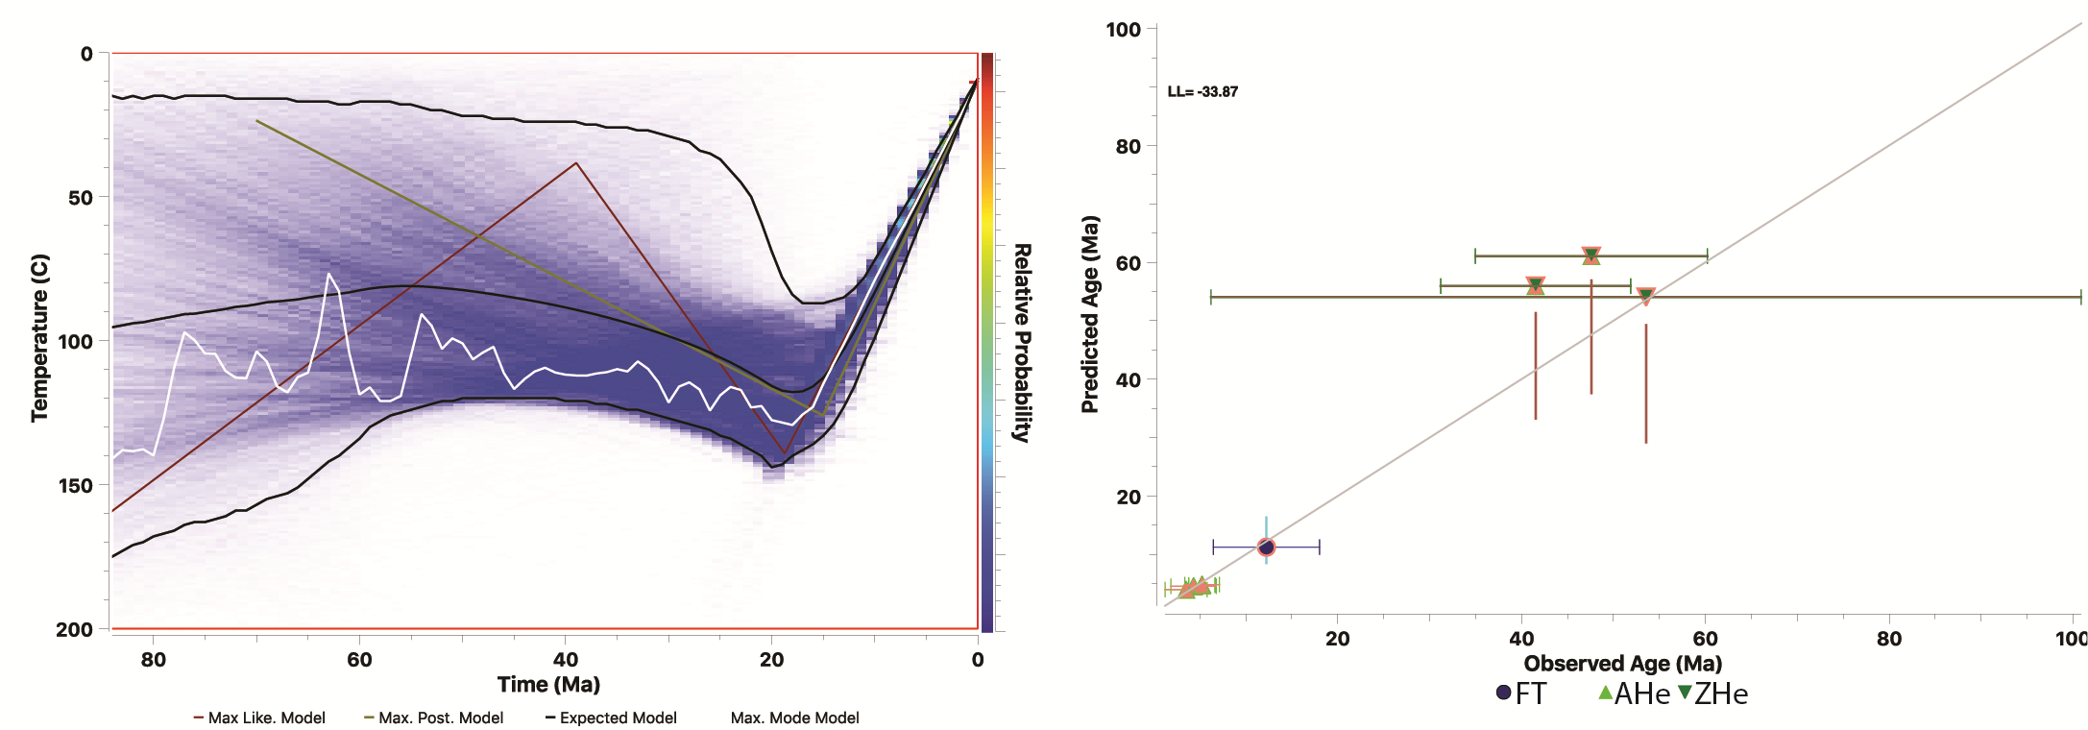
Figure 46. Time-temperature probability plot for sample HG28 and predicted vs. observed age plot for final model run.

HG34
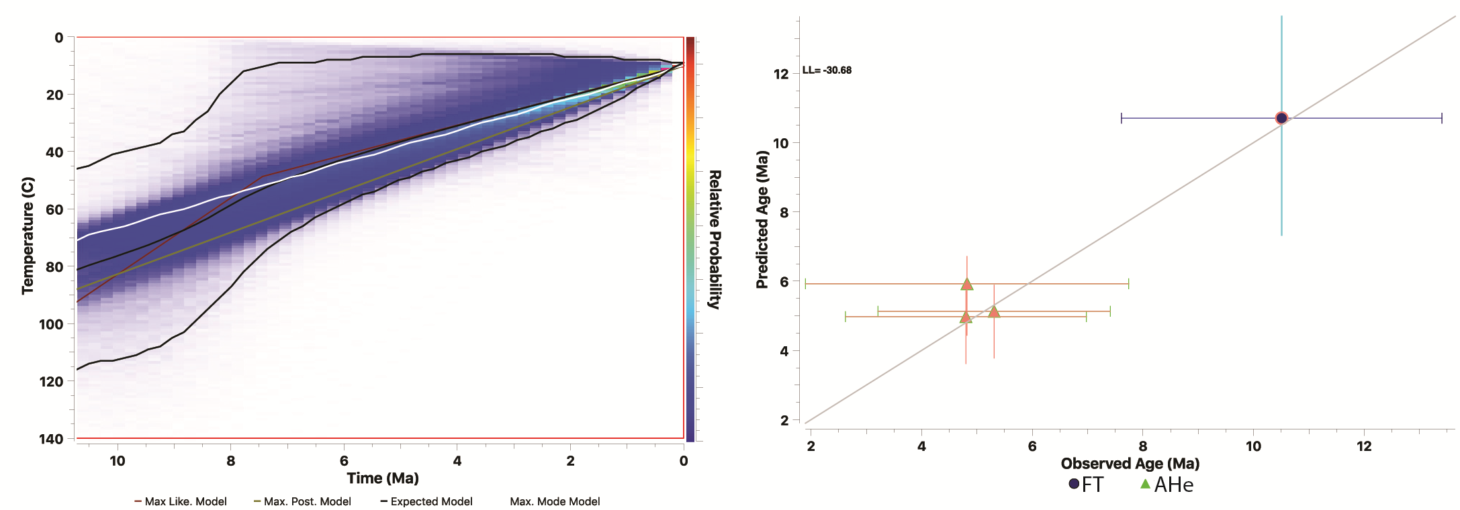
Figure 47. Time-temperature probability plot for sample HG34 and predicted vs. observed age plot for final model run.

06CD16
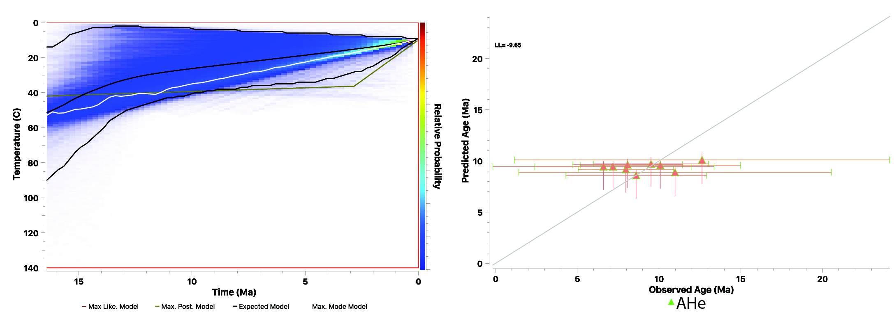
Figure 48. Time-temperature probability plot for sample 06CD16 and predicted vs. observed age plot for final model run.

07CD16
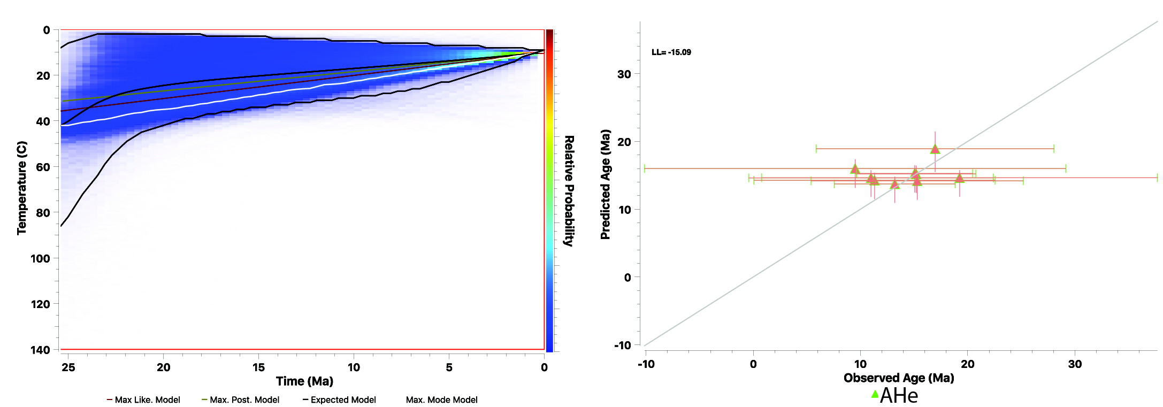
Figure 49. Time-temperature probability plot for sample 07CD16 and predicted vs. observed age plot for final model run.

29CD16
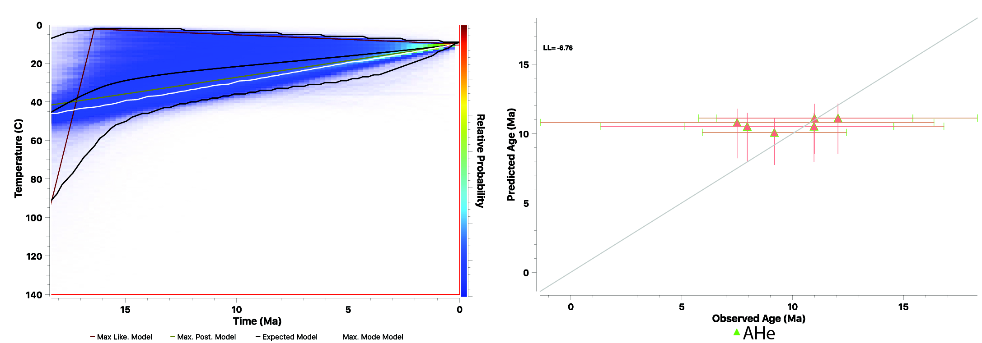
Figure 50. Time-temperature probability plot for sample 07CD16 and predicted vs. observed age plot for final model run.

